Emergency Procedures Training
2017/6/15-108 (I) PP

Abstract: Lasting 10 to 15 minutes, this presentation acquaints the audience with the benefits of Emergency Procedures Training.
Format: Information Briefing - Power Point presentation
Required Personnel – FAASTeam Program Manager or designated FAASTeam Rep (s)
Optional Personnel – CFIs and DPEs who can speak on Emergency Procedures Training
AFS 850 Support:
In addition to this guidance document, a Power Point presentation that supports the program is provided. FPMs and presenters are encouraged to customize this presentation to reflect each individual program.

Appendix I – Equipment and Staging
Equipment:
- Projection Screen & Video Projector suitable for expected audience
  - Remote computer/projector control available at lectern or presenter location
    - In lieu of remote – detail a Rep to computer/projector control.
- Presentation Computer
  - Note: It is strongly suggested that the entire program reside on this computer.
- Back up Projector/Computer/Media as available.
- PA system suitable for expected audience
  - Microphones for Moderator and Panel
    - Optional Microphone (s) for audience
- Lectern (optional)
Staging:
- Arrange the projection screen for maximum visibility from the audience.
- Equip with PA microphones
- Place Lectern to one side of screen. This will be used by presenters and moderator

Slides | Script
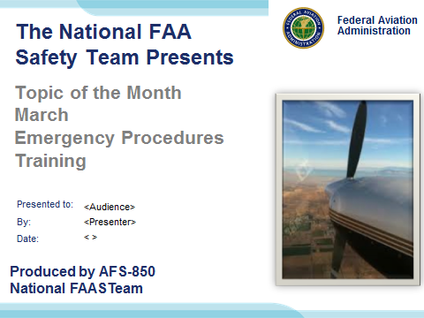 | Slide 1  2017/6/15-108 (I) PP Original Author: J. Steuernagle May 2017 POC: K. CloverAFS-850 Operations Lead Office 562-888-2020  Presentation Note: This is the title slide for Emergency Procedures Training  Presentation notes (stage direction and presentation suggestions) will be preceded by a Bold header: the notes themselves will be in Italic fonts.  Program control instructions will be in bold fonts and look like this: (Click) for building information within a slide; or this: (Next Slide) for slide advance.  Some slides contain background information that supports the concepts presented in the program.  Background information will always appear last and will be preceded by a bold Background: identification.  We have included a script of suggested dialog with each slide. Presenters may read the script or modify it to suit their own presentation style.  The production team hope you and your audience will enjoy the show. Break a leg!  (Next Slide)
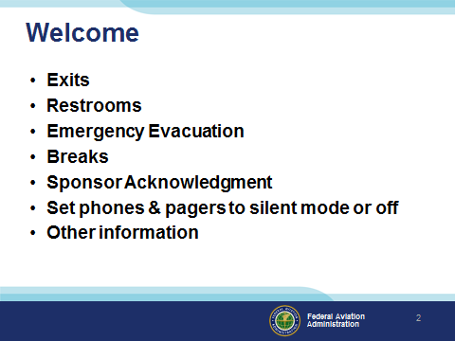 | Slide 2  Presentation Note: Here’s where you can discuss venue logistics, acknowledge sponsors, and deliver other information you want your audience to know in the beginning.  You can add slides after this one to fit your situation. (Next Slide)
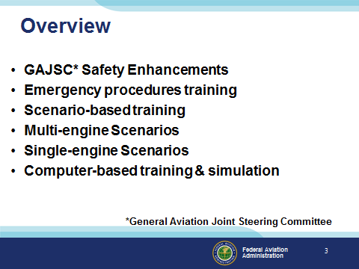 | Slide 3  In this presentation we’ll discuss recommendations from a work group that studies loss of control. The General Aviation Joint Steering Committee or GAJSC is a government/industry group that studies GA accidents and makes recommendations for adoption of what they call safety enhancements. One safety enhancement promotes Emergency Procedures Training as a means to reduce fatal general aviation accidents. Scenario-based Training is encouraged because it places pilots in realistic, complex situations. Scenario-based training works well for single and multi-engine airplanes and it’s also effective in Computer-based training and Simulation.  Presentation Note: If you’ll be discussing additional items, add them to this list  (Next Slide)
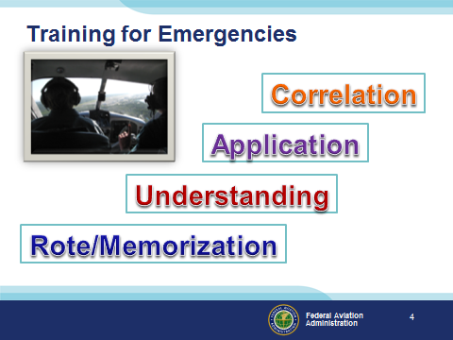 | Slide 4  Instructors in training study the levels of learning which are: (Click)  Rote or Memorization is useful to gain some knowledge quickly but rote will only get you so far. For instance; a student might memorize the airspeeds for best rate and best angle of climb but be hard pressed to describe the difference between them apart from the fact that one is faster than the other (Click)  Understanding the relationship between these speeds and aircraft performance is essential in order to choose which speed to use for which flight environment. (Click)  Choosing Vx for a takeoff with obstructions is an example of applying that understanding to a specific condition. (Click)  Finally through correlation of Vx/Vy knowledge with climb performance at high density altitudes, engine cooling and traffic spotting requirements, a pilot may opt to begin a departure climb at Vx, transition to Vy after obstacles are cleared, and maintain Vy until a safe maneuvering altitude is reached, then transition to cruise climb to improve traffic spotting.  Teaching and learning at the correlation level is desired because it represents the highest level of learning. But operating at that level can be a bit tricky for instructors and for their students.  (Next Slide)
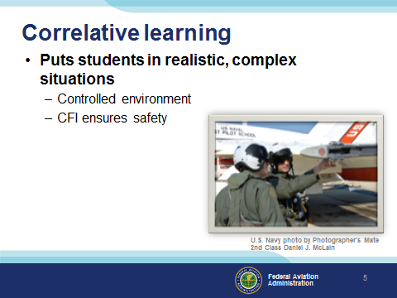 | Slide 5  Correlative learning takes place when students are able to apply previously acquired knowledge to solving new problems. Instructors strive to put students in realistic, complex situations in a controlled learning environment. Effective Emergency Procedures Training prepares pilots for proper and timely response to hazardous situations. Thus it’s essential that CFIs ensure the safety of flight as their students deal with emergency situations.  (Next Slide)
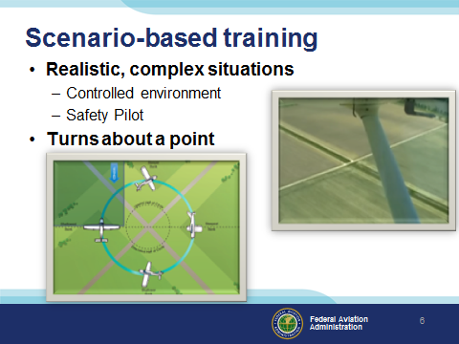 | Slide 6  Correlative learning is often accomplished through Scenario-based Training that provides realistic, complex problems for students to solve in a controlled environment. (click)  All airplane pilots are familiar with turns about a point – one of the basic ground reference maneuvers. Let’s take a look at how this maneuver might become part of a training scenario.  (Next Slide)
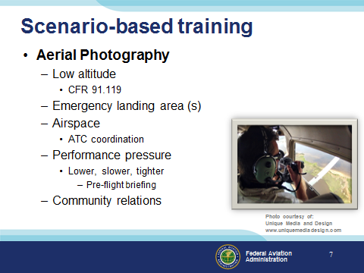 | Slide 7  A training scenario might involve an aerial photography mission. There are a host of considerations to discuss and skills to demonstrate.  Photo missions often involve relatively low altitudes so a review of CFR 91.119 is in order. They rarely occur in the practice area so emergency landing sites are definitely a consideration.  And what about airspace? Will ATC coordination be required? Are there aircraft equipment requirements?  And of course the pilot will be pressured to perform – often by someone who is focused on the mission to the exclusion of flight considerations. A thorough pre-flight briefing is essential so that the photographer’s expectations don’t exceed pilot and aircraft capability.  And finally community relations. Have you planned the mission to cause minimum inconvenience to persons on the ground?  (Next Slide)
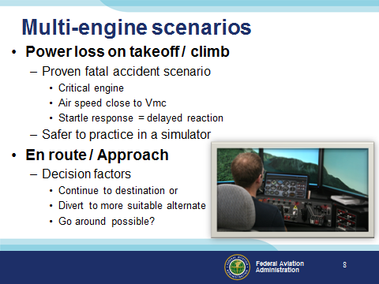 | Slide 8  A classic multi-engine fatal accident sequence goes like this:  The aircraft is climbing after takeoff and the critical engine fails. With climb attitude and airspeed you’re close to Vmc (minimum control speed). Any reduction in speed or increase in angle of attack is likely to result in an un-commanded roll toward the good engine. It’s one thing to deal with an event you know is coming with a flight instructor on board for back up and safety. It’s quite another problem to deal with an event that catches you by surprise. In these cases the human startle response may consume precious seconds before action is taken. (Click)  Losing an engine on takeoff is a very serious event and much safer to practice in a simulator. When practicing for this event in flight, be sure to begin at a safe altitude and establish a “hard deck” altitude that you’ll be at or above throughout the scenario.  (Click)  Losing an engine en route or on approach is less critical because you’ll likely have more airspeed and possibly more altitude to deal with; but what if you have to go around? Single-engine go-arounds in light twins often don’t go well and they should be avoided if possible. Planning for the emergency and practicing your response in advance will give you a huge advantage if it happens for real.  (Next Slide)
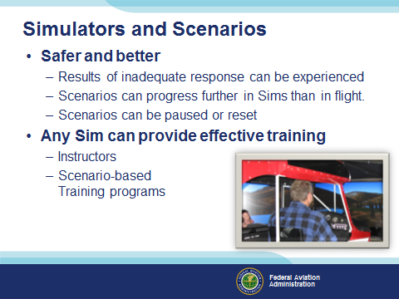 | Slide 9  Practicing emergency scenarios in a simulator or Personal Computer Aviation Training Device (PCATD) is not only safer but in many ways it’s better. The results of an improper or inadequate response to emergency can be experienced safely – even if a crash is involved. With simulation, emergency scenarios can be allowed to progress much further than in airplanes. Instructors must intervene in the interest of safety when training in an airplane but students can fly the entire event in a simulator.  Sims are also more efficient because scenarios can be paused at any time for discussion or reset to the beginning of the scenario to practice the event again.  Finally – you don’t need a multimillion dollar simulator to get effective training. CFIs are the key to training excellence in airplanes and in Sims. Great Instructors and great scenario-based training programs equal great training in any aircraft or simulator.  (Next Slide)
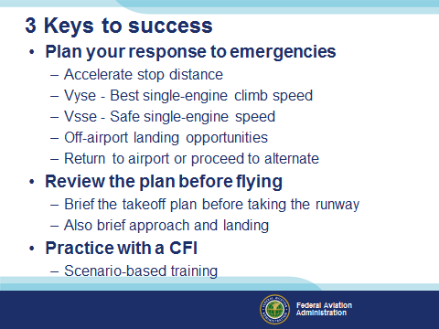 | Slide 10  Finally, let’s explore at least 3 keys to success that will help you deal with CFI-led scenarios and in real life.  Presentation note: Before clicking through the list you can ask the audience to suggest keys to success. They’ll likely come up with these and they may have other valuable suggestions to offer. When discussion is complete:  Great discussion, and here’s our list: (Click)  First and foremost – plan what you’ll do in emergency situations. For takeoffs; know the runway length and calculate accelerate/stop distance.  For multi-engine airplanes; know your best single-engine climb speed (Vyse). This will be your target airspeed after engine failure.  Lower than this speed is Vsse or safe single-engine speed. Except for Minimum Control Speed (Vmca) demonstrations, commit to maintaining Vsse or higher at all times.  For single and multi-engine airplanes, know where you’ll go if you can’t make it back to the departure airport.  Multi-engine pilots should decide in advance whether they’ll return to the airport of origin or proceed to a more suitable alternate if an engine is lost after takeoff. (Click)  Professional crews brief every takeoff, approach, and landing. It’s a good idea for any pilot to do the same. Just a quick refresher of what you’ll do before you do it can improve your chances that your response will be timely and correct. (Click)  And finally practice often with a CFI and when you do, take advantage of scenario-based training. It’s the best preparation for successful emergency response.  (Next Slide)
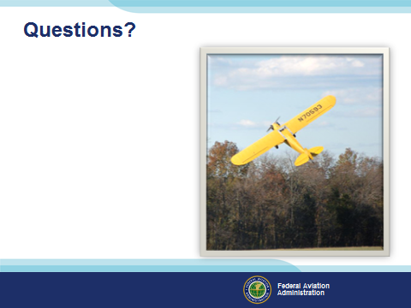 | Slide 11  Presentation Note: You may wish to provide your contact information and main FSDO phone number here. Modify with  Your information or leave blank.  (Next Slide)
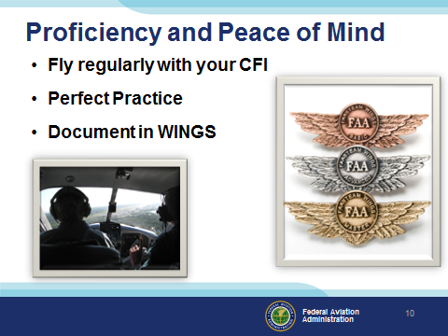 | Slide 12  There’s nothing like the feeling you get when you know you’re playing your A game and in order to do that you need a good coach (Click)  So fly regularly with a CFI who will challenge you to review what you know, explore new horizons, and to always do your best. Of course you’ll  have to dedicate time and money to your proficiency program but it’s well worth it for the peace of mind that comes with confidence. (Click)  Vince Lombardi, the famous football coach said, “Practice does not make perfect. Only perfect practice makes perfect.” For pilots that means  flying with precision. On course, on altitude, on speed all the time. (Click)  And be sure to document your achievement in the Wings Proficiency Program. It’s a great way to stay on top of your game and keep you flight review current.  (Next Slide)
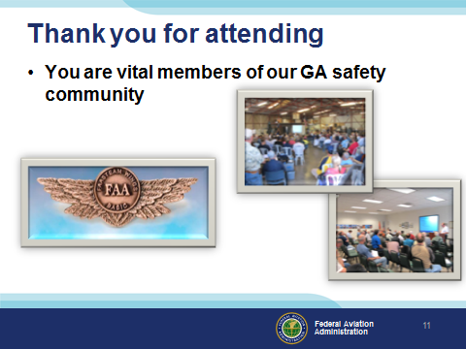 | Slide 13  Your presence here shows that you are vital members of our General Aviation Safety Community. The high standards you keep and the examples you set are a great credit to you and to GA.  Thank you for attending.  (Next Slide)
Slide 14

(The End)

