General Aviation Joint Steering Committee
Loss of Control Working Group

Presentation Notes
Avoiding Controlled Flight Into Terrain Accidents
2020/10-28-177(I)PP

This outreach guidance is provided to all FAA and aviation industry groups that are participating in outreach efforts sponsored by the General Aviation Joint Steering Committee (GAJSC). It is important that all outreach on a given topic is coordinated and is free of conflicts. Therefore, all outreach products should be in alignment with the outline and concepts listed below for this topic.

Outreach Month: November 2021

Topic: CFIT (SE 34 Output)
The FAA and industry will conduct a public education campaign emphasizing the need for training and currency when flying in mountainous areas.

Background:

Technological advances in situational awareness have dramatically reduced the number of General Aviation CFIT accidents over the past 20 years. Nevertheless CFIT accidents continue to occur and at least half of them are fatal. This program acquaints the audience with the nature of CFIT accidents, their precursors, technological and safety risk management solutions to CFIT challenges.

Teaching Points:
- Pilots of all certificate levels are prone to CFIT accidents.
- Most General Aviation CFIT accidents occur during the day and half occur in VMC.
- Pilots must accurately assess the risk associated with each flight and plan accordingly. They must also continuously reassess risk en route and commit to alternate plans before they are in a state of emergency.

References:
- Avoiding Controlled Flight Into Terrain – PPT and Presentation Notes
  - Available on the National FAASTeam Share Point site under Approved Presentations.
- AC 61-134 General Aviation Controlled Flight Into Terrain Awareness
  - https://www.faa.gov/regulations_policies/advisory_circulars/index.cfm/go/document.information/documentID/22907
- Pilot’s Handbook of Aeronautical Knowledge (FAA-H-8083-25A) – Chapter 2 – Aeronautical Decision Making.
  - http://www.faa.gov/regulations_policies/handbooks_manuals/aviation/phak/
- Aeronautical Information Manual Chapter 7- Safety of Flight, Section 5 – Potential Flight Hazards, 7-5-6 - Mountain Flying
  - http://www.faa.gov/air_traffic/publications/

IMPORTANT – Once you have completed outreach on this topic, please help us track the outreach you have done by entering a PTRS record.

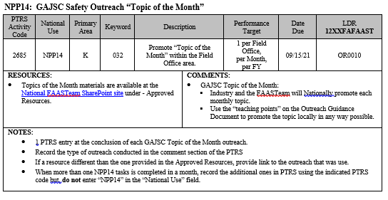
Abstract: Lasting 10 to 20 Minutes, this presentation acquaints the audience with the hazards of fliying in CFIT environments and provides suggestions for avoiding CFIT Accidents.

Format: Informatin Briefing – Power Point presentation

Required Personnel: FAASTeam Program Manager or designated FAASTeam Rep (s)

Optional Personnel: Flight Instructor or others who can speak on CFIT

AFS 850 Support: In addition to this document, a Power Point presentation that supports the program is provided. FPMs and presentaers are encouraged to customize this presentation to reflect each individual program.

Slides | Script
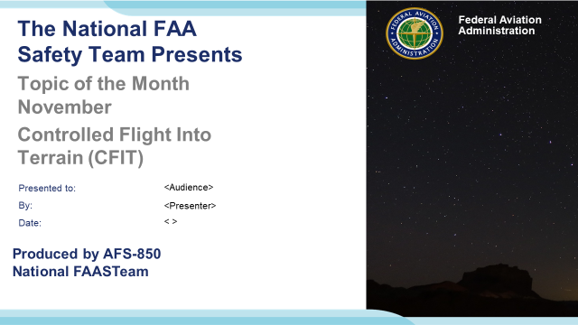 | Slide 1  2020/10-28-177(I)PP Original Author: J. Steuernagle October 2019 POC: K. CloverAFS-850 Operations Lead Office 562-888-2020  Presentation Note: This is the title slide for Avoiding Controlled Flight Into Terrain (CFIT) Accidents  - Script - We have included a script of suggested dialog with most slides. The script will always appear in a non-italic font. Presenters may read the script or modify it to suit their own presentation style. See template slides 5 and 6 for examples of a slides with script.  - Presentation Instructions - (stage direction and presentation suggestions) will be preceded by a Bold header: the instructions themselves will be in Italic fonts. See slides 2, 3, and 4 for examples of slides with Presentation Instructions only.  - Program control instructions - will be in bold fonts and look like this: (Click) for building information within a slide; or this: (Next Slide) for slide advance.  - Background information - Some slides may contain background information that supports the concepts presented in the program.  Background information will always appear last and will be preceded by a bold Background: identification.  The production team hope you and your audience will enjoy the show. Break a leg!  (Next Slide)
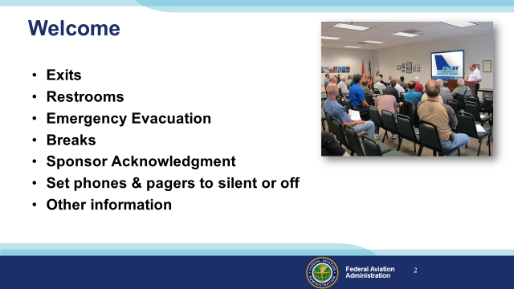 | Slide 2  Presentation Note: Here’s where you can discuss venue logistics, acknowledge sponsors, and deliver other information you want your audience to know in the beginning.  You can add slides after this one to fit your situation (Next Slide)
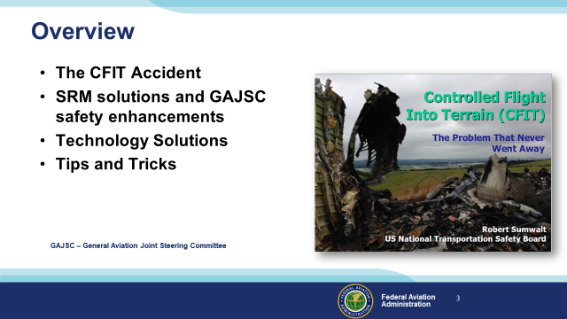 | Slide 3  Preventing CFIT accidents has been a safety goal for some time. In a 2014 presentation at the Bombardier Safety Stand Down NTSB Chairman Robert Sumwalt characterized CFIT as “The Problem that Never Went Away”. Even today, with commonly available, greatly improved flight position displays, we still see accidents where airworthy aircraft under positive control are unintentionally flown into terrain or structures.  In this presentation we’ll talk a little bit about Controlled Flight Into Terrain (CFIT) Accidents and recommendations (termed safety enhancements) from the General Aviation Joint Steering Committee - a work group that studies General Aviation Accidents. We’ll discuss some Safety Risk Management and Technological solutions to CFIT challenges and, finally; we’ll give you some tips and tricks that will help you to avoid CFIT accidents.  Presentation Note: If you’ll be discussing additional items, add them to this list.  (Next Slide)
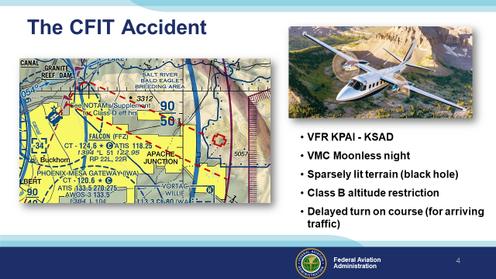 | Slide 4  The Rockwell Turbo Commander with two instrument-rated pilots and four passengers, departed Falcon Field near Phoenix, Arizona in night VMC conditions bound for Safford, AZ. No VFR Class B Clearance or Flight Following Services were requested but the pilots did ask for a right turn out. There was no moon and the route of flight was toward sparsely lit rising terrain. Such “black hole” lighting conditions make it very difficult to discern terrain features. Because the pilots had not requested Class B clearance, the flight would have to remain below five thousand feet until clear of Class B airspace. . (Click)  After takeoff, the flight was instructed to maintain runway heading for arrival traffic. About 2 minutes later, the flight was cleared for the right turn. The flight climbed to 4,500 feet, leveled off, and took up a course directly to the destination. About four minutes later the flight impacted a mountain in a wings-level attitude at an altitude of 4,500 feet.  Presentation note: A copy of the NTSB report on this accident (AZ Crash) is included in Approved Resources.  (Next Slide)
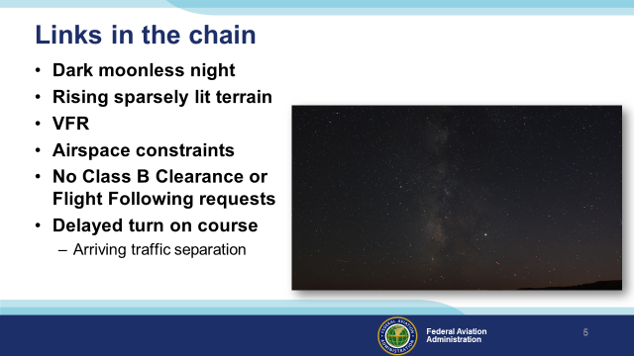 | Slide 5  Looking backward it’s relatively easy to identify accident chain links. The trick, of course, is to identify accident chain links before they lead to  unsatisfactory aircraft states. Often eliminating or mitigating the hazard posed by a single link will prevent an accident. Let’s take a minute or so to list the links in this chain and as we do that, let’s also suggest what we could do to eliminate or mitigate the hazards they present.  Presentation note: Lead a short discussion of accident chain links and hazard mitigation. Then: (Click)  That’s right it was a dark, moonless night and the flight was over rising sparsely lit terrain. Even a little sky or ground illumination, as we see in the lower right corner of this photo, can silhouette terrain features. But absent that light, and especially if there’s an overcast cloud layer, the view ahead is just a deep black hole.  Although both pilots were instrument-rated, they chose to proceed VFR. Getting an IFR clearance would have likely delayed their departure but, in retrospect, it would likely have saved their lives.  Absent an IFR clearance, a clearance to climb through the Class B airspace and/or VFR Flight Following would have made a huge difference.  And finally, if their turn on course had not been delayed they would have flown toward lower terrain and there would have been ample time to climb above it after passing under the Class B.  (Next Slide)
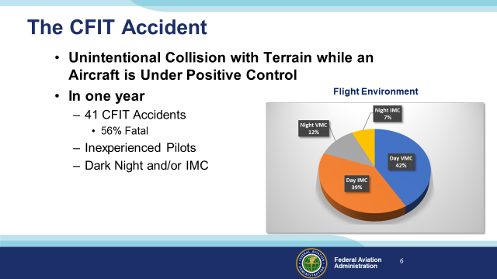 | Slide 6  For this presentation we looked at a typical year in which we see about forty CFIT Accidents at least half of which are fatal. (Click)  It’s logical to think that CFIT accidents usually involve inexperienced pilots in dark night and/or instrument meteorological conditions. (Click)  In fact, in a typical year more than 75 percent of CFIT accidents occur in daylight and more than half of those are in visual conditions.  (Next Slide)
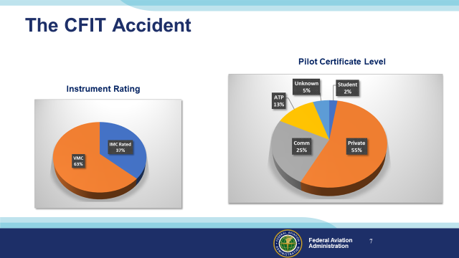 | Slide 7  As we might expect – the majority of CFIT pilots hold Private certificates but Commercial and ATP pilots and flight instructors are well represented too.  You might think that most CFIT Pilots are not instrument rated and that’s correct. (Click)  But in a typical year, more than a third of CFIT pilots hold instrument ratings.  (Next Slide)
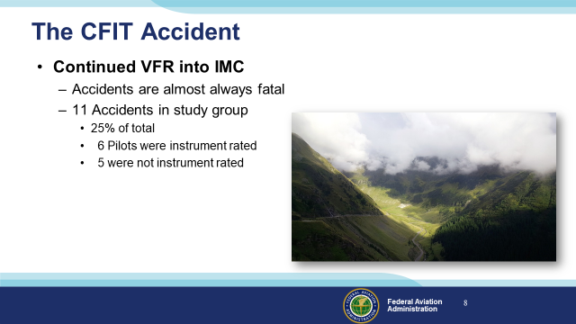 | Slide 8  Continued VFR into IMC is the deadliest accident precursor. We don’t know how often pilots are successful in pursuing the impossible dream. Undoubtedly some get away safely but continued VFR into IMC accidents are usually fatal. (Click)  Of the 41 accidents in our study group, 11 – or 25% of the total – were preceded by Continued VFR into IMC and they were all fatal. You’d think that VFR pilots would more often be involved in Continued VFR accidents but they were evenly split in this study group.  (Next Slide)
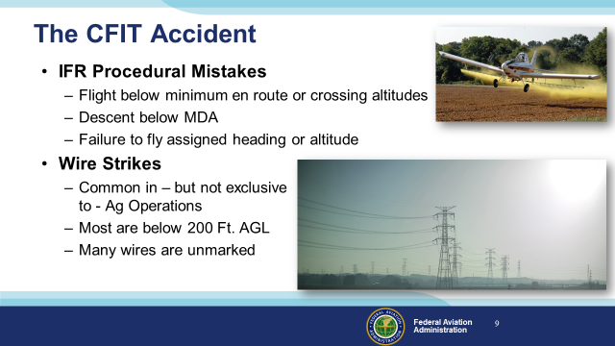 | Slide 9  IFR procedural mistakes account for a significant portion of CFIT accidents each year. Instrument pilots must be sure they’re complying with all aspects of the clearances they accept and the procedures they fly. (Click)  Wire Strikes are often cited in CFIT accident reports and they are common in Agricultural Operations but more than half of them are not associated with Ag flying. It’s true that there are some very high towers around and their support wires can extend well beyond the tower itself. But there are relatively few collisions with tall towers or their support structures. (Click)  In fact, most wire strikes occur below 200 feet AGL. You’ve got to wonder; what required the pilots to be that low – especially in the vicinity of wires? (Click)  And be aware that many wires are unmarked. Give yourself some room. A little extra altitude – even 500 feet – will keep you above 90% of the wires.  (Next Slide)
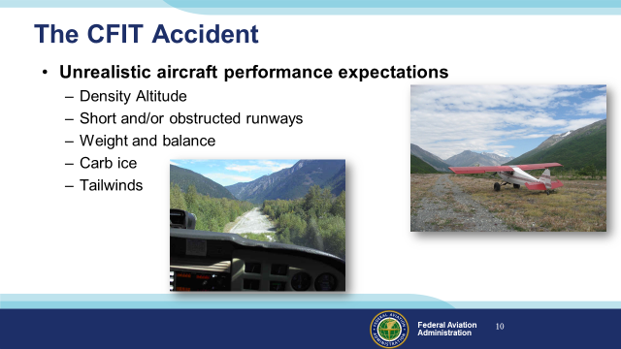 | Slide 10  Some CFIT accidents are caused by unrealistic expectations for aircraft performance. High Density Altitude combined with a short and/or obstructed runway and aircraft at near gross weight have resulted in collisions with terrain and obstacles on take off or go-around. Carburetor or induction system ice can reduce climb performance with the same result. And tailwinds on approach or takeoff can precede CFIT.  (Next Slide)
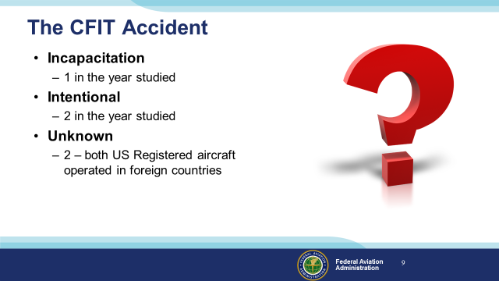 | Slide 11  Finally we had one pilot incapacitation accident, 2 intentional collisions with terrain (only one of which was fatal), and 2 accidents involving US registered aircraft operating abroad.  (Next Slide)
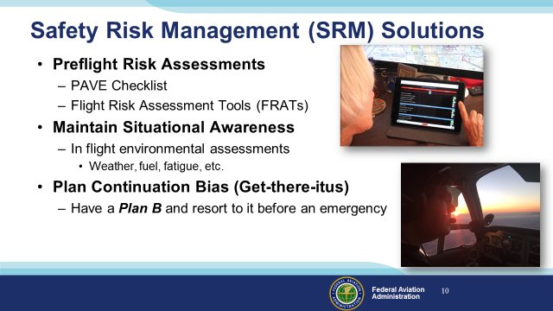 | Slide 12  Safety risk management is all about knowing what you’re getting into and understanding what capabilities and resources you have that will ensure that each flight is completed safely. (Click)  SRM begins with a solid Preflight Risk Assessment. The assessment considers the Pilot, the Aircraft, the Environment within which the flight will take place, and External Pressures that may affect pilot judgement and performance. (Click)  There are various Flight Risk Assessment Tools or FRATs available to assist pilots in building their Risk Assessments. (Click)  Good preflight risk assessments mean you’ll have excellent Situational Awareness when you take off. The trick is to maintain that awareness until you’re tied down or in the hangar at your destination. Maintaining Situational Awareness means you’re constantly adjusting your assessments by answering questions such as:  - Is the weather what I expected? Is my groundspeed as predicted? How long will it be till I get to the next checkpoint or to my destination? What will be my fuel status when I get there?  Harder to answer are questions such as:  - Am I becoming fatigued? Can I continue with my flight as planned or is it time to adjust my expectations? Am I making my decisions solely on the safety of flight or am I feeling pressure to complete the flight as planned? (Click)  That brings us to Plan Continuation Bias. You may know it as Get-there-itus. Whatever you call it it’s real and every pilot must learn how to rationally deal with it. This deadly bias will tempt you to delay resorting to Plan B until you’ve already entered Instrument Meteorological Conditions while trying to maintain VFR. It’s also contributed to pilots overflying en route fueling opportunities and running short of fuel at the destination. We’ll discuss this in depth in an upcoming Topic of the month but for now – deal with Get-there-itus by having a Plan B and maybe even C and make the decision to go to it before an emergency is in progress.  (Next Slide)
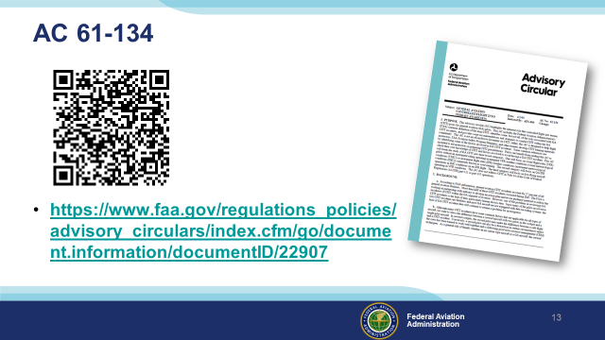 | Slide 13  For more CFIT information and avoidance solutions consult AC 61-134. It’s available at the URL shown here. I’ll leave this slide on  screen for a bit so that you can copy or photograph the information.  Next we’re going to quickly review another CFIT accident. It illustrates the fact that no matter what the situation – somebody has to fly the airplane.  Presentation note: Give the audience a chance to photograph the screen or copy the URL. Then:  (Next Slide)
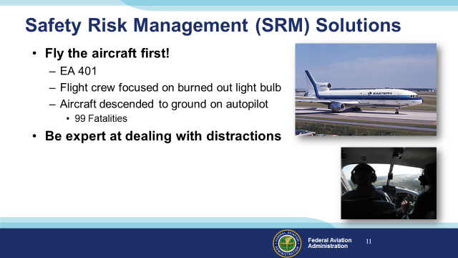 | Slide 14  On 29 December 1972 Eastern Airlines Flight 401, Lockheed L-1011, was scheduled to fly from JFK in New York to Miami International Airport in Florida.  3 flight crew and one non-revenue company employee were in the cockpit as the flight began the approach to Miami.  After extending the landing gear on final approach the first officer noticed the nose wheel down & locked light was not illuminated. The approach was aborted and the aircraft entered a 2,000 foot holding pattern west of the airport The crew engaged the autopilot while all 4 cockpit occupants engaged in trouble shooting the problem. When the autopilot was engaged it was inadvertently placed in Control Wheel Steering (CWS) mode. In this mode the airplane would maintain the attitude last commanded by the pilot. One of the pilots – most likely the Captain – bumped the control column as he turned to speak with the flight engineer. The airplane was placed in a shallow descent that was maintained all the way to the ground. Four professional aviators – any one of whom could have detected the descent – were so focused on a non-critical task that they failed to detect and arrest the descent.  Autopilots are great at reducing pilot workload. And – let’s face it – they fly more precisely than we do. But autopilots must be monitored because they will maintain heading and altitude right into the ground if that’s what you’ve tasked them to do. (Click)  Distracted pilots have flown aircraft into terrain without auto pilot assistance too. No matter what you’re dealing with you must fly the aircraft first. Make sure you’re always under control, properly configured, and in a safe flight environment.  (Next Slide)
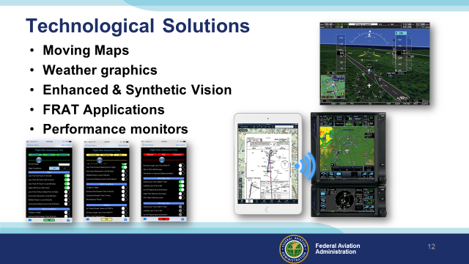 | Slide 15  There are a host of technological programs, applications, and devices that can aid pilots in situational awareness and risk assessment. Moving maps with terrain overlays are common so there’s no excuse for not knowing how close you are to a collision. Flight planning tools can now integrate with charting programs, cockpit displays and weather imagery. FRAT applications make it easy to conduct pre and in-flight risk assessments and performance monitoring equipment keeps pilots apprised of their aircraft’s capability.  Pilots have access to more information than ever before and that has already contributed to a 20-year reduction in CFIT accidents. But all that information comes in many different forms so pilots must be thoroughly familiar with and proficient in device operation and information interpretation.  (Next Slide)
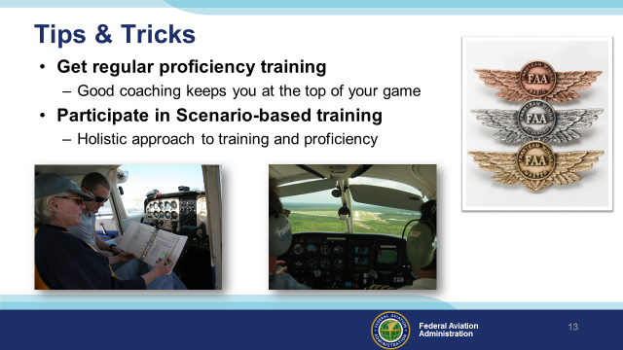 | Slide 16  Successful professionals, no matter what their specialty, rely on coaching to keep them on top of their game. Pilots are no exception. Regular proficiency training with a Flight Instructor is the best investment you can make in safety and peace of mind.  There are a wealth of proficiency training programs available. Of course we recommend FAA WINGS Pilot Proficiency Training but, no matter what program or instructor you choose – please participate in scenario-based training. This holistic approach to proficiency looks at all aspects of safe flight from preflight planning to securing the aircraft at the end of the flight. Holistic training reinforces your skill at collectively managing all pilot processes and tasks in realistic scenarios.  (Next Slide)
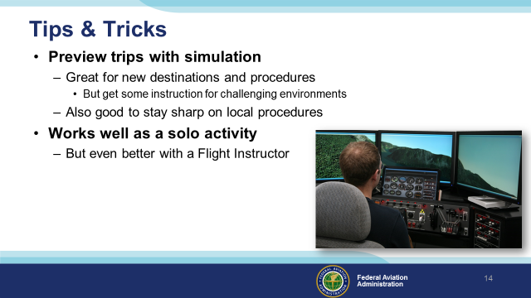 | Slide 17  You can keep your skills sharp between flights by flying simulators or flight training devices. Many feature realistic graphics so you can get a look at unfamiliar destination environments. And you can practice instrument procedures before you have to fly them for real. But one caution here – simulation is not adequate preparation for flights to unfamiliar challenging if not hostile environments such as mountains, obstructed, short runways, and high density altitude environments. For those areas consult a Flight Instructor who is thoroughly familiar with the environment. (Click)  Simulation works well as a solo activity but it’s much better if you have a flight instructor managing the simulator and scenario while you do the flying.  (Next Slide)
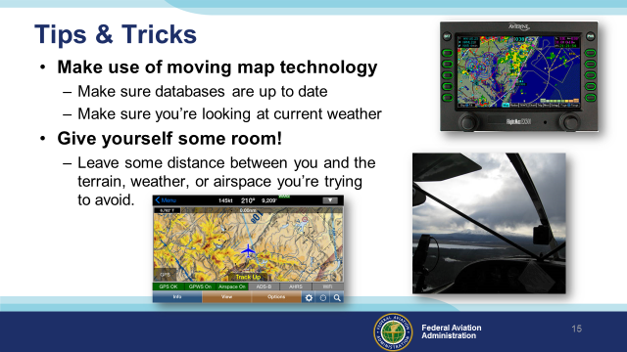 | Slide 18  Moving map, enhanced, and synthetic vision technology is now available on installed equipment and hand held devices. Nothing has done more for situational awareness than this technology but you have to commit to keeping the databases up to date and you must confirm that you’re looking at the latest weather imagery. Also be aware that even the latest weather pictures are not real time so give a wide berth to any weather you’re trying to avoid.  And the availability of this technology has given rise to a paradox: Pilots are more situationally aware than ever before but CFIT and weather accidents still occur and Pilot Deviations continue to rise. Perhaps this is because pilots are more confident in their position so they fly closer to things they’re trying to avoid. Obviously the solution is to give yourself some breathing room. That means at least a mile from airspace and 2000 feet vertically from terrain you’re trying to avoid. Airspace and terrain don’t move much but weather is very dynamic so greater clearance distances will be required.  (Next Slide)
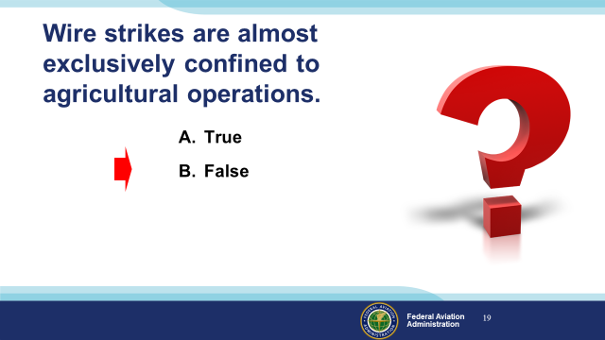 | Slide 19  Presentation Note: Ask the audience to answer this question. When they have answered; click to reveal the correct answers.  Now for a quick review:  Wire strikes are almost exclusively confined to agricultural operations. (Click)  False – many wire strikes do occur in agricultural operations but they occur in en route operations as well.  (Next Slide)
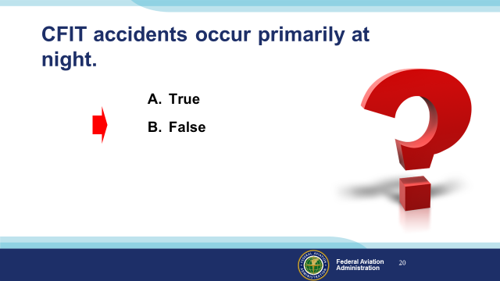 | Slide 20  Presentation Note: Ask the audience to answer this question. When they have answered; click to reveal the correct answers.  CFIT accidents occur primarily during night conditions. (Click)  False: The majority of CFIT accidents occur during the day  (Next Slide)
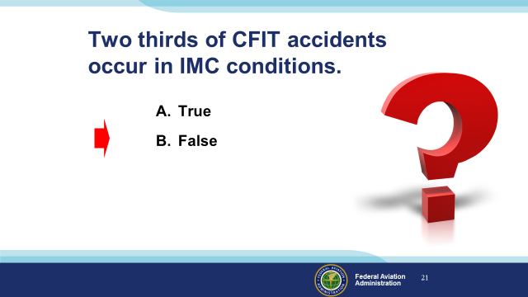 | Slide 21  Presentation Note: Ask the audience to answer this question. When they have answered; click to reveal the correct answers.  Two thirds of CFIT accidents occur in IMC conditions.  (Click) False – CFIT accidents are almost evenly split between IMC and VMC conditions.  (Next Slide)
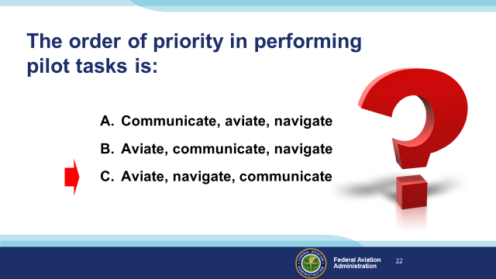 | Slide 22  Presentation Note: Ask the audience to answer this question. When they have answered; click to reveal the correct answers.  The order of priority in performing pilot tasks is: (Click)  C – Aviate, navigate, communicate. It’s true that all of these things happen at nearly the same time but your first priority is to fly the airplane, followed by navigating so as to avoid impacting terrain. Once you’ve got those under control, it’s time to communicate your intentions.  (Next Slide)
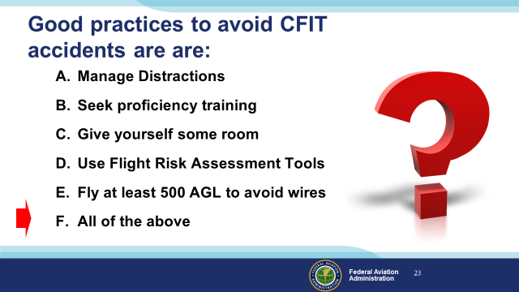 | Slide 23  Presentation Note: Ask the audience to answer this question. When they have answered; click to reveal the correct answers.  Good practices to avoid CFIT are: (Click)  All of the above.  (Next Slide)
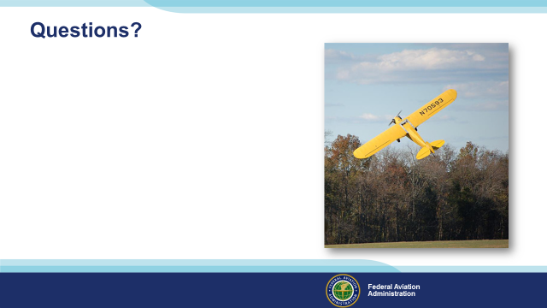 | Slide 24  Presentation Note: You may wish to provide your contact information and main FSDO phone number here. Modify with  Your information or leave blank.  (Next Slide)
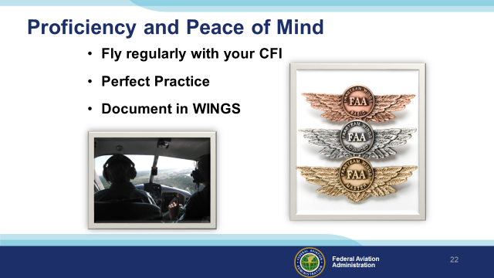 | Slide 25  There’s nothing like the feeling you get when you know you’re playing your A game and in order to do that you need a good coach (Click)  So fly regularly with a CFI who will challenge you to review what you know, explore new horizons, and to always do your best. Of course you’ll  have to dedicate time and money to your proficiency program but it’s well worth it for the peace of mind that comes with confidence. (Click)  Vince Lombardi, the famous football coach said, “Practice does not make perfect. Only perfect practice makes perfect.” For pilots that means  flying with precision. On course, on altitude, on speed all the time. (Click)  And be sure to document your achievement in the Wings Proficiency Program. It’s a great way to stay on top of your game and keep you flight review current.  (Next Slide)
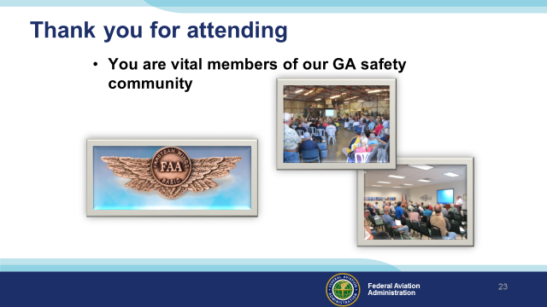 | Slide 26  Your presence here shows that you are vital members of our General Aviation Safety Community. The high standards you keep and the examples you set are a great credit to you and to GA.  Thank you for attending.  (Next Slide)
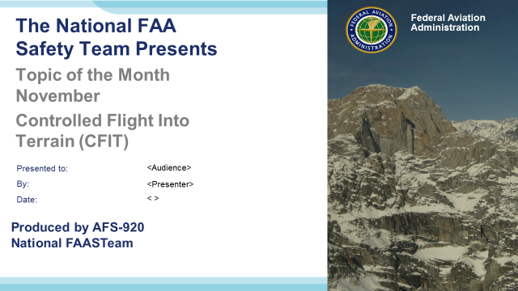 | Slide 27  (The End)

Appendix I – Equipment and Staging
Equipment:
- Projection Screen & Video Projector suitable for expected audience
  - Remote computer/projector control available at lectern or presenter location
    - In lieu of remote – detail a Rep to computer/projector control.
- Presentation Computer
  - Note: It is strongly suggested that the entire program reside on this computer.
- Back up Projector/Computer/Media as available.
- PA system suitable for expected audience
  - Microphones for Moderator and Panel
    - Optional Microphone (s) for audience
- Lectern (optional)
Staging:
- Arrange the projection screen for maximum visibility from the audience.
- Equip with PA microphones
- Place Lectern to one side of screen. This will be used by presenters and moderator

