General Aviation Joint Steering Committee
Best Glide
Outreach Guidance & Notes Document
2022/03-17-249(I)PP
This outreach guidance is provided to all FAA and aviation industry groups that are participating in outreach efforts sponsored by the General Aviation Joint Steering Committee (GAJSC). It is important that all outreach on a given topic is coordinated and is free of conflicts. Therefore, all outreach products should be in alignment with the outline and concepts listed below for this topic.
Outreach Month: April 2023

Topic: Best Glide Speed
The FAA and industry will conduct a public education campaign emphasizing the best practices associated with obtaining and maintaining Best Glide Speed while maneuvering during emergency descents, approaches, and landings.
Background:
The General Aviation Joint Steering Committee (GAJSC) has studied a number of General Aviation accidents. Recently the Committee studied system and component failure accidents and they determined that a significant number of fatal accidents result from unsuccessful forced landing attempts. The Committee feels that improved pilot knowledge of and proficiency in flying at best glide speed and configuration will increase the chances of a successful forced landing.
Teaching Points:
- General aviation accidents have resulted from loss of control while maneuvering during emergency descents, approaches, and landings.
- The likelihood of executing successful forced landings can be improved through obtaining and maintaining Best Glide Speed or Minimum Sink Speed.
- Pilots should determine Best Glide and Minimum Sink Speeds for the aircraft they fly.
- Pilots should periodically train and practice to achieve and maintain proficiency in forced landings.

References:
- Airplane Flying Handbook (FAA-H-8083-3C)
  - Chapter 3 – Basic Flight Maneuvers
  - Chapter 9 – Approaches and Landings
- Pilot’s Handbook of Aerounautical Knowledge (FAA-H-8083-25B)
  - Chapter 2 – Aeronautical Decision Making
  - Chapter 11 – Aircraft Performance

Introduction to SRM
Abstract: Lasting 15 to 30 minutes, this presentation introduces the subject of Best Glide Speed.
Format: Information Briefing - Power Point presentation
Required Personnel – FAASTeam Program Manager or designated FAASTeam Rep (s)
Optional Personnel – CFIs and DPEs who can speak on Best Glide Speed
Natonal FAASTeam Support:
In addition to this guidance document, a Power Point presentation that supports the program is provided. FPMs and presenters are encouraged to customize this presentation to reflect each individual program.

Slides | Script
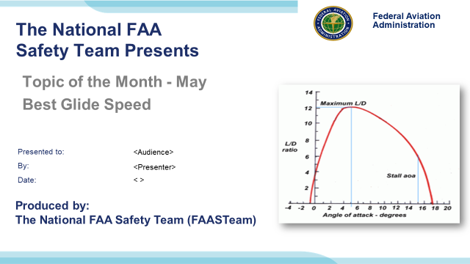 | Slide 1  2022/03-17-249(I)PP Original Author: J. Steuernagle May 2022 POC: K. National FAASTeam Program Manager (Operations) Office 562-888-2020  Presentation Note: This is the title slide for Best Glide Speed  - Script - We have included a script of suggested dialog with most slides. The script will always appear in a non-italic font. Presenters may read the script or modify it to suit their own presentation style. See template slides 5 and 6 for examples of a slides with script.  - Presentation Instructions - (stage direction and presentation suggestions) will be preceded by a Bold header: the instructions themselves will be in Italic fonts. See slides 2, for an example of slides with Presentation Instructions only.  - Program control instructions - will be in bold fonts and look like this: (Click) for building information within a slide; or this: (Next Slide) for slide advance.  - Background information - Some slides may contain background information that supports the concepts presented in the program.  Background information will always appear last and will be preceded by a bold Background: identification.  The production team hope you and your audience will enjoy the show. Break a leg!  (Next Slide)
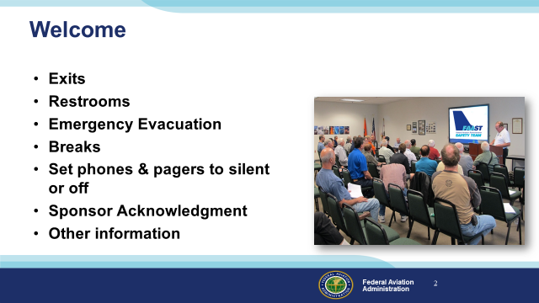 | Slide 2  Presentation Note: Here’s where you can discuss venue logistics, acknowledge sponsors, and deliver other information you want your audience to know in the beginning.  You can add slides after this one to fit your situation (Next Slide)
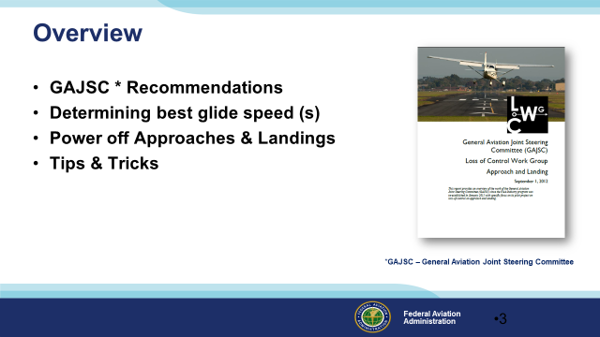 | Slide 3  In this presentation we’ll address recommendations from the General Aviation Joint Steering Committee – a government / industry group that analyzes GA accidents and incidents. Recently the Committee studied system and component failure accidents and they determined that a significant number of fatal accidents result from unsuccessful forced landing attempts. The Committee feels that improved pilot knowledge of and proficiency in flying at best glide speed and configuration will increase the chances of a successful forced landing.  Presentation Note: If you’ll be discussing additional items, add them to this list  (Next Slide)
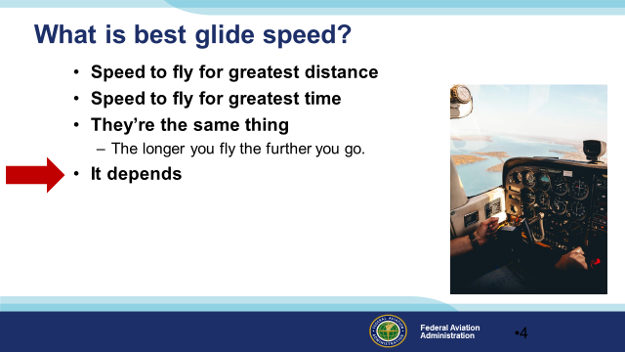 | Slide 4  So what is best glide speed anyway? (Click)  Is it the speed that will get you the greatest distance? (Click)  Or the speed that will get you the longest time in the air? (Click)  Are they the same thing – the longer you fly the further you go.  Presentation Note: Ask the audience to comment then (Click)  Well as so often is the case best glide speed depends on what you’re trying to do. Let’s look at some alternatives.  (Next Slide)
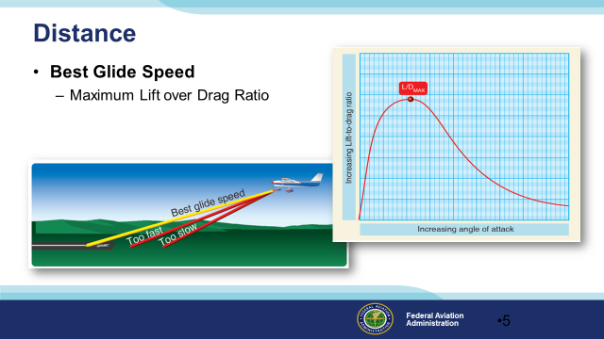 | Slide 5  If distance is what you want, you’ll need a speed and configuration that will get you the most distance forward for each increment of altitude lost. The best glide airspeed is one at which the airplane travels the greatest forward distance for a given loss of altitude. This Best Glide Airspeed occurs at the highest lift to drag ratio. Flying either faster or slower than the best glide speed will result in less distance traveled over the ground.  (Next Slide)
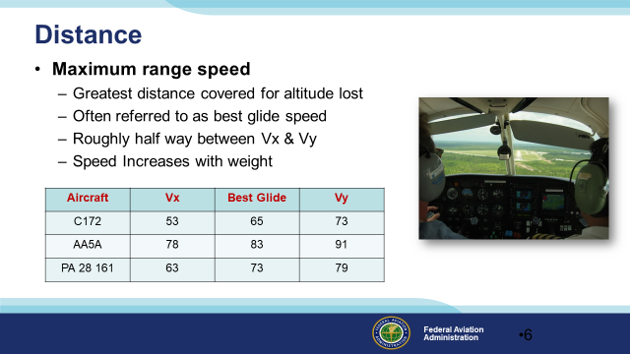 | Slide 6  For most most airplanes the Best Glide Speed is roughly half way between Vx and Vy. The speed will increase with weight so most manufacturers will establish the best glide speed at gross weight for the aircraft. That means your best glide speed will be a little lower for lower aircraft weights.  Not all manufacturers publish a best glide speed but here’s a chart with examples from some who do.  (Next Slide)
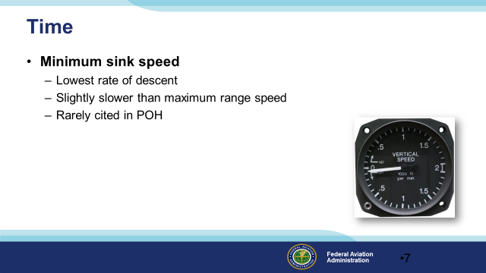 | Slide 7  Maybe you’re not as concerned with how far you’ll glide. You might want to stay in the air as long as possible to either fix the problem or to communicate your intentions and prepare for a forced landing. In this case you’d want to know the minimum sink speed. This speed is rarely found in POHs but it will be a little slower than maximum range speed.  (Next Slide)
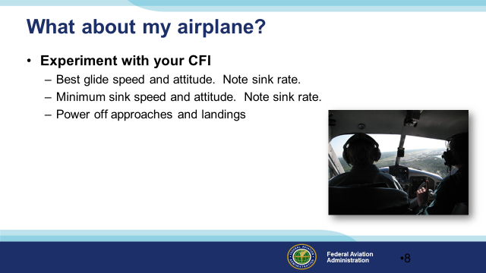 | Slide 8  If you’re wondering about the airplane you fly, you can do some experiments on a dual flight with your CFI. Start at Vy or manufacturer’s recommended best glide speed with power off – you did remember the carb heat didn’t you? – and note speed vs sink rate as you adjust pitch to reduce airspeed. For the most useful results, you should do this as close to typical mission weight as possible. Remember optimal glide speeds will be slower as aircraft weight decreases.  It’ll be easy to identify minimum sink speed. It’s the speed to fly for the lowest rate of descent. Maximum Glide Range speed will be a little higher than minimum sink. Here you’re looking for the highest speed forward for the lowest rate of descent.  Once you’ve identified minimum sink and maximum range glide speeds you’ve got a couple of good numbers to use for the future. The next big challenges are to know your height above the terrain and to glide the airplane to a point from which you can make a successful forced landing. Power off approaches and landings are the best ways to train for the main event.  (Next Slide)
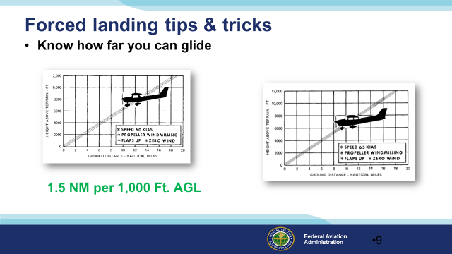 | Slide 9  How many miles you can glide per 1,000 feet of altitude is a very useful thing to know. A rule of thumb for Cessna 152s and 172s is 1.5 nautical miles per 1,000 feet of altitude AGL. Remember this is altitude above ground level – not sea level.  Experiment to see how far you can glide in your airplane.  (Next Slide)
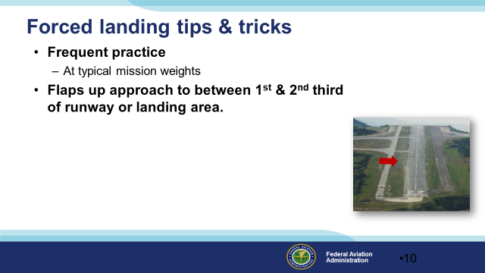 | Slide 10  Frequent forced landing practice at typical mission weights as an excellent way to maintain proficiency and peace of mind. Forced landing skills diminish rapidly over time but with practice, you’ll be able to consistently land on your chosen touchdown spot regardless of wind. (Click)  Some pilots choose a spot between the 1st and 2nd third of the available landing area for an initial aim point.  (Next Slide)
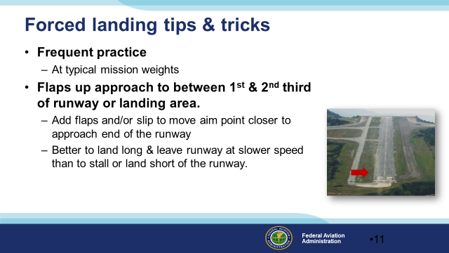 | Slide 11  As they see they can make that initial spot, they’ll add flaps and perhaps slip the airplane to move the aiming spot to the 1st third of the landing area. This is done to reduce the chance of landing short or a final approach stall while trying to stretch the glide to the runway.  Even if the landing is so long it results in an overrun, it’s usually better to land long & leave the runway at a slower speed than to stall or land short of the runway.  (Next Slide)  Background: Some attendees will recognize the Catalina, CA airport shown here. Catalina sits on top of a mountain with no overrun opportunities on either end of the single runway. This is one place where you absolutely must get it right the first time. There are no viable options if you can’t go around.  (Next Slide)
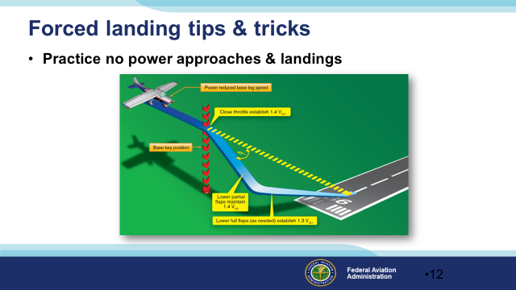 | Slide 12  Altitude estimation and speed control are very important when gliding close to the ground. The 90º power-off approach is seen here. Note that in this and all other gliding approaches, we want to reach a key position on base from which we know we can make a successful landing. Until the key position is reached we’ll keep the airplane configured for best glide. After we pass the key position, we’ll add flaps and gear to configure the airplane for landing and fly the final approach at not less than 1.3 times the stalling speed in landing configuration. (1.3 Vso)  (Next Slide)
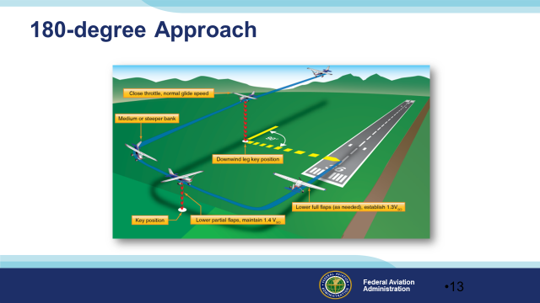 | Slide 13  In the 180º power-off approach, the throttle is closed on downwind abeam the intended touchdown point. As in the 90º degree power-off approach we’ll fly at best glide speed and configuration until we reach the key position. After that we’ll configure the airplane for landing. Note that there are two key positions for this approach. The first occurs on downwind opposite the targeted touchdown point. The second key position occurs on base leg at the same place as it would in a 90º approach.  (Next Slide)
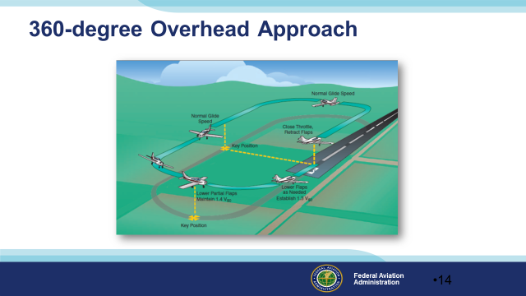 | Slide 14  The 360º Overhead Approach calls for even more judgment and skill. Here, we close the throttle while over or slightly adjacent to the intended landing point and glide a complete albeit shorter pattern to a landing. This maneuver is usually started at 2,000 feet over the runway. As with the 180º approach there are 2 key positions. The first is abeam the selected touchdown point. The second is on base when in position to land.  (Next Slide)
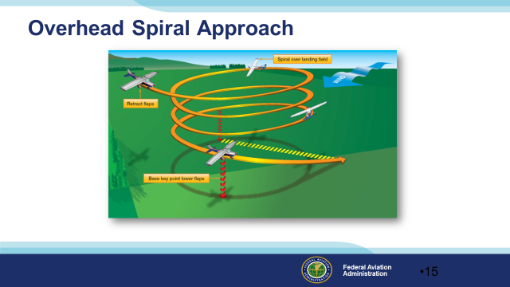 | Slide 15  Finally we have the Overhead Spiral Approach. This technique is used to descend from cruise altitude over a selected forced landing area or runway. Best glide speed and configuration should be maintained until the base leg key point is reached where the airplane is configured for landing at not less than 1.3 Vso.  (Next Slide)
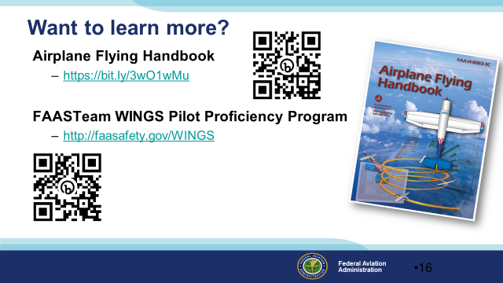 | Slide 16  Want to learn more?  Check out the Airplane Flying Handbook – available at the web address shown.  Want to learn even more? Participate in the FAASTeam WINGS Proficiency Program. It’s a great way to get expert coaching that will keep you at the top of your flying game.  Presentation note: You can take questions while audience is copying information from this slide. Then advance to:  (Next Slide)
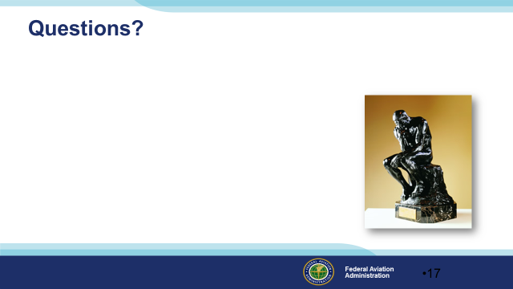 | Slide 17  Presentation Note: You may wish to provide your contact information and main FSDO phone number here. Modify with  Your information or leave blank.  (Next Slide)
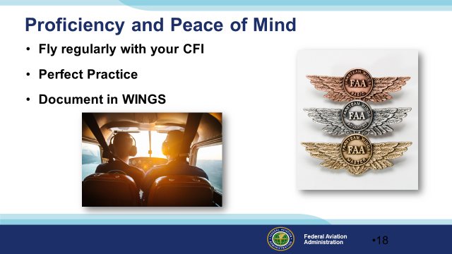 | Slide 18  There’s nothing like the feeling you get when you know you’re playing your A game and in order to do that you need a good coach (Click)  So fly regularly with a CFI who will challenge you to review what you know, explore new horizons, and to always do your best. Of course you’ll  have to dedicate time and money to your proficiency program but it’s well worth it for the peace of mind that comes with confidence. (Click)  Vince Lombardi, the famous football coach said, “Practice does not make perfect. Only perfect practice makes perfect.” For pilots that means  flying with precision. On course, on altitude, on speed all the time. (Click)  And be sure to document your achievement in the Wings Proficiency Program. It’s a great way to stay on top of your game and keep you flight review current.  (Next Slide)
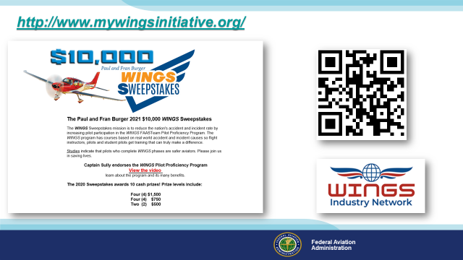 | Slide 19  Every time you complete a WINGS Phase you’re eligible to win cash in the WINGS Sweepstakes.  The sweepstakes is generously funded by Paul Burger, a long time advocate for general aviation safety and a retired aviator who believes participation in this program saves lives. VISIT WWW.MYWINGSINITATIVE.ORG to learn more and enter the sweepstakes.  Just navigate to http://www.mywingsinitiative.org or scan the QR code for details. By the way, Instructors can also enter the sweepstakes. But there are even better reasons to participate in WINGS.  (Next Slide)
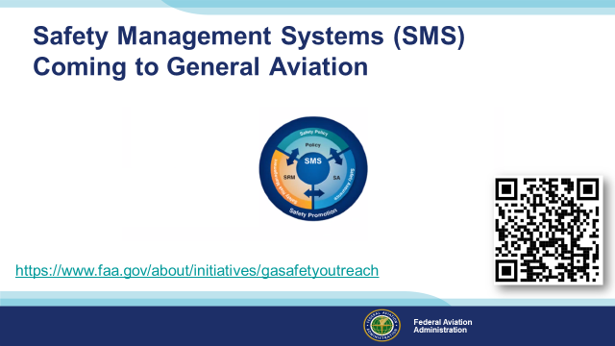 | Slide 20  Safety Management Systems are a set of policies and processes that can increase the safety and efficiency of any flight operation. And FAA is bringing SMS to General Aviation. You may have heard of SMS but thought it was only for large organizations but actually SMS can be scaled to fit any operation large or small.  There are 4 major components to a Safety Management System (Click)  Safety Policy – a documented commitment to safety that runs from the head of an organization to its newest member. (Click)  Safety Risk Management – a process that identifies hazards within an operation, determines to what extent an identified hazard may impact flight safety, and controls the risk of occurrence to an acceptable level. (Click)  Safety Assurance – By collecting and analyzing information derived from safety performance data Safety Assurance ensures the performance and effectiveness of Safety Risk Controls. (Click)  Safety Promotion communicates safety information and commitment throughout the organization. (Click)  You can find more information about Safety Management Systems at the URL on the Screen.  (Next Slide)
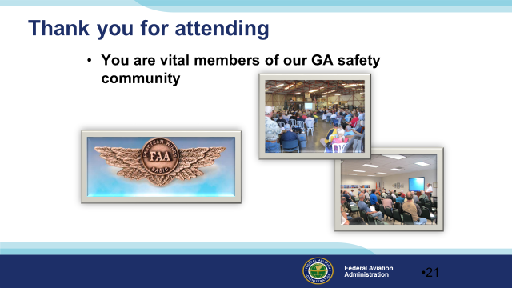 | Slide 21  Your presence here shows that you are vital members of our General Aviation Safety Community. The high standards you keep and the examples you set are a great credit to you and to GA.  Thank you for attending.  (Next Slide)
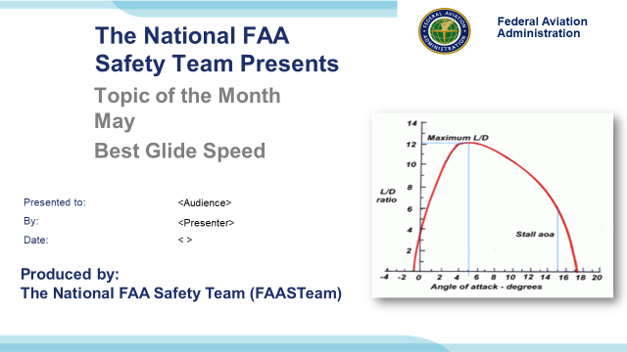 | Slide 22  (The End)

Appendix I – Equipment and Staging
Equipment:
- Projection Screen & Video Projector suitable for expected audience
  - Remote computer/projector control available at lectern or presenter location
    - In lieu of remote – detail a Rep to computer/projector control.
- Presentation Computer
  - Note: It is strongly suggested that the entire program reside on this computer.
- Back up Projector/Computer/Media as available.
- PA system suitable for expected audience
  - Microphones for Moderator and Panel
    - Optional Microphone (s) for audience
- Lectern (optional)
Staging:
- Arrange the projection screen for maximum visibility from the audience.
- Equip with PA microphones
- Place Lectern to one side of screen. This will be used by presenters and moderator

IMPORTANT – Once you have completed outreach on this topic, please help us track the outreach you have done by entering a SAS record.


