General Aviation Joint Steering Committee
CFIT Working Group

Outreach Guidance Document
2022/11-29-267(I)PP

This outreach guidance is provided to all FAA and aviation industry groups that are participating in outreach efforts sponsored by the General Aviation Joint Steering Committee (GAJSC). It is important that all outreach on a given topic is coordinated and is free of conflicts. Therefore, all outreach products should be in alignment with the outline and concepts listed below for this topic.

Outreach Month: October 2024

Topic: Gaming the System
The FAA and industry will conduct a public education campaign emphasizing the necessity of disclosing and discussing all medical history, conditions, and medications with Aviation Medical Examiners during the course of medical certification and Basic Med evaluations.

Background:

GAJSC study of General Aviation CFIT Accidents found that a significant number of pilot fatality post-mortem examinations detected the presence of pre-existing medical conditions and/or prescription and over-the-counter medication use. A smaller number of cases revealed recreational drug use. Of concern is the fact that some pilots do not disclose a complete medical history and medication inventory making it impossible for medical examiners to determine fitness to fly.

Teaching Points:

- Disclose and discuss all medical history, condition, symptoms, prescription and OTC drug use during the medical certification process.
- Be aware of individual drug effects and the effects of combinations of drugs.
- Perform basic self assessments before each flight.
- Pilots operating under Basic Med must realize that withdrawal, suspension, or revocation of the medical certificate upon which Basic Med is based will void the Basic Med authorization as well.
  - Expiration of a valid base medical certificate does not affect the Basic Med Authorization.

References:
- Gaming the System PowerPoint
  - Available on the National FAASTeam Share Point site under Approved Resources.

- Pilot Information on Aeromedical Certification
  - Available on FAA.gov
  - https://www.faa.gov/pilots/medical_certification

Abstract: Lasting 10 to 15 minutes, this presentation acquaints the audience with the necessity of providing complete and accurate information to airman medical applications and medical personnel. It also offers suggestions for pilot self evaluations before flight

Format: Information Briefing - Power Point presentation
Required Personnel – FAASTeam Program Manager or designated FAASTeam Rep (s)
Optional Personnel – AME’s and other medical practitioners who can speak on the topic of medical certification for pilots.

National FAASTeam Support:
In addition to this guidance document, a Power Point presentation that supports the program and a folder containing background information are provided. FPMs and presenters are encouraged to customize this presentation to reflect each individual program.

Slides | Script
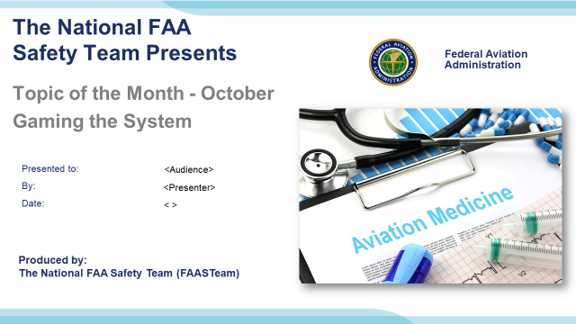 | Slide 1  2022/11/14-266(I)PP Original Author: John Steuernagle; POC Kevin Clover, National FAASTeam Program Mgr. Ops., Office 562-888-2020  Presentation Note: This is the title slide for Gaming the System  Script - We have included a script of suggested dialog with most slides. The script will always appear in a non-italic font. Presenters may read the script or modify it to suit their own presentation style. See template slides 5 and 6 for examples of a slides with script.  Presentation Instructions - (stage direction and presentation suggestions) will be preceded by a Bold header: the instructions themselves will be in Italic fonts. See slides 2, for an example of slides with Presentation Instructions only.  Program control instructions - will be in bold fonts and look like this: (Click) for building information within a slide; or this: (Next Slide) for slide advance.  Background information - Some slides may contain background information that supports the concepts presented in the program.  .  The production team hope you and your audience will enjoy the show. Break a leg!  (Next Slide)
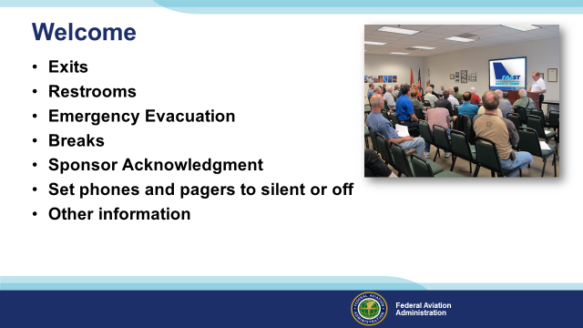 | Slide 2  Presentation Note: Here’s where you can discuss venue logistics, acknowledge sponsors, and deliver other information you want your audience to know in the beginning.  You can add slides after this one to fit your situation.  (Next Slide)
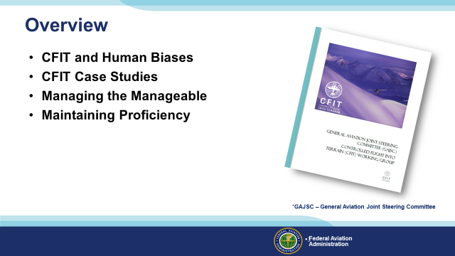 | Slide 3  In this presentation we’ll talk a little bit about recent GAJSC and FAA studies that deal with aeromedical factors identified in a selection of general aviation accident investigations.  We’ll talk about medical certification options and we’ll talk generally about flying while medicating and the problems associated with taking multiple drugs.  Throughout the presentation we’ll be discussing why “gaming the system” is a bad idea – especially when it involves aeromedical issues.  Presentation Note: If you’ll be discussing additional items, add them to this list  (Next Slide)
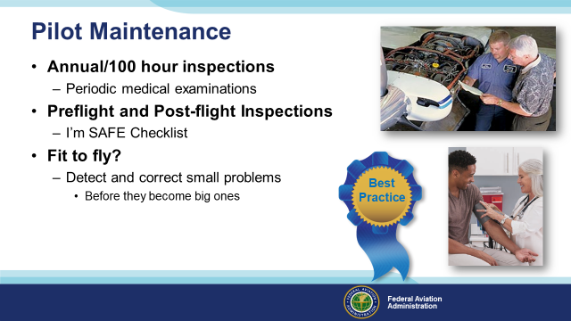 | Slide 4  You may have seen and heard this before but it’s so basic to safe flight operations that we’ll do a quick review.  We talk a lot about aircraft maintenance and inspection but what about pilot maintenance?  Aviation regulations and common sense require that we periodically inspect the aircraft we fly and that we correct any mechanical discrepancies that we discover. (Click)  The same is true for pilots. Periodic medical examinations and certifications just make good sense. But what about the times between inspections? (Click)  Well that’s why we do pre and post-flight inspections. We want to take a good look at critical components and systems before we fly. And a good post-flight inspection can detect discrepancies that should be addressed before the next flight. (Click)  For pilots that means a check of how we’re feeling, whether we’re adequately fed, hydrated, and rested, and whether internal and external pressures are likely to compromise our ability to perform. There’s a cool checklist that covers this that we’ll see in the next slide. (Click)  Of course the goal of all this inspection and – in the case of pilots – introspection is to affirm that on a given day, we are physically and emotionally fit to fly. And in the course of making that determination, to detect and correct small problems before they become big ones. (Click)  And that’s a best practice not only for flying but for every day living.  (Next Slide)
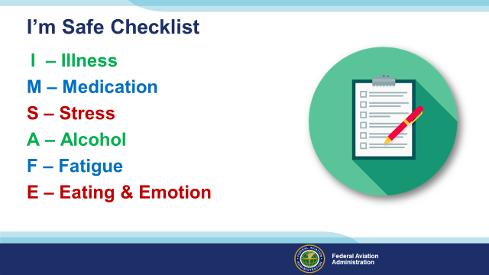 | Slide 5  The I’m Safe checklist has been around for a long time and it’s still relevant. The checklist is designed to answer six questions. (Click)  Am I feeling ill today? If the answer is yes, it’s probably not a good day to fly or perhaps even drive a car. (Click)  Am I taking any prescription or over-the-counter medication that could compromise my ability to fly? Many medicines caution against operating machinery and aircraft certainly qualify as complex machines. (Click)  Am I under unusual stress today? We all cope with stress each day and a little stress has been shown to improve human performance. But, if we’re under moderate to heavy stress our performance will definitely not be our best and it may even be dangerous. If, for instance, we are flying to a very important meeting that cannot be re-scheduled or delayed, the importance of the mission could compromise our pre and in-flight decision making. (Click)  Have I ingested any alcohol – in the previous twenty four hours? I know the rule says eight hours but lingering affects can persist. (Click)  Am I adequately rested before this flight? And just as important, will I become fatigued during the flight? We may be fine for the short drive home after a long day at work, but embarking on a flight perhaps at night, may be a greater challenge than we should accept. Getting a good night’s sleep and starting in the morning may well be the safer choice. (Click)  And finally; Am I adequately nourished and hydrated? And am I emotionally ready for this flight? We like to say we leave our problems on the ground when we fly but, for most of us, that’s not really true. If we’re worried or even very happy about something we may dwell on the topic at the expense of our flight duties or our decision making may be compromised.  (Next Slide)
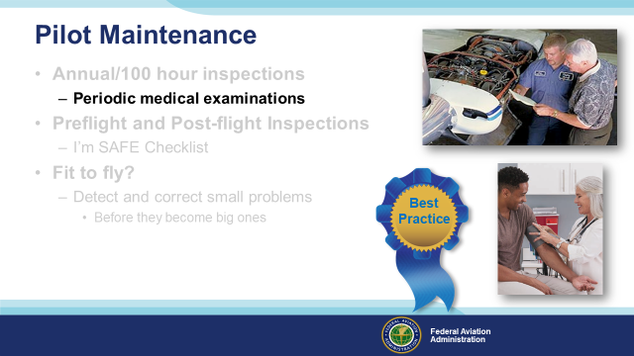 | Slide 6  We all must undergo periodic examinations from licensed physicians in order to exercise the privileges of our pilot certificates and that can get a bit complicated. So let’s take a quick look at our options.  (Next Slide)
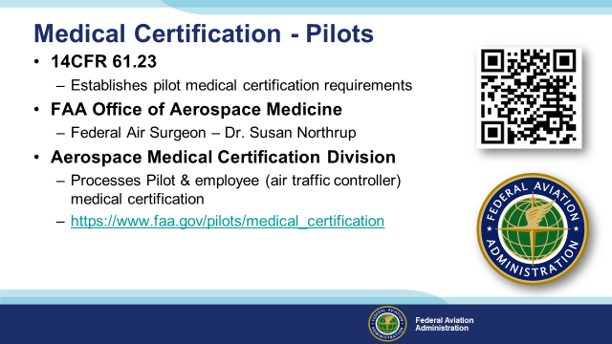 | Slide 7  14 CFR 61.23 establishes pilot medical certification requirements and also defines conditions and circumstances under which a medical certificate is not required. (Click)  Led by the Federal Air surgeon, the FAA Office of Aerospace Medicine includes, (Click)  The Aerospace Medical Certification Division. This is where pilots begin their medical certification process. You can access the division through the URL or QR Code shown on screen.  Presentation note: Pause for audience to copy information then:  (Next Slide)
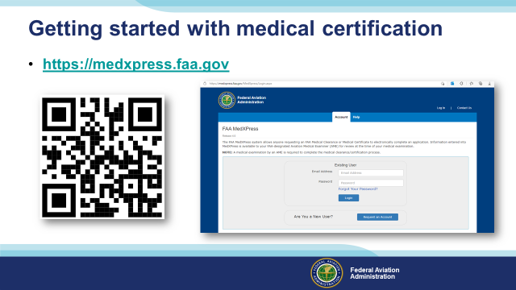 | Slide 8  For most of us, the path to medical certification begins with a visit to FAAs Medxpress website. There you’ll be able to complete an application for any FAA Medical certificate and upload any supporting medical history. The application and information will also be available to your Aviation Medical Examiner. Paper 8500-8s are no longer allowed. All applications are through MedXpress. MedXpress includes a dashboard where pilots can track their exam through the system.  (Next Slide)
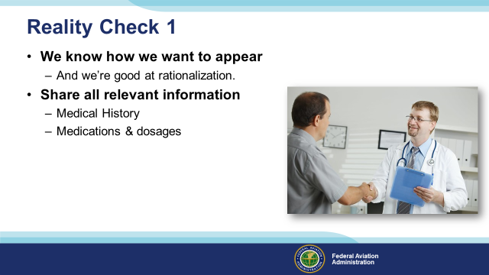 | Slide 9  While completing the MedXpress application, we have an opportunity for our first reality check. For most of us, there’s an image we want to project and for some of us there’s a slightly less magnificent reality. The medical certification process is no time to hold back, so commit to sharing everything about your health on your application and with your examiner. We humans are good at rationalization so we may be tempted to think, “I’m not feeling myself these days but I’m not really ill either. Things are bound to get better.” Remember when we said one of the goals of the process was to detect and correct small problems before they get bigger? This our opportunity to get everything on the table.  Don’t try to “game the system” by withholding information. Your aviation medical examiner needs to know everything in order to make an accurate fitness determination and, equally importantly, to make useful recommendations for improvement.  (Next Slide)
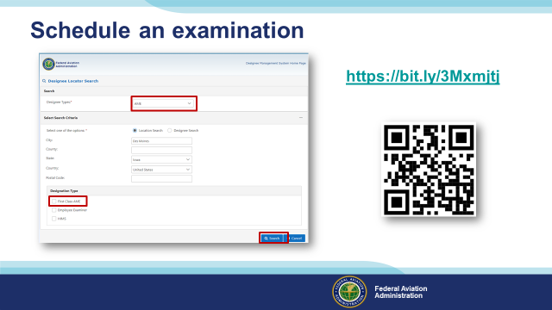 | Slide 10  Once you’ve completed your application, it’s time to schedule an examination. If you’re looking for an AME you can search for one at FAAs Medical Certification website. (Click)  Just select the type of designee you’re looking for, enter your location, and click on search. The system will return a list for all designees in the area. (Click)  If you want to see only those Doctors who can issue First Class Medical Certificates, select the First Class AME box. Then click on search.  There is an alternative to traditional medical certification that may suit your needs and it’s known as BasicMed.  (Next Slide)
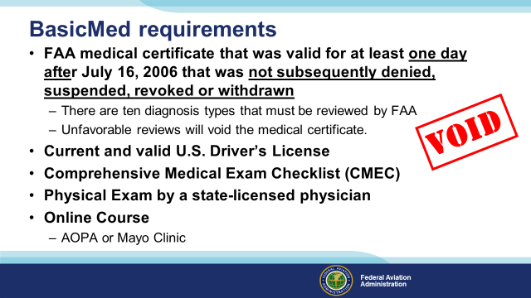 | Slide 11  Basic Med is an alternative option to traditional medical certification. As of this writing, the BasicMed alternative to medical certification has been in operation for more than five years and more than fifty thousand pilots are flying under the program. We’ll get into aircraft and pilot limitations in a minute but first let’s take a look at what you’ll need to qualify for BasicMed. (Click)  To qualify for BasicMed, you must have held an FAA medical certificate of any class for at least one day after July 16, 2006 that wasn’t subsequently denied, suspended, revoked, or withdrawn. If not, you’ll have to obtain at least a 3rd class medical certificate before qualifying for BasicMed. (Click)  In addition, there are ten groups of diagnoses that must come back through the FAA for a one time special issuance. See 14 CFR part 68. You may receive a valid medical certificate pending review. If that review is unfavorable your medical certificate will not be valid. (Click)  You’ll also have to maintain a current and valid United States Driver’s License, download and complete a Comprehensive Medical Exam Checklist and undergo a physical examination conducted by a United States State-licensed physician.  Once you’ve completed the physical exam you’ll complete an online course. At present there are two course alternatives; one from the Aircraft Owners and Pilot’s Association and the other from the Mayo Clinic.  (Next Slide)
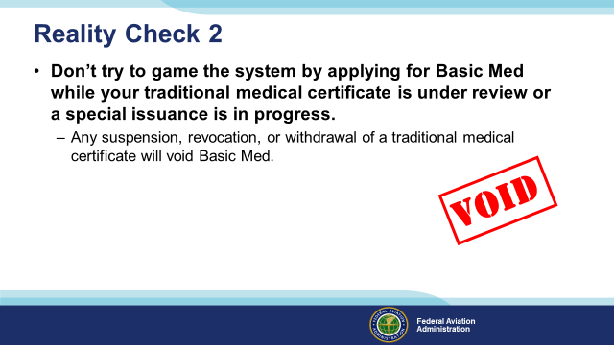 | Slide 12  Don’t try to game the system by applying for Basic Med while your medical certificate is under review. If your traditional medical certificate is withdrawn your Basic Medical will also be void.  Don’t try to “game the system” by withholding information. Your aviation medical examiner needs know everything in order to make an accurate fitness determination and, equally importantly, to make useful recommendations for improvement.  (Next Slide)  Background: There have been several cases of pilots applying for Basic Med based on traditional medical certificates that were subsequently withdrawn. This voids the Basic Med and requires a pilot to acquire at least a 3rd class medical certificate before applying for Basic Med.  Applying for Basic Med based on an expired medical certificate – that was valid for at least one day after 16 July, 2006 and remained valid until expiration– is acceptable.
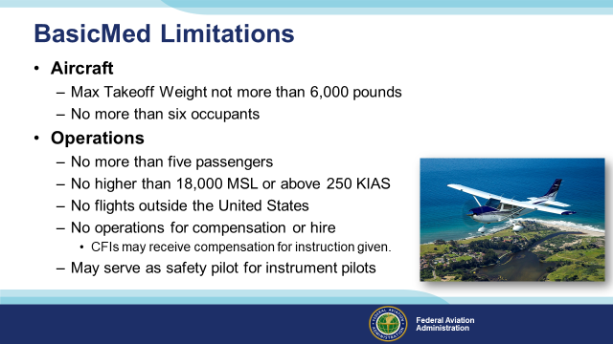 | Slide 13  Pilots flying under BasicMed are limited to aircraft that weigh no more than six thousand pounds and that can accommodate no more than six occupants.  Each flight operation is restricted to the pilot and no more than five passengers, no higher than 18,000 feet MSL or faster than 250 Knots Indicated Airspeed. Flight outside the United States is typically prohibited but not in all cases and, except for CFIs giving flight instruction, you may not receive compensation for flying. A recent amendment to Basic Med rules allows pilots operating under basic med to act as safety pilots for instrument practice operations without acting as pilots in command.  (Next Slide)
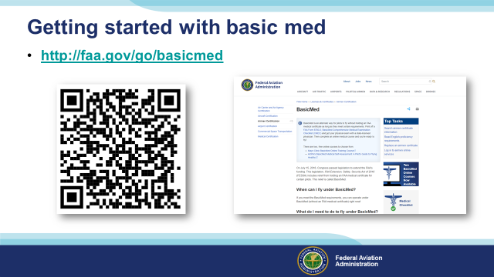 | Slide 14  To get started; navigate to the BasicMed home page and review the provisions of the program. Then download the Comprehensive Medical Checklist.  (Next Slide)
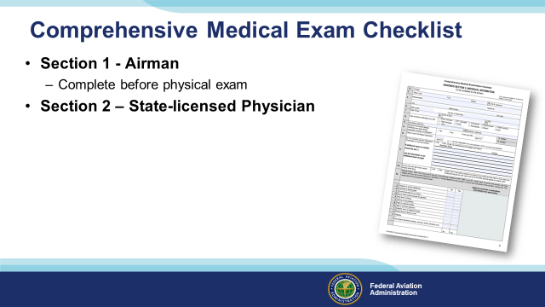 | Slide 15  Next; complete the Airman information and medical history portion of the checklist. It’s very similar to airman information and medical history collected during traditional medical certifications.  Then make an appointment with a State-licensed physician who will conduct a physical examination and record the results on the checklist. Once you have this, make a copy and put it somewhere safe. The state-licensed physician is not required to keep a copy and the FAA won’t have one either.  (Next Slide)
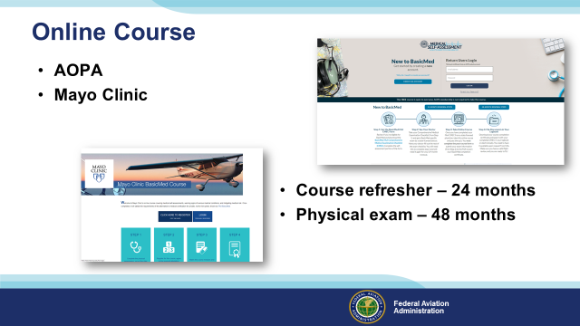 | Slide 16  After you’ve had your physical exam, take one of the available online courses. Upon successful completion, a course completion certificate will be issued and you’ll be good to go. Be sure to maintain a copy of your course completion certificate in your logbook or on your phone.  You’ll need to refresh your knowledge each 24 months by completing another course and you must have completed a physical exam checklist with a physician within the preceding 48 months in order to fly as pilot in command.  And you’ll have to assess your fitness before every flight. A very important part of that assessment has to do with a sobering statistic.  (Next Slide)
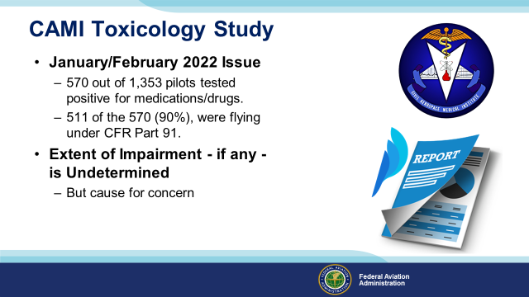 | Slide 17  We’ve talked about this issue before but it’s worth reviewing.  In a 2011 study conducted by FAA’s CAMI Toxicology Lab, drugs/medications were found in 570 pilots (42%) from 1,353 total deceased pilots tested. Most of the pilots with positive drug results, 511 (90%), were flying under CFR Part 91.”.  While there were a couple instances of recreational drugs, the majority were prescription or over the counter medications. Antihistamines were the most commonly found. Left undetermined was the extent of pilot impairment – if any – due to drug use but the issue is cause for concern for several reasons:  (Next Slide)
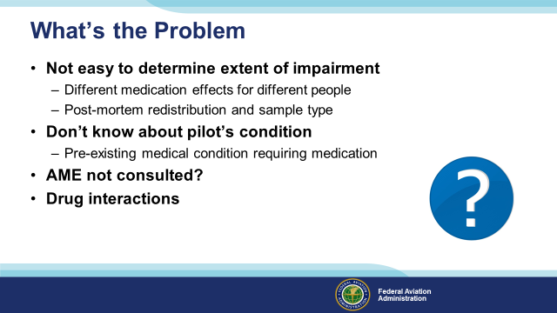 | Slide 18  So what’s the problem:  First of all – We all know that some medications may compromise a pilot’s ability to control the aircraft and/or adversely affect judgment and decision-making. (Click)  What’s not so obvious is it’s difficult for investigators to say for sure that pilot performance was compromised because the effect of drugs and medications varies widely among individuals. In addition, post-mortem redistribution of a substance creates some confusion as to the actual blood levels prior to the accident. The amount of a substance may vary considerably in different tissues. (Click)  A less obvious problem poses the question; what pre-existing physical condition requires the use of medication in the first place? (Click)  It’s not unusual to find that pilots are evaluated and treated for conditions that are not revealed to their Aviation Medical Examiners. In those cases an AME doesn’t have an opportunity to review the complete medical history of diagnoses and treatments for some of the pilots they examine. (Click)  (Next Slide)
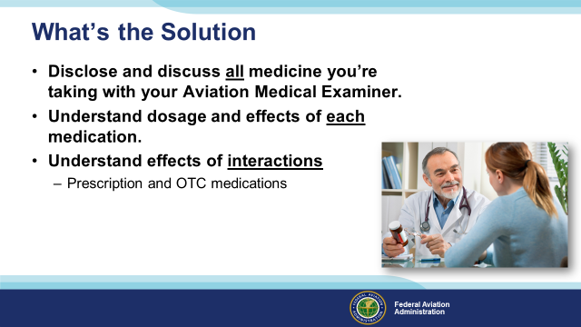 | Slide 19  The solution?  First of all – Make sure you disclose and all of the medications you’re taking with your Aviation Medical Examiner. If you’re undergoing a Basic Med examination your doctor will not have had the specialized training required of AMEs and may not be familiar with the demands of flight. Still you should get a good idea of how each medication and combinations of medications will affect your ability to fly safely.  (Next Slide)
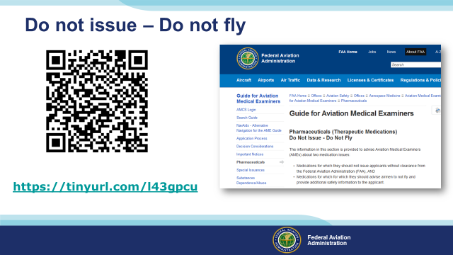 | Slide 20  You and your doctor can access lists of medications that preclude medical certificate issuance (Do not Issue) or medications that are not  compatible with safe flight operations (Do not Fly). Those lists are available at the website shown on the screen.  Presentation Note: You can access the Do not Issue – Do not Fly lists at this URL: https://www.faa.gov/about/office_org/headquarters_offices/avs/offices/aam/ame/guide/pharm/dni_dnf/  Remember, “FAA.gov”, where one can navigate through the various portals.  (Next Slide)
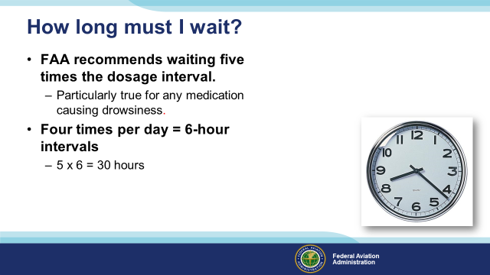 | Slide 21  If you’ve been taking a medication that precludes flying, how long must you wait after ceasing the medication before you return to the air? (Click)  This is a good question for your AME to answer but the general rule is to wait until 5 times the dosage interval has passed. (Click)  For example; if you take a medication 4 times a day (6-hour intervals) you should wait at least 30 hours before resuming pilot duties.  (Next Slide)
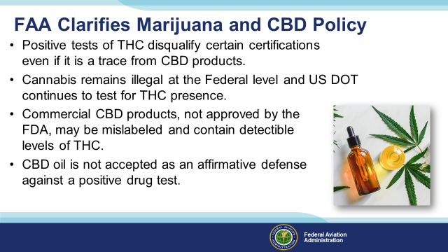 | Slide 22  Several states including have legalized the use of hemp and it’s derivatives such as CBD which is short for Cannabidiol, a chemical compound from the Cannabis plant, commonly referred to as marijuana.  Because of the popularity of CBD Products, the Federal Air Surgeon’s office received a number of inquiries about marijuana use. Although, not a prescription or over-the-counter drug, it is important to caution airman on the use of hemp or it’s derivatives as no allowances will be made by the FAA for pilots who wish to use cannabis medicinally.  (Next Slide)
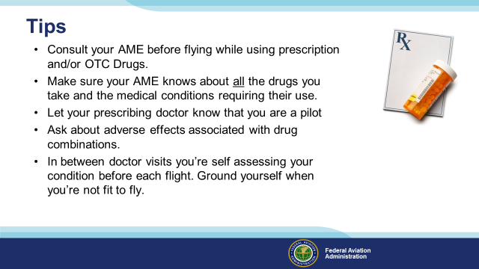 | Slide 23  Finally – here are some tips for safe flying while taking prescribed or OTC medications.  Consult your AME before flying while using prescription and/or OTC Drugs.  Make sure your AME knows about all the drugs you take and the medical conditions requiring their use.  Let your prescribing doctor know that you are a pilot.  Ask about adverse effects associated with drug combinations.  In between doctor visits you’re self assessing your condition before each flight. Ground yourself when you’re not fit to fly.  (Next Slide)
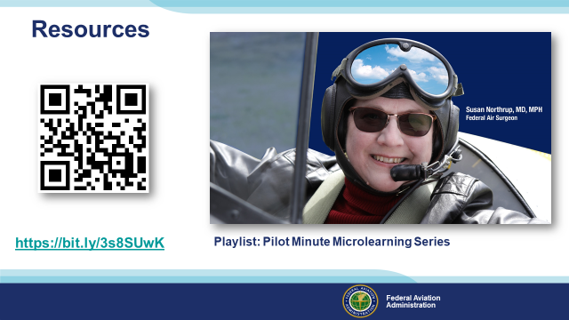 | Slide 24  Here’s a link to the Pilot Minute series of videos produced by the Civil Aerospace Medical Institute. These short presentations address  medical and performance issues for aviators.,  Next Slide  https://www.youtube.com/playlist?list=PL5vHkqHi51DQvRjGJo1SuXyZpKl5HbzOI
Slide 25
Here is an example of the Acceleration Tolerance Pilot Minute Video
(Next Slide)
Presentation note: If you have internet connectivity in your venue you can click on the URL to access the video. If you don’t have connectivity
please hide this slide.
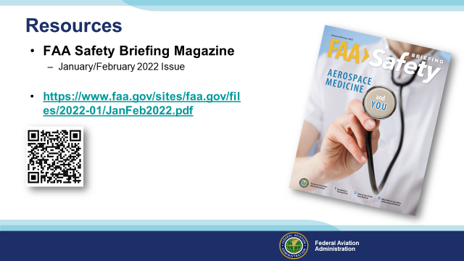 | Slide 26  Finally – here’s a link to an issue of FAA Safety Briefing Magazine that’s devoted to Aerospace Medicine.  Presentation note: Give the audience time to copy the URL and/or scan the QR code. The questions slide follows so you could begin taking questions with this slide. Then:  (Next Slide)
Slide 27
Have you earned your WINGS? Proficiency is key to success in almost every thing worth doing – especially flying. Proficient pilots are confident, capable, and safe.
WINGS is a proficiency training system specifically designed for general aviation pilots and, regular participation will keep you on top of your flying game. You can earn WINGS credit while developing your personal minimums with your CFI.
(Next Slide)
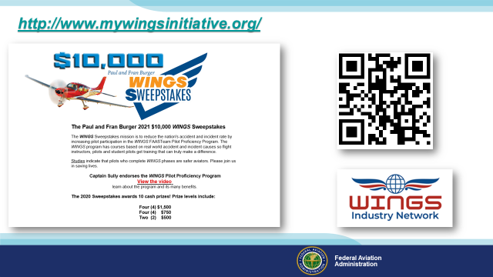 | Slide 28  Every time you complete a WINGS Phase you’re eligible to win cash in the WINGS Sweepstakes.  The sweepstakes is generously funded by Paul Burger, a long time advocate for general aviation safety and a retired aviator who believes participation in this program saves lives. VISIT WWW.MYWINGSINITATIVE.ORG to learn more and enter the sweepstakes.  Just navigate to http://www.mywingsinitiative.org or scan the QR code for details. By the way, Instructors can also enter the sweepstakes. But there are even better reasons to participate in WINGS.  (Next Slide)
Slide 29
Presentation Note: You may wish to provide your contact information and main FSDO phone number here. Modify with your information or leave blank.
(Next Slide)
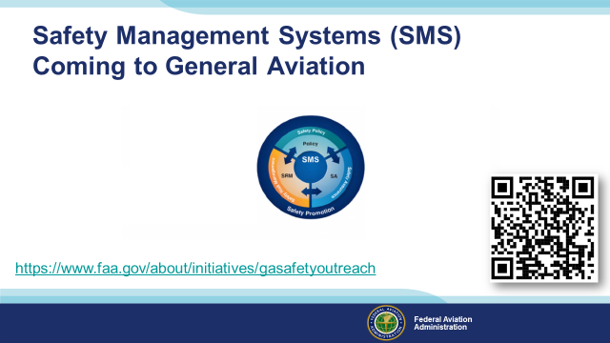 | Slide 30  Safety Management Systems are a set of policies and processes that can increase the safety and efficiency of any flight operation. And FAA is bringing SMS to General Aviation. You may have heard of SMS but thought it was only for large organizations but actually SMS can be scaled to fit any operation large or small.  There are 4 major components to a Safety Management System (Click)  Safety Policy – a documented commitment to safety that runs from the head of an organization to its newest member. (Click)  Safety Risk Management – a process that identifies hazards within an operation, determines to what extent an identified hazard may impact flight safety, and controls the risk of occurrence to an acceptable level. (Click)  Safety Assurance – By collecting and analyzing information derived from safety performance data Safety Assurance ensures the performance and effectiveness of Safety Risk Controls. (Click)  Safety Promotion communicates safety information and commitment throughout the organization. (Click)  You can find more information about Safety Management Systems at the URL on the Screen.  (Next Slide)
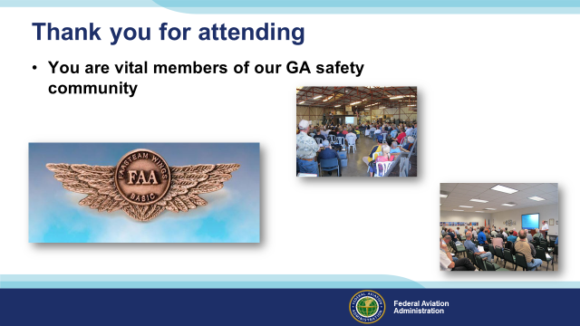 | Slide 31  Your presence here shows that you are vital members of our General Aviation Safety Community. The high standards you keep and the examples you set are a great credit to you and to GA.  Thank you for attending.  (Next Slide)
Slide 32

(The End)

Appendix I – Equipment and Staging
Equipment:
- Projection Screen & Video Projector suitable for expected audience
  - Remote computer/projector control available at lectern or presenter location
    - In lieu of remote – detail a Rep to computer/projector control.
- Presentation Computer
  - Note: It is strongly suggested that the entire program reside on this computer.

- Back up Projector/Computer/Media as available.
- PA system suitable for expected audience
  - Microphones for Moderator and Panel
    - Optional Microphone (s) for audience
- Lectern (optional)
Staging:
- Arrange the projection screen for maximum visibility from the audience.
- Equip with PA microphones
- Place Lectern to one side of screen. This will be used by presenters and moderator

IMPORTANT – Once you have completed outreach on this topic, please help us track the outreach you have done by entering a SAS record.

