General Aviation Joint Steering Committee
CFIT Working Group

Outreach Guidance Document
2022/11/14-266(I)PP

This outreach guidance is provided to all FAA and aviation industry groups that are participating in outreach efforts sponsored by the General Aviation Joint Steering Committee (GAJSC). It is important that all outreach on a given topic is coordinated and is free of conflicts. Therefore, all outreach products should be in alignment with the outline and concepts listed below for this topic.

Outreach Month: November 2024

Topic: CFIT and Normalization of Deviation Bias
The FAA and industry will conduct a public education campaign emphasizing the dangers posed by human biases in cases of controlled flight into terrain

Background:

GAJSC study of General Aviation CFIT Accidents suggested that human biases, particularly Plan Continuation Bias, may compromise effective pilot decision making and lead to CFIT accidents.

Teaching Points:

- Human biases are patterns of reasoning that weigh the value of information according to pre-conceived beliefs. Biases present as a prejudice in favor or or against one thing, person, or group compared with another; often in a way considered to be unfair.
- Normalization of Deviance Bias features progressive deviation from standards and limitations resulting in new norms.
- As deviation from standards and limitations progresses, system safety factors are eroded or lost.
- Pilots should commit to operating within established standards, limitations, and norms.
- Development and documentation of personal minimums and periodic objective pilot performance assessments should be made in consultation with a Flight Instructor.
- Objective in-flight “how-goes-it?” assessments should be made in order to confirm that operations are conducted within standards, limitations, and norms.

References:
- CFIT & Normalization of Deviance Power Point
  - Available on the National FAASTeam Share Point site under Approved Resources.

- Risk Management Handbook – FAA H 8083-2a
  - Available on FAA.gov
  - https://www.faa.gov/regulationspolicies/handbooksmanuals/risk-management-handbook-faa-h-8083-2a

Abstract: Lasting 10 to 15 minutes, this presentation acquaints the audience with human biases that may compromise effective Aeronautical Decision Making

Format: Information Briefing - Power Point presentation
Required Personnel – FAASTeam Program Manager or designated FAASTeam Rep (s)
Optional Personnel – DPEs and CFIs who can speak to CFIT hazards associated with Plan Continuation Bias

National FAASTeam Support:
In addition to this guidance document, a Power Point presentation that supports the program and a folder containing background information are provided. FPMs and presenters are encouraged to customize this presentation to reflect each individual program.

Slides | Script
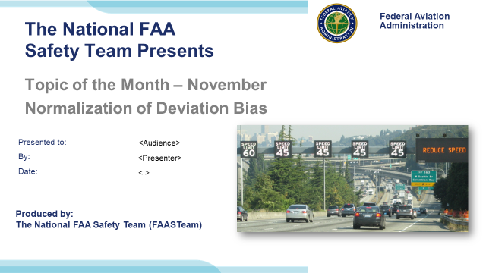 | Slide 1  2022/11/14-266(I)PP Original Author: John Steuernagle; POC Kevin Clover, National FAASTeam Program Mgr. Ops., Office 562-888-2020  Presentation Note: This is the title slide for CFIT and Plan Continuation Bias  Script - We have included a script of suggested dialog with most slides. The script will always appear in a non-italic font. Presenters may read the script or modify it to suit their own presentation style. See template slides 5 and 6 for examples of a slides with script.  Presentation Instructions - (stage direction and presentation suggestions) will be preceded by a Bold header: the instructions themselves will be in Italic fonts. See slides 2, for an example of slides with Presentation Instructions only.  Program control instructions - will be in bold fonts and look like this: (Click) for building information within a slide; or this: (Next Slide) for slide advance.  Background information - Some slides may contain background information that supports the concepts presented in the program.  .  The production team hope you and your audience will enjoy the show. Break a leg!  (Next Slide)
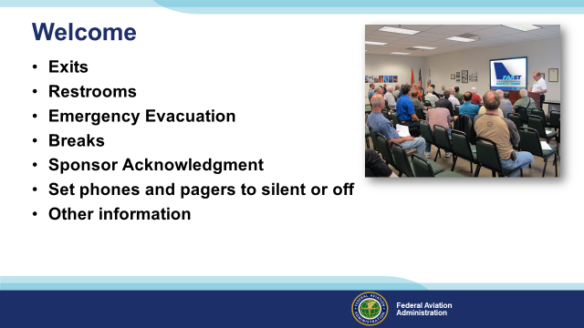 | Slide 2  Presentation Note: Here’s where you can discuss venue logistics, acknowledge sponsors, and deliver other information you want your audience to know in the beginning.  You can add slides after this one to fit your situation.  (Next Slide)
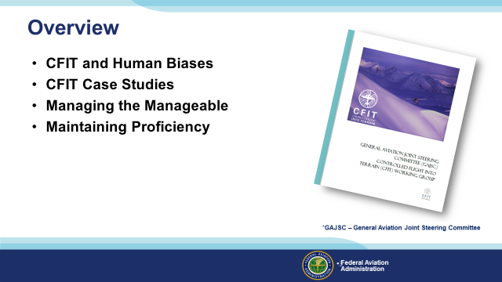 | Slide 3  The General Aviation Joint Steering Committee (GAJSC) Controlled Flight Into Terrain (CFIT) work group report suggests that certain human biases may be significant factors in CFIT accidents. In this presentation we’ll talk a little bit about CFIT and human biases that may negatively influence pilot decision making. We’ll review some CFIT case studies and we’ll offer some thoughts on how to effectively manage things that we can control and plan for dealing with things that are beyond our control. Finally we’ll offer a few suggestions for maintaining pilot proficiency.  Presentation Note: If you’ll be discussing additional items, add them to this list  (Next Slide)
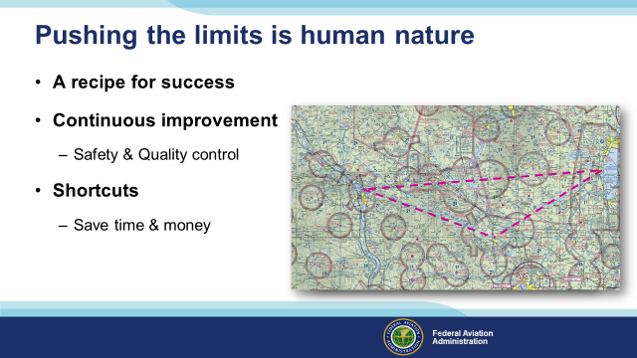 | Slide 4  Make no mistake – human beings are programmed to push their limits. It’s a recipe for success. Athletic training and coaching are designed to improve performance over time.  We’ve all heard that, “records are made to be broken” and that’s certainly been the case in nearly every field of human endeavor. The first person to run a mile in less than four minutes achieved that milestone in 1954. Since then runners have shaved more than 16 seconds from that record! (Click)  Every corporate management systems calls for continuous improvement of output and production efficiency. If we can produce more product in less time with fewer employees then that’s a good thing provided safety is maintained and product quality doesn’t suffer. (Click)  And people are always looking to take advantage of shortcuts. (Click)  Why take the long way around when you can save time and money by going direct?  (Next Slide)
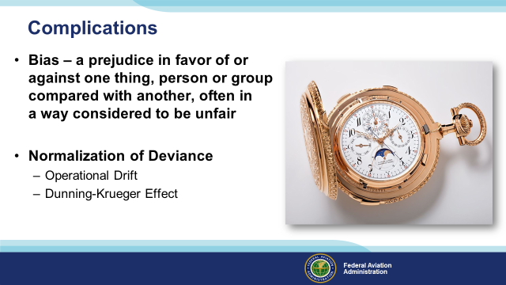 | Slide 5  In watchmaking, the term, “complication” refers to added features that complicate the challenge of designing elegant machines that provide a wealth of information in a small package. Here we’re using the word to describe human biases that complicate the process of making sound decisions. (Click)  Bias is defined as a prejudice in favor of or against one thing, person, or group compared with another, often in a way considered to be unfair. (Click)  Normalization of Deviance describes the human tendency, often well intended, to deviate from established procedures and norms over time and the acceptance of those deviations as new norms. These deviations are sometimes referred to as Operational Drift. (Click)  Deviation can be influenced by The Dunning-Krueger Effect that has to do with self-assessment of one’s capabilities. Dunning and Krueger discovered two interesting  Things about humans that we’ll get to in a couple of slides but first let’s look at some examples of normalization of deviance.  (Next Slide)
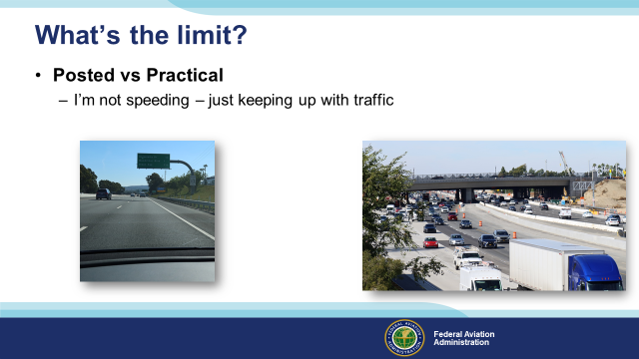 | Slide 6  To facilitate our discussion we’ll talk about limits. Let’s take for example, Interstate highway 405 in California. The posted speed limit where the highway transits Los Angeles is 65 miles per hour. But if traffic congestion isn’t heavy, speed averages closer to 75 miles per hour. We might think that average speeds are higher because resources are not available to enforce the limit but in fact the highway is patrolled. (Click)  You’ve probably noticed this phenomenon of posted vs practical speed limits on some of the highways you use. In many areas, traffic flows at higher than posted speed limits. After a while this speed becomes the new normal and drivers will not consider they’re speeding unless they go faster than the flow. You wouldn’t say you were speeding if you’re just keeping up with the traffic. But you might well think ill of the occasional maniac who’s chewing up the highway at well over the average traffic speed. When that happens you may be influenced by another unhelpful human bias. We’ll get to that in a couple of minutes but first.  (Next Slide)
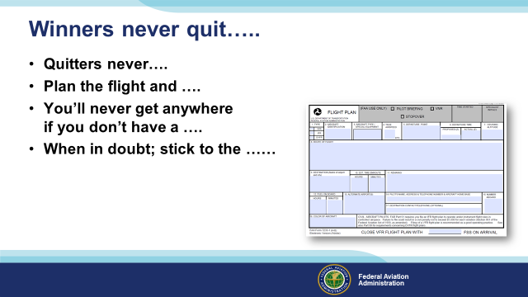 | Slide 7  In any process, limits are established to define and ensure acceptable performance. Limits are often safety driven and, if they are well designed, there is a cushion of safety to compensate for human, machine, and operational environment variations. Thus we are comfortable with the notion that exceeding a limitation, by just a bit or for a brief moment is not likely to result in catastrophe. But because we are human, this comfort with brief excursions from limits can cause big problems over time. Here’s how that works.  Because we want to conserve energy and operate efficiently, we tend to push performance limits. Exceeding aircraft speed or weight limitations by “just a bit” will allow us to be more efficient and after all, we have a safety cushion to rely on. Over time we come to accept deviations and they become our new norms. So what’s the problem?  You guessed it, once we’re comfortable with the new norm we’ll be tempted to push that limit. This tendency to progressively exceed limits is known as Operational Drift. Each deviation is so slight that it seems inconsequential until one day. (Click)  We have a failure.  (Next Slide)
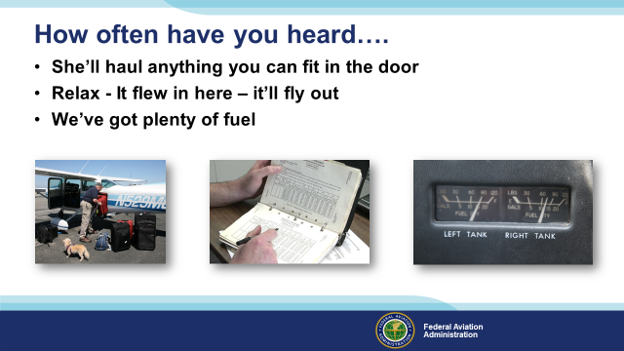 | Slide 8  How often have you heard these statements. You may even have said them yourself. Each of these statements relates to aircraft and pilot performance expectations.  Occasionally, in the course of accident investigation, we discover that those expectations were unreasonable. And occasionally we find that pilots have progressively deviated from established limitations until there is no safety factor and an accident occurs.  (Next Slide)
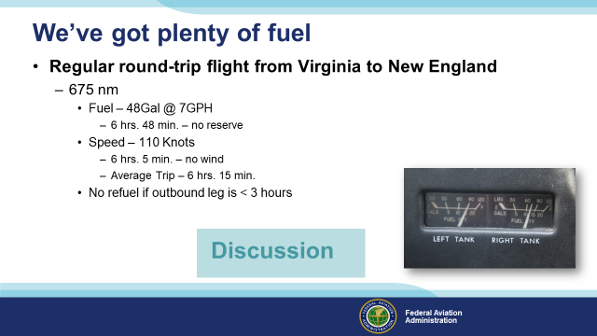 | Slide 9  A pilot based in Virginia made regular 675 mile round trip flights to visit relatives in New England.  The fuel capacity of his aircraft was 48 gallons. At 65% power the aircraft burned 7 gallons per hour – enough for  6 hours and 48 minutes of flight with no reserve. (Click)  65% power yielded 110 Knots true airspeed. That equated to 6 hours and 5 minutes for the round  trip assuming no wind. Over several trips the average total trip time was 6 hours and 10 minutes. That yielded  a 38-minute fuel reserve for the return trip. (Click)  Initially the pilot would purchase fuel in New England – even though he had sufficient fuel on board for the return trip.  But fuel was much more expensive than at his home field so the pilot became accustomed to returning without refueling,  “if the outward trip had taken less than 3 hours”.  On one occasion the pilot experienced symptoms of carburetor ice in the initial climb out on the return leg. Carburetor  heat solved the problem and the return leg was uneventful. Until the fuel was exhausted 20 miles north of his destination in  night VMC conditions.  Presentation Note: Lead a discussion on what the audience thinks was the cause of the accident. Factors include the use of carburetor heat  and the resultant richer fuel mixture on the return leg, the less than legal fuel reserve for night operations, and the complacency from having  Been successful on many previous trips. Over time and banking on a 30-minute fuel reserve, the pilot became comfortable with making the trip  without refueling even though winter operations often resulted in landing after dark.  (Next Slide)
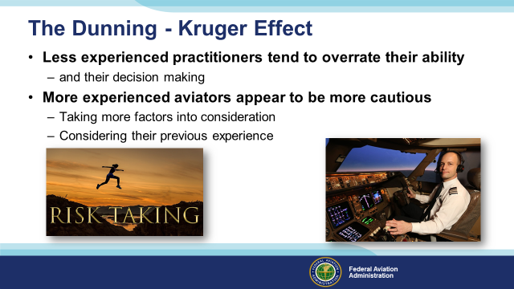 | Slide 10  The Dunning-Kruger effect has to do with the tendency of people who are relatively inexperienced in a task to overestimate their ability with respect to it.  This may explain some of the overly confident behavior of some low-time pilots.  Conversely, more experienced practitioners tend to underestimate their abilities. They may well be taking their previous experience into account when making conservative estimates of future performance.  Even so – pilots who are new to the game and old pros are equally susceptible to Normalization of Deviation Bias.  (Next Slide)
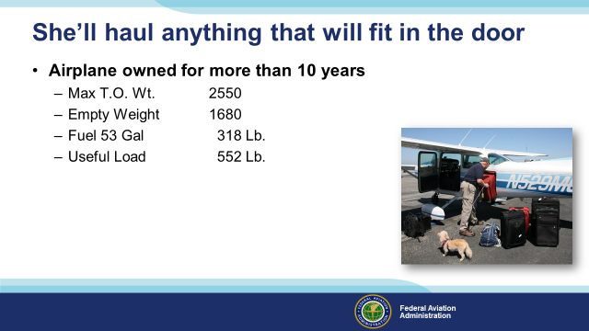 | Slide 11  When the pilot bought this aircraft it was ideal for a couple and a small dog. Ten years later the dog is still small but the people and their essential traveling gear have grown larger and heavier.  (Next Slide)
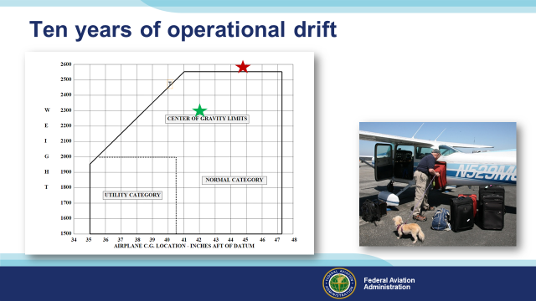 | Slide 12  Ten years ago the aircraft was comfortably within the allowable weight travel essentialso grew the CG moved progressively aft and the weight increased until now he’s regularly flying overweight. (Click)  Because the weight increased gradually, aircraft performance reduced gradually too. Sure it takes a little more runway to takeoff and a little more time to climb but each slight degradation of performance has, over time, become the new normal.  To see why this can be problematic, let’s take a couple of minutes to discuss aircraft design and limitations.  (Next Slide)
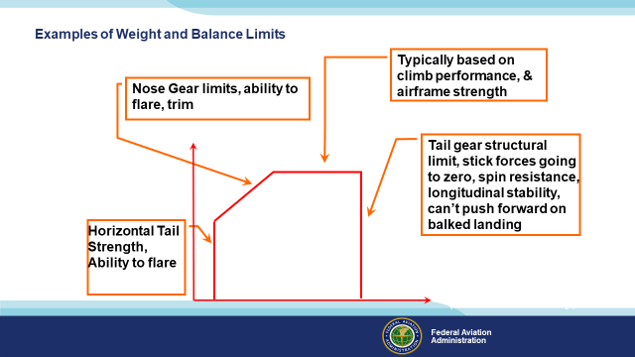 | Slide 13  You’ve all seen weight and balance limits graphed like this red box. Each part of the box is an expression of a design or performance limitation. (Click)  At lower weights you can stay within nose gear stress limits, and you can flare & trim with a forward center of gravity. As weight increases though the CG must move aft to avoid exceeding design and control limits. That’s why this line slants aft. (Click)  This upper weight limit is typically based on climb performance criteria and airframe strength. Maximum gross weight is established early in the design process and each structural component is designed to support that figure.. (Click)  The aft limit is predicated on tail wheel strength, pitch control forces approaching zero, spin resistance, longitudinal stability – see control forces approaching zero – and the ability to control pitch with full power application as in a go around from a balked landing. (Click)  Finally – the forward limit is determined by the empennage strength, the ability to flare, and nose gear design limits.  (Next Slide)
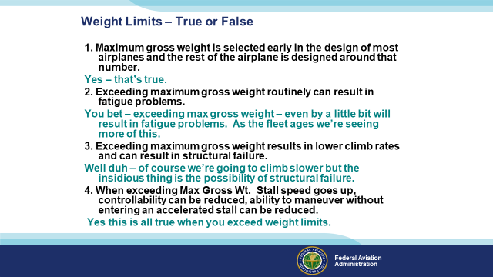 | Slide 14  With that in mind, let’s look at a few true false questions. These all have to do with the maximum gross weight limit.  What do you think about this statement? (Click)  - Well we just talked about that so yes – that’s true. (Click)  - You bet – exceeding max gross weight – even by a little bit will result in fatigue problems. As the fleet ages we’re seeing more of this. (Click)  - Well duh – of course we’re going to climb slower but the insidious thing is the possibility of structural failure. It’s important to note that, unlike humans who can successfully recover from stress injuries, aircraft can’t. For aircraft, stress is cumulative and operating beyond design limitations will, at some point, result in failure. (Click)  4. Yes this is all true when you exceed weight limits.  (Next Slide)
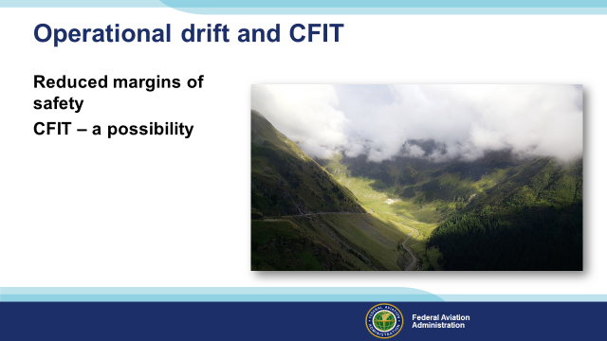 | Slide 15  Environmental familiarity can encourage operational drift. Pilots new to an area are likely to insist on excellent ceiling and visibility conditions before attempting flight. But as they become familiar with the environment, they may accept less than ideal weather conditions. This practice can reduce margins of safety to the point where VFR flight is no longer possible and controlled flight into terrain becomes more likely.  (Next Slide)
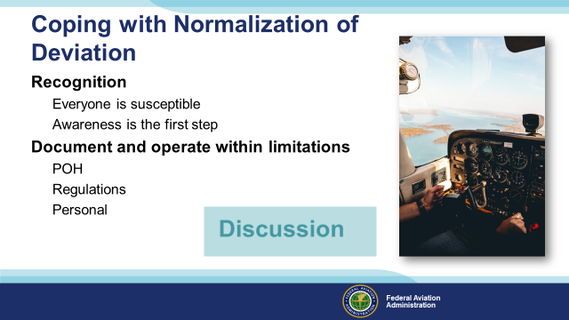 | Slide 16  Let’s have a little discussion on what to do next.  First of all – everyone is susceptible to human biases so awareness of that fact is the logical first step to take. So what do we do about it? (Click)  It’s tough to know if we’re exceeding limitations if we don’t know what they are so it’s a good idea to document them. That way we have a ready reference to consult.  So what would that documentation look like?  Presentation note: Lead a discussion of the question. Hopefully the audience will cite the Pilot’s Operating Handbook, Weight & Balance, and performance calculations. Be sure to make the point that aviation regulations also document limitations, equipment, and operational requirements for aircraft and for the people who fly and maintain them. Finally, introduce the topic of personal limitations or minimums. (Click)  Well that was an interesting discussion. Obviously we have to do more than document limitations. We must commit to operating within them – all of the time.  Now let’s turn our attention to documenting personal capabilities and limitations with a simple safety risk management mnemonic found in the Risk Management Handbook.  (Next Slide)
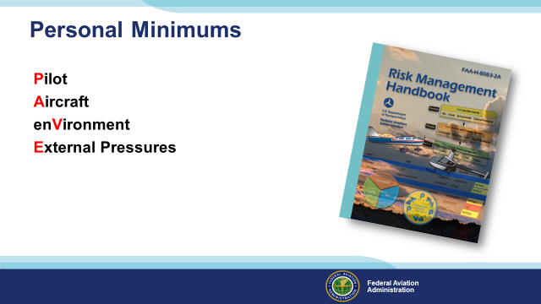 | Slide 17  “A man’s got to know his limitations”. Clint Eastwood as Dirty Harry said it 40 years ago and it’s still true today. But how do we know what our personal limitations are? Our Pilot Capabilities are not fixed in stone. Our ability to cope with wind and weather changes from year to year, day to day, and even hour to hour. That’s why many successful pilots develop personal minimums for all their flying activities. (Click)  Chapter 2 in FAA’s Risk Management Handbook shows us how to set Personal Minimums. Parameters to consider are associated with the acronym PAVE. (Click)  We’ll discuss the meaning of the letters and the curious case of the misaligned V in the following slides,.  P represents the pilot. (Click)  A stands for Aircraft (Click)  V represents the environment within which we’ll be operating (Click)  And E has to do with external pressures and distractions. We’ll take a more in depth look at each of these areas in following slides.  (Next Slide)
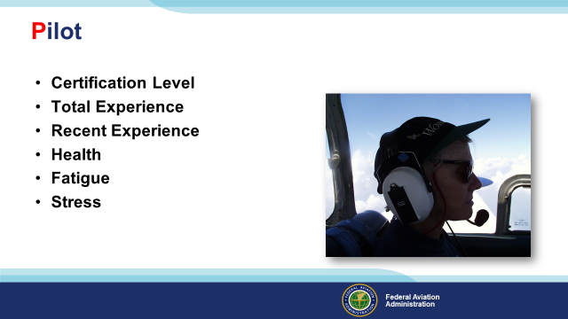 | Slide 18  To assess pilot capabilities we want to look at (Click)  Certification Level (Click)  Total experience including time in make and model and (Click)  Recent Experience – overall and in make and model (Click)  Pilot health is obviously important and should be a no brainer but we include it here because a recent study found over the counter or prescriptions in post mortem toxicology screens of 80% of pilots in fatal accidents.  We’re not saying that those drugs were the cause of the accidents but the surprising high percentage does make us wonder about what medical conditions those pilots were treating and how those conditions may have affected pilot performance. (Click)  Fatigue is another big issue these days. Accident investigation data show that fatigue is often a pilot performance degrading factor. (Click)  Finally we have stress. We’ll also address this under external pressures but internal – self imposed – stress is something most pilots live with and, if it’s excessive, it can contribute to reduced pilot performance.  (Next Slide)
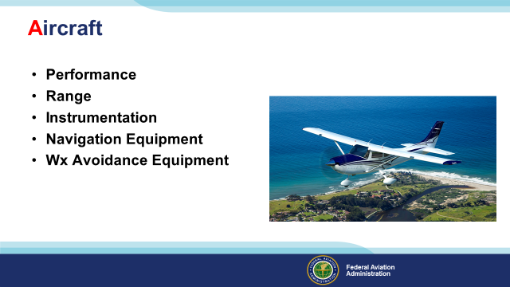 | Slide 19  Naturally, we want to consider aircraft performance parameters with respect to the mission. (Click)  Range, instrumentation, navigation and weather avoidance equipment must also match the mission.  (Next Slide)
Slide 20
And of course pilots must carefully consider the environments they fly in. Topography, lighting conditions, wind, weather, runways and approach aids. All of these taken together provide environmental challenges on every flight.
(Next Slide)
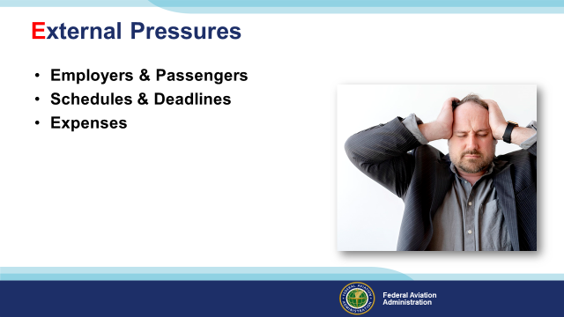 | Slide 21  Employers and Passengers can exert enormous pressure on pilots to complete their missions on time regardless of changing conditions (Click)  And we’ve seen accidents that could have been prevented if the pilot had only purchased 10 gallons more of that unexpectedly expensive fuel at the destination airport. We’ve also seen accidents where the pilot should have gone to the expense of remaining overnight but took off into darkness and marginal weather instead.  (Next Slide)
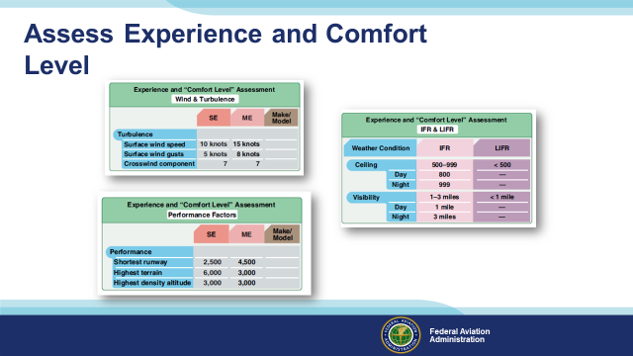 | Slide 22  Developing a personal minimums document is a matter of assessing your pilot experience and comfort level with respect to various mission and environmental conditions. You’ll complete several tables like the these and together they’ll comprise your personal minimums.  (Next Slide)
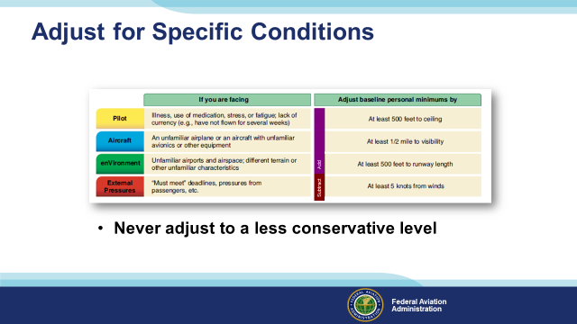 | Slide 23  Once you have established your personal minimums, you can adjust them for specific conditions as we can see here. One caveat and it’s very important. (Click)  If you’re going to adjust a previously determined minimum always do so in a more conservative direction. In other words if you want less conservative minimums you must acquire pilot and aircraft capability to ensure safety. An example would be a flight operation that wants to operate to Category II approach minimums must have specially trained crew and navigation equipment as well as recent experience, to fly the Cat II approach.  .  (Next Slide)
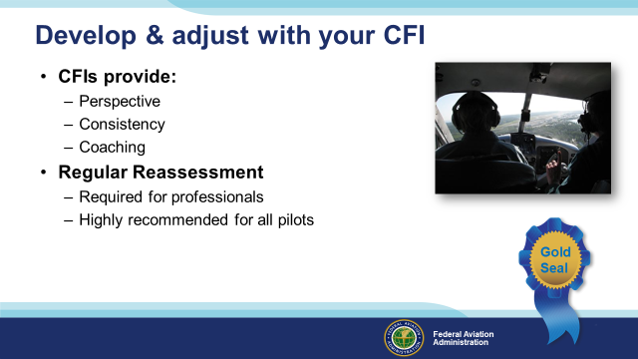 | Slide 24  We strongly encourage you to develop and periodically reassess your personal minimums in consultation with your CFI. Flight Instructors are trained to assess pilot performance. They can provide perspective and consistency and they can coach pilots in improvement. Professional pilots are required to undergo periodic evaluations and, although not required, re-assessing pilot performance and personal minimums regularly is a gold seal best practice for general aviation pilots at all certificate levels.  (Next Slide)
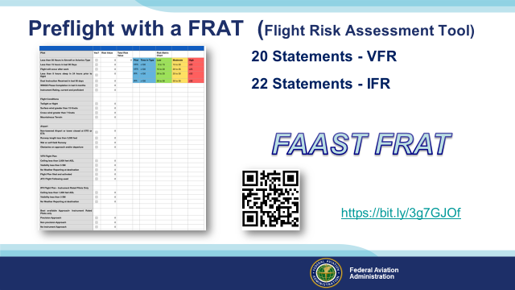 | Slide 25  A Flight Risk Assessment Tool – or FRAT – is one means of consistently evaluating hazards that may be associated with any flight.  The FAAST FRAT is a simple automated spread sheet that contains 20 condition statements for VFR pilots; 22 for IFR pilots.  The statements describe common general aviation flight liabilities and assets. Pilots simply click the “yes” box next to each statement that applies to their flight.  Each yes statement generates a risk value and those values are totaled on the sheet.  The total risk value is related to the risk matrix chart to determine whether the flight risk is likely to be low, moderate, or high.  The FAAST FRAT is available in the FAASafety.gov library. Scan the QR code or navigate to the URL on screen to download your copy.  (Next Slide)
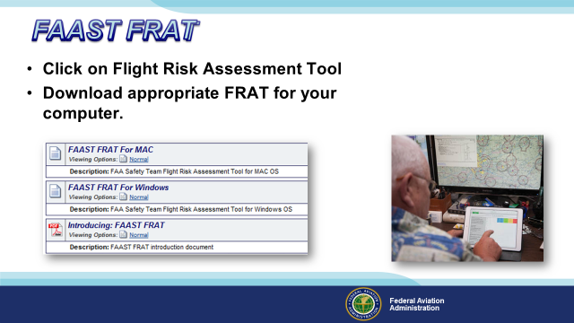 | Slide 26  Click on Flight Risk Assessment Tool (FRAT)  Download the appropriate FRAT for your computer.  (Next Slide)
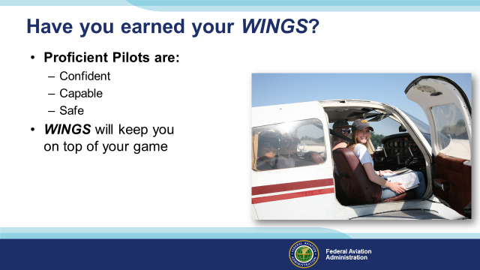 | Slide 27  Have you earned your WINGS? Proficiency is key to success in almost every thing worth doing – especially flying. Proficient pilots are confident, capable, and safe.  WINGS is a proficiency training system specifically designed for general aviation pilots and, regular participation will keep you on top of your flying game. You can earn WINGS credit while developing your personal minimums with your CFI.  (Next Slide)
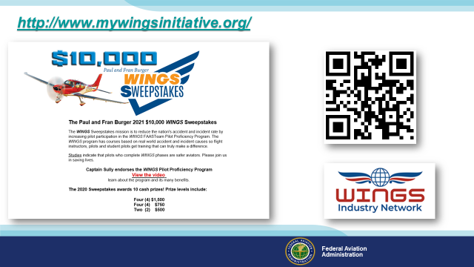 | Slide 28  Every time you complete a WINGS Phase you’re eligible to win cash in the WINGS Sweepstakes.  The sweepstakes is generously funded by Paul Burger, a long time advocate for general aviation safety and a retired aviator who believes participation in this program saves lives. VISIT WWW.MYWINGSINITATIVE.ORG to learn more and enter the sweepstakes.  Just navigate to http://www.mywingsinitiative.org or scan the QR code for details. By the way, Instructors can also enter the sweepstakes. But there are even better reasons to participate in WINGS.  (Next Slide)
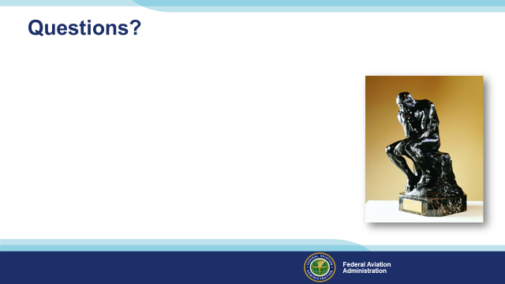 | Slide 29  Presentation Note: You may wish to provide your contact information and main FSDO phone number here. Modify with your information or leave blank.  (Next Slide)
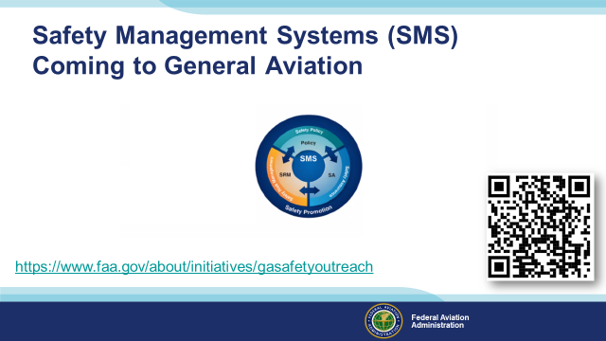 | Slide 30  Safety Management Systems are a set of policies and processes that can increase the safety and efficiency of any flight operation. And FAA is bringing SMS to General Aviation. You may have heard of SMS but thought it was only for large organizations but actually SMS can be scaled to fit any operation large or small.  There are 4 major components to a Safety Management System (Click)  Safety Policy – a documented commitment to safety that runs from the head of an organization to its newest member. (Click)  Safety Risk Management – a process that identifies hazards within an operation, determines to what extent an identified hazard may impact flight safety, and controls the risk of occurrence to an acceptable level. (Click)  Safety Assurance – By collecting and analyzing information derived from safety performance data Safety Assurance ensures the performance and effectiveness of Safety Risk Controls. (Click)  Safety Promotion communicates safety information and commitment throughout the organization. (Click)  You can find more information about Safety Management Systems at the URL on the Screen.  (Next Slide)
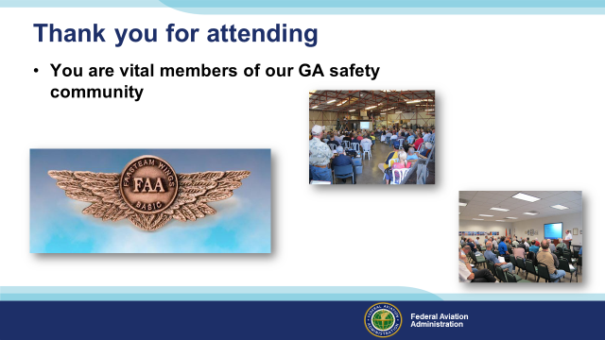 | Slide 31  Your presence here shows that you are vital members of our General Aviation Safety Community. The high standards you keep and the examples you set are a great credit to you and to GA.  Thank you for attending.  (Next Slide)
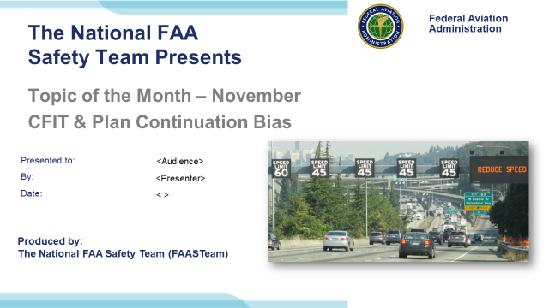 | Slide 32  (The End)

Appendix I – Equipment and Staging
Equipment:
- Projection Screen & Video Projector suitable for expected audience
  - Remote computer/projector control available at lectern or presenter location
    - In lieu of remote – detail a Rep to computer/projector control.
- Presentation Computer

  - Note: It is strongly suggested that the entire program reside on this computer.
- Back up Projector/Computer/Media as available.
- PA system suitable for expected audience
  - Microphones for Moderator and Panel
    - Optional Microphone (s) for audience
- Lectern (optional)
Staging:
- Arrange the projection screen for maximum visibility from the audience.
- Equip with PA microphones
- Place Lectern to one side of screen. This will be used by presenters and moderator

IMPORTANT – Once you have completed outreach on this topic, please help us track the outreach you have done by entering a SAS record.

