General Aviation Joint Safety Committee
Energy Management
Outreach Guidance & Notes Document
2022/12-07-272(I)PP
This outreach guidance is provided to all FAA and aviation industry groups that are participating in outreach efforts sponsored by the General Aviation Joint Safety Committee (GAJSC). It is important that all outreach on a given topic is coordinated and is free of conflicts. Therefore, all outreach products should be in alignment with the outline and concepts listed below for this topic.
Outreach Month: April 2024

Topic: Energy Management
The FAA and industry will conduct a public education campaign emphasizing the best practices associated with managing aircraft energy in flight.
Background:
The General Aviation Joint Safety Committee (GAJSC) has studied a number of General Aviation accidents. Recently the Committee studied system and component failure accidents and they determined that a significant number of fatal accidents result from pilots allowing aircraft energy state to decay sufficiently to make sustained flight impossible
Teaching Points:
- General aviation accidents have resulted from loss of control while maneuvering and during emergency descents, approaches, and landings.
- The likelihood of maintaining positive control and executing successful forced landings can be improved through awareness of and successful managing of aircraft energy state throughout all flight phases.

References:
- Airplane Flying Handbook (FAA-H-8083-3C)
  - Chapter 4 – Energy Management

- Pilot’s Handbook of Aerounautical Knowledge (FAA-H-8083-25B)
  - Chapter 2 – Aeronautical Decision Making
  - Chapter 11 – Aircraft Performance

Aircraft Energy Management
Abstract: Lasting 15 to 30 minutes, this presentation introduces the subject of Energy Management
Format: Information Briefing - Power Point presentation
Required Personnel – FAASTeam Program Manager or designated FAASTeam Rep (s)
Optional Personnel – CFIs and DPEs who can speak on Best Glide Speed
Natonal FAASTeam Support:
In addition to this guidance document, a Power Point presentation that supports the program is provided. FPMs and presenters are encouraged to customize this presentation to reflect each individual program.

Slides | Script
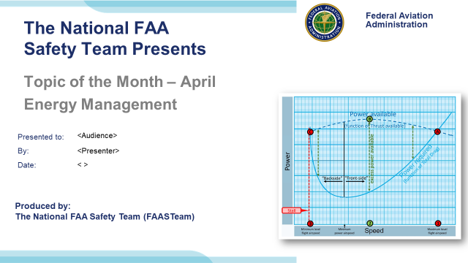 | Slide 1  2022/12-05-268(I)PP Original Author: John Steuernagle; POC Kevin Clover, AFS-850 Operations Program Manager, Office 562-888-2020  Presentation Note: This is the title slide for Energy Management  - Script - We have included a script of suggested dialog with most slides. The script will always appear in a non-italic font. Presenters may read the script or modify it to suit their own presentation style. See template slides 5 and 6 for examples of a slides with script.  - Presentation Instructions - (stage direction and presentation suggestions) will be preceded by a Bold header: the instructions themselves will be in Italic fonts. See slide 2 for an example of slides with Presentation Instructions only.  - Program control instructions - will be in bold fonts and look like this: (Click) for building information within a slide; or this: (Next Slide) for slide advance.  - Background information - Some slides may contain background information that supports the concepts presented in the program.  Background information will always appear last and will be preceded by a bold Background: identification.  The production team hope you and your audience will enjoy the show. Break a leg!  (Next Slide)
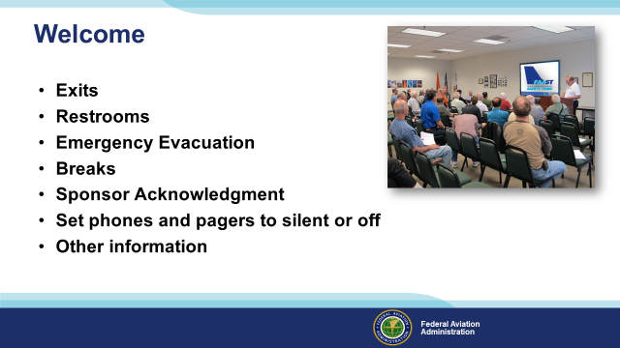 | Slide 2  Presentation Note: Here’s where you can discuss venue logistics, acknowledge sponsors, and deliver other information you want your audience to know in the beginning.  You can add slides after this one to fit your situation (Next Slide)
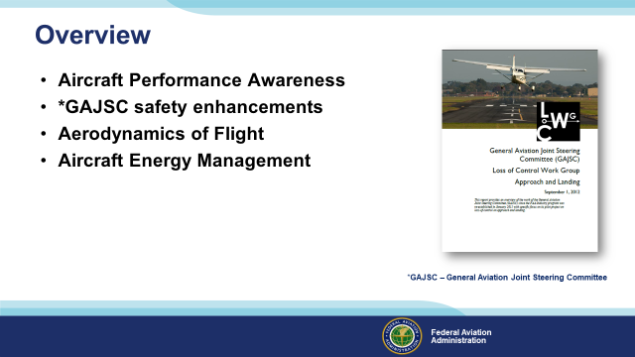 | Slide 3  The General Aviation Joint Safety Committee (GSJSC) has identified additional knowledge in aircraft performance and aerodynamics as beneficial to reducing accidents.  In this presentation we’ll talk a little bit about aircraft performance awareness.  We’ll discuss the aerodynamics of flight.  And we’ll consider aircraft performance in the context of energy management.  Presentation Note: If you’ll be discussing additional items, add them to this list  (Next Slide)
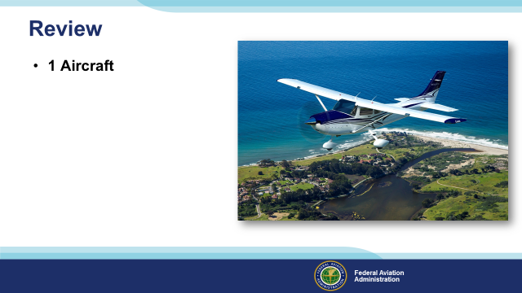 | Slide 4  Just a quick Review before we get started. Here we have one aircraft.  (Next Slide)
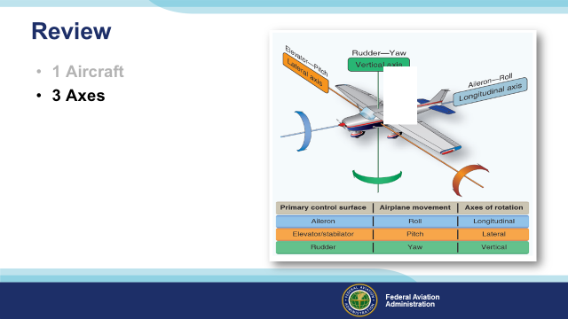 | Slide 5  That moves about 3 axes of motion.  (Next Slide)
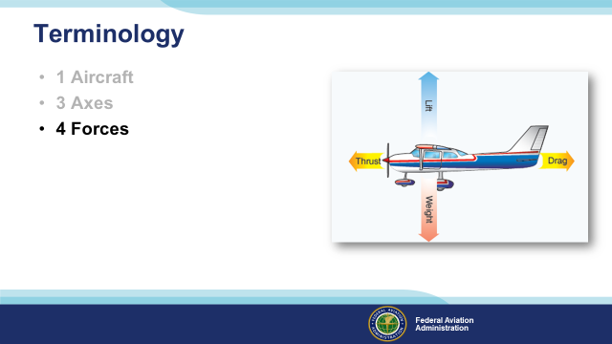 | Slide 6  While balancing 4 forces – Thrust and Drag – Lift and Weight or Gravity.  (Next Slide)
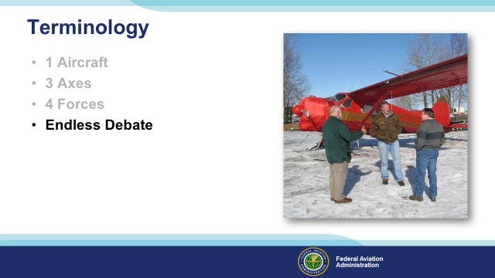 | Slide 7  And generating endless debate as to how it all works. Let’s take a few minutes to look at a few important details.  (Next Slide)
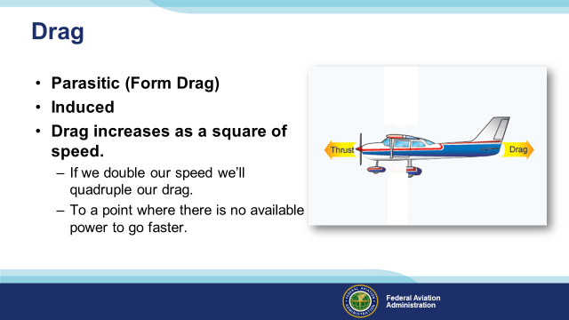 | Slide 8  Drag comes in 2 varieties; Parasitic or Form Drag that is the air’s resistance to the aircraft’s passage through it. (Click)  And Induced Drag that is created as a consequence of lift. (Click)  Drag increases as a square of speed. If we double our speed we’ll quadruple our drag. (Click)  Eventually we get to a point where there is no available power to increase speed. Thrust and drag are balanced  and we can’t go any faster while maintaining level flight.  Now let’s take a look at the airplane as an energy system.  (Next Slide)
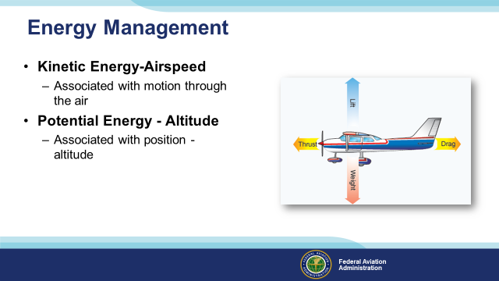 | Slide 9  Energy comes in two varieties; Kinetic Energy is associated with motion, and such things as the production of sound, and heat. (Click)  Potential Energy is associated with position such as altitude. By manipulating the flight controls, pilots can convert potential energy to kinetic energy and vice versa.  Thus we can think of an aircraft in flight as an open energy system. It can gain energy from a source such as fuel or altitude and it can lose energy to the environment principally through drag.  Here we see a system in balance. Energy from the engine is creating thrust in opposition to drag and is providing lift in opposition to gravity.  (Next Slide)
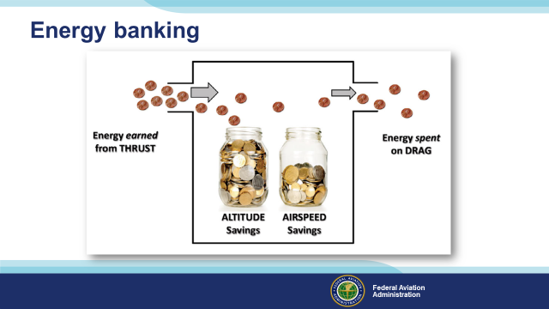 | Slide 10  Looking at it another way, energy earned from thrust can be spent in various ways. Obviously a large portion of our energy income must be spent on drag but excess energy income can be saved as altitude and airspeed.  Having a substantial energy savings account is very useful when it comes to dealing with situations such as loss of power. (Next Slide)
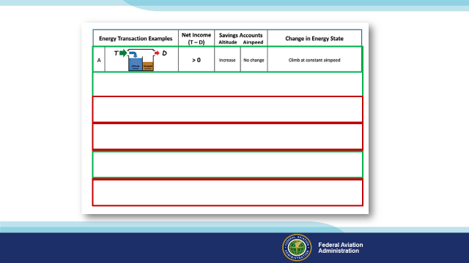 | Slide 11  Here’s an illustration of common energy transactions from the latest edition of the Airplane Flying Handbook.  After takeoff, as we climb at a constant airspeed, we’re making deposits to our altitude account. (Click)  While cruising at constant altitude and airspeed, we’re neither depositing or withdrawing from our energy accounts (Click)  IF we accelerate at a constant altitude we’ll increase the balance in our airspeed account. But remember; drag increases as a square of speed  so we’ll quickly get to the point where there’s not enough power to go faster. (Click)  Deceleration at constant altitude with no increase in power will debit our airspeed account. (Click)  Here’s an example of how we can transfer from one account to another. Climbing while decelerating will transfer assets from our airspeed to our altitude account. This brings us to a very useful energy exchange. (Click)  With power fixed, or worse, unavailable; we can always draw on our altitude account to maintain airspeed and control while maneuvering to land. Controlling speed will be important here. Too fast and we’ll be giving up altitude too quickly. Too slow and we won’t travel as far.  (Next Slide)
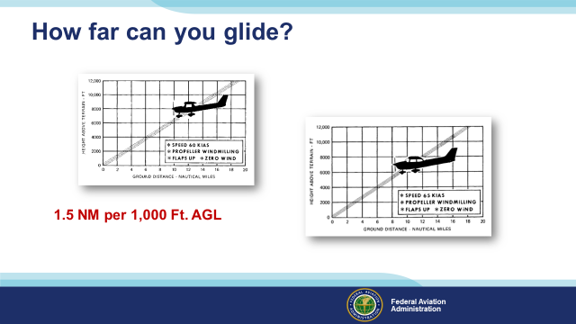 | Slide 12  How many miles you can glide per 1,000 feet of altitude is a very useful thing to know. A rule of thumb for Cessna 152s and 172s is 1.5 nautical miles per 1,000 feet of altitude AGL. Remember this is altitude above ground level – not sea level.  Consult your POH for best glide speed and distance information and experiment with your CFI to see how far you can glide in your airplane.  (Next Slide)
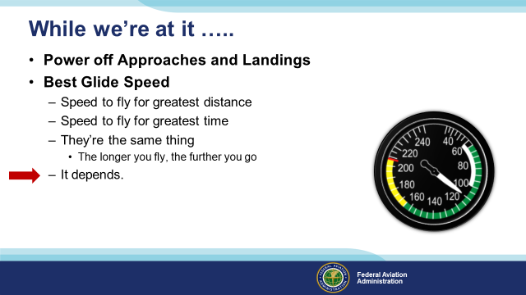 | Slide 13  While we’re at it, let’s briefly discuss power off approaches and landings (Click)  To ensure success in forced landings, we must be well acquainted with best glide speed. We’ll start with a definition. (Click)  Which of these statements is true with respect to best glide speed?  Presentation note: Ask the audience to comment then: (Click)  Well as so often is the case best glide speed depends on what you’re trying to do. Let’s look at some alternatives  (Next Slide)
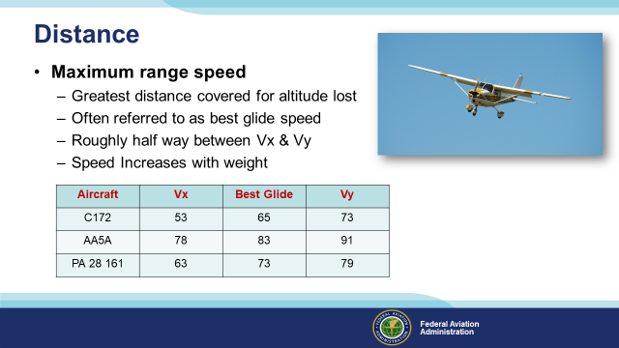 | Slide 14  If distance is what you want, you’ll need a speed and configuration that will get you the most distance forward for each increment of altitude lost. This speed is often referred to as best glide speed and, on most airplanes it’ll be roughly half way between Vx and Vy. The speed will increase with weight so most manufacturers will establish the best glide speed at gross weight for the aircraft. That means your best glide speed will be a little lower for lower aircraft weights.  Not all manufacturers publish a best glide speed but here’s a chart with examples from some who do.  (Next Slide)
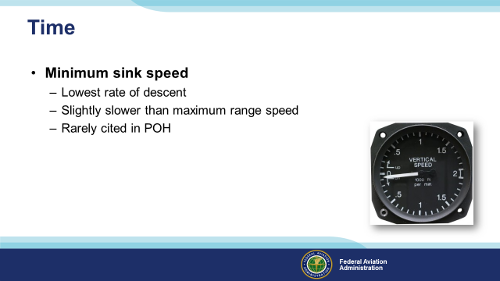 | Slide 15  If you’re looking to maximize your time in the air then Minimum Sink Speed is what you’ll need. It’s slightly slower than maximum range speed and rarely cited in the POH.  But you and your CFI can figure out what it is for your aircraft. We’ll get to how you do that next.  (Next Slide)
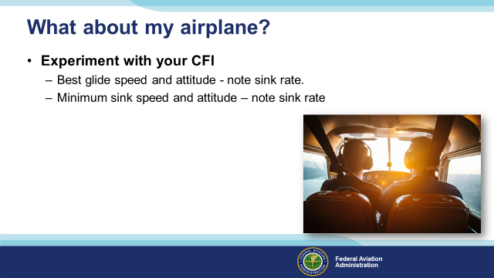 | Slide 16  If you’re wondering about the airplane you fly, you can do some experiments on a dual flight with your CFI. Start at Vy or manufacturer’s recommended best glide speed with power off – you did remember the carb heat didn’t you? – and note speed vs sink rate as you adjust pitch to reduce airspeed. For the most useful results, you should do this as close to typical mission weight as possible. Remember optimal glide speeds will be slower as aircraft weight decreases.  It’ll be easy to identify minimum sink speed. It’s the speed to fly for the lowest rate of descent. Maximum Glide Range speed will be a little higher than minimum sink. Here you’re looking for the highest speed forward for the lowest rate of descent.  Once you’ve identified minimum sink and maximum range glide speeds you’ve got a couple of good numbers to use for the future. The next big challenges are to know your height above the terrain and to glide the airplane to a point from which you can make a successful forced landing. Power off approaches and landings are the best ways to train for the main event.  It’s instructive to note that we’ve just been discussing emergency energy management. With power unavailable, we’re redistributing energy in our altitude account to maintain the optimum airspeed for our situation.  (Next Slide)
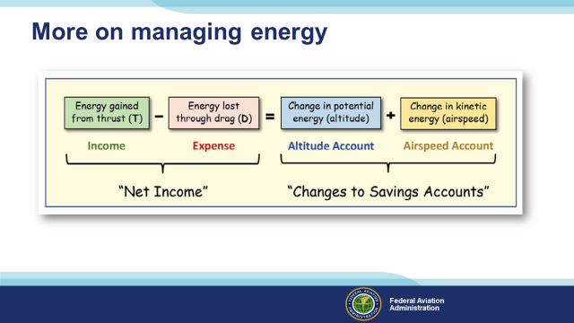 | Slide 17  To continue with the energy as money analogy; the left side of this energy balance equation would represent the airplane’s “net income,” while the right side would reflect matching changes to the airplane’s “savings accounts”.  Thus, the left side controls changes to the airplane’s total energy while the right side regulates the distribution of the resulting change in energy over altitude and airspeed.  A change in total energy resulting from the difference between thrust and drag always matches the change in total energy redistributed over altitude and airspeed.  (Next Slide)
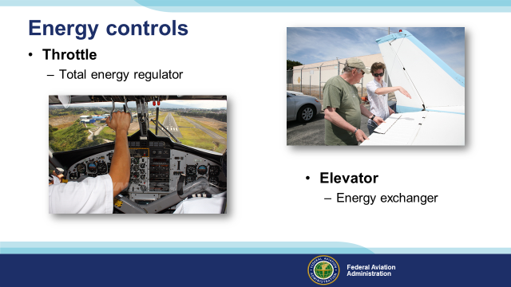 | Slide 18  Pilots manage energy through manipulation of flight controls.  The throttle regulates total energy… (Click)  And the elevator controls energy distribution to and from the airspeed and altitude accounts.  When you think about it, most of the aircraft we fly are equipped with sophisticated energy management instrumentation.  (Next Slide)
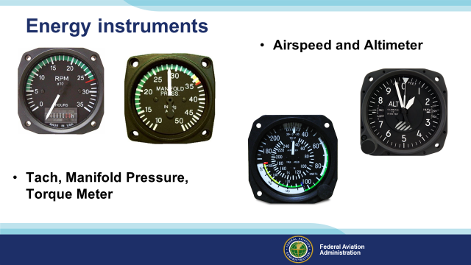 | Slide 19  Pilots can measure energy regulated by the throttle by referencing Tachometer, Manifold Pressure, and Torque meters.  And they can measure the exchange of energy, controlled by the elevator, by referencing airspeed indicators and altimeters.  (Next Slide)
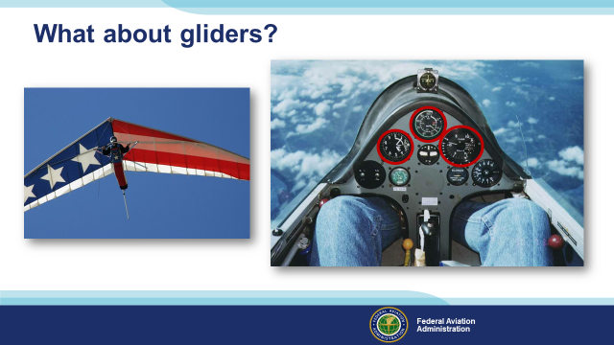 | Slide 20  Most gliders have instrumentation too. Airspeed Indicators and altimeters measure the balance in our airspeed and altitude accounts. (Click)  And rate of climb indicators, in many cases extremely sensitive instruments, measure power. Here we’re climbing at a constant airspeed and the ROC is indicating the amount of lift we’re enjoying. The energy in our altitude account can be tapped when we encounter areas of sink. (Click)  We said most gliders are instrument equipped but here’s a case where performance is measured solely by pilot observations.  (Next Slide)
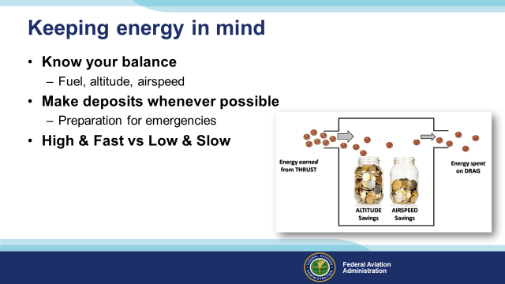 | Slide 21  Keeping your energy state in mind is a best practice for all pilots. (Click)  Knowing your energy account balance will inform your decision making – especially useful when coping with emergencies. (Click)  Make deposits to your energy accounts whenever possible. Like money in the bank, it’s great to know you can cover planned and unplanned expenses. (Click)  With plenty of altitude and airspeed you’re in the best position to cover emergency expenses. But if you’re slow and close to the ground, your forced landing options may be reduced to bracing for impact and landing straight ahead.  (Next Slide)
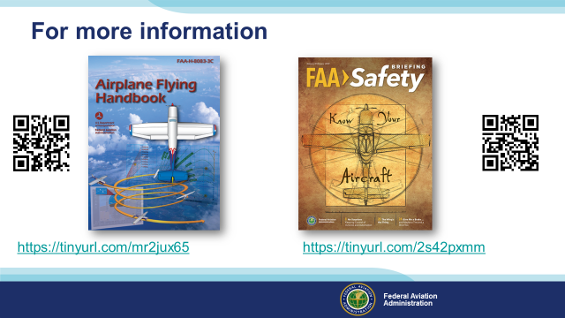 | Slide 22  For more information on energy management see FAA’s Airplane Flying Handbook Revision 3C, Chapter 4.  https://www.faa.gov/sites/faa.gov/files/regulations_policies/handbooks_manuals/aviation/airplane_handbook/00_afh_full.pdf  And “On the Money” – an article from FAA Safety Briefing January/February 2020 edition. https://express.adobe.com/page/RqrY13xKoY4wI/  (The End)
 | Slide 23  Presentation Note: You may wish to provide your contact information and main FSDO phone number here. Modify with your information or leave blank.  (Next Slide)
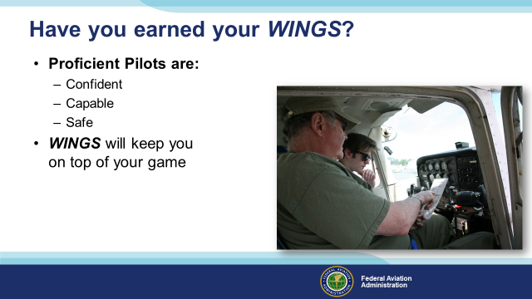 | Slide 24  Have you earned your WINGS? Proficiency is key to success in almost every thing worth doing – especially flying. Proficient pilots are confident, capable, and safe.  WINGS is a proficiency training system specifically designed for general aviation pilots and, regular participation will keep you on top of your flying game.  (Next Slide
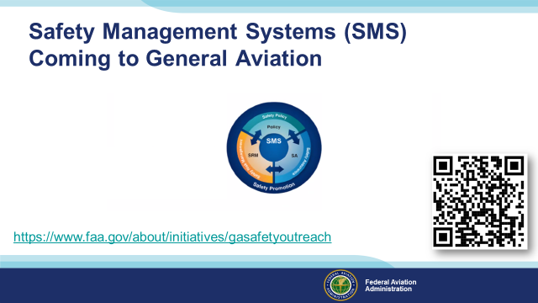 | Slide 25  Safety Management Systems are a set of policies and processes that can increase the safety and efficiency of any flight operation. And FAA is bringing SMS to General Aviation. You may have heard of SMS but thought it was only for large organizations but actually SMS can be scaled to fit any operation large or small.  There are 4 major components to a Safety Management System (Click)  Safety Policy – a documented commitment to safety that runs from the head of an organization to its newest member. (Click)  Safety Risk Management – a process that identifies hazards within an operation, determines to what extent an identified hazard may impact flight safety, and controls the risk of occurrence to an acceptable level. (Click)  Safety Assurance – By collecting and analyzing information derived from safety performance data Safety Assurance ensures the performance and effectiveness of Safety Risk Controls. (Click)  Safety Promotion communicates safety information and commitment throughout the organization. (Click)  You can find more information about Safety Management Systems at the URL on the Screen.  (Next Slide)
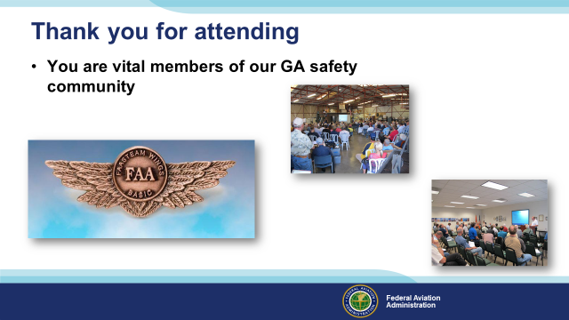 | Slide 26  Your presence here shows that you are vital members of our General Aviation Safety Community. The high standards you keep and the examples you set are a great credit to you and to GA.  Thank you for attending.  (Next Slide)
Slide 27
Your presence here shows that you are vital members of our General Aviation Safety Community. The high standards you keep and the examples you set are a great credit to you and to GA.
Thank you for attending.
(Next Slide)
Slide 28

(The End)

Appendix I – Equipment and Staging
Equipment:
- Projection Screen & Video Projector suitable for expected audience
  - Remote computer/projector control available at lectern or presenter location
    - In lieu of remote – detail a Rep to computer/projector control.
- Presentation Computer
  - Note: It is strongly suggested that the entire program reside on this computer.
- Back up Projector/Computer/Media as available.
- PA system suitable for expected audience
  - Microphones for Moderator and Panel
    - Optional Microphone (s) for audience
- Lectern (optional)
Staging:
- Arrange the projection screen for maximum visibility from the audience.
- Equip with PA microphones
- Place Lectern to one side of screen. This will be used by presenters and moderator

IMPORTANT – Once you have completed outreach on this topic, please help us track the outreach you have done by entering a SAS record.


