Preflight After Maintenance
Abstract: Lasting 15 to 20 minutes, this presentation acquaints the audience with: Taking special care during the preflight immediately following maintenance on an aircraft.
Format: Information Briefing - Power Point presentation
Required Personnel – FAASTeam Program Manager or designated FAASTeam Rep (s)
Optional Personnel – A&P’s or A&P with IA who can speak on past experiences of the first flight after maintenance when something wasn’t right.
AFS 850 Support:
In addition to this guidance document, a Power Point presentation that supports the program is provided. FPMs and presenters are encouraged to customize this presentation to reflect each individual program.
Appendix I – Equipment and Staging
Equipment:
- Projection Screen & Video Projector suitable for expected audience
  - Remote computer/projector control available at lectern or presenter location
    - In lieu of remote – detail a Rep to computer/projector control.
- Presentation Computer
  - Note: It is strongly suggested that the entire program reside on this computer.
- Back up Projector/Computer/Media as available.
- PA system suitable for expected audience
  - Microphones for Moderator and Panel
    - Optional Microphone (s) for audience
- Lectern (optional)
Staging:
- Arrange the projection screen for maximum visibility from the audience.
- Equip with PA microphones
- Place Lectern to one side of screen. This will be used by presenters and moderator

Slides | Script
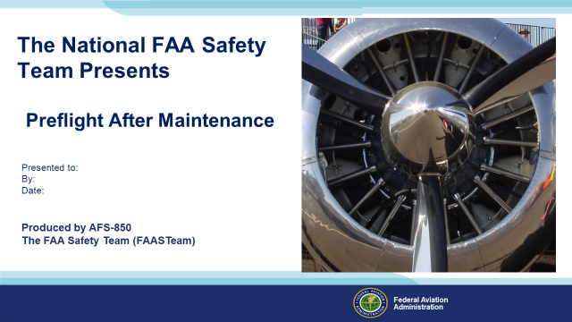 | Slide 1  2020/06-30-193(I)PP Original Author: Ken Kelley (05/08/2020); POC Guy Minor, AFS-850 Airworthiness Lead  Presentation Note: This is the title slide for Preflight After Maintenance.  - Script - We have included a script of suggested dialog with most slides. The script will always appear in a non-italic font. Presenters may read the script or modify it to suit their own presentation style. See template slides 5 and 6 for examples of a slides with script.  - Presentation Instructions - (stage direction and presentation suggestions) will be preceded by a Bold header: the instructions themselves will be in Italic fonts. See slides 2, 3, and 4 for examples of slides with Presentation Instructions only.  - Program control instructions - will be in bold fonts and look like this: (Click) for building information within a slide; or this: (Next Slide) for slide advance.  - Background information - Some slides may contain background information that supports the concepts presented in the program.  Background information will always appear last and will be preceded by a bold Background: identification.  The production team hope you and your audience will enjoy the show. Break a leg!  (Next Slide)
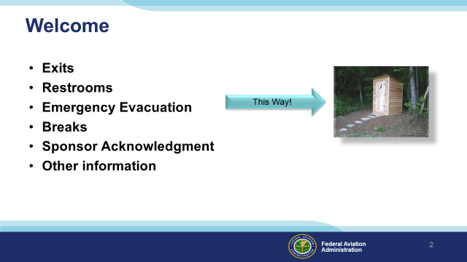 | Slide 2  Presentation Note: Here’s where you can discuss venue logistics, acknowledge sponsors, and deliver other information you want your audience to know in the beginning.  You can add slides after this one to fit your situation. (Next Slide)
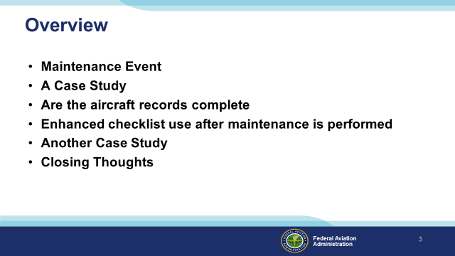 | Slide 3  Script - In this presentation we’ll look at an incident caused by a mechanic’s mistake, which then was exacerbated by a pilot not noticing that a flight control was operating in reverse, during preflight after maintenance. We’ll discuss things to consider adding to your normal checklists after maintenance, as well as the suggestion that you need to pay VERY close attention when preparing to fly for the first time after an annual inspection.  We’ll close with an accident that resulted from a pilot’s less than thorough preflight and starting procedure, due to a mechanic likely putting the fuel selectors in the aircraft in a position different from where the pilot normally left them.  (Next Slide)
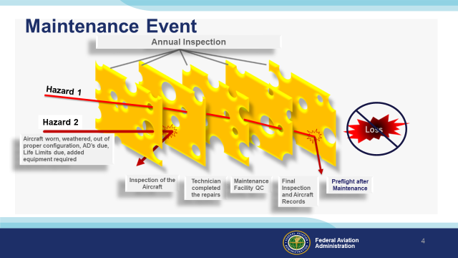 | Slide 4  Script: During any maintenance event on your aircraft, there are hazards to safe flight that appear (as noted by the red arrows), these usually include the reason for the maintenance and then the maintenance action itself. There are defenses to the hazard as noted along the bottom of the illustration. Aircraft loss and personal loss can be averted along any one of the barriers, but notice that the last barrier of defense is your Preflight after Maintenance.  (Next Slide)
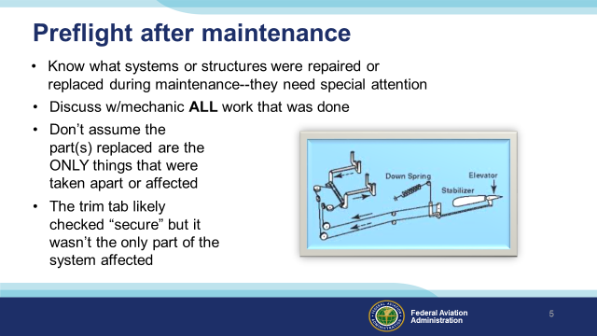 | Slide 5  Presentation Instructions: Don’t overlook the text on the slide, the bullet points are quite important.  Script:  - Know what systems or structures were repaired or replace during maintenance. Click  - Discuss all work that was done with the mechanic(s). Click  - Don’t assume the part(s) replaced are the only parts removed. Often disassembly needs to be done to get to the inoperative part. Click  - The trim tab likely checked “secure” but wasn’t the only part of the system affected. Click  Example: In this example, the trim tab was, in fact, replaced as part of the maintenance on this aircraft. However, the trim system itself was mis-rigged internally, causing the problem that could easily have caused an accident with injuries or worse.  In many cases, seemingly unrelated external parts, or more importantly, internal parts, must be disassembled to perform inspections, repairs, or replacements. During the first preflight after maintenance, and for several flights thereafter, it is a good practice to check that things function and look correct.  (Next Slide)
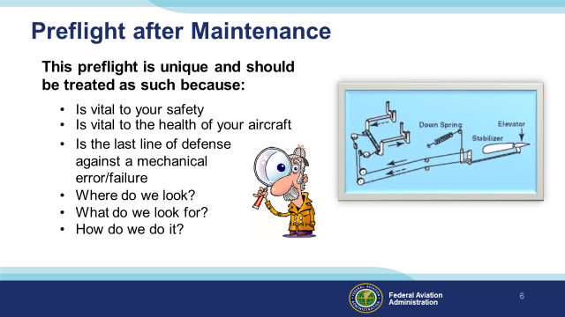 | Slide 6  Presentation Instructions: Don’t overlook the text on the slide, the bullet points are quite important.  Script: Learn all you can about the maintenance performed, pay attention to trim positions (there have been several exciting moments when the pilot discovered, (right after the aircraft lifted off) that one of the trims were left in a position he/she wasn’t expecting. If work was done directly on the trim system, make sure the deflections go in the proper direction!  (Next Slide)
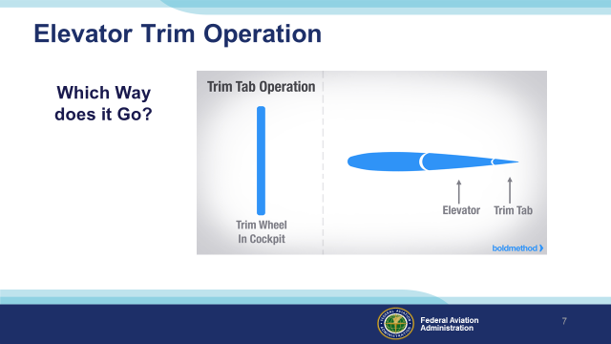 | Slide 7  Presentation Instructions: Allow the animations to run while you discuss the slide.  Script: Fully understand which way the trim tab need to travel when trim input is given to the control. Make sure it moves the correct direction!!!  (Next Slide)
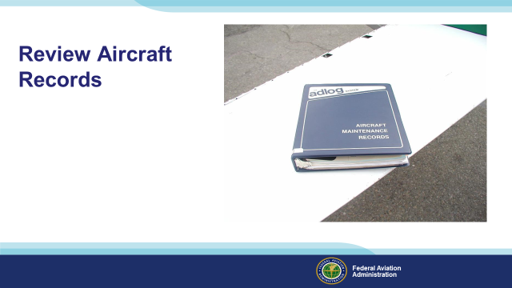 | Slide 8  Script: Always check your log book and paperwork after the aircraft comes out of maintenance and prior to flight to ensure the correct records have been entered. If the records aren’t completed, it isn’t legal to fly it. Look over the records to determine what areas of the aircraft had maintenance performed on it.  (Next Slide)
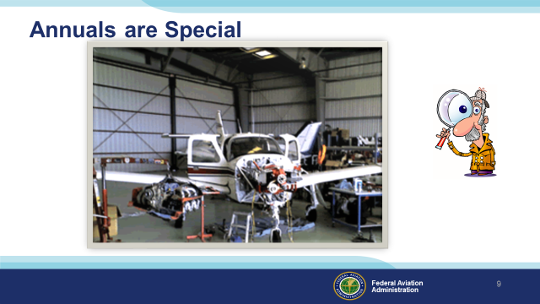 | Slide 9  Script: Annual inspections, and 100-hour inspections, often require opening up the entire aircraft. Click  If you have not participated in one, or at least watched one being performed, it is recommended that you do so. Afterward, you will never perform an ‘enhanced preflight’ after maintenance the same way again!! Click  There are so many ways the aircraft can be put back together incorrectly, or something can come loose very soon after return to service. Click  Another idea: Use your senses, and a notepad, to write down ANYTHING you sense is not right. LISTEN to the airplane (not just the engine!). Do you SMELL anything abnormal? Fuel? Oil? Does it vibrate more than usual (FEEL)? Do you TASTE (or smell for that matter) any of that acrid smoke that comes with burning electrical items? Does anything LOOK out of place? Click  Regarding this last item, now is the THE time to take steps back, away from the airplane, and just look at it. Something that might be overlooked,when we are close to it, jumps out at us when we’re 10-15 feet back.  (Next Slide)
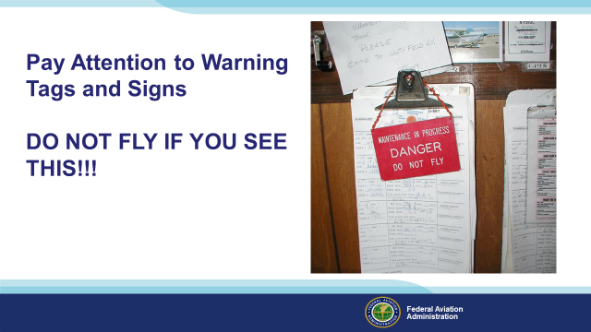 | Slide 10  Script: If you see a warning tag or sign on the aircraft sign out clip board, status board or on the aircraft itself. DO NOT FLY THE AIRCRAFT!!! Check with the maintenance facility prior to taking the aircraft if it was supposed to be ready for flight. It is possible the aircraft work was not completed when expected.  This is a real-life experience…this tag was on the clipboard for the aircraft because the aircraft wasn’t ready to fly. Early in the morning prior to the shop opening, the owner came to fly the aircraft. He apparently conducted a perfunctory preflight, and did not notice; no cotter key in the axle nut, no safety wire on the break caliper, a gap between the brake cylinder and backing plate.  A bad experience waiting for a place to happen.  (Next Slide)
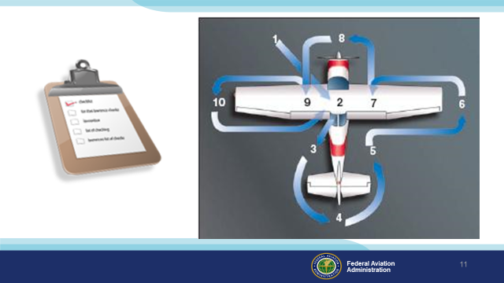 | Slide 11  Script: Performing a thorough preflight after maintenance will help ensure your flight is both safe and enjoyable. Start with your preflight checklist, then enhance the visual/tactile inspection.  (Next Slide)
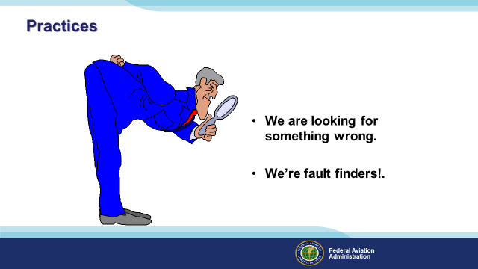 | Slide 12  Script: You should say to yourself During the preflight:  “We’re fault finders. We don’t just look for things to be right, we look for something wrong, don’t we?  For example: Is the ‘B’ nut loose? Is safety wire loose or backward?? Are there any rags laying around?  To put yourself in the right mindset, you need to (graciously) assume that there is something wrong, even if you used the best mechanic in the universe. mindset. If you assume that all is right, you’ll miss the mistakes, worn items, miss-rigging or whatever else might be wrong.  Remember, it’s your life and well-being in the aircraft.  (Next Slide)
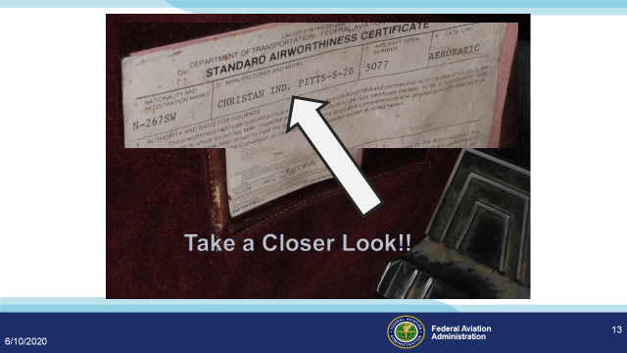 | Slide 13  Presentation Note: Animation is automatic.  Script: Depending on the type of maintenance or inspections that were performed on your aircraft it may have been necessary to remove the airworthiness certificate and registration to validate that those documents are current and accurate. Always ensure you have the correct documents on board.  In this case the Airworthiness Certificate is for a different aircraft (You are looking in a Cessna 172, the Airworthiness Certificate is for a Christian Ind. Pitts-S-2B).  (Next Slide)
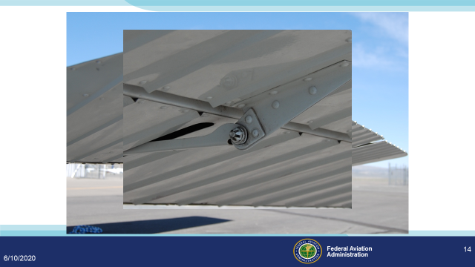 | Slide 14  Presentation Note: Animation is automatic.  Script: Inspect all control fasteners for missing cotter pins. A missing cotter pin can cause the nut to loosen and fall off. Once the bolt falls out the control surface or trim tab can move without pilot input or it can flutter sometimes causing catastrophic results.  (Next Slide)
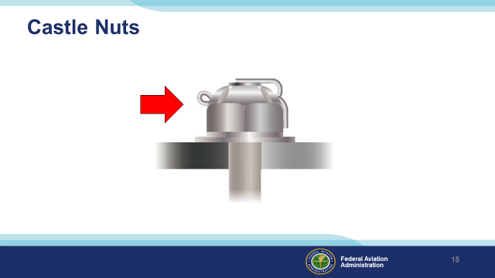 | Slide 15  Presentation Note:  Castle Nuts require a cotter pin to lock them.  (Next Slide)
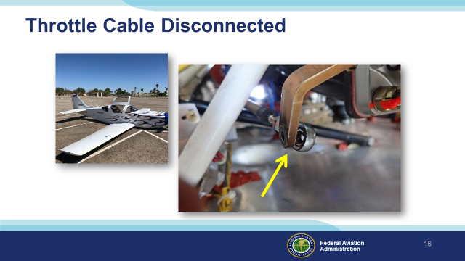 | Slide 16  Presentation Note:  WPR18LA250, August 27, 2018 About 37 minutes into the flight, the pilot noticed that the engine manifold pressure was dropping, along with the airplane's airspeed, consistent with a partial loss of engine power. The engine then experienced a total loss of power while he was maneuvering for an emergency landing to a nearby airport.  Post accident examination of the engine revealed that the throttle linkage had detached from the throttle arm of the fuel injection servo. The rod end bearing for the linkage and the throttle arm were intact and undamaged, but the connecting bolt and its associated washers, castellated nut, and cotter pin were missing. It is likely that the bolt securing the linkage had not been sufficiently tightened and secured with a cotter pin during the installation.  (Next Slide)
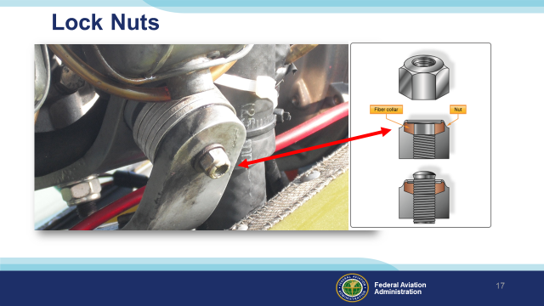 | Slide 17  Script: This isn’t safety wire, but it is another issue that might cause you to ask a question. See how the locking fiber is not contacting the bolt?  Background:  AC 43.13 will say: After the nut has been tightened, make sure the rounded or chamfered end of the bolts, studs, or screws extends at least the full round or chamfer through the nut. Flat end bolts, studs, or screws should extend at least 1⁄32 inch through the nut.  (Next Slide)
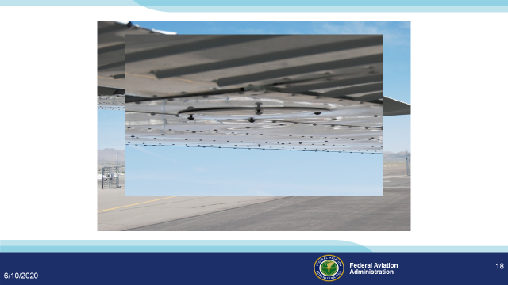 | Slide 18  Presentation Note: Animation is automatic.  Script: Always make sure all inspection panels are secure and their fasteners are tight.  (Next Slide)
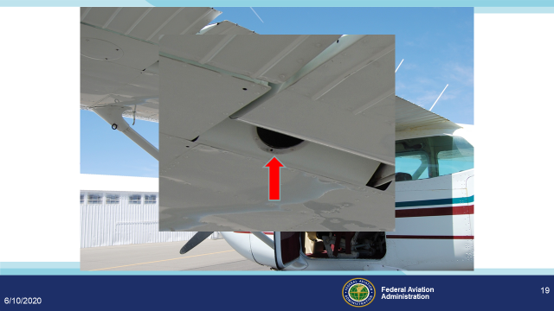 | Slide 19  Presentation Note: Animation is automatic.  Script: Make sure all panels are installed and secured prior to flight. This will be most important after the aircraft comes out of maintenance.  (Next Slide)
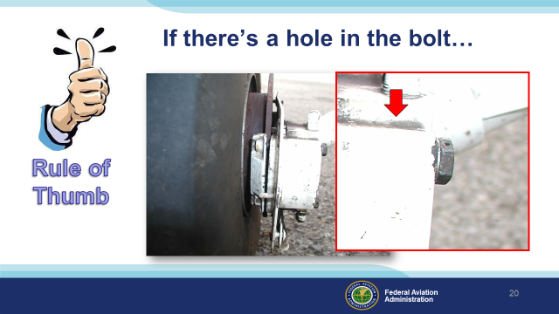 | Slide 20  Script: Always look over any part of the aircraft that has maintenance performed on it. Sometimes parts are loosely assembled in order to move the aircraft and keep all the parts with the aircraft. Check all visible bolts and if they have a hole in the bolt head there should be safety wire in it.  (Next Slide)
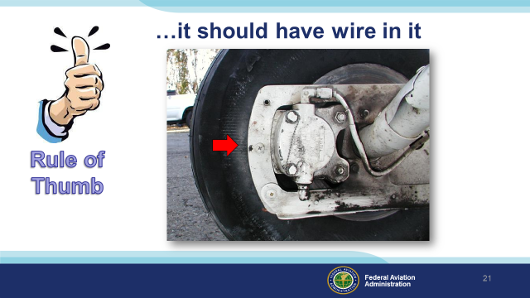 | Slide 21  Script: It should have wire in it like this one. If it doesn’t it is time to ask the rational question, “Why isn’t this bolt safety wired?” There could be good reason, or it could be the maintenance is not finished.  (Next Slide)
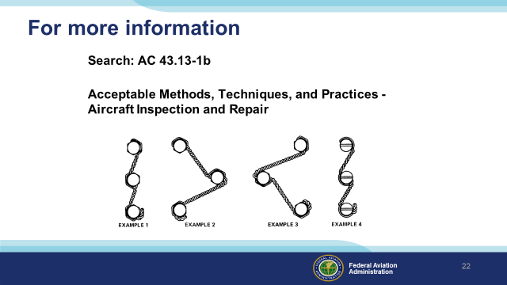 | Slide 22  Script:  For more information on aircraft fastener safety search AC43.13-1b. AC 43.13-1b is free online and in section seven you will find the definitive reference for aircraft fastener safety.  (Next Slide)
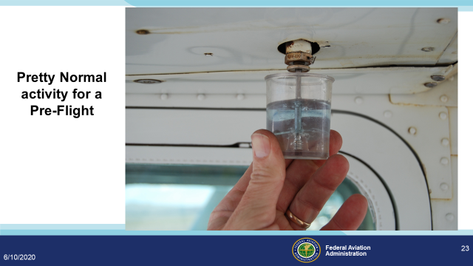 | Slide 23  Script: Let’s say your aircraft went into maintenance for a faulty radio issue. Parts had to be ordered and shop space was needed for another job so your aircraft was towed to the ramp and tied down until the parts arrive. After a week of sitting outside and weathering a few downpours the work was completed on your aircraft and you picked it up at the maintenance facility. The POH states in the preflight section that you should do the following:  Before the first flight of the day and after each refueling, use sampler  cup and drain small quantity of fuel from fuel tank sump quick drain  valve to check for water, sediment and proper fuel grade.  This is a very important task that never be overlooked prior to flight. Especially after the aircraft has been in the weather.  (Next Slide)
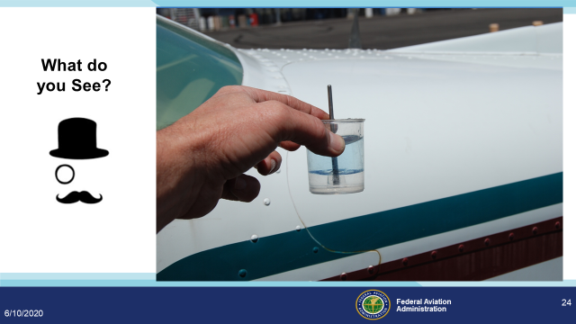 | Slide 24  Script: Let’s say your aircraft went into maintenance for a faulty radio issue. Parts had to be ordered and shop space was needed for another job so your aircraft was towed to the ramp and tied down until the parts arrive. After a week of sitting outside and weathering a few downpours the work was completed on your aircraft and you picked it up at the maintenance facility. The POH states in the preflight section that you should do the following:  Before the first flight of the day and after each refueling, use sampler cup and drain small quantity of fuel from fuel tank sump quick drain valve to check for water, sediment and proper fuel grade.  This is a very important task that never be overlooked prior to flight. Especially after the aircraft has been in the weather.  First picture shows fuel sample. See anything here? (CLICK) Second picture shows fuel sample held up to the sky. Do you see anything in this picture? (CLICK) Third picture shows the same fuel sample held up against the white fuselage. Now what do you see? It is good practice to place the strainer cup in front of white background or lighter background to check for water. Holding it up to the blue sky or a blue background can make it more difficult to see water that is in the fuel.  Also before first flight of the day and after each refueling, pull out strainer drain knob for about four seconds to clear fuel strainer of possible water and sediment. Check strainer drain closed. If water is observed, the fuel system may contain additional water, and further draining of the system at the strainer, fuel tank sumps, and fuel selector valve drain plug will be necessary.  (Next Slide)
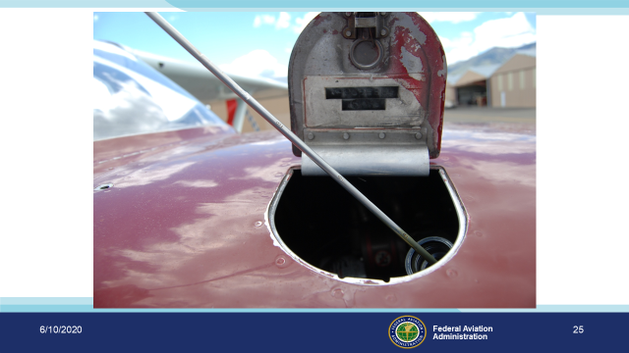 | Slide 25  Script: Engine Oil Level – ALWAYS CHECK the engine oil level to ensure it was serviced with the proper amount of oil after an oil change. Remember that most oil filters will take up to a quart of oil to fill it. Even though the maintenance facility may have added 8 quarts of oil the dipstick will only indicate a little over 7 in the sump after the run up. Most aircraft engines will tend to blow approximately a quart of oil overboard in a few flight hours. You may find that your particular engine likes to operate around 6-7 quarts indicated on the dip stick. Lycoming says do not operate with less than four quarts. Fill to six quarts for extended flight. Remember oil serves two purposes. One for lubrication and the other is for cooling of the engine.  (Next Slide)
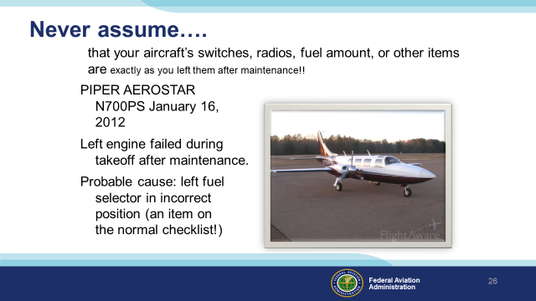 | Slide 26  Script: A mechanic had taxied the airplane out to the runway, done a full run up on both engines, with no issues found. He taxied the airplane to a fueling area, and 41.5 gallons was put in the fuselage tank. The mechanic then taxied the airplane to the ramp, and placed both fuel selectors in the ‘OFF’ position.  The pilot, who was killed, taxied out, apparently with no run up (!) and during takeoff, the left engine failed. Investigators concluded that the left engine quit due to fuel starvation. The left and right wing tanks had about 5 gallons of fuel in them (3 gallons are unusable in each). The pilot apparently did NOT change the fuel selectors to the fuselage tank, an item on the checklist for this aircraft.  Be careful about assuming that “Trims”, “Fuel Tank Selection”, etc. are where you think they are. This is not a unique situation.  Below is a link to the narrative regarding this accident:  Background: http://www.ntsb.gov/_layouts/ntsb.aviation/brief2.aspx?ev_id=20120116X53349&ntsbno=ERA12FA146&akey=1  (Next Slide)
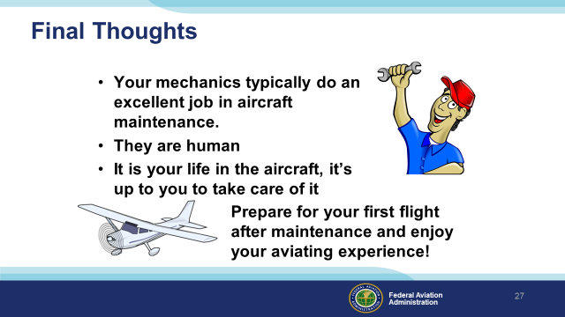 | Slide 27  Script:  - Your mechanics typically do an excellent job in aircraft maintenance. Click  - They are human Click  - It is your life in the aircraft, it’s up to you to take care of it Click  - Prepare for your first flight after maintenance and enjoy your aviating experience!  (Next Slide)
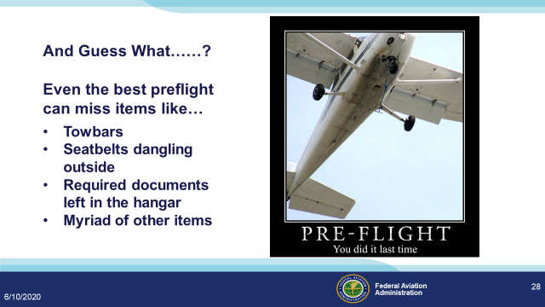 | Slide 28  Script: Don’t become the cause of a misadventure, make sure you have the tow bar, seatbelts, required documents, and anything else that is essential taken care of before you fly.  (Next Slide)
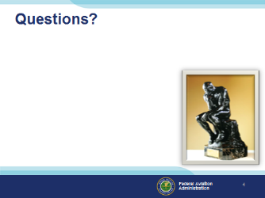 | Slide 29  Presentation Note: You may wish to provide your contact information and main FSDO phone number here. Modify with your information or leave blank.  (Next Slide)
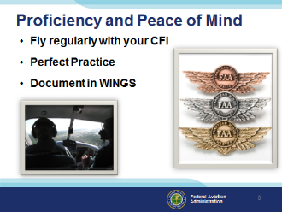 | Slide 30  There’s nothing like the feeling you get when you know you’re playing your A game and in order to do that you need a good coach (Click)  So fly regularly with a CFI who will challenge you to review what you know, explore new horizons, and to always do your best. Of course you’ll  have to dedicate time and money to your proficiency program but it’s well worth it for the peace of mind that comes with confidence. (Click)  Vince Lombardi, the famous football coach said, “Practice does not make perfect. Only perfect practice makes perfect.” For pilots that means  flying with precision. On course, on altitude, on speed all the time. (Click)  And be sure to document your achievement in the Wings Proficiency Program. It’s a great way to stay on top of your game and keep you flight review current.  (Next Slide)
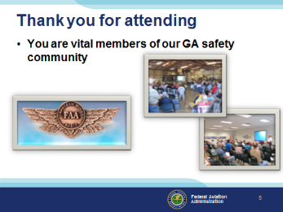 | Slide 31  Your presence here shows that you are vital members of our General Aviation Safety Community. The high standards you keep and the examples you set are a great credit to you and to GA.  Thank you for attending.  (Next Slide)
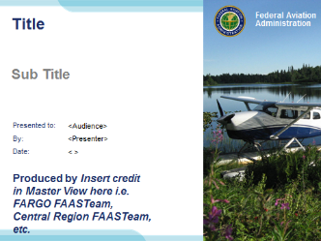 | Slide 32  (The End)

