Notes
Avoiding Adverse Drug Interactions
2020/10-04-176(I)PP
Outreach Guidance and Presentation Notes
This outreach guidance is provided to all FAA and aviation industry groups that are participating in outreach efforts sponsored by the General Aviation Joint Steering Committee (GAJSC). It is important that all outreach on a given topic is coordinated and is free of conflicts. Therefore, all outreach products should be in alignment with the outline and concepts listed below for this topic.
Outreach Month: October 2020

Topic: Avoiding Adverse Drug Interactions
The FAA and industry will conduct a public education campaign emphasizing dangers of interactions between multiple prescription and/or over-the-counter drugs.

Background:
Several studies published by the FAA Toxicology Laboratory on toxicology samples of deceased pilots indicated the presence of illicit drugs, and prescription or over-the counter medications in 42% of subjects tested. While NTSB and FAA have not necessarily cited drug or medication use as a causal factor in these accidents; the magnitude of these findings poses two questions. Have the drugs found in recent investigations, diminished pilots ability to safely conduct flight operations? Have the medical conditions requiring use of those drugs compromised pilots ability to fly safely? It may be impossible to say after the fact to what extent a drug compromised a pilot’s capability but it’s safe to say that a consultation with one’s Aviation Medical Examiner (AME) is a good idea before flying while using any drug.
The sometimes adverse reactions between prescribed and OTC drugs and between drugs and food, beverages, and dietary supplements is also cause for concern – particularly so because most pilots are not sufficiently knowledgable to predict these adverse reactions. AMEs are trained to identify possible adverse reactions and to recommend appropriate courses of action.
Teaching Points:
- 42% of pilots in fatal crashes had some sort of drug/medication in their systems during the flight.
- In the United States, 65% of visits to medical doctors result in the writing of a prescription.
- Some of these medications carry very specific warnings against operating machinery or motor vehicles or performing tasks requiring alertness. Flying certainly is included, even in a glider or hot-air balloon.
- Illicit drugs always impair human performance.
- Healthcare providers may prescribe drugs that could compromise pilot’s abilities – especially if the doctor is not aware that the patient is a pilot.
- Combinations of prescription and OTC medications can be particularly dangerous. Pilots should consult their AME before taking a combination of medications.
- Adverse reactions can also occur between prescribed or OTC medications and certain foods, beverages, and dietary supplements.
- AMEs are trained to advise pilots on negative and positive effects of drugs with respect to aviation.
- Pilots must truthfully report all medical conditions and drug use on their medical application forms and should consult their AME with respect to all medical conditions and drug use before flight.

Abstract: Lasting 10 to 15 minutes, this presentation acquaints the audience with the hazards associated with flying while taking combinations of prescription and/or over-the-counter (OTC) medications and with combining drugs with certain foods, food supplements, and beverages.
Format: Information Briefing - Power Point presentation
Required Personnel – FAASTeam Program Manager or designated FAASTeam Rep (s)
Optional Personnel – Medical Doctors, EMTs, Nurses, and Medical Workers who can speak on the hazards of flying while medicating.
AFS 850 Support:
In addition to this guidance document, a Power Point presentation that supports the program is provided. FPMs and presenters are encouraged to customize this presentation to reflect each individual program.

Presentation Notes
Slides | Script
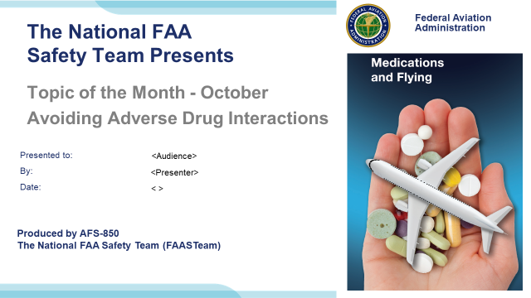 | Slide 1  2020/10-04-176(I)PP Original Author: John Steuernagle; POC Kevin Clover, AFS-850 Operations Lead, Office 562-888-2020  Presentation Note: This is the title slide for Avoiding Adverse Drug Interactions  - Script - We have included a script of suggested dialog with most slides. The script will always appear in a non-italic font. Presenters may read the script or modify it to suit their own presentation style. See template slides 5 and 6 for examples of a slides with script.  - Presentation Instructions - (stage direction and presentation suggestions) will be preceded by a Bold header: the instructions themselves will be in Italic fonts. See slides 2, 3, and 4 for examples of slides with Presentation Instructions only.  - Program control instructions - will be in bold fonts and look like this: (Click) for building information within a slide; or this: (Next Slide) for slide advance.  - Background information - Some slides may contain background information that supports the concepts presented in the program.  Background information will always appear last and will be preceded by a bold Background: identification.  The production team hope you and your audience will enjoy the show. Break a leg!  (Next Slide)
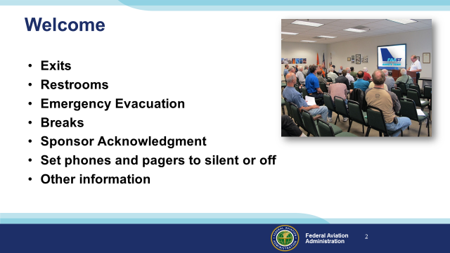 | Slide 2  Presentation Note: Here’s where you can discuss venue logistics, acknowledge sponsors, and deliver other information you want your audience to know in the beginning.  You can add slides after this one to fit your situation. (Next Slide)
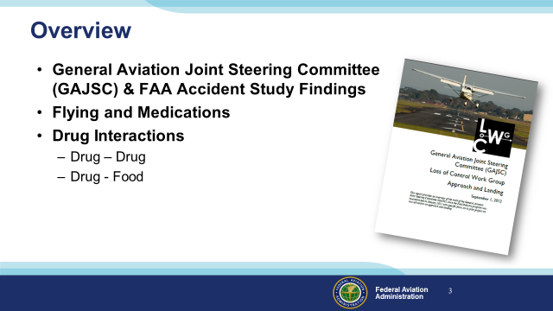 | Slide 3  In this presentation we’ll talk a little bit about a recent GAJSC and FAA studies that feature some interesting findings with respect to pilots and medications  We’ll talk generally about flying while medicating and specifically about drug interaction problems you may encounter when taking more than one drug. Or  when taking a drug with certain foods or alcohol.  Presentation Note: If you’ll be discussing additional items, add them to this list  (Next Slide)
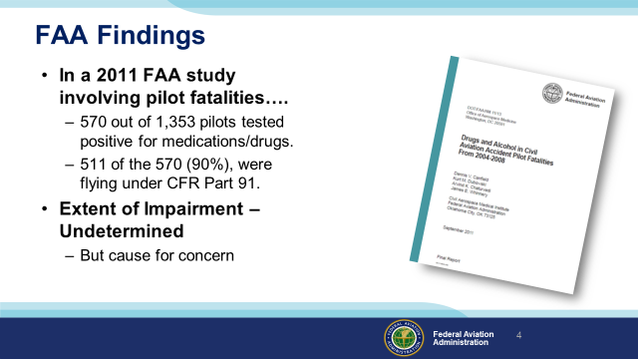 | Slide 4  In a 2011 study from the FAA’s CAMI Toxicology Lab drugs/medications were found in 570 pilots (42%) from 1,353 total fatal pilots tested. Most of the pilots with positive drug results, 511 (90%), were flying under CFR Part 91.”. (Click)  While there were some instances of recreational drugs, the majority were prescription or over the counter medications. Antihistamines were the most commonly found. Left undetermined was the extent of pilot impairment – if any – due to drug use but the issue is cause for concern for several reasons:  (Next Slide)
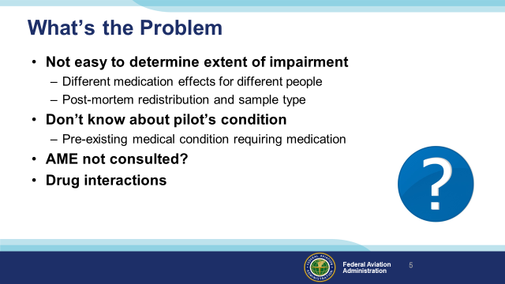 | Slide 5  So what’s the problem:  First of all – We all know that some medications may compromise a pilot’s ability to control the aircraft and/or adversely affect judgment and decision-making. (Click)  What’s not so obvious is it’s difficult for investigators to say for sure that pilot performance was compromised because the effect of drugs and medications varies widely among individuals. In addition, post-mortem redistribution of a substance creates some confusion as to the actual blood levels prior to the accident. The amount of a substance may vary considerably in different tissues. (Click)  A less obvious problem poses the question; what pre-existing physical condition requires the use of medication in the first place? (Click)  It’s not unusual to find that pilots are evaluated and treated for conditions that are not revealed to their Aviation Medical Examiners. In those cases an AME doesn’t have an opportunity to review the complete medical history of diagnoses and treatments for some of the pilots they examine. (Click)  There’s also the issue of drug interactions and that’s what we’re going to discuss today.  (Next Slide)
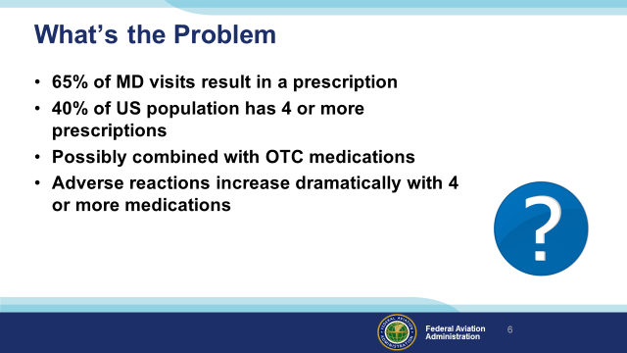 | Slide 6  In the United States, roughly 65% of all doctor visits result in a prescription. (Click)  and 40% of the United States population has 4 or more prescriptions. - (Click)  that may be combined with OTC medications. (Click)  The odds of an adverse reaction increase dramatically with 4 or more prescribed medications.  So how can pilots know which drugs in combination are likely to compromise safe flight?  (Next Slide)
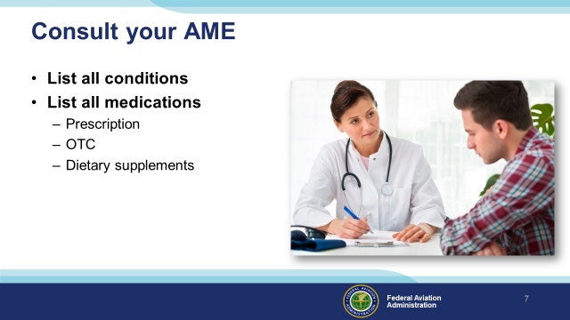 | Slide 7  Well before we go any further let’s just say that when it comes to potential drug interactions; we need to consult our AMEs  Aviation medical examiners are trained to look for potential drug interaction problems but they can’t help if they don’t have the complete picture.  So list all your medical conditions and the medications prescribed to treat them. And list any over-the-counter drugs you’re taking – even aspirin. (Click)  And finally, because dietary supplements can react adversely with some medications, tell your AME about them as well.  Armed with this information AMEs can advise their patients effectively.  (Next Slide)
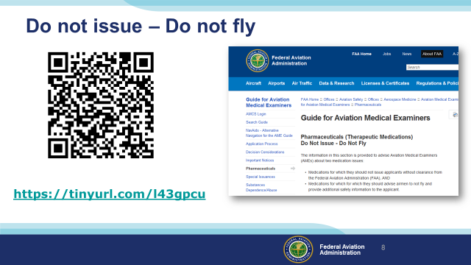 | Slide 8  You and your Aviation Medical Examiner can access lists of medications that preclude medical certificate issuance (Do not Issue) or medications that are not  compatible with safe flight operations (Do not Fly). Those lists are available at the website shown on the screen.  That’s the easy and obvious part. What’s not so easy or obvious is how drugs interact with other drugs and with food or alcohol. For that information we’ll have to dig a little deeper.  Presentation Note: You can access the Do not Issue – Do not Fly lists at this URL: https://www.faa.gov/about/office_org/headquarters_offices/avs/offices/aam/ame/guide/pharm/dni_dnf/  (Next Slide)
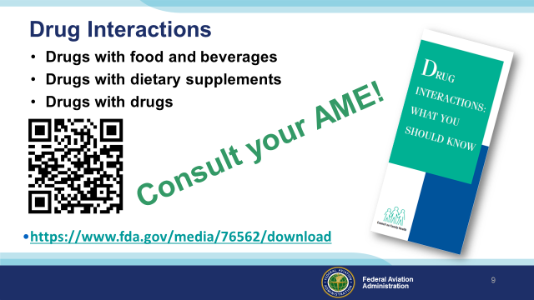 | Slide 9  When we speak of drug interactions, we’re talking about how prescription and OTC drugs interact with (Click)  What we eat and drink (Click)  Including products we use to supplement our diet (Click)  And how the drugs we’re taking react with each other.  The resource links on screen will take you to a handy pamphlet that will get you started on the topic.  But the pamphlet doesn’t address all the possible adverse interactions. For that evaluation you’ll need to……  Presentation note: Ask for input from the audience. You’re looking for, “Consult your AME”! When audience input has been received (Click)  That’s right – consult your AME!  There’s another thing you need to do. Any ideas as to what it is? It has to do with each prescribed and OTC medication you intend to use.  Presentation note: Ask for input from the audience. You’re looking for, “Read the label and product information for each medication” When audience input has been received advance to:  (Next Slide)
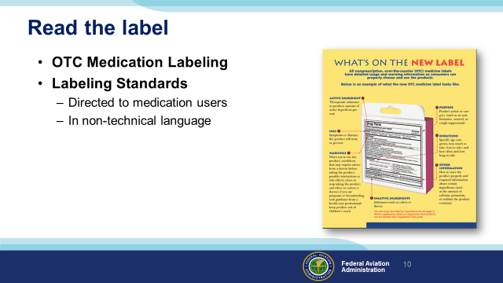 | Slide 10  Food and Drug Administration (FDA) OTC labeling requirements are directed to users so be sure to read the label before you medicate and fly.  (Next Slide)
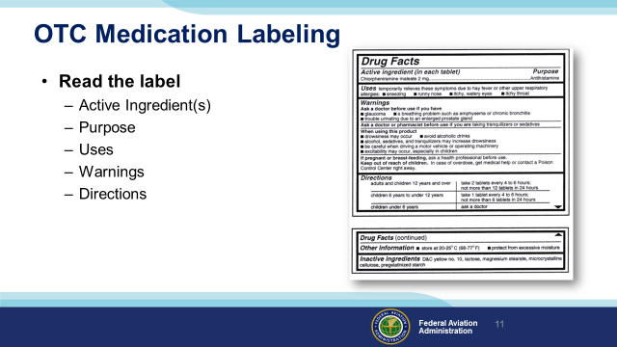 | Slide 11  The standard OTC Label will tell you the active ingredients, purpose, and uses for the drug as well as warnings and directions for use.  Note in this example we’re looking at an antihistamine that we might take to address cold symptoms.  Note the warnings of drowsiness and those associated with driving a motor vehicle or operating machinery. Do you think it would be safe to fly while using this drug? How long will it reside in your system? How soon would you be safe to fly after stopping the drug?  You won’t find the answers to any of those questions on the label. This might be a good time to consult your AME.  (Next Slide)
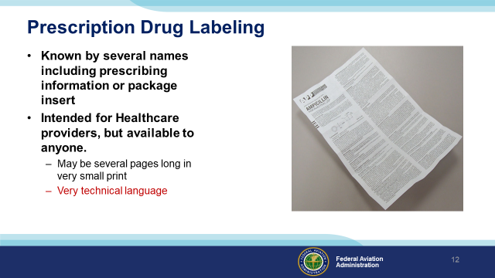 | Slide 12  Per Food and Drug Administration (FDA) the acceptable names are: prescribing information, package insert, professional labeling, direction circular, package circular  This information is intended for health professionals and is rarely given to the patient although it is readily available on line. Currently it consists of a document included in the medication box or attached to a container, but FDA is trying to change this to electronic format. Prescription drug labeling features highly detailed information in technical language; presented in a standard format.  (Next Slide)
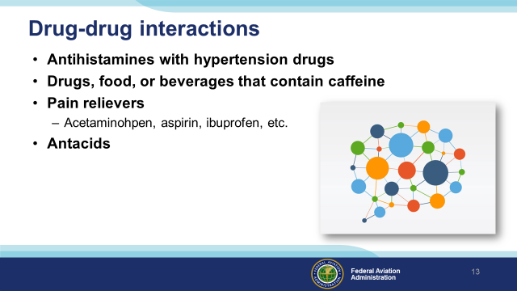 | Slide 13  Antihistamines can be prescribed and they are readily available over the counter. They are not recommended for flying and they can adversely react with some prescription drugs used to treat high blood pressure.  Drugs, food, or beverages that contain caffeine can react adversely with other drugs. The same is true for some pain relievers and antacids.  (Next Slide)
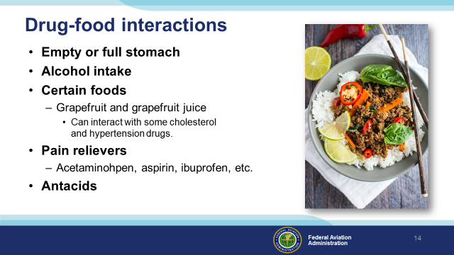 | Slide 14  Whether to take on an empty or full stomach has to do with drug absorption characteristics and possible adverse side effects such as nausea.  Alcohol intake may interfere with drug absorption or promote adverse reactions to the drug/alcohol combination. Many drugs are incompatible with alcohol.  Certain foods can increase or decrease concentration of some drugs. For instance, grapefruit and grapefruit juice can affect how well some medicines work and it may cause dangerous side effects.  Prescription and OTC pain relievers and Antacids may also react adversely with food.  (Next Slide)
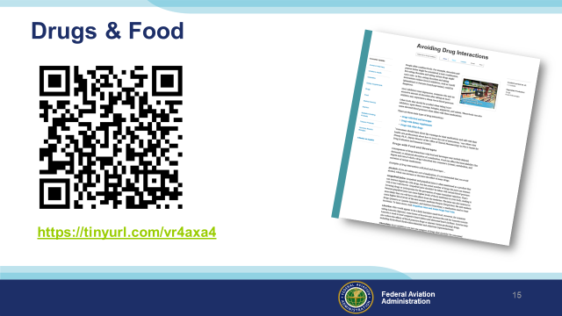 | Slide 15  Here’s a resource you can use to learn more about adverse food and drug reactions.  It describes some but by no means all, adverse drug and food interactions.  (Next Slide)  Presentation note: The tiny URL on the slide should work. In case it does not - here is the complete link to the Drug Interactions web page:  https://www.fda.gov/consumers/consumer-updates/avoiding-drug-interactions
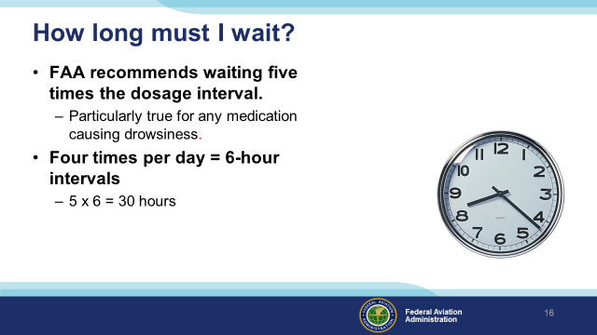 | Slide 16  If you’ve been taking a medication that precludes flying, how long must you wait after ceasing the medication before you return to the air? (Click)  This is a good question for your AME to answer but the general rule is to wait until 5 times the dosage interval has passed. (Click)  For example; if you take a medication 4 times a day (6-hour intervals) you should wait at least 30 hours before resuming pilot duties.  (Next Slide)
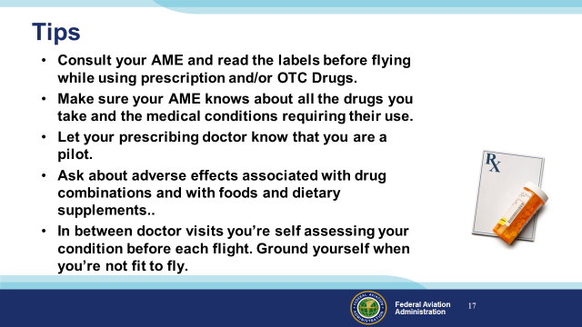 | Slide 17  Finally – here are some tips for safe flying while taking prescribed or OTC medications.  Consult your AME and read the labels before flying while using prescription and/or OTC Drugs.  Make sure your AME knows about all the drugs you take and the medical conditions requiring their use.  Let your prescribing doctor know that you are a pilot.  Ask about adverse effects associated with drug combinations and with foods and dietary supplements.  In between doctor visits you’re self assessing your condition before each flight. Ground yourself when you’re not fit to fly.  (Next Slide)
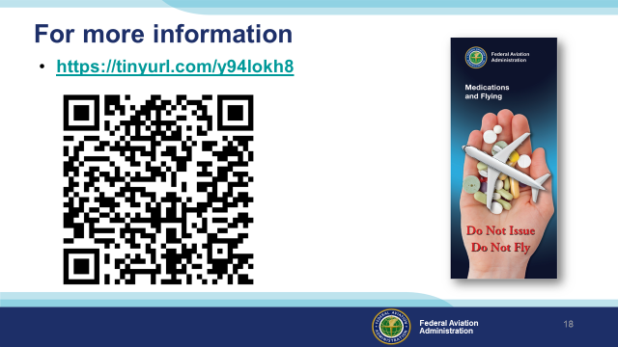 | Slide 18  Much of the information in this presentation was taken from FAA’s Medications and Flying Brochure. You can download a copy at the URL or QR code on the screen.  (Next Slide)
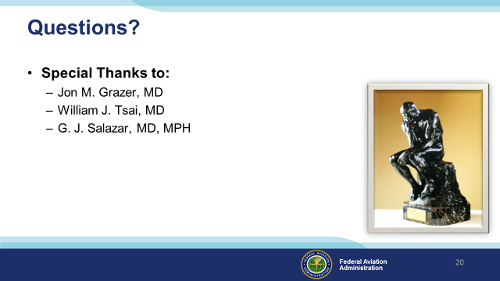 | Slide 19  Presentation Note: You may wish to provide your contact information and main FSDO phone number here. Modify with your information or leave blank.  (Next Slide)
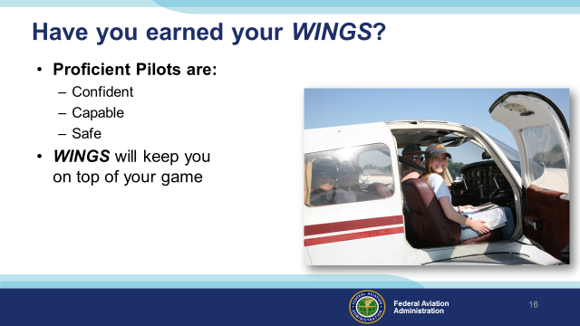 | Slide 20  Have you earned your WINGS? Proficiency is key to success in almost every thing worth doing – especially flying. Proficient pilots are confident, capable, and safe.  WINGS is a proficiency training system specifically designed for general aviation pilots and, regular participation will keep you on top of your flying game.  (Next Slide)
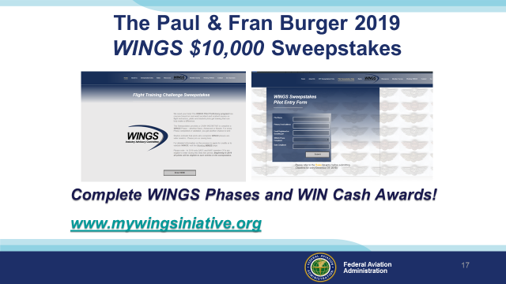 | Slide21  Now there’s even more reasons to participate in WINGS. Every time you complete a WINGS Phase you’re eligible to win cash the WINGS Sweepstakes.  The sweepstakes is generously funded by Paul Burger, a long time advocate for general aviation safety and a retired aviator who believes participation in this program saves lives. VISIT WWW.MYWINGSINIATIVE.ORG to learn more and enter the sweepstakes.  (Next Slide)
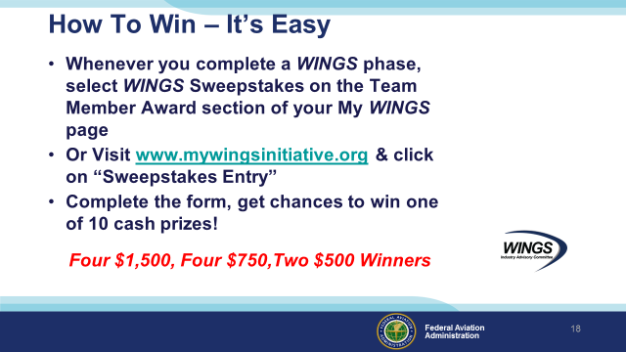 | Slide 22  After you’ve completed a phase of WINGS you can enter the sweepstakes by clicking on “Claim Rewards” in the “WINGS – at a glance” section of your My WINGS page and select WINGS Sweepstakes. Or you can go directly to the mywingsinitiative.org website.  (Next Slide)
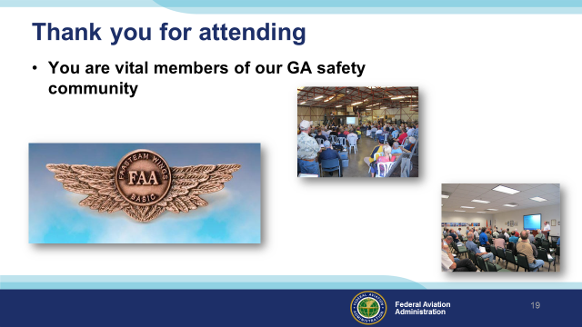 | Slide 23  Your presence here shows that you are vital members of our General Aviation Safety Community. The high standards you keep and the examples you set are a great credit to you and to GA.  Thank you for attending.  (Next Slide)
Slide 24

(The End)

Appendix I – Equipment and Staging
Equipment:
- Projection Screen & Video Projector suitable for expected audience
  - Remote computer/projector control available at lectern or presenter location
    - In lieu of remote – detail a Rep to computer/projector control.
- Presentation Computer
  - Note: It is strongly suggested that the entire program reside on this computer.
- Back up Projector/Computer/Media as available.
- PA system suitable for expected audience
  - Microphones for Moderator and Panel
    - Optional Microphone (s) for audience
- Lectern (optional)
Staging:
- Arrange the projection screen for maximum visibility from the audience.
- Equip with PA microphones
- Place Lectern to one side of screen. This will be used by presenters and moderator

References:
- Pilots and Medication Power Point
  - Available on the National FAASTeam Share Point site under Approved Presentations.
- Guide for Aviation Medical Examiners
  - Pharmaceuticals (Therapeutic Medications)
  - Do Not Issue – Do Not Fly
  - http://www.faa.gov/about/office_org/headquarters_offices/avs/offices/aam/ame/guide/pharm/dni_dnf/
- Medications and Flying
  - https://tinyurl.com/y94lokh8
- Avoid Food-Drug Interactions
  - https://www.fda.gov/consumers/consumer-updates/avoiding-drug-interactions
- Drug Interactions: What You Should Know
https://www.fda.gov/media/76562/download

IMPORTANT – Once you have completed outreach on this topic, please help us track the outreach you have done by entering a PTRS record.


