Presentation Notes
Aircraft Performance Monitoring 2020/11/27-179(I)PP

This outreach guidance is provided to all FAA and aviation industry groups that are participating in outreach efforts sponsored by the General Aviation Joint Steering Committee (GAJSC). It is important that all outreach on a given topic is coordinated and is free of conflicts. Therefore, all outreach products should be in alignment with the outline and concepts listed below for this topic.

Outreach Month: December 2020

Topic: Aircraft Performance Monitoring (SCF-SE-49)
The FAA and industry will conduct a public education campaign emphasizing the safety benefits of Aircraft Performance Monitoring

Background:

The General Aviation Steering Committee (GAJSC) System/Component Failure work group contends that unreasonable expectations with respect to aircraft performance have contributed to fatal GA accidents.. The GAJSC also feel that flight data monitoring can help to forecast system/component problems before they reach the point of failure.

Airlines have long been required to equip their aircraft with flight data and voice recorders. These were, in the beginning, rudimentary devices to record basic flight information. But now they have evolved to a plethora of sensors throughout the aircraft. Data from these sensors are recorded onboard or streamed to the ground where they undergo manual or automated analysis. Information derived from the data is very useful in maintenance planning and invaluable in accident investigation.

While it’s true that most GA aircraft don’t have dedicated automatic flight data recording devices now; we will be able to enjoy the benefits of equipage in the future. In the meantime it’s often surprising to see what we already have. Manufacturers are already offering self-contained flight data and visual data recorders for GA airplanes and helicopters.

Regardless of how they monitor performance, pilots continue to hold unreasonable expectations for their aircraft and themselves. Reasonable performance expectations based on realistic data result in safer flight operations.

Teaching Points:
- Discuss the hazards associated with unreasonable performance expectations
- Discuss the safety benefits of Flight Data Monitoring (FDM).
- Acquaint pilots with the availability of FDM hardware and software.
- Encourage pilots to adopt FDM processes.

References:
- Aircraft Performance and Performance Monitoring Power Point

- Flight Data Monitoring Systems and Non-Required Safety Enhancing Equipment

Abstract: Lasting 10 to 20 Minutes, this presentation acquaints the audience with the benefits of Aircraft Performance Monitoring in developing performance expectations and predicting aircraft component life limits.

Format: Informatin Briefing – Power Point presentation

Required Personnel: FAASTeam Program Manager or designated FAASTeam Rep (s)

Optional Personnel: Flight Instructor or others who can speak on CFIT

AFS 850 Support: In addition to this document, a Power Point presentation that supports the program is provided. FPMs and presentaers are encouraged to customize this presentation to reflect each individual program.

Slides | Script
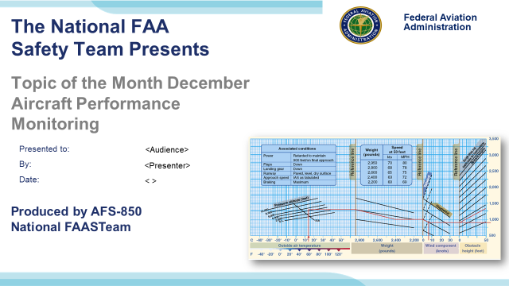 | Slide 1  2020/11/27-179(I)PP Original Author: J. Steuernagle July 2014 POC K CloverAFS-850 Operations Lead Office 562-888-2020 revised by J Steuernagle Nov 2019.  Presentation Note: This is the title slide for Avoiding Controlled Flight Into Terrain (CFIT) Accidents  - Script - We have included a script of suggested dialog with most slides. The script will always appear in a non-italic font. Presenters may read the script or modify it to suit their own presentation style. See template slides 5 and 6 for examples of a slides with script.  - Presentation Instructions - (stage direction and presentation suggestions) will be preceded by a Bold header: the instructions themselves will be in Italic fonts. See slides 2, 3, and 4 for examples of slides with Presentation Instructions only.  - Program control instructions - will be in bold fonts and look like this: (Click) for building information within a slide; or this: (Next Slide) for slide advance.  - Background information - Some slides may contain background information that supports the concepts presented in the program.  Background information will always appear last and will be preceded by a bold Background: identification.  The production team hope you and your audience will enjoy the show. Break a leg!  (Next Slide)
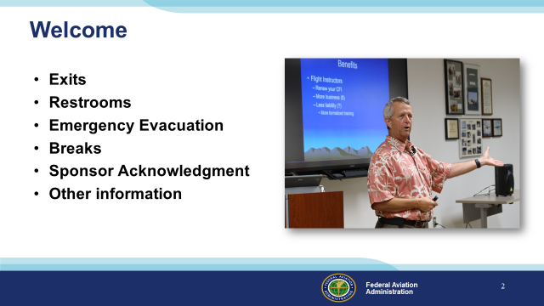 | Slide 2  Presentation Note: Here’s where you can discuss venue logistics, acknowledge sponsors, and deliver other information you want your audience to know in the beginning.  You can add slides after this one to fit your situation (Next Slide)
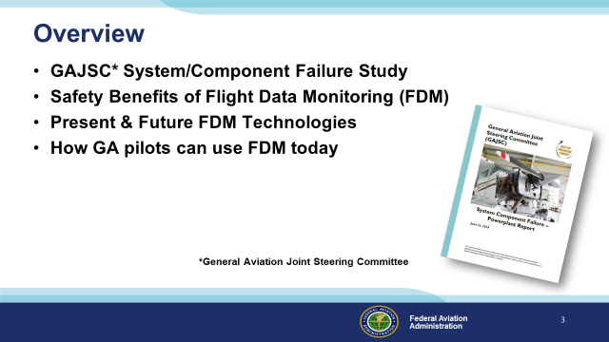 | Slide 3  Recently, the GAJSC System/Component Failure Work Group identified released Safety Enhancements dealing with Engine Maintenance and Flight Data Monitoring.  We want to take just a few minutes to talk about best practices for reciprocating engine maintenance and operation, and  the safety benefits of Flight Data Monitoring – a technology and process that’s now coming to General Aviation.  We’ll look at present & future FDM technologies, and we’ll talk about how to use FDM today.  Presentation Note: If you’ll be discussing additional items, add them to this list  (Next Slide)
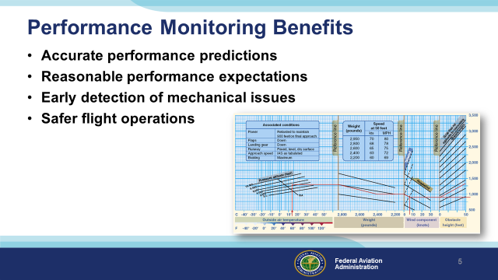 | Slide 4  The Pilots Operating Handbook will help you to predict your aircrafts’ performance but only by monitoring your personal performance can you know what to expect. Comparing your performance with the POH will enable you to develop accurate performance predictions and reasonable performance expectations.  Changes in aircraft performance can presage developing mechanical issues. Taken together that adds up to safer flight operations.  (Next Slide)
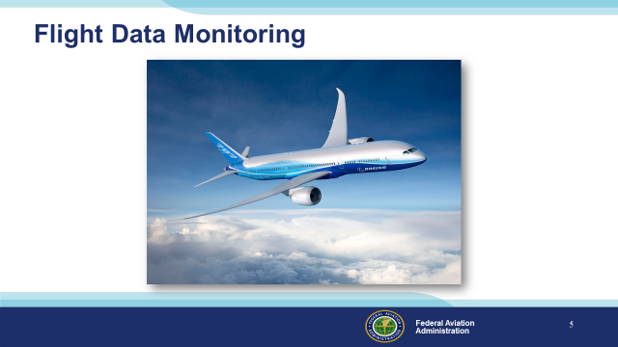 | Slide 5  Flight data monitoring has been around since before the jet age and modern airplanes make extensive use of the technology. Systems comprised of sensors, computer hardware, and software acquire and archive flight data for use in trend analysis and investigations of accidents and incidents.  (Next Slide)
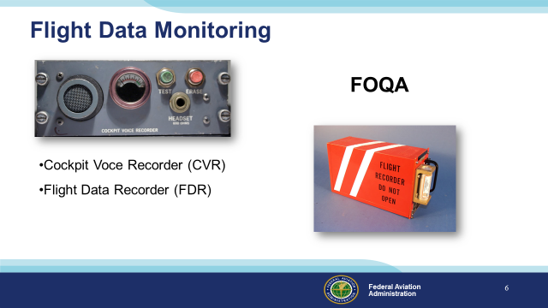 | Slide 6  While it’s true that most GA aircraft don’t have dedicated automatic flight data recording devices now; we will be able to enjoy the benefits of equipage in the future. In the meantime it’s often surprising to see what we already have. (Click)  Manufacturers are already offering self-contained flight data and visual data recorders for GA airplanes and helicopters. Most operators of this equipment must periodically down load and analyze the recorded data – often with the aid of dedicated computer programs.  (Next Slide)
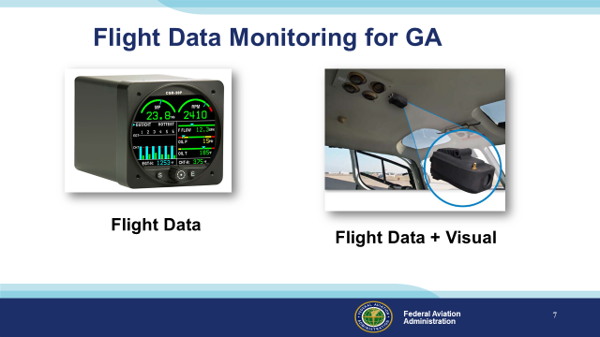 | Slide 7  While it’s true that most GA aircraft don’t have dedicated automatic flight data recording devices now; we will be able to enjoy the benefits of equipage in the future. In the meantime it’s often surprising to see what we already have. (Click)  Manufacturers are already offering self-contained flight data and visual data recorders for GA airplanes and helicopters. Most operators of this equipment must periodically down load and analyze the recorded data – often with the aid of dedicated computer programs.  (Next Slide)
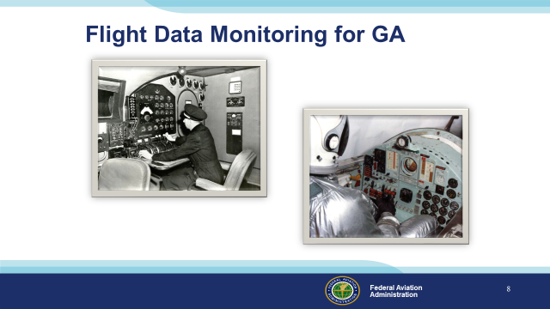 | Slide 8  Many data monitoring operations involve no automation at all. Flight engineers used to handle the monitoring and record keeping (Click)  And test pilots were expected to keep notes while flying.  (Next Slide)
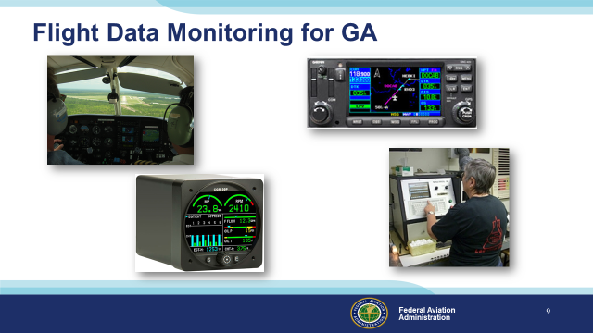 | Slide 9  GA pilots can do much the same thing by tracking engine power, fuel flow, oil temperature and pressure. Panel mounted GPS systems and many hand held units are already capable of recording position, heading, speed, and altitude. Some engine monitors have recording capability and many aircraft owners participate in oil analysis programs – a tool for gauging engine health and heading off expensive or, in some cases, disastrous problems. Some aircraft – particularly helicopters are equipped with metallic chip detectors that can forecast engine and transmission failures in time to make a safe landing.  (Next Slide)
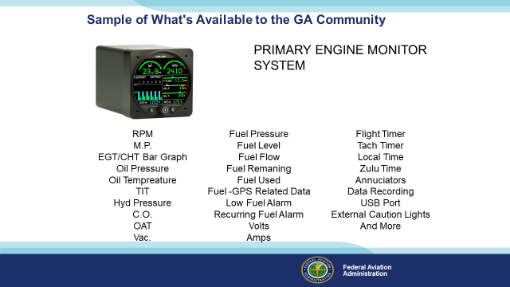 | Slide 10  Here’s just one example of the information available in one small box. This example doesn’t include recording capability but it’s certainly one-stop shopping for engine information.  (Next Slide)
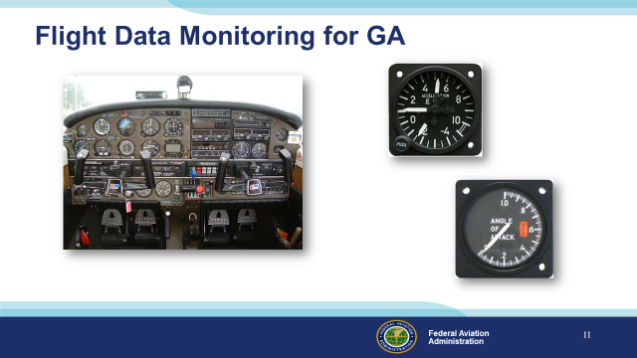 | Slide 11  And don’t forget basic instrumentation such as Air Speed Indicators, Attitude Indicators, Angle of Attack, Manifold Pressure, RPM, and G indicators – all of which give immediate feedback as to whether design limitations have or are about to be exceeded.  (Next Slide)
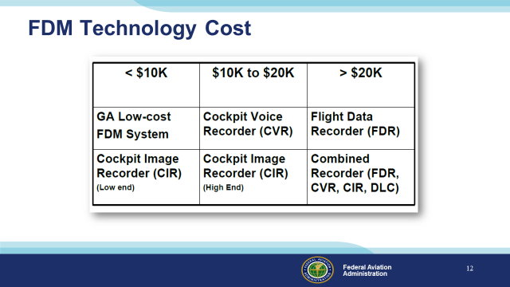 | Slide 12  At present GA FDM Technology ranges from a little less than $10,000.00 to more than $20,000.00 but as competition and equipage increase, prices are expected to fall.  (Next Slide)
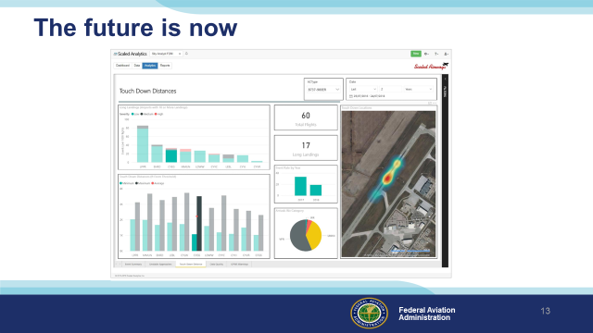 | Slide 13  We’re already seeing multi-sensor analysis programs on high-end GA aircraft. Here we see a graphic representation of landing performance by airport. With integrated performance, navigation, and route information almost anything is possible. In this case the aircraft operator can adjust Company Operations and Pilot Training programs to ensure safe landing  performance at each destination.  Documenting your landing performance manually can yield the same result. If you find you’re consistently landing long or short, you can adjust your approaches to land on the sweet spot.  (Next Slide)
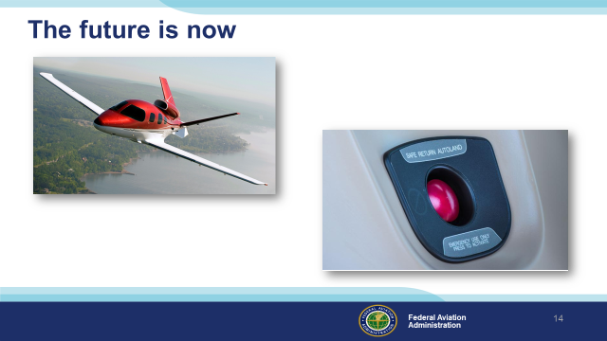 | Slide 14  It’s interesting to consider all of the flight data required to carry out a successful autonomous landing. Auto landing systems are already making their way into some GA aircraft now  and, over time, they’ll become available in lower-priced platforms. Those same data can be useful in refining your aircraft control right now. We are certainly in an age of innovation where information, technology, and pilot performance combine to make flying safer than ever before. Soon performance data will be automatically collected, processed, and made available to GA pilots.  (Next Slide)
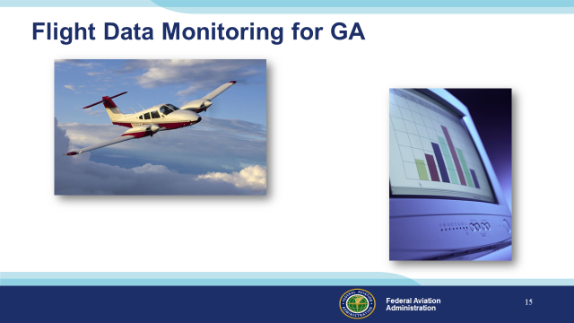 | Slide 15  In the meantime, we urge you to consider the information that’s already available on every flight.  (Next Slide)
Slide 16
Presentation Note: You may wish to provide your contact information and main FSDO phone number here. Modify with
Your information or leave blank.
(Next Slide)
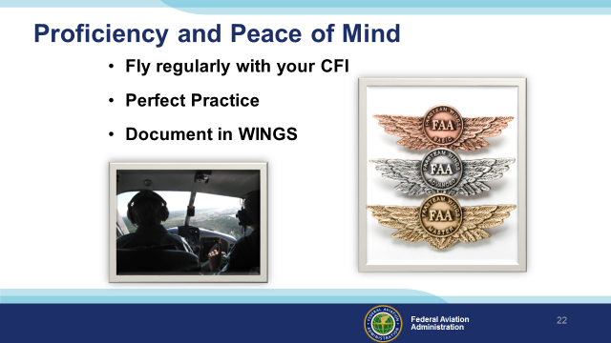 | Slide 17  There’s nothing like the feeling you get when you know you’re playing your A game and in order to do that you need a good coach (Click)  So fly regularly with a CFI who will challenge you to review what you know, explore new horizons, and to always do your best. Of course you’ll  have to dedicate time and money to your proficiency program but it’s well worth it for the peace of mind that comes with confidence. (Click)  Vince Lombardi, the famous football coach said, “Practice does not make perfect. Only perfect practice makes perfect.” For pilots that means  flying with precision. On course, on altitude, on speed all the time. (Click)  And be sure to document your achievement in the Wings Proficiency Program. It’s a great way to stay on top of your game and keep you flight review current.  (Next Slide)
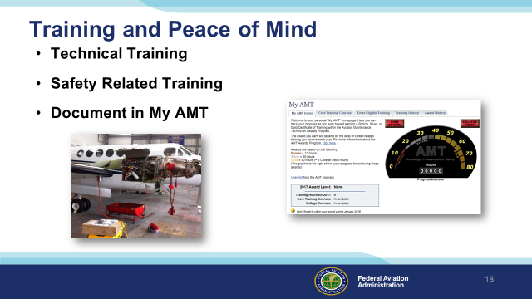 | Slide 18  The AMT Awards program encourages AMTs and employers to take advantage of initial and recurrent training by issuing awards based on training received in one calendar year.  The program has several levels, or phases, of recognition for both you and your employer. You can obtain an FAA Certificate of Training upon successful completion of the program requirements. Employers can obtain a Gold or Diamond Award of Excellence yearly depending on the percentage of their employees receiving awards.  Training earned toward an AMT Award falls into one of two categories; Mandatory Core Training and Eligible Training.  Mandatory Core Training is one or more on-line training courses, depending on FAA evaluation of training needs. The Core Training course(s) can be located and completed in the Aviation Learning Center at FAASafety.gov.  Eligible Training is the hourly training that can be credited toward an individual AMT Certificate of Training. This training must be aviation maintenance career related training.  Be sure to document your achievement in the AMT Awards Program. It’s a great way to stay on top of your game and keep stay proficient.  (Next Slide)
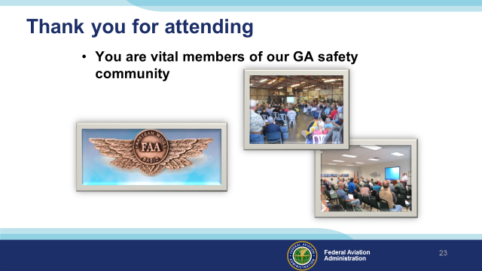 | Slide 19  Your presence here shows that you are vital members of our General Aviation Safety Community. The high standards you keep and the examples you set are a great credit to you and to GA.  Thank you for attending.  (Next Slide)
Slide 20

(The End)

Appendix I – Equipment and Staging
Equipment:
- Projection Screen & Video Projector suitable for expected audience
  - Remote computer/projector control available at lectern or presenter location
    - In lieu of remote – detail a Rep to computer/projector control.
- Presentation Computer
  - Note: It is strongly suggested that the entire program reside on this computer.
- Back up Projector/Computer/Media as available.
- PA system suitable for expected audience
  - Microphones for Moderator and Panel
    - Optional Microphone (s) for audience
- Lectern (optional)
Staging:
- Arrange the projection screen for maximum visibility from the audience.
- Equip with PA microphones
- Place Lectern to one side of screen. This will be used by presenters and moderator
- IMPORTANT – Once you have completed outreach on this topic, please help us track the outreach you have done by entering a PTRS record.

