Presentation Notes
Aircraft Performance Monitoring 2020/12-01-215(I)PP

This outreach guidance is provided to all FAA and aviation industry groups that are participating in outreach efforts sponsored by the General Aviation Joint Steering Committee (GAJSC). It is important that all outreach on a given topic is coordinated and is free of conflicts. Therefore, all outreach products should be in alignment with the outline and concepts listed below for this topic.

Outreach Month: December 2021

Topic: Engine Maintenance and Performance Monitoring (SCF-SE-49)
The FAA and industry will conduct a public education campaign emphasizing the safety benefits of Aircraft Performance Monitoring

Background:

The General Aviation Steering Committee (GAJSC) System/Component Failure work group contends that unreasonable expectations with respect to aircraft performance have contributed to fatal GA accidents.. The GAJSC also feel that flight data monitoring can help to forecast system/component problems before they reach the point of failure.

Airlines have long been required to equip their aircraft with flight data and voice recorders. These were, in the beginning, rudimentary devices to record basic flight information. But now they have evolved to a plethora of sensors throughout the aircraft. Data from these sensors are recorded onboard or streamed to the ground where they undergo manual or automated analysis. Information derived from the data is very useful in maintenance planning and invaluable in accident investigation.

While it’s true that most GA aircraft don’t have dedicated automatic flight data recording devices now; we will be able to enjoy the benefits of equipage in the future. In the meantime it’s often surprising to see what we already have. Manufacturers are already offering self-contained flight data and visual data recorders for GA airplanes and helicopters.

Regardless of how they monitor performance, pilots continue to hold unreasonable expectations for their aircraft and themselves. Reasonable performance expectations based on realistic data result in safer flight operations.

Teaching Points:
- Discuss the Pilot in Command responsibility for airworthiness determinations.
- Discuss the safety benefits of Flight Data Monitoring (FDM).
- Acquaint pilots with the availability of FDM hardware and software.
- Encourage pilots to adopt FDM processes.

References:
- FAA Safety Briefing (January/February 2016)

- Flight Data Monitoring Systems and Non-Required Safety Enhancing Equipment – GAJSC Safety Enhancements - Loss of Control

Abstract: Lasting 10 to 20 Minutes, this presentation acquaints the audience with the benefits of Aircraft Performance Monitoring in developing performance expectations and predicting aircraft component life limits.

Format: Information Briefing – Power Point presentation

Required Personnel: FAASTeam Program Manager or designated FAASTeam Rep (s)

Optional Personnel: Flight Instructor or others who can speak on Flight Data Monitoring.

AFS 850 Support: In addition to this document, a Power Point presentation that supports the program is provided. FPMs and presentaers are encouraged to customize this presentation to reflect each individual program.

Slides | Script
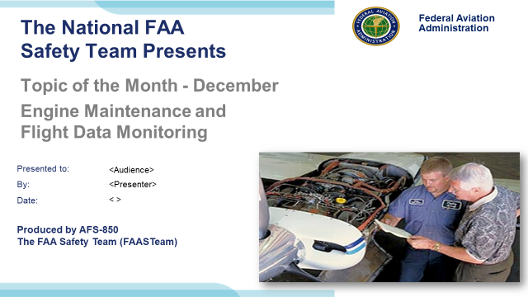 | Slide 1  2020/12-01-215(I)PP Original Author: J. Steuernagle December 2020 POC: K CloverAFS-850 Operations Lead Office 562-888-2020.  Presentation Note: This is the title slide for Avoiding Controlled Flight Into Terrain (CFIT) Accidents  - Script - We have included a script of suggested dialog with most slides. The script will always appear in a non-italic font. Presenters may read the script or modify it to suit their own presentation style. See template slides 5 and 6 for examples of a slides with script.  - Presentation Instructions - (stage direction and presentation suggestions) will be preceded by a Bold header: the instructions themselves will be in Italic fonts. See slides 2, for an example of slides with Presentation Instructions only.  - Program control instructions - will be in bold fonts and look like this: (Click) for building information within a slide; or this: (Next Slide) for slide advance.  - Background information - Some slides may contain background information that supports the concepts presented in the program.  Background information will always appear last and will be preceded by a bold Background: identification.  The production team hope you and your audience will enjoy the show. Break a leg!  (Next Slide)
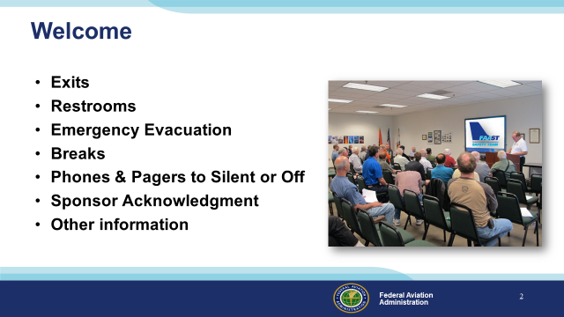 | Slide 2  Presentation Note: Here’s where you can discuss venue logistics, acknowledge sponsors, and deliver other information you want your audience to know in the beginning.  You can add slides after this one to fit your situation (Next Slide)
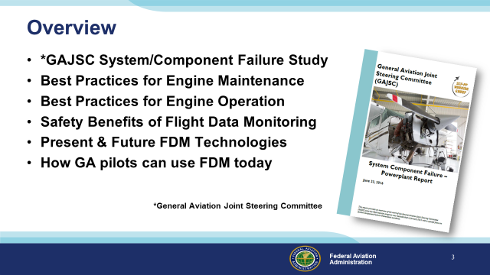 | Slide 3  Recently, the GAJSC System/Component Failure Work Group released Safety Enhancements dealing with Engine Maintenance and Flight Data Monitoring. The work group feels that  Flight Data Monitoring can help to identify emerging problems with aircraft systems and components and facilitate replacement or repair before failure.  We want to take just a few minutes to talk about best practices for reciprocating engine maintenance and operation, and  the safety benefits of Flight Data Monitoring – a technology and process that’s now coming to General Aviation.  We’ll look at present & future FDM technologies, and we’ll talk about how to use FDM today.  Presentation Note: If you’ll be discussing additional items, add them to this list  (Next Slide)
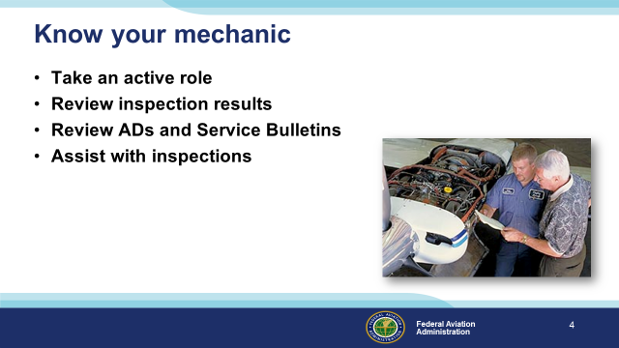 | Slide 4  Ideally, pilots and mechanics should work together to ensure that aircraft are operated and maintained properly. Pilots are encouraged to take  an active role in maintenance; reviewing inspection results and discussing Airworthiness Directives and Service Bulletins.  Assisting with inspections is a great way to get to know your mechanic and your aircraft but let’s face it, most of us don’t have the opportunity to so.  Still, as pilots we have extensive airworthiness responsibilities. Let’s take a look at why that’s so.  (Next Slide)
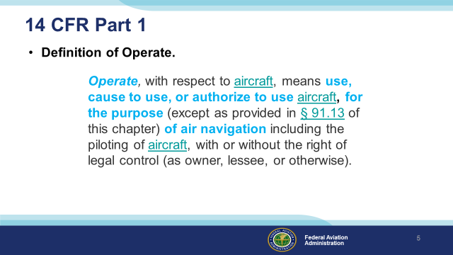 | Slide 5  We’ll begin with 14 CFR Part 1 – Definitions. To operate an aircraft means to use, cause to use or authorize an aircraft for the purpose of air navigation.  By the way 14CFR 91.13 has to deal with careless and/or reckless operation of aircraft. Interestingly, whether or not you have the legal right or permission to do so, piloting an aircraft is operating it and the importance of that is addressed in the next slide.  (Next Slide)
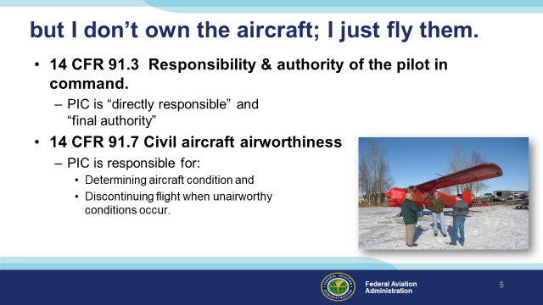 | Slide 6  A common misconception among renter pilots is that they are only responsible for the preflight walk around inspection and perhaps VOR and Navigational Data Base checks. Others are responsible for maintenance inspections, service bulletins, and AD Compliance. Well CFR 91.3 makes the Pilot in Command directly responsible for and the final authority as to the operation of an aircraft and CFR 91.7 specifically charges the PIC with determining the airworthiness of an aircraft before flight and for discontinuing flight when un-airworthy conditions occur.  That’s a tall order for a rental pilot and impossible to execute without some communication between aircraft maintainers and pilots. But before we talk about that, what does airworthy mean?  (Next Slide)
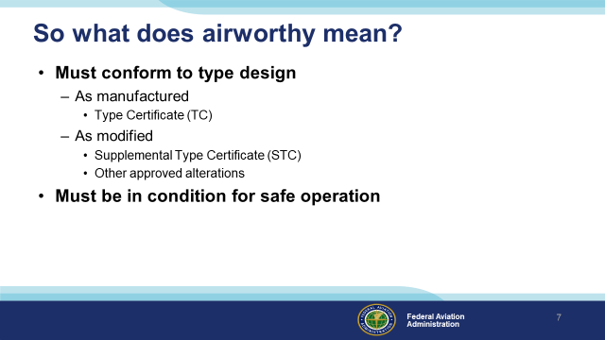 | Slide 7  There are two tests for airworthiness. (Click)  First – the aircraft must conform to its’ type design. The Type Certificate (TC) attests to the fact that the aircraft conforms to all design specifications.  But we know that many aircraft are extensively modified over time. Those modifications are memorialized in Supplemental Type Certificates (STCs). TCs, STCs, and other approval documents  specify conformance to type design. (Click)  Second – In addition to conforming to type design, the aircraft must be in condition for safe operation. An aircraft may conform to type design yet not be safe to fly. That’s a determination that pilots make each time they do their preflight walk around checks.  (Next Slide)
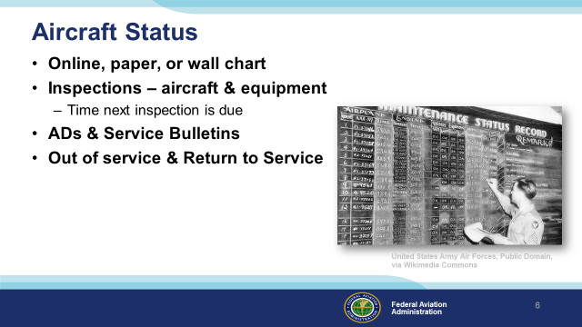 | Slide 8  Researching applicable Ads and compiling a status report can take an experienced mechanic 6 to 8 hours to accomplish. Most pilots will  take longer….. a lot longer! That’s why it’s vitally important to have a good information sharing process. A trusted aircraft status information  source is essential to fulfilling pilot in command responsibilities.  Aircraft status can be documented on paper (logbooks, status sheets, squawk sheets), on a wall chart, or in a computer. Whatever method is chosen  the documentation must be accurate and up to date. Whenever an aircraft is taken out of service there must be a documented Return to Service  statement in the appropriate airframe or power plant log. (Click)  Caution! – With the possible exception of an online maintenance documentation system, the information sources discussed here are not the official “permanent” records  for maintenance and inspection. For most of us, the permanent records are the Airframe and Power Plant logbooks. If we’re not looking at these we must have utmost confidence in the information we’re getting, as it were, second hand.  (Next Slide)
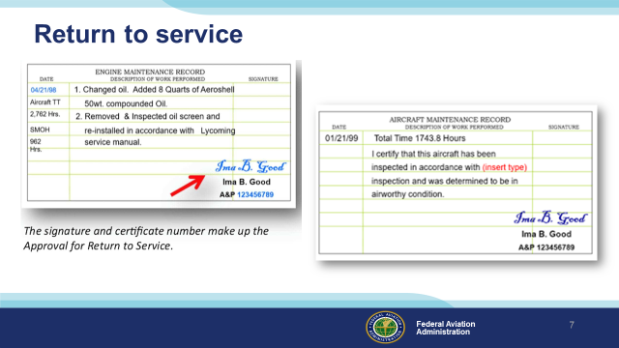 | Slide 9  Here are two examples of aircraft return to service documentation. Pilots don’t usually check the aircraft logs before each flight but they are still responsible for knowing that maintenance has been completed and, more importantly, that work is still being done and the aircraft has not been returned to service. A simple return to service entry on a status board can prevent a nasty surprise in flight. There are too many cases of accidents occurring in aircraft that were flown before maintenance was complete.  (Next Slide)
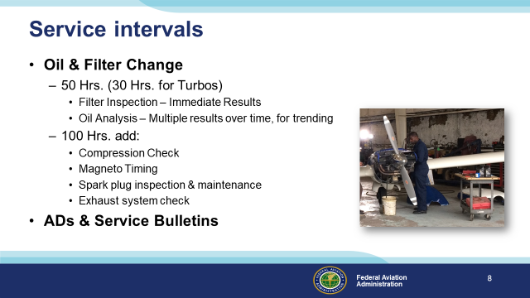 | Slide 10  Comply with all manufacturer-recommended service intervals. Fifty-hour oil changes are recommended for most normally aspirated piston engines.  Turbo-charged engines should undergo oil changes more frequently. Oil filter inspection with each oil change yields immediate feedback. If metal particulate is discovered in the filter, it could be cause for concern.  Oil analysis can reveal a lot about engine health as well but it works best when a trend can be identified over several samples. It’s not a bad idea to do a compression check, Mag timing, Spark plug inspection and Exhaust system check every other oil change.  It’s also a good idea to check ADs & Service Bulletins during regular service as well.  (Next Slide)
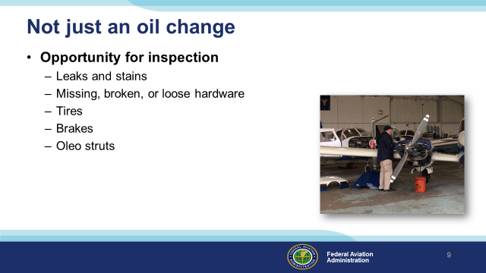 | Slide 11  Whether you’re assisting your mechanic or doing it yourself, every service interval is an opportunity to see things that are covered most of the time. While the oil is draining, take the time to give your aircraft a once-over. Look for leaks and stains in the engine compartment and wherever fuel or hydraulic fluid flows. Look for missing, broken or loose hardware. Check the condition of hoses, belts, and baffles. Tires, brakes, and oleo struts deserve your attention as well. It’s a lot easier to identify and quicker to correct deficiencies while your bird is in the shop than to make another service appointment.  (Next Slide)
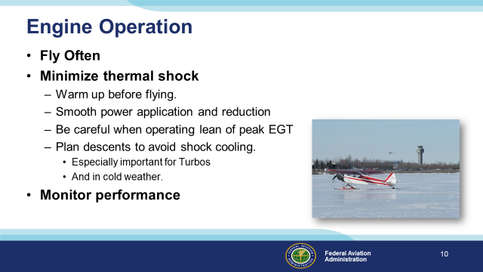 | Slide 12  How we operate our engines has a lot to do with how long they’ll last.  First of all – fly often. It’s actually harder on an engine if the airplane is in a hangar – or worse - a ramp queen. Regular operation keeps your engine components lubricated - markedly reducing corrosion potential.  Thermal shock can be very hard on engines so be sure yours has reached operating temperature before taking off.  Smooth, steady power changes are good for engine longevity. This is especially true for turbo charged power plants.  Be sure to strictly follow manufacturers’ recommendations when operating on the lean side of peak Exhaust Gas Temperature. It’s not worthsaving a gallon or so per hour if your engine overheats in the process.  Once again - especially for Turbos - plan your descents with some power to keep the engine warm.  Finally, monitor engine performance from flight to flight. Small changes over time can forecast developing engine problems.  We’ll talk about monitoring in detail in the next slides.  (Next Slide)
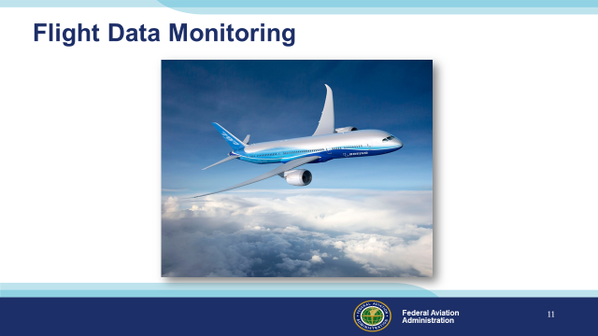 | Slide 13  Flight data monitoring has been around since before the jet age and modern airplanes make extensive use of the technology. Through Flight Data Monitoring, aircraft operators can develop  optimal maintenance schedules, confirm aircraft performance expectations, and predict system or component failures before they occur. Flight Data Monitoring and Recording are also of great value in accident investigation.  (Next Slide)
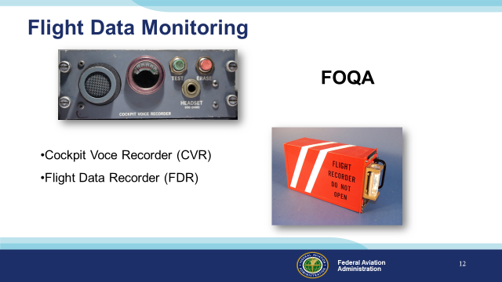 | Slide 14  In its’ simplest form, FDM consists of a cockpit voice recorder that records at least the most recent 15 minutes of crew conversations, and a flight data recorder that preserves such things as engine parameters, control position, heading, altitude, and airspeed data. (Click)  The equipment and processes to acquire and distribute the data are collectively known as Flight Operational Quality Assurance or FOQA (pronounced: Fohqua)  But this equipment is only for the big guys right? General Aviation aircraft don’t have anything like this ……………………. Or do they?  (Next Slide)
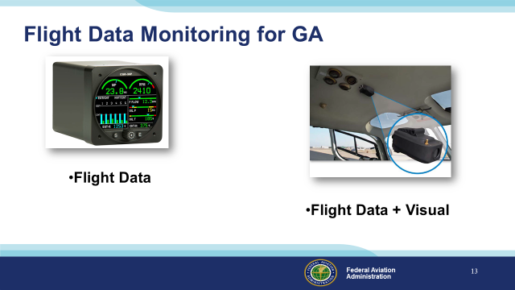 | Slide 15  While it’s true that most GA aircraft don’t have dedicated automatic flight data recording devices now; we will be able to enjoy the benefits of equipage in the future. In the meantime it’s often surprising to see what we already have. (Click)  Manufacturers are already offering self-contained flight data and visual data recorders for GA airplanes and helicopters. Most operators of this equipment must periodically down load and analyze the recorded data – often with the aid of dedicated computer programs.  (Next Slide)
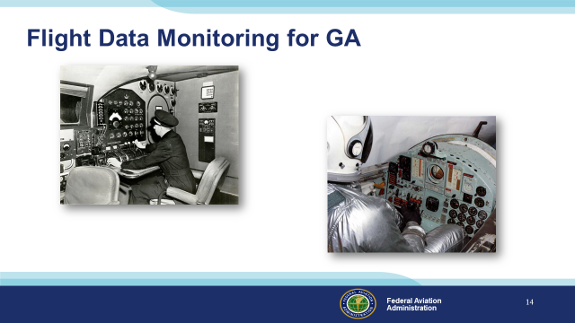 | Slide 16  Many data monitoring operations involve no automation at all. Flight engineers used to handle the monitoring and record keeping (Click)  And test pilots were expected to keep notes while flying.  (Next Slide)
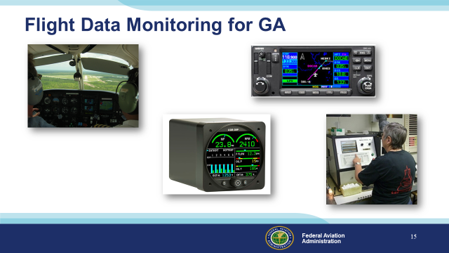 | Slide 17  GA pilots can do much the same thing by tracking engine power, fuel flow, oil temperature and pressure. Some GPS systems and engine monitors have recording capability and many aircraft owners participate in oil analysis programs – a tool for gauging engine health and heading off expensive or, in some cases, disastrous problems. Some aircraft – particularly helicopters are equipped with metallic chip detectors that can forecast engine and transmission failures in time to make a safe landing.  (Next Slide)
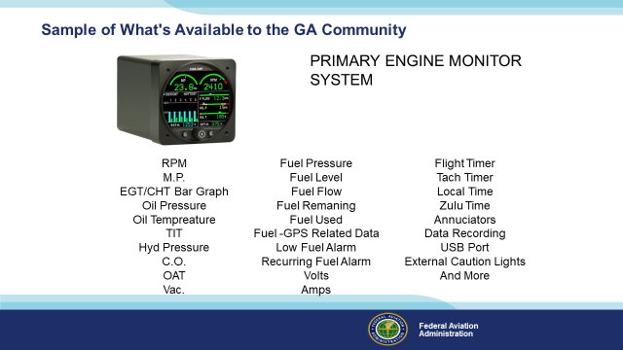 | Slide 18  Here’s just one example of the information available in one small box. This example doesn’t include recording capability but it’s certainly one-stop shopping for engine information.  (Next Slide)
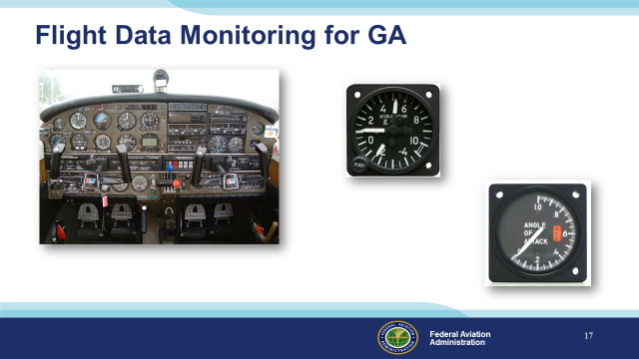 | Slide 19  And don’t forget basic instrumentation such as Air Speed Indicators, Attitude Indicators, Angle of Attack, Manifold Pressure, RPM, and G indicators – all of which give immediate feedback as to whether design limitations have or are about to be exceeded.  (Next Slide)
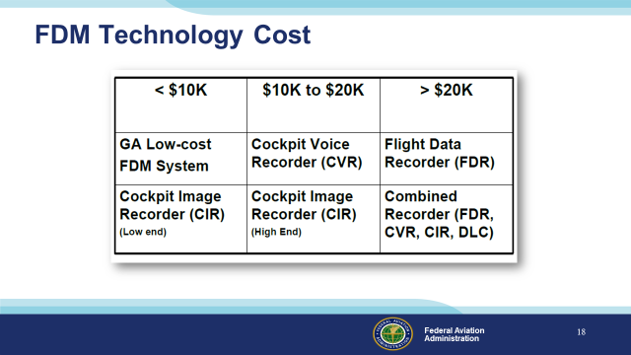 | Slide 20  At present FDM Technology costs from a little less than $10,000.00 to more than $20,000.00 but as competition and equipage increase, prices are expected to fall.  (Next Slide)
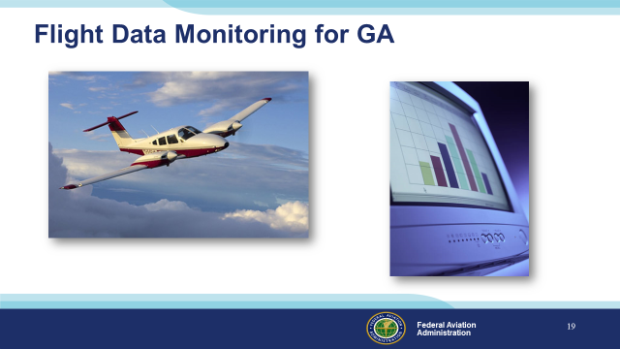 | Slide 21  In the meantime, we urge you to consider the information that’s already available on every flight.  (Next Slide)
Slide 22
Presentation Note: You may wish to provide your contact information and main FSDO phone number here. Modify with
Your information or leave blank.
(Next Slide)
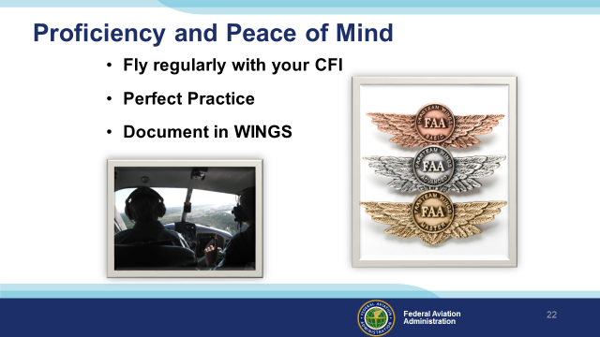 | Slide 23  There’s nothing like the feeling you get when you know you’re playing your A game and in order to do that you need a good coach (Click)  So fly regularly with a CFI who will challenge you to review what you know, explore new horizons, and to always do your best. Of course you’ll  have to dedicate time and money to your proficiency program but it’s well worth it for the peace of mind that comes with confidence. (Click)  Vince Lombardi, the famous football coach said, “Practice does not make perfect. Only perfect practice makes perfect.” For pilots that means  flying with precision. On course, on altitude, on speed all the time. (Click)  And be sure to document your achievement in the Wings Proficiency Program. It’s a great way to stay on top of your game and keep you flight review current.  (Next Slide)
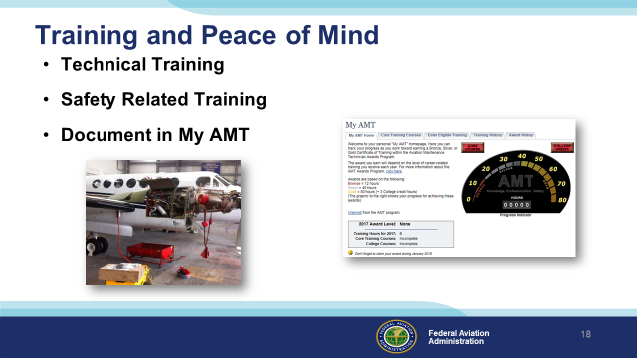 | Slide 24  The AMT Awards program encourages AMTs and employers to take advantage of initial and recurrent training by issuing awards based on training received in one calendar year.  The program has several levels, or phases, of recognition for both you and your employer. You can obtain an FAA Certificate of Training upon successful completion of the program requirements. Employers can obtain a Gold or Diamond Award of Excellence yearly depending on the percentage of their employees receiving awards.  Training earned toward an AMT Award falls into one of two categories; Mandatory Core Training and Eligible Training.  Mandatory Core Training is one or more on-line training courses, depending on FAA evaluation of training needs. The Core Training course(s) can be located and completed in the Aviation Learning Center at FAASafety.gov.  Eligible Training is the hourly training that can be credited toward an individual AMT Certificate of Training. This training must be aviation maintenance career related training.  Be sure to document your achievement in the AMT Awards Program. It’s a great way to stay on top of your game and keep stay proficient.  (Next Slide)
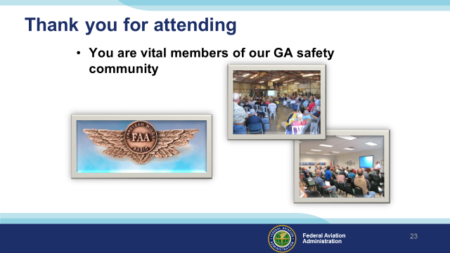 | Slide 25  Your presence here shows that you are vital members of our General Aviation Safety Community. The high standards you keep and the examples you set are a great credit to you and to GA.  Thank you for attending.  (Next Slide)
Slide 26

(The End)

Appendix I – Equipment and Staging
Equipment:
- Projection Screen & Video Projector suitable for expected audience
  - Remote computer/projector control available at lectern or presenter location
    - In lieu of remote – detail a Rep to computer/projector control.
- Presentation Computer
  - Note: It is strongly suggested that the entire program reside on this computer.
- Back up Projector/Computer/Media as available.
- PA system suitable for expected audience
  - Microphones for Moderator and Panel
    - Optional Microphone (s) for audience
- Lectern (optional)
Staging:
- Arrange the projection screen for maximum visibility from the audience.
- Equip with PA microphones
- Place Lectern to one side of screen. This will be used by presenters and moderator
- IMPORTANT – Once you have completed outreach on this topic, please help us track the outreach you have done by entering a PTRS record.

