Presentation Notes
Stall/Spin/Upset Training 2021/03-11-220(I)PP

This outreach guidance is provided to all FAA and aviation industry groups that are participating in outreach efforts sponsored by the General Aviation Joint Steering Committee (GAJSC). It is important that all outreach on a given topic is coordinated and is free of conflicts. Therefore, all outreach products should be in alignment with the outline and concepts listed below for this topic.

Outreach Month: February 2022

Topic: Expanding Your Horizons – Stall/Spin/Upset Training
The FAA and industry will conduct a public education campaign emphasizing training to in Stall/Spin/Upset awareness & prevention.

Background:

The General Aviation Steering Committee (GAJSC) System/Component Failure work group feels that proficiency training and education in Stall, spins, and upsets including unusual attitudes will help to reduce the incidence of Loss of Control and associated accidents.

Teaching Points:
- Discuss the safety benefits of stall recognition and prevention training.
- Discuss the safety benefits of spin awareness and prevention training.
- Discuss the safety benefits of aircraft upset and unusual attitude training.
- If applicable, acquaint the audience with local options for the training listed above.
- Encourage pilots to participate in WINGS Pilot Proficiency Training.

References:
- 14CFR 91.303 – Aerobatic Flight
- 14CFR 91.307 – Parachutes and Parachuting
- AC No: 61-67C - Stall and Spin Awareness Training
- FAA-H-8083 – Airplane Flying Handbook

- Flight Data Monitoring Systems and Non-Required Safety Enhancing Equipment – GAJSC Safety Enhancements - Loss of Control

Abstract: Lasting 10 to 15 Minutes, this presentation acquaints the audience with the benefits of post-certification training in Stall/Spin recognition, prevention, and recovery, Aircraft Upset, and Unusual Attitudes

Format: Information Briefing – Power Point presentation

Required Personnel: FAASTeam Program Manager or designated FAASTeam Rep (s)

Optional Personnel: Flight Instructors or others who can speak on the Stall/Spin, Aircraft Upset, and Unusual Attitude training.

AFS 850 Support: In addition to this document, a Power Point presentation that supports the program is provided. FPMs and presenters are encouraged to customize this presentation to reflect each individual program.

Slides | Script
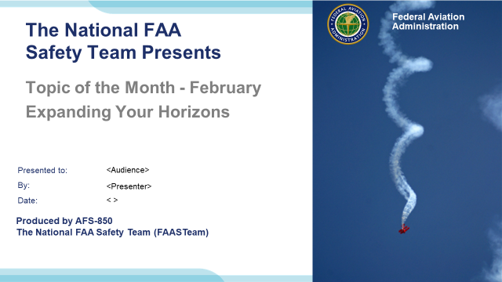 | Slide 1  2021/03-11-220(I)PP Original Author: John Steuernagle (03/11/2021); POC: Kevin Clover, AFS-850 Operations Lead Office (562-888-2020);  Presentation Note: This is the title slide for The Startle Response  - Script - We have included a script of suggested dialog with most slides. The script will always appear in a non-italic font. Presenters may read the script or modify it to suit their own presentation style. See template slides 5 and 6 for examples of a slides with script.  - Presentation Instructions - (stage direction and presentation suggestions) will be preceded by a Bold header: the instructions themselves will be in Italic fonts. See slides 2, for an example of slides with Presentation Instructions only.  - Program control instructions - will be in bold fonts and look like this: (Click) for building information within a slide; or this: (Next Slide) for slide advance.  - Background information - Some slides may contain background information that supports the concepts presented in the program.  Background information will always appear last and will be preceded by a bold Background: identification.  The production team hope you and your audience will enjoy the show. Break a leg!  (Next Slide)
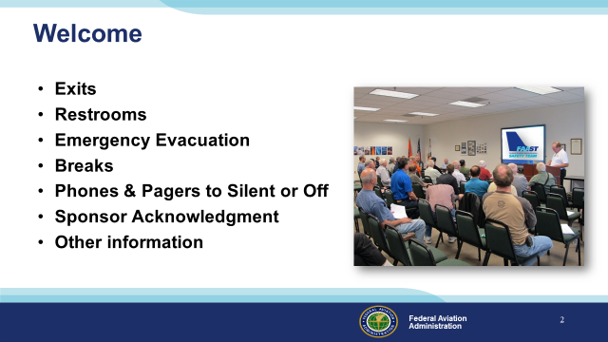 | Slide 2  Presentation Note: Here’s where you can discuss venue logistics, acknowledge sponsors, and deliver other information you want your audience to know in the beginning.  You can add slides after this one to fit your situation (Next Slide)
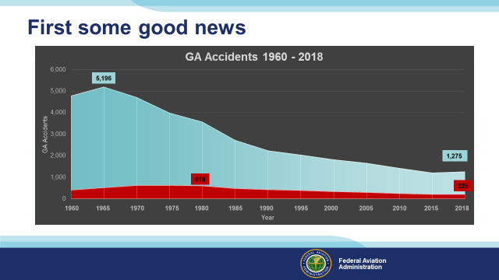 | Slide 3  First some good news. In the nineteen sixties we averaged five thousand general aviation accidents in the United States each year. (Click)  Of that five thousand, nearly five hundred were fatal. Although the number of accidents peaked in 1965, fatal accident numbers continued to rise through 1980. Since then we’ve seen a steady decline in GA accidents. (Click)  In 2018 – the latest year for which we have final data – There were only 1,275 GA Accidents of which, 225 were fatal. But that’s not the best news.  In 1960, the US General Aviation fleet flew about 13 million hours. By the year 2000 we were flying almost 28 million hours. In 2018 we flew about 22 million hours. In order to get a better  understanding of how well we’re doing we need to look at accident rates. For example: how many accidents occur per one hundred thousand hours of flying?  (Next Slide)
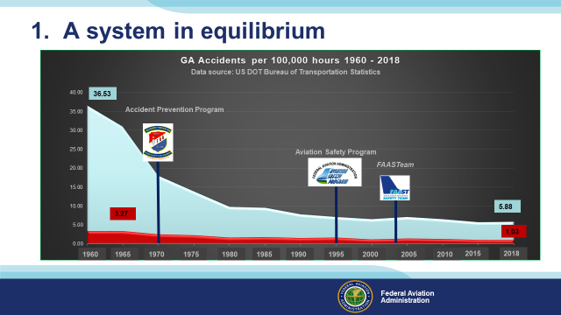 | Slide 4  GA Accident rates tell a better story. In the same time period we’ve gone from more than thirty six accidents per hundred thousand hours to less than six and from 3 to just over 1 fatal accident per hundred thousand hours flown. This has been a remarkable achievement due in to improvements in safety technology to be sure; (Click)  and to FAA’s more than fifty-year commitment to General Aviation safety; but also due to the safety community of aviators like you. There’s still work to be done and together we can do better. To get below one accident per hundred thousand hours, we’ll have to tackle some predominant accident causes and chief among them is Loss of Aircraft Control.  (Next Slide)
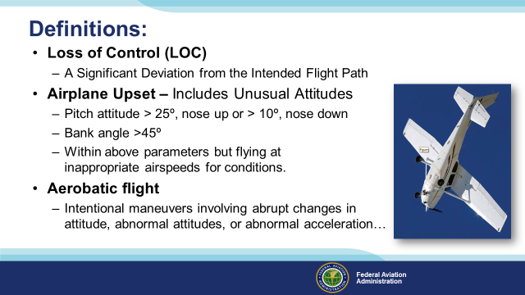 | Slide 5  We’ll need some definitions going forward. Loss of Control is simply defined as a significant deviation from the intended flight path. (Click)  An airplane upset – we’re more familiar with the term Unusual Attitude - involves a pitch attitude greater than 25º nose up or greater than 10º nose down, a bank angle greater than 45º, or flying within those parameters but at inappropriate airspeeds for conditions. Although upset recovery is a part of large airplane training programs, it’s also useful in small airplane training programs. (Click)  And finally, aerobatic flight is defined as an intentional maneuver involving an abrupt change in an aircraft’s attitude, an abnormal attitude, or abnormal acceleration not necessary for normal flight.  That definition is important because loss of control or upset training could involve aerobatic flight and aerobatics have additional aircraft and equipment requirements.  (Next Slide)  Background: References include 14 CFR 91.303 (Aerobatic Flight), 14 CFR 91.307 (Parachutes and Parachuting), and AC No: 61-67C (Stall and Spin Awareness Training)
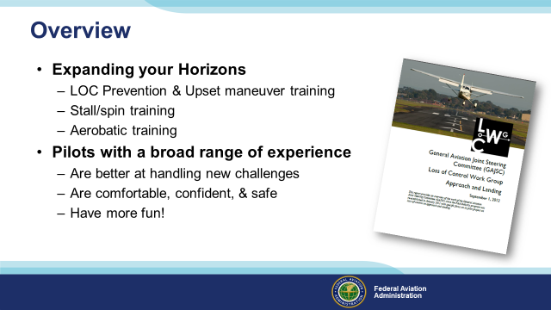 | Slide 6  We pilots can become quite comfortable in our normal flying. Most of us don’t range very far from our comfort zone. That can lead to less than ideal responses to conditions outside of our normal experience. A recent study of general aviation accidents suggests that, additional training in Loss of Control prevention, Upset recovery, Stall/Spin awareness, prevention, and & recovery and Aerobatic training can go a long way toward reducing General Aviation mishaps. (Click)  Just as importantly pilots with a broad range of experience tend to be better at meeting new challenges. They’re more comfortable, confident, and safe, (Click)  And they just have more fun!  We’ll be touching on all of this in the next few minutes but first let’s hear what noted aviation educator Rich Stowell has to say on the subject.  Presentation Note: If you’ll be discussing additional items, add them to this list  (Next Slide)
Slide 7
Presentation Note: Let the embedded video play to the end – then advance to the next slide.
(Next Slide)
Background: Video courtesy of Rich Stowell
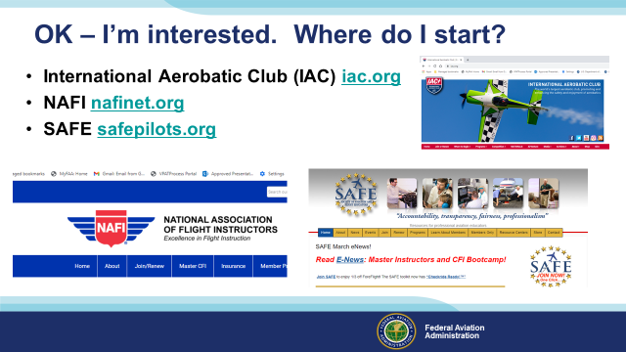 | Slide 8  After that intro I’m sure at least some of us are interested in getting some Stall/Spin Upset training but where does one go to find it? A good place to start is with the International Aerobatic Club, The National Association of Flight Instructors, and the Society for Aviation Flight Educators. Thankfully their URLs are shorter than their organizational names. Each of these organizations can provide you with a list of local aerobatic flight instructors. Even if you don’t want to do any maneuvers except stalls and spins – aerobatic Flight Instructors are the way to go. They will have hundreds of hours teaching spins and they’ll know where to rent aerobatic airplanes in your local area. That’s import if you won’t be providing your own airplane for the training. Come to think of it, now would be a good time to start a list of essentials for Stall/Spin/Upset training.  Presentation note: The URLs on screen are hyper linked to the organization’s home pages. The links may not work with MS Internet Explorer but should work with the MS Edge or Google Chrome browsers.  (Next Slide)
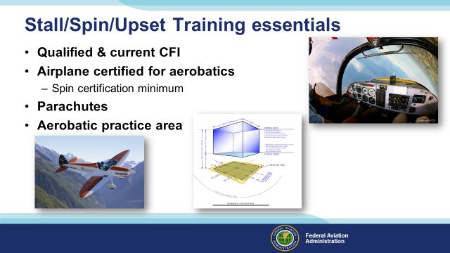 | Slide 9  Here’s a list of Stall/Spin/Upset Training essentials. Be sure to discuss these items during your interviews of potential Flight Instructors.  - Obviously you’ll need a qualified and current CFI who is experienced in teaching aerobatics.  - Most of us don’t fly aerobatic airplanes so ask your CFI candidates for rental recommendations. They will know what sort of equipment is locally available.  - Although they’re not required if you’re only doing spin training, parachutes are required equipment for all other aerobatic flight and they just make sense for spin training too. If you’re renting an aerobatic airplane it may come with approved and current parachutes. Once again your CFI will know what’s available.  - Finally you’ll need an approved aerobatic practice area. That way you know you’re in airspace that’s approved for aerobatics and pilots familiar with the area will know to avoid it or transition with caution. Unfortunately most aerobatic practice areas are not charted but that may change in the future. For now – local knowledge is essential.  So now that we have an instructor, an airplane, parachutes, and a place to fly; what are we going to do in the practice area? Well – in the beginning it’s back to basics.  (Next Slide)
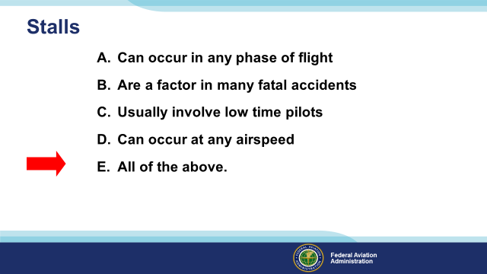 | Slide 10  Which of these statements are true with respect to stalls?  Presentation Note: Ask the audience to consider these statements with respect to stalls. When they have answered; click to reveal the correct answer.  (Click)  That’s right. Stalls can occur at any airspeed in any phase of flight. They are a factor in many fatal accidents and often – but not always – involve low time pilots.  (Next Slide)
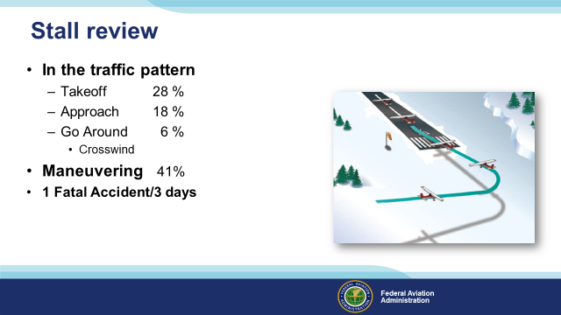 | Slide 11  Here’s the lowdown on Stall/Spin Accidents. They are deadly. More than half occur in the traffic pattern and most of the rest involve maneuvering – usually too close to the ground for recovery.  That all works out to one fatal accident every three days for the past ten years. So a good place to start our training is with a review of slow flight & stalls  (Next Slide)
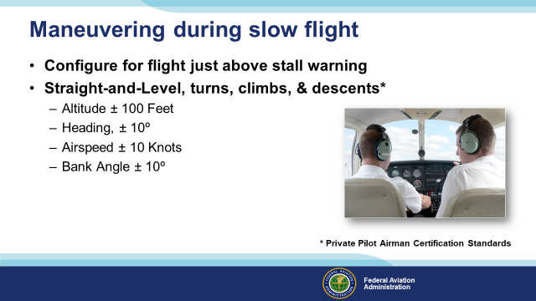 | Slide 12  Maneuvering during slow flight is an excellent exercise to get you in tune with your airplane. For slow flight, we’ll configure for an airspeed at which any increase in angle of attack, or load factor, or reduction in power, would result in a stall warning. Then maneuver at that airspeed within the parameters on screen. Although the Airman Certification Standards require you to maneuver above the stall warning angle of attack, your training will involve operations above stall but below stall warning angle of attack. That way you’ll get a sense of how close you are to pre-stall indications and warnings.  (Next Slide)
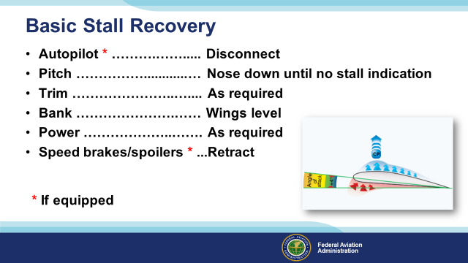 | Slide 13  You’ll also want to review stalls and stall recoveries. You’ll stall power on and off, in turns, and with cross controls; always recovering to controlled flight at a pre-determined altitude.  (Next Slide)
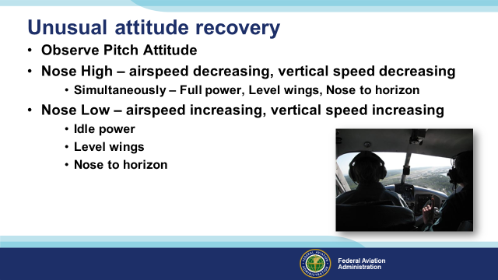 | Slide 14  When you think about it, unusual attitude exercises are mini scenarios. While your attention is diverted, the aircraft enters an unusual and potentially dangerous attitude.  When your attention is redirected to your aircraft’s attitude you must quickly assess the situation and apply appropriate control inputs to return to level flight. Your  assessment begins with observing pitch attitude. Your airspeed indicator will give you a near instantaneous pitch indication.  - If pitch attitude is nose high, airspeed and vertical speed will be decreasing.  - Note your bank attitude and simultaneously add full poser, level your wings, and pitch to the horizon.  - If your pitch attitude is nose low; airspeed and vertical speed will be increasing. Recovery is accomplished in three separate steps  - Reduce power to idle  - Note bank angle and level wings, then  - Pitch to the horizon  (Next Slide)
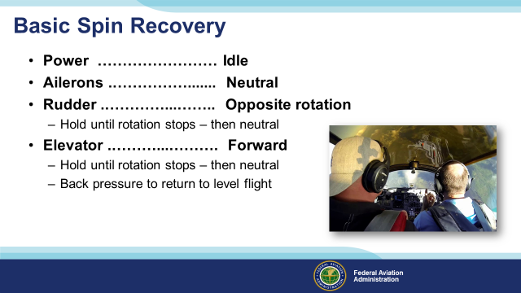 | Slide 15  With a solid review of stalls and slow flight – you’re ready for spin training. Your instructor will show you how to recover from incipient, and developed spins.  Be sure to consult your POH for instructions specific to your aircraft but here are basic steps for spin recovery that work in most general aviation airplanes.  - Reduce power to idle  - Neutralize ailerons  - Briskly apply full rudder opposite the direction of rotation. Keep rudder in this position until rotation stops – then neutralize.  - Immediately after applying full rudder, briskly move elevator control forward.  - Keep rudder and elevator controls in these positions until rotation stops then  - Apply gentile back pressure to return to level flight.  (Next Slide)
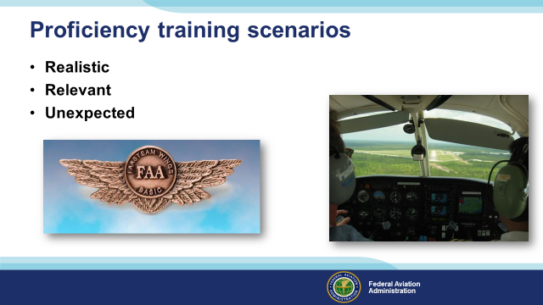 | Slide 16  We may learn and practice flight maneuvers in isolation from other flight tasks but proficiency training scenarios require that you fly the aircraft while attending to navigation, communication, fuel state, performance monitoring, present & forecast en route, destination, and alternate weather, and more. Excellent flight instructors construct complex training scenarios that are realistic and relevant to you, your aircraft, and the missions you typically fly. (Click)  The very best scenarios include unexpected problems to analyze and resolve – all while maintaining positive aircraft control. (Click)  By the way – WINGS – FAA’s Pilot Proficiency Program features ground and flight training activities for pilots of all certificate and experience levels.  (Next Slide)
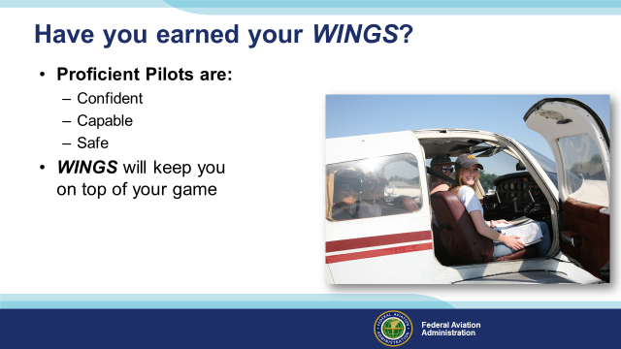 | Slide 17  Proficiency is key to success in almost every thing worth doing – especially flying. Proficient pilots are confident, capable, and safe.  WINGS is a proficiency training system specifically designed for general aviation pilots and, regular participation will keep you on top of your flying game.  Your FAA Safety Team Program Managers and volunteer WINGSPros are available to help you with the program.  (Next Slide)  Presentation Note: This is a good time to introduce any Reps or WINGSPros in attendance.  (Next Slide)
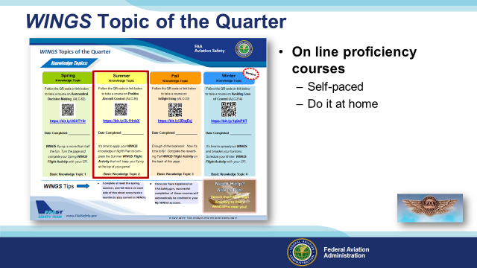 | Slide 18  Proficiency Training works best if it’s not done all at once, but rather spaced out at regular intervals. The WINGS Topic of the Quarter program consists of eight activities pursued over the course of one year.  Each quarter, WINGS Pilots take an on-line safety course. All courses are self-paced. Most take no more than an hour or two and they can be completed at home. In this example the Summer Knowledge Topic is Positive Aircraft Control.  (Next Slide)
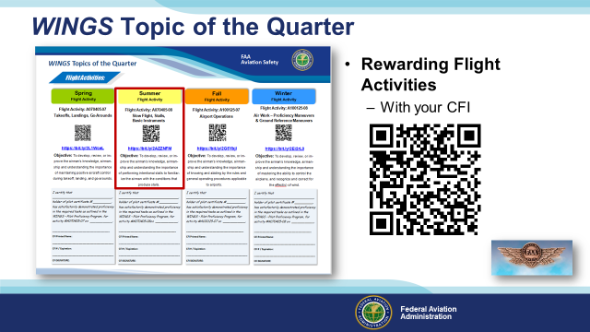 | Slide 19  Program participants also fly with a Flight Instructor to complete a WINGS Flight Activity at least once each quarter. (Click)  The summer quarter flight activity pictured here is an excellent review of stalls & slow flight. (Click)  Check out the WINGS Topic of the Quarter in the FAASafety.gov Library.  (Next Slide)  Background: FAASafety.gov Library URL = https://faasafety.gov/gslac/ALC/lib_tableofcontents.aspx  FAASafety.gov Library WINGS URL = https://faasafety.gov/gslac/ALC/lib_categoryview.aspx?categoryId=39  (Next Slide)
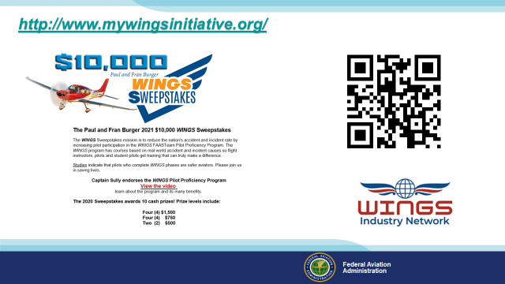 | Slide 20  Now there are even more reasons to participate in WINGS. Every time you complete a WINGS Phase you’re eligible to win cash the WINGS Sweepstakes.  The sweepstakes is generously funded by Paul Burger, a long time advocate for general aviation safety and a retired aviator who believes participation in this program saves lives. VISIT WWW.MYWINGSINITATIVE.ORG to learn more and enter the sweepstakes.  (Next Slide)
Slide 21
Presentation Note: You may wish to provide your contact information and main FSDO phone number here. Modify with
Your information or leave blank.
(Next Slide) (Next Slide)
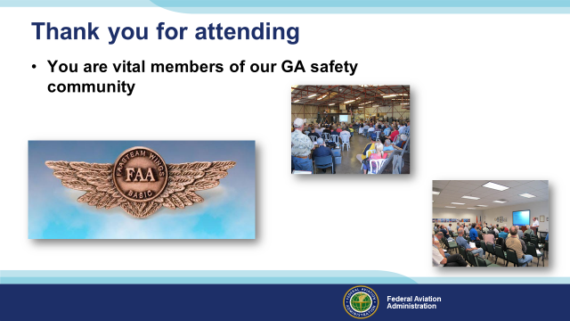 | Slide 22  Your presence here shows that you are vital members of our General Aviation Safety Community. The high standards you keep and the examples you set are a great credit to you and to GA.  Thank you for attending.  (Next Slide)
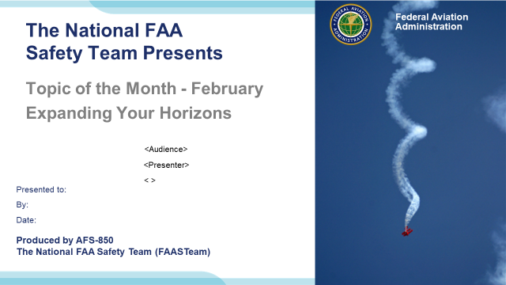 | Slide 23  (The End)

Appendix I – Equipment and Staging
Equipment:
- Projection Screen & Video Projector suitable for expected audience
  - Remote computer/projector control available at lectern or presenter location
    - In lieu of remote – detail a Rep to computer/projector control.
- Presentation Computer
  - Note: It is strongly suggested that the entire program reside on this computer.
- Back up Projector/Computer/Media as available.
- PA system suitable for expected audience
  - Microphones for Moderator and Panel
    - Optional Microphone (s) for audience
- Lectern (optional)
Staging:
- Arrange the projection screen for maximum visibility from the audience.
- Equip with PA microphones
- Place Lectern to one side of screen. This will be used by presenters and moderator
- IMPORTANT – Once you have completed outreach on this topic, please help us track the outreach you have done by entering a PTRS record.

