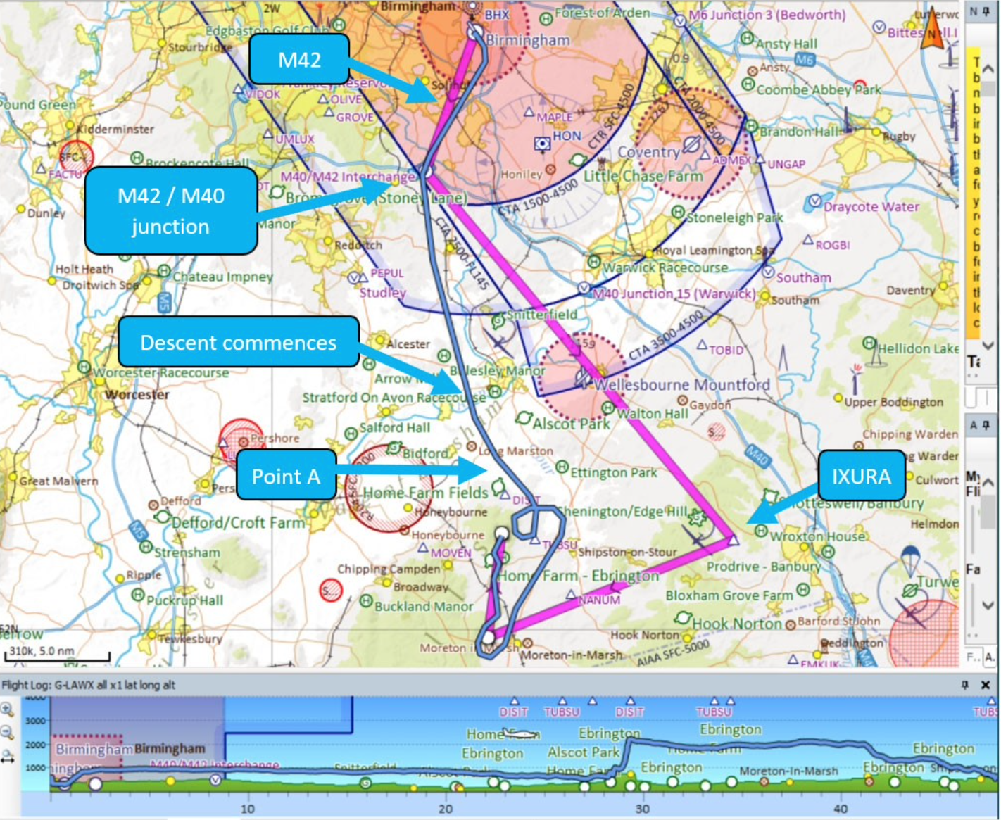

On 14 October 2019, a Sikorsky S92A manoeuvring below low cloud in poor daylight visibility in an unsuccessful attempt to locate the intended private landing site flew north towards rising ground approximately ¾ mile east of it, coming within a recorded 28 feet above terrain near to occupied houses before making an emergency climb and over-torqing the engines followed by an unstable but successful second approach. The Investigation found relevant operator procedures absent or ineffective, an intention by the management pilot in command to reach the landing site despite conditions and uncertainty about the applicable regulatory context for the flight.

S92, manoeuvring, near Shipston-on-Stour UK, 2019
Summary:
On 14 October 2019, a Sikorsky S92A manoeuvring below low cloud in poor daylight visibility in an unsuccessful attempt to locate the intended private landing site flew north towards rising ground approximately ¾ mile east of it, coming within a recorded 28 feet above terrain near to occupied houses before making an emergency climb and over-torqing the engines followed by an unstable but successful second approach. The Investigation found relevant operator procedures absent or ineffective, an intention by the management pilot in command to reach the landing site despite conditions and uncertainty about the applicable regulatory context for the flight.
Event Details
When:
14/10/2019
Event Type:
CFIT, HF
Day/Night:
Day
Flight Conditions:
VMC
Flight Details
Aircraft:

SIKORSKY S-92

Operator:
Starspeed
Type of Flight:
Private
Flight Origin:
Birmingham International Airport
Take-off Commenced:
Yes
Flight Airborne:
Yes
Flight Completed:
No
Phase of Flight:
Missed Approach
Location
Approx.:
near Shipston-on-Stour, UK
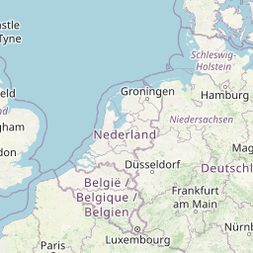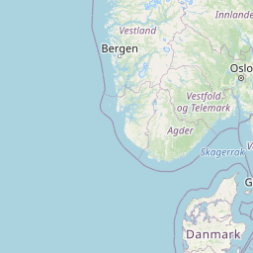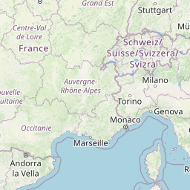
+-
Leaflet | OSM Mapnik
General
Tag(s):
Approach not stabilised, Helicopter Involved, Inadequate Aircraft Operator Procedures, PIC less than 500 hours in Command on Type, Visual Approach
CFIT
Tag(s):
No Visual Reference, Lateral Navigation Error, Vertical navigation error, VFR flight plan
HF
Tag(s):
Authority Gradient, Inappropriate crew response (automatics), Manual Handling, Plan Continuation Bias, Procedural non compliance
Outcome
Damage or injury:
No
Non-aircraft damage:
No
Non-occupant Casualties:
No
Off Airport Landing:
Yes
Ditching:
No
Causal Factor Group(s)
Group(s):
Aircraft Operation
Safety Recommendation(s)
Group(s):
Aircraft Operation, Airport Management
Investigation Type
Type:
Independent

Description
On 14 October 2019, the crew of a Sikorsky S92A (G-LAWX) being operated by Starspeed on a private commercial passenger flight from Birmingham to a private landing site near Shipston-on-Stour were attempting to locate their intended destination in marginal day VMC when they became uncertain of their position and descended to within 28 feet agl of rising terrain close to a house before the engines were significantly over-torqued when making an unstable emergency climb into IMC. A second approach at night was initially unstable but then unexpectedly successful. The helicopter was deemed in need of maintenance inspections and was subsequently ferried to London Stansted where it was eventually found that no damage had been caused during the unsuccessful first approach.

Investigation
A particularly comprehensive Field Investigation was carried by the UK AAIB. Relevant information was downloaded from the CVFDR and the EGPWS.

The Flight Crew
The two-pilot crew were both of Captain rank who routinely flew together and would alternate in command and as PF/PM. They often operated away from base together for several days at a time. The 54 year-old Captain in command and also acting as PF on the investigated flight was also the operator’s Managing Director, Accountable Manager and Safety Manager as well as being the company’s “principal point of contact” for the S92 client for whom the flight was being undertaken. He had been with the operator in a management role for 8 years and only flew the S92. He had a total of 6,200 hours flying experience which included 441 hours on type which had been accumulated at a rate of “less than 100 hours each year”. The Captain acting as PM had no management responsibilities and had a total of 732 hours flying experience on type of which 250 hours had been accumulated the previous year.
Both pilots had originally served as military helicopter pilots flying the Sea King. Prior to joining the operator, the commander had also flown offshore and onshore mainly in the AS365N but also with time on other types including the EC155 and AS355. Prior to joining the operator, the Captain acting as PM had gained previous S92 experience in the offshore oil and gas sector and in onshore HEMS (Helicopter Emergency Medical Services), and corporate operations. Both pilots had been operating for several days from the destination private landing site located in the village of Foxcote, Warwickshire. They stated that they had both been “properly rested”after flying the previous day. On the day of the investigated flight they were to meet nine passengers who would be arriving by fixed-wing aircraft at Birmingham Airport and transfer them to the private landing site.

What Happened
The crew positioned the helicopter from the private landing site to Birmingham airport with same pilot in command and acting as PF as would be the case for the subsequent return flight. The area weather conditions for the 20 minute flight were assessed as having been a cloud base of 1,000 feet QNH and 5 km visibility and the PF flew a manual ILS into Birmingham. The ETA of the passengers’ flight was 1710 which was met and the intention was to complete their flight to the private landing site in daylight (sunset was at 1716) since a VFR approach would be necessary there in relatively poor visibility. The crew recognised that this would be challenging even with a quick transfer of the passengers and to cover the possibility that the weather prevented a landing, arrangements to divert to Wellesbourne Mountford were made and the landing site estate manager advised accordingly.
Whilst waiting for the passengers to board, the pilots discussed the plan and the PF Captain expressed increasing anxiety about the chances of completing the flight in daylight, remarking that “we are really up against it”. The flight took off from Birmingham, where the lowest cloud was being reported as BKN (broken) at 800 feet aal, at 1730. The illustration on the ‘Sky Demon’ chart below shows the planned flight path and the flight path actually flown to save time. During the climb, when the PM prompted the PF to call for the HTAWS radio altimeter alert value to be set to 500 feet, he received the response to set it to 400 feet. The helicopter then levelled at around 950 feet QNH which at that point was equivalent to marginally above 500 feet agl. It was noted that although the helicopter was fitted with a barometric altitude alert independent of the radio altimeter altitude alert incorporated in the HTAWS, there was no associated SOP and no such alerts were recorded during the flight which indicated that the value set was either above or below all the altitudes flown.
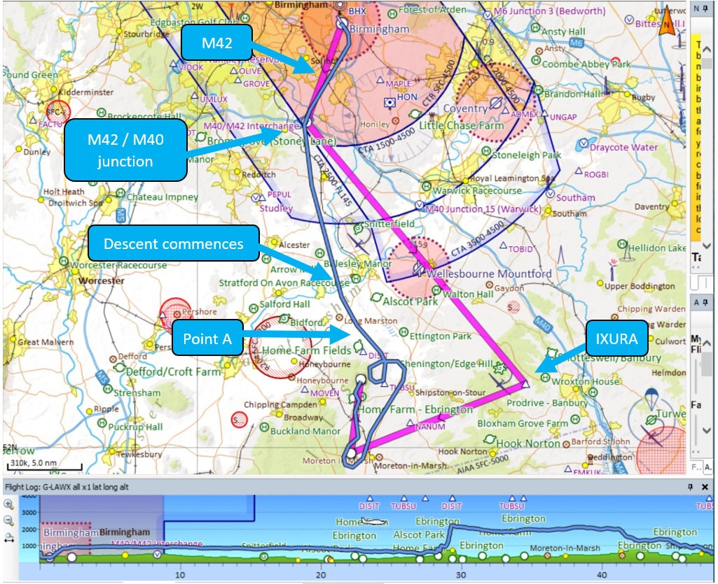
The planned ground track (pink) and actual one (blue) with the latter against the terrain below. [Reproduced from the Official Report}
As the flight reached the VRP at the exit from the Birmingham CTR (control zone), the PF advised the PM that he was going to route direct and requested him to update the flight planin the FMS in order to try and get in “whilst its daylight”. Almost immediately, an HTAWS ‘ALTITUDE’ alert was annunciated several times as the helicopter passed over rising ground. The helicopter flew just below the cloud base and was obliged to descend steadily from the originally achieved 950 feet QNH whilst remaining mainly above 500 feet agl over lowering terrain.
On reaching a position about 10 nm north of the landing site, the initial approach checks and an approach briefing were completed and the PF remarked that the weather was “marginal”. Continuing south southeast to position for a westerly approach to the landing site, at about 5 nm from it, a descent was commenced, the airspeed was reduced and the landing checks were commenced. The PF asked the PM to delay resetting the HTAWS altitude alert value until they were visual with the landing site. Then, while they were still doing the landing checks, the HTAWS ‘ALTITUDE alert was again annunciated and acknowledged by the PM.
Soon after the landing checks had been completed, the PM stated that the landing site was 2½ nm to the right and another HTAWS ALTITUDE alert occurred to which the PF responded by asking the PM to reset the altitude alert value to 150 feet agl, an action which was stated by the Investigation to have been “in accordance with the operator’s SOPs”.
Just before the right turn onto a westerly track was commenced, the HTAWS ‘look ahead’ mode generated a ‘CAUTION TERRAIN’ alert. The PF acknowledged this and responded that he could see the ground and asked the PM to update the FMS to show a direct track to the landing site. As the turn began, an HTAWS annunciation ‘WARNING TERRAIN’ occurred (see the illustration below) which the PF acknowledged by calling “visual” and continued the right turn onto a westerly track. The descent continued to 230 feet agl (significantly below the elevation of the landing site which was 559 feet agl) before a climb was initiated. The PF then stated he “could see some lights” and began to continue the right turn onto north at or below an airspeed of 60 knots.
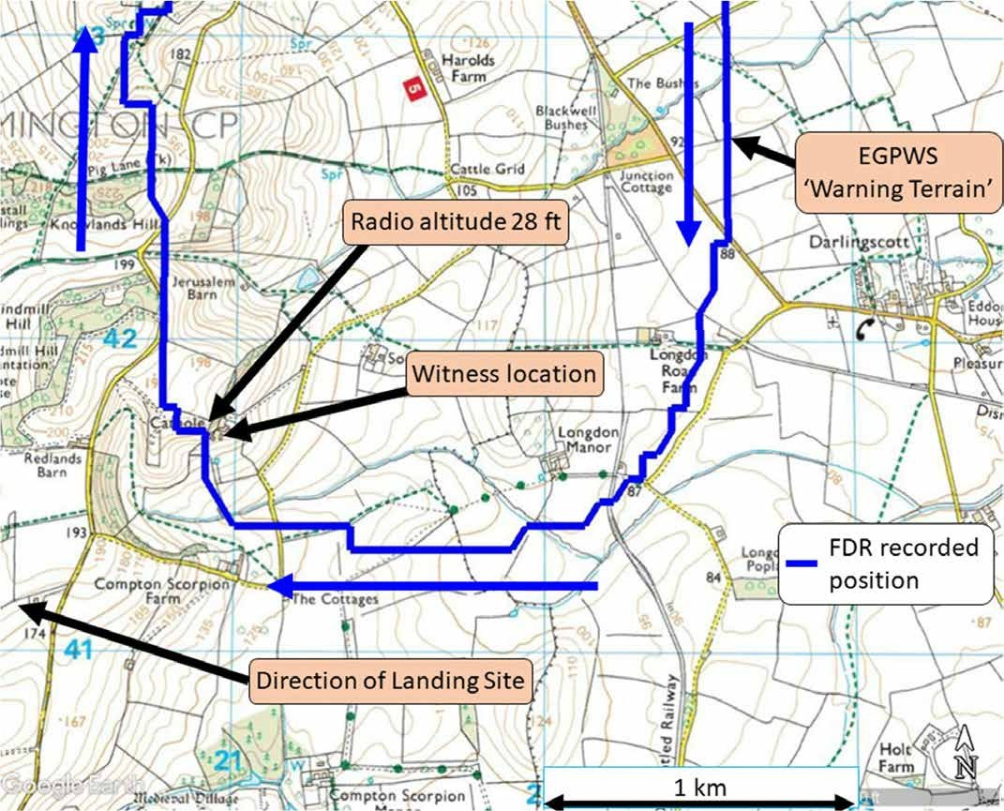
The flight track during the first unsuccessful attempt to locate the landing site. [Reproduced from the Official Report]
The altitude remained approximately constant at less than 200 feet “above gently rising ground” but still less than 100 feet above the elevation of the landing site. The turn onto a northerly track was completed with a climb to a recorded 883 feet QNH (324 feet above the landing site altitude). During this climb, the PM called that they were “losing visuals” and a descent back to 750 feet QNH was subsequently made with the helicopter beginning to “accelerate and descend rapidly towards a hill 500 metres ahead”. As this sharply rising ground was approached with a groundspeed of 35 knots, the PF called that they were “just coming over a house” and the PM responded with “yeah roger ... got the trees”. The PF then said “where’s the house”, the PM replied saying “it should be directly on the nose” and the PF said “no it’s not” as another HTAWS ‘ALTITUDE’ alert occurred. There was no recorded response to this and the helicopter continued to fly towards the rising ground, descending to within 28 feet of the ground as it passed over “trees beside a house”. Unknown to the crew, the landing site was about ¾ nm to the west of their position. A witness in the house over flown by the helicopter subsequently stated that around the time it occurred, “there was low cloud, poor visibility and drizzle”.
A continued search for the landing site was unsuccessful and the PF was recorded as saying “where’s the landing site”. When the PM responded with “I’m looking, can’t see it”, the PF announced “err ok we are going around”. The illustration below shows the ground track around this time in detail.
Editor's Note: The absence of any HTAWS activation when passing close to the house, trees or terrain is explained by the low forward speed which would have meant that the HTAWS forward-looking mode, which initially annunciates a ‘CAUTION TERRAIN/ OBSTACLE’ alert (and if clearance ahead reduces further follows this with a continuous ‘WARNING TERRAIN/OBSTACLE’) would have been inactive. Also, the excessive terrain closure rate (Mode 2), which gives a ‘TERRAIN’ caution followed by a ‘PULL UP’ warning if appropriate, is automatically inhibited when the forward looking mode is active and has “high integrity”.
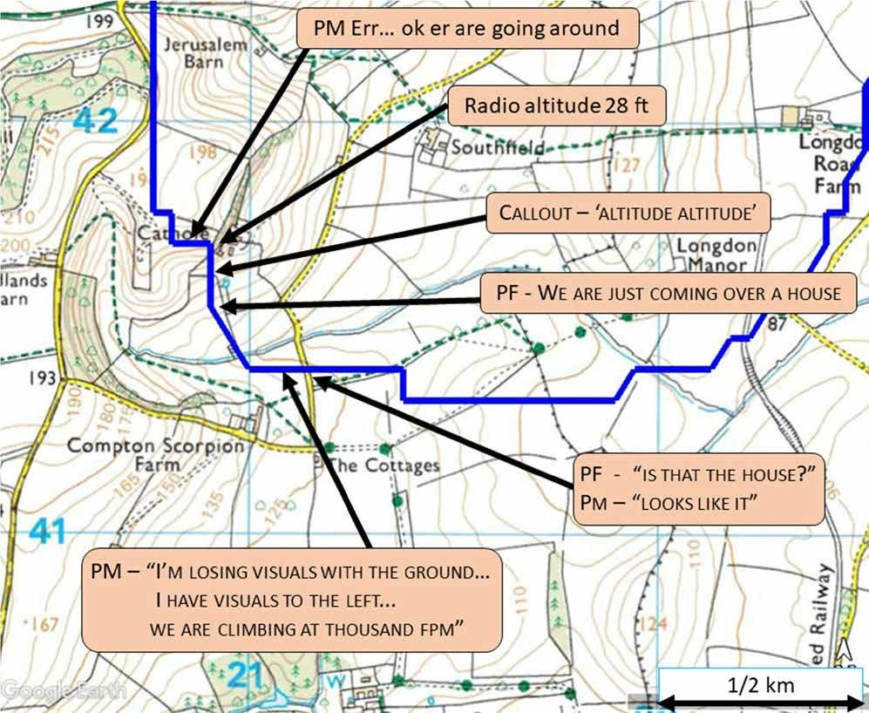
A detailed ground track as the helicopter approached 28 feet agl close to a house. [Reproduced from the Official Report]
The PF then commenced an emergency climb by rapidly raising the collective and increasing the engine torque to 131% and a ‘low rotor’ warning was annunciated. The pitch attitude of the helicopter remained below the horizon and after initially achieving a positive rate of climb, this ceased and it flew level at less than 300 feet agl until the PM prompted the PF to raise the nose significantly above the horizon which achieved a high rate of climb at negligible airspeed. It was noted that the HTAWS ALTITUDE call value not reset following the emergency climb “which indicates that the pilots did not complete the go-around checks”.
The helicopter was levelled off at just over 2,200 feet QNH (1,500 feet agl) and began a right turn onto east whilst accelerating and becoming stabilised and the PF called “visual”. Soon after this, the PM stated that he was “visual with the ground”. It was now night and the PF then confirmed that he intended to attempt another approach to the landing site using the ‘Dragon GL3’ visual approach aid (see under ‘Discussion’ below) which he had set up at the landing site and that if this was unsuccessful, they would divert back to Birmingham. He subsequently stated that he had “recognised that a significant over-torque had occurred during the emergency climb and as a result, he was concerned for the serviceability of the helicopter and sought to land as soon as possible”.
The PF then flew the helicopter to a point 5 nm south of the landing site, since the GL3 had been set up for an approach from that direction. He declined another suggestion from the PM to make use of the automation capability. Initially, this second approach "varied 45° either side of the approach track of 010º (M) as the PF sought to avoid cloud”. The PM gave deviation calls as well as expressing doubts about continuing and when 3 nm from the landing site, suggested returning to Birmingham. The PF responded with “I’m just going to….err….try one more mile” but passing 800 feet agl, he stated “it’s not going to happen” with the PM agreeing and the PF then saying “we are going around”.
However, the PF took no action to commence a go-around and the PM called that they were descending at 1,000 fpm and the pitch attitude was -10°. This prompted the PF to level off upon which the PM then stated that he was “not happy with this” which the Captain acknowledged but without taking any relevant action. Ten seconds later, 1.1 nm from the landing site and approximately 500 feet agl (and 1000 feet QNH) the PF called, “there’s the landing light, there’s the landing light” upon which the approach was stabilised and a landing followed two minutes later.

Discussion
It was considered that the familiarity of the PF with the landing site and surrounding area was likely to have influenced the extent of pre-flight planning and threat assessment prior to departure for what would need to be a VMC approach to the landing site. It was also concluded that the decision to attempt to reach the landing site in the prevailing weather conditions and under time pressure indicated that “the crew felt under pressure to conduct the flight, but may not have recognised this pressure or the effect it had on their decisions”. In the case of the PF Captain, this pressure was likely to have been “aggravated by the combination of his operational and client-facing roles” which was liable to increase his focus on achieving the operator’s commercial objectives whilst diminishing his ability to make safety-focused decisions in marginal weather conditions.
The landing site lacked any significant cultural lighting as did the area where the closest terrain proximity occurred during the unsuccessful first approach. On request, the UK Meteorological Office calculated that the light level in the vicinity of the landing sight would have been 457 millilux when the helicopter left Birmingham, 110 millilux at 1740 just before 28 feet agl was recorded and 52 millilux at 1745, just after the emergency climb had been commenced. For comparison with good night conditions (night was from 1746) , a full moon on a clear night was stated to provide a light level of approximately 250 millilux.
The available evidence suggested that the extent to which the PM had felt able to challenge the operational decisions of the PF had been limited. It was noted in this context that whilst the OM stated that the company “would support the decision of a pilot not to fly, there was no formal process for actively challenging a decision to fly”.
The unstable flight path which characterised both approaches towards the landing site was considered to be a classic illustration of the challenges of operating in a degraded visual environment, of the importance of avoiding such circumstances in the first place but if they cannot be avoided, identifying and actively managing the threats arising, using automation to deliver platform stability and ensuring training to transition safely to instrument flight.
The PF Captain’s reluctance to use any of the available automation capability was, according to his subsequent statement, that he was “concerned to maintain his manual flying skills, mindful of his limited flying currency”.
The portable ‘Dragon GL3’ visual approach aid which the PF Captain stated that he intended to use for the second night approach to the landing site was, according to the aircraft operator, “only expected to be used in VMC” but its use otherwise was not prohibited in the OM.
The findings of the Investigation led to a series of observations in respect of various aspects of the conduct of the flight including, in summary, the following:
▪ Observing the Rules of the Air when landing
Rules of the Air in many jurisdictions, including the UK and those subject to the EASA regulatory regime, allow descent below the otherwise applicable minimum height. Pilots planning to use this landing exception to descend below the relevant minimum height before reaching the destination increase their risk of operating in circumstances that are not suitable for visual flight.
▪ Off-Aerodrome Landings - Stabilised Approaches
There is no regulatory requirement for helicopter operators to establish stabilised approach criteria for visual approaches despite the fact that such approach procedures can be highly beneficial, especially (but not only) at night. The Investigation concluded that, as in this case, recognition that a flight path is becoming / has become unstable is often delayed beyond the point where corrective action is required.
▪ Degraded Visual Environments
The broader hazards of flying a helicopter in one or more of reduced visibility, low cloud and declining light levels are well recognised as a factor in unstable helicopter flight paths but guidance on managing such hazards is not offered.
▪ Use of GPS-based navigation systems
These systems are capable of displaying current position relative to a desired position but reference to such information, as in the case of the first approach and its close proximity to buildings and terrain, is likely to be poor when crew attention is fully focused on maintaining visual references.
▪ HTAWS Altitude Alerting
The necessary facility to change altitude alerting value in the HTAWS or other radio altimeter-based system in helicopters provides pilots, as in this case, with the option to set the alert to a value which is 100 feet below the minimum height for VFR flight in daylight in circumstances where it would not be possible to maintain the required separation from any person, vehicle or structure. It was also noted that the fact that the PF Captain indicated that pilots “considered some altitude and terrain alerts a nuisance, creating a distraction and providing no benefit”was a result of the setting of alert values which were either inappropriate for the phase of flight or not consistent with available SOPs.
▪ Barometric Altitude Alerting
The opportunity to include a procedure for use of the available barometric altitude alerting system in the [[OM]] was not availed of yet setting alerts at pre-determined en route and approach minima for visual flight provides an additional barrier to inadvertent descent below those minima.
▪ Onshore PinS (Point in Space) operations
GNSS-based PinS operations enable helicopters to conduct flight in IMC to or from a PinS abeam the aerodrome or landing site and the helicopter then flies to or from the PinS visually. It was noted that the UK CAA accepts that the helicopter IFR operations are limited to the use of procedures designed for fixed-wing aircraft and in general many available helicopter landing sites lack ground navigation aids hence the potential role for PinS procedures.
▪ Helicopter Flight Data Monitoring (HFDM)
Operators are expected to have methods to detect actions contrary to their existing SOPs, breaches of the Rules of the Air and unstabilised approaches but there are no UK or European requirements which indicate how such risks, either actual or predicted by trending should be identified. It was noted that the CAA has noted the benefits of regulatory requirements HFDM which apply to offshore helicopters and large aeroplanes and has previously stated that similar requirements for onshore operations “should be considered” despite the challenges it presents.
The Conclusion of the Investigation was formally stated as follows:
The helicopter flew unintentionally to within 28 feet of rising terrain because the pilots had lost situational awareness in low visibility approaching night, in conditions that were not suitable for the flight to be conducted under VFR. The available automatic and terrain awareness systems were not employed effectively. The Serious Incident could have been avoided by not conducting the flight, by flying to an alternate aerodrome available en route, or by diverting either to the departure aerodrome or to the alternate aerodrome as soon as the flight was no longer able to comply with VFR. The pilots’ ability to make effective decisions was probably adversely affected by several cognitive biases arising from the circumstances of the flight and their desire to accomplish the mission. The helicopter was equipped, and its pilots qualified, to fly under IFR to an aerodrome with published instrument approaches. The helicopter was equipped with a TAWS that functioned correctly and provided warnings that, if heeded, would have prevented the unintended flight towards terrain.
Eight Safety Recommendations were made as follows:
* that the Civil Aviation Authority publish guidance on the meaning and intention of the phase of flight alleviations in UK SERA where detailed as “except for take-off and landing” to better enable pilots to plan and act on minimum height requirements for safe operations.[2021-025]
* that Starspeed Ltd specify in its operations manual stabilised approach criteria for visual approaches, including at off-aerodrome landing sites. [2021-026]
* that the Civil Aviation Authority encourage the development and deployment of Point-in-Space operations at landing sites. [2021-027]
* that the Civil Aviation Authority revise its guidance on helicopter flight in degraded visual conditions to include further information on managing the associated risks. [2021-028]
* that Starspeed Ltd describe in its operations manual for the Sikorsky S92 helicopter the criteria for setting barometric altitude alert values at each stage of a flight. [2021-029]
* that Starspeed Ltd specify in its operations manual a formal process for crew members to monitor, escalate concerns and, if necessary, take control during a flight. [2021-030]
* that the Civil Aviation Authority ensure that operators show clear evidence within their system for operational control as required by UK ORO.GEN.110 (c), of how the tasking process separates the customer from the flight crew. [2021-031]
* that the Civil Aviation Authority assess the safety benefits and feasibility of Helicopter Flight Data Monitoring programmes for onshore helicopter operators conducting commercial operations or non-commercial complex operations and publish its findings. [2021-032]
Safety Action taken by Starspeed as a result of the investigated event was noted as having included:
- transferring the role of Safety Manager from the PF Captain involved in the investigated event to the Compliance Manager and has begun the process of delegating responsibility for the SMS from the Accountable Manager to the Compliance Manager
- adding a note to the GL3 Procedure in the EFB stating that “the GL3 is NOT an aid for poor or marginal visual conditions and is to be used as Visual Approach Aid in VMC ONLY”. No corresponding change to the OM was notified.
- Amended the OM Part ‘A’ to address operations in marginal weather conditions including the following areas:
  - Definition of ‘marginal conditions’ by day and night
  - Departure at night in VMC
  - Airspeeds to be flown
  - Indicated airspeeds to be flown
  - Assessment of cloud base at off-airfield landing sites
  - Light levels and time of year
  - Planning and briefing of approach and departure routes
  - Use of the GL3
  - The requirement for an alternate plan
  - Operational control and supervision of the go/no go decision in marginal conditions
  - Operational control and supervision of management post holders when flying
- Revised OM Parts A, B and D and included an SOP for deviation calls in multi-pilot operations.

