Mountain Flying
2018/2-26-31 (E) PP

Abstract: Lasting 15 to 30 minutes, this presentation acquaints the audience with some essential elements of Mountain Flying and the benefits of Mountain Flying instruction from qualified CFIs.
Format: Information Briefing - Power Point presentation
Required Personnel – FAASTeam Program Manager or designated FAASTeam Rep (s)
Optional Personnel – CFIs and DPEs who can speak on mountain flying challenges and the benefits of environment-specific flight training. Local Mountain Flying experts will be particularly effective in this regard.
AFS 850 Support:
In addition to this guidance document, a Power Point presentation that supports the program is provided. FPMs and presenters are encouraged to customize this presentation to reflect each individual program.

Appendix I – Equipment and Staging
Equipment:
- Projection Screen & Video Projector suitable for expected audience
  - Remote computer/projector control available at lectern or presenter location
    - In lieu of remote – detail a Rep to computer/projector control.
- Presentation Computer
  - Note: It is strongly suggested that the entire program reside on this computer.
- Back up Projector/Computer/Media as available.
- PA system suitable for expected audience
  - Microphones for Moderator and Panel
    - Optional Microphone (s) for audience
- Lectern (optional)
Staging:
- Arrange the projection screen for maximum visibility from the audience.
- Equip with PA microphones
- Place Lectern to one side of screen. This will be used by presenters and moderator

Slides | Script
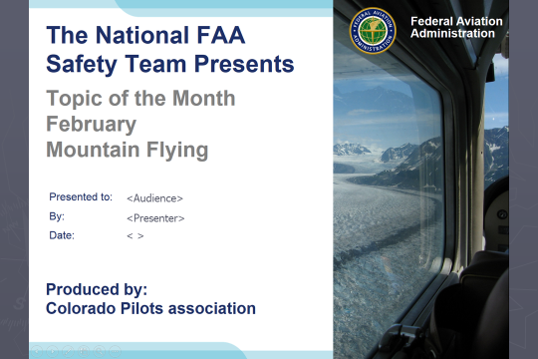 | Slide 1  2018/2-26-31 (E) PP Original Author, Bill Standerfer (CO Pilots Association); POC Kevin Clover, AFS-920 Operations Lead, Office 562-888-2020; reviewed by John Steuernagle 02/05/2018  Presentation Note: This is the title slide for Mountain Flying  Presentation notes (stage direction and presentation suggestions) will be preceded by a Bold header: the notes themselves will be in Italic fonts.  Program control instructions will be in bold fonts and look like this: (Click) for building information within a slide; or this: (Next Slide) for slide advance.  Some slides contain background information that supports the concepts presented in the program.  Background information will always appear last and will be preceded by a bold Background: identification.  We have included a script of suggested dialog with each slide. Presenters may read the script or modify it to suit their own presentation style.  The production team hope you and your audience will enjoy the show. Break a leg!  (Next Slide)
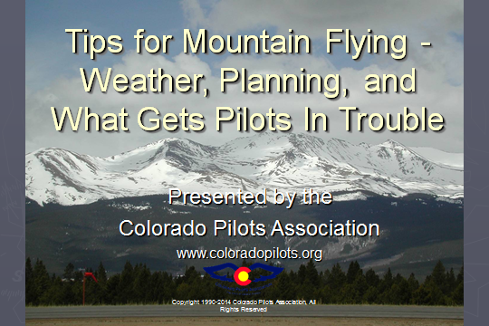 | Slide 2  Welcome to Tips for Mountain Flying – Prepared for the Topic of the Month series by the Colorado Pilots Association. This presentation contains valuable information compiled by veteran mountain pilots but it is not a comprehensive mountain flying course. Pilots new to mountain flying should seek experienced mountain flying instruction before venturing into the high country.  (Next Slide)
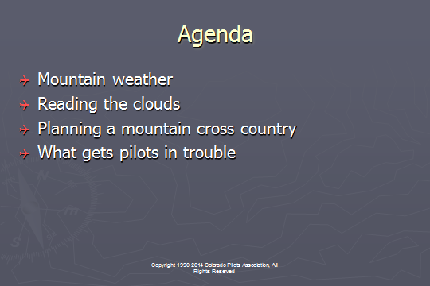 | Slide 3  This briefing will highlight some of the important aspects you will learn in a quality mountain flying course. It is not a complete course, but should be a reminder to get good training before you fly in the mountains.  Presentation Note: Here’s where you can also discuss venue logistics, acknowledge sponsors, and deliver other information you want your audience to know in the beginning.  You can add slides after this one to fit your situation. (Next Slide)
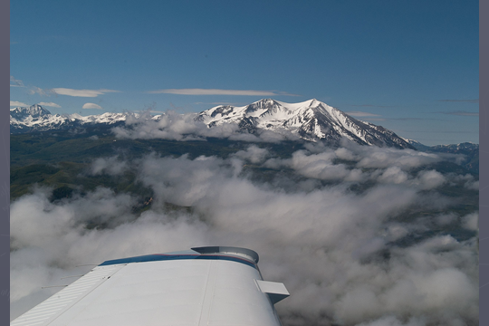 | Slide 4  Flying in the in the mountains offers beautiful scenery and views you can’t get from the ground. It doesn’t matter whether it’s the Rockies, the Appalachians, or the Alps, there are scenes that are unforgettable.  (Next Slide)
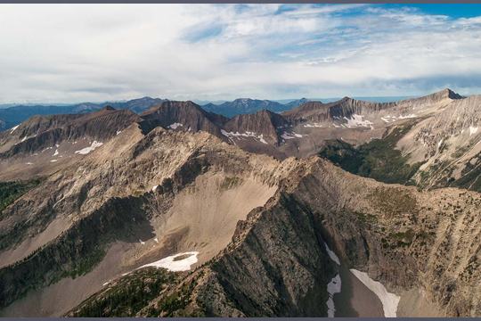 | Slide 5  However, the mountains’ beautiful scenery also involves more risks than flying over the flatlands.  (Next Slide)
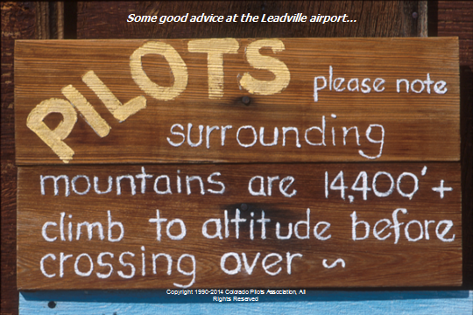 | Slide 6  This picture that used to grace the entrance to the FBO at Leadville, Colorado tells the story. In many cases in the mountains, especially the Colorado Rockies, pilots are confronted with very high terrain that will press the limits of most GA aircraft. For example, Colorado has 54 peaks over 14,000’ and over 600 peaks above 13,000’. To safely fly in these areas, you must get quality ground training to master the basics of mountain flying, then fly with an experienced flight instructor in the mountains to get practice the techniques used to safely operate around the high terrain.  In this presentation, we will focus on operating in the Rockies of the western US, but the principles are the same for flying in any mountainous areas.  (Next Slide)
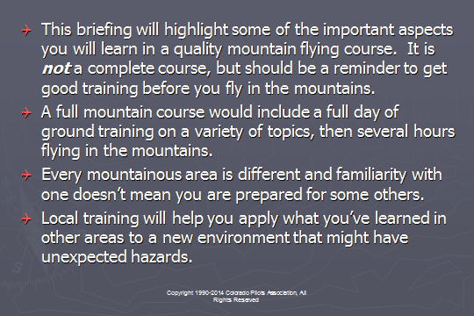 | Slide 7  Presentation Note: Review the slide content with the audience. Make sure they understand that the Topic of the Month subject does not qualify pilots to fly safely in mountain environments.  (Next Slide)
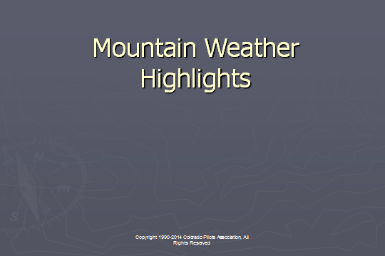 | Slide 8  A good mountain ground school will spend a lot of time on mountain weather factors. It is very important that you get a solid understanding of how the weather interacts with the terrain and how that might affect your ability to fly safely in the mountains.  (Next Slide)
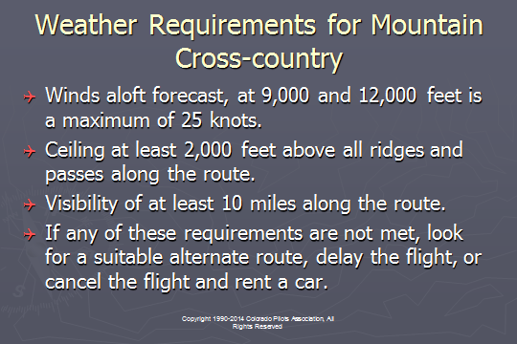 | Slide 9  For pilots with little or no experience flying in the mountains, the winds at mountaintop level should be no more than 25 knots. Above that level, the turbulence and up and down drafts could be uncomfortable at best and often dangerous for GA aircraft.  A ceiling of at least 2000’ above all ridges on the route will help reduce the exposure to the most hazardous turbulence in most cases. This should be increased as the wind speed increases.  Good visibility, well above the basic VFR requirements, is needed since you will generally be using pilotage for navigating. GPS is an excellent tool, but there are times when picking out a particular pass or valley will need to be done visually. Good visibility is the only way to be able to do that safely.  (Next Slide)
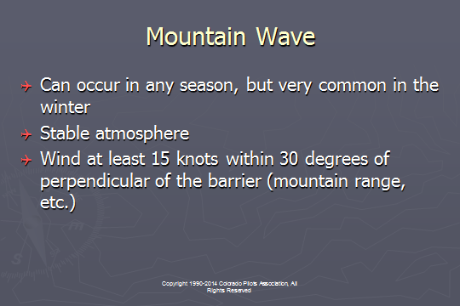 | Slide 10  Mountain wave can cause very strong up and down drafts that will easily exceed the capability of almost any GA aircraft. There is also severe or worse turbulence associated with the rotor that develops with mountain wave. It requires a stable upper atmosphere and moderate wind across a barrier, like a mountain range or even a single peak.  (Next Slide)
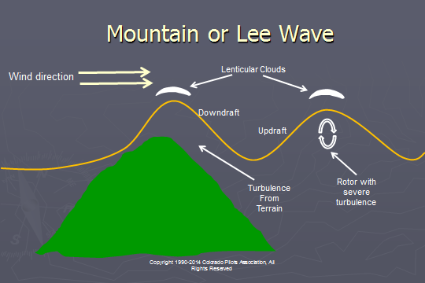 | Slide 11  During a mountain wave event, there are strong up and down drafts downwind from the ridges. The downdrafts in even moderate mountain waves an exceed 1000 feet per minute, making it difficult or impossible to cross the ridge. Rotors are caused by the wind shear and rotating moment underneath the crest of a mountain wave. The rotors will cause severe or greater turbulence and must be avoided.  (Next Slide)
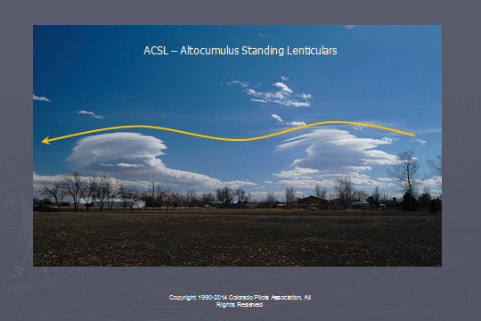 | Slide 12  Your mountain flying course should include a thorough discussion of how to read the clouds. This image, taken looking south from Fort Collins, shows two crests of a mountain wave. There are also a few rotor clouds. You should be able to pick out the places to fly and those places which would be unsafe to operate.  (Next Slide)
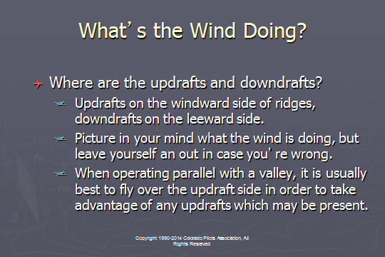 | Slide 13  One of the most important things you can do when learning to fly in the mountains is to learn how to visualize what the wind is doing as it interacts with the terrain. Make an educated guess about where the updrafts and downdrafts are, then leave yourself a good out as you test your theory.  (Next Slide)
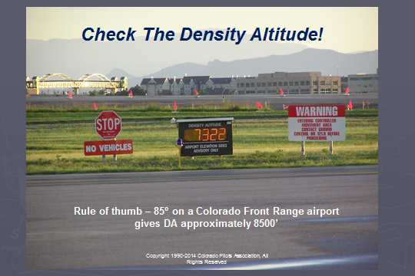 | Slide 14  Failure to take density altitude into consideration has led many pilots into situations their aircraft couldn’t handle. It is imperative that you understand how your aircraft performance is affected by density altitude. This image was taken at Centennial Airport just before sunset one summer evening. You can see that, even in the early evening, the density altitude is quite high and can present problems if you are not properly trained and prepared.  (Next Slide)
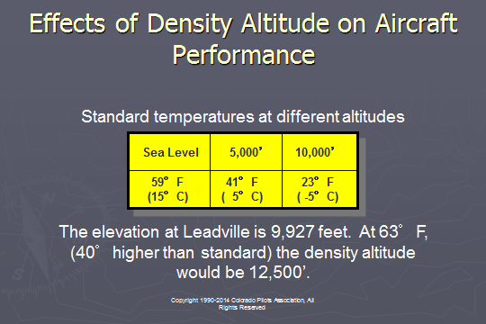 | Slide 15  Above the standard temperature at the altitude you are at means that the density altitude is above the field elevation (assuming altimeter setting of 29.92”). Note that, when the snow is melting at Leadville, Colorado (9937’ MSL), the density altitude is already above the field elevation.  (Next Slide)
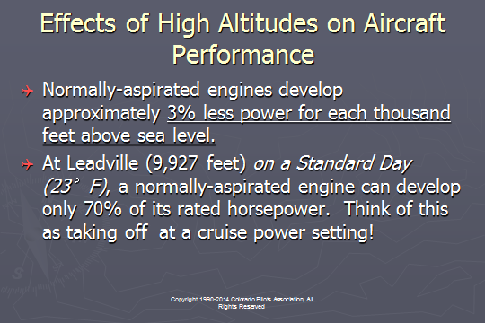 | Slide 16  In order to attain the normal indicated airspeed required for rotation at Leadville, the airplane’s true airspeed will be 20% greater than a sea level. Combine this with a normally aspirated engine, which is putting out 30% less horsepower than at sea level (3% power loss per thousand feet), and you have two factors working against you.  The airplane will be going faster over the ground than what you are used to. You must fight the tendency to attempt to make the aircraft fly before it is ready.  Many pilots have said about an airstrip, “If I can get the airplane into there, I can get it out!” In high density altitudes, that will often not be the case.  (Next Slide)
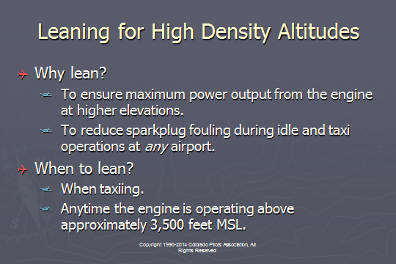 | Slide 17  During your mountain flight training, your instructor should discuss the proper way to lean your aircraft engine. At sea level or the low levels of the Midwest, takeoffs with full rich mixture are required. However, at higher density altitudes, even those found at airports along the Front Range of the Rockies from New Mexico to Wyoming, leaning for takeoff is the only way to get the expected performance from a normally aspirated engine.  (Next Slide)
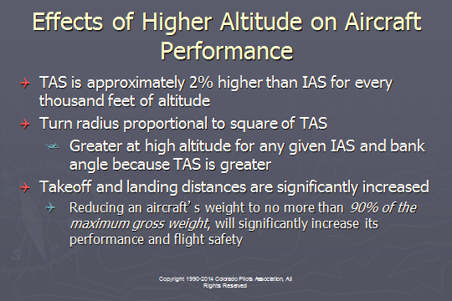 | Slide 18  An indicated airspeed of 80 knots would be approximately 96 knots true airspeed at 10,000 feet above sea level.  For a given bank angle, a greater speed results in a greater turn radius. So even though you may be flying at 80 knots indicated, you true airspeed is 96 knots and your turn radius for the same bank angle is significantly greater.  The higher true airspeed translates into a longer landing roll as the aircraft touchdown has 20% more speed than it would at sea level. The effect is similar to landing with a tailwind!  This also causes a visual illusion during landing. As you get close to touchdown, the ground appears to be rushing by faster than what you are accustomed to at lower elevation. You must override your intuition and fly the airplane based on its indicated airspeed.  (Next Slide)
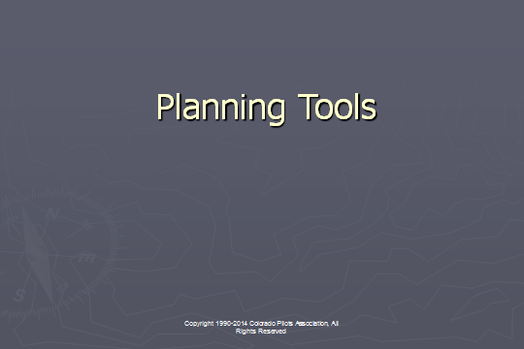 | Slide 19  (Next Slide)
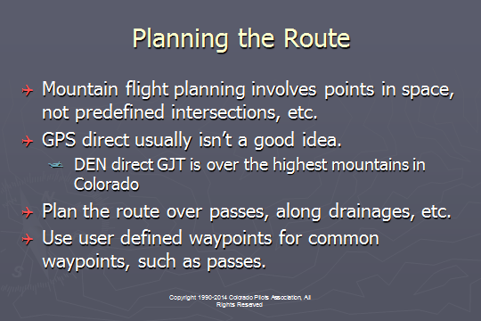 | Slide 20  Planning a mountain flight involves finding points in space, not predefined intersections. You are looking for terrain features, such as passes and drainages. Using GPS waypoints in conjunction with an iPad app, such as Foreflight or Garmin Pilot, is a good way to maintain situational awareness and avoid getting lost in unfamiliar terrain. A good mountain flying course will teach you how to select routes over passes and along drainages that will keep you safe.  (Next Slide)
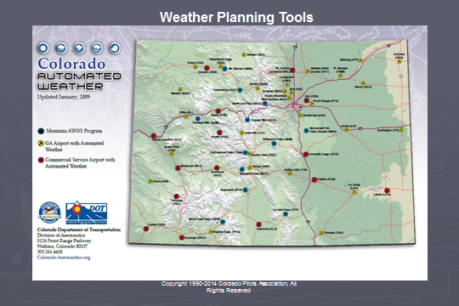 | Slide 21  Some states produce tools to help pilots navigate their mountains safely. This example is produced by the Colorado Aeronautical Division and shows all of the AWOS locations in the state, including those on mountain ridges.  (Next Slide)
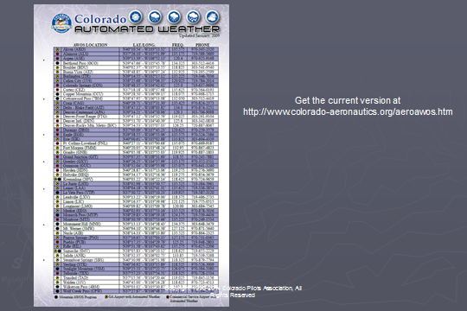 | Slide 22  The back side of the page has the frequency and phone numbers of each of the AWOS locations so you can call directly while planning your flight and get real time updates before you launch.  (Next Slide)
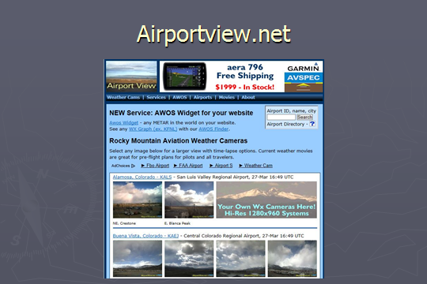 | Slide 23  Webcams are also useful for a real time look at the weather along your route. Airportview.net is one place to go for cameras located at airports. Most state departments of transportation also have webcams that will give you a real time look weather in places you may be operating.  (Next Slide)
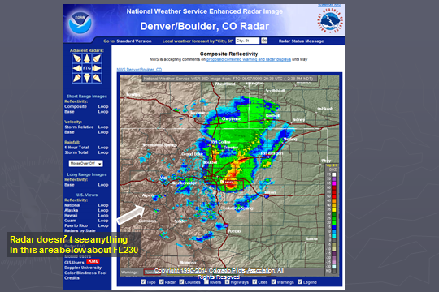 | Slide 24  Many of us are now using radar on our iPad apps while in flight. However, radar and mountains don’t mix very well. For example, the Denver NEXRAD system can’t see anything below about FL230 over the central part of the state. You may not be seeing the complete picture because of these limitations.  (Next Slide)
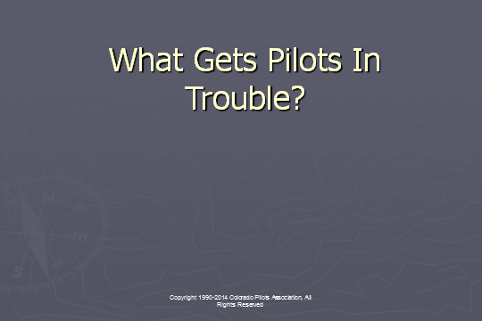 | Slide 25  (Next Slide)
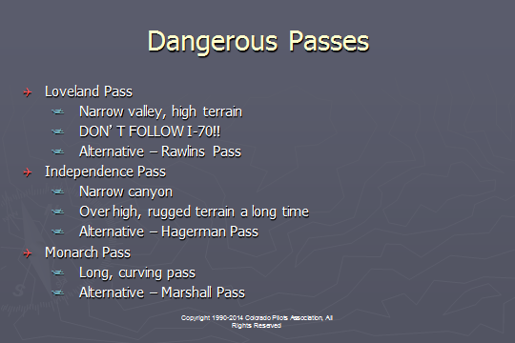 | Slide 26  Picking the wrong route has claimed many pilots who didn’t have local knowledge of issues that might be associated with some passes. For example, in Colorado, these three passes have historically had more aircraft accidents than any other passes in the state. Under the right conditions, you could, of course, use these passes, but most local instructors will recommend avoiding them in favor of nearby alternates.  (Next Slide)
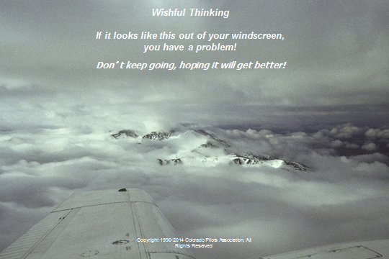 | Slide 27  Hoping that bad weather will suddenly get better when we need it to has trapped many pilots. Mountains obscured with clouds has taken the lives of many pilots in the mountains who continued instead of landing or turning around.  (Next Slide)
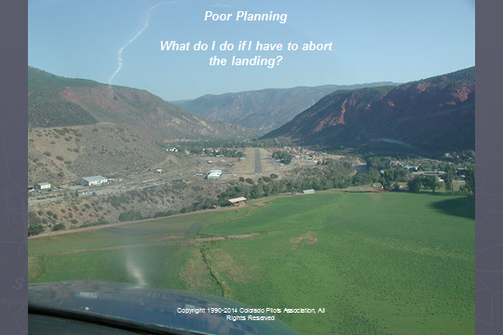 | Slide 28  Before descending into a mountain airport, look at what your options are for go-arounds and takeoff routes. On this approach to the Glenwood Springs airport, if you had not surveyed the area before descending, you might get here on final and wonder it that really is a box canyon ahead.  (Next Slide)
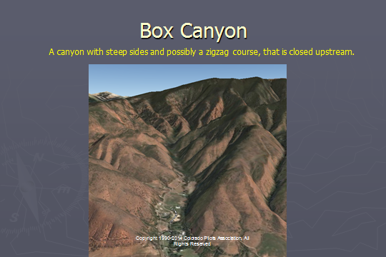 | Slide 29  Never fly up a canyon that you haven’t already flown down so that you know if there is room to turn around. NEVER try to out climb the terrain in ANY airplane.  (Next Slide)
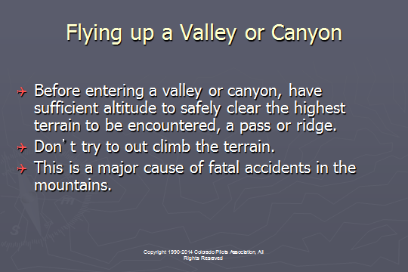 | Slide 30  Many pilots have lost the bet that their airplane can out-climb terrain that leads to a box canyon. Careful route planning will help avoid this.  (Next Slide)
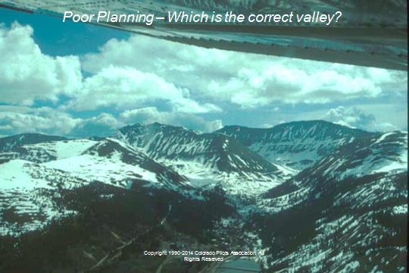 | Slide 31  Doing adequate preflight planning will give you the correct heading to expect when picking the right valley to fly through. Making the wrong choice could get you into a position from which you can’t escape. In this case, there are at least four valleys you might take, but only one is correct. The other three quickly become box canyons with rapidly rising terrain that you wouldn’t be able to out-climb or turn around in.  (Next Slide)
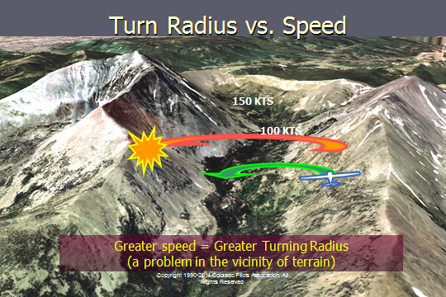 | Slide 32  PLANNING YOUR ESCAPE: Always leave plenty of room for turns in canyons.  - Do NOT enter a canyon which will not allow a 180 degree turn plus a descent.  - Remember that turn radius increases as the square of true airspeed. It will be dramatically wider with even small increases in TAS.  (Next Slide)
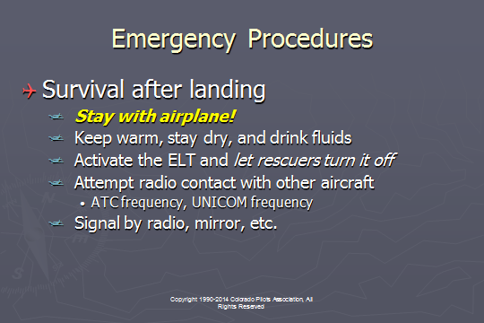 | Slide 33  It is extremely important to stay with the airplane after an accident. Individual people are very difficult to see from a search airplane. If you survived the crash, that means that the cabin is probably in tact enough to be used as a shelter until you are rescued.  After the crash, remove the ELT from the aircraft, turn it on, and let your rescuers turn it off.  (Next Slide)
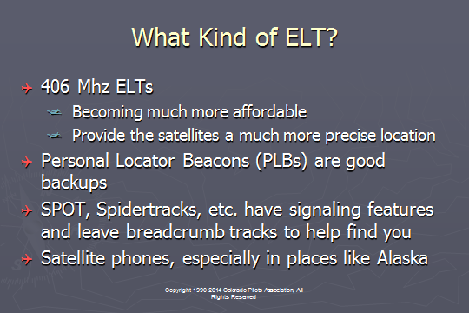 | Slide 34  Satellites no longer monitor 121.5 Mhz, so you have to depend on some ground station or other aircraft to hear it. 406 Mhz is monitored now and the higher frequency gives a much more precise location for searchers. Some units also have the ability to transmit your GPS coordinates.  PLBs can be good backups and can be carried in your pocket incase the aircraft’s ELT is damaged in the crash. SPOT, Spidertracks, and other similar locators also have a way to signal that you need help. They also transmit your position back to a monitoring facility, so searchers can narrow down the search area and find you much quicker.  (Next Slide)
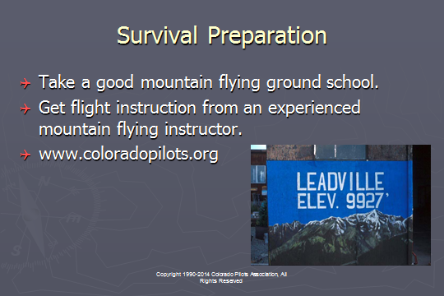 | Slide 35  The Colorado Pilots Association comprehensive mountain flying training, including a full day ground school and a mountain training flight with an experienced mountain instructor. For more information and class dates, contact the CPA at www.coloradopilots.org.  (Next Slide)
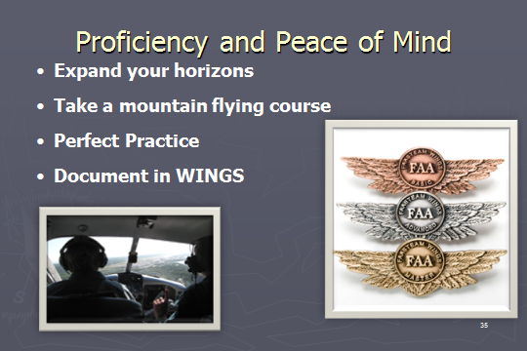 | Slide 36  There’s nothing like the feeling you get when you know you’re playing your A game and in order to do that you need a good coach. (Click)  So fly regularly with a CFI who will challenge you to review what you know, explore new horizons, and to always do your best. Of course you’ll  have to dedicate time and money to your proficiency program but it’s well worth it for the peace of mind that comes with confidence. (Click)  If you’re a flat lander why not take a mountain flying course as part of your proficiency training. Learning something new is always rewarding and much of what  you learn while training in the mountains will improve your performance in lower terrain environments as well.  Vince Lombardi, the famous football coach said, “Practice does not make perfect. Only perfect practice makes perfect.” For pilots that means  flying with precision. On course, on altitude, on speed all the time. (Click)  And be sure to document your achievement in the Wings Proficiency Program. It’s a great way to stay on top of your game and keep you flight review current.  (Next Slide)
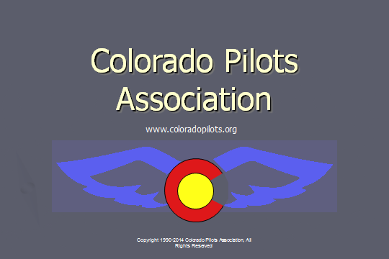 | Slide 37  The End

