Notes
Pilots and Medications
2019/02-15-157(I)PP

Abstract: Lasting 10 to 15 minutes, this presentation acquaints the audience with the hazards associated with flying while taking prescription and/or over-the-counter (OTC) medications
Format: Information Briefing - Power Point presentation
Required Personnel – FAASTeam Program Manager or designated FAASTeam Rep (s)
Optional Personnel – Medical Doctors, EMTs, Nurses, and Medical Workers who can speak on the hazards of flying while medicating.
AFS 920 Support:
In addition to this guidance document, a Power Point presentation that supports the program is provided. FPMs and presenters are encouraged to customize this presentation to reflect each individual program.

Appendix I – Equipment and Staging
Equipment:
- Projection Screen & Video Projector suitable for expected audience
  - Remote computer/projector control available at lectern or presenter location
    - In lieu of remote – detail a Rep to computer/projector control.
- Presentation Computer
  - Note: It is strongly suggested that the entire program reside on this computer.
- Back up Projector/Computer/Media as available.
- PA system suitable for expected audience
  - Microphones for Moderator and Panel
    - Optional Microphone (s) for audience
- Lectern (optional)
Staging:
- Arrange the projection screen for maximum visibility from the audience.
- Equip with PA microphones
- Place Lectern to one side of screen. This will be used by presenters and moderator

Slides | Script
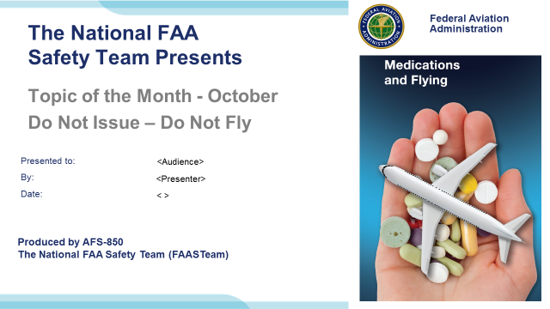 | Slide 1  2019/02-15-157(I)PP Original Author: John Steuernagle; POC Kevin Clover, AFS-850 Operations Lead, Office 562-888-2020  Presentation Note: This is the title slide for Do not Issue – Do not Fly.  Presentation notes (stage direction and presentation suggestions) will be preceded by a Bold header: the notes themselves will be in Italic fonts.  Program control instructions will be in bold fonts and look like this: (Click) for building information within a slide; or this: (Next Slide) for slide advance.  Some slides may contain background information that supports the concepts presented in the program.  Background information will always appear last and will be preceded by a bold Background: identification.  We have included a script of suggested dialog with each slide. Presenters may read the script or modify it to suit their own presentation style.  The production team hope you and your audience will enjoy the show. Break a leg!  (Next Slide)
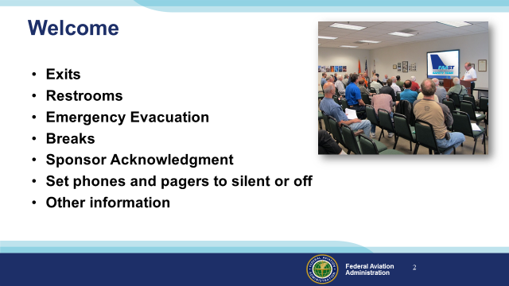 | Slide 2  Presentation Note: Here’s where you can discuss venue logistics, acknowledge sponsors, and deliver other information you want your audience to know in the beginning.  You can add slides after this one to fit your situation. (Next Slide)
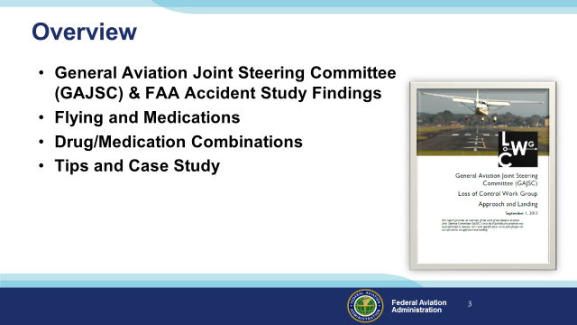 | Slide 3  In this presentation we’ll talk a little bit about a recent GAJSC and FAA studies that feature some interesting findings with respect to pilots and medications  We’ll talk generally about flying while medicating and specifically about FAA’s Do not Issue (medical certificates) and Do not Fly Lists of over-the-counter and  prescription drugs.  Presentation Note: If you’ll be discussing additional items, add them to this list  (Next Slide)
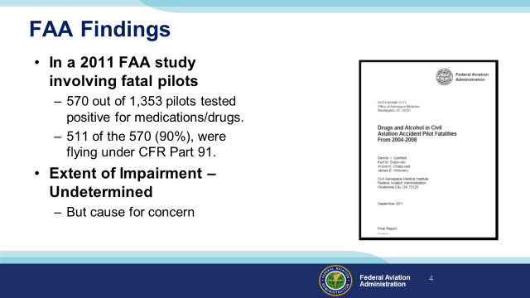 | Slide 4  In a 2011 study from the FAA’s CAMI Toxicology Lab drugs/medications were found in 570 pilots (42%) from 1,353 total fatal pilots tested. Most of the pilots with positive drug results, 511 (90%), were flying under CFR Part 91.”. (Click)  While there were a couple instances of recreational drugs, the majority were prescription or over the counter medications. Antihistamines were the most commonly found. Left undetermined was the extent of pilot impairment – if any – due to drug use but the issue is cause for concern for several reasons:  (Next Slide)
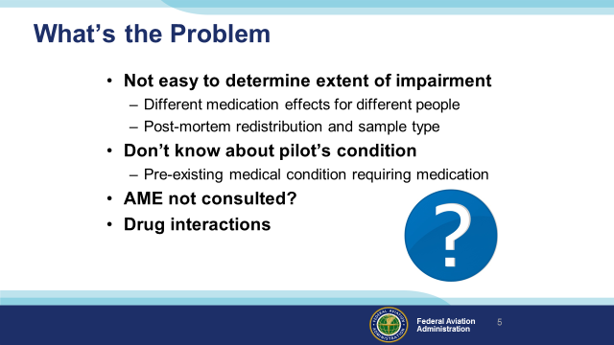 | Slide 5  So what’s the problem:  First of all – We all know that some medications may compromise a pilot’s ability to control the aircraft and/or adversely affect judgment and decision-making. (Click)  What’s not so obvious is it’s difficult for investigators to say for sure that pilot performance was compromised because the effect of drugs and medications varies widely among individuals. In addition, post-mortem redistribution of a substance creates some confusion as to the actual blood levels prior to the accident. The amount of a substance may vary considerably in different tissues. (Click)  A less obvious problem poses the question; what pre-existing physical condition requires the use of medication in the first place? (Click)  It’s not unusual to find that pilots are evaluated and treated for conditions that are not revealed to their Aviation Medical Examiners. In those cases an AME doesn’t have an opportunity to review the complete medical history of diagnoses and treatments for some of the pilots they examine. (Click)  There’s also the issue of drug interactions but we’ll get to that a little bit later. (Click)  A less obvious problem poses the question; what underlying physical condition requires the use of medication in the first place? (Click)  It’s not unusual to find that pilots are evaluated and treated for conditions that are not revealed to their Aviation Medical Examiners. In those cases the AME doesn’t have an opportunity to review complete pilot history of diagnosis and treatment. (Click)  There’s also the issue of drug interactions but we’ll get to that a little bit later.  (Next Slide)
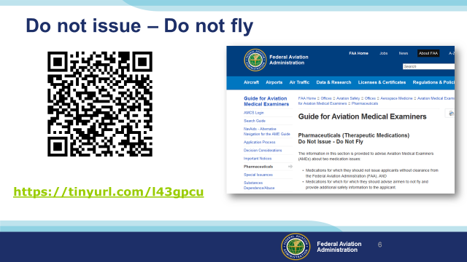 | Slide 6  You and your Aviation Medical Examiner can access lists of medications that preclude medical certificate issuance (Do not Issue) or medications that are not  compatible with safe flight operations (Do not Fly). Those lists are available at the website shown on the screen.  In the following slides we’ll take a quick look at drugs on the list.  Presentation Note: You can access the Do not Issue – Do not Fly lists at this URL: https://www.faa.gov/about/office_org/headquarters_offices/avs/offices/aam/ame/guide/pharm/dni_dnf/  (Next Slide)
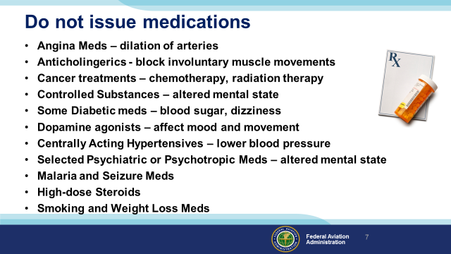 | Slide 7  Although Medical Examiners may not issue medical certificates to pilots who are taking medicines on this list; they may be able to suggest alternative allowable medicines.  But in order to have that conversation you’ll need to disclose ALL the medications – prescribed and OTC – to your AME.  (Next Slide)
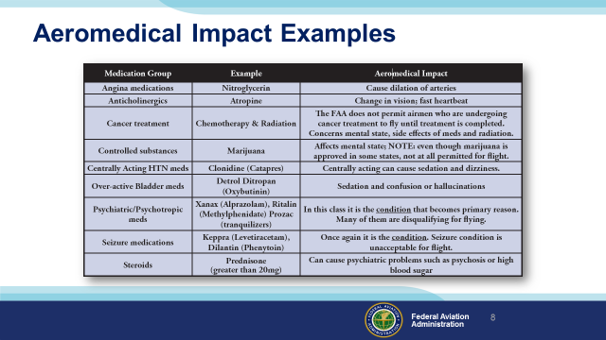 | Slide 8  Here’s a little insight as to why some drugs appear on the Do not Issue - Do not Fly lists.  Obviously the impact of these drugs can be serious. The extent of impairment depends on the individual but the use of these drugs  and the underlying diseases they treat are obvious disqualifying factors for medical certification.  (Next Slide)
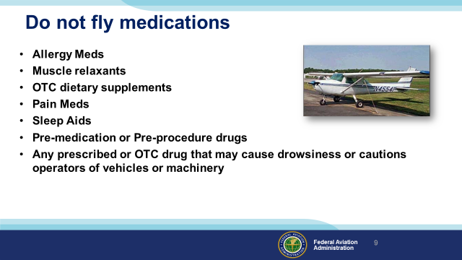 | Slide 9  While these drugs may not disqualify applicants for medical certificates, they do preclude flying until the effects of the drug are no longer present.  (Next Slide)
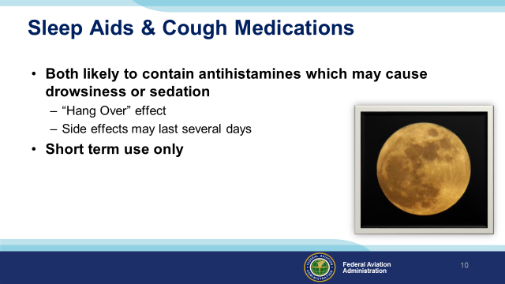 | Slide 9  A word on OTC sleep aids and cough medications: (Click)  Sleep aids obviously are intended to promote sleep but their effects – resembling a hangover - may persist into the several days – not a good idea if you’re going flying. (Click)  Also – tolerance to active ingredients builds quickly so you’ll find you’re taking more and more medicine to achieve the same result. (Click)  All OTC medications are intended for temporary use. Taking them for longer than the recommended time may mask symptoms of a significant or serious underlying medical condition.  (Next Slide)
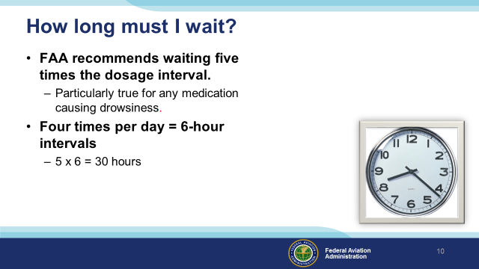 | Slide 11  If you’ve been taking a medication that precludes flying, how long must you wait after ceasing the medication before you return to the air? (Click)  This is a good question for your AME to answer but the general rule is to wait until 5 times the dosage interval has passed. (Click)  For example; if you take a medication 4 times a day (6-hour intervals) you should wait at least 30 hours before resuming pilot duties.  (Next Slide)
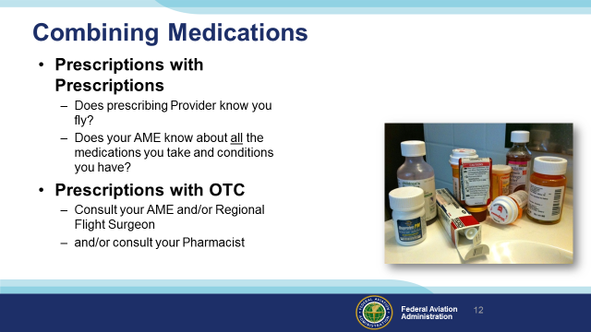 | Slide 12  Look into any medicine cabinet and you’re likely to find a mixture of OTC and prescription meds. Who’s responsible for assessing the affects and possible drug interactions? Making those assessments is something they don’t teach us in pilot school so this may also be a good time to seek some professional help. Before you do that though let’s talk about prescription drugs alone or in combination.  Does your prescribing doctor know you fly? Maybe a more suitable drug could be prescribed if your doctor knows you’re a pilot.  Even more importantly, does your AME know about all the drugs you take and the conditions for which you take them?  Combining prescription and OTC drugs introduces another challenge – the self medicating pilot. Once again it’s safer to consult your AME and/or pharmacist before adding OTC meds to your system.  We’re not going to address recreational drugs here. We all know that flying is about the best recreation there is. It’s not safe and not legal to fly under the influence.  We will look at one case from the GAJSC study though. We’ll discuss it with respect to the PAVE checklist that’s familiar to most if not all of us. I think you’ll find the case study illuminating.  (Next Slide)
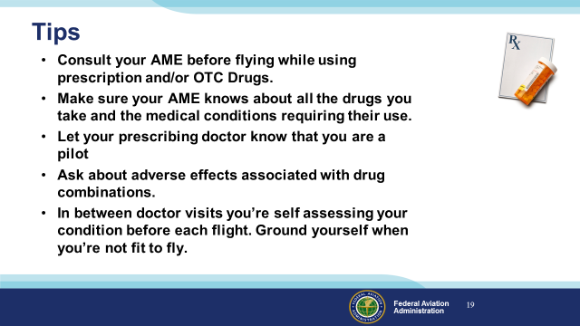 | Slide 13  Finally – here are some tips for safe flying while taking prescribed or OTC medications.  Consult your AME before flying while using prescription and/or OTC Drugs.  Make sure your AME knows about all the drugs you take and the medical conditions requiring their use.  Let your prescribing doctor know that you are a pilot.  Ask about adverse effects associated with drug combinations.  In between doctor visits you’re self assessing your condition before each flight. Ground yourself when you’re not fit to fly.  (Next Slide)
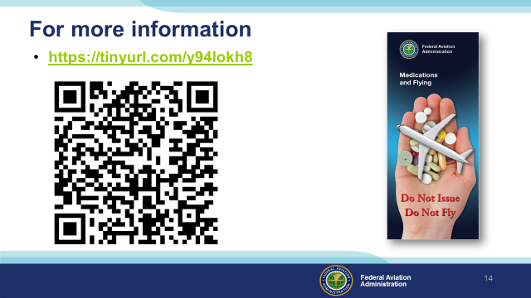 | Slide 14  Much of the information in this presentation was taken from FAA’s Medications and Flying Brochure. You can download a copy at the URL or QR code on the screen.  (Next Slide)
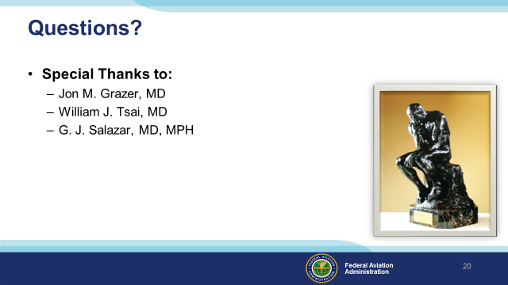 | Slide 15  Presentation Note: You may wish to provide your contact information and main FSDO phone number here. Modify with your information or leave blank.  (Next Slide)
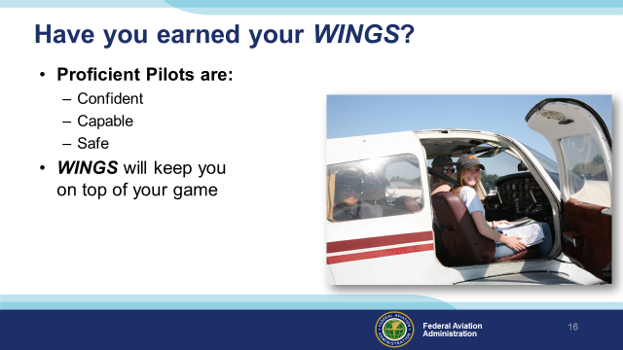 | Slide 16  Have you earned your WINGS? Proficiency is key to success in almost every thing worth doing – especially flying. Proficient pilots are confident, capable, and safe.  WINGS is a proficiency training system specifically designed for general aviation pilots and, regular participation will keep you on top of your flying game.  (Next Slide)
 | Slide 17  Now there’s even more reasons to participate in WINGS. Every time you complete a WINGS Phase you’re eligible to win cash the WINGS Sweepstakes.  The sweepstakes is generously funded by Paul Burger, a long time advocate for general aviation safety and a retired aviator who believes participation in this program saves lives. VISIT WWW.MYWINGSINIATIVE.ORG to learn more and enter the sweepstakes.  (Next Slide)
 | Slide 18  After you’ve completed a phase of WINGS you can enter the sweepstakes by clicking on “Claim Rewards” in the “WINGS – at a glance” section of your My WINGS page and select WINGS Sweepstakes. Or you can go directly to the mywingsinitiative.org website.  (Next Slide)
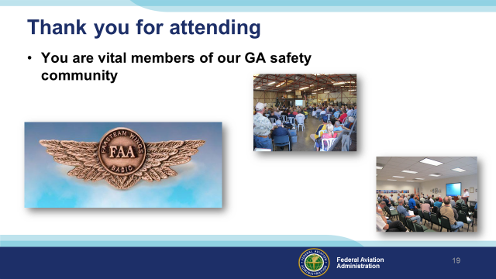 | Slide 19  Your presence here shows that you are vital members of our General Aviation Safety Community. The high standards you keep and the examples you set are a great credit to you and to GA.  Thank you for attending.  (Next Slide)
Slide 20

(The End)

