General Aviation Joint Steering Committee
Outreach Guidance Document
2020/03-06-184(I)PP

This outreach guidance is provided to all FAA and aviation industry groups that are participating in outreach efforts sponsored by the General Aviation Joint Steering Committee (GAJSC). It is important that all outreach on a given topic is coordinated and is free of conflicts. Therefore, all outreach products should be in alignment with the outline and concepts listed below for this topic.

Outreach Month: September 2021

Topic: Service Bulletins and the Aircraft Owner
The FAA and industry will conduct a public education campaign emphasizing the value compliance with manufacturer’s Service Instructions and Service Bulleting
Background:
Manufacturer’s aircraft component Service Bulletins are created in response to servicing issues that may affect airworthiness. Depending on circumstances, compliance with Service Bulletins may or may not be mandatory but they should always be considered.to ensure continued airworthiness. Online access to Service Bulletins and Service Instructions is readily available to aircraft owners, pilots, and mechanics.
Teaching Points:
- In order to ensure the best product possible and to improve product design and maintenance, aircraft manufacturers constantly research the performance of their products.
- Product performance research, including accident investigation, may reveal unanticipated issues with aircraft components.
- As aircraft age new issues may be discovered that require action.
- Service Bulletins and Service Instructions are means to share issues with aircraft owners and maintainers and to guide them in issue resolution.

References:
- Pilot Proficiency and WINGS PowerPoint
  - Available on the National FAASTeam Share Point site under Approved Presentations.
- AC 61-91J – WINGS – Pilot Proficiency Programs

- AC 61-98D – Currency Requirements and Guidance for the Flight Review and Instrument Proficiency Check

Abstract: Lasting 10 to 20 minutes, this presentation acquaints the audience with the benefits of compliance with manufacturer’s Service Bulletins and Service Instructions and provides an example of how Service Bulletins are developed in responsed to identified issues.
Format: Information Briefing - Power Point presentation
Required Personnel – FAASTeam Program Manager or designated FAASTeam Rep (s)
Optional Personnel – Mechanics and IAs who can speak on Service Bulletins and Service Instructions.
AFS 850 Support:
In addition to this guidance document, a Power Point presentation that supports the program is provided. FPMs and presenters are encouraged to customize this presentation to reflect each individual program.

Slides | Script
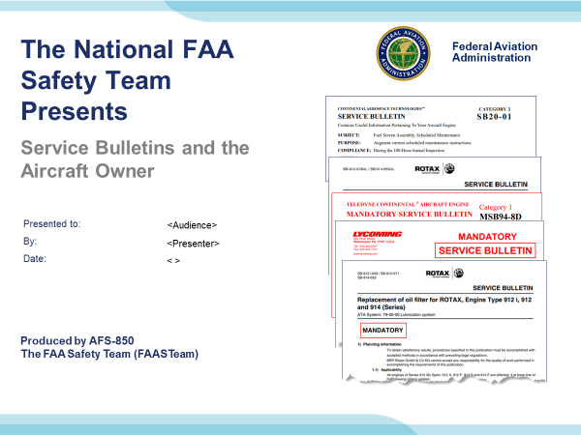 | Slide 1  2020/10-09-208(I)PP Original Author: Gary Knaggs 10/21/2020; POC Guy Minor, AFS-850 Airworthiness Lead, Office (707) 704-3530 revised by Original 10/21/2020  Slide 1 is the title slide for Service Bulletins and the Aircraft Owner  - Script - We have included a script of suggested dialog with most slides. The script will always appear in a non-italic font. Presenters may read the script or modify it to suit their own presentation style. See template slides 5 and 6 for examples of slides with a script.  - Presentation Instructions - (stage direction and presentation suggestions) will be preceded by a Bold header: the instructions themselves will be in Italic fonts. See slides 2, 3, and 4 for examples of slides with Presentation Instructions only.  - Program control instructions - will be in bold fonts and look like this: (Click) for building information within a slide; or this: (Next Slide) for slide advance.  - Background information - Some slides may contain background information that supports the concepts presented in the program.  Background information will always appear last and will be preceded by a bold Background: identification.  The production team hope you and your audience will enjoy the show. Break a leg!  (Next Slide)
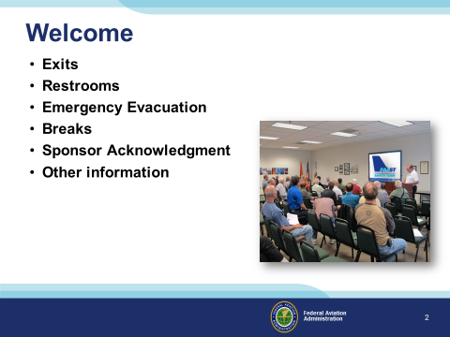 | Slide 2  Presentation Note: Here’s where you can discuss venue logistics, acknowledge sponsors, and deliver other information you want your audience to know in the beginning.  You can add slides after this one to fit your situation. (Next Slide)
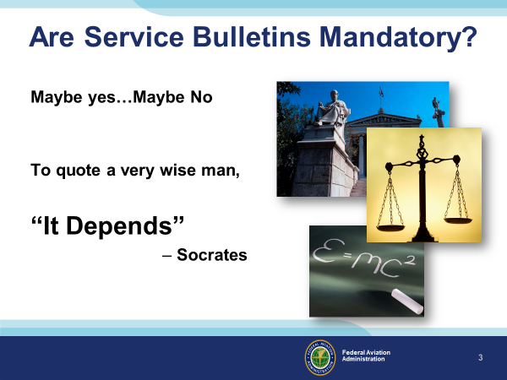 | Slide 3  And you thought we were going to answer the question! For this presentation, let’s just stipulate that mandatory does not really mean mandatory because of the type operation and the type of aircraft you fly.  Imagine this awkward conversation with your mechanic. They try to convince you that the service information from the manufacturer is essential. You ask if the rule requires you to accomplish Service Bulletins, Service Letters, or Service Instructions. Let’s say in your case the answer is no, they are not required. You leave wondering if the mechanic has your interest in mind or their own. Service bulletins are expensive to accomplish. If they were that important, then maybe the regulations would require them. You decide to defer the work.  Here’s the deal with Service Bulletins. They may not be required by public law, by regulation, or by policy, but the fundamental laws may well require them, physical laws like gravity and two things can’t fit in the same space at the same time…those laws.  It is just good sense to heed the advice of the aircraft manufacturer. It is also inconvenient to crash and very embarrassing to crash because of a known safety issue. Here are a few examples.  (Next Slide)
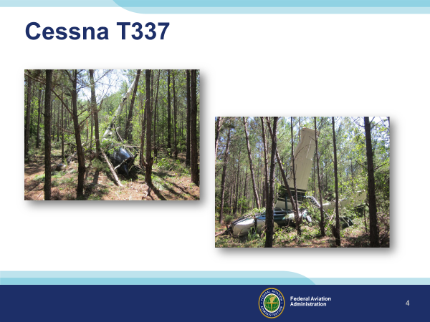 | Slide 4  On July 7, 2017, a Cessna T337 crashed in the woods. Fortunately, and very unusually, the pilot and passenger were only slightly injured (We like stories that end this way). The airplane had run out of gas. The NTSB says the reason was that the pilot didn’t look in the fuel tanks before they took off, and the fuel gages didn’t work. The airplane manufacturer published a mandatory service bulletin (SB) about 18 years before the accident, which required inspection of the fuel quantity indicating system to verify that each fuel gauge showed the precise fuel amount. The SB also required an initial inspection of the system to be completed within 100 hours of operation and subsequent recurring inspections every 12 months. Examination of the airplane’s maintenance logbooks revealed no evidence of compliance with the SB.  Background:  ERA17LA235  Analysis  The flight instructor and private pilot, who did not have a multiengine rating, were conducting a familiarization flight in the centerline thrust, multiengine airplane. Following the preflight inspection, the instructor and the pilot believed that both fuel tanks were about 1/2 to 3/4 full. After practicing maneuvers uneventfully for about 30 minutes, the front engine lost all power. The instructor told the pilot to return to the departure airport; the rear engine was operating at this time. However, before reaching the airport, the rear engine lost all power. With insufficient altitude remaining to reach a runway, the pilot transferred control to the instructor, who then conducted a forced landing into trees. Post-accident examination of the accident site revealed no smell of fuel, and only about 6 gallons of fuel (of a possible 131 gallons with all fuel tanks filled to capacity, 3 gallons of which were unusable) were recovered from both wing fuel tanks. Examination of both engines revealed no evidence of any preaccident mechanical malfunctions or failures that would have precluded normal operation. The four fuel quantity sender units (two for each main fuel tank) were removed and tested with an ohm meter. In the empty position, the left outboard fuel sender unit displayed a resistance value equal to an approximate 1/2-tank reading. The left and right inboard fuel sender units displayed a resistance value equal to an approximate full-tank reading. The right outboard fuel sender unit displayed inconsistent resistance readings throughout its range of travel. The airplane manufacturer published a mandatory service bulletin (SB) about 18 years before the accident, which required inspection of the fuel quantity indicating system to verify that each fuel gauge indicated the accurate fuel amount. The SB also required that an initial inspection of the system be completed within 100 hours of operation and subsequent recurring inspections every 12 months. Examination of the airplane’s maintenance logbooks revealed no evidence of compliance with the SB. Given the lack of fuel found at the accident site and that post-accident examination of the engines revealed no mechanical issues, it is likely that the pilots did not adequately verify the quantity of fuel during the preflight inspection, in part due to erroneous fuel quantity indications provided by the fuel quantity indicating system, which resulted in fuel exhaustion and a subsequent loss of all engine power to both engines. The airplane operator’s failure to comply with the SB precluded the pilots from being able to identify the fuel quantity in flight.  Probable Cause and Findings  The National Transportation Safety Board determines the probable cause(s) of this accident to be: The pilots’ inadequate preflight inspection, during which they failed to adequately verify the quantity of fuel, which resulted in fuel exhaustion, a subsequent total loss of power to both engines, and a forced landing into trees. Contributing to the accident were the erroneous fuel quantity displayed by the fuel quantity indicating system fuel sender units and the operator’s failure to comply with a mandatory service bulletin addressing inaccuracies in the fuel quantity indicating system.  (Next Slide)
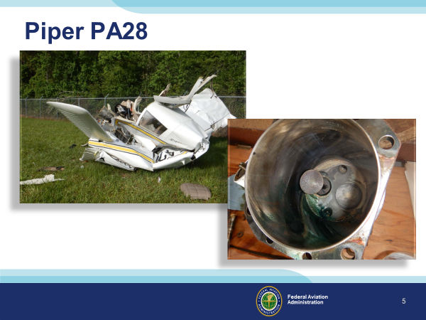 | Slide 5  05/06/2019, Piper PA28, A flight instructor and student pilot, simulated engine-out emergency procedures in the airport traffic pattern. After takeoff, about 300-400 ft above ground level, witnesses reported that the flight instructor announced on the radio that the engine had quit. Witnesses said that the airplane then entered a nose-high, steep left turn before pitching down and impacting the ground. The engine examination revealed that excessive combustion deposits had jammed the No. 4 cylinder exhaust valve in the valve guide. The stuck exhaust valve likely resulted in a partial loss of engine power. Manufacturer service instructions suggested inspecting for valve sticking at regular intervals or sooner if operators suspected valve sticking. In this case, a flight instructor had reported the engine was running roughly the day before the accident. If a valve inspection had been completed according to engine manufacturer guidance the day before the accident following the engine roughness report, maintainers would have detected the heavy carbon deposits on the exhaust valve.  Background:  ERA19FA164  Analysis  The flight instructor and student pilot were conducting simulated engine-out emergency procedures in the airport traffic pattern. About 300-400 ft above ground level after takeoff, witnesses reported that the flight instructor announced on the radio that the engine had quit. Witnesses reported that the airplane then entered a nose-high, steep left turn before pitching down and impacting the ground. The day before the accident flight, the aircraft experienced engine roughness. Following that flight, a mechanic cleaned the sparkplugs, performed an engine run-up, and returned the airplane to Service; however, maintenance records did not show that the engine valves were inspected for sticking at that time. Manufacturer service instructions suggested inspecting for valve sticking at regular intervals or sooner if sticking was suspected. If a valve inspection had been completed in accordance with engine manufacturer guidance the day before the accident following the report of engine roughness, it is likely that the heavy carbon deposits on the exhaust valve would have been detected.  Post-accident examination of the airframe and flight controls revealed no mechanical anomalies that would have precluded normal operation. Examination of the engine revealed that the No. 4 cylinder exhaust valve was stuck in the valve guide due to excessive combustion deposits. It is likely that the stuck exhaust valve resulted in a partial loss of engine power.  A flight instructor who flew the accident airplane the day before the accident flight reported experiencing engine roughness when performing simulated engine-out procedures. Following that flight, a mechanic cleaned the sparkplugs, performed an engine run-up, and returned the airplane to Service; however, maintenance records did not show that the engine valves were inspected for sticking at that time. Manufacturer service instructions suggested inspecting for valve sticking at regular intervals or sooner if sticking was suspected. If a valve inspection had been completed in accordance with engine manufacturer guidance the day before the accident following the report of engine roughness, it is likely that the heavy carbon deposits on the exhaust valve would have been detected.  Given that the flight instructor reportedly had students trim the airplane nose-up when landing, it is possible that the airplane was trimmed nose-high at the time of takeoff and the subsequent loss of engine power. Such a trim setting would have led to excessive pitch up, resulting in a rapid loss of airspeed, an exceedance of the airplane’s critical angle of attack, and an aerodynamic stall at low altitude.  Probable Cause and Findings  The National Transportation Safety Board determines the probable cause(s) of this accident to be:  A partial loss of engine power due to a stuck exhaust valve and the flight instructor’s exceedance of the airplane’s critical angle of attack following the loss of power, which resulted in an aerodynamic stall at low altitude.  Valve sticking in Lycoming reciprocating aircraft engines is addressed in Lycoming Service Instruction No. 1425A, dated January 19, 1988, Suggested Maintenance Procedures to Reduce the Possibility of Valve Sticking. The Service Instruction is applicable to all Lycoming direct-drive engines and states in part, that:  Investigations have shown that exhaust valve sticking occurs more frequently during hot ambient conditions. The lead salts that accumulate in the lubricating oil from the use of leaded fuels contribute to the deposit build up in the valve guides. This condition is eliminated each time the oil and filter are changed. Depending on the amount of deposits, sticking between the valve stem and guide can restrict the valve movement, which is often identified by an intermittent engine hesitation or miss.  The Service Instruction further states that, “exposing the engine to sudden cool down, as in a rapid descent with the power reduced, or shutting the engine down before it has sufficiently cooled down can also induce valve sticking.” Textron Lycoming recommends a 50-hour interval oil change and filter replacement for all engines using a full-flow filtration system. A review of the accident airplane maintenance logs revealed that the engine had accrued 44.48 hours since the last oil change.  Valve sticking in Lycoming reciprocating aircraft engines is further addressed in Lycoming Mandatory Service Bulletin 388C and Lycoming Service Instruction 1485A. Mandatory Service Bulletin 388C, which, according to FAA regulations, is not mandatory for aircraft operated under 14 CFR Part 91, calls for all Lycoming reciprocating aircraft engines to be inspected at 400-hour intervals or earlier if valve sticking is suspected. If the valve and guide do not pass the inspection, then corrective action is to be taken as defined in Service Instruction 1485A. Once the guides are replaced with the newer Hi-Chrome guides, inspection is called for every 1,000 hours, half of the published time between overhauls (TBO), or when valve sticking is suspected, whichever occurs first.  Review of the accident airplane maintenance logs revealed that the No. 4 cylinder had accumulated a total of 591.85 hours since replacement with an Engine Component Inc. (ECI) Titan cylinder, part number TIST-04-1CA. ECI does not offer guidance regarding the frequency of inspection of the Hi-Chrome valve guides in order to detect valve sticking. A valve inspection was not performed after the flight instructor reported engine roughness the day before the accident flight.  FAA Order 8620.2A, National Policy, Applicability and Enforcement of Manufacturer’s Data states in part, “…unless any method, technique, or practice prescribed by an OEM in any of its documents is specifically mandated by a regulatory document, such as Airworthiness Directive (AD), or specific regulatory language such as that in Federal Aviation Regulation Part 43.15(b), those methods, techniques, or practices are not mandatory.”  (Next Slide)
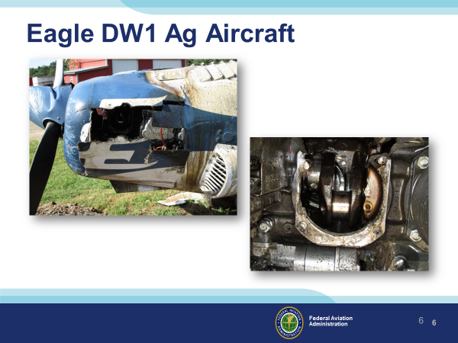 | Slide 6  Service Instructions usually contain cylinder torque specs. So the question is, “Are Service Instructions mandatory”? Well, they are, unless you want your engine to come apart like a tasty pistachio!  07/18/2018 The pilot stated that while maneuvering at 1,500 ft, he heard a “deep knock” in the engine; the entire windshield became covered with oil, and the engine lost power.  Background:  ERA18LA195  Analysis  The commercial pilot was conducting an aerial application flight. He stated that while maneuvering at 1,500 ft, he heard a “deep knock” in the engine; the entire windshield became covered with oil, and the engine lost power. The pilot made a forced landing to a service road, during which the airplane struck a barbed-wire fence with the right wings before coming to rest in a field. Post-accident examination of the engine revealed the No. 2 cylinder had separated from the cylinder mounting deck. Investigators found two fractured sections of the left crankcase that included part of the No. 2 cylinder bore in the engine cowling. All but one of the No. 2 cylinder base studs and through-bolts remained in the cylinder bore and were fractured. The fractured surfaces exhibited signatures consistent with fatigue. The No. 2 cylinder stud’s and through bolt’s fatigue failure and the crankcase fracture led to the loss of engine power.  Probable Cause and Findings  The National Transportation Safety Board determines the probable cause(s) of this accident to be:  Fatigue failure of the No. 2 cylinder studs/through bolts and the crankcase fracture, which resulted in a total loss of engine power.  (Next Slide)
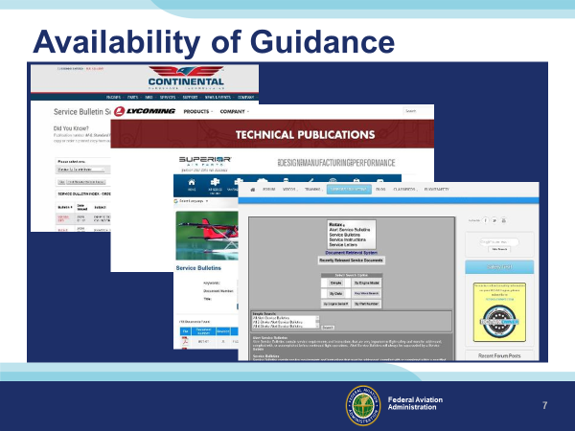 | Slide 7  Service Bulletins are available online. They are free, and you can read them at your leisure. It might give you confidence your mechanic is on your team if you read them yourself. It is a great way to be informed of the safety issues your aircraft manufacturer has discovered over many years of supporting your aircraft.  (Next Slide)
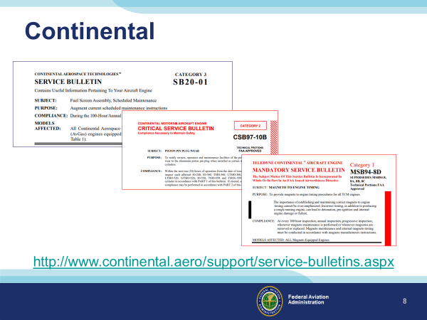 | Slide 8  These are examples of Continental Service Bulletins. Notice that Continental is printing three types of service bulletins. They include Useful, Critical, and Mandatory information. The hyperlink is on the slide to point out that the bulletins are online and free.  (Next Slide)
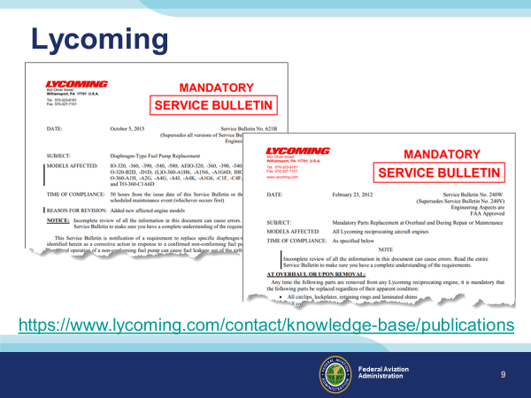 | Slide 9  Here are a couple of examples of Lycoming Service Bulletins, also online and free.  (Next Slide)
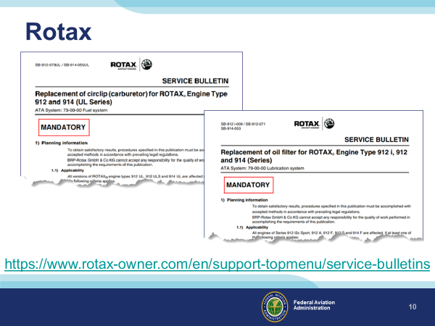 | Slide 10  Rotax too. Most any engine or airframe manufacturer posts their Service Bulletins online.  (Next Slide)
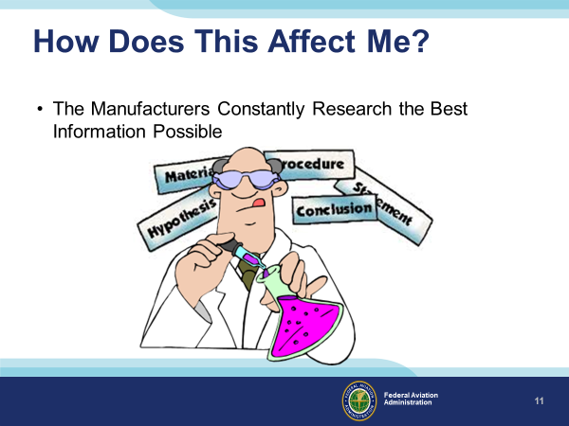 | Slide 11  The manufacturers continuously research accident reports, service difficulty reports, and any other data they feel will give them the information they can use for product improvement.  The manufacturers also attend many accidents, fatal and otherwise. They become a “Party to the Investigation” to share the knowledge they have about the aircraft and gain as much useful information as they can for further safety actions.  All aircraft and engine manufacturers have similar events and similar resources. They all have their unique situations.  (Next Slide)
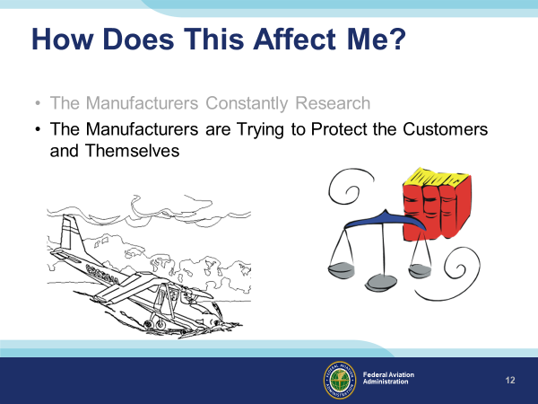 | Slide 12  Manufacturers try to protect the customers and themselves by discovering trends, weaknesses, and items that tend to wear without being noticed. They publish Service Bulletins to make all of us aware of safety improvements that we should make.  As our aircraft age, new items pop-up that need attention. It’s often the easiest to research and publish a service bulletin to disseminate the information. The manufacturer will sometimes request that the FAA issue an AD on this subject if they feel it is needed.  Since this is about the various groups watching their “6,” you can imagine the aircraft manufacturers are quick to point out Service Bulletins that operators did not complete in the accident report.  (Next Slide)
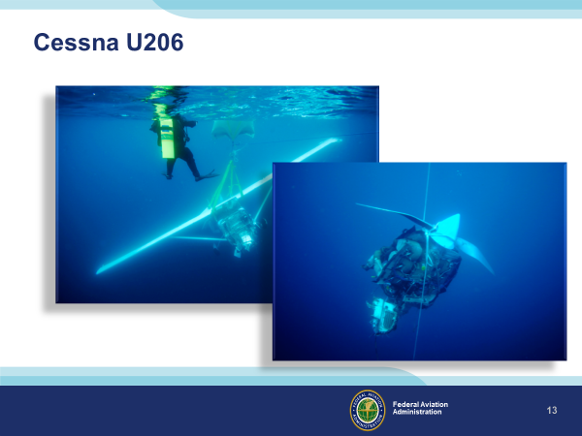 | Slide 13  This example is an illustration of how Service Bulletins come about.  On 07/23/2010, a Cessna U206F was crossing Lake Michigan at 10,000 feet above mean sea level when the engine lost power. They were near the mid-point of the lake (about 24 miles from the shoreline) with a 40-knot headwind, so the pilot turned to return to shore. He attempted to restart the engine but was unsuccessful. The pilot ditched the airplane about 5 miles from shore, and it quickly sank.  Background:  CEN10FA465  Analysis  1: The pilot reported that he was crossing Lake Michigan at 10,000 feet above mean sea level when the engine lost power. He was about 24 miles from the shoreline with a 40-knot headwind, so he turned around to return to land. He attempted to restart the engine but was unsuccessful. The pilot ditched the airplane about 5 miles from shore. It quickly sank.  Post-accident inspection of the airplane revealed that the firewall fuel strainer gasket did not provide a complete seal between the fuel screen and the fuel strainer’s upper body. The inspection revealed that the fuel strainer gasket was installed backward. This created a gap that allowed debris in the fuel to migrate to the engine’s fuel inlet filter screen in the fuel metering assembly.  The fuel inlet filter screen was also partially obstructed with debris. The orifice of the fuel inlet passage contained the same debris. This obstructed the flow of fuel through the orifice to the fuel screen.  The airplane had undergone an annual maintenance inspection about 7.5 hours before the accident. The mechanic, who had an inspection authorization, reported that he did not inspect the gasket on the firewall fuel strainer, nor did he remove and check the fuel inlet filter screen as required by the manufacturer’s service manual.  The debris consisted of materials similar to wood chips, sawdust, paint, varnish, cloth, glass fibers, metal shavings, sand, and soil. The investigators did not discover the source of the contaminants. The post-accident inspection revealed no other preexisting airframe anomalies. Investigators ran the engine on a test stand, and the engine produced the rated horsepower. The airplane’s owner’s manual indicated that the glide distance for an aircraft at 10,000 feet above the water’s surface was 15 miles.  Probable Cause  The total loss of engine power due to fuel starvation as a result of accumulated debris in the fuel system from an undetermined source. Also causal was the inadequate annual maintenance inspection that did not include inspection of the firewall fuel strainer and the fuel inlet screen.  (Next Slide)
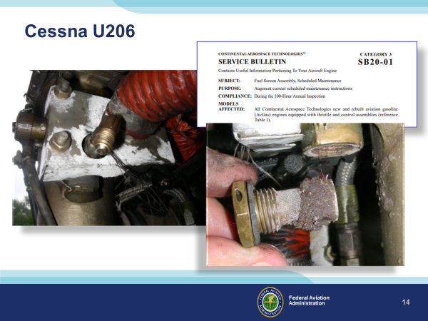 | Slide 14  During the investigation, investigators determined that dirt clogged the fuel inlet screen to the fuel metering valve. The clog caused complete fuel starvation at a very inopportune time.  Cessna and Continental determined that they should do something to draw maintainer’s attention to the screen to make sure they inspected and cleaned it. The manufacturer issued SB20-10, which addresses this situation. It is an excellent idea to comply with SB20-10 if your aircraft has a large Continental engine installed.  (Next Slide)
 | Slide 15  When manufacturers use the word “Mandatory” in big red letters, they emphasize a significant subject.  (Next Slide)
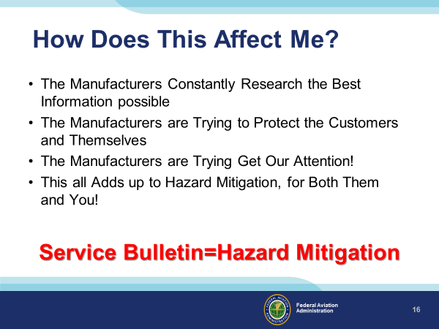 | Slide 16  Manufacturers constantly research accident reports, service difficulty reports, and any other data they feel will give them the information they can use to improve and continue.  The manufacturers are trying to protect the customers (you) and themselves by discovering trends, weaknesses, and items that tend to wear without being noticed. They publish the Service Bulletins to make all of us aware of improvements we should make to enhance safety.  Sometimes the FAA makes AD’s from these publications. This makes them mandatory. Those that don’t become AD’s are still highly recommended.  (Next Slide)
 | Slide 17  It is just so much better than crashing!  (Next Slide)
Slide 18
Presentation Note: You may wish to provide your contact information and main FSDO phone number here. Modify with your information or leave blank.
(Next Slide)
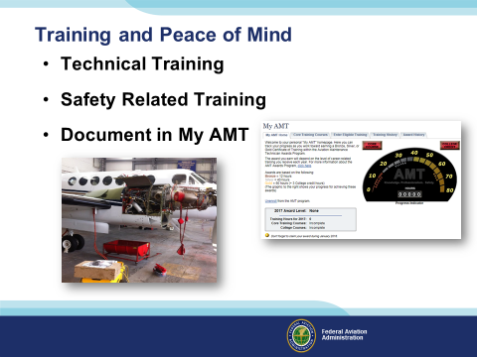 | Slide 19  The AMT Awards program encourages AMTs and employers to take advantage of initial and recurrent training by issuing awards based on training received in one calendar year.  The program has several levels, or phases, of recognition for both you and your employer. You can obtain an FAA Certificate of Training upon successful completion of the program requirements. Employers can obtain a Gold or Diamond Award of Excellence yearly depending on the percentage of their employees receiving awards.  Training earned toward an AMT Award falls into one of two categories; Mandatory Core Training and Eligible Training.  Mandatory Core Training is one or more online training courses, depending on FAA evaluation of training needs. The Core Training course(s) can be located and completed in the Aviation Learning Center at FAASafety.gov.  Eligible Training is the hourly training that can be credited toward an individual AMT Certificate of Training. This training must be aviation maintenance career related training.  Be sure to document your achievement in the AMT Awards Program. It’s a great way to stay on top of your game and keep stay proficient.  (Next Slide)
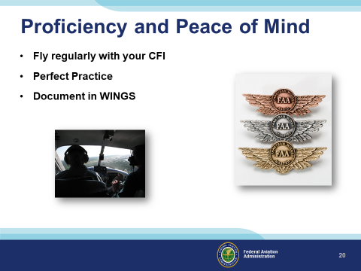 | Slide 20  There’s nothing like the feeling you get when you know you’re playing your A game and in order to do that you need a good coach (Click)  So fly regularly with a CFI who will challenge you to review what you know, explore new horizons, and to always do your best. Of course you’ll  have to dedicate time and money to your proficiency program but it’s well worth it for the peace of mind that comes with confidence. (Click)  Vince Lombardi, the famous football coach said, “Practice does not make perfect. Only perfect practice makes perfect.” For pilots that means  flying with precision. On course, on altitude, on speed all the time. (Click)  And be sure to document your achievement in the Wings Proficiency Program. It’s a great way to stay on top of your game and keep you flight review current.  (Next Slide)
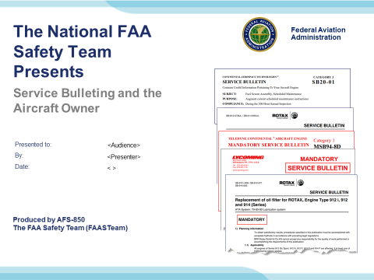 | Slide 21  (The End)

Appendix I – Equipment and Staging
Equipment:
- Projection Screen & Video Projector suitable for expected audience
  - Remote computer/projector control available at lectern or presenter location
    - In lieu of remote – detail a Rep to computer/projector control.
- Presentation Computer
  - Note: It is strongly suggested that the entire program reside on this computer.
- Back up Projector/Computer/Media as available.
- PA system suitable for expected audience
  - Microphones for Moderator and Panel
    - Optional Microphone (s) for audience
- Lectern (optional)
Staging:
- Arrange the projection screen for maximum visibility from the audience.
- Equip with PA microphones
- Place Lectern to one side of screen. This will be used by presenters and moderator

IMPORTANT – Once you have completed outreach on this topic, please help us track the outreach you have done by entering a PTRS record.



