General Aviation Joint Steering Committee
CFIT Working Group

Outreach Guidance Document
2022/03-08-244(I)PP

This outreach guidance is provided to all FAA and aviation industry groups that are participating in outreach efforts sponsored by the General Aviation Joint Steering Committee (GAJSC). It is important that all outreach on a given topic is coordinated and is free of conflicts. Therefore, all outreach products should be in alignment with the outline and concepts listed below for this topic.

Outreach Month: October 2022

Topic: Aerospace Medicine and You
The FAA and industry will conduct a public education campaign emphasizing the dangers associated with operations with a medicial deficiency or while impaired.

Background:

GAJSC study of General Aviation Loss of Control Accidents show that a significant number of pilots in those accidents were operating with a known medical deficiency and/or impaired.

Teaching Points:

- FAA’s Office of Aerospace Medicine provides medical certification guidance and medical information to pilots.
- BasicMed – an alternative to traditional pilot medical certification is available to most pilots who are not engaged in flying for compensation or hire.
- The effects of commonly prescribed and over-the-counter drugs can comprise pilot’s ability to fly safely.
- Pilots must consider the effects of combinations of drugs. This is difficult to do without consulting a physician.
- AMEs are the best source for the effects of drugs and combinations of drugs.
- Pilots must disclose all of their medical issues to their AMEs in order to receive a comprehensive assessment of their medical condition and fitness to fly.

References:
  - FAA Safety Briefing Magazine
    - January/Februar 2022 Issue
    - https://www.faa.gov/sites/faa.gov/files/2022-01/JanFeb2022.pdf

Abstract: Lasting 10 to 15 minutes, this presentation acquaints the audience with the services provided by FAAs Office of Aerospace Medicine and the medical certification process for pilots. Standards for drug labeling are explained and the difficulty of determining the effects of drugs used in combination is discussed. FAAs policy on Marijuana and it’s derivitives is addressed and tips for healthy flying are offered

Format: Information Briefing - Power Point presentation
Required Personnel – FAASTeam Program Manager or designated FAASTeam Rep (s)
Optional Personnel – Medical Doctors, DPEs and CFIs who can speak on Aerospace Medicine issues.

National FAASTeam Support:

In addition to this guidance document, a Power Point presentation that supports the program and a folder containing background information are provided. FPMs and presenters are encouraged to customize this presentation to reflect each individual program.

Slides | Script
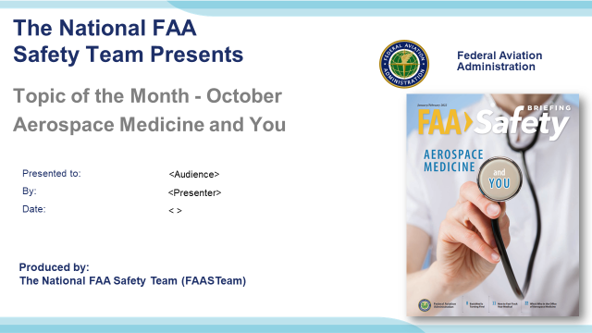 | Slide 1  2022/03-08-244(I)PP Original Author: John Steuernagle; POC Kevin Clover, National FAASTeam Program Manager (Operations), Office 562-888-2020  Presentation Note: This is the title slide for Aerospace Medicine and You.  Script - We have included a script of suggested dialog with most slides. The script will always appear in a non-italic font. Presenters may read the script or modify it to suit their own presentation style. See template slides 5 and 6 for examples of a slides with script.  Presentation Instructions - (stage direction and presentation suggestions) will be preceded by a Bold header: the instructions themselves will be in Italic fonts. See slides 2, for an example of slides with Presentation Instructions only.  Program control instructions - will be in bold fonts and look like this: (Click) for building information within a slide; or this: (Next Slide) for slide advance.  Background information - Some slides may contain background information that supports the concepts presented in the program.  .  The production team hope you and your audience will enjoy the show. Break a leg!  (Next Slide)
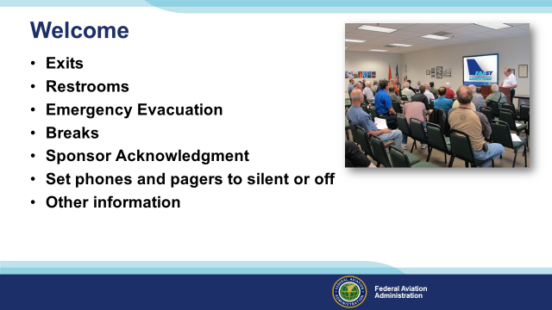 | Slide 2  Presentation Note: Here’s where you can discuss venue logistics, acknowledge sponsors, and deliver other information you want your audience to know in the beginning.  You can add slides after this one to fit your situation.  (Next Slide)
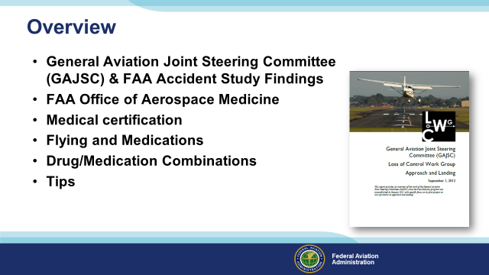 | Slide 3  In this presentation we’ll talk a little bit about recent GAJSC and FAA studies that feature some interesting findings with respect to pilots and medications.  We’ll acquaint you with FAA’s Office of Aerospace Medicine and its’ services to pilots.  We’ll talk generally about flying while medicating and the problems associated with taking multiple drugs.  Finally we’ll offer some tips for safe flying while on medications.  Presentation Note: If you’ll be discussing additional items, add them to this list.  (Next Slide)
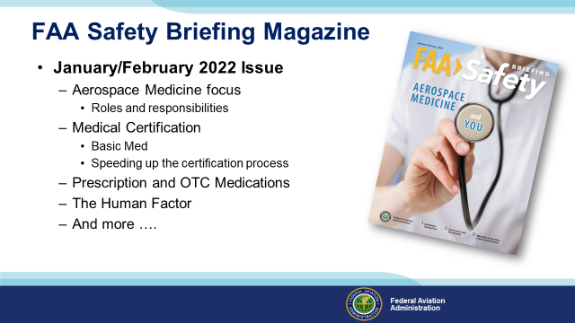 | Slide 4  Much of the content of this presentation were excerpted from the January/February 2022 issue of FAAs Safety Briefing Magazine. That issue focused on Aerospace Medicine with articles on the medical certification process and the various roles and responsibilities of FAA’s Office of Aerospace Medicine.  (Next Slide)
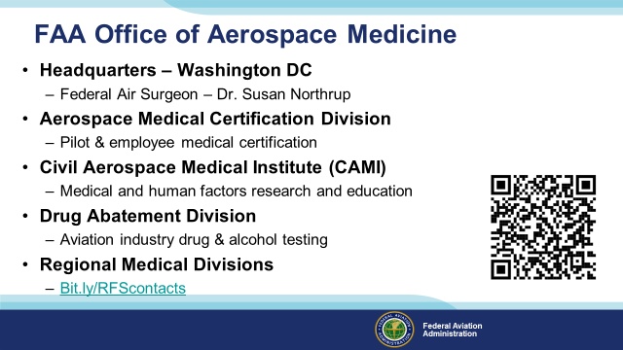 | Slide 5  When pilots think of FAA’s medical activities, we think of medical certification requirements and our local Aviation Medical Examiners but there’s a lot more to consider. Headquartered in Washington DC and led by the Federal Air Surgeon, the FAA Office of Aerospace Medicine is responsible for the Aerospace Medical Certification Division and the Civil Aerospace Medical Institute; both located in Oklahoma City, OK., 9 regional Flight Surgeons and a Drug Abatement division. (Click)  The Certification Division processes pilot and FAA employee i.e. air traffic controller medical certifications. (Click)  The Civil Aerospace Medical Institute conducts, medical and human factors research and medical education activities.  (Click)  The Drug Abatement Division administers aviation industry drug and alcohol programs. (Click)  Finally, there are 9 Regional and one international Air Surgeon offices. Because they’re often the first point of contact for pilots, we’ve included a url and QR code to access the office list.  Presentation note: Give the audience time to copy the URL and/or QR code. Then:  (Next Slide)
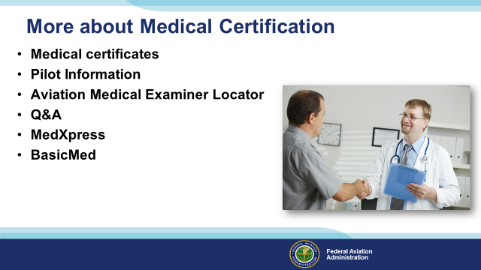 | Slide 6  The Medical Certification Office is responsible for Medical certification of pilots and other safety-sensitive employees such as Air Traffic Controllers who require medical certification. The office maintains a database of pilot information and they manage MedXpress – an online medical certification application service and BasicMed – an alternative to traditional medical certification of pilots. Their home page also features frequently asked questions and their answers.  (Next Slide)
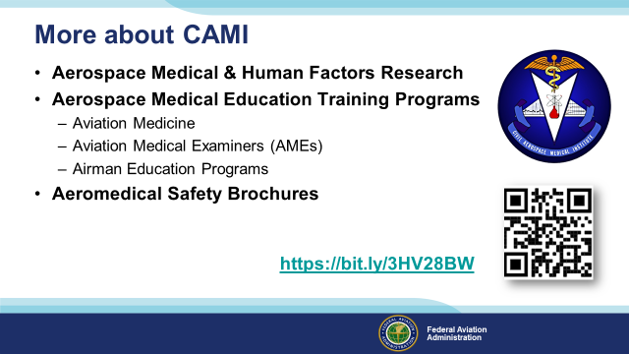 | Slide 7  The Civil Aerospace Medical Institute, or CAMI, conducts aerospace medical and human factors research projects and they also produce and distribute high-quality medical education and training programs for pilots and Aviation Medical Examiners. You can also access CAMI’s excellent series of Aeromedical Safety Brochures from their home page.  (Next Slide)
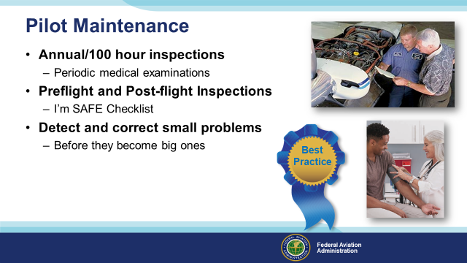 | Slide 8  We talk a lot about aircraft maintenance and inspection but what about pilot maintenance?  Aviation regulations and common sense require that we periodically inspect the aircraft we fly and that we correct any mechanical discrepancies that we discover. (Click)  The same is true for pilots. Periodic medical examinations and certifications just make good sense. But what about the times between inspections? (Click)  Well that’s why we do pre and post-flight inspections. We want to take a good look at critical components and systems before we fly. And a good post-flight inspection can detect discrepancies that should be addressed before the next flight. (Click)  For pilots that means a check of how we’re feeling, whether we’re adequately fed, hydrated, and rested, and whether internal and external pressures are likely to compromise our ability to perform. There’s a cool checklist that covers this that we’ll see in the next slide. (Click)  Of course the goal of all this inspection and – in the case of pilots – introspection is to detect and correct small problems before they become big ones. (Click)  And that’s a best practice not only for flying but for every day living.  (Next Slide)
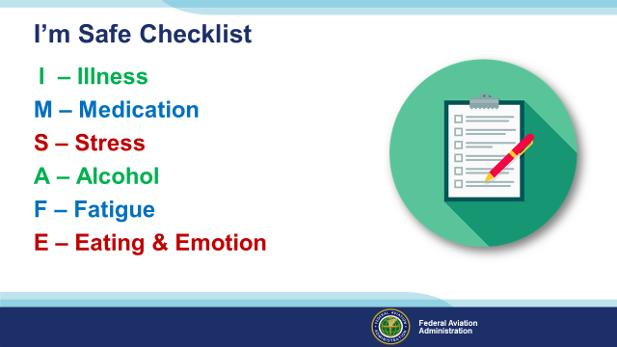 | Slide 9  The I’m Safe checklist has been around for a long time but it’s a good idea to review it here. The checklist is designed to answer six questions. (Click)  Am I feeling ill today? If the answer is yes, it’s probably not a good day to fly or perhaps even drive a car. (Click)  Am I taking any prescription or over-the-counter medication that could compromise my ability to fly? Many medicines caution against operating machinery and aircraft certainly qualify as complex machines. (Click)  Am I under unusual stress today? We all cope with stress each day and a little stress has been shown to improve human performance. But, if we’re under moderate to heavy stress our performance will definitely not be our best and it may even be dangerous. If, for instance, we are flying to a very important meeting that cannot be re-scheduled or delayed, the importance of the mission could compromise our pre and in-flight decision making. (Click)  Have I ingested any alcohol – in the previous twenty four hours? I know the rule says eight hours but lingering affects can persist. (Click)  Am I adequately rested before this flight? And just as important, will I become fatigued during the flight? We may be fine for the short drive home after a long day at work, but embarking on a flight perhaps at night, may be a greater challenge than we should accept. Getting a good night’s sleep and starting in the morning may well be the safer choice. (Click)  And finally; Am I adequately nourished and hydrated? And am I emotionally ready for this flight? We like to say we leave our problems on the ground when we fly but, for most of us, that’s not really true. If we’re worried or even very happy about something we may dwell on the topic at the expense of our flight duties or our decision making may be compromised.  (Next Slide)
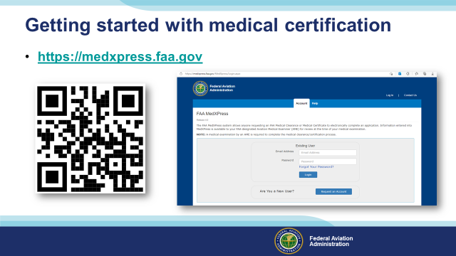 | Slide 10  For most of us, the path to medical certification begins with a visit to FAAs Medxpress website. There you’ll be able to complete an application for any FAA Medical certificate and upload any supporting medical history. The application and information will also be available to your Aviation Medical Examiner. Yes – at this point, you can still complete a paper application in the AME’s office but the information will end up in the same place anyway so why not provide it in advance?  (Next Slide)
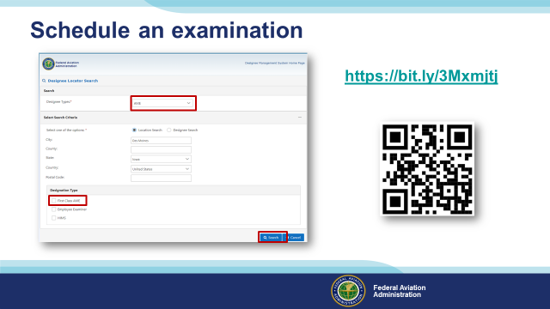 | Slide 11  Once you’ve completed your application, it’s time to schedule an examination. If you’re looking for an AME you can search for one at FAAs Medical Certification website. (Click)  Just select the type of designee you’re looking for, enter your location, and click on search. The system will return a list for all designees in the area. (Click)  If you want to see only those Doctors who can issue First Class Medical Certificates, select the First Class AME box. Then click on search.  There is an alternative to traditional medical certification that may suit your needs and it’s known as BasicMed.  (Next Slide)
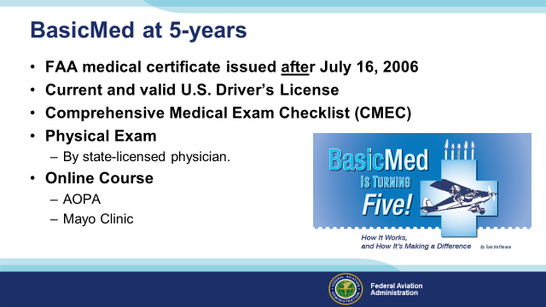 | Slide 12  As of this writing, the BasicMed alternative to medical certification has been in operation for more than five years and more than fifty thousand pilots are flying under the program. We’ll get into aircraft and pilot limitations in a minute but first let’s take a look at what you’ll need to qualify for BasicMed. (Click)  To qualify for BasicMed, you must have held an FAA medical certificate of any class issued after July 16, 2006. If not, you’ll have to obtain at least a 3rd class medical certificate before qualifying for BasicMed.  You’ll also have to maintain a current and valid United States Driver’s License, download and complete a Comprehensive Medical Exam Checklist and undergo a physical examination conducted by a United States State-licensed physician.  Once you’ve completed the physical exam you’ll complete an online course. At present there are two course alternatives; one from the Aircraft Owners and Pilot’s Association and the other from the Mayo Clinic.  (Next Slide)
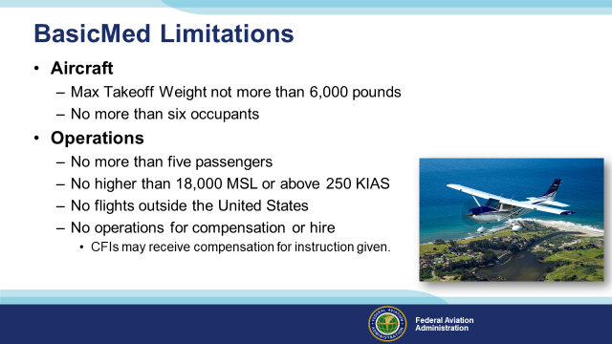 | Slide 13  Pilots flying under BasicMed are limited to aircraft that weigh no more than six thousand pounds and that can accommodate no more than six occupants.  Each flight operation is restricted to the pilot and no more than five passengers, no higher than 18,000 feet MSL or faster than 250 Knots Indicated Airspeed. Flight outside the United States is prohibited and, except for CFIs giving flight instruction, you may not receive compensation for flying.  (Next Slide)
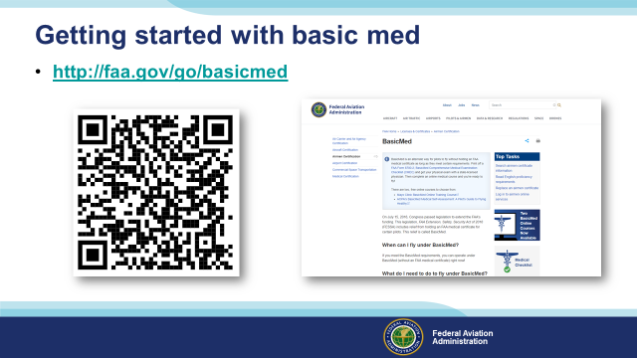 | Slide 14  To get started; navigate to the BasicMed home page and review the provisions of the program. Then download the Comprehensive Medical Checklist.  (Next Slide)
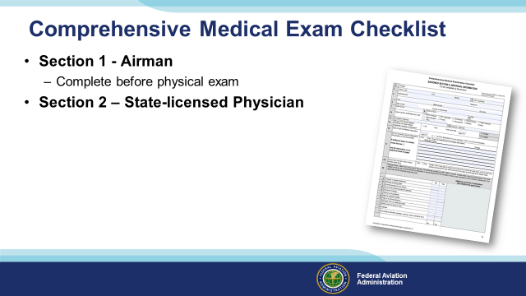 | Slide 15  Next; complete the Airman information and medical history portion of the checklist. It’s very similar to airman information and medical history collected during traditional medical certifications.  Then make an appointment with a State-licensed physician who will conduct a physical examination and record the results on the checklist.  (Next Slide)
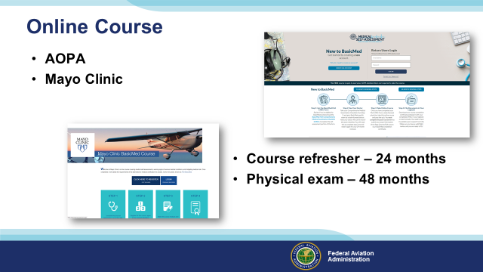 | Slide 16  After you’ve had your physical exam, take one of the available online courses. Upon successful completion, a course completion certificate will be issued and you’ll be good to go. Be sure to maintain a copy of your course completion certificate in your logbook or on your phone.  You’ll need to refresh your knowledge each 24 months by completing another course and you must have completed a physical exam checklist with a physician within the preceding 48 months in order to fly as pilot in command.  And you’ll have to assess your fitness before every flight. A very important part of that assessment has to do with a sobering statistic.  (Next Slide)
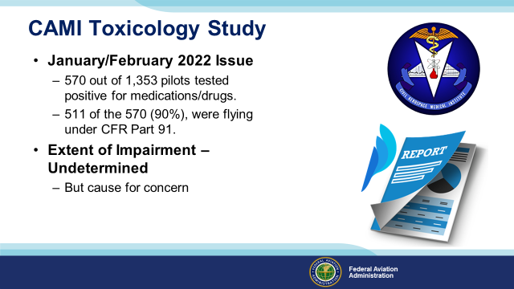 | Slide 17  We’ve talked about this issue before but it’s worth reviewing.  In a 2011 study conducted by FAA’s CAMI Toxicology Lab, drugs/medications were found in 570 pilots (42%) from 1,353 total deceased pilots tested. Most of the pilots with positive drug results, 511 (90%), were flying under CFR Part 91.”.  While there were a couple instances of recreational drugs, the majority were prescription or over the counter medications. Antihistamines were the most commonly found. Left undetermined was the extent of pilot impairment – if any – due to drug use but the issue is cause for concern for several reasons:  (Next Slide)
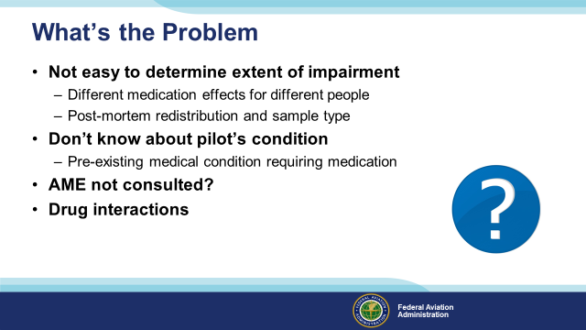 | Slide 18  So what’s the problem:  First of all – We all know that some medications may compromise a pilot’s ability to control the aircraft and/or adversely affect judgment and decision-making. (Click)  What’s not so obvious is it’s difficult for investigators to say for sure that pilot performance was compromised because the effect of drugs and medications varies widely among individuals. In addition, post-mortem redistribution of a substance creates some confusion as to the actual blood levels prior to the accident. The amount of a substance may vary considerably in different tissues. (Click)  A less obvious problem poses the question; what pre-existing physical condition requires the use of medication in the first place? (Click)  It’s not unusual to find that pilots are evaluated and treated for conditions that are not revealed to their Aviation Medical Examiners. In those cases an AME doesn’t have an opportunity to review the complete medical history of diagnoses and treatments for some of the pilots they examine. (Click)  There’s also the issue of drug interactions but we’ll get to that a little bit later.  (Next Slide)
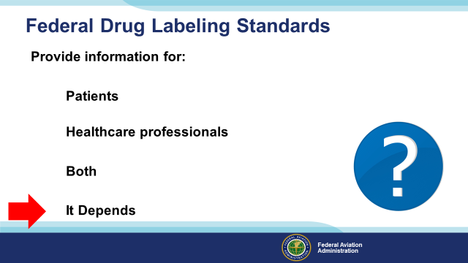 | Slide 19  Fortunately – the FDA requires standard labeling for prescription and over-the-counter (OTC) medications but are those labeling standards primarily for patients or healthcare providers or both.  Presentation Note: Ask for a show of hands with respect to each statement then (Click)  As it turns out the correct answer is it depends on the type of drug and the packaging. OTC labeling is for the medication user, while prescription labeling is primarily for healthcare providers.  (Next Slide)
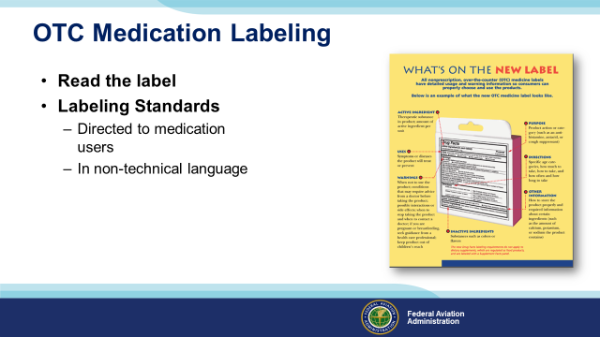 | Slide 20  Food and Drug Administration (FDA) OTC (Over the Counter) labeling requirements are directed to users so be sure to read the label before you medicate and fly.  (Next Slide)
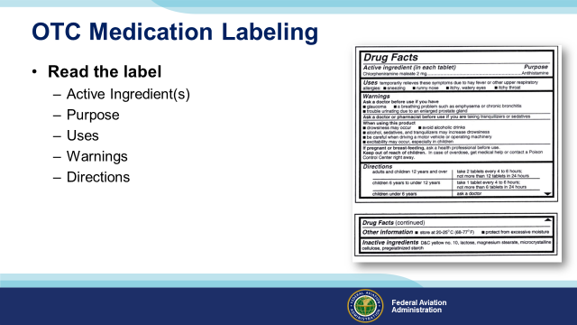 | Slide 21  The standard OTC Label will tell you the active ingredients, purpose, and uses for the drug as well as warnings and directions for use.  Note in this example we’re looking at an antihistamine that we might take to address cold symptoms.  Note the warnings of drowsiness and those associated with driving a motor vehicle or operating machinery. Do you think it would be safe to fly while using this drug? How long will it reside in your system? How soon would you be safe to fly after stopping the drug?  You won’t find the answers to any of those questions on the label. This might be a good time to consult your AME.  (Next Slide)
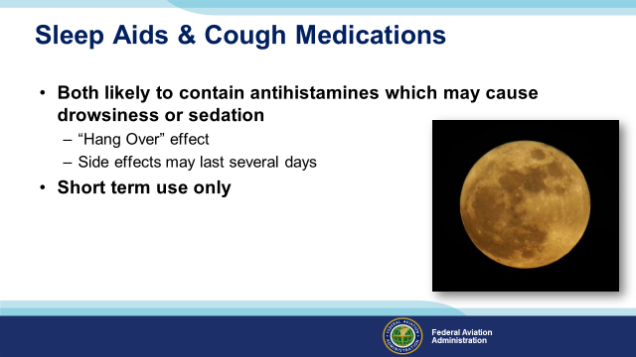 | Slide 22  A word on OTC sleep aids and cough medications: (Click)  Both are likely to cause drowsiness or sedation. (Click)  Sleep aids obviously are intended to promote sleep but their effects – resembling a hangover - may persist for several days – not a good idea if you’re going flying. (Click)  Also – tolerance to active ingredients builds quickly so you’ll find you’re taking more and more medicine to achieve the same result.  All OTC medications are intended for temporary use. Taking them for longer than the recommended time may mask symptoms of a significant or serious underlying medical condition.  (Next Slide)  c
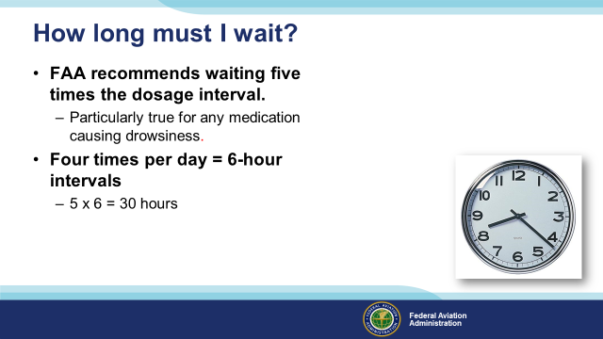 | Slide 23  If you’ve been taking a medication that precludes flying, how long must you wait after ceasing the medication before you return to the air? (Click)  This is a good question for your AME to answer but the general rule is to wait until 5 times the dosage interval has passed. (Click)  For example; if you take a medication 4 times a day (6-hour intervals) you should wait at least 30 hours before resuming pilot duties.  (Next Slide)
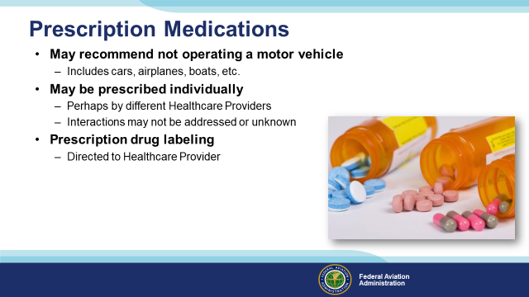 | Slide 24  Prescription meds are different. They’re often stronger versions of what you can get over-the-counter. Many carry a warning to not operate motor vehicles or perform tasks that require alertness. Remember boats and planes are considered motor vehicle and piloting an airplane certainly requires alertness!  Prescription drugs are often prescribed individually – sometimes by different healthcare providers. Interactions may not be addressed or may be unknown.  Unlike those for OTC products, the labeling standards for prescription drugs are primarily for the use of medical professionals so they’re not as helpful to the lay public. Be sure to remind your prescribing healthcare provider you are a pilot and ask how the drug is likely to affect your motor skills, judgment, and decision-making.  (Next Slide)
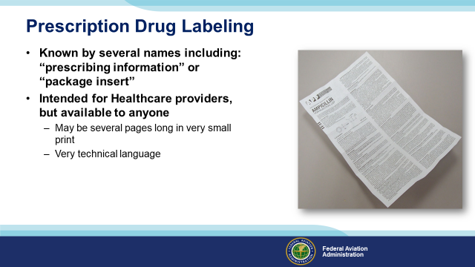 | Slide 25  Per Food and Drug Administration (FDA) the acceptable names are: prescribing information, package insert, professional labeling, direction circular, package circular.  This information is intended for health professionals and is rarely given to the patient although it is readily available on line. Currently it consists of written document included in the medication box or attached to a container, but FDA is trying to change this to electronic format. Highly detailed information in technical language and in a standard format.  (Next Slide)
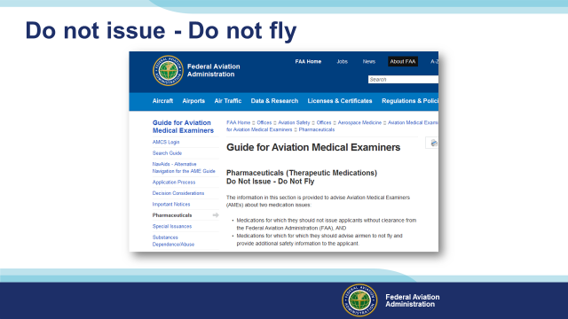 | Slide 26  The FAA maintains a list of many medications that should not be taken while in flight status or that may preclude the issuance of any medical certificate. The lists of medications in this section are not meant to be all-inclusive or comprehensive, but rather address the most common concerns. The easiest way to access the list is to Search for “Do Not Issue – Do Not Fly”. You’ll be directed to the web page shown here.  There are other lists available to members of pilot organizations and to the public. If you don’t see your medication on the list or if you have any questions call your AME or Regional Flight Surgeon for the latest information. For your Regional Flight Surgeon search “Regional Flight Surgeon Contact Information”.  (Next Slide)
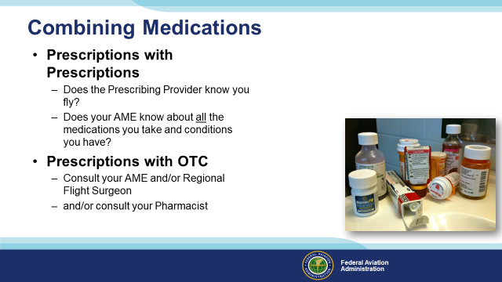 | Slide 27  Look into any medicine cabinet and you’re likely to find a mixture of OTC and prescription meds. Who’s responsible for assessing the affects and possible drug interactions? Making those assessments is something they don’t teach us in pilot school so this may also be a good time to seek some professional help. Before you do that though let’s talk about prescription drugs alone or in combination.  Does your prescribing doctor know you fly? Maybe a more suitable drug could be prescribed if your doctor knows you’re a pilot.  Even more importantly, does your AME know about all the drugs you take and the conditions for which you take them?  Combining prescription and OTC drugs introduces another challenge – the self medicating pilot. Once again it’s safer to consult your AME and/or pharmacist before adding OTC meds to your system.  We’re not going to address recreational drugs here. We all know that flying is about the best recreation there is. It’s not safe and not legal to fly under the influence.  We will look at one case from the GAJSC study though. We’ll discuss it with respect to the PAVE checklist that’s familiar to most if not all of us. I think you’ll find the case study illuminating.  (Next Slide)
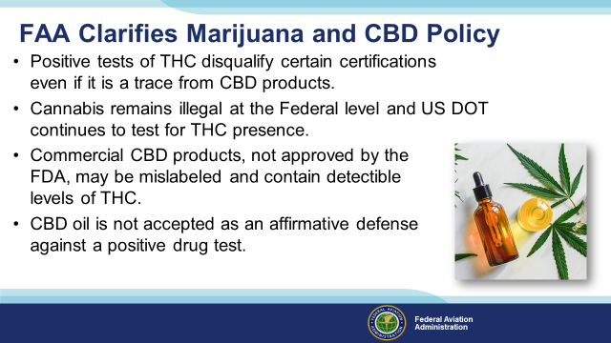 | Slide 28  Several states including have legalized the use of hemp and it’s derivatives such as CBD which is short for Cannabidiol, a chemical compound from the Cannabis plant, commonly referred to as marijuana.  Because of the popularity of CBD Products, the Federal Air Surgeon’s office received a number of inquiries about marijuana use. Although, not a prescription or over-the-counter drug, it is important to caution airman on the use of hemp or it’s derivatives as no allowances will be made by the FAA for pilots who wish to use cannabis medicinally.  (Next Slide)
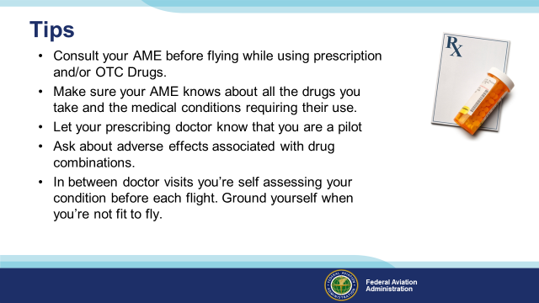 | Slide 29  Finally – here are some tips for safe flying while taking prescribed or OTC medications.  Consult your AME before flying while using prescription and/or OTC Drugs.  Make sure your AME knows about all the drugs you take and the medical conditions requiring their use.  Let your prescribing doctor know that you are a pilot.  Ask about adverse effects associated with drug combinations.  In between doctor visits you’re self assessing your condition before each flight. Ground yourself when you’re not fit to fly.  (Next Slide)
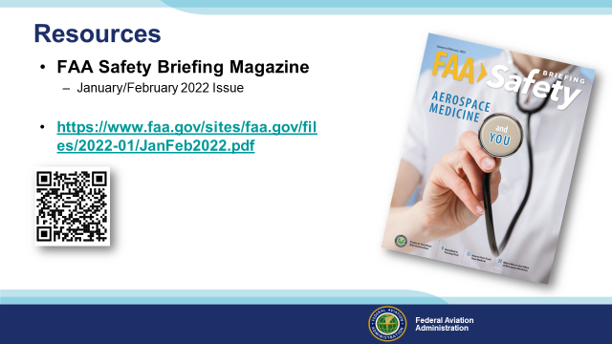 | Slide 30  Presentation note: Give the audience time to copy the URL and/or scan the QR code. The questions slide follows so you could begin taking questions with this slide. Then:  .  (Next Slide)
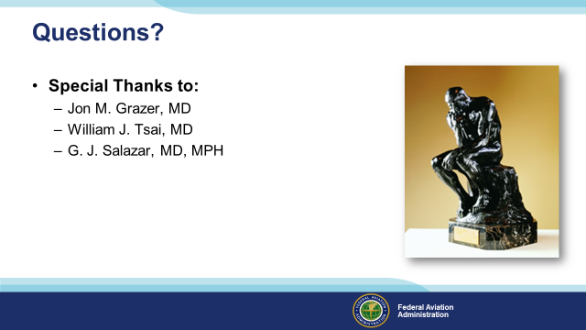 | Slide 31  Special thanks to Doctors John M. Grazer, William J. Tsai, and G.J. Salazar for their assistance in editing this program.  Presentation Note: You may wish to provide your contact information and main FSDO phone number here. Modify with  your information or leave blank.  (Next Slide)
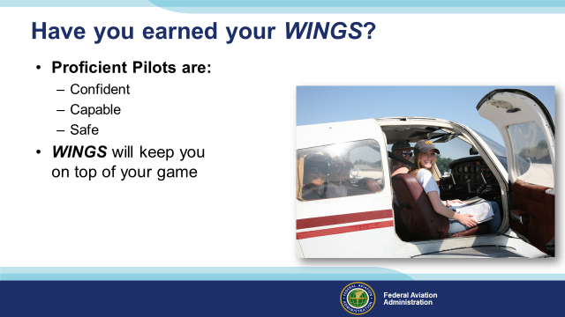 | Slide 32  Have you earned your WINGS? Proficiency is key to success in almost every thing worth doing – especially flying. Proficient pilots are confident, capable, and safe.  WINGS is a proficiency training system specifically designed for general aviation pilots and, regular participation will keep you on top of your flying game.  (Next Slide)
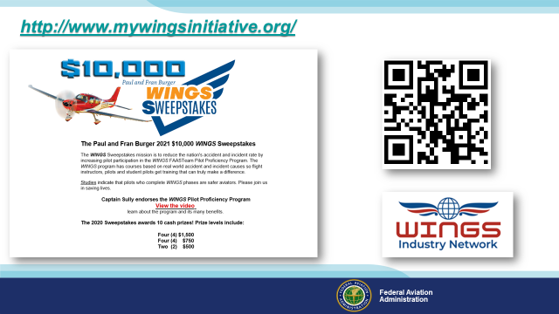 | Slide 33  Every time you complete a WINGS Phase you’re eligible to win cash in the WINGS Sweepstakes.  The sweepstakes is generously funded by Paul Burger, a long time advocate for general aviation safety and a retired aviator who believes participation in this program saves lives. VISIT WWW.MYWINGSINITATIVE.ORG to learn more and enter the sweepstakes.  Just navigate to http://www.mywingsinitiative.org or scan the QR code for details. By the way, Instructors can also enter the sweepstakes. But there are even better reasons to participate in WINGS.  (Next Slide)
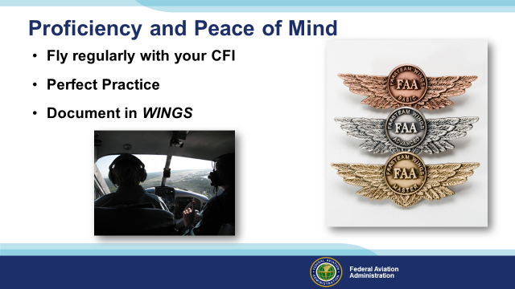 | Slide 34  - There’s nothing like the feeling you get when you know you’re playing your A game and in order to do that you need a good coach (Click)  - So fly regularly with a CFI who will challenge you to review what you know, explore new horizons, and to always do your best. Of course you’ll  have to dedicate time and money to your proficiency program but it’s well worth it for the peace of mind that comes with confidence. (Click)  - Vince Lombardi, the famous football coach said, “Practice does not make perfect. Only perfect practice makes perfect.” For pilots that means  flying with precision. On course, on altitude, on speed all the time. (Click)  - And be sure to document your achievement in the Wings Proficiency Program. It’s a great way to stay on top of your game and keep you flight review current.  (Next Slide)
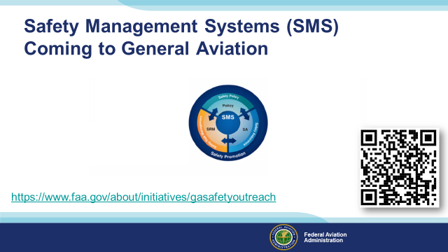 | Slide 35  Safety Management Systems are a set of policies and processes that can increase the safety and efficiency of any flight operation. And FAA is bringing SMS to General Aviation. You may have heard of SMS but thought it was only for large organizations but actually SMS can be scaled to fit any operation large or small.  There are 4 major components to a Safety Management System (Click)  Safety Policy – a documented commitment to safety that runs from the head of an organization to its newest member. (Click)  Safety Risk Management – a process that identifies hazards within an operation, determines to what extent an identified hazard may impact flight safety, and controls the risk of occurrence to an acceptable level. (Click)  Safety Assurance – By collecting and analyzing information derived from safety performance data Safety Assurance ensures the performance and effectiveness of Safety Risk Controls. (Click)  Safety Promotion communicates safety information and commitment throughout the organization. (Click)  You can find more information about Safety Management Systems at the URL on the Screen.  (Next Slide)
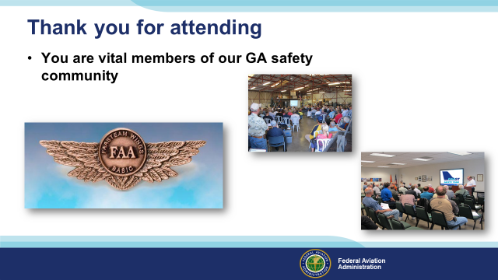 | Slide 36  Your presence here shows that you are vital members of our General Aviation Safety Community. The high standards you keep and the examples you set are a great credit to you and to GA.  Thank you for attending.  (Next Slide)
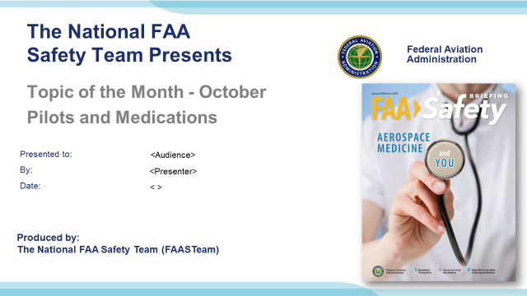 | Slide 37  (The End)

Appendix I – Equipment and Staging
Equipment:
- Projection Screen & Video Projector suitable for expected audience
  - Remote computer/projector control available at lectern or presenter location
    - In lieu of remote – detail a Rep to computer/projector control.
- Presentation Computer

  - Note: It is strongly suggested that the entire program reside on this computer.
- Back up Projector/Computer/Media as available.
- PA system suitable for expected audience
  - Microphones for Moderator and Panel
    - Optional Microphone (s) for audience
- Lectern (optional)
Staging:
- Arrange the projection screen for maximum visibility from the audience.
- Equip with PA microphones
- Place Lectern to one side of screen. This will be used by presenters and moderator

IMPORTANT – Once you have completed outreach on this topic, please help us track the outreach you have done by entering a SAS record.

