General Aviation Joint Steering Committee
CFIT Working Group

Outreach Guidance Document
2022/03-03-242(I)PP

This outreach guidance is provided to all FAA and aviation industry groups that are participating in outreach efforts sponsored by the General Aviation Joint Steering Committee (GAJSC). It is important that all outreach on a given topic is coordinated and is free of conflicts. Therefore, all outreach products should be in alignment with the outline and concepts listed below for this topic.

Outreach Month: November 2022

Topic: CFIT and Plan Continuation Bias
The FAA and industry will conduct a public education campaign emphasizing the dangers posed by Plan Continuation Bias

Background:

GAJSC study of General Aviation CFIT Accidents suggested that human biases, particularly Plan Continuation Bias, may compromise effective pilot decision making and lead to CFIT accidents.

Teaching Points:

- Human biases are patterns of reasoning that weigh the value of information according to pre-conceived beliefs. Biases present as a prejudice in favor or or against one thing, person, or group compared with another; often in a way considered to be unfair.
- Plan Continutuation Bias is a form of Confirmation Bias that features pressing on with a plan even though information that indicates the plan should be modified or abandoned is readily available. It appears stronger as one nears completion of the activity (e.g. nearing a destination).
- Realistic pre-flight planning should objectively consider aircraft and pilot capabilities, route and weather challenges, and alternative destinations.
- Periodic objective pilot performance assessments should be made in consultation with a Flight Instructor.
- Objective in-flight “how-goes-it?” assessments should be made in order to inform decision making with respect to continuing, modifying, or abandoning the plan.

References:
- CFIT & Plan Continuation Power Point
  - Available on the National FAASTeam Share Point site under Approved Resources.

- 7 Approaches – 1 Landing
  - Background information article available on the National FAASTeam Share Point site under Approved Resources.
- U K Heli
  - Background information article available on the National FAASTeam Share Point site under Approved Resources.

Abstract: Lasting 10 to 15 minutes, this presentation acquaints the audience with human biases that may compromise effective Aeronautical Decision Making

Format: Information Briefing - Power Point presentation
Required Personnel – FAASTeam Program Manager or designated FAASTeam Rep (s)
Optional Personnel – DPEs and CFIs who can speak to CFIT hazards associated with Plan Continuation Bias

AFS 850 Support:
In addition to this guidance document, a Power Point presentation that supports the program and a folder containing background information are provided. FPMs and presenters are encouraged to customize this presentation to reflect each individual program.

Slides | Script
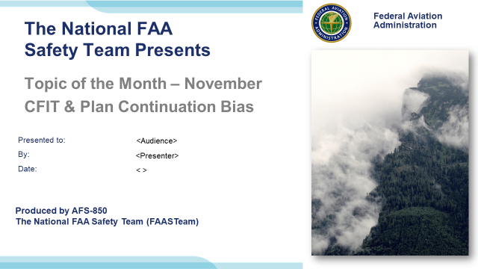 | Slide 1  2022/03-03-242(I)PP Original Author: John Steuernagle; POC Kevin Clover, National FAASTeam Program Manager (Operations), Office 562-888-2020  Presentation Note: This is the title slide for CFIT and Plan Continuation Bias  Script - We have included a script of suggested dialog with most slides. The script will always appear in a non-italic font. Presenters may read the script or modify it to suit their own presentation style. See template slides 5 and 6 for examples of a slides with script.  Presentation Instructions - (stage direction and presentation suggestions) will be preceded by a Bold header: the instructions themselves will be in Italic fonts. See slides 2, for an example of slides with Presentation Instructions only.  Program control instructions - will be in bold fonts and look like this: (Click) for building information within a slide; or this: (Next Slide) for slide advance.  Background information - Some slides may contain background information that supports the concepts presented in the program.  .  The production team hope you and your audience will enjoy the show. Break a leg!  (Next Slide)
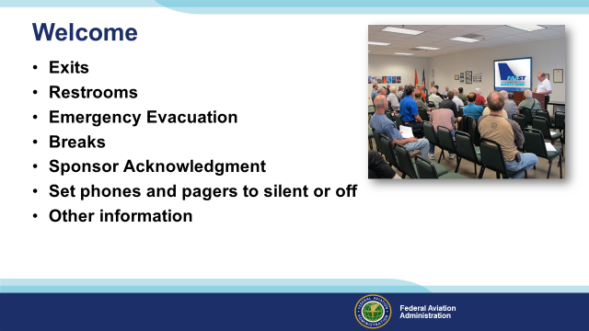 | Slide 2  Presentation Note: Here’s where you can discuss venue logistics, acknowledge sponsors, and deliver other information you want your audience to know in the beginning.  You can add slides after this one to fit your situation.  (Next Slide)
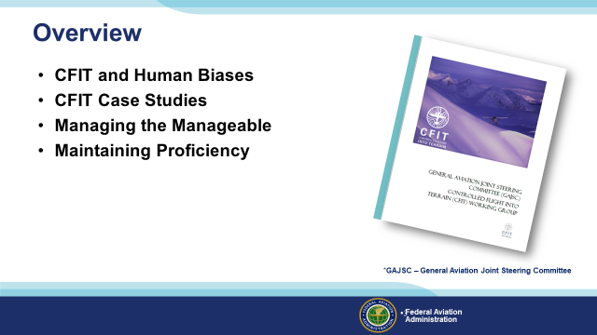 | Slide 3  The General Aviation Joint Steering Committee (GAJSC) Controlled Flight Into Terrain (CFIT) work group report suggests that human bias – particularly Plan Continuation Bias – may be significant factors in CFIT accidents. In this presentation we’ll talk a little bit about CFIT and human biases that may negatively influence pilot decision making. We’ll review some CFIT case studies and we’ll offer some thoughts on how to effectively manage things that we can control and plan for dealing with things that are beyond our control. Finally we’ll offer a few suggestions for maintaining pilot proficiency.  Presentation Note: If you’ll be discussing additional items, add them to this list  (Next Slide)
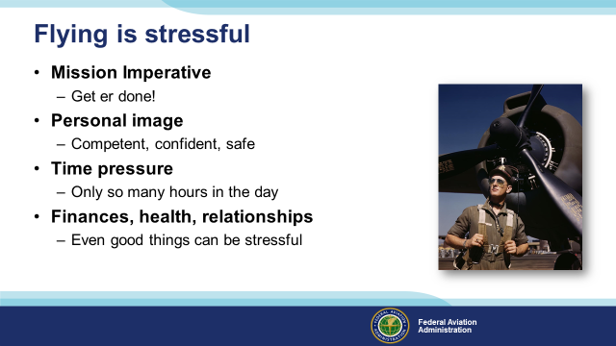 | Slide 4  Flying is stressful. That’s a fact. But we pilots see that stress as a challenge to be met and we take pleasure and yes, considerable pride in meeting the challenge and getting the job done. (Click)  We are mission-oriented, get er done people who honor our commitments. (Click)  We project a personal image of competence, confidence, and safety. (Click)  We know there are only 24 hours in each day and we strive to be on schedule or even a little early. (Click)  And we’re subject to all the stresses, good and bad, that our ground bound friends deal with every day. The difference is – we manage those stresses to ensure safe operations. Many of us will say, “I leave my problems on the ground while I’m flying.” While that may not be strictly true, we do excel in managing all the demands of the dynamic and ever challenging realm of flight.  One of the ways we do this is to manage the manageable.  (Next Slide)
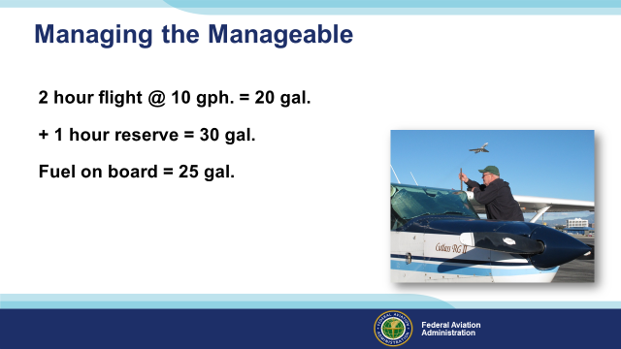 | Slide 5  Managing stress and errors and safety is a big subject but there are some simple things pilots can do to get started. The key is to know as much as you can about what you’re getting into, manage the things that are within your control, and have a plan for how do deal with things that you can’t control. Here’s a simple scenario to think about.  Assume you are to be honored at a prestigious luau themed dinner meeting in a city 2 hours away. You plan to spend the night & return the next morning. The weather is VMC and will remain so for your flight. A weather system will move through the destination area about 2 hours after your arrival but it will be VMC again by morning. If you leave right after work you’ll be at the venue at least an hour before the event begins. You can’t leave earlier because of an important business meeting in the afternoon. It seems we’ve introduced some stress before we even take off. (Click)  Your airplane burns 10 gallons an hour so you’ll need 20 gallons for the trip. (Click)  You want a 1 hour reserve so that brings the total fuel required to 30 gallons. There will be plenty of fuel because there’s a standing order for the airplane to be topped off after every flight. (Click)  But during preflight you note that your evil partner failed to fuel the plane…. again! You’ve only got 25 gallons on board. What do you do?  (Next Slide)
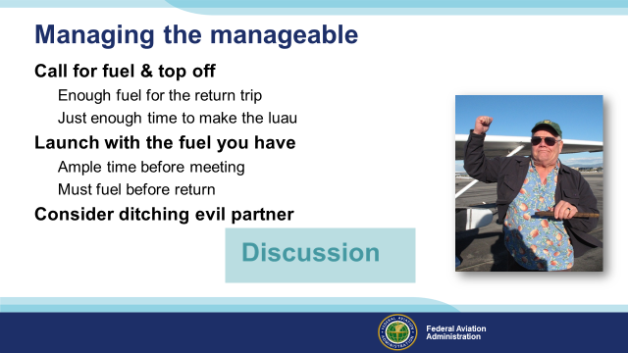 | Slide 6  Let’s have a little discussion on what to do next.  Presentation note: Let the audience discuss these and other options Click once & you’ll bring up points under each of the first 2 options. Some folks will think it’s better to fuel first and perhaps be a little late for the dinner; others will want to get there with time to spare and fuel for the return trip the next day. The key is to think about how you respond to the scenario and what’s best for you. (Click)  Well that was an interesting discussion and there was some diversity of opinion. Except when it came to ditching the partner. We’ll look at this scenario in a different way a little later but first let’s talk about a process the leads to success in nearly everything we do.  (Next Slide)
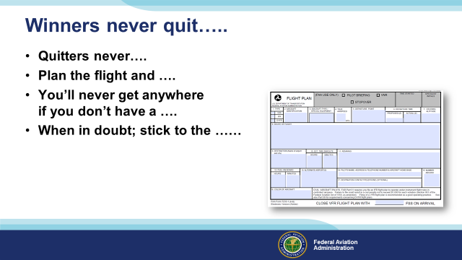 | Slide 7  Winners never quit …. For as long as most of us can remember, we’ve heard this from our parents, coaches, and teachers.  Here are some other famous words to live by; let’s see if we can fill in the blanks: (Click)  Presentation Note: Ask the audience to fill in each blank. The correct responses are given in the text below.  Quitters never win (Click)  Plan the flight and fly the plan (Click)  You’ll never get anywhere if you don’t have a plan (Click)  When in doubt; stick to the plan  Why are we told this repeatedly? Because it works …………… most of the time … but sometimes sticking to the plan can have us flying to someplace we definitely don’t want to be.  (Next Slide)
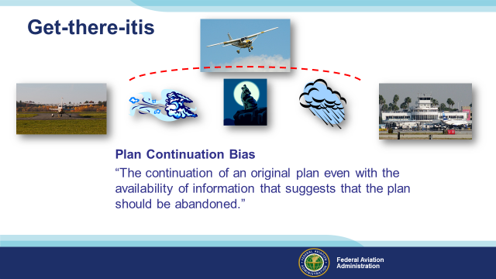 | Slide 8  Let’s revisit our scenario with the trip to the dinner meeting and let’s say we elect to take off without our desired one-hour fuel reserve. (Click)  We decide to take off with the fuel we have. We’ll still have a half hour VFR reserve when we land and there will be plenty of time to mix and mingle before the dinner. (Click)  Shortly into the flight we notice that the headwind is stronger than forecast. That means the trip will take longer. Good thing we didn’t wait around for fuel. (Click)  Our original plan called for us to land just before sunset. It now looks as if it will be dark before we get there. That’s OK we’re night current but we won’t have our 45 minute fuel reserve. It’ll be more like 20 minutes. Ah well – that’s what fuel reserves are for. (Click)  Rats! – only 20 minutes to go and our destination is going down in rain showers. That wasn’t supposed to happen for hours. Not that it’s a particular problem. The weather’s not convective, we’re instrument rated and equipped. If there’s any delay in getting an approach though we’re going to be really tight on fuel. Interestingly the closer we get to reaching the destination the greater the compulsion to continue the plan. How can we ignore so much in flight that is so obvious to everyone after the fact? It could be the powerful but unconscious cognitive bias to continue the original plan.  (Click)  Psychologists call the continuation of an original plan even when information suggests the plan should be abandoned Plan Continuation Bias. We have another name for it don’t we?  Presentation note: Wait for audience to come up with it then: (Click)  Get-there-itis.  (Next Slide)  Background  Plan continuation bias is an unconscious cognitive bias to continue the original plan in spite of changing conditions. It appears stronger as one nears completion of the activity (e.g., approach to landing). This bias may prevent noticing subtle cues indicating original conditions have changed. It may combine with other cognitive biases such as frequency sampling bias ("It's always worked before") and that reactive responding is easier than proactive thinking.  (Next Slide)
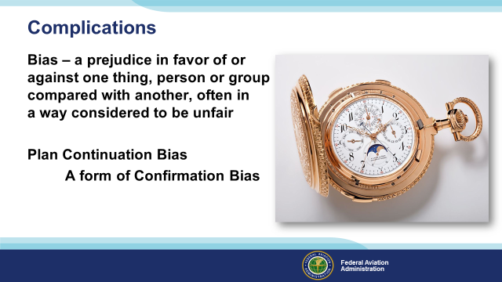 | Slide 9  In watchmaking, the term, “complication” refers to added features that complicate the challenge of designing elegant machines that provide a wealth of information in a small package. Here we’re using the word to describe human biases that complicate the process of making sound decisions. (Click)  Bias is defined as a prejudice in favor of or against one thing, person, or group compared with another, often in a way considered to be unfair.  Plan continuation bias is an unconscious cognitive bias to continue the original plan in spite of changing conditions. It appears stronger as one nears completion of the activity (e.g., approach to landing).  The way this works is. There is a very strong motivation to get something done, like attend the dinner. Then as the journey continues there are weak motivations to turn around or land for fuel. The pilot ignores the weak ones because they are so much weaker than the original motivation. However, the weak motivations tend to add up at some point to be stronger than the initial motivation. At that point it may be too late to complete the flight in safety.  This bias may prevent noticing subtle cues indicating original conditions have changed. It may combine with other cognitive biases such as frequency sampling bias ("It's always worked before"). (Click)  Plan Continuation Bias is a form of Confirmation Bias – the tendency to search for, interpret, favor, and recall information in a way that confirms or supports one’s prior beliefs or values. Confirmation Bias can lead pilots to favor information that supports their plan and reject or discount non-supportive information.  (Next Slide)
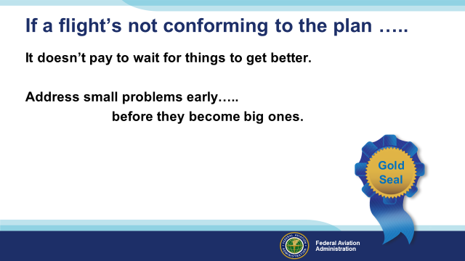 | Slide 10  If a flight’s not going as planned, it doesn’t pay to wait for things to get better. Obviously it’s much better to address small problems early; before they become big ones.  It’s also obvious that effective flight planning doesn’t stop with the taxi out but rather continues throughout the flight.  (Next Slide)
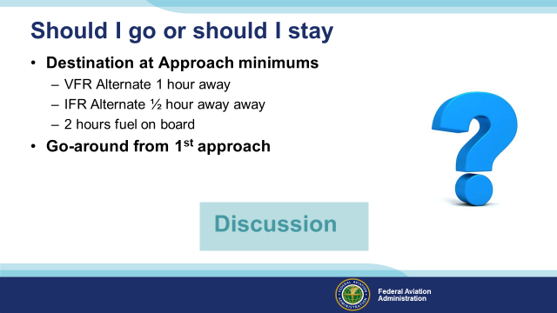 | Slide 11  Here’s a hypothetical scenario for consideration:  You’re approaching your destination airport with 2-hours of fuel on board. The destination weather is at precision approach minimums.  An alternate airport with VMC weather but no instrument approach options is one hour away. There’s a closer IFR option a half hour away. It has only non-precision approach options but the weather is well above minimums. (Click)  You shoot an ILS approach at the destination airport but can’t see the runway at the missed approach point so you initiate a go-around and head for the missed approach holding fix.  So do you fly another approach at the destination or head for one of the alternates? (Click)  Presentation note: Lead a discussion on alternatives. If the pilot was on course and on glide path at the missed approach point does it make sense to try another approach? We will feel the pressure to complete the mission and land at the destination airport. And flying another approach will be easier than proceeding to a new destination but, if the first approach was perfect and the weather hasn’t changed, we should proceed to our alternate. But which alternate? After discussion is complete:  (Next Slide)  Background: The background information article, 7 Approaches – 1 Landing, that details the flight discussed on this and the next two slides is included in the Approved Resources folder for this presentation.
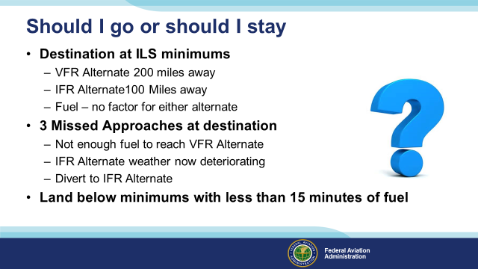 | Slide 12  Now that we’ve discussed a hypothetical case, let’s take a look at the same sort of circumstances that prevailed during an actual B 737 flight from the middle east to India. The destination weather was at ILS minimums as the crew made their first approach. A decent VFR Alternate was 200 miles away. An IFR alternate served by a non-precision instrument approach was 100 miles closer. There was enough fuel on board to reach either alternate airport. (Click)  But after three missed approaches at the destination, the VFR alternate option was beyond their fuel range so they flew to the IFR alternate where the weather was now deteriorating. With no other options, they flew 3 more missed approaches (Click)  Before landing with less than 15 minutes of fuel on board.  (Next Slide)
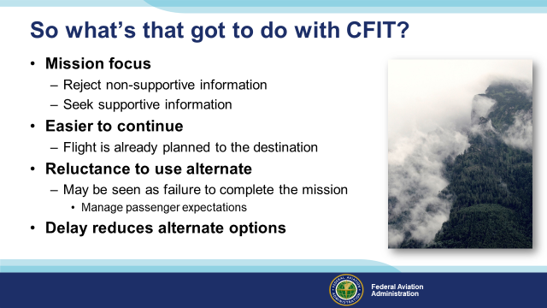 | Slide 13  So what has all this got to do with CFIT? Well sometimes we’re so focused on and committed to the mission that we don’t notice serious flight hazards along the way. We seek support for our decisions to continue while rejecting information that argues for changing the plan. (Click)  Besides – it’s usually easier to continue an established plan than to come up with a new plan while still flying the aircraft. That’s why it’s essential to have at least one alternative plan ready to go. (Click)  Don’t be reluctant to exercise your alternate plan. Diversion to an alternate should be viewed as a success – not a failure. We don’t want to disappoint or inconvenience our passengers but our job  is to get them on the ground safely. If that means landing at an alternate destination so be it. Diversion to an alternate is a lot easier for passengers to accept if you manage their expectations by briefing them on the possibility before the flight. Explain that conditions are such that landing at the preferred destination may be impossible. If that’s the case you’ll divert to the alternate. (Click)  Finally, keep in mind that the longer you wait to exercise your alternate options, the fewer options will be available. The pilots in our story waited until their VFR alternate option was impossible to reach and ended up making a bad situation worse.  (Next Slide)
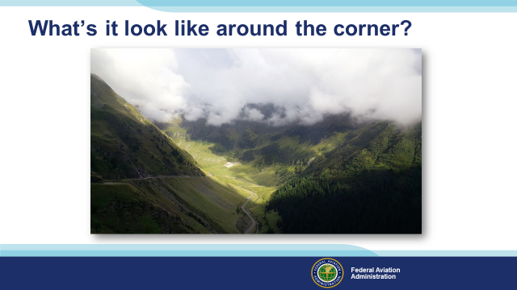 | Slide 14  Wouldn’t it be nice to know what the weather ahead looks like? From what we can see in this picture we’re probably too low to fly IFR so the question becomes, “can we maintain VFR?”.  If there’s an airport just around the corner and they report the weather, we may have the answer to our question. If not, it looks like we’ll have to descend to take a look. That’s a tough decision to make and, as we’ll see, familiarity with the environment can lead you to make some bad choices. This is a classic setup for a CFIT accident and this is what the GAJSC is trying to avoid. To illustrate our point we’re going to discuss a commercial helicopter flight. It’s probably not the flight that comes immediately to mind but there are some frightening similarities.  (Next Slide)
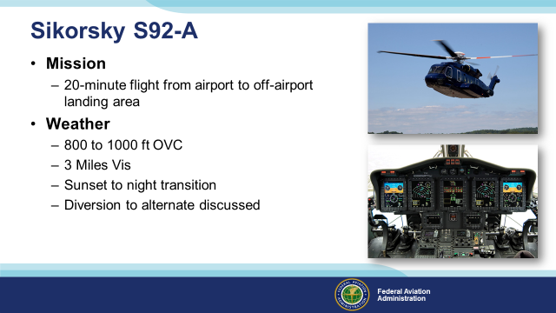 | Slide 15  The helicopter is a Sikorsky S92-A equipped for VFR and IFR Day and Night flight. For this mission, it’s crewed by two captain-qualified pilots who have frequently flown as a crew. Their practice is to alternate Pilot in Command (Pilot Flying) and Pilot Monitoring roles from flight to flight. (Click)  The Pilot Flying has 6,200 hours of flight time with 441 hours in the S92. In addition to flying duties, he is the Managing Director and the Safety Manager for his company.  He is also the Principal Point of Contact for the client on this flight so he’s quite familiar with the client’s service requirements and the operational environment. (Click)  The Pilot Monitoring has 732 hours of flight time with 250 hours in Type. He has no managerial roles with the company.  (Next Slide)  Background: U K Heli - an article detailing the incident discussed here and in the next 3 slides is included in Approved Resources..  (Next Slide)  Background: The background information article, U K Heli - detailing the incident discussed here and in the next 3 slides is included in Approved Resources.
Slide 16
The mission is to pick up passengers from commercial airport and fly them to a private landing site on the Client’s estate. The incoming flight is scheduled to land just before sunset so the pilots are hoping for an expeditious transfer so that they can reach the destination before nightfall.
The weather is running between 800 and 1,000 feet Overcast with 3 Miles Visibility. On the inbound positioning flight, the crew flew an ILS approach to the commercial airport. They discuss diverting to an nearby airport with an instrument approach if they are unable to land at the destination.

(Next Slide)
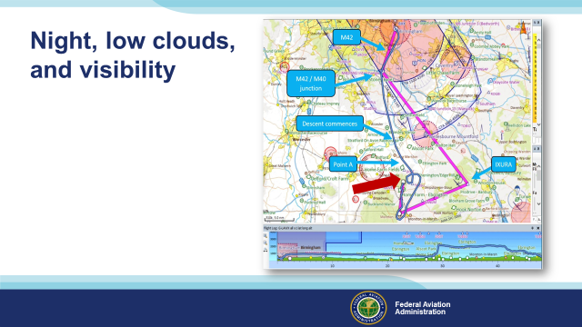 | Slide 17  Here we see a plan view of the flight. The magenta line shows the planned route. This would position the aircraft for an approach from the south; making it possible to see a portable visual approach aid at the landing site. But, trying to complete the flight in daylight, the PIC elected to head direct to the field and approach from the north as shown by the blue line. (Click)  Although the flight descended to less than 50 feet above the ground and came within less than a mile of the destination; they failed to see it; and a climb and go-around were initiated. It was now night and the PIC stated that he would try an approach from the south in hopes of seeing the portable visual approach aid. Low clouds and poor visibility in drizzle persisted on this approach and the crew discussed returning to the origin airport but the portable approach aid was seen at 1 mile and the flight was completed to the destination.  (Next Slide)
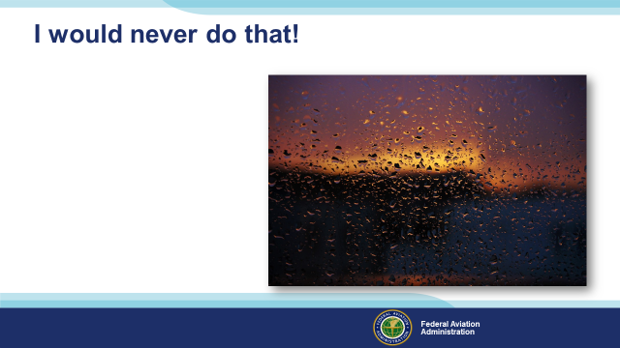 | Slide 18  Another complicating bias leads us to think, “I would never do that”! And I’m sure the helicopter crew would never have made the flight if they knew how close they would come to disaster.  But they didn’t know how the flight would progress when they took off. It’s easy to say, “I would never do that!”, when we know how the story ends. We’re looking at the story in the blinding light of Hindsight Bias.  (Next Slide)
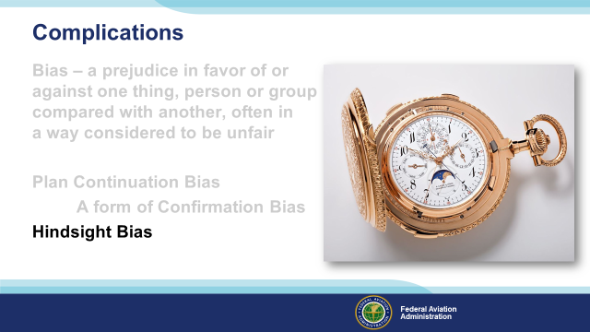 | Slide 19  As investigators construct the chain of events from the end to the beginning, it’s easy to see where things went wrong. Hindsight bias leads to the contention that the persons who err knew, or should have known, that their actions would lead to disaster. Once we know how the story ends, it’s easy to think, “that couldn’t happen to me”.  Well, there’s a big problem with that way of thinking.  (Next Slide)
Slide 20
The problem with hindsight bias is that people don’t usually set out to create a disaster – certainly not for their loved ones or themselves. Kierkegaard is saying that we understand life through reflection but it’s difficult or often impossible to reflect forward.
Still, when seeking to understand why accidents happen, we must look at the pilot’s decision making process from the beginning. Only then can we begin to understand why what happens – happens.

(Next Slide)
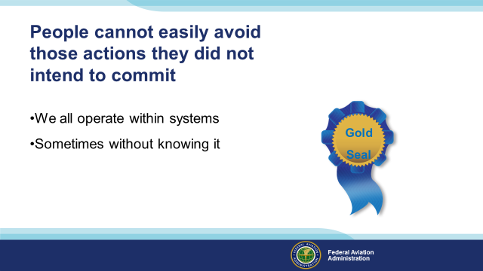 | Slide 21  Here’s another really important point. People cannot easily avoid those actions they didn’t intend to commit.  It’s very difficult to see that the choices you’re making are directing you along a path to tragedy. Whatever the activity, people rarely set out to create a disaster and yet – sometimes – circumstances and environment and human decisions combine with decidedly unfavorable results. And there’s usually a system component to the error. (Click)  We all operate within multiple systems – sometimes without even knowing it. (Click)  Good system design supports safe and effective decision making. But some systems support the opposite. Just take a look at this:  (Next Slide)
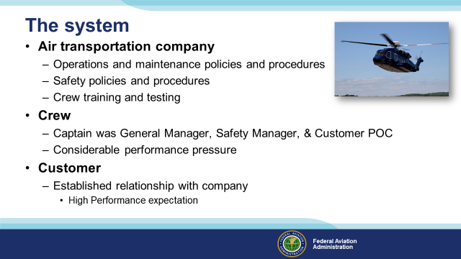 | Slide 22  Here’s just a rudimentary look at the system involved in our story. The Air transportation company and it’s flight personnel were licensed by the government and governed by applicable laws and regulations.  Company operations, maintenance, and safety policies and procedures controlled how business was done. (Click)  As General Manager and Safety Manager, the captain had a key role in defining company culture and, as the Principal Point of Contact for this customer, he managed the relationship with the client. He was under considerable pressure to deliver his customer to the off-airport landing site. (Click)  The customer was very important to the company and, based on prior experience, performance expectation was high. Regardless of circumstances, the customer expected the company to complete the mission to the landing site.  Looking at it this way there are a lot of systemic elements to consider and some of those elements provide strong motivation to get the job done.  (Next Slide)
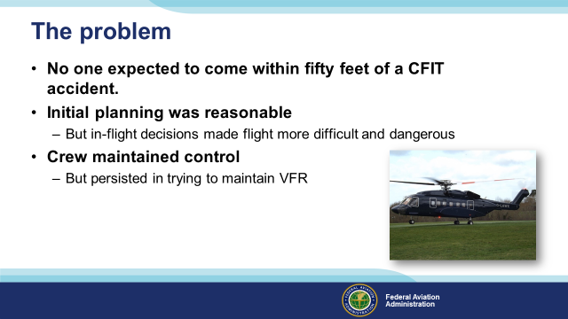 | Slide 23  When the flight took off, no one expected to come within 50 feet of a CFIT accident. But they did. Although company operations procedures supported diversion to alternates, the “can do” culture encouraged and rewarded completing flights as specified and delivering customers to where they wanted to go.  The initial flight plan was reasonable: Fly to a position where you can acquire a visual approach aid and follow its’ guidance to the landing site. If we can’t maintain visual flight, we’ll proceed to the alternate airport and fly an instrument approach.  But that plan would result in an after dark arrival so the crew elected to save time, proceed direct to the landing site, and approach from a position where they would not be able to see the approach aid. If the weather had cooperated, the flight would have been quicker and would have ended with a day VFR approach and landing. If the weather had cooperated, the customer and crew would be pleased with the result and we wouldn’t be talking about this flight.  The crew did attend to the most important task. They maintained aircraft control throughout the flight even though there were periods when they could not discern ground references and had to rely on instruments. The safest alternative, once ground contact was lost, was likely to fly to the alternate where an instrument approach could be made. They didn’t exercise their IFR option but happily they were able to complete the flight after reverting to the original plan.  .  (Next Slide)
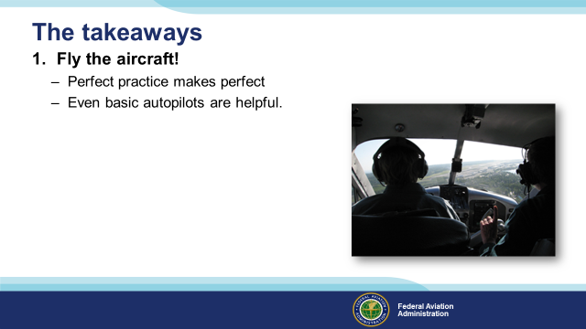 | Slide 24  Of course the number one priority on any flight is to Fly the Aircraft! That’s easy to do in good weather; much harder to do if you’re coping with deteriorating weather and navigating to an alternate airport.  There are definitely times when any pilot approaches task saturation and that’s not a comfortable place to be. Regular practice, guided by a Flight Instructor, and honed to perfection, is the best preparation for all flight challenges.  An autopilot is well worth considering for VFR and IFR flying. Even a basic wing leveler can reduce pilot work load and make more time for in-flight decision making.  (The End)
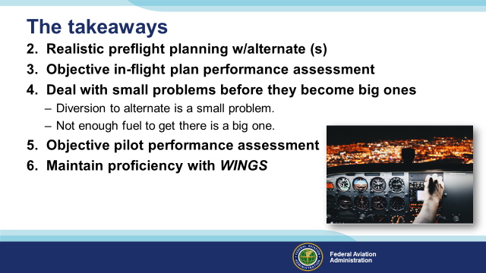 | Slide 25  It’s important to note that there are multiple influences associated with any flight. Pilots need to effectively manage those influences to ensure a safe outcome. (Click)  The process begins with realistic preflight planning that considers pilot and aircraft capabilities as well as mission requirements. The process should include consideration of factors that could compromise success and alternative plans for dealing with them. (Click)  While in flight, pilots must continually and objectively assess how well the flight is conforming to plan. In addition to route progress and weather, fuel state and performance monitoring must be considered. There will always be variations from plan most of which won’t compromise the safe completion of the flight; but they should be noted and dealt with. (Click)  Deal with problems and variances as soon as they are noted. That way you can take care of small problems before they become big ones. In the grand scheme; diversion to an alternate is a small problem – especially if you’ve planned for it. But not having enough fuel to reach the alternate is a big problem. (Click)  Pilots must be prepared to deal with any challenges that occur in flight and in order to do that we must know what we and our aircraft are capable of. That requires an objective assessment of our performance – preferably made by a flight instructor. Your instructor can help you to develop and document Personal Performances minimums. (Click)  And finally; we must maintain our proficiency in order to meet our performance minimums. A regular program of proficiency training with a CFI is best and we urge you to consider the FAA WINGS Pilot Proficiency Program.  (Next Slide)
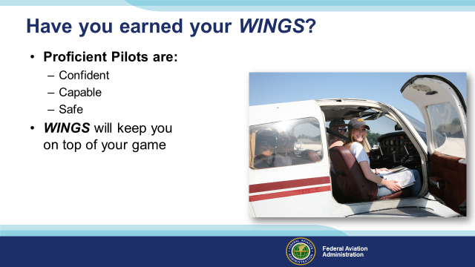 | Slide 26  Have you earned your WINGS? Proficiency is key to success in almost every thing worth doing – especially flying. Proficient pilots are confident, capable, and safe.  WINGS is a proficiency training system specifically designed for general aviation pilots and, regular participation will keep you on top of your flying game.  (Next Slide)
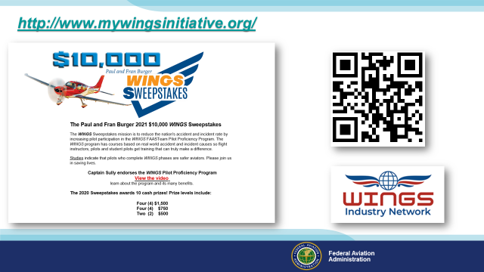 | Slide 27  Every time you complete a WINGS Phase you’re eligible to win cash in the WINGS Sweepstakes.  The sweepstakes is generously funded by Paul Burger, a long time advocate for general aviation safety and a retired aviator who believes participation in this program saves lives. VISIT WWW.MYWINGSINITATIVE.ORG to learn more and enter the sweepstakes.  Just navigate to http://www.mywingsinitiative.org or scan the QR code for details. By the way, Instructors can also enter the sweepstakes. But there are even better reasons to participate in WINGS.  (Next Slide)
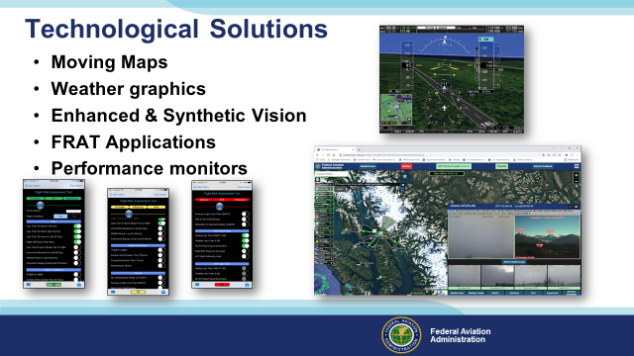 | Slide 27  There are a host of technological programs, applications, and devices that can aid pilots in situational awareness and risk assessment. Moving maps with terrain overlays are common so there’s no excuse for not knowing how close you are to a collision. Flight planning tools can now integrate with charting programs, cockpit displays and weather imagery. FRAT applications make it easy to conduct pre and in-flight risk assessments, performance monitoring equipment keeps pilots apprised of their aircraft’s capability, and weather cams provide another way to keep pilots apprised of weather conditions..  Pilots have access to more information than ever before and that has already contributed to a 20-year reduction in CFIT accidents. But all that information comes in many different forms so we must be thoroughly familiar with and proficient in device operation and information interpretation.  Note: Augmented Visual Technology for GA: Encourage GA pilots and operators to equip and utilize Enhanced Vision System (EVS)/Synthetic Vision System (SVS) technology to enhance situational awareness with respect to surrounding terrain.  (Next Slide)
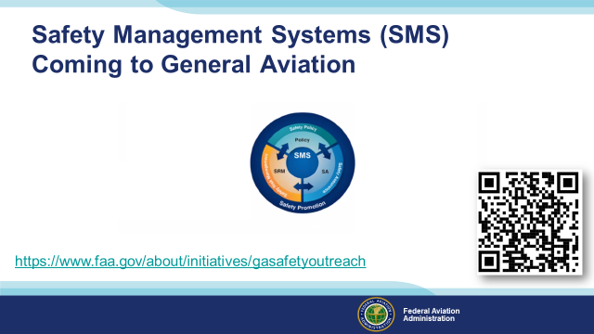 | Slide 28  Safety Management Systems are a set of policies and processes that can increase the safety and efficiency of any flight operation. And FAA is bringing SMS to General Aviation. You may have heard of SMS but thought it was only for large organizations but actually SMS can be scaled to fit any operation large or small.  There are 4 major components to a Safety Management System (Click)  Safety Policy – a documented commitment to safety that runs from the head of an organization to its newest member. (Click)  Safety Risk Management – a process that identifies hazards within an operation, determines to what extent an identified hazard may impact flight safety, and controls the risk of occurrence to an acceptable level. (Click)  Safety Assurance – By collecting and analyzing information derived from safety performance data Safety Assurance ensures the performance and effectiveness of Safety Risk Controls. (Click)  Safety Promotion communicates safety information and commitment throughout the organization. (Click)  You can find more information about Safety Management Systems at the URL on the Screen.  (Next Slide)
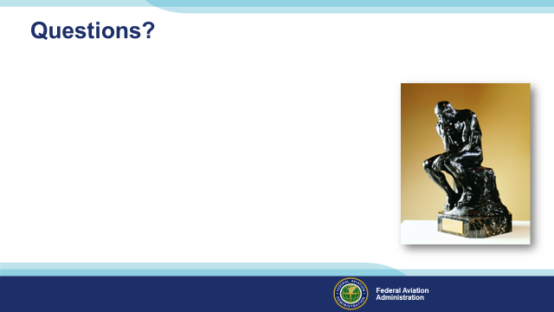 | Slide 28  Presentation Note: You may wish to provide your contact information and main FSDO phone number here. Modify with your information or leave blank.  (Next Slide)
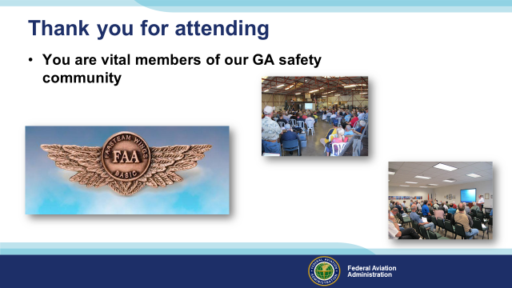 | Slide 29  Your presence here shows that you are vital members of our General Aviation Safety Community. The high standards you keep and the examples you set are a great credit to you and to GA.  Thank you for attending.  (Next Slide)
Slide 30

(The End)

Appendix I – Equipment and Staging
Equipment:
- Projection Screen & Video Projector suitable for expected audience
  - Remote computer/projector control available at lectern or presenter location
    - In lieu of remote – detail a Rep to computer/projector control.
- Presentation Computer

  - Note: It is strongly suggested that the entire program reside on this computer.
- Back up Projector/Computer/Media as available.
- PA system suitable for expected audience
  - Microphones for Moderator and Panel
    - Optional Microphone (s) for audience
- Lectern (optional)
Staging:
- Arrange the projection screen for maximum visibility from the audience.
- Equip with PA microphones
- Place Lectern to one side of screen. This will be used by presenters and moderator

IMPORTANT – Once you have completed outreach on this topic, please help us track the outreach you have done by entering a SAS record.

