General Aviation Joint Steering Committee
Loss of Control Working Group
Outreach Guidance Document
2022/03-17-249(I)PP

This outreach guidance is provided to all FAA and aviation industry groups that are participating in outreach efforts sponsored by the General Aviation Joint Steering Committee (GAJSC). It is important that all outreach on a given topic is coordinated and is free of conflicts. Therefore, all outreach products should be in alignment with the outline and concepts listed below for this topic.

Outreach Month: May 2023

Topic: The $300.00 Inspection
The FAA and industry will conduct a public education campaign emphasizing the value of detailed aircraft inspections conducted by qualified aircraft mechanics with Inspection Authorization..
Background:
Inadequate maintenance and inspections are common accident causal factors. Aircraft owners seeking bargain-priced mechanical services may see unairworthy aircraft returned to service following cursory inspections .
Teaching Points:
- Periodic aircraft inspections are necessary in order to detect and correct discrepancies that cannot be discovered in the course of normal preflight inspections..
- Aircraft owners and pilots should insist on regulatory compliant inspections and documentation..
- Owners of light single-engine airplanes should expect an annual inspection charge to include fifteen and thirty hours of labor. Airworthiness Directive compliance, oil changes, repairs, parts, and supplies will be additional charges
- Aircraft Owners should seek reputable mechanical services and expect to pay a fair price to obtain them.

References:
- 14 CFR 43.15 - Additional Performance Rules for Inspections
- 14 CFR 43 Appendix D – Scope and Detail of Items to be Included in Annual and 100-Hour Inspections
- AC 61-67C – Stall and Spin Awareness Training
Abstract: Lasting 10 to 15 minutes, this presentation acquaints the audience with the benefits of detailed periodic aircraft inspections.
Format: Information Briefing - Power Point presentation
Required Personnel – FAASTeam Program Manager or designated FAASTeam Rep (s)
Optional Personnel – CFIs and Mechanis who can speak on pilot/mechanic communication.
National FAASTeam Support:
In addition to this guidance document, a Power Point presentation that supports the program is provided. FPMs and presenters are encouraged to customize this presentation to reflect each individual program.

Slides | Script
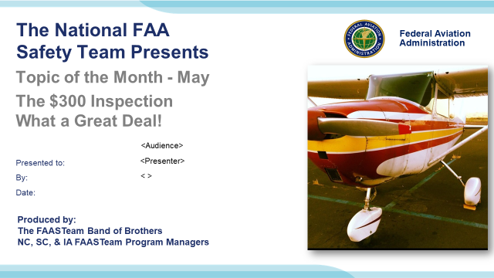 | Slide 1  2022/03-17-250(I)PP Original Authors: (Tim Haley, Eddie Shields, David Hintz, and James A. Dangerfield) POC Guy Minor Office: 707-704-3530  Presentation Note: This is the title slide for (The $300.00 Inspection – What a Great Deal!)  Presentation note: This is the title slide for Angle of Attack.  - Script - We have included a script of suggested dialog with most slides. The script will always appear in a non-italic font. Presenters may read the script or modify it to suit their own presentation style. See template slides 5 and 6 for examples of a slides with script.  - Presentation Instructions - (stage direction and presentation suggestions) will be preceded by a Bold header: the instructions themselves will be in Italic fonts. See slides 2, 3, and 4 for examples of slides with Presentation Instructions only.  - Program control instructions - will be in bold fonts and look like this: (Click) for building information within a slide; or this: (Next Slide) for slide advance.  - Background information - Some slides may contain background information that supports the concepts presented in the program.  Background information will always appear last and will be preceded by a bold Background: identification.  The production team hope you and your audience will enjoy the show. Break a leg!  (Next Slide)
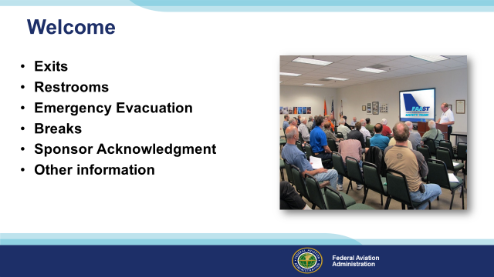 | Slide 2  Presentation Note: Here’s where you can discuss venue logistics, acknowledge sponsors, and deliver other information you want your audience to know in the beginning.  You can add slides after this one to fit your situation. (Next Slide)
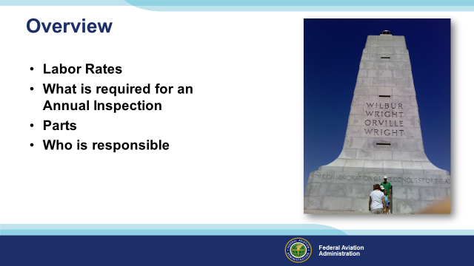 | Slide 3  In this presentation, we will address various issues that have been found in a “real deal” annual inspection. What is the actual value of a cheap annual inspection?  We are going to cover:  Labor Rates  Requirements of an Annual Inspection  Necessary parts and their cost…  …and who is responsible for the condition of the airplane  Presentation Note: If you are discussing additional items, add them to this list  (Next Slide)
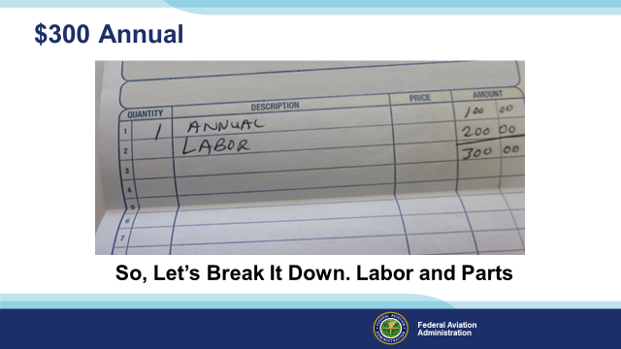 | Slide 4  Inspectors reviewed the maintenance records of a Piper Cub after an accident. This receipt was found in the paperwork. It is an actual invoice for an Annual. The Annual was $100, Labor was $200, and Parts…well, no parts. Three hundred dollars, what a great value! So, Let’s Break It Down. What do you think you get for 300 Dollars? (Next Slide)
 | Slide 5  Let’s compare several shop rates. Listed here are labor rates for automobile and truck maintenance. Diesel truck shops run around $150.00 per hour!  (Next Slide)
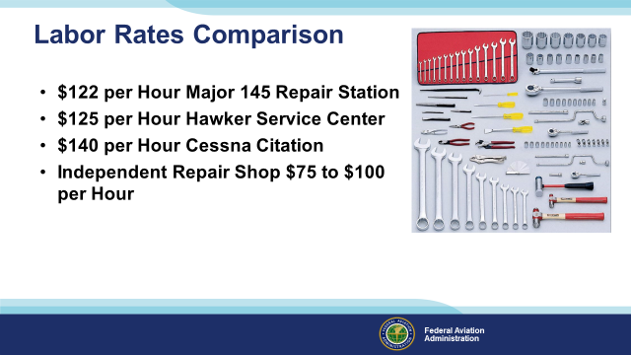 | Slide 6  Here are the prices for a few aircraft repair shops. So, why is there a difference between aircraft and the auto industry when the aircraft industry has a lot more responsibility and liability? We are also subject to regulations that hold us to a higher standard.  (Next Slide)
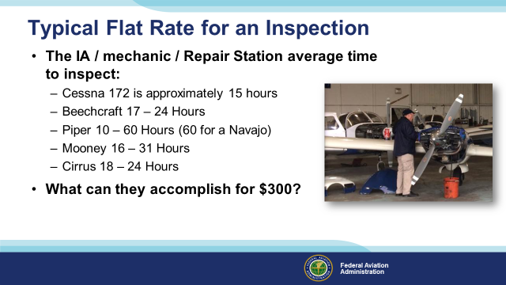 | Slide 7  The flat rate to inspect a Cessna 172 is approximately 15 hours. This DOES NOT include an oil change, cleaning and gapping spark plugs, compliance AD notes, or any repairs. Those are extras charged at the shop rate.  Cessna 172; is approximately 15 hours  Beechcraft; 17 – 24 Hours  Piper; 10 – 60 Hours (60 for a Navajo)  Mooney; 16 – 31 Hours  Cirrus; 18 – 24 Hours  Presentation note: Suggest to the audience to share their experiences, minus names and places.  (Next Slide)
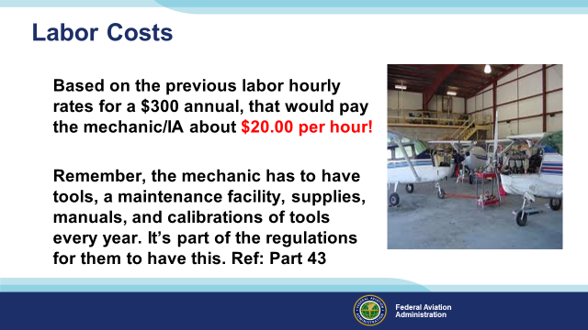 | Slide 8  Can a person make a living at $20.00 per hour? There are also expenses. Things like electricity, water, maintenance and rent on the building, insurance, more specialized tooling, etc.  Mechanics, Repair Stations, and even Owners performing Preventative Maintenance must meet the same requirements for tooling, manuals, and calibrated tools.  (Next Slide)
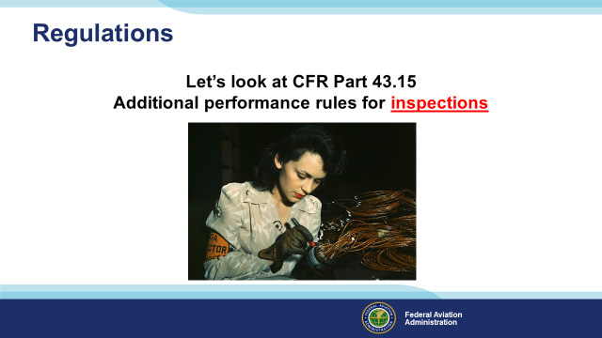 | Slide 9  Let’s look at CFR Part 43.15, Additional performance rules for inspections.  (Next Slide)
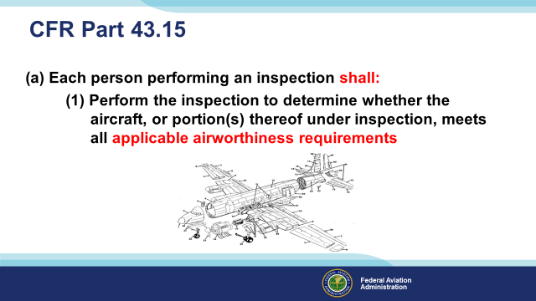 | Slide 10  CFR Part 43.15 states that, in general, each person performing an inspection required by parts 91, 125, or 135 of this chapter shall perform the inspection to determine whether the aircraft or portion(s) thereof under inspection, meets all applicable airworthiness requirements*; and if the inspection, is one provided for in parts 125, 135, or Sec. 91.409(e) of this chapter, perform the inspection per the instructions and procedures outlined in the inspection program for the aircraft being inspected.  *Airworthiness requirements are found on the aircraft A/W certificate.  (Next Slide)
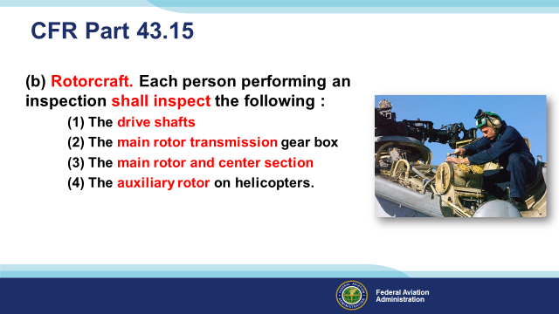 | Slide 11  For rotorcraft. Each person performing an inspection required by Part 91 on a rotorcraft shall inspect the following systems per the maintenance manual or Instructions for Continued Airworthiness of the manufacturer concerned, the drive shafts or similar systems, the main rotor transmission gearbox for apparent defects, the main rotor and center section (or the equivalent area), and the auxiliary rotor on helicopters.  (Next Slide)
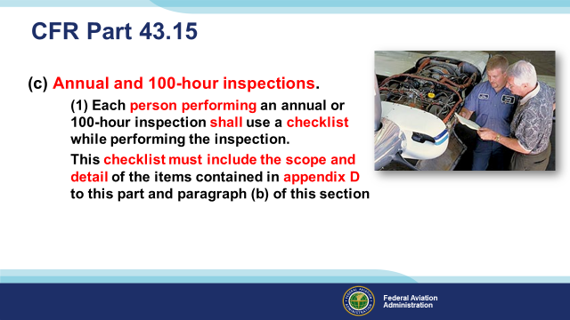 | Slide 12  For Annual and 100-hour inspections. Each person performing an annual or 100-hour inspection shall use a checklist while performing the inspection. The checklist may be of the person's own design, one provided by the manufacturer of the equipment being inspected, or one obtained from another source.  This checklist (at a minimum) must include the scope and detail of the items contained in appendix D to this part and paragraph (b) of this section.  You must also consider the more complex the aircraft; the more inspection items must be added to the minimum required inspection items listed in appendix D. Consider a Cessna 421; it has a highly complex gear retract system, larger turbocharged engines, pressurized cabin, electronic systems, etc., all these systems must be added to the inspection form. Also, Appendix D does not cover Modifications. Supplemental Type Certificates (STC) and their instructions for continued airworthiness (ICA) that must be included in any inspection checklist.  (Next Slide)
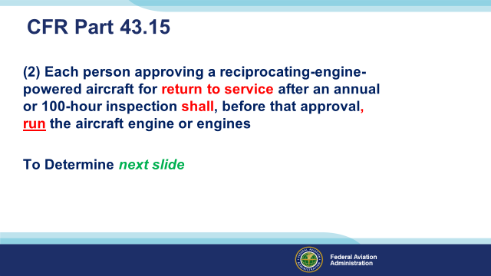 | Slide 13  Each person approving a reciprocating-engine-powered aircraft for return to service after an annual or 100-hour inspection shall, before that approval, run the aircraft engine or engines to determine satisfactory performance per the manufacturer's recommendations.  (Next Slide)
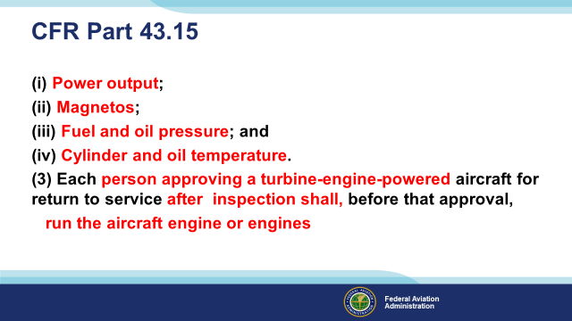 | Slide 14  To determine:  Power output (static and idle r.p.m.);  Magnetos;  Fuel and oil pressure; and  Cylinder and oil temperature.  Each person approving a turbine-engine-powered aircraft for return to service after an annual, 100-hour, or progressive inspection shall, before that approval, run the aircraft engine or engines to determine satisfactory performance per the manufacturer's recommendations.  Progressive inspection. (1) Each person performing a progressive inspection shall, at the start of a progressive inspection system, inspect the aircraft completely. After this initial inspection, routine and detailed inspections must be conducted as prescribed in the progressive inspection schedule. Routine inspections consist of visual examination or check of the appliances, the aircraft, and its components and systems, insofar as practicable without disassembly. Detailed inspections consist of a thorough examination of the appliances, the aircraft, and its components and systems, with such disassembly as necessary. For the purposes of this subparagraph, the overhaul of a component or system is considered to be a detailed inspection.  If the aircraft is away from the station where inspections are customarily conducted, an appropriately rated mechanic, a certificated repair station, or the manufacturer of the aircraft may perform inspections in accordance with the procedures and using the forms of the person who would otherwise perform the inspection  Have you ever seen someone complete an inspection without an engine run or operational check of systems?  (Next Slide)
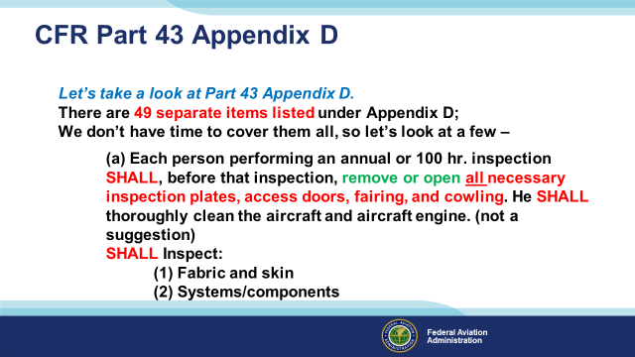 | Slide 15  The first sentence states that the aircraft must be thoroughly cleaned before the inspection. This includes below the floorboards to facilitate a good inspection. Have you cleaned under floorboards? It can be an experience. However, it takes time and has to be accomplished.  Each person performing an annual or 100-hour inspection shall, before that inspection, remove or open all necessary inspection plates, access doors, fairing, and cowling. He shall thoroughly clean the aircraft and aircraft engine  (Next Slide)
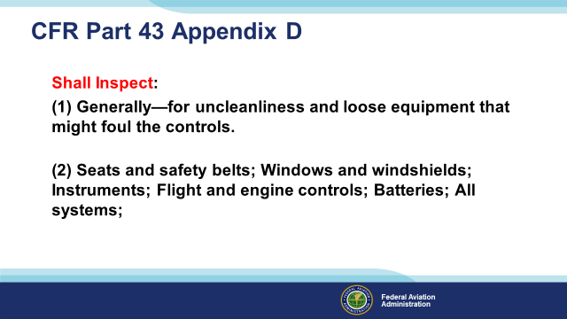 | Slide 16  Each person performing an annual or 100 hr. inspection shall inspect, generally—for uncleanliness and loose equipment that might foul the controls, as well as seats and safety belts; windows and windshields; instruments; flight and engine controls; batteries, and all systems.  (Next Slide)
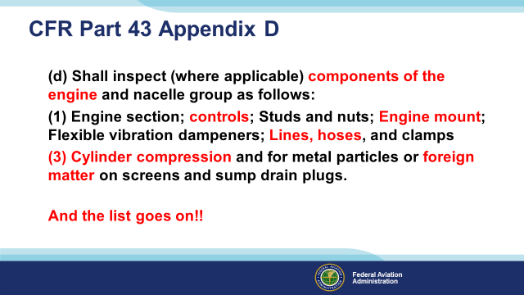 | Slide 17  And the list goes on!! This list speaks to the minimum that is REQUIRED to be accomplished per regulations.  On Slide 15, we said, “open all necessary inspection plates, access doors, fairing, and cowlings” So everything just mentioned and more must be opened up. It takes time to prepare an airplane for inspection. 15 to 25 hours is probably a conservative estimate.  (Next Slide)
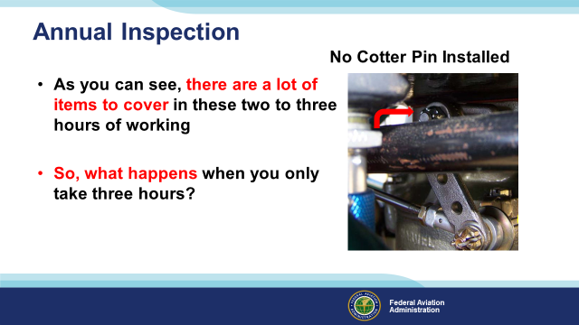 | Slide 18  Two hundred dollars of labor, even for a Cub, is not much. As you can see, there are many items to cover in these two to three hours of working. So, what happens when you only take three hours? Things…things happen like the issue in the photo. In this photo, the throttle control arm disengaged from the serrated half of the throttle shaft when the castellated nut backed off in flight. No cotter pin was installed.  (Next Slide)
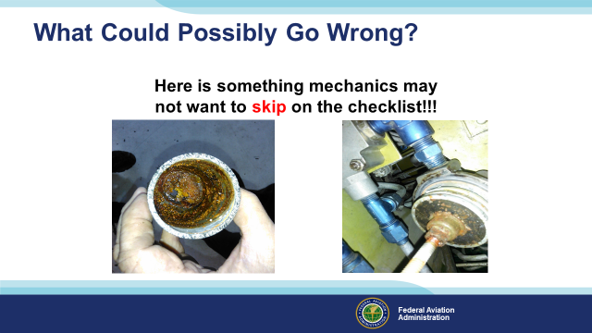 | Slide 19  The mechanic may not have time in two hours to check things like the primary fuel bowls and screens and carburetor inlet screens. What could go wrong? Here rust has made it to the filter. Do you think some might make its way to the carburetor jets?  How much longer might the aircraft continue to run? The plane represented by the picture on the right of the slide made an emergency landing due to low fuel flow to the engine.  (The End)
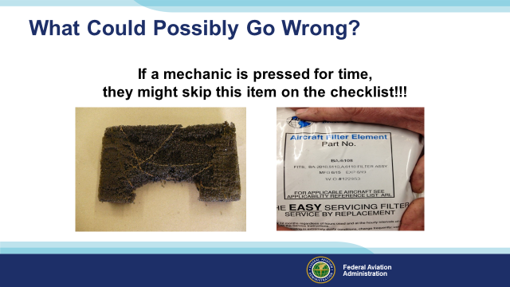 | Slide 20  Foam air filters do not tolerate backfires well, and the damage happens instantly, so mechanics can expect damage anytime they inspect foam air filters. Brackett’s induction air filters must be replaced annually or every 100 hrs. Whichever comes first (Per Brackets ICA’s). They have a shelf life when they are stored. It is printed on the package. Yep, another ten bucks added to the annual/100 hr. inspection!  Where did the soot and all the pieces of the air filter go? Could this cause an engine failure?  (The End)
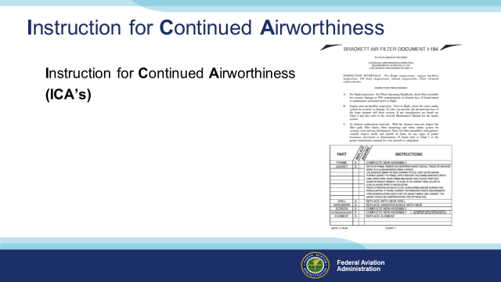 | Slide 21  The ICA for the Bracket air filter from the previous slide is pictured here. The ICA requires it to be replaced at each annual inspection. The ICA is also where the maintenance instructions for modifications installed on the aircraft can be found.  (Next Slide)
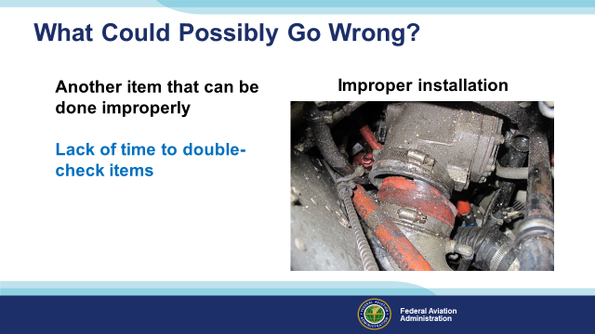 | Slide 22  Lack of time to double-check items. Two A&Ps and an IA did a fast inspection and did not follow the Instructions for Continued Airworthiness on a turbocharger installation. This did not end well, causing an accident.  (Next Slide)
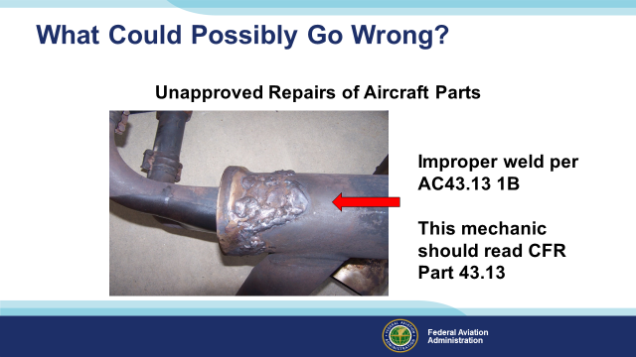 | Slide 23  Did the IA /shop open the shroud around the exhaust system to inspect for cracks? Unknown or bad repairs can’t be seen unless the system is opened up and inspected. Poor muffler repairs are a great way to introduce carbon monoxide into the cabin.  This type of repair usually indicates a thinning of the original muffler. Look for it to “Blow Out” again. What kind of stress is this causing? Stress cracks? Metal fatigue?  43.13 (b) Each person maintaining or altering, or performing preventive maintenance, shall do that work in such a manner and use materials of such a quality that the condition of the aircraft, airframe, aircraft engine, propeller, or appliance worked on will be at least equal to its original or properly altered condition (with regard to aerodynamic function, structural strength, resistance to vibration and deterioration, and other qualities affecting airworthiness).  (Next Slide)
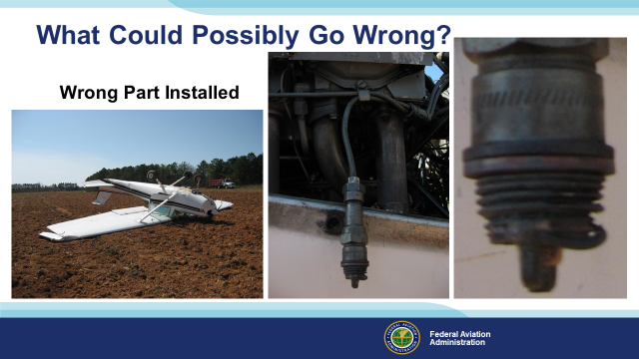 | Slide 24  Here is an example of the wrong part being installed. A spark plug Helicoil was replaced a few hours before this spark plug was blown out of the engine. It was found that the mechanic did not use the proper Helicoil in accordance with the OEM manual. The manual called for an oversized Helicoil, but the Mechanic used a standard size.  Background  ERA10LA187 March 24, 2010, Cessna 152,  The local instructional flight had departed from the airport about 30 minutes before the accident. After completing several aerial maneuvers, including slow flight and power-off stalls, the student pilot began a recovery from another power-off stall. When he applied throttle, the engine immediately began to run rough. The certificated flight instructor decided to perform a forced landing in a farm field. During the landing roll, the nosewheel came in contact with the soft soil and the airplane nosed over. A postaccident examination of the engine by a Federal Aviation Administration inspector revealed that the bottom sparkplug and associated Helicoil on the No. 4 cylinder had separated from the cylinder. It ran normally after a new sparkplug and Helicoil were installed. The airplane's engine maintenance logbook showed that four days before the accident, the bottom sparkplug and Helicoil had been replaced on the No. 4 cylinder due to a bad Helicoil. The mechanic had installed a standard Helicoil contrary to the engine manufacturer's recommendation to install oversized spark plug inserts.  (Next Slide)
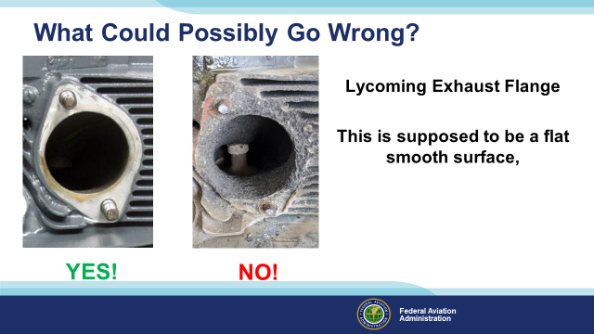 | Slide 25  This aircraft was flown to a new maintenance shop due to the original IA retiring. The new mechanic told the aircraft owners what he had found and told them they needed a new cylinder. They got rather belligerent and stated that it had been that way for years. The new mechanic also mentioned the price for the annual inspection of $1,500. The aircraft owners were astonished and said they had never paid more than $300 for an annual. It goes without saying that the aircraft needed a lot of repairs, and AD compliances, to make it airworthy again.  (Next Slide)
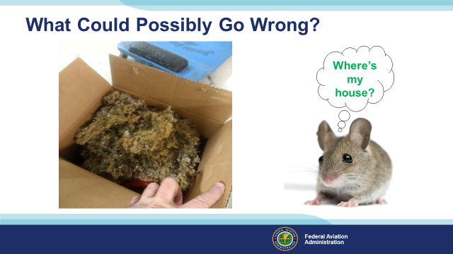 | Slide 26  In this case, an aircraft owner complained for several years about a rodent smell in the aircraft. After the sixth year of annual inspections with the same mechanic, the owner decided to take the plane to a different shop for an annual inspection. The shop removed a large box full of rodent nest material in the aircraft wing.  (Next Slide)
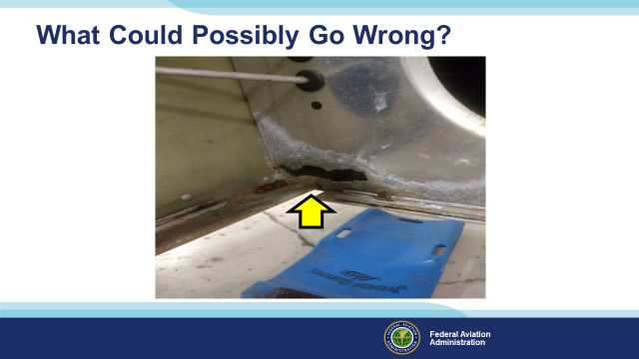 | Slide 27  Rodents are rough on the aluminum structure. During the inspection, there was a large amount of corrosion in the wing, including a hole (pictured) in the wing rib and corrosion of the wing skins and spar.  Currently, the wing has been removed from the aircraft and shipped to a repair station to determine the extent of the repair.  (Next Slide)
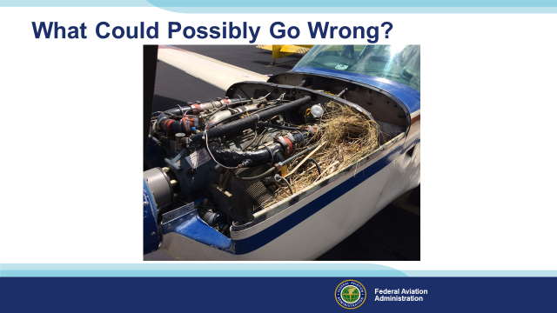 | Slide 28  During your preflight this coming spring, it would be good to conduct a careful inspection every time you fly! Birds can make a new home within hours.  (Next Slide)
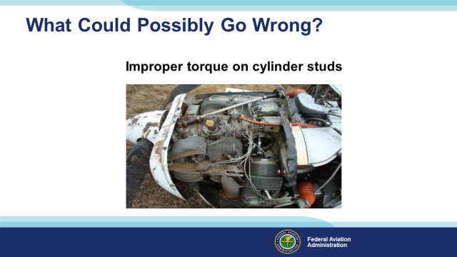 | Slide 29  During the annual inspection, the aircraft owner should ensure the mechanic follows the recommended factory manuals if any repairs are needed. Improper torque on cylinders retaining hardware continues to be a significant problem. This mechanic probably didn’t have time to remove baffling on the opposite side of the engine to torque the mount nuts properly. Some studs are slid into the engine from one side to the other, meaning the stud can rotate if not installed correctly.  Also, placing RTV (a common silicone sealant)under cylinders has been found not to let the cylinders be appropriately torqued due to the RTV spongativity. After a few hours, the RTV works loose and leaves loose cylinder hold-down nuts, and eventually, the cylinder will depart from the engine. See the Continental service bulletin on approved sealants to verify this.  (The End)
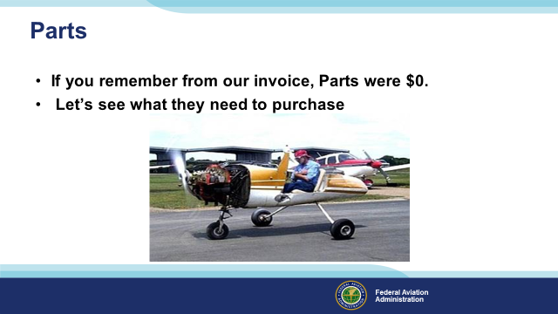 | Slide 30  If you remember from our invoice, Parts were $0.  Let’s see what they need to purchase.  (Next Slide)
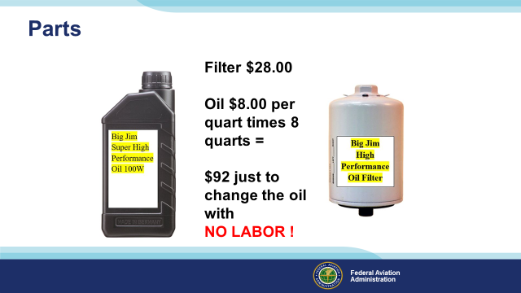 | Slide 31  Just oil and filter. Really? Oil and filter! That’s all? There are no seals for fuel bowls, carburetor fitting at inlet screens, no air filter, no supplies like approved greases and lubricants, and cleaners for aircraft and engines before the annual inspection. The list goes on…Instrument inlet filters need to be replaced regularly.  Cessna has specific grease for the flap actuators on the single-engine airframes and special greases for ignition switches.  (Next Slide)
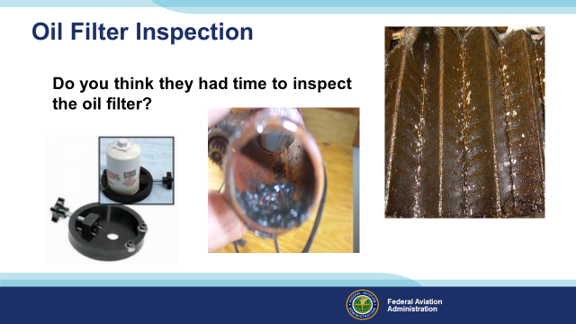 | Slide 32  Did the IA let the owner change oil? Did the IA inspect the screen/filter for metal particles? If not, how can an IA determine the airworthiness condition of the engine? Metal in the filter is one of the ways to assess internal engine condition and airworthiness. There are tools to cut the filter open easily, and they’re not too expensive! The oil filter cutter on the slide is an example of a low-cost tool.  (Next Slide)
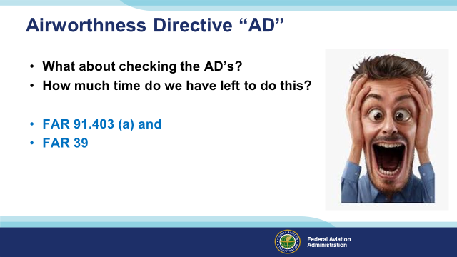 | Slide 33  For a maintenance shop to research a new set of logbooks, it is not uncommon to take more than six hrs. To research them, determine if they apply, verify that they have been complied with, and verify the log entry on every AD note on the aircraft.  Annual inspections that have been done cheaply usually have poor AD compliance records, and it takes more time to research to verify AD compliance on every AD. The owner should receive a compliance sheet showing where, how, and by whom the Ads were complied with and when the recurring ADs must be re-inspected.  (Next Slide)
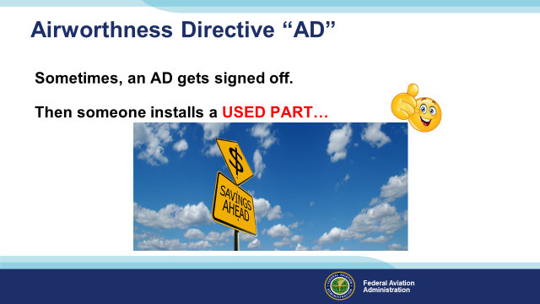 | Slide 34  Details like what mag switch is installed matter. Many aircraft have had an AD signed off on an ignition switch for years, and the plane doesn’t even have that one installed! Look at the type and name of the ignition switch.  All instruments and engine accessories have to be verified with compliance on AD notes. Do you have those listed? Does the IA look at those every year? Where is the list? There is a recommended AD list template in most AMT CFR manuals printed by vendors.  Sometimes an AD will be signed off; then, someone replaces a part with a used part that has not had the AD complied with. This causes the AD to be due again, and the aircraft is un-airworthy until it is accomplished.  Do you have a compliance sheet showing all components for compliances of AD’s? Was the compliance sheet updated to show compliance with an AD after a used part was installed?  (Next Slide)
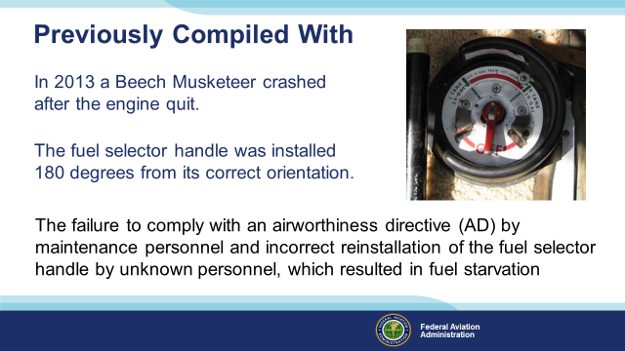 | Slide 35  This item should have been checked on the post-run-up of the aircraft after the inspection. Examination of the wreckage after the accident revealed that the airplane’s fuel selector handle was installed 180 degrees from its correct orientation. When the handle portion of the selector was pointing at the desired tank, the pointer (arrow) was pointing in the opposite direction, so when the pilot selected the left main fuel tank, the fuel selector valve was positioned to the right main fuel tank, which had little fuel at takeoff and was found empty after the accident.  The fuel selector handle was also missing its roll pin, which allowed it to be installed incorrectly. The fuel system was designed so the return fuel went to the left main fuel tank, so the pilot generally flew with the fuel selector positioned to the left main fuel tank.  The fuel selector handle was often removed and reinstalled during maintenance inspections to allow access to the floorboards in the cockpit. An airworthiness directive (AD) for the fuel valve required repetitive inspection of the fuel selector handle roll pin during annual inspections per a manufacturer service instruction or replacing the roll pin valve with a D-handle type valve.  A review of maintenance records revealed that about 38 years before the accident, a logbook entry indicated that the AD was complied with by installing a D-handle fuel valve; however, a roll pin type valve was installed at the time of the accident. Maintenance personnel performing subsequent inspections would assume, per the logbook entry, that the D-handle valve had been installed, and any maintenance reference to the roll pin valve would not be applicable. The mechanic who performed the most recent annual inspection stated that he was unaware of a roll pin. The mechanic added that he removed and replaced the fuel selector handle to the same position he had found it during the annual inspection.  The pilot had owned the airplane for about 45 years and performed maintenance. The investigation could not determine when the fuel selector handle was installed incorrectly or by whom in the airplane's history.  After interiors have been replaced, a very close examination of all systems should be conducted.  NTSB # ERA13LA285  (Next Slide)
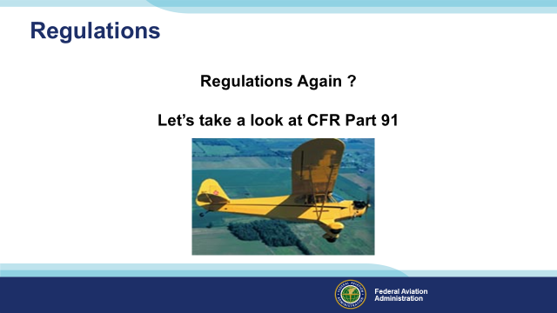 | Slide 36  Regulations Again? Let’s take a look at CFR Part 91.  (Next Slide)
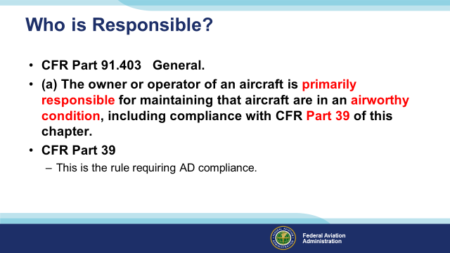 | Slide 37  Part 91 is the operation rule. This means that owners and operators are responsible for complying with them. It is good for aircraft owners and operators to read 14 CFR 91. Subpart E is for owners and operators. You know, pilots. It includes the responsibility to fly an airworthy aircraft. It includes the requirement to inspect aircraft. It even makes it the owner’s responsibility to ensure the maintenance people enter the proper entry indicating the plane has been returned for service. Like this, “Shall ensure that maintenance personnel make appropriate entries in the aircraft maintenance records indicating the aircraft has been approved for return to service.” Aircraft Owners and operators are responsible for the airworthiness of the aircraft, not the maintenance people…Cool! 14 CFR 91. Subpart E, it’s a good read!  Part 39? This is a rather obscure rule. Not much to it. We suggest you read it. It will take less than five minutes. It is the basis of AD notes.  (Next Slide)
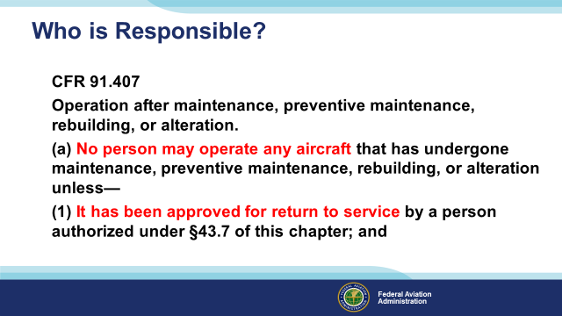 | Slide 38  Remember, the owner/operator of the aircraft is solely responsible for the airworthiness of the aircraft. The owners /operators also must ensure that they assure the mechanic/IA/repair station signs a return to service statement in their logbook records.  Remember Part 91 consists of owner/operator Rules.  (Next Slide)
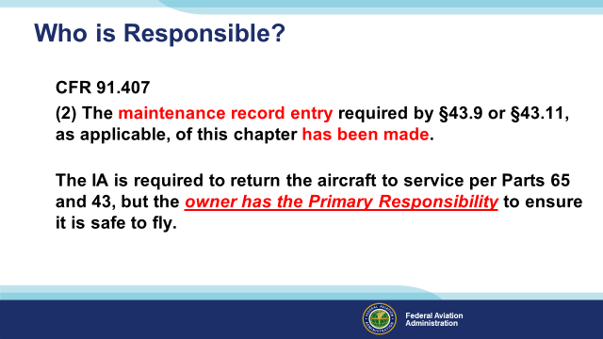 | Slide 39  It is very clear in Part 91 who has the final responsibility of a safe aircraft. Make sure as an owner all AD’s are complied with and the minimum check list covers everything in accordance with Part 43 appendix D. Ask to see the check list.  Does it seem we have a theme today?  (Next Slide)
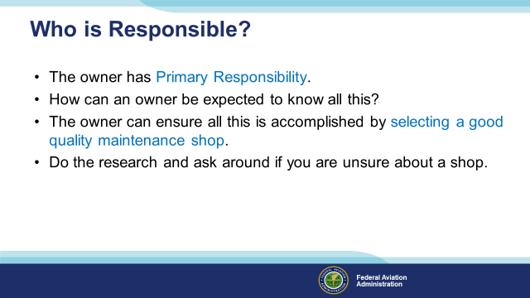 | Slide40  It is very clear in Part 91 who has the final responsibility for a safe aircraft. The owner has the Primary Responsibility. How can an owner be expected to know all this??  The owner can ensure all this is accomplished by selecting a good-quality maintenance shop.  Do the research and ask around if you are unsure about a shop.  (Next Slide)
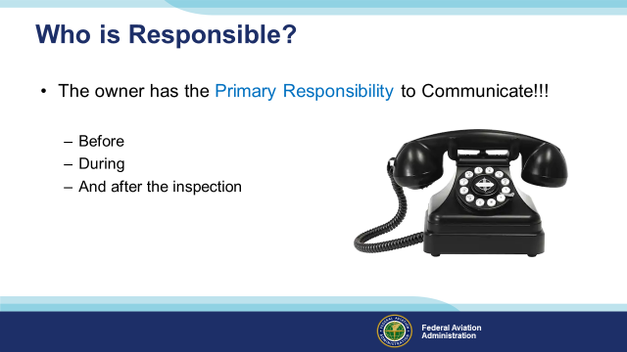 | Slide 41  The #1 complaint FAA Inspectors hear from owners about maintenance shops has to do with communications between owners and the mechanics. So, we developed a presentation on that topic all by itself.  Before the inspection is the time to talk about owner assistance, get price quotes before starting repairs, and become familiar with issues with the aircraft. It is time to consider the Service Bulletins you might want to have the shop perform.  During the inspection is the time to find out what the shop found. What the options for repair they offer, and what will it cost.  After the inspection is the time to find out what the shop did. Review the return to service and find out when the next item is due? Determine the status of the aircraft Ads.  (Next Slide)
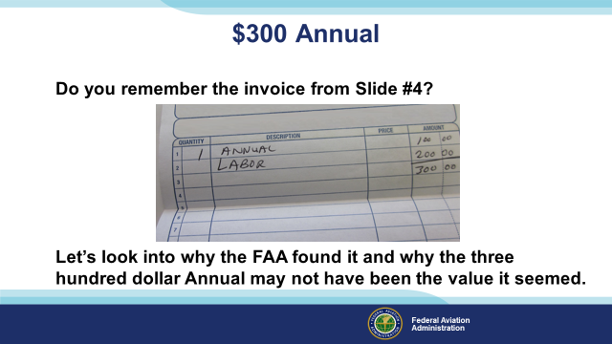 | Slide 42  Do you remember the invoice from Slide #4? Let’s look into why the FAA found it and why the three-hundred-dollar Annual Inspection may not have been the value it initially seemed.  (Next Slide)
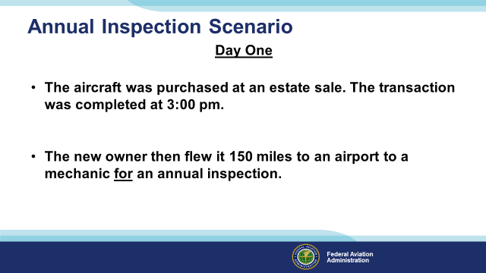 | Slide 43  The aircraft was out of annual.  What do you need to request from the FAA to fly an aircraft that is out of annual? A Ferry Permit or Special Flight Authorization.  (Next Slide)
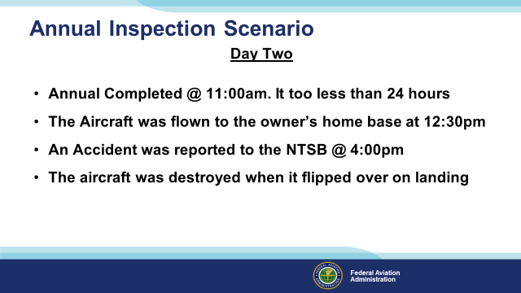 | Slide 44  The Annual inspection was completed by 11:am the next day with the owner’s and two friends’ assistance. The owner had a family function and asked his friends to fly the airplane to the owner’s home base at 12:30 pm. An Accident was reported to the NTSB @ 4:00 pm. The aircraft had been destroyed when it flipped over on landing.  The aircraft was flown for approximately 3 hours with stops at airports with control towers. This might seem to be an odd remark but hold the thought for a couple of slides.  (Next Slide)
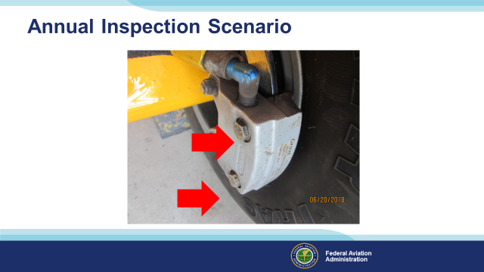 | Slide 45  So, what caused this misery? Someone failed to safety wire the brake caliper. The NTSB reported that the brake caliper was bent, and it appeared to have happened when someone over-torqued the brakes. The NTSB stated that the brakes locked due to this over-torquing.  (Next Slide)
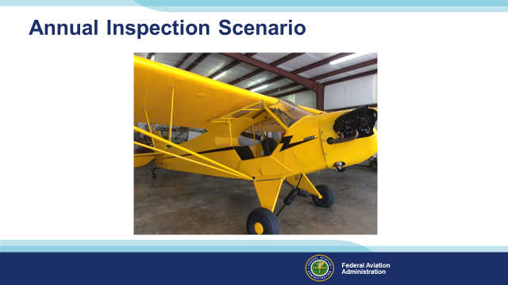 | Slide 46  It was noted that only two of the wing inspection holes had been cut open. The mechanic stated he used a borescope to inspect the whole wing from these two locations. But could not produce the borescope or explain how he inspected the wing with the borescope.  How many aircraft have you seen with un-cut inspection holes after several years of inspections after a re-cover?  (Next Slide)
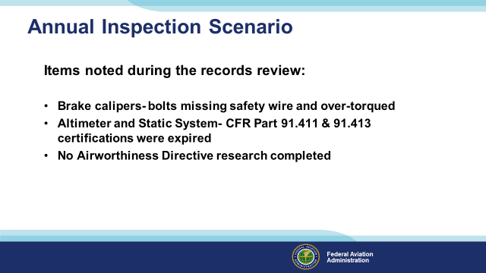 | Slide 47  There were a lot of items that appeared to be overlooked. Here are a few. Brake calipers, the bolts were missing safety wire and over-torqued. (Causing the aircraft to be destroyed). No AD research was completed, and  the Altimeter and Static System CFR Part 91.411 & 91.413 certification was expired. There is quite a lot of paperwork for an annual inspection, and the time provided by a 300-dollar annual may not be enough.  Have you heard the old cliché, “We don’t have a problem until we have a problem?” Imagine how a violation for flying in controlled airspace with an expired transponder certification would be like a cherry on top of the ice cream Sunday of misery.  (Next Slide)
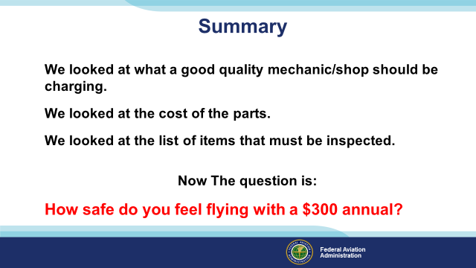 | Slide 48  In summary, We looked at what a good quality mechanic/shop should be charging. We looked at the cost of the parts. We looked at the list of items that must be inspected. We then pointed out that it might not be a good idea to put a mechanic under time pressure when conducting an Annual Inspection.  Flying has never been known to be cheap, so don’t skimp on annual inspections. It just isn’t a very good value. Your life and your family's lives depend on it!  (Next Slide)
 | Slide 49  Presentation Note: You may wish to provide your contact information and main FSDO phone number here. Modify with Your information or leave blank.  (Next Slide)
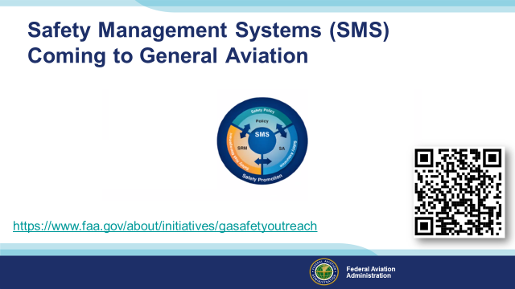 | Slide 50  Safety Management Systems are a set of policies and processes that can increase the safety and efficiency of any flight operation. And FAA is bringing SMS to General Aviation. You may have heard of SMS but thought it was only for large organizations but actually SMS can be scaled to fit any operation large or small.  There are 4 major components to a Safety Management System (Click)  Safety Policy – a documented commitment to safety that runs from the head of an organization to its newest member. (Click)  Safety Risk Management – a process that identifies hazards within an operation, determines to what extent an identified hazard may impact flight safety, and controls the risk of occurrence to an acceptable level. (Click)  Safety Assurance – By collecting and analyzing information derived from safety performance data Safety Assurance ensures the performance and effectiveness of Safety Risk Controls. (Click)  Safety Promotion communicates safety information and commitment throughout the organization. (Click)  You can find more information about Safety Management Systems at the URL on the Screen.  (Next Slide)
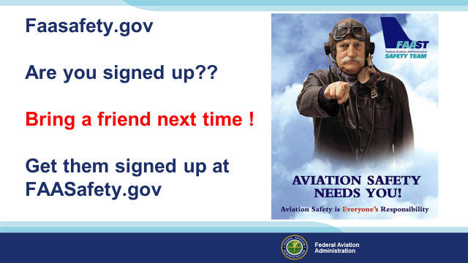 | Slide 51  Presentation Note: You may wish to provide your contact information. Modify with your information or leave blank.  (Next Slide)
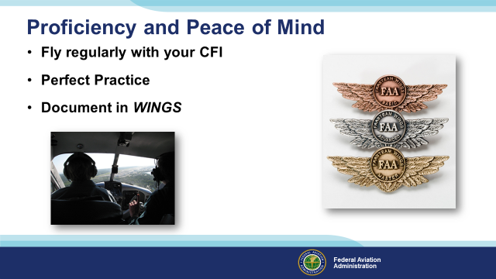 | Slide 52  There’s nothing like the feeling you get when you know you’re playing your A game and in order to do that you need a good coach (Click)  So fly regularly with a CFI who will challenge you to review what you know, explore new horizons, and to always do your best. Of course you’ll  have to dedicate time and money to your proficiency program but it’s well worth it for the peace of mind that comes with confidence. (Click)  Vince Lombardi, the famous football coach said, “Practice does not make perfect. Only perfect practice makes perfect.” For pilots that means  flying with precision. On course, on altitude, on speed all the time. (Click)  And be sure to document your achievement in the WINGS Proficiency Program. It’s a great way to stay on top of your game and keep you flight review current.  (Next Slide)
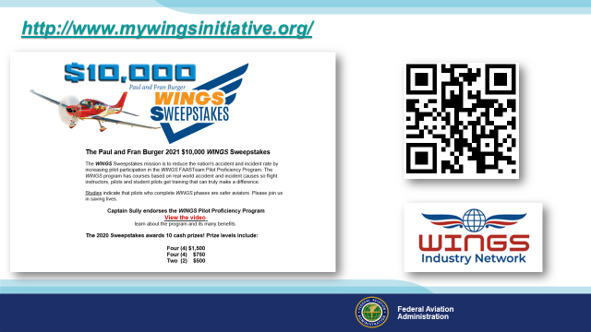 | Slide 53  Every time you complete a WINGS Phase you’re eligible to win cash in the WINGS Sweepstakes.  The sweepstakes is generously funded by Paul Burger, a long time advocate for general aviation safety and a retired aviator who believes participation in this program saves lives. VISIT WWW.MYWINGSINITATIVE.ORG to learn more and enter the sweepstakes.  Just navigate to http://www.mywingsinitiative.org or scan the QR code for details. By the way, Instructors can also enter the sweepstakes. But there are even better reasons to participate in WINGS.  (Next Slide)
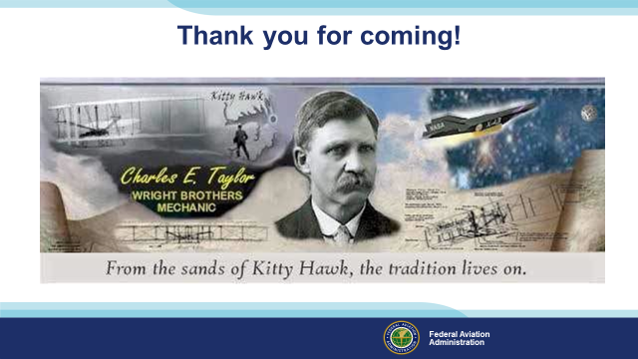 | Slide 54  Your presence here shows that you are vital members of our General Aviation Safety Community. The high standards you keep and the examples you set are a great credit to you and to GA.  Thank you for attending.  Presentation Note: You may wish to provide your contact information. Modify with your information or leave blank.  Discuss Charles Taylor Master Mechanic Awards and the Wright Brothers Master Pilot Awards.  (Next Slide)
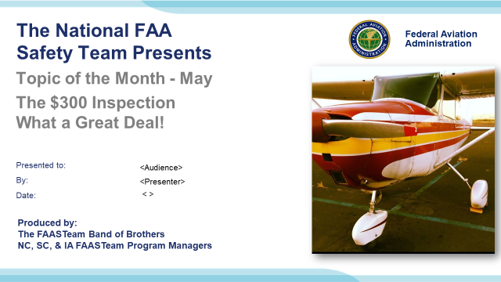 | Slide 55  (The End)

Appendix I – Equipment and Staging
Equipment:
- Projection Screen & Video Projector suitable for expected audience
  - Remote computer/projector control available at lectern or presenter location
    - In lieu of remote – detail a Rep to computer/projector control.
- Presentation Computer
  - Note: It is strongly suggested that the entire program reside on this computer.
- Back up Projector/Computer/Media as available.
- PA system suitable for expected audience
  - Microphones for Moderator and Panel
    - Optional Microphone (s) for audience
- Lectern (optional)
Staging:
- Arrange the projection screen for maximum visibility from the audience.
- Equip with PA microphones
- Place Lectern to one side of screen. This will be used by presenters and moderator

IMPORTANT – Once you have completed outreach on this topic, please help us track the outreach you have done by entering a SAS record.


