General Aviation Joint Steering Committee
Loss of Control Working Group

Outreach Guidance Document
2020/03-06-184(I)PP

This outreach guidance is provided to all FAA and aviation industry groups that are participating in outreach efforts sponsored by the General Aviation Joint Steering Committee (GAJSC). It is important that all outreach on a given topic is coordinated and is free of conflicts. Therefore, all outreach products should be in alignment with the outline and concepts listed below for this topic.

Outreach Month: March 2021

Topic: Pilot Proficiency and WINGS
The FAA and industry will conduct a public education campaign emphasizing the value of regular proficiency training.

Background:

Proficiency training is so beneficial to aviation safety that it is required of most professional pilots. Proficiency training is also beneficial to general aviation pilots as well. Studys have shown that pilots who participate in regular proficiency training are much less likely to experience accidents.

The FAA WINGS Pilot Proficiency Program is one way for general aviation pilots to ensure they are competent, confident, and safe in their flight operations.

Note: This program discusses WINGSPro activities. We suggest you invite local WINGSPros to attend and to assist with the presentation.

Teaching Points:

- WINGS is FAA’s Pilot Proficiency Program.
- WINGS is most beneficial if training is not done all at once but rather spaced out throughout the year.
- The WINGS Topic of the Quarter is an easy way to pursue regular proficiency training.
- Completion of any phase of WINGS satisfies the 14 CFR 61.56 requirements for Flight Reviews.
- A cadre of WINGSPros is available to assist Flight Instructors and pilots with WINGS.

References:
- Pilot Proficiency and WINGS PowerPoint
  - Available on the National FAASTeam Share Point site under Approved Presentations.
- AC 61-91J – WINGS – Pilot Proficiency Programs

- AC 61-98D – Currency Requirements and Guidance for the Flight Review and Instrument Proficiency Check

Abstract: Lasting 10 to 20 minutes, this presentation acquaints the audience with the benefits of engaging in regular proficiency training through the FAA WINGS Pilot Proficiency Program.
NOTE: This program also satisfies requirements for Spring WINGS Topic of the Quarter Outreach
Format: Information Briefing - Power Point presentation
Required Personnel – FAASTeam Program Manager or designated FAASTeam Rep (s)
Optional Personnel – DPEs, CFIs, WINGSPros, and other pilots who can speak on the benefits of proficiency training.
AFS 850 Support:
In addition to this guidance document, a Power Point presentation that supports the program is provided. FPMs and presenters are encouraged to customize this presentation to reflect each individual program.

Slides | Script
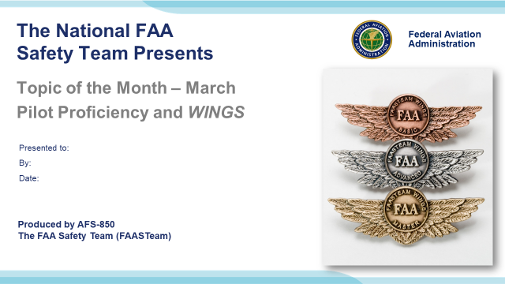 | Slide 1  2020/03-06-184(I)PP Original Author: J. Steuernagle March 2020 POC: K. CloverAFS-920 Operations Lead Office 562-888-2020 Revised by: Name Date  Presentation Note: This is the title slide for Pilot Proficiency and WINGS  - Script - We have included a script of suggested dialog with most slides. The script will always appear in a non-italic font. Presenters may read the script or modify it to suit their own presentation style. See template slides 5 and 6 for examples of a slides with script.  - Presentation Instructions - (stage direction and presentation suggestions) will be preceded by a Bold header: the instructions themselves will be in Italic fonts. See slides 2, 3, and 4 for examples of slides with Presentation Instructions only.  - Program control instructions - will be in bold fonts and look like this: (Click) for building information within a slide; or this: (Next Slide) for slide advance.  - Background information - Some slides may contain background information that supports the concepts presented in the program.  Background information will always appear last and will be preceded by a bold Background: identification.  The production team hope you and your audience will enjoy the show. Break a leg!  (Next Slide)
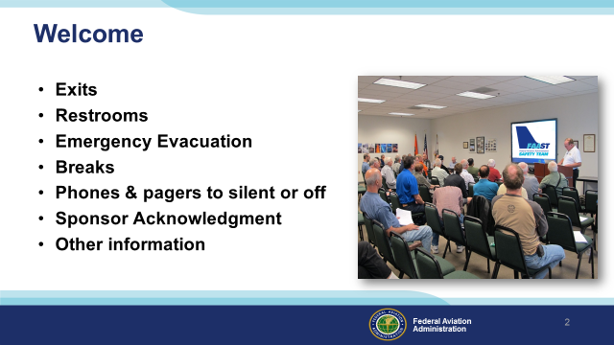 | Slide 2  Presentation Note: Here’s where you can discuss venue logistics, acknowledge sponsors, and deliver other information you want your audience to know in the beginning.  You can add slides after this one to fit your situation. (Next Slide)
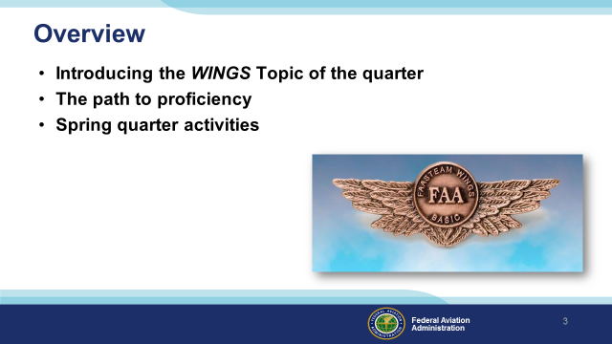 | Slide 3  Today we’ll be discussing an exciting new program – the WINGS Topic of the Quarter.  We’ll show you how WINGS participation puts pilots on the path to proficiency  And we’ll detail this quarter’s knowledge and flight activities.  Presentation Note: If you’ll be discussing additional items, add them to this list  (Next Slide)
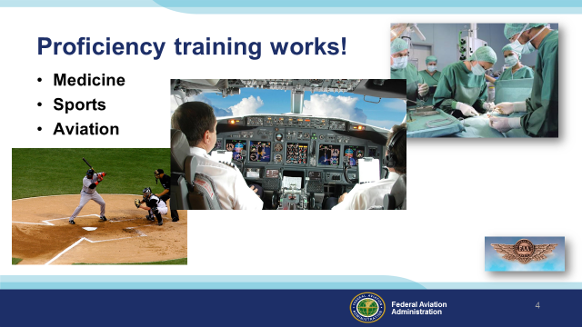 | Slide 4  Can you imagine how well professional athletes would perform if they didn’t practice between games or stay in shape during the off season? (Click)  Would you choose to be treated by doctors who had no continuing education since graduating from medical school? (Click)  Or how about a professional pilot flight crew who never train for emergencies?  Pros know that proficiency is not a destination but rather a journey that never ends.  Regular training keeps the them at peak performance every time they take to the air.  (Next Slide)
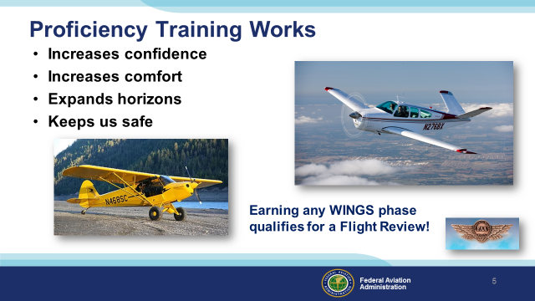 | Slide 5  Proficiency training works for General Aviation pilots too. Pilots who participate in the FAA WINGS Pilot Proficiency program fly with more confidence. They and their passengers are comfortable in the air. And proficiency training can expand our horizons by exploring the operational capabilities of our present aircraft or introducing us to more complex and capable planes as well as more challenging destinations.  Most importantly - proficiency training keeps us safe. (Click)  And pilots who earn WINGS phases also qualify for a flight review.  (Next Slide)
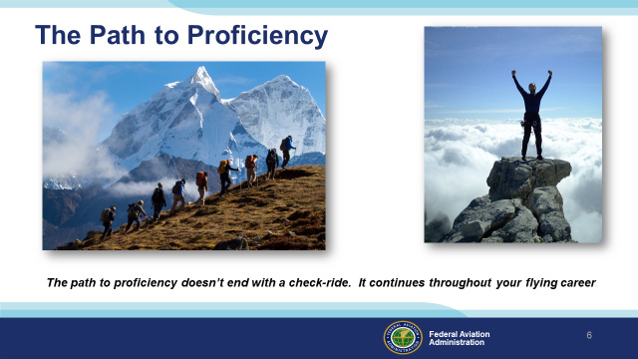 | Slide 6  Proficient Pilots and Flight Instructors realize that proficiency is not a destination but rather a journey that never ends. Pilots who follow the Path to Proficiency are well aware of their capabilities and their limitations. They dedicate time and resources to practice and training. And they understand that continuing education through Proficiency Training is essential to keeping them on top of their game.  (Next Slide)
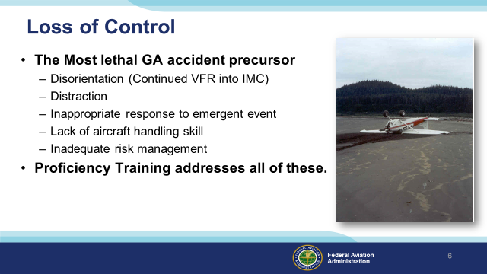 | Slide 7  Loss of control is the most lethal General Aviation accident precursor and there are 5 principal reasons why LOC occurs. (Click)  We’ve all heard about disorientation following intentional or inadvertent continued VFR into Instrument Meteorological Conditions. Indeed more than 90 percent of GA accidents that occur in this phase of flight are fatal. Advancements in pilot training and aircraft equipment have reduced the numbers of Continued VFR into IMC accidents so they’re not the top GA fatal accident cause. Loss of Control during maneuvering flight has that distinction. (Click)  Sometimes accidents occur while pilots are distracted by something on the ground or in the airplane. The term “Moose Stall” is familiar to Alaskan pilots. More than a few Alaskan aviators have lost control while maneuvering for a better view of a moose on the ground. Low altitude maneuvering for aerial photography is another activity that generates opportunities for loss of control due to distraction. (Click)  The FAASTeam has done several programs on the “Startle Response” that human quality that delays or inhibits response to hazards that occur suddenly. There are many stories of pilots who lost control of their aircraft while maneuvering to return to the airport following an engine failure on takeoff or climb out. (Click)  Lack of – or rusty aircraft handling skill has contributed to loss of control in crosswind operations. (Click)  And finally, inadequate risk management has led many pilots into situations that they lacked the skill to cope with. (Click)  The beautiful thing about proficiency training is that: through it, you can maintain and improve pilot performance with respect to each of these loss of control precursors; making it much less likely that LOC will occur.  (Next Slide)
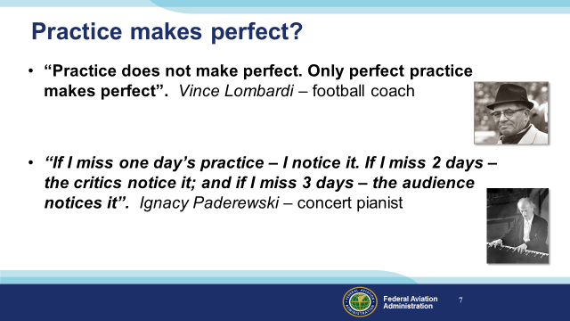 | Slide 8  We’ve all heard the phrase, “practice makes perfect”. But does it really? (Click)  According to Vince Lombardi only perfect practice makes perfect. In other words you must execute plays and procedures perfectly in practice if you expect to them to be perfect in the big game, or - in the case of pilots – in flight. (Click)  This quote is attributed to Paderewski (Pad er ev ski) and many other professional musicians. It acknowledges the necessity of regular practice in order to stay on top of your game. In our case we might substitute co-pilots and passengers for critics and the audience. The main takeaway is, of course, that no matter what your profession, regular practice to perfection is essential to operating at the top of your game..  (Next Slide)
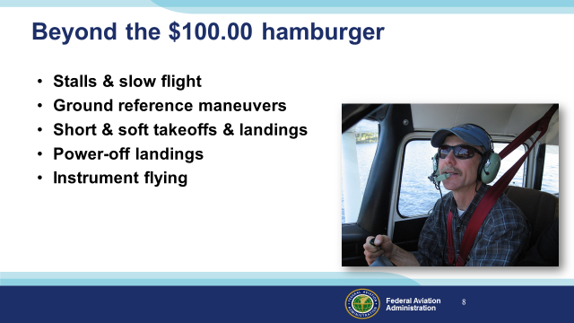 | Slide 9  Most of us have a favorite destination for that hundred dollar hamburger. We’ve been there before, the route is familiar, and we often bring the family along. That’s not the ideal proficiency flight though. Proficiency flying should involve less frequently practiced evolutions such as stalls, slow flight, ground reference maneuvers, takeoffs and landings, and instrument flying.  While it’s good to practice at typical mission weights, passengers may not enjoy the experience; at least not as much as straight and level to a popular destination.  And passengers are not usually good at critiquing performance or offering useful suggestions for improvement. For that you need a coach.  (Next Slide)
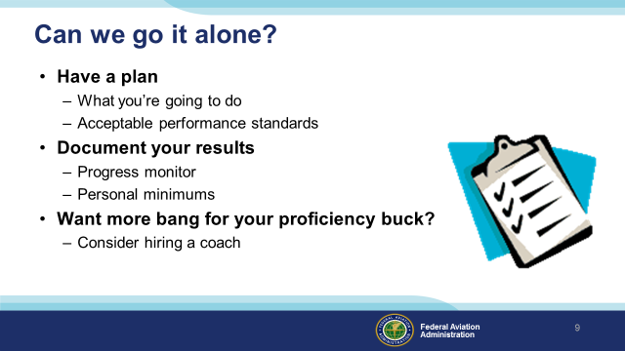 | Slide 10  Can we maintain and enhance our proficiency while flying solo? That’s a good question and the answer is yes ….. sort of. All practice hours are worthwhile but some are definitely more worthwhile than others. If you’re going to practice on your own you need to make the most of each opportunity. Here are some suggestions: (Click)  First of all we strongly suggest that you have a plan that lists what maneuvers and evolutions you’re going to fly and what the acceptable performance standards will be for each item. Write your plan on paper and take it with you on your flight. Check off each maneuver completed and whether or not you met the standard. (Click)  Back on the ground – document your results. That way you can see progress and you’ll have information to document your baseline performance that will, in turn, feed into your personal minimums. More about that later. (Click)  For now – let’s just say solo proficiency flying is useful but there’s a way to get much more bang for your proficiency buck and that’s to hire a coach.  (Next Slide)
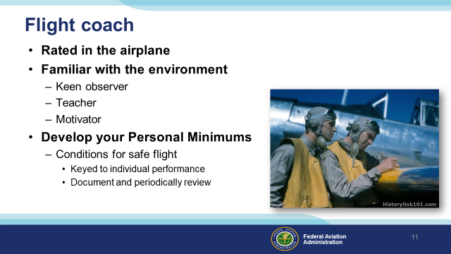 | Slide 11  Every profession relies on coaching to keep practitioners sharp. All Flight Instructors are trained in performance evaluation and critique and most make great coaches. Obviously you’re going to look for a coach who’s expert in the airplane you’ll be flying and familiar with the flight environment. For best results you want a keen observer and teacher who will push you to excellence in flying. (Click)  Together you and your CFI can develop your Personal Minimums – A set of conditions, procedures, rules, criteria, and guidelines that help pilots to decide when it’s safe to fly. As the name implies, your Personal Minimums are unique to you and keyed to your demonstrated ability. As you do when you fly solo – be sure to document your results. Because our abilities change with experience you should review and adjust your personal minimums periodically.  (Next Slide)
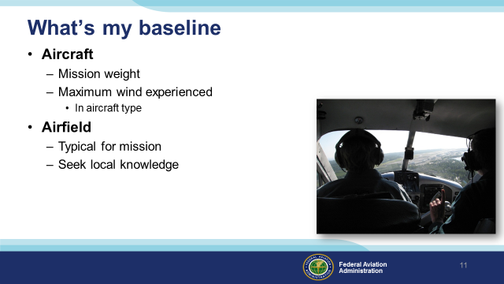 | Slide 12  In order to establish personal minimums you need to have a baseline – think of it as your personal, documented, demonstration of performance. We suggest you document your performance at least once a year with a CFI. Try to pick a day when you can experience actual cross-wind conditions in the airplane you usually fly and loaded to your typical mission weight. Select an airfield that’s typical for the missions you fly. If you’re planning trips to a short, obstructed runway; try to find something similar to train on. Gather information about the destination airfield from pilots who’ve flown there and share that information with your instructor. That will help your CFI to construct realistic scenarios for you to fly.  (Next Slide)
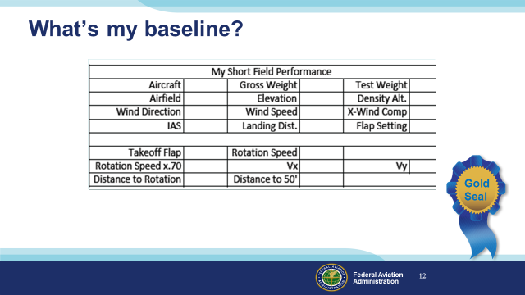 | Slide 13  Here’s a chart that some pilots use to document their wind, takeoff and landing performance. We’ll tell you where you can find this and other useful charts at the end of this program.  Once you’ve completed the chart you’ll have a performance baseline to work with. You can adjust the performance expectations to compensate for human factors such as stress and fatigue and you can also adjust your baseline as you gain experience and skill. If you want to adjust your baseline we strongly suggest that you do it with a CFI. That way you’ll have an objective assessment of your capabilities and a flight instructor may offer suggestions and instruction for improving your baseline performance.  (Next Slide)
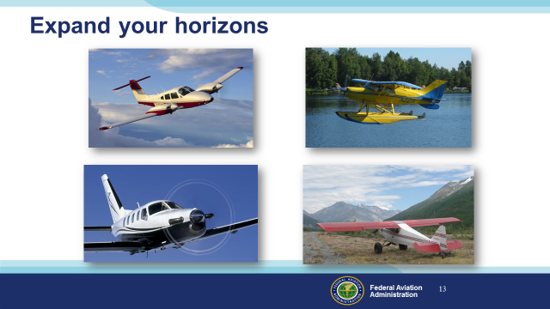 | Slide 14  Pilots usually think of proficiency training in terms of their usual aviation operations but if you are willing to expand your horizons there are host of options to make proficiency flying more interesting. Twin engine, turbine, or instrument training can boost capability and confidence in cross country operations. Seaplane and tailwheel training are particularly satisfying for folks who learned in nose wheel airplanes.  And even if you don’t take on the challenges of another rating or airframe, there’s another great way to expand your horizons.  (Next Slide)
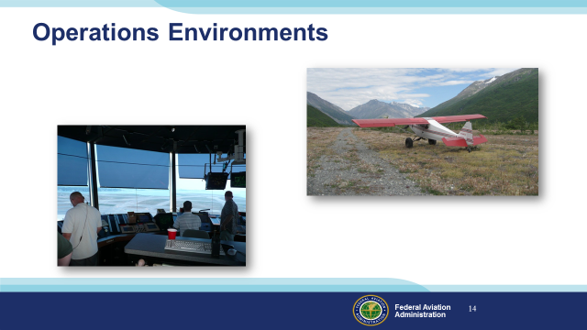 | Slide 15  Training in new operational environments builds confidence too. If you learned to fly at a small country airport you’re probably very comfortable in a non-towered environment. How about a trip to a major metropolitan airport with your flight coach? The traffic and rapid pace of ATC communications can be daunting at first but mastering the environment can be very satisfying.  Likewise, big city pilots who are comfortable with busy towered operations can be overwhelmed when operating to non-towered or back country airstrips. Back country transition training can acquaint you with the nuances of rural environments and ensure your wilderness flying can be done safely.  (Next Slide)
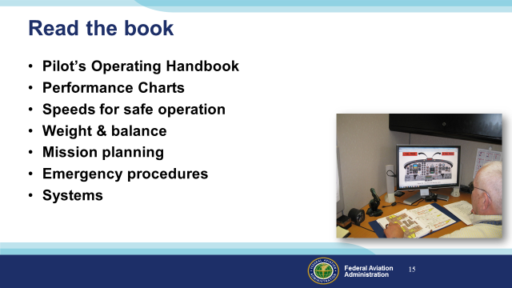 | Slide 16  Whatever proficiency training you do, you’re ahead of the game if you study the book first.  Be sure to know these cold before flying with your coach :  Emergency procedures  Speeds, power settings, & configurations for normal operations  As you progress with your study, note any questions you have and review them when you fly with your CFI.  (Next Slide)
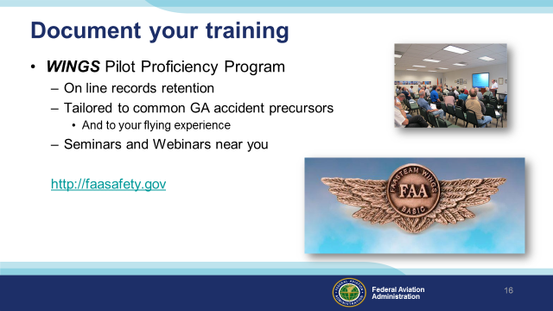 | Slide 17  FAA’s WINGS Pilot Proficiency Program is an excellent way to document your training. Your training record is retained on line and always available to you and to your CFI.  WINGS knowledge and flight activities are designed to address common general aviation accident precursors and your flight activities can be further customized to fit your operations and experience. And there are hundreds of WINGS seminars, webinars, and on line courses available to you each year.  It’s all available on one website: faasafety dot gov.  (Next Slide)
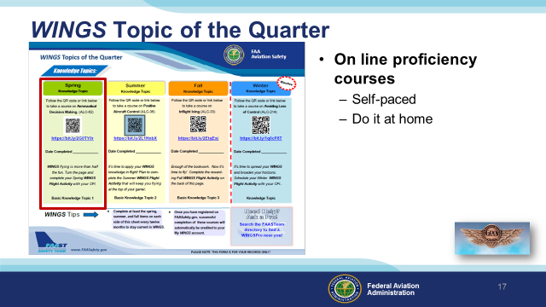 | Slide 18  Proficiency Training works best if it’s not done all at once, but rather spaced out at regular intervals. The WINGS Topic of the Quarter program consists of eight activities pursued over the course of one year.  Each quarter, WINGS Pilots take an on-line safety course. All courses are self-paced. Most take no more than an hour or two and they can be completed at home.  (Next Slide)
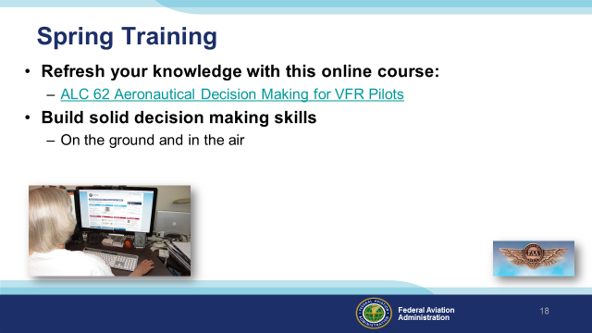 | Slide 19  WINGS spring training begins with Aeronautical Decision Making for VFR Pilots. This on-line course helps pilots to build solid, reliable, decision making skills for use on the ground and in the air.  (Next Slide)
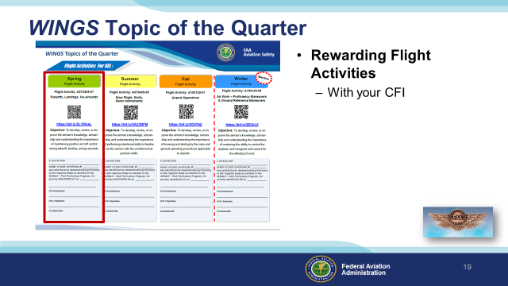 | Slide 20  Program participants also fly with a Flight Instructor to complete a WINGS Flight Activity at least once each quarter.  Let’s take a look at the activities for the spring quarter. (Next Slide)
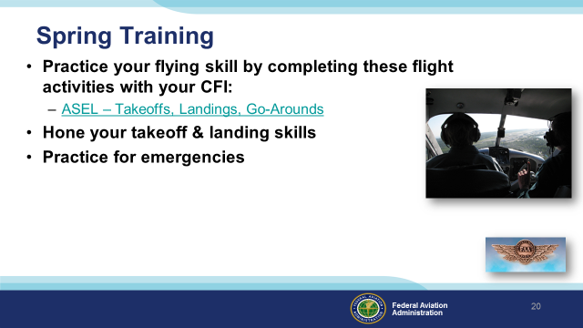 | Slide 21  Spring is also a great time to practice takeoffs, landings, go-arounds and forced landing emergencies.  The strong spring winds in many parts of the country add to the challenge. At the end of this WINGS flight activity you’ll be well aware of the aircraft’s performance capabilities and you’ll have the confidence that comes from practice and expert coaching from your CFI.  (Next Slide)
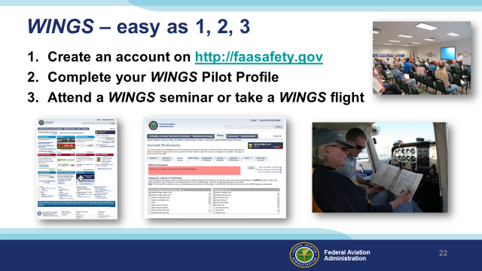 | Slide 22  Getting started in WINGS is as easy as one, two, three.  - Create an account on faasafety.gov  - Complete your WINGS Pilot Profile  - Attend a WINGS seminar or take a WINGS flight with your CFI.  (Next Slide)
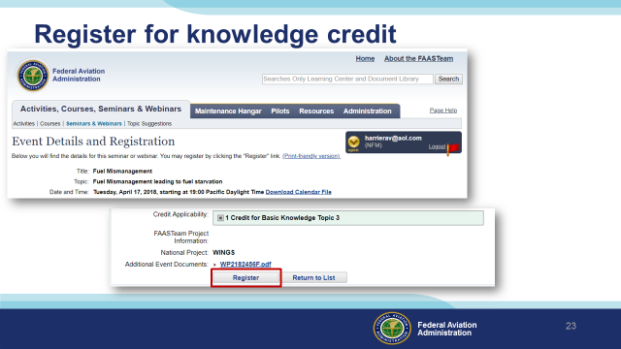 | Slide 23  You can pre-register for credit on FAASafety.gov or you can register via the sign-in sheet at the seminar door.  (Next Slide)
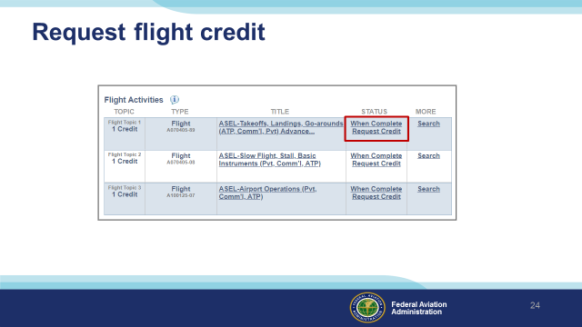 | Slide 24  You’ll need to request credit for each flight activity. It’s easy to do. Just go to your “My Wings” page and click on request credit after the activity has been completed.  (Next Slide)
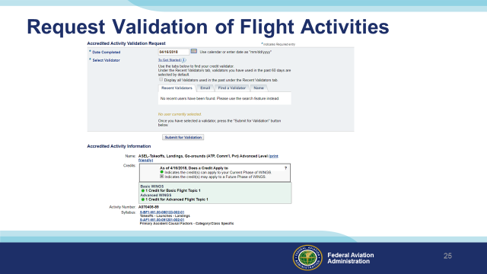 | Slide 25  You’ll see a screen that looks like this. Normally CFIs validate flight credit and requests are sent to them. But if your CFI doesn’t participate in WINGS you can find a credit validator near you.  (Next Slide)
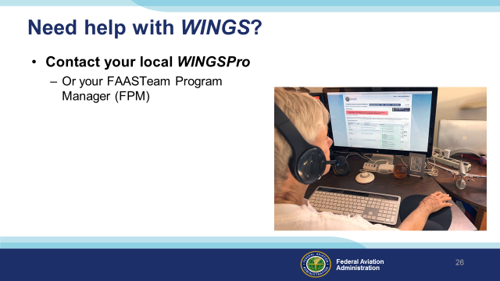 | Slide 26  WINGSPros in your area are available to help you with the FAA WINGS Pilot Proficiency Program. Here’s how to find your local WINGSPro(s).  Presentation note: You may want to introduce local WINGSPros in attendance and ask them to present this section.  (Next Slide)
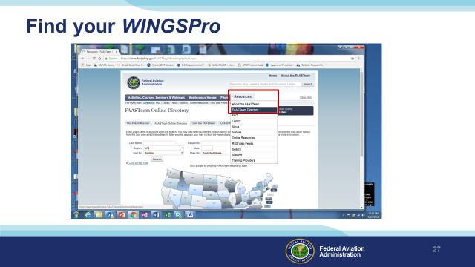 | Slide 27  To find your local WINGSPros just navigate to FAASafety.gov. Hover over the resources tab and click on FAASTeam Directory.  (Next Slide)
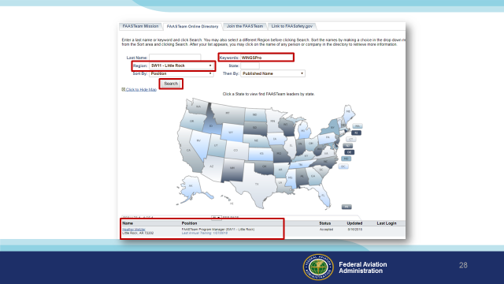 | Slide 28  First select your region and district in this drop down box. (Click)  Next type WINGSPro in the key word box, (Click)  Then click on search. (Click)  Your WINGSPros will appear in the list below.  Presentation note: We suggest that you modify this slide with your local WINGSPro information.  (Next Slide)
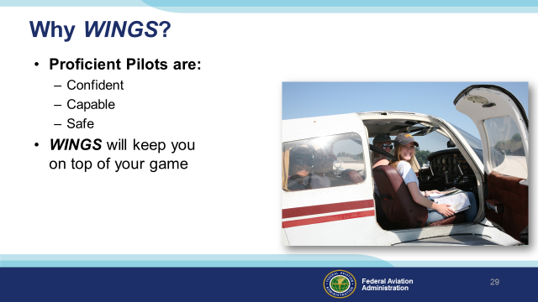 | Slide 29  So why WINGS? Well proficiency is key to success in almost every thing worth doing – especially flying. Proficient pilots are confident, capable, and safe.  WINGS is a proficiency training system specifically designed for general aviation pilots and, regular participation will keep you on top of your flying game.  (Next Slide)
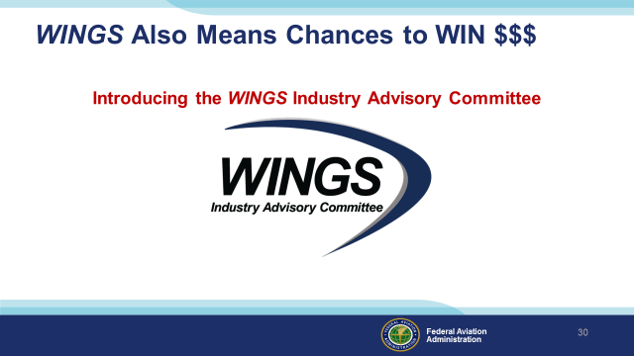 | Slide 30  One more thing - WINGS participation also means chances to win cash! (Click)  The WINGS Industry Advisory Committee is a coalition of FAASTeam Industry Partners, associations and devoted individuals committed to increasing awareness and participation in the WINGS program. And they believe it WINGS enough to offer chances to win cash prizes for completion or validation of WINGS phases!  (Next Slide)
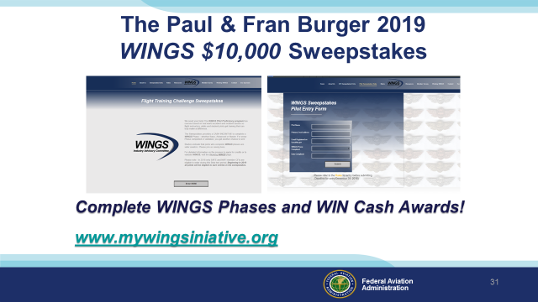 | Slide 31  The sweepstakes is generously funded by Paul Burger, a long time advocate for general aviation safety and a retired aviator who believes participation in this program saves lives. VISIT WWW.MYWINGSINIATIVE.ORG to learn more and enter the sweepstakes.  (Next Slide)
 | Slide 32  After you’ve completed a phase of WINGS you can enter the sweepstakes by clicking on “Claim Rewards” in the “WINGS – at a glance” section of your My WINGS page and select WINGS Sweepstakes. Or you can go directly to their website.  (Next Slide)
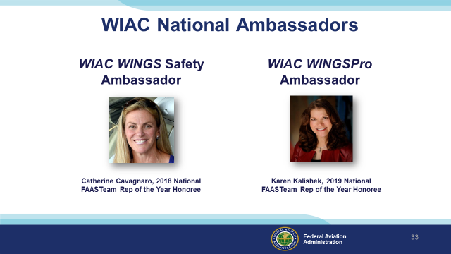 | Slide 33  Catherine Cavagnaro and Karen Kalishek – FAASTeam Representatives of the Year Honorees - are staunch WINGS supporters. They join us in inviting your participation.  (Next Slide)
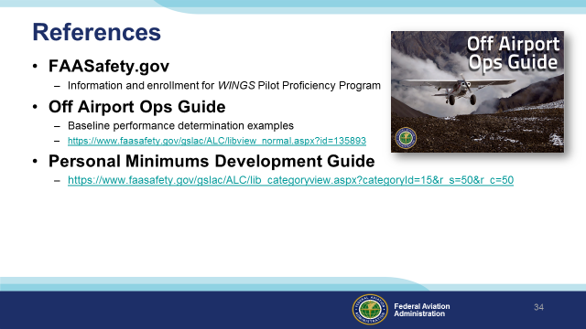 | Slide 34  Here are a few references for additional information:  FAASafety.gov is the FAASTeam website where you’ll find a wealth of safety information. You can enroll and track your progress in the FAA WINGS Pilot Proficiency Program here.  Look in the FAASafety.gov library for the Off Airport Operations Guide. In it you’ll find instructions for developing a short field performance baseline together with other useful information on operating to small fields.  Also in the FAASafety.gov Library – the Personal Minimums Development Guide – Your documented proficiency performance can be used to develop minimums that are tailored to you, your aircraft, and your mission.  I’ll leave this slide on screen while I take some questions from the audience.  Presentation note: Take questions from the audience while they copy information from the screen. Then:  (Next Slide)
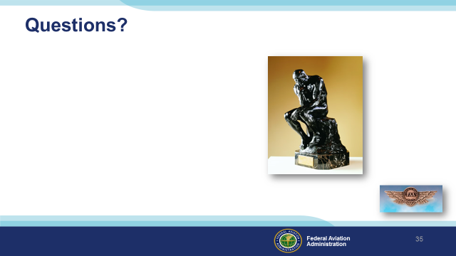 | Slide35  Presentation Note: You may wish to provide your contact information and main FSDO phone number here. You can also add WINGSPro contact information.  Modify with your information or leave blank.  (Next Slide)
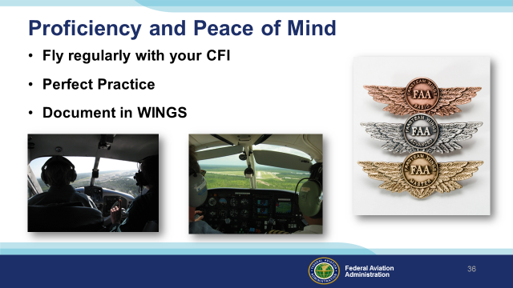 | Slide 36  There’s nothing like the feeling you get when you know you’re playing your A game and in order to do that you need good coaching (Click)  So fly regularly with a CFI who will challenge you to review what you know, explore new horizons, and to always do your best. Of course you’ll  have to dedicate time and money to your proficiency program but it’s well worth it for the peace of mind that comes with confidence. (Click)  Vince Lombardi, the famous football coach said, “Practice does not make perfect. Only perfect practice makes perfect.” For pilots that means  flying with precision. On course, on altitude, on speed all the time. (Click)  And be sure to document your achievement in the Wings Proficiency Program. It’s a great way to stay on top of your game and keep you flight review current.  (Next Slide)
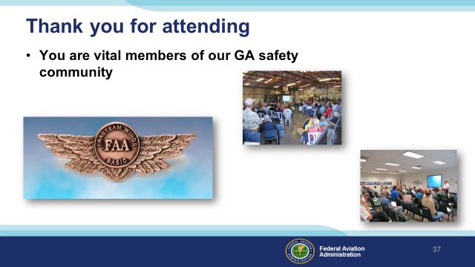 | Slide 37  Your presence here shows that you are vital members of our General Aviation Safety Community. The high standards you keep and the examples you set are a great credit to you and to GA.  Thank you for attending.  (Next Slide)
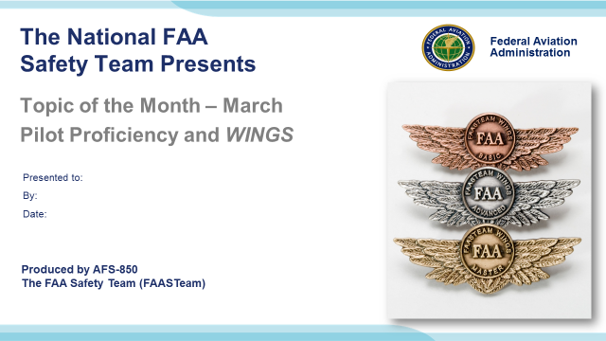 | Slide 38  (The End)

Appendix I – Equipment and Staging
Equipment:
- Projection Screen & Video Projector suitable for expected audience
  - Remote computer/projector control available at lectern or presenter location
    - In lieu of remote – detail a Rep to computer/projector control.
- Presentation Computer
  - Note: It is strongly suggested that the entire program reside on this computer.
- Back up Projector/Computer/Media as available.
- PA system suitable for expected audience
  - Microphones for Moderator and Panel
    - Optional Microphone (s) for audience
- Lectern (optional)
Staging:
- Arrange the projection screen for maximum visibility from the audience.
- Equip with PA microphones
- Place Lectern to one side of screen. This will be used by presenters and moderator

IMPORTANT – Once you have completed outreach on this topic, please help us track the outreach you have done by entering a PTRS record.

