Outreach Guidance and Presentation Notes
This outreach guidance is provided to all FAA and aviation industry groups that are participating in outreach efforts sponsored by the General Aviation Joint Steering Committee (GAJSC). It is important that all outreach on a given topic is coordinated and is free of conflicts. Therefore, all outreach products should be in alignment with the outline and concepts listed below for this topic.
Outreach Month: June 2021

Topic: Angle of Attack
Background:
- The General Aviation Joint Steering Committee feel to reduce the risk of inadvertent stall/departure resulting in loss-of-control (LOC) accidents, the GA community should install and use AOA-based systems for better awareness of stall margin

Teaching Points:
- Studies suggest that a significant number of General Aviation accidents could have been prevented had the airman been trained how to identify stalls through both hands on visuals and AOA technology.
- Pilots with a wide range of experience are better able to cope with new flight situations
  - Acquiring experience in a wide range of environments improves overall pilot performance
- Pilots who want to be more proficient should seek instruction from CFIs who are proficient in stall recognition and the look and feel associated with it.
- New technology such as an Angle of Attack Indicator or AOA require more than just an installation. Stall awareness starts with knowing how the aircraft feels and should look before adding a possible distraction or piece of additional equipment.

Abstract: Lasting 15 to 20 minutes, this presentation acquaints the audience with the look and feel of aircraft attiude, pitch, and roll with regard to Angle of attack both in our perceptions and how it can look and feel mechanically through the use of AOA indicators.
Format: Information Briefing - Power Point presentation
Required Personnel – FAASTeam Program Manager or designated FAASTeam Rep (s)
Optional Personnel – Professional Pilots experienced in the use and technology of AOAs, CFIs, Professors on the theory of flight and aerodynamics.
AFS 850 Support:
In addition to this guidance document, a Power Point presentation that supports the program is provided. FPMs and presenters are encouraged to customize this presentation to reflect each individual program.

Slides | Script
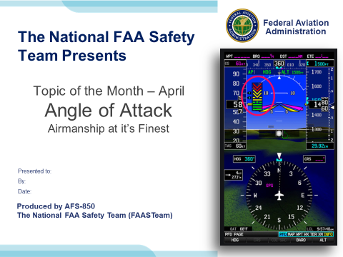 | Slide 1  Presentation Note: This is the title slide for Angle of Attack.  - Script - We have included a script of suggested dialog with most slides. The script will always appear in a non-italic font. Presenters may read the script or modify it to suit their own presentation style. See template slides 5 and 6 for examples of a slides with script.  - Presentation Instructions - (stage direction and presentation suggestions) will be preceded by a Bold header: the instructions themselves will be in Italic fonts. See slides 2, for an example of slides with Presentation Instructions only.  - Program control instructions - will be in bold fonts and look like this: (Click) for building information within a slide; or this: (Next Slide) for slide advance.  - Background information - Some slides may contain background information that supports the concepts presented in the program.  Background information will always appear last and will be preceded by a bold Background: identification.  The production team hope you and your audience will enjoy the show. Break a leg!  (Next Slide)
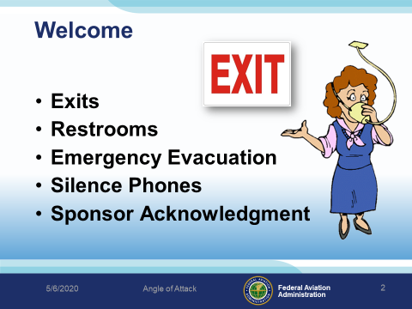 | Slide 2  Presentation Note: Here’s where you can discuss venue logistics, acknowledge sponsors, and deliver other information you want your audience to know in the beginning.  You can add slides after this one to fit your situation.  (Next Slide)
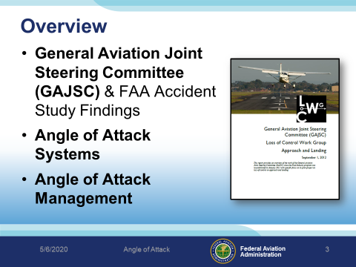 | Slide 3  GAJSC’s safety enhancement encourages the installation of AoA indicator technology as a means to reducing General Aviation LOC accidents.  Background: As a result of its study on loss of control accidents, the General Aviation Joint Steering Committee (GA JSC), in coordination with the Part 23 ARC, placed emphasis on enhanced aircraft state awareness systems for small airplanes. This led to the development of two GA JSC safety enhancements: SE-1: AoA for New Airplanes and SE-2: AoA for Existing Fleet. SE-1 recommends AoA systems for in-production aircraft and new type designs. SE-2 recommends finding solutions for retrofitting AoA systems on the existing GA fleet. The culmination of this work led to the release of a policy memorandum from Federal Aviation Administration (FAA) AIR-100 in February 2014 outlining the approval of non-required AoA indicator systems for GA aircraft. This policy memorandum fueled considerable interest from the avionics community and led to four new AoA systems being introduced at the Experimental Aircraft Association’s AirVenture Oshkosh fly-in convention in July of that year. Since then, more systems have been released for retrofit as well as several models of GA aircraft now being offered with AoA as standard or optional equipment. With the recent focus on AoA systems in GA, two studies have been conducted to look at their effectiveness in mitigating the risks of inflight loss of control accidents.  (Next Slide)
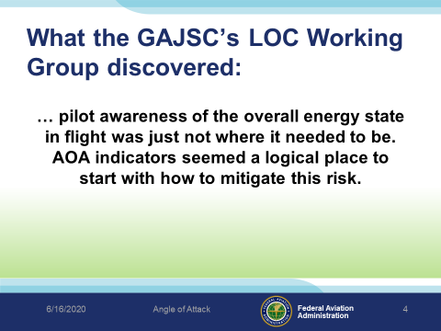 | Slide 4  What the GAJSC’s LOC Working Group discovered was that a pilot’s awareness of overall energy state in flight was just not where it needed to be. AOA indicators seemed a logical place to start with how to mitigate this risk. At the time, there was a path to having AOA indicators installed, but these were qualified as primary flight instruments requiring a more costly and labor intensive process, hardly within the means of an average GA pilot. What was lacking was a means of having this equipment installed as a supplementary system that would require a lighter touch regulation-wise, but still be permissible in type-certificated aircraft.  (Next Slide)
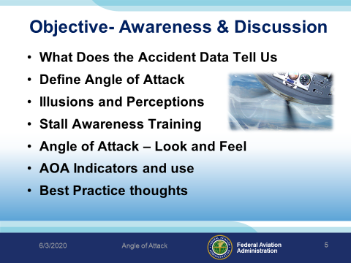 | Slide 5  Here is what we will cover today:  What does the accident data tell us? We will review the National LOC data. Many Loss of Control accidents have occurred due to airmen being unfamiliar with the visual and/or cockpit instrument cues of their aircraft in flight.  Define Angle of Attack. First we must know what the definition is before you can learn.  Introduce AOA indicators – the new safety tools for your cockpit  Illusions and perceptions – what it is and what you may think it looks like.  Stall awareness Training – Walking you though the procedure and how to set up a good baseline for training.  Angle of attack Look and Feel – More training  AOA indicators and use - What the AOA can do for you  Considerations – thoughts or best practices  (Next Slide)
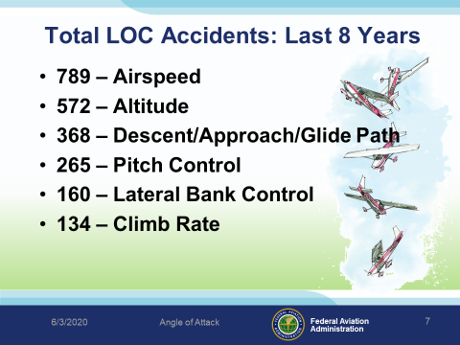 | Slide 6  Note: Pull the latest numbers from the FATDAT for this slide. The above data was derived by searching for the past eight years/National accident database/Phase of Flight/Loss of Control accidents.  (Next Slide)
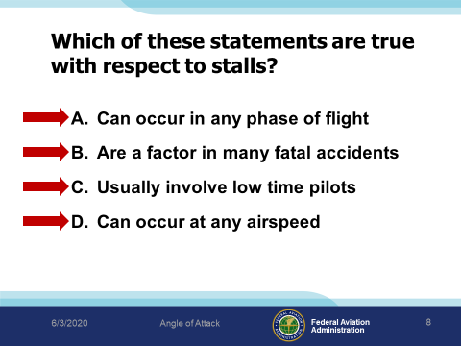 | Slide 7  Which of these statements are true with respect to stalls?  Presentation Note: Ask the audience to consider these statements with respect to stalls. When they have answered; click to reveal the correct answer.  Give the audienace a moment to read the questions.  (Click)  So, “what does Angle of Attack have to do with stalls?”  Answer: of course is “Everything”.  The big point to make here is that airspeed isn’t the best way to define stall AOA.  True it’s what most of us have but there is a better way and aren’t you itching to know what it is?  To get started, let’s define Angle of Attack.  (Next Slide)
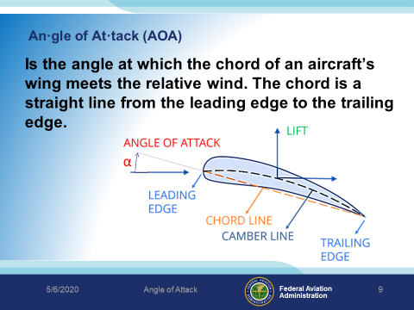 | Slide 8  an·gle of at·tack - the angle between the chord of an airfoil and the direction of the surrounding undisturbed flow of gas or liquid.  At low angles of attack, the airflow over the top of the wing flows smoothly and produces lift with a relatively small amount of drag. As the AOA increases, lift as well as drag increases; however, above a wing’s critical AOA, the flow of air separates from the upper surface and backfills, burbles and eddies, which reduces lift and increases drag. This condition is a stall, which can lead to loss of control and an abrupt loss of altitude if the AOA is not reduced.  (Next Slide)
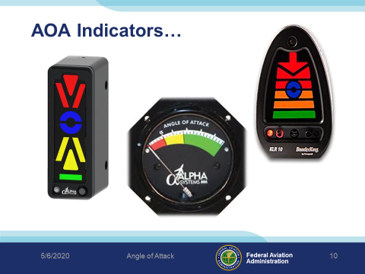 | Slide 9  Since we know that stall speed changes with the aircraft’s configuration (e.g., cruise, landing, etc.) and aerodynamic loads, the use of an AOA indicator can help provide a more reliable indication of airflow over the wing, regardless of its configuration. Without it, AOA is essentially “invisible” to pilots.  (Next Slide)
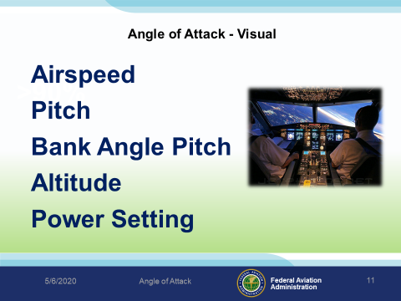 | Slide 10  For a given configuration, an airplane will always stall at the same AOA, called the critical angle-of-attack.  The pilot must understand and appreciate factors such as airspeed, pitch, attitude, bank or load factor, pitch or relative wind, power setting, and aircraft configuration in order to develop a reasonably accurate mental picture of the wing’s angle of attack at any particular time.  (Click)  The critical AOA does NOT change with:  Weight  Bank Angle  Temperature  Density Altitude  Center of Gravity  It is essential to flight safety that a pilot take into consideration this visualization of the wing’s angle of attack. Let’s consider these visual cues further.  (Next Slide)
 | Slide 11  It’s all about the illusion…The dragon in this short video may surprise you. (Click)  (Next Slide)
 | Slide 12  Lets take a look at this illusion: Straight lines or angled lines?  They’re all straight!  (Next Slide)
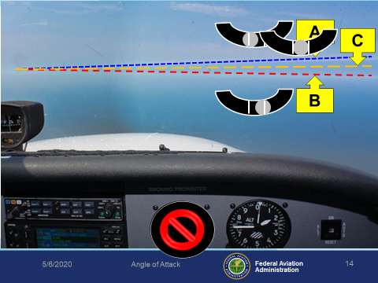 | Slide 13  Note: There are several animated parts to this slide. Click once for the “A” animation which will show and then disappear. Click again and the B animation will show and so forth.  Guess which line is the actual horizon.  Note how uncoordinated flight can also affect that view.  Note: There are several Clicks that will take you through the various views on this slide.  (Click) “A” – Cloud deck, “How coordinated are we?”  (Click) Reset depiction  (Click) “B” – Actual? “How coordinated are we?”  (Click) Reset depiction  (Click) “C” – Actual obscured by the Clouds in “A”?  (Click) Reveals the Artificial Horizon  (Next Slide)
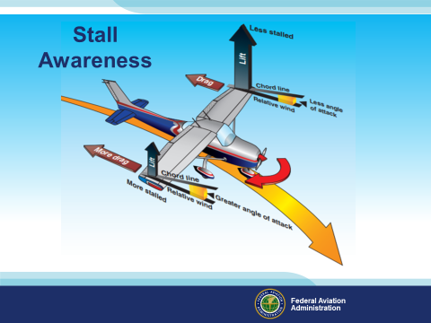 | Slide 14  14 CFR Part 61 requires that a student pilot receive and log flight training in stalls and stall recovery prior to Solo flight. During this training, the flight instructor should emphasize that the direct cause of every stall is an excessive angle of attack. The student pilot should fully understand that there are any number of flight maneuvers which may produce an increase in the wings angle of attack, but the stall does not occur until the angle of attack becomes excessive.  This ‘critical’ angle of attack varies from 16 to 20 degrees depending on the airplane design. The flight instructor must emphasize that low speed is not necessary to produce a stall. The wing can be brought to an excessive angle of attack at any speed. High pitch attitude is not an absolute indication of proximity to a stall.  (Next Slide)
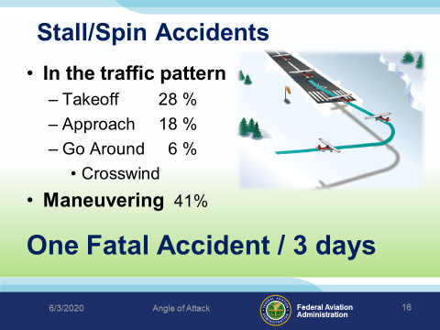 | Slide 15  The National accident data shows us that 54% of the accidents take place in the pattern or local to an airport and 41% involve maneuvering.  That all works out to one fatal accident every three days for the past ten years.  (Next Slide)
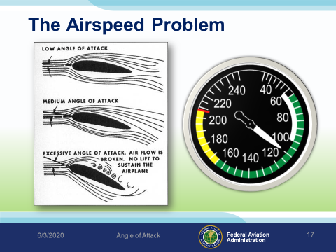 | Slide 16  We often discuss stalls with respect to airspeed and that can be a problem.  Wings stall when their critical angle of attack is exceeded. Remember from your training that it can happen at any pitch or bank angle. Airspeed is a secondary indication of how close we are to the critical angle of attack.  (Next Slide)
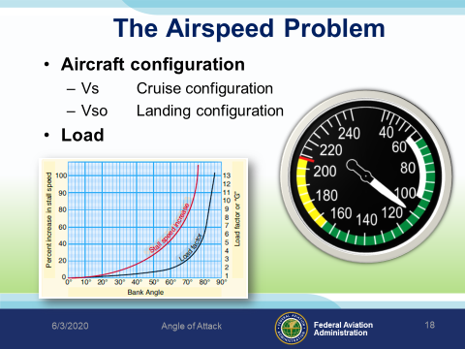 | Slide 17  There are problems with using airspeed indications for stall avoidance.  One being that Stall speed changes with aircraft configuration.  Another has to do with aircraft load. As load or weight increase stall speed will also increase.  So if a wing can stall at any airspeed in any configuration pilots must manage angle of attack and that argues for an AoA display and/warning system in the aircraft.  (Next Slide)
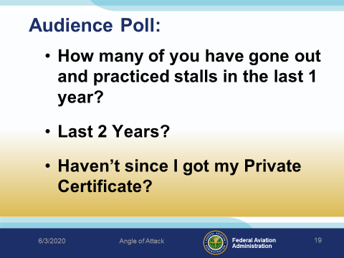 | Slide 18  Time for a little poll:  How many of you have gone out and practiced stalls in the last year?  Last 2 Years?  Haven’t since I got my Private Certificate?  (Note the answers and save for your future risk assessments)  (Next Slide)
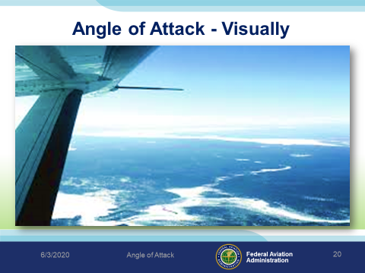 | Slide 19  The key to stall awareness is the pilot’s ability to visualize the wing’s angle of attack in any particular circumstance, and thereby be able to estimate his/her margin of safety above stall.  This is a learned skill that must be acquired early in flight training and carried through the pilot’s entire flying career.  (Next Slide)
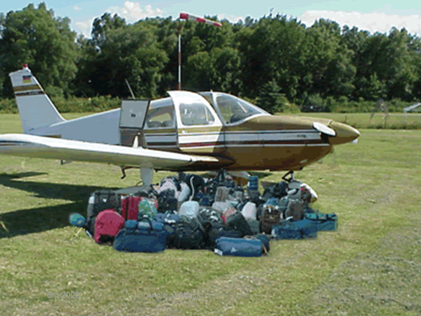 | Slide 20  How many of you have done this? How many are reasonably certain that the aircraft was within weight and balance?  (Next Slide)
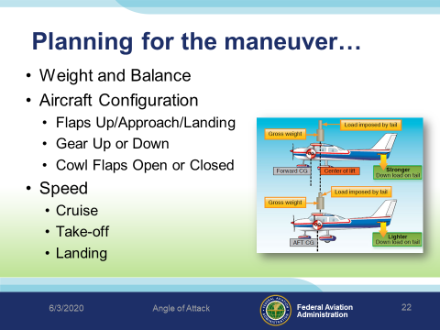 | Slide 21  Keep in mind that a tail heavy aircraft will present a different, level attitude picture, than being in the normal or centered weight configuration. Your response and recovery under this situation will be different as well. Training for tail heavy or nose heavy flight inside the envelope needs to be understood before the situation arises.  Flap settings, gear position, even cowl flap position can alter your perception of a level flight attitude. Speed variation affects pitch as you should already know.  Discuss with your CFI prior to training. Understand the concept, the action, and the outcome of each stall maneuver you are going to Practice various combinations of these to fully understand how the aircraft feels to further understand your angle of attack.  (Next Slide)
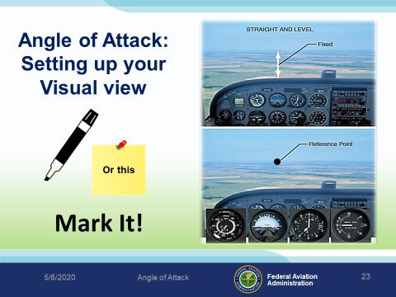 | Slide 22  A few recommendations, Trim the airplane with elevator trim so that it will maintain hands-off level flight at cruise airspeed. For Practice purposes, visual markers such as marking the windscreen somehow…post it, or piece of tape to mark your reference point at a “level flight attitude”.  (Next Slide)
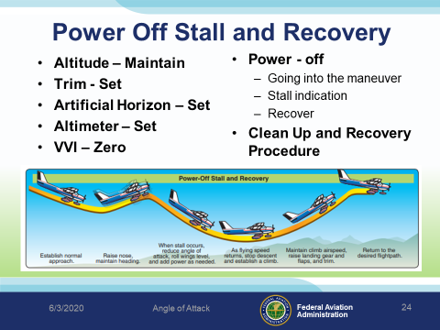 | Slide 23  Let’s walk through setting up a power off stall and recovery:  - Altitude – Maintain  - Trim – Set  - Artificial Horizon – Set  - Altimeter – Set  - VVI – Zero  - Power - Off  - Going into the maneuver  - Stall indication  - Recover  - Clean Up and Recovery Procedure  (Next Slide)
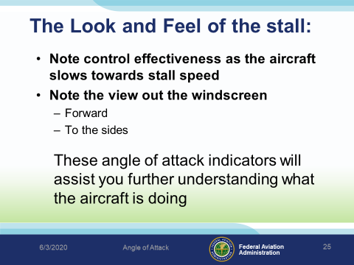 | Slide 24  The lesson here is what did you see, hear, and feel during the maneuver?  Note control effectiveness as the aircraft slows towards stall speed  Note the view out the windscreen  Forward  To the sides  These angle of attack indicators will assist you further understanding what the aircraft is doing  Training and paying attention is the only way this maneuver can be mastered and judging by the accidents we’ve reviewed, many of you need more practice.  The AoA can alert you and confirm that the aircraft is in a state that requires your attention.  (Next Slide)

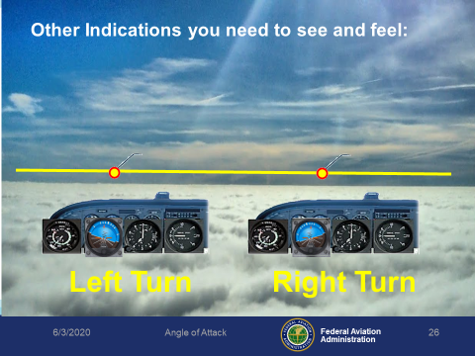 | Slide 25  Note: There is animation on this slide.  (Click) The “left turn” graphic will animate first.  As you can see here, your reference to a level flight attitude varies with your bank angle.  (Click) The “right turn” graphic will animate.  Practice and time has showed you that you must increase pitch or angle of attack and power in order to sustain a level flight altitude at a given speed.The beauty of the AOA is that it will always tell you where the critical angle is in relation to power, airspeed, pitch, and bank not matter where the aircraft is pointed.  (Next Slide)
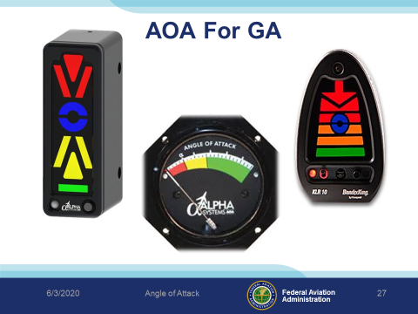 | Slide 26  AOA indicators are showing up on many new aircraft and there are also a number of affordable options for retrofit as well. Angle of attack sensing & display that go a long way toward reducing the number of stall/spin accidents.  (Next Slide)
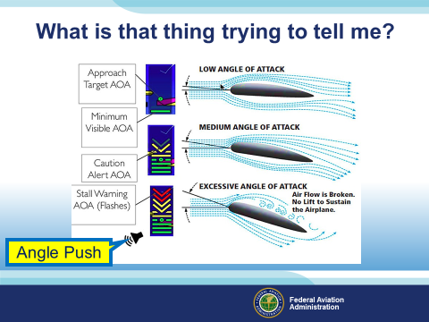 | Slide 27  Note: There is no animation on this slide.  The AOA delivers critical information visually or through an aural tone to indicate the actual safety margin above an aerodynamic stall.  The more efficiently the airfoil operates; the larger stall margin that is present.  - Green – Nice and clean  - Yellow – Extreme Caution to the fellow  - Red – Your gonna bump your head  (Next Slide)
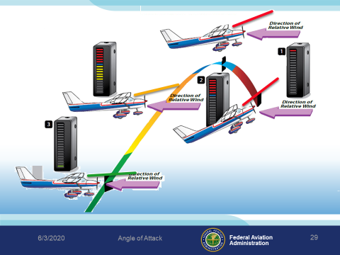 | Slide 28  Pilots can change Angle of Attack or AOA.  Increase AOA or increase pitch to a yellow indication and lift will go up.  Decrease pitch to a green indication translates less lift is being made.  This is why airplanes cruise at low AOA, but upon slowing down, increase AOA to compensate for the decrease in lift formed by the airflow speed.  Amazingly, every AOA equates to a specific airspeed, once the plane is allowed to settle down. More simply, for each individual airspeed, a specific AOA is required to support flight, note your findings.  (Next Slide)
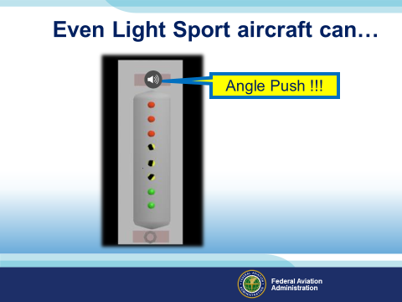 | Slide 30  This example of a Light Sport AOA gives an aural warning “Angle Push” when the lowest of three red (incremental to Angle of Attack) lights illuminate.  (Next Slide)
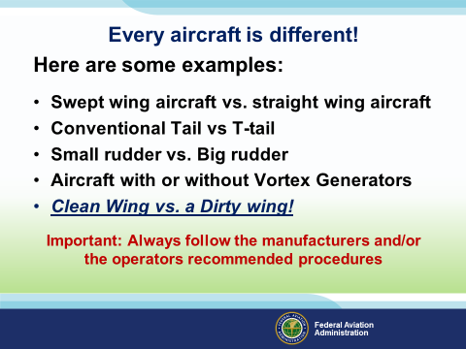 | Slide 30  Note: Sweeping the wing allows the relative airflow over its surface to occur in a more span-wise direction. Compared with a straight wing, the airflow encounters less pronounced camber along this path and so doesn't accelerate as much.  Tail design or convention can change aircraft handling at slow or high speeds or even during certain wind conditions  Rudder size can make a big difference in aircraft control. Those of you that have flown older aircraft with a smaller rudder know what it is we are talking about. Just remember, not aircraft designs are alike.  Vortex Generators  Clean wing – nothing but what the manufacture built it with.  Dirty wing – Ice, snow, bugs, or dents all affect the efficiency of the wing.  Keep in mind that not all aircraft are treated the same. Every aircraft is different, even from one Cessna 172 to another or Piper Cherokee to another.  Here are some simple and complex variations in aircraft design to consider:  - Swept wing aircraft vs. straight wing aircraft -  - Conventional Tail vs. T-Tail Type  - Small Rudder vs. Big Rudder  - Aircraft with or without Vortex Generators  - Clean Wing vs. Dirty Wing  Important: Always follow the manufacturers’ and/or operators’ recommended procedures. Talk to the owners of other similar aircraft. What do they have to say?  (Next Slide)
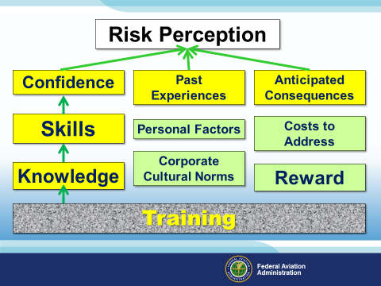 | Slide 31  Risk perception is relative to you!  (Click) Training! is the key foundational point that gives us what is needed to remain an active participant in stall recognition and recovery. As you can see here the trail from training leads to:  (Click) knowledge  (Click) skill, and  (Click) confidence, it also leads to your ability to  (Click) anticipate the consequences which pull your  (Click) past experiences into your overall confidence in managing stalls.  The remaining areas the affect your perception are:  (Click) Reward, well reward comes with value in your training.  Cost to address is how you perceive training can benefit your abilities.  Corporate Cultural Norms depend on how the company you work for perceive the value of training in the workplace.  Personal Factors can limit your abilities through lack of knowledge or understanding of what is necessary to manage a stall in your day to day flying.  (Next Slide)
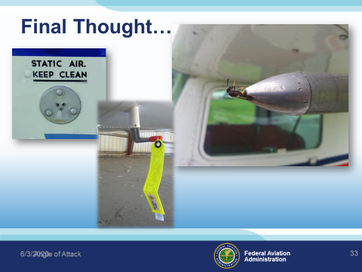 | Slide 32  Final thought, now that you have a working knowledge of angle of attack issues and the equipment available to assist you in more effectively sustaining flight across most flight regimes, how closely do you actually LOOK at the static port during preflight? Did you crawl under that wing to inspect the Pitot Tube? What are the chances that a bee or some critter would hit perfectly on the inlet port of the pitot tube?  The AOA indicator can be used to provide additional situation and configuration awareness to the pilot.  (Next Slide)
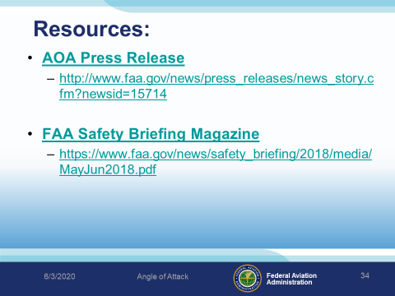 | Slide 33  Presentation Note: If you have an internet connection you can access the resources by clicking on text. If there’s no internet access the audience can copy the URLs below each item.  Here are some places you can go for more information.  (Next Slide)
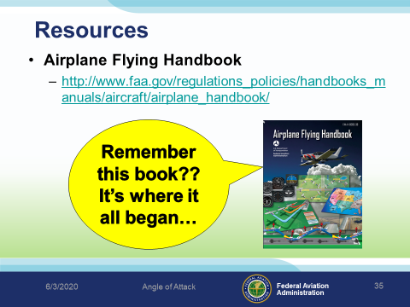 | Slide 34  Presentation Note: If you have an internet connection you can access the resources by clicking on text. If there’s no internet access the audience can copy the URLs below each item.  Here are some places you can go for more information.  (Next Slide)
 | Slide 35  Join us on the website. WINGS, Safety events, and much more.  Master Pilot and Master Mechanic Award information.  (Next Slide)
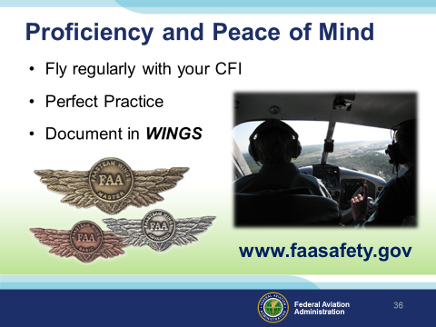 | Slide 36  There’s nothing like the feeling you get when you know you’re playing your A game and in order to do that you need a good coach.  So fly regularly with a CFI who will challenge you to review what you know, explore new horizons, and to always do your best. Of course you’ll  have to dedicate time and money to your proficiency program but it’s well worth it for the peace of mind that comes with confidence.  Vince Lombardi, the famous football coach said, “Practice does not make perfect. Only perfect practice makes perfect.” For pilots that means  flying with precision. On course, on altitude, on speed all the time.  And be sure to document your achievement in the Wings Proficiency Program. It’s a great way to stay on top of your game and keep you flight review current.  (Next Slide)
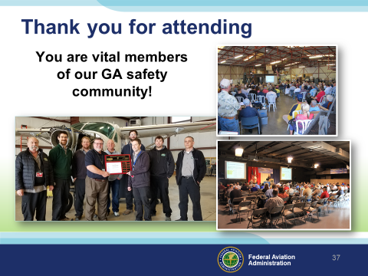 | Slide 37  Your presence here shows that you are vital members of our General Aviation Safety Community. The high standards you keep and the examples you set are a great credit to you and to GA.  Thank you for attending.  (Next Slide)
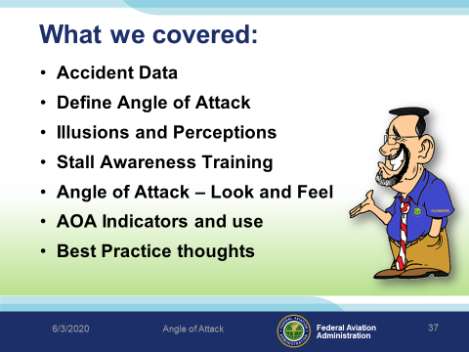 | Slide 38  Here is what we’ve covered:  - Accident Data  - Define Angle of Attack  - Illusions and Perceptions  - Stall Awareness Training  - Angle of Attack – Look and Feel  - AOA Indicators and use  - Best Practice thoughts  (Next Slide)
 | Slide 39  (Next Slide)
 | Slide 40  Presenter: Add you local FSDO Information here.  (Next Slide)
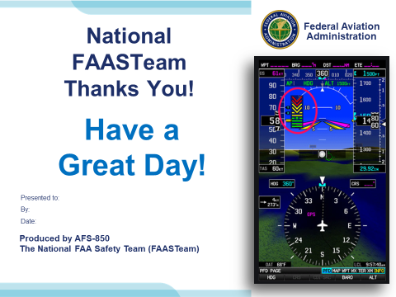 | Slide 41  Have a great day!

Appendix I – Equipment and Staging
Equipment:
- Projection Screen & Video Projector suitable for expected audience
  - Remote computer/projector control available at lectern or presenter location
    - In lieu of remote – detail a Rep to computer/projector control.
- Presentation Computer
  - Note: It is strongly suggested that the entire program reside on this computer.
- Back up Projector/Computer/Media as available.
- PA system suitable for expected audience
  - Microphones for Moderator and Panel
    - Optional Microphone (s) for audience
- Lectern (optional)
Staging:
- Arrange the projection screen for maximum visibility from the audience.
- Equip with PA microphones
- Place Lectern to one side of screen. This will be used by presenters and moderator

References:

AOA Press Release - http://www.faa.gov/news/press_releases/news_story.cfm?newsid=15714

FAA Safety Briefing Magazine - https://www.faa.gov/news/safety_briefing/2018/media/MayJun2018.pdf

IMPORTANT – Once you have completed outreach on this topic, please help us track the outreach you have done by entering a PTRS record.
