Presentation Notes
The Startle Response 2020/11-07-214(I)PP

This outreach guidance is provided to all FAA and aviation industry groups that are participating in outreach efforts sponsored by the General Aviation Joint Steering Committee (GAJSC). It is important that all outreach on a given topic is coordinated and is free of conflicts. Therefore, all outreach products should be in alignment with the outline and concepts listed below for this topic.

Outreach Month: January 2022

Topic: Startle Response
The FAA and industry will conduct a public education campaign emphasizing training to effectively cope with unexpected events

Background:

The General Aviation Steering Committee (GAJSC) System/Component Failure work group feels that training and education in coping with events that startle pilots will help to mitigate inappropriate response to sudden onset emergencies
Teaching Points:
- Discuss the difference between reflexive and reasoned responses to stimulii.
- Discuss the safety benefits of flight risk assessment and management.
- Discuss the safety benefits of emergency procedures training.
- Encourage pilots to participate in WINGS Pilot Proficiency Training.

References:
- FAA Safety Briefing (January/February 2016)

- Flight Data Monitoring Systems and Non-Required Safety Enhancing Equipment – GAJSC Safety Enhancements - Loss of Control

Abstract: Lasting 10 to 20 Minutes, this presentation acquaints the audience with the nature of human mental functoing and response to stimuli. It describes the human startle response and how it may contribute to aviation accidents. Suggestions for risk management are offered and pilot proficiency training is recommended.

Format: Information Briefing – Power Point presentation

Required Personnel: FAASTeam Program Manager or designated FAASTeam Rep (s)

Optional Personnel: Flight Instructors or others who can speak on the Human Startle Response.

AFS 850 Support: In addition to this document, a Power Point presentation that supports the program is provided. FPMs and presenters are encouraged to customize this presentation to reflect each individual program.

Slides | Script
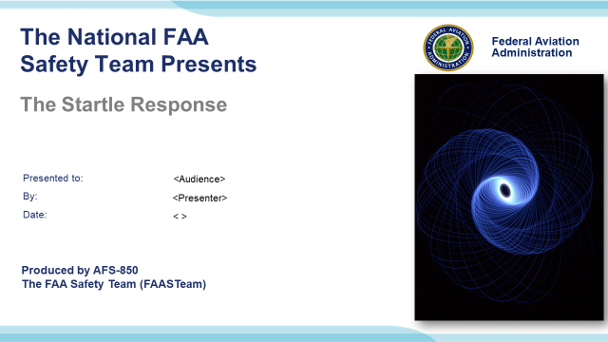 | Slide 1  2020/11-07-214(I)PP Original Author: John Steuernagle (12/18/2020); POC: Kevin Clover, AFS-850 Operations Lead Office (562-888-2020); Revised by: (Name) (MM/DD/YYYY)  Presentation Note: This is the title slide for The Startle Response  - Script - We have included a script of suggested dialog with most slides. The script will always appear in a non-italic font. Presenters may read the script or modify it to suit their own presentation style. See template slides 5 and 6 for examples of a slides with script.  - Presentation Instructions - (stage direction and presentation suggestions) will be preceded by a Bold header: the instructions themselves will be in Italic fonts. See slides 2, for an example of slides with Presentation Instructions only.  - Program control instructions - will be in bold fonts and look like this: (Click) for building information within a slide; or this: (Next Slide) for slide advance.  - Background information - Some slides may contain background information that supports the concepts presented in the program.  Background information will always appear last and will be preceded by a bold Background: identification.  The production team hope you and your audience will enjoy the show. Break a leg!  (Next Slide)
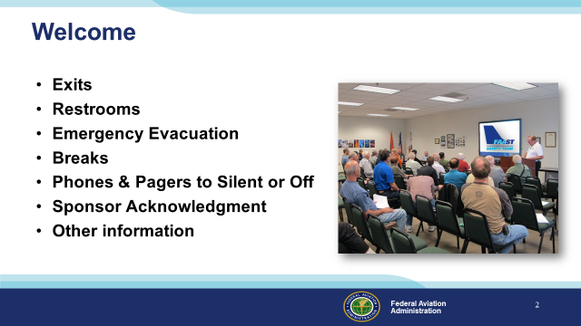 | Slide 2  Presentation Note: Here’s where you can discuss venue logistics, acknowledge sponsors, and deliver other information you want your audience to know in the beginning.  You can add slides after this one to fit your situation (Next Slide)
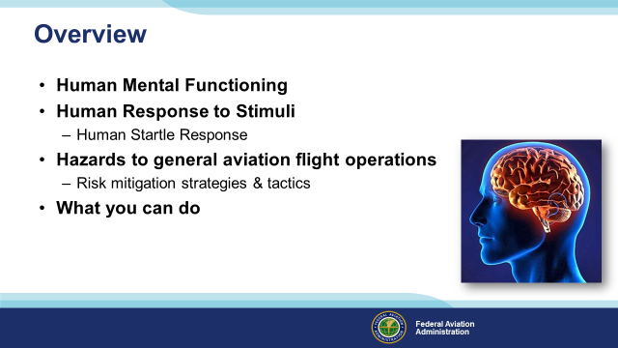 | Slide 3  Today we’ll talk about human mental functioning and responses to stimuli. We’ll discuss how humans respond to stimuli – particularly when startled.  We’ll touch on hazards to general aviation flight operations and suggest some strategies & tactics to eliminate or mitigate risk.  Finally we’ll talk about some things you can do to improve your response to unexpected events.  Presentation Note: If you’ll be discussing additional items, add them to this list  (Next Slide)
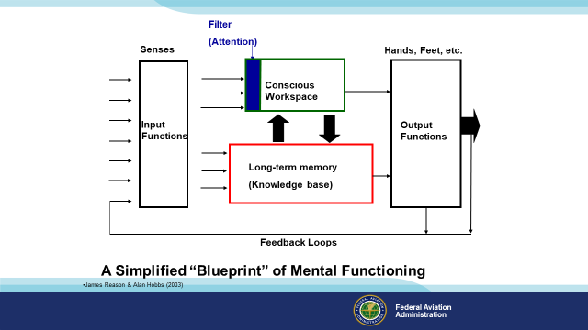 | Slide 4  We’ll start with a blank sheet of paper & draw a blueprint of Human Mental Functioning. There’s a lot more going on than we’ll discuss here but this will give you an idea of how we process data. (Click)  Primarily through our sense of sight and our other senses, data is conveyed to 2 areas of our brain. (Click)  It flows to the Conscious Workspace – think of it as your CPU (Click)  but we have to be paying attention. The world is a very complex place and our brains do a wonderful job of filtering out unimportant details. If we’re preoccupied with something else the attention filter won’t let the data through. (Click)  Sensory data also flows to our Long-term Memory – sort of like the Random Access Memory of our computers. (Click)  and – like our computers - data is exchanged between the Conscious Workspace and Long-term Memory (Click)  Processing results in output functions assigned to speech, movement, etc. (Click)  Finally there are feedback loops that report how our output is achieving the desired result.  (Next Slide)  Background:  A 'Blueprint' of Mental Functioning  This slide outlines the basic structural components of mental functioning. It is not a wiring diagram or a picture of brain anatomy, rather it is a very simplified 'systems representation' of the important elements and their inter-connections. Sensory data comes into the brain via a number of input functions. These are the senses—vision, hearing, taste, touch, smell and the various position and motion receptors. Vision is the dominant sense, so much so that it can override conflicting inputs from the other senses. A small proportion of the total available sense data enters the conscious workspace after having been screened by the attention filter. Here, the selected data are broken down, added to or recombined by the computationally powerful (though slow and effortful) processes of thought, reasoning and judgment. The conscious workspace can act directly upon the various output functions—hands, limbs, feet, speech and so on—commanding them to perform certain actions or utterances.  Some of the input data passes directly to long-term memory, the knowledge base, where highly specialized knowledge structures or schemata act upon it. Whereas the conscious workspace keeps 'open house' to all kinds of sensory data, long-term memory seeks out only those pieces of information that are relevant to its stored knowledge structures. Each schema 'looks out for' only those bits of information relating specifically to it. Thus, a schema for recognizing cats is only interested in things having a certain size and shape, four legs, sharp claws, fur, whiskers and the like.  Information from long-term memory goes two ways.  • First, it can go directly to the output functions in the form of pre-packaged bursts of instructions. In engineering terms, we can say that whereas action control via the conscious workspace is feedback-driven, that via long-term memory is feedforward-driven. We will look at these control modes in more detail later.  • Second, the long-term memory is continually sending information to the conscious workspace. Sometimes, this information is deliberately sought by conscious retrieval mechanisms, but often items of information just pop into consciousness, seemingly of their own accord, but actually driven by the two basic search rules of similarity matching (match like to like) and frequency gambling (where two or more items have been located on the basis of similarity, favour the one that is most frequently and recently used in this situation).1 An item of information thus delivered might be a thought, an image or an action.  The conscious workspace (CW) and long-term memory (LTM) usually operate in subtle harmony to guide our actions in the way that we intend. Sometimes things go wrong, but this happens comparatively rarely. The characteristics of these two controlling mechanisms (CW and LTM) stand in marked contrast one to another.  Limitations of the Conscious Workspace  An important difference between the conscious workspace and long-term memory is that the capacity of the conscious workspace is severely limited. When you look up a phone number and keep it in mind until you dial it, you are depending on the conscious workspace. Mental arithmetic is another situation where we have to keep several items stored in memory until we have found the answer. The conscious workspace has a time span of around one-and-a-half seconds, and operates like a leaky bucket. New bits of information or thoughts displace older items of information. The limits of the conscious workspace have important implications for maintenance work. Interruptions and other distractions can easily lead to steps being omitted and other failures of memory. James Reason and Alan Hobbs 2003  (Next Slide)
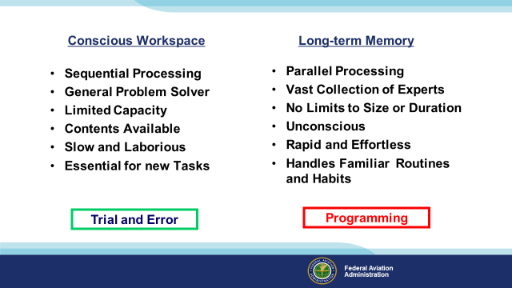 | Slide 5  Here are some attributes of the Conscious Workspace and Long-term Memory. There’s no need to memorize these lists. We’ll get to some practical exercises in a minute. (Click)  For now just remember that the conscious workspace works through trial and error. (Click)  And long-term memory is more about running programs.  (Next Slide)
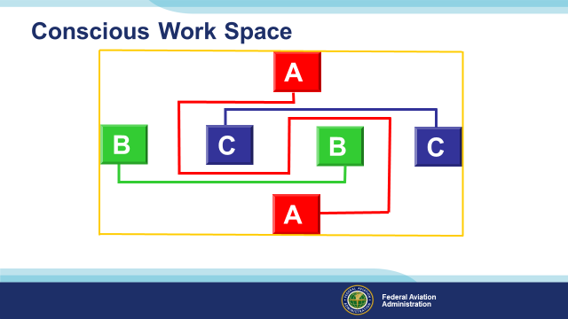 | Slide 6  To illustrate how this works let’s take a trip to the Conscious Work Space.  Stay within the yellow lines (Click)  and connect A to A, B to B, and C to C with continuous lines that don’t cross.  Use paper and pencil if you like and raise your hand when you’ve solved the problem. You are now working in the Conscious Work Space.  Presentation note: Give the audience some time – at least a minute - to work the problem then:  You are now in the Conscious Work Space. Are you comfortable working there? How comfortable would you be if you were processing information this way while driving a car or landing a plane?  Obviously we can’t function in the Conscious Work Space exclusively. It’s too slow and ponderous to live life this way and yet ….. we have to go there unless wecan run a program from our Long Term Memory. We’ll get to that in a minute but first, here’s how the problem is solved. (Click) (Click) (Click)  (Next Slide)
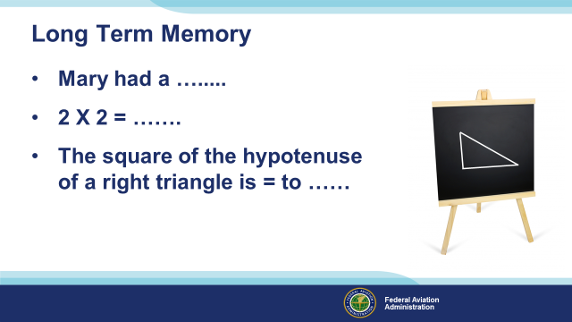 | Slide 7  While working in the conscious workspace is sequential, slow, and laborious, accessing long term memory is virtually effortless and astoundingly quick. Here’s an illustration. Just complete the statements aloud:: (Click)  Presentation note: Pause briefly for the audience to complete each statement. Then move to the next statement  Right – we all remember the nursery rhyme. (Click)  And in this age of calculators in everyone’s pocket or purse we still remember multiplication tables. (Click)  Right again. The square of the hypotenuse of a right triangle is equal to the sum of the squares of the two adjacent sides. Some of us had to access our memory attic for Pythagoras’ Theorem but you get the point.  There’s another aspect of long term memory that helps us make sense of the world and it has to do with association.  (Next Slide)
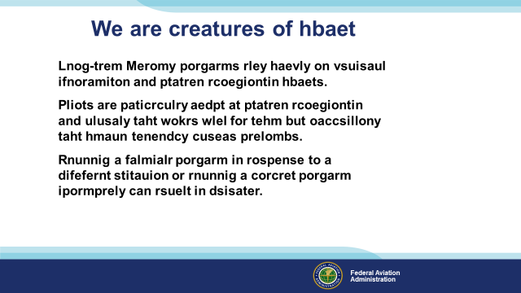 | Slide 8  We make sense of the world by relating the new situations and stimuli to our previous experience. Our ability to associate is quite remarkable as we’re about to see (Click)  Presentation Note: Ask for a volunteer to read the text on the screen. Then……  This exercise illustrates how powerful our habit patterns are and the human need to match new situations to previous experience. Our brains look at chaos and, fill in the blanks to  construct a picture that makes sense. It’s very true that we see what we expect to see and in this case our pattern recognition programming led to success.  We are in the habit of speaking and reading English but what if the on-screen text isn’t English but Elbonian? We might incorrectly interpret a mine field warning and ignorantly walk into a disaster.  The most insidious new situations are very similar to familiar situations and, if we’re not paying attention, we’re likely to miss the subtle differences.  Now let’s take a quick look at human response to stimuli.  (Next Slide)
 | Slide 9  Presentation note: Wait a few seconds for the audience to react to the photos then:  Almost everyone who has experience with lemons is already responding to these pictures. Many of us are salivating now and we can almost detect the familiar lemon aroma.  Folks who have no prior experience with lemons would not react in this way.  (Next Slide)
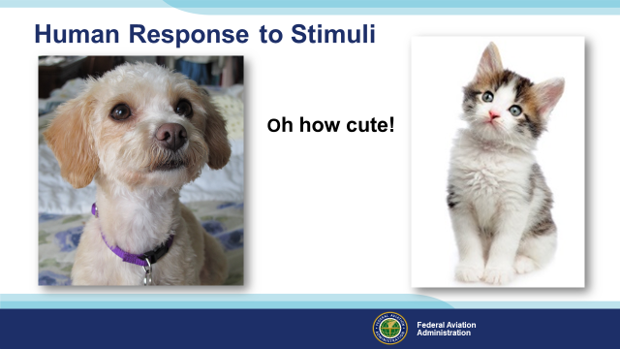 | Slide 10  We respond almost instantly to familiar stimuli. Puppies and kittens are almost guaranteed to elicit a positive response in most people  (Next Slide)
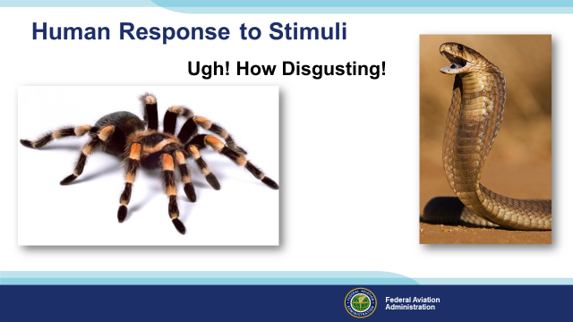 | Slide 11  Spiders and snakes…. Well not so much. Indeed most of us will view these as potential threats and take immediate action to secure our safety. Threats – especially unanticipated ones – can  elicit unhelpful, even dangerous responses Unexpected threats can activate our fight or flight reflexes or, in some cases, cause us to freeze in inaction. Let’s turn our attention next to the human startle response and how it may compromise our safety in flight.  (Next Slide)
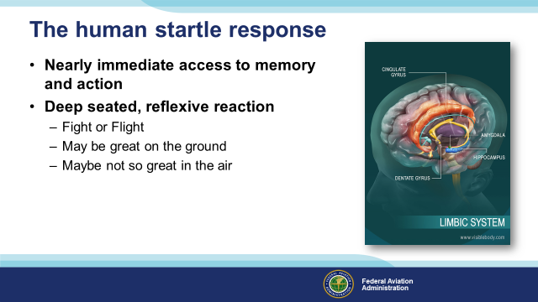 | Slide 12  The human startle response is a deep seated reflexive action initiated by the amygdala in the limbic system – the most ancient part of our brain. For eons it’s been a recipe for evolutionary success; a deep seated reflexive reaction to stimuli that instantly prepares us to fight, or to run for our lives.  Running or fighting may not be helpful when coping with a rapidly developing aviation emergency. Success or failure will depend on how well we are prepared to deal with the emergency and all too often – how close we are to the ground when it happens.  (Next Slide)
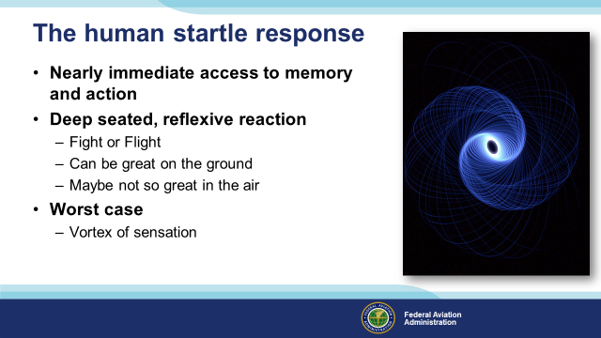 | Slide 13  Because the startle response is reflexive it’s virtually instantaneous – when we’re startled we begin to respond before we have time to consider what we’re doing. In some cases the Amygdala hijacks our thought processes, controlling our actions – often in inappropriate ways. Amygdala hijacks are immediate, overwhelming emotional responses to perceived threats unsupported by reasoned analyses of our situations. In worst case scenarios, we may find ourselves in a vortex of inappropriate action or unable to act at all. At the bottom of the vortex we are spending all of our mental energy on staying alive with no capacity to reason our way out of our predicament .  Let’s look at a case study of an accident that may have involved a startle response.  (Next Slide)
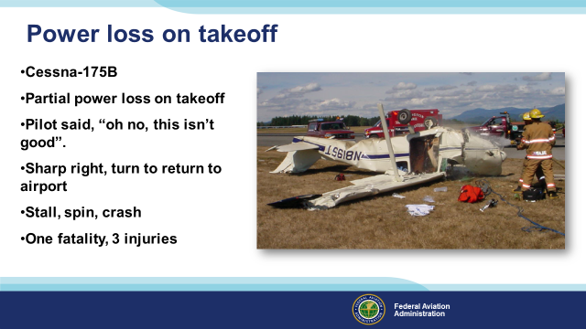 | Slide 14  Here was a case where a return to the airport didn’t work out. From the photograph it would seem there were off airport landing alternatives. We also note that there was not a total loss of power.  Partial power might have been sufficient to allow for more landing options. The pilot was the only fatality and, although he survived the crash, he died before he could be interviewed. Thus, we don’t have the benefit of his thinking. It’s possible though that he was so committed to turning back that he was blind to alternative landing opportunities.  (Next Slide)  Background: The NTSB report on this accident is included in the presentation materials. The report documents the presence of OTC and prescription drugs that may have impaired pilot performance.  (Next Slide)
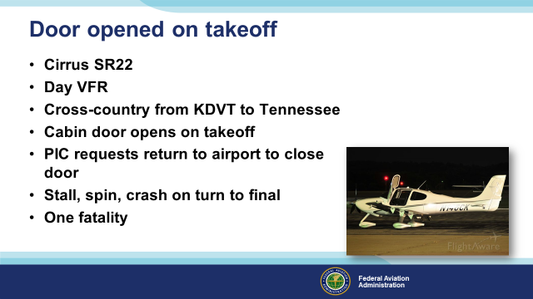 | Slide 15  This is a classic example of an abnormal situation that was NOT managed well. Either because of distraction from the door being open, noise, trying to close the door, or some combination of those, the PIC lost control of the aircraft while maneuvering to land and solve the problem. This ‘unexpected event’ became an ‘unexpected emergency’ when it didn’t have to.  (Next Slide)  Background: The NTSB report on this accident is included in the presentation materials.  (Next Slide)
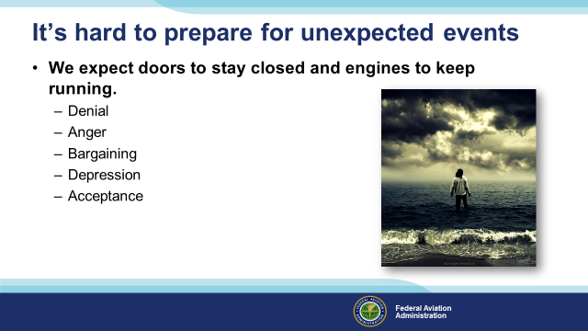 | Slide 16  Aircraft are so reliable and we are so accustomed to flights going as planned that when we do experience a failure we often resort to a very human 5-stage process that must be dealt with quickly before we can do anything useful to improve our situation. A lot of you know what I’m talking about.  Presentation note: You can ask for audience input here if you like. Someone is likely to cite the 5 Stages of Grief. Then (Click)  That’s right – we may quickly run through these stages when a non-optimal event occurs but we won’t be able to do anything useful until we accept the situation and deal with it. It’s much better to prepare for unexpected events before they occur.  (Next Slide)
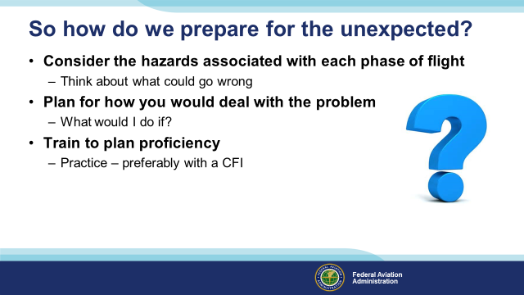 | Slide 17  So how do we prepare for the unexpected? We think about what could go wrong. It’s useful to consider things that could go wrong in each phase of flight. Generally speaking – problems are more serious – the less room we have to maneuver. Looking at it that way – a power loss on climb out would be more serious than one at altitude or in the pattern when a landing is assured.  (Next Slide)
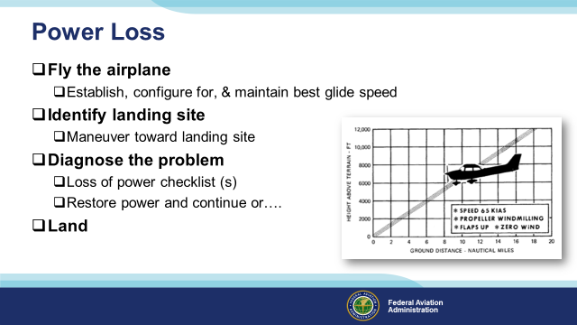 | Slide 18  Let’s consider a sudden and unexpected loss of power. What’s the first and most important thing we must do?  Presentation note: Wait for the audience to answer. Usually they will say, “Fly the airplane!” then: (Click)  That’s right – If we don’t maintain aircraft control this will not end well. While maintaining control; establish, configure for, and maintain best glide speed. (Click)  If we’re VFR or maneuvering near an airport we should already have some idea of suitable off airport landing sites nearby. Heading toward the best choice of these is good insurance in case we’re unable to restore power. (Click)  Now, if there’s sufficient time, we can try to diagnose and correct the problem. The POH will likely have some checklists to follow but, because most power loss events are fuel related, Mixture – Rich, Fuel Pump – On, Fuel – On Proper Tank will often do the trick. But if we can’t restore power ……. (Click)  We land keeping the aircraft under positive control throughout. If you can keep everything under control and you have a remote ELT switch, activate the ELT while maneuvering to land and turn cell phones on. Both will help in guiding rescuers to your landing site.  If we are able to restore power - unless we’re sure we know what caused the power loss, we know we’ve corrected the problem, and we’re emotionally and intellectually prepared to continue the flight, a precautionary landing is in order. At least it can be at an airport of our choosing instead of a farmer’s field. Seriously – responding to emergencies is physically, emotionally, and intellectually draining. Time spent regrouping on the ground is well spent.  (Next Slide)
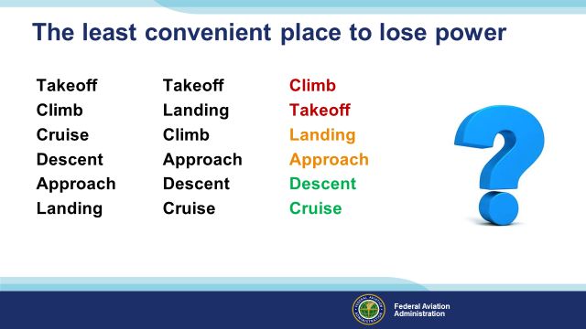 | Slide 19  Continuing with the power loss example, here’s a practice exercise in hazard identification and risk mitigation. Complete or partial power loss is never a welcome event but it does happen so we train and practice for that eventuality. Let’s begin by thinking about which flight phases pose the greatest challenges to coping with power loss. Let’s rank this list by how much time we’d have to solve the problem. (Click)  We’re very close to the ground while taking off and landing so there’s little time to deal with a power loss in these flight phases. If we’re landing, at least there’s a runway in front of us. If we’re taking off, most of the runway may be behind us. The same logic works with climb and approach. We generally climb away from and approach toward airports. Cruise and descent will usually give us the most time to deal with a power loss.  So using this line of reasoning we come up with a list that looks like this: (Click)  The least convenient time to lose power is during climb out. We’re at lower than cruise speed and possibly below approach speed as well, we have a climb angle of attack and the nearest runway is usually behind us. A power loss here will require fast action to avoid a stall and maintain aircraft control while maneuvering for a landing. (Click)  Takeoff is only better if we have room to land straight ahead. There won’t be time to run a power loss checklist. If we’ve already lifted off the only thing we can do is to maintain aircraft control and land straight ahead. (Click)  Power Loss during cruise will usually give us time pick a landing site and to run some checklists. We’ll establish best glide speed first thing; then go about the business of restoring power or getting on the ground. (Click)  Landing is a great time to lose power if we’re just about to touch down or if we’re in the pattern and we can glide to the runway. It’s not so great if we’re dragging it in on a long final approach. Then about the only thing we can do is to land more or less straight ahead and short of the runway. (Click)  We’re usually headed toward an airport while descending so that’s an advantage but the closer we get to the ground, the less time there will be for problem solving (Click)  Coping with power loss on approach depends on how far along we are in the procedure. Obviously if we’re outbound in a procedure turn and can’t restore power quickly, we’ll be landing off airport.  We can see that the optimum response to power loss is different depending on our phase of flight and other factors including terrain and suitable off airport landing areas. Success in dealing with unexpected events depends in large part on pilot preparation and skill. The exercise we’ve just been through is part of that preparation. Now, let’s take a few minutes to talk about maintaining our piloting skills.  (Next Slide)
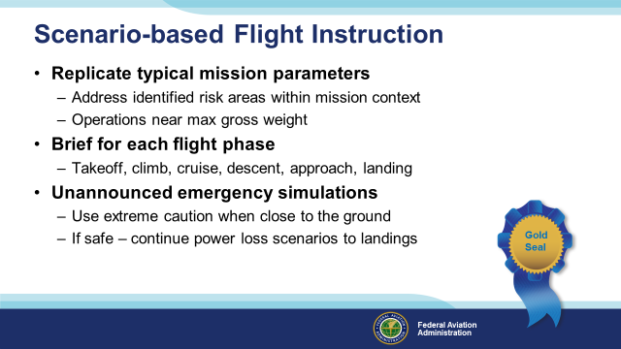 | Slide 20  Proficiency training is central to maintaining and improving our flight operations. The coaching you get from your CFI will keep you on top of your game. The best flight instruction  Is based in holistic scenarios that replicate the challenges you’re likely to face. Your CFI can help you to identify risk areas and to develop effective risk mitigation strategies and tactics.  You’ll fly at least some scenarios that deal with conditions that approach the performance limitations – for example: near max gross weight operations - of you and your aircraft.  You’ll practice briefing for each flight phase noting what you expect to happen and what you’ll do if it doesn’t.  Your CFI will simulate emergency situations without announcing their onset. That way you’ll become accustomed to the element of surprise. Obviously you’ll be cautious and conservative – especially when you’re close to the ground. If conditions are favorable and you can do so safely; we recommend that at least some power loss scenarios feature a power off approach and landing at a suitable airfield.  (Next Slide)
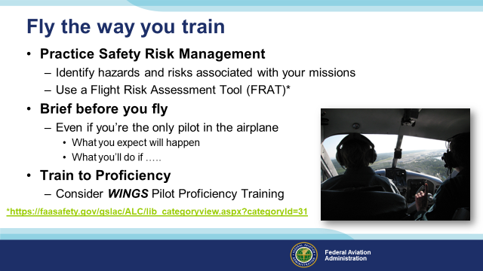 | Slide 21  Finally – fly the way you train. Practice safety risk management for every flight. Identify potential hazards and have a plan to eliminate them or mitigate them to an acceptable level of risk. A Flight Risk Assessment Tool or FRAT can help you with this. You can find one in the FAASafety.gov library.  https://faasafety.gov/gslac/ALC/lib_categoryview.aspx?categoryId=31  (Next Slide)
 | Slide 22  Presentation Note: You may wish to provide your contact information and main FSDO phone number here. Modify with  Your information or leave blank.  (Next Slide)
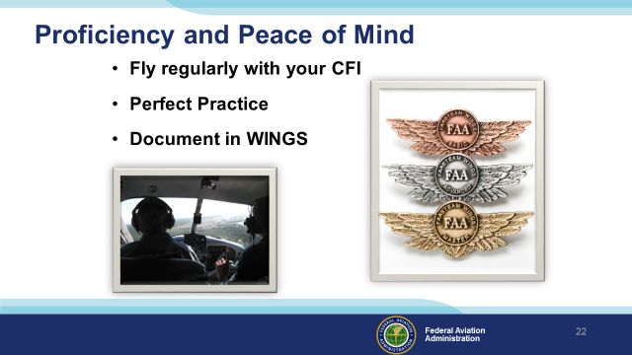 | Slide 23  There’s nothing like the feeling you get when you know you’re playing your A game and in order to do that you need a good coach (Click)  So fly regularly with a CFI who will challenge you to review what you know, explore new horizons, and to always do your best. Of course you’ll  have to dedicate time and money to your proficiency program but it’s well worth it for the peace of mind that comes with confidence. (Click)  Vince Lombardi, the famous football coach said, “Practice does not make perfect. Only perfect practice makes perfect.” For pilots that means  flying with precision. On course, on altitude, on speed all the time. (Click)  And be sure to document your achievement in the Wings Proficiency Program. It’s a great way to stay on top of your game and keep you flight review current.  (Next Slide)
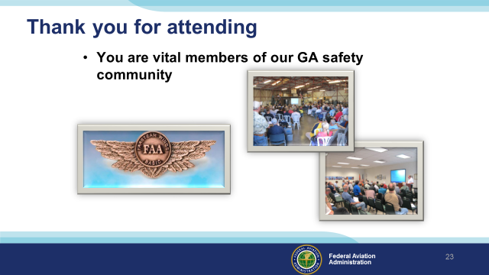 | Slide 24  Your presence here shows that you are vital members of our General Aviation Safety Community. The high standards you keep and the examples you set are a great credit to you and to GA.  Thank you for attending.  (Next Slide)
Slide 25

(The End)

Appendix I – Equipment and Staging
Equipment:
- Projection Screen & Video Projector suitable for expected audience
  - Remote computer/projector control available at lectern or presenter location
    - In lieu of remote – detail a Rep to computer/projector control.
- Presentation Computer
  - Note: It is strongly suggested that the entire program reside on this computer.
- Back up Projector/Computer/Media as available.
- PA system suitable for expected audience
  - Microphones for Moderator and Panel
    - Optional Microphone (s) for audience
- Lectern (optional)
Staging:
- Arrange the projection screen for maximum visibility from the audience.
- Equip with PA microphones
- Place Lectern to one side of screen. This will be used by presenters and moderator
- IMPORTANT – Once you have completed outreach on this topic, please help us track the outreach you have done by entering a PTRS record.

