Presentation Notes
Managing Component Failures 2021/01-27-216(I)PP

This outreach guidance is provided to all FAA and aviation industry groups that are participating in outreach efforts sponsored by the General Aviation Joint Steering Committee (GAJSC). It is important that all outreach on a given topic is coordinated and is free of conflicts. Therefore, all outreach products should be in alignment with the outline and concepts listed below for this topic.

Outreach Month: May 2022

Topic: Managing Component Failures (SCF-SE-28)
The FAA and industry will conduct a public education campaign emphasizing the safety benefits of Managing Component Failures.

Background:

This Safety Enhancement will be used to educate flight instructors and pilots on the need for preparing for unexpected events in the cockpit, focusing on: the importance of briefing for emergencies; recognition and management of “startle response”. This work will also better prepare pilots for engine failure after takeoff. Work will include developing best practices, refining the takeoff pre-brief to emphasize what action will be taken dependent on current situation (altitude, airspeed, terrain, etc.) and recommend training/practicing the developed best practices on a regular basis.

Teaching Points:
- Discuss the Pilot in Command responsibility for managing system and component failures.
- Discuss the safety benefits of scenario based training, reviewing, developing strategies, training and reviewing common in flight failures to reduce response human factors and outcomes.
- Acquaint pilots to the process of working with a CFI in practicing these scenarios.

References:
- FAA Safety Briefing, “When the Best Made Plans Go Awry,” Nov/Dec 2010 http://1.usa.gov/2p2VV2O

- FAA Safety Briefing, “Between a Rock and Hard Spot—Handling a Partial-Power Takeoff,” Nov/Dec 2010 http://1.usa.gov/2p2UIYY

- FAA Safety Briefing, “When the Lights Go Out—What You Should Know About Aircraft Electrical Systems,” Nov/Dec 2010 http://1.usa.gov/2opLsNB

- FAA Risk Management Handbook, chapter 5: ADM; and chapter 6: Single Pilot Resource Management http://go.usa.gov/x9gnj

- Pilot Response to Unexpected Events – GAJSC Safety Enhancements - Loss of Control

Abstract: This presentation acquaints the audience with the benefits of Managing Component Failures through planning and preparation. Through pilot skill and knowledge development an airman can prepare for the emergency, determine and gain skills for initial appropriate action managing the usual chain of events that lead to disaster.

Format: Information Briefing – Power Point presentation

Required Personnel: FAASTeam Program Manager or designated FAASTeam Rep(s)

Optional Personnel: Flight Instructor or others who can speak on Flight Data Monitoring.

AFS 850 Support: In addition to this document, a Power Point presentation that supports the program is provided. FPMs and presentaers are encouraged to customize this presentation to reflect each individual program.

Slides | Script
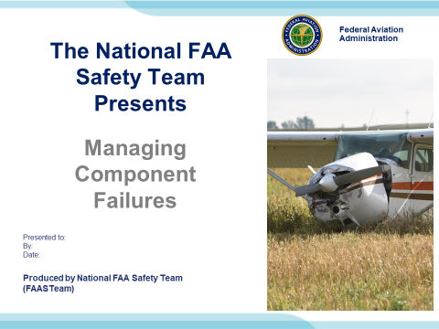 | Slide 1  2021/01-27-216(I)PP Original Author: Jay M Flowers; POC Kevin Clover, AFS-850 Operations Lead, Office 562-888-2020  Presentation Note: This is the title slide for Managing Component Failure.  Script - We have included a script of suggested dialog with most slides. The script will always appear in a non-italic font. Presenters may read the script or modify it to suit their own presentation style. See template slides 5 and 6 for examples of a slides with script.  Presentation Notes and Instructions - (stage direction and presentation suggestions) will be preceded by a Bold header: the instructions themselves will be in Italic fonts. See slides 2, for an example of slides with Presentation Instructions only.  Program control instructions - will be in bold fonts and look like this: (Click) for building information within a slide; or this: (Next Slide) for slide advance.  Background information - Some slides may contain background information that supports the concepts presented in the program.  Background information will always appear last and will be preceded by a bold Background: identification.  The production team hope you and your audience will enjoy the show. Break a leg!  (Next Slide)
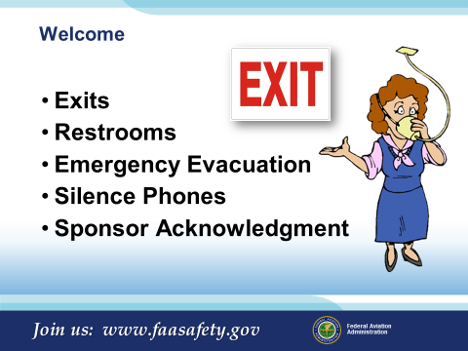 | Slide 2  Presentation Note: Here’s where you can discuss venue logistics, acknowledge sponsors, and deliver other information you want your audience to know in the beginning.  You can add slides after this one to fit your situation.  (Next Slide)
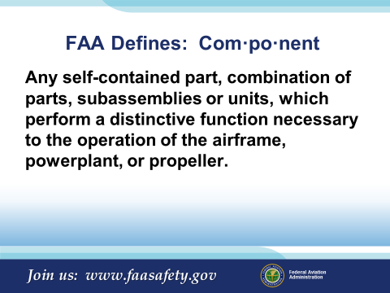 | Slide 3  FAA Define Component as:  Any self-contained part, combination of parts, subassemblies or units, which perform a distinctive function necessary to the operation of the airframe, powerplant, or propeller.  (Next Slide)
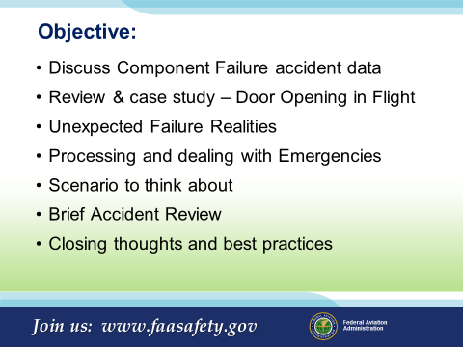 | Slide 4  Objective for todays discussion:  Discuss Component Failure accident data  Review & case study – Door Opening in Flight  Unexpected Failure Realities  Processing and dealing with Emergencies  Scenario to think about  Brief Accident Review  Closing thoughts and best practices  (Next Slide)
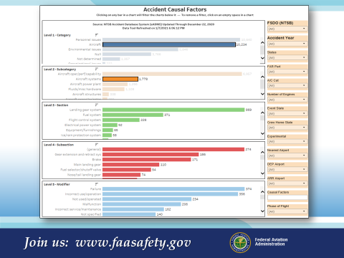 | Slide 5  Presentation note: The current accident Causal Factors data can be looked up in the FATDAT and placed here. The data in the slide is from 10/01/2009 to 01/11/2021.  In this look, there were over 10,200 aircraft related causal factors, 1,778 of those were aircraft systems (that’s 17% of the factors found to cause the accident).  Over time, this number has remained fairly constant.  Systems generally found to be faulty:  - Landing Gear Systems (48%)  - Fuel Systems (20%)  - Flight Control Systems (13%)  - Electrical Power Systems (5%)  These four comprise 86% of the total aircraft system failures. IT DOES HAPPEN!  (Next Slide)
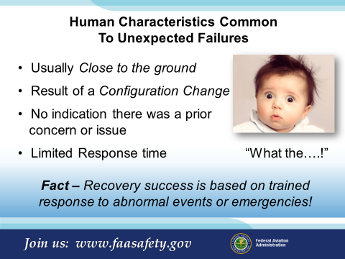 | Slide 6  Characteristics Common To Unexpected Failures  - Usually Close to the ground  - Result of a Configuration Change  - Generally no time to use a checklist  - Limited Response time: “What the….!”  - Your chances of success improve if your responses  to abnormal events or emergencies are  thought about ahead of time!!  Presentation note: An example you might use:  Helicopter engine failures that require autorotation. These must be practiced so that the response from the pilot is quick and assertive.  Multi-engine pilots need to be current and proficient with engine-out procedures on takeoff. With both single and multi-engine aircraft an engine out situation close to the ground requires a pre-planned course of action.  ME pilots practice this throughout their training, but many single pilots don’t have any pre-planned idea of what they will do or where they will go in such a case.  You can think of other emergencies where this kind of pre-planning will make for a better outcome.  (Next Slide)
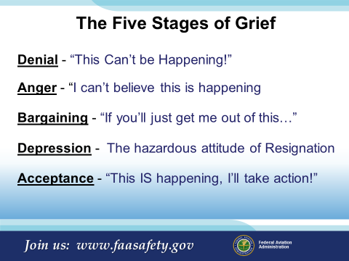 | Slide 7  Here are the Five Stages in Detail, as theorized by Elisabeth Kubler-Ross:  The stages, popularly known by the acronym DABDA, include:^{[2]}  Denial — One of the first reactions is Denial, wherein the survivor imagines a false, preferable reality.  Anger — When the individual recognizes that denial cannot continue, it becomes frustrated, especially at proximate individuals. Certain psychological responses of a person undergoing this phase would be: "Why me? It's not fair!"; "How can this happen to me?"; '"Who is to blame?"; "Why would God let this happen?".  Bargaining — The third stage involves the hope that the individual can avoid a cause of grief. Usually, the negotiation for an extended life is made with a higher power in exchange for a reformed lifestyle. Other times, they will use anything valuable against another human agency to extend or prolong the life. People facing less serious trauma can bargain or seek compromise.  Depression — "I'm so sad, why bother with anything?"; "I'm going to die soon so what's the point?"; "I miss my loved one, why go on?"  During the fourth stage, the individual becomes saddened by the certainty of death. In this state, the individual may become silent, refuse visitors and spend much of the time mournful and sullen.  Acceptance — "It's going to be okay."; "I can't fight it, I may as well prepare for it."  In this last stage, individuals embrace mortality or inevitable future, or that of a loved one, or other tragic event. People dying may precede the survivors in this state, which typically comes with a calm, retrospective view for the individual, and a stable condition of emotions.  (Next Slide)
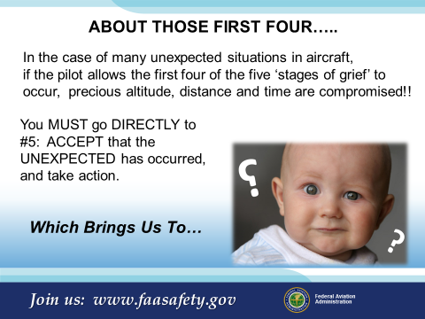 | Slide 8  ABOUT THOSE FIRST FOUR…..  In the case of many unexpected situations in aircraft, if the pilot allows the first four of the five ‘stages of grief’ to  occur, precious altitude, distance and time are compromised!!  You MUST go DIRECTLY to #5: ACCEPT that the UNEXPECTED has occurred, and take action.  When dealing with the unexpected, particularly if at low altitude on takeoff or landing, there is the element of surprise. Talk to any pilot who has experienced an engine failure on takeoff who DID NOT brief what they would do below leveling off at the cruise altitude, and they will tell you about the ‘Denial’ phase.  CFIs, when planning to surprise a student with a simulated engine failure, landing gear system problem, allow at least 5 seconds (often longer) before expecting them to react. Practice and preparation will likely reduce this reaction time. You can think of and explain similar reactions from pilots that involve Anger, Bargaining, or Depression.  (Next Slide)
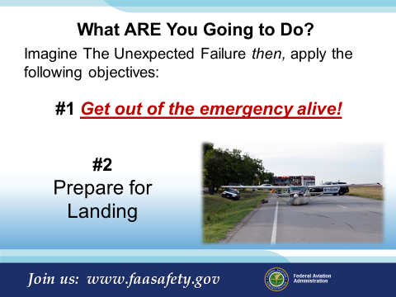 | Slide 9  What ARE You Going to Do?  Imagine The UNEXPECTED SITUATION or EMERGENCY then apply the following objectives:  #1 Get out of the emergency alive!  #2 Prepare for Landing  Our theme throughout this presentation: think about the unexpected ahead of time!!! In the comfort of your home or office, it is much easier to think through your responses to such an event in light of these two (and there are others!) objectives.  (Next Slide)
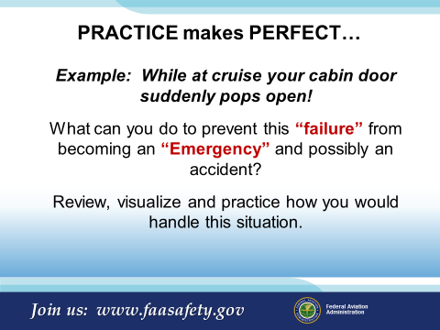 | Slide 10  PRACTICE makes PERFECT  Example: While at cruise your cabin door suddenly pops open!  What can you do to prevent this “failure” from becoming an “Emergency” and possibly an accident?  Review, visualize and practice how you would  handle this situation.  Knowledge and skill are your Super Power.  Once created, it is important to regularly review and commit to memory procedures you’ve practiced. We’re not dealing with the kind of emergency where there is time to pull out the AFM or a printed checklist to make sure we did all the steps however reviewing those emergencies are just as important. In these situations there’s not time for that, things are happening too quick, to low to the ground!! A Best Practice you may find helpful is to sit in your aircraft and follow the step by step process of recovery which would include touching the controls and managing the issue mentally.  (Next Slide)
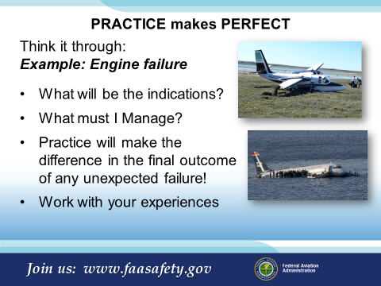 | Slide 11  PRACTICE makes PERFECT  Think it through  Example: Engine Failure  - What will be the indications?  - What must I Manage?  - Practice will make the difference in the final outcome of any unexpected failure!  - Work with your experiences  Unfortunately for Sully’s crew, they never professionally trained for a duel engine out emergency, over highly volatile terrain, landing onto a river?  Who does that?  Years of expertise, knowledge of the aircraft, aircraft systems, skill of the crew, training, and the determination to Fly the Airplane is one facet of the outcome in this or any emergency! Another key element to survival of any accident or incident is the training, education, and location of the EMS services on the ground once you get there.  (Next Slide)
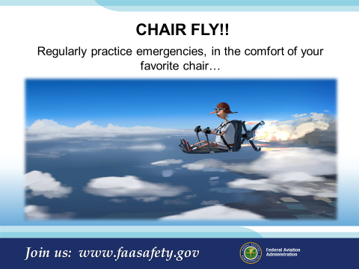 | Slide 12  CHAIR FLY!!  Regularly practice emergencies, in the comfort of your favorite chair…and you’ll be ready when, hopefully never,  the time comes when you have to manage the unexpected!  Like our pilot buddy here, practicing your emergency procedures regularly, and imagining what you will do, will expose areas where you need more knowledge or practice. NOW you have a chance to sort it out and come up with a plan of action that works better and/or makes more sense.  (Next Slide)
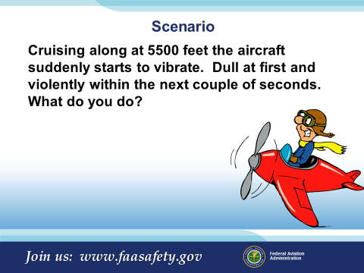 | Slide 13  Scenario #1:  Cruising along at 5000 feet the aircraft suddenly starts to vibrate. Dull at first and violently within the next couple of minutes. What do you do?  (Next Slide)
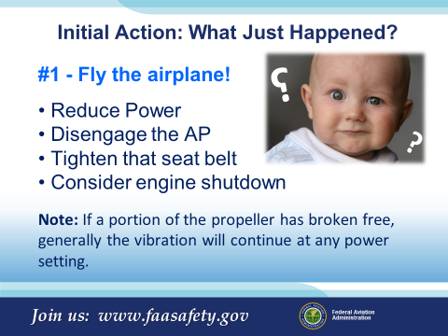 | Slide 14  Initial Action: What just happened?  #1 - Fly the airplane!  Reduce Power  Note: If a portion of the propeller has broken free, generally the vibration will continue at any power setting.  Disengage the AP  Tighten that seat belt  Consider engine shutdown  If a reduction in power either lessens the degree of the vibration or eliminates the vibration, something, either the engine or the propeller will fail. If a portion of a propeller has departed the aircraft the only action may be to shut off the suspected engine immediately.  What do you do?  (Next Slide)
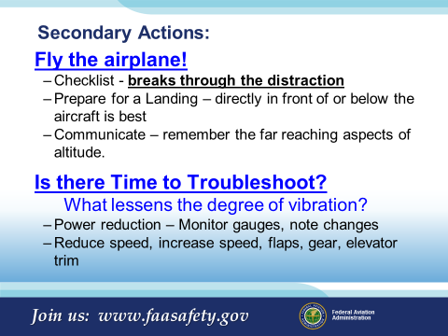 | Slide 15  Secondary Actions:  Fly the airplane!  - Checklist - time permitting, checklist breaks through the distraction and will remind you, make you think  - Look for a place to land – a spot directly in front or below is best  - Communicate – ATC, AFSS, ATCT; remember the far reaching aspects of altitude.  What lessens the degree of vibration?:  - Power reduction – Monitor engine gauges, note changes  - Reduce speed, increase speed, flaps, gear, elevator trim  Troubleshooting the issue will not only give you something to report to the mechanic but it will give you an overall look at  what you are dealing with. KNOW WHAT YOU HAVE, WORK WITH IT!  (Next Slide)
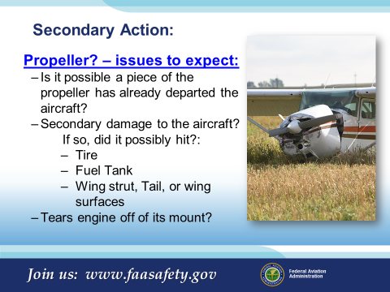 | Slide 16  Secondary Action:  Propeller – issues to expect:  Is it possible a piece of the propeller has already departed the aircraft?  Secondary damage to the aircraft?  If so, did it possibly hit?:  - Tire  - Fuel Tank  - Wing strut  - Tail or wing surfaces  - Tears engine off of its mount?  (Next Slide)
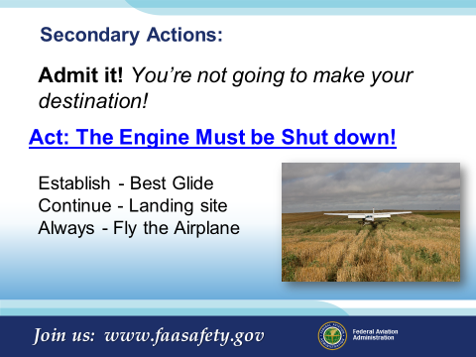 | Slide 17  Secondary Actions:  Admit it! You’re not going to make your destination!  Act: The Engine Must be Shut down!  - Establish - Best Glide  - Continue - Landing site  - Always - Fly the Airplane  (Next Slide)
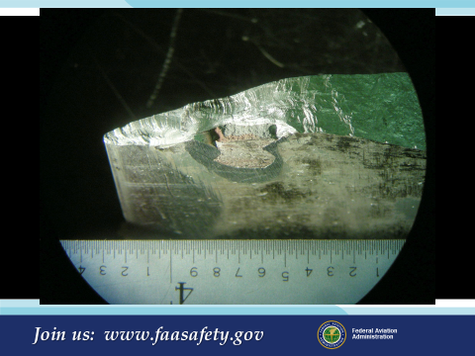 | Slide 18  The manufacturer was tasked with finding out why the blade failed. At first there were no indications of why the blade should have failed.  Upon further Investigation and stripping the propeller of its paint, the investigation found a reveling point of interest. They found that the propeller had been repaired with a commonly used epoxy resin. It is unknown how long the propeller had been operated with this repair.  (Next Slide)
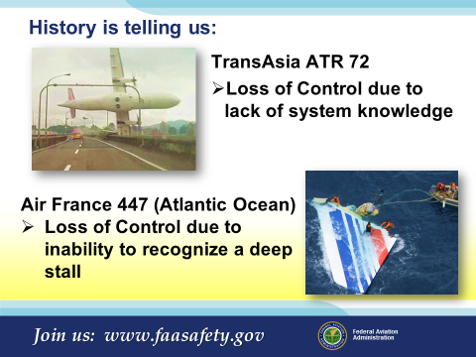 | Slide 19  History is telling us that:  TransAsia ATR 72 – Loss of Control due to lack of system knowledge  Air France 447 (Atlantic Ocean) – Loss of Control due to inability to recognize a deep stall  These accidents could have been avoided given the crews ability to manage the unexpected events with their aircraft.  (Next Slide)
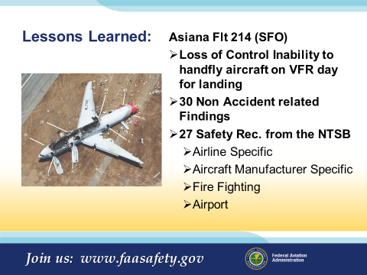 | Slide 20  History is telling us that:  Asiana Flt 214 (SFO) – Loss of Control Inability to handfly aircraft on VFR day for landing  - Loss of Control Inability to handfly aircraft on VFR day for landing  - 30 Non Accident related Findings  - 27 Safety Rec. from the NTSB  - Airline Specific  - Aircraft Manufacturer Specific  - Fire Fighting  - Airport  Note/Factual: The National Transportation Safety Board determined that the probable cause of this accident was the flight crew’s mismanagement of the airplane’s descent during the visual approach, the pilot flying’s unintended deactivation of automatic airspeed control, the flight crew’s inadequate monitoring of airspeed, and the flight crew’s delayed execution of a go-around after they became aware that the airplane was below acceptable glidepath and airspeed tolerances. Contributing to the accident were; (1) the complexities of the autothrottle and autopilot flight director systems that were inadequately described in Boeing’s documentation and Asiana’s pilot training, which increased the likelihood of mode error; (2) the flight crew’s nonstandard communication and coordination regarding the use of the autothrottle and autopilot flight director systems; (3) the pilot flying’s inadequate training on the planning and executing of visual approaches; (4) the pilot monitoring/instructor pilot’s inadequate supervision of the pilot flying; and (5) flight crew fatigue which likely degraded their performance.  The following can be found within the Notes of the presentation. Factual data is more thoroughly explained in the notes there.  The safety issues discussed in the report relate to the need for the following:  - Adherence of Asiana pilots to standard operating procedures (SOP) regarding callouts.  - Reduced design complexity and enhanced training on the airplane’s auto-flight system.  - Opportunity at Asiana for new instructors to supervise trainee pilots in operational service during instructor training.  - Guidance for Asiana pilots on use of flight directors during a visual approach.  - More manual flight for Asiana pilots.  - A context-dependent low energy alert.  - Research that examines the injury potential from significant lateral forces in airplane crashes and the mechanism that produces high thoracic spinal injuries.  - Evaluation of the adequacy of slide/raft inertia load certification testing.  - Aircraft rescue and firefighting (ARFF) training for officers placed in command of an aircraft accident.  - Guidance on when to pierce the fuselage of a burning airplane with a skin-piercing nozzle.  - Integration of the medical supply buses at SFO into the airport’s preparation drills.  - Guidance or protocols for ensuring the safety of passengers and crew at risk of being struck or rolled over by a vehicle during ARFF operations.  - Requirements for ARFF staffing.  - Improvements in emergency communications at SFO.  - Increased FAA oversight of SFO’s emergency procedures manual.  (Next Slide)
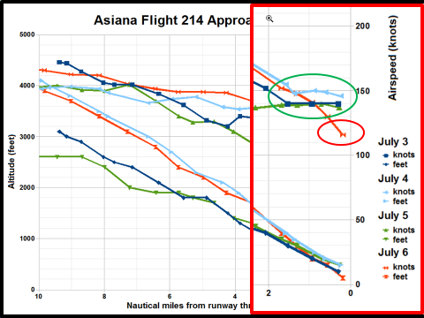 | Slide 21  As you can see in this graphic, the crew had a good 3 day run prior to the accident.  On this particular flight the crew experienced a rather unique combination of aircraft configuration and circumstances which led to the very hard landing.  The NTSB concluded the Pilot Flying deactivated auto throttle, only one flight director (Instructor’s) was active, and both pilots failed to adequately monitor airspeed during the approach.  Automation complexity, crew coordination, instructional supervision inadequacies, and fatigue were also mentioned.  Many of you might say, “that couldn’t happen to me, I don’t even have an autopilot”. What can we take away from this example?  Be aware that, when things are happening too quickly for us to keep up with or we don’t understand exactly what’s going on, it behooves us to buy some time to understand the situation. Tough to do if you have no power but easy in this case.  A go-around would have given the crew plenty of opportunity to sort things out & be better prepared for the landing. (Next Slide)
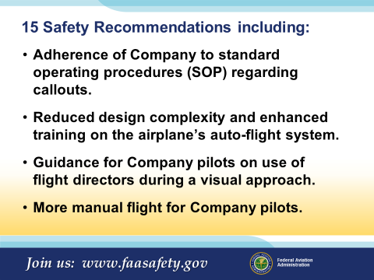 | Slide 22  15 Safety Recommendations including:  - Adherence of Company to standard operating procedures (SOP) regarding callouts.  - Reduced design complexity and enhanced training on the airplane’s auto-flight system.  - Guidance for Company pilots on use of flight directors during a visual approach.  - More manual flight for Company pilots.  As a GA Pilot, are these recommendations something you can use in your day to day flying?  - Your Personal Minimums – Just like an Company SOP, the standards and procedures you set for yourself must be adhered to.  - Checklist Usage  - Landing Gear Operational procedures – Hand on the handle/move the handle/verify as selected/three green no red/gear is down/gear mirror  - When is the last time you read up on the auto-pilot system in your aircraft? Actually performed a preflight test?  - What are the AP limits? Roll ±18 degrees left or right…etc.  - As a GA Pilot, your guidance may be the owners manual, have you ever read it? Understand all the limits of operation?  - May have learned a best practice in SIM training  - Is it easier to justify a smooth ride for you passengers if you turn the AP ON? If so, your flying skills are not what they need to be.  (Next Slide)
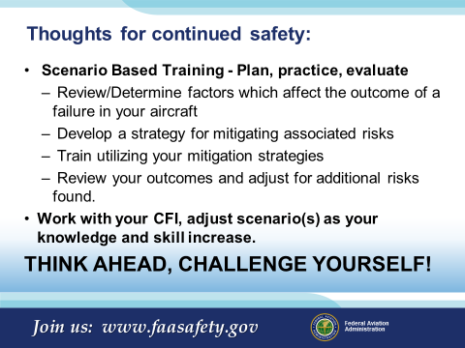 | Slide 23  Thoughts for continued safety:  Scenario Based Training - Plan, practice, evaluate  - Determine factors which are affected by a failure(s)  - Develop a strategy for mitigating associated risks  - Train utilizing your mitigation strategies  - Review your outcomes and adjust for additional risks found.  Work with you CFI, adjust scenario(s) as your knowledge and skill increase.  THINK AHEAD, CHALLENGE YOURSELF!  (Next Slide)
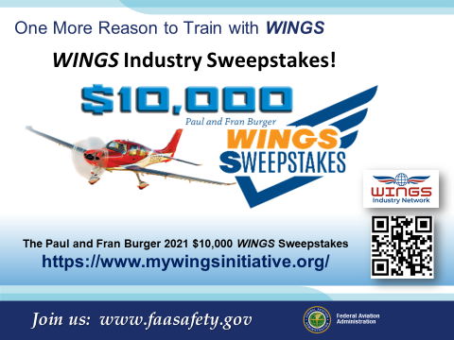 | Slide 24  One More Reason to Train with WINGS?  WINGS Industry Sweepstakes!  Paul and Fran Burger are offering $10,000 in their sweepstakes aging this year!  The WINGS Sweepstakes mission is to reduce the nation's accident and incident rate by increasing pilot participation in the WINGS FAASTeam Pilot Proficiency Program. The WINGS program has courses based on real world accident and incident causes so flight instructors, pilots and student pilots get training that can truly make a difference.  Studies indicate that pilots who complete WINGS phases are safer aviators. Please join us in saving lives.  Learn about the program and its many benefits at : https://www.mywingsinitiative.org/  The 2020 Sweepstakes awards 10 cash prizes! Prize levels include:  - Four (4) $1,500  - Four (4) $750  - Two (2) $500  (Next Slide)
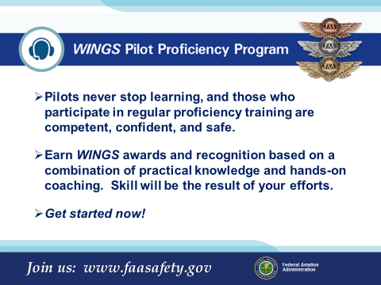 | Slide 25  The WINGS Pilot Proficiency Program.  - Pilots never stop learning, and those who participate in regular proficiency training are competent, confident, and safe.  - Earn WINGS awards and recognition based on a combination of practical knowledge and hands on coaching or skill  - Get started now!  (Next Slide)
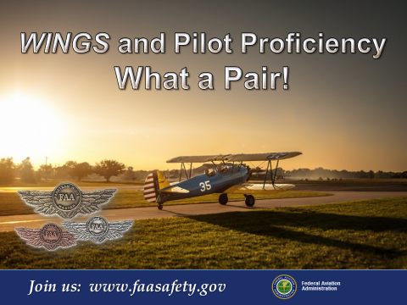 | Slide 26  Credit for this meeting is available from FAASafety.gov. Please be certain to sign the attendance roster prior to your departure. Join us on the web at FAASafety.gov for more learning options.  (Next Slide)
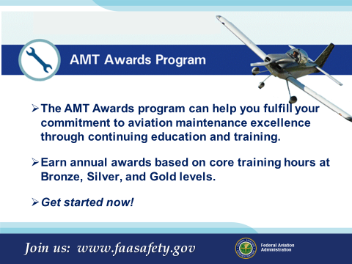 | Slide 27  The AMT Awards Program.  - The AMT Awards program can help you fulfill your commitment to aviation maintenance excellence through continuing education and training.  - Earn annual awards based on core training hours at Bronze, Silver, and Gold levels.  - Get started now!  (Next Slide)
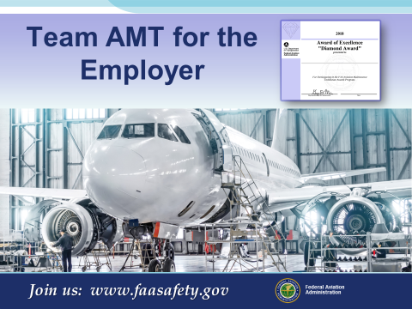 | Slide 28  Aviation safety begins on the ground and in the hangar. As an AMT you are an invaluable member of the aviation safety team.  Having the proper "tools" to do your job involves more than just filling your tool box with nice, shiny wrenches. The FAA Safety Team (FAASTeam) is committed to helping you achieve the highest level of safety by providing "tools" and resources to enhance your knowledge and proficiency.  (Next Slide)
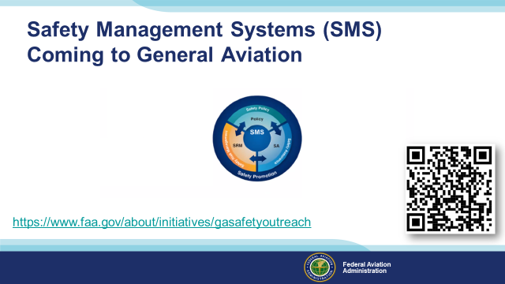 | Slide 29  Safety Management Systems are a set of policies and processes that can increase the safety and efficiency of any flight operation. And FAA is bringing SMS to General Aviation. You may have heard of SMS but thought it was only for large organizations but actually SMS can be scaled to fit any operation large or small.  There are 4 major components to a Safety Management System (Click)  Safety Policy – a documented commitment to safety that runs from the head of an organization to its newest member. (Click)  Safety Risk Management – a process that identifies hazards within an operation, determines to what extent an identified hazard may impact flight safety, and controls the risk of occurrence to an acceptable level. (Click)  Safety Assurance – By collecting and analyzing information derived from safety performance data Safety Assurance ensures the performance and effectiveness of Safety Risk Controls. (Click)  Safety Promotion communicates safety information and commitment throughout the organization. (Click)  You can find more information about Safety Management Systems at the URL on the Screen.  (Next Slide)
 | Slide 29  Have questions regarding the program or aviation safety in general, contact your local FAASTeam Representatives, FAASTeam program Manager or your local Flight Standards Office for assistance.  (Next Slide)
Slide 30

(The End)

Appendix I – Equipment and Staging
Equipment:
- Projection Screen & Video Projector suitable for expected audience
  - Remote computer/projector control available at lectern or presenter location
    - In lieu of remote – detail a Rep to computer/projector control.
- Presentation Computer
  - Note: It is strongly suggested that the entire program reside on this computer.
- Back up Projector/Computer/Media as available.
- PA system suitable for expected audience
  - Microphones for Moderator and Panel
    - Optional Microphone (s) for audience
- Lectern (optional)
Staging:
- Arrange the projection screen for maximum visibility from the audience.
- Equip with PA microphones
- Place Lectern to one side of screen. This will be used by presenters and moderator if so needed.
- IMPORTANT – Once you have completed outreach on this topic, please help us track the outreach you have done by entering a SAS record.

