Presentation Notes
Prelight After Maintenance 2021/02-19-218(I)PP

This outreach guidance is provided to all FAA and aviation industry groups that are participating in outreach efforts sponsored by the General Aviation Joint Steering Committee (GAJSC). It is important that all outreach on a given topic is coordinated and is free of conflicts. Therefore, all outreach products should be in alignment with the outline and concepts listed below for this topic.

Outreach Month: September 2022

Topic: Preflight After Maintenance (SCF-SE-28)
The FAA and industry will conduct a public education campaign emphasizing the safety benefits of Preflight After Maintenance.

Background:

The General Aviation Joint Steering Committee (GAJSC) and the National Transportation Safety Board (NTSB) have determined that a significant number of general aviation fatalities could be avoided if pilots were to conduct more thorough preflight inspections of aircraft that have just been returned to service. In-flight emergencies have been the direct result of maintenance personnel who have serviced or installed systems incorrectly.

Teaching Points:
- Learn all you can about the maintenance that was performed.
- Don’t assume the part(s) replaced are the only parts removed.
- Pay attention to trim positions. Check for unimpeded flight control surface deflections. Make sure they go in the proper direction!
- Make sure all inspection panels are secure and their fasteners are tight.
- Check fuel tank for water, sediment, and proper fuel grade.
- After an oil change, always check the engine oil level to ensure it has the proper amount of oil.
- Always check your logbook and paperwork prior to flight to ensure the correct records have been entered.
- If you see a warning tag / sign on the aircraft, or on the sign-out or status board, DO NOT FLY THE AIRCRAFT! Check with the maintenance facility prior to taking the aircraft.
- Participate in, or observe your mechanic perform, an annual or 100 hour inspection.

References:
- NTSB Safety Alert — Advanced Preflight After Maintenance: https://go.usa.gov/cK7Py

- FAA’s Advanced Preflight Pamphlet: https://go.usa.gov/xVy44

- “Advanced Preflight,” FAA Safety Briefing, Mar/Apr 2012: https://go.usa.gov/cK7ma

Abstract: This presentation acquaints the audience with maintenance-related problems found to be at the root of some of the most deadly causes of accidents in general aviation. Contributing to this is a pilot’s failure to identify maintenance discrepancies because of a lack of knowledge and improper techniques used during the preflight of the aircraft.

Format: Information Briefing – Power Point presentation

Required Personnel: FAASTeam Program Manager or designated FAASTeam Rep(s)

Optional Personnel: Flight Instructor or others who can speak on Preflight and are knowledgeable in Maintenance of an aircraft.

AFS 850 Support: In addition to this document, a Power Point presentation that supports the program is provided. FPMs and presentaers are encouraged to customize this presentation to reflect each individual program.

Slides | Script
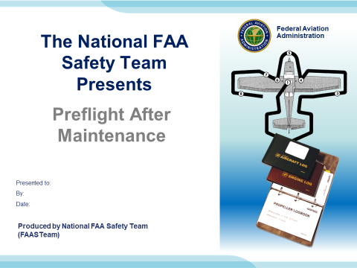 | Slide 1  2021/02-19-218(I)PP Original Author: Jay M Flowers; POC Kevin Clover, AFS-850 Operations Lead, Office 562-888-2020  Presentation Note: This is the title slide for Preflight After Maintenance.  Script - We have included a script of suggested dialog with most slides. The script will always appear in a non-italic font. Presenters may read the script or modify it to suit their own presentation style. See template slides 5 and 6 for examples of a slides with script.  Presentation Notes and Instructions - (stage direction and presentation suggestions) will be preceded by a Bold header: the instructions themselves will be in Italic fonts. See slides 2, for an example of slides with Presentation Instructions only.  Program control instructions - will be in bold fonts and look like this: (Click) for building information within a slide; or this: (Next Slide) for slide advance.  Background information - Some slides may contain background information that supports the concepts presented in the program.  Background information will always appear last and will be preceded by a bold Background: identification.  The production team hope you and your audience will enjoy the show. Break a leg!  (Next Slide)
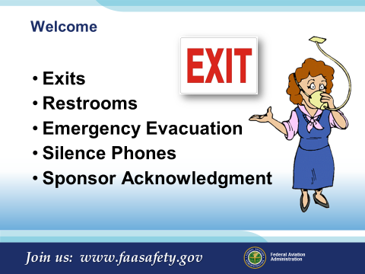 | Slide 2  Presentation Note: Here’s where you can discuss venue logistics, acknowledge sponsors, and deliver other information you want your audience to know in the beginning.  You can add slides after this one to fit your situation.  (Next Slide)
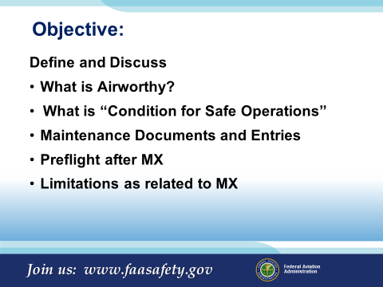 | Slide 3  Objective for todays discussion:  Define and Discuss  What is Airworthy?  What is “Condition for Safe Operations”  Maintenance Documents and Entries  Preflight after MX  ADs and AD Compliance  Limitations as related to MX  (Next Slide)
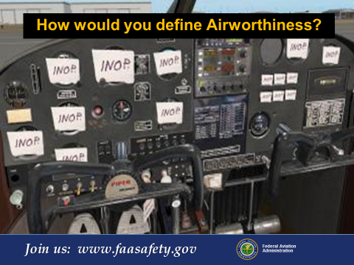 | Slide 4  How would you define Airworthiness?  Airworthiness is basically “with everything it rolled off the factory floor with”, and anything that has been added or altered since.  (Next Slide)
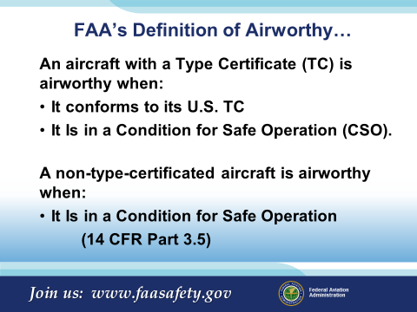 | Slide 5  FAA Definition of Airworthy…  Note: 14 CFR Part 3.5 contains the FAA’s Definition of Airworthy  An aircraft with a type certificate (TC) is airworthy when:  It conforms to its U.S. TC  Is in a Condition for Safe Operation (CSO).  If a non-type-certificated aircraft is airworthy when:  Is in a Condition for Safe Operation  What is meant by the term "in a condition for safe operation?"  This is an initial determination by an FAA inspector or authorized Representative of the Administrator that the overall condition of an aircraft is conducive to safe operations. This refers to the condition of the aircraft relative to wear and deterioration, e.g., skin corrosion, window delamination/crazing, fluid leaks, tire wear, etc.  Plus…  How does the FAA determine that an aircraft is in a condition for safe operation?  The FAA inspector or authorized Representative of the Administrator will make an initial determination as to the overall condition of the aircraft. The aircraft items evaluated depend on information such as aircraft make, model, age, type, completeness of maintenance records of the aircraft, and the overall condition of the aircraft.  (Next Slide)  Presentation Note: Each Type Certificate is considered to include the type design, the operating limitations, the certificate data sheet, the applicable regulations of this subchapter with which the FAA records compliance, and any other conditions or limitations prescribed or the product of this subchapter.
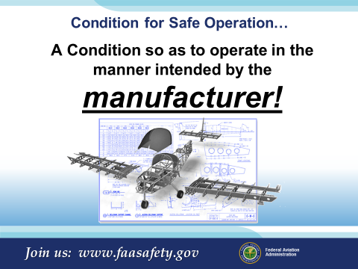 | Slide 6  Condition for Safe Operation (CSO)…  A Condition so as to operate in the manner intended by the manufacturer!  That strip of duct tape on the wing covering up that fresh air vent on your Cessna 172 is NOT manufacturer intended.  Ask your mechanic if you are not certain. Something as simple as hanging a Go Pro under the wing could be catastrophic.  Example: Main tires on a Citation 500 Series aircraft are limited to ±5 lbs. of air from that specified in the manual. Any operation of the aircraft with the air pressure limit out of CSO requires replacing the affected tire(s).  (Next Slide)
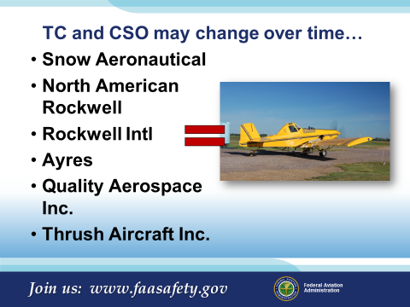 | Slide 7  An example of manufacturer history, the Thrush Aircraft TC has had 6 owners since its original TC was approved. Each has revised or added new aircraft models to the TC.  Changes to increase the max gross weight, changes affecting control surfaces, or a host of other items such as hopper size, winglets, GPS Systems, etc. are monitored by the TC holders. The new TC holders and their alterations must go through the approval process of testing and certification with their new modifications. The originally approved TC will then be “Revised” or a new model added. Consider who the manufacturer was at the time of certification, this is often based on aircraft serial number rather than a specific type (i.e. Cessna 172).  Note: The TC will have limitations and special provisions necessary to maintain airworthiness.  (Next Slide)
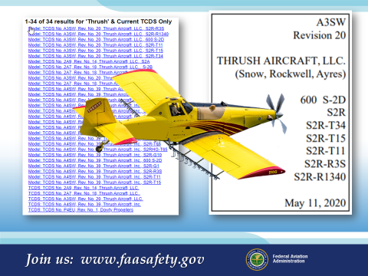 | Slide 8  As you can see here, there are 34 TCs available for the same airframe, or rather revisions or modifications to the original TC.  Something to think about:  In its day, a Snow Aircraft was designed to be flown at a Maximum weight of 6000 lbs. Under the terms outlined in the TC, Civil Aeronautics Manual 8 (CAM 8) (Advisory back in the day…) could be referred to if the owner chose to increase a manufacturers maximum weight (not a limitation by TC). What once was considered a 35,000 hour airframe is today considered to be a 6-8000 hour airframe due to operations exceeding the maximum weight while disregarding the intent of the CAM. Typically, CAM 8 would allow for a 31% (1800 lbs.) increase in Gross weight to a maximum bank angle of 30 degrees. Accident data from Owner/Operators on these weight increases has been reported as high as 62% over the “BEST PRACTICE” which greatly exceeds that allowed in the TC by the manufacturer and suggested by the CAM.  Expression used in aviation: “If it fits in there and you can get the door closed…”  That does not mean it’s true.  (Next Slide)
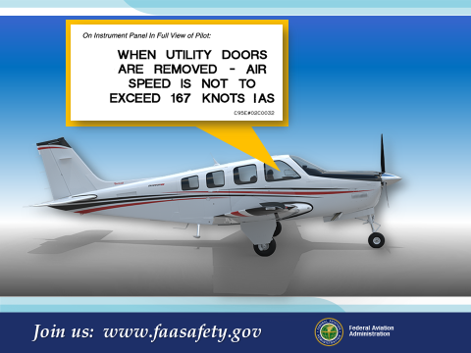 | Slide 9  For example, an operation that may come up would be a flight with a door removed from your aircraft. Some manufacturers allow, some do not.  Review the history of your airframe to fully understand what is allowed by the type design.  Contact the TC holder if you have any questions about your operation of the aircraft.  (Next Slide)
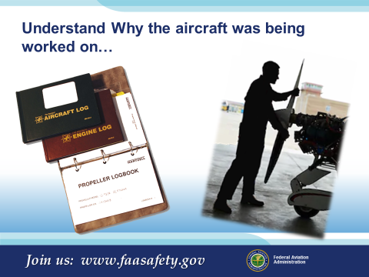 | Slide 10  Understand Why the aircraft was being worked on…  Remember, everything we are talking about here leads us to a better preflight.  Note: Knowing that the WING Spar was inspected may lead you to a more thorough inspection of the seats removed for that inspection, inspection covers, screws, control cable function, and alignment. We do this anyway, but the point being, someone had this thing apart, let’s make certain they put it back together correctly.  (Next Slide)
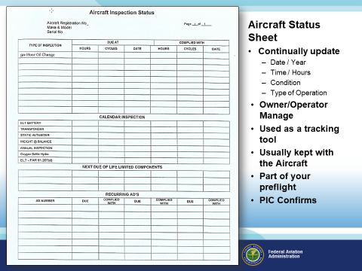 | Slide 11  Aircraft Status Boards/Sheets are a great way to stay on top life limited or time sensitive maintenance on your aircraft.  Information you may want to included would be:  - Date / Year  - Time / Hours  - Life Limited or On Condition  - 100 Hour  - Annual  - ELT Battery  - VOR Check  - GPS Database  Owner/Operator Manage  - Used as a tracking tool  - Usually kept with the Aircraft  - Part of your preflight  - PIC Confirms  Just out of Maintenance, did the Mechanic update the data on the Status Sheet or does that still need to be done? Here’s a great opportunity for you to confirm that any required endorsements (Approval for return to service) made it into the official records of the aircraft.  (Next Slide)
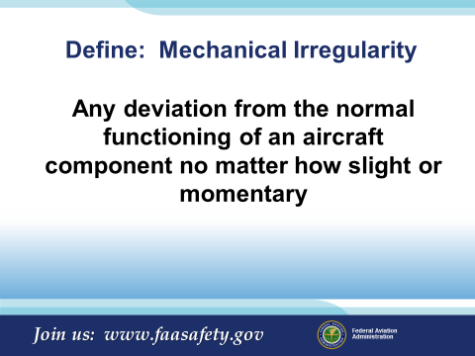 | Slide 12  Define: Mechanical Irregularity:  Any deviation from the normal functioning of an aircraft component no matter how slight or momentary.  So what do you typically do with the maintenance irregularities you find?  During Preflight: Contact Owner/Operator/aviation mechanic.  During the Flight: Monitor, record, troubleshoot, record,  Back at the hangar: Record/advise of your discrepancy in a record or form agreeable to the owner/operator/mechanic of the detected or failed item.  Once the work has been accomplished, verify CSO prior to flight.  (Next Slide)
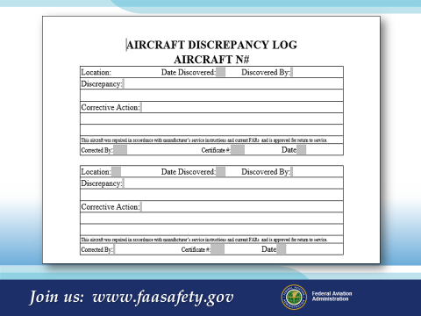 | Slide 13  Keeping track of the discrepancies on your aircraft will help refresh your memory of issues in the past, remind you to get something fixed, and serve as a sign off record for issues the aircraft has had repaired. This record could replace the entry in your aircraft logbook as long as you retain this record and it has the correct information applied to it. It also serves as a communication between you, the aircraft operator the mechanic, and other airman that may be flying this particular aircraft.  (Next Slide)
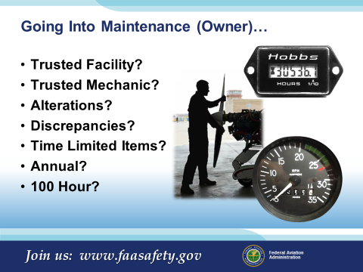 | Slide 14  Going Into Maintenance (Owner)…as a renter you may not even know that the aircraft has gone into maintenance or why, ASK!  - Trusted Facility? – Maybe the normal facility was not available  - Trusted Mechanic? – New mechanic  - Alterations? – Add or subtract something from the aircraft  - Discrepancies? – Did any issues get replaced or repaired  - Time Limited Items? – What was done  - Annual? – Requires a more extensive aircraft teardown  - 100 Hour? – Doing some instruction with your aircraft?  All this needs to be in the back of your mind before…  (Next Slide)
 | Slide 15  The FBO Just Called and You Are Good to Go!  Time to get out to the airport and have some fun…but wait!  We have few things to do first.  (Next Slide)  Presentation Note: The photo is a Copyright free photo.
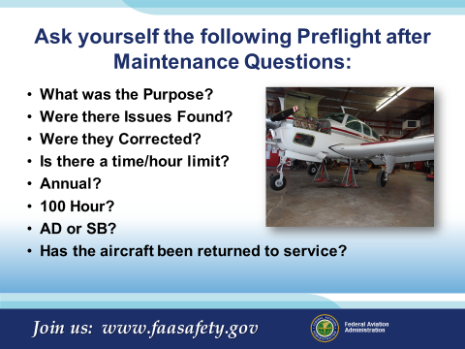 | Slide 16  Ask yourself the following Preflight after Maintenance Questions:  - What was the Purpose?  - Were there Issues Found?  - Were they corrected?  - Is there a time/hour limit?  - Annual?  - 100 Hour?  - AD or SB?  - Has the aircraft been returned to service? (Next Slide)
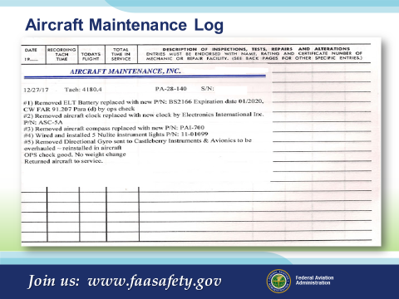 | Slide 17  Here is one look at a logbook entry.  Is it a valid logbook entry? –  Let’s look further…  (Next Slide)
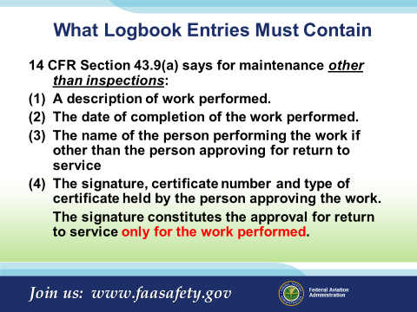 | Slide 18  14 CFR Section 43.9(a) says for maintenance other than inspections:  - A description of work performed.  - The date of completion of the work performed.  - The name of the person performing the work if other than the person approving for return to service  - The signature, certificate number and type of certificate held by the person approving the work.  The signature constitutes the approval for return to service only for the work performed.  You may have seen logbook entries with “According to the definition in 14 CFR Part 1…” the term “RR” means low or medium frequency radio range station. So if the mechanic RR’d a component he did not remove and replace it. These shortcuts in log book entries are a good sign that the mechanic wants to just get the job over with and get his money. He must give you a proper description of the work performed.  Note: Interesting remark about the R&R…I, along with many of my co-workers have used R&R countless times. We would follow up the acronym with details about the component change. I had no idea we were talking about radio range. Kind of like defining FAR’s, A/C, etc.  Although not required, I would ask, “if components were removed and replaced, include the part number/serial number removed as well as the part number/serial number installed”, that way it will be easier to track what has been done in the future.  This record procedure makes it easy on you if there were to be an Airworthiness Directive issued on a certain component installed on your aircraft. The serial number is usually a factor in whether the A.D. applies to your specific component or not.  14 CFR section 43.9 requires the mechanic include all of these components for a proper sign off and return to service after maintenance has been performed.  (Next Slide)
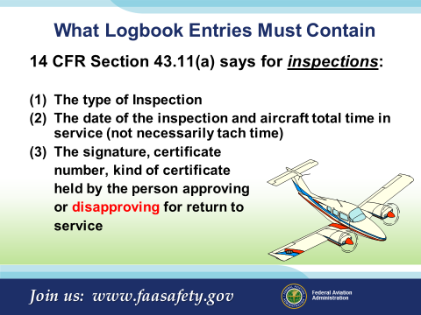 | Slide 19  For inspections, these are the minimum log book entry components as well. Note: Aircraft total time almost always is not tach time. And a lot of the time it’s not Hobbs meter time either. The aircraft records are the only place to be sure of total time and usually only after some research.  If the mechanic has discovered discrepancies and you choose not to repair them with that mechanic, he/she should sign off your log books as unairworthy and give you a list of discrepancies. You may then take it to another mechanic for further repairs. Remember: If you fly it, you must obtain a Special Flight Permit “ferry permit” before flight.  (Next Slide)
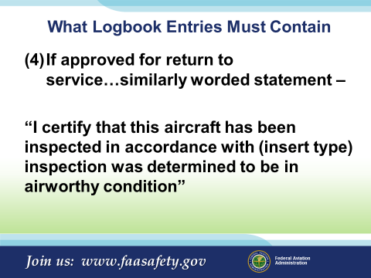 | Slide 20  Presenter: Pose these questions to the audience. See if they know the answers:  What are the differences between Discrepancies and Unairworthy Items?  Can you fly the aircraft with open discrepancies? How can this be done?  Can you fly the aircraft with open Unairworthy Items? How can this be done?  (Next Slide)
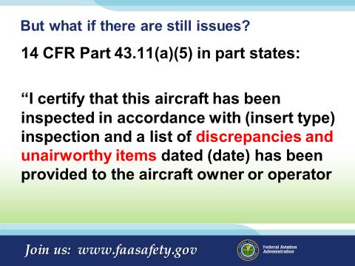 | Slide 21  14 CFR Part 43.11(a)(5) in part states:  “I certify that this aircraft has been inspected in accordance with (insert type) inspection and a list of discrepancies and unairworthy items dated (date) has been provided to the aircraft owner or operator  Note: (b) Listing of discrepancies and placards. If the person performing any inspection required by part 91 or 125 or part 91.213(a)(1) of this chapter finds that the aircraft is unairworthy or does not meet the applicable type certificate data, airworthiness directives, or other approved data upon which its airworthiness depends, that persons must give the owner or lessee a signed and dated list of those discrepancies. For those items permitted to be inoperative under part 91.213(d)(2) of this chapter, that person shall place a placard, that meets the aircraft's airworthiness certification regulations, on each inoperative instrument and the cockpit control of each item of inoperative equipment, marking it “Inoperative,” and shall add the items to the signed and dated list of discrepancies given to the owner or lessee.  (Next Slide)
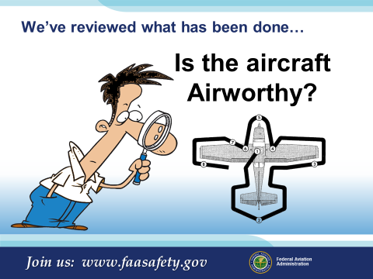 | Slide 22  We’ve reviewed what has been done…  Its time to take a good look at the aircraft.  (Next Slide)
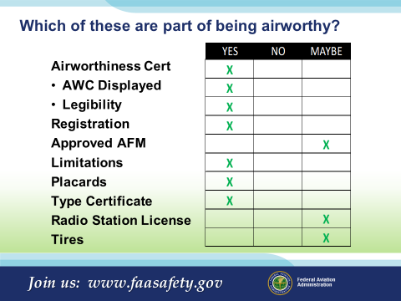 | Slide 23  Airworthiness Certificate –  - Displayed properly -  - Legibility –  - Data from the aircraft data plate needs to match the A/W Certificate, Registration and in some cases would be listed in the AFM.  - The aircraft MUST have a current Registration  Aircraft Registration – Must contain the Aircraft Owners name, must match the “N” on the aircraft. Registration must be renewed every 2 years, beyond that date period the aircraft is not airworthy.  Approved AFM – All aircraft manufactured after 1979 must have an AFM. Prior aircraft depended on category, weight, STC…  Limitations – can be found in the placards, AFM, POH, or TCDS of the aircraft  Placards – must be in location discussed in AFM or POH, be of readable character size and legible. Some manufacturers may require them to have a specific part number on them (Piper).  Type Certificate – Held by the Manufacturer, it is what the aircraft was approved under, found in FAA database.  Radio Station License – Not needed in the US. Needed if flying to Canada or some other foreign countries.  Tires – Aircraft specific to AFM  (Next Slide)
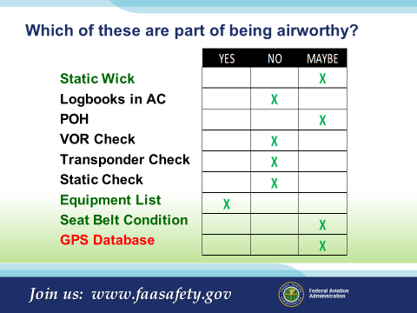 | Slide 24  - Static Wick – Determined by aircraft manufacturer or the avionics installed. Type design may require, MEL may allow for operation with one or two missing. (AC 25.899-1 Electrical Bonding and Protection against static electricity)  - Logbooks – Not required. A record of maintenance must be kept.  - POH – Not all are approved, Some maybe approved.  - VOR Check – Operation requirement not an airworthiness issue  - Transponder Check – ATC transponder equipment installed must meet the performance and environmental requirements of any class of TSO-C74b (Mode A) or any class of TSO-C74c (Mode A with altitude reporting capability) as appropriate, or the appropriate class of TSO-C112 (Mode S)  in order to be used during the flight.  - If Mode C capable, Mode C must be turned on.  - If Mode C is not accurate, repairs must be made prior to next use.  - If 24 month check is current, transponder must be ON for normal operations in all airspace.  - If 24 month check has expired you need to placard the transponder “INOP” and note such in a record or logbook.  - Other affected instruments or systems must be placarded and secured. Some may require a mechanic or special flight permit from the FSDO. (Example: ADS-B equipment.)  Note: Review 14 CFR Part 91.213 Inoperative instruments and equipment for complete INOP procedures.  - Static Check - Required for various operations (IFR, Airspace, ADS-B, etc.)  - Equipment List – Necessary for Weight and Balance to be accurate  - Seat Belt Condition – by either TSO (tag) or inspection procedure  - GPS Database – Dependent on airspace and operation  Note: Final Rule states: § 43.3 Persons authorized to perform maintenance, preventive maintenance, rebuilding, and alterations. (k) Updates of databases in installed avionics meeting the conditions of this paragraph are not considered maintenance and may be performed by pilots provided:  - The database upload is: (i) Initiated from the flight deck; (ii) Performed without disassembling the avionics unit; and (iii) Performed without the use of tools and/or special equipment.  (2) The pilot must comply with the certificate holder’s procedures or the manufacturer’s instructions.  (3) The holder of operating certificates must make available written procedures consistent with manufacturer’s instructions to the pilot that describe how to: (i) Perform the database update; and (ii) Determine the status of the data upload.  (Next Slide)
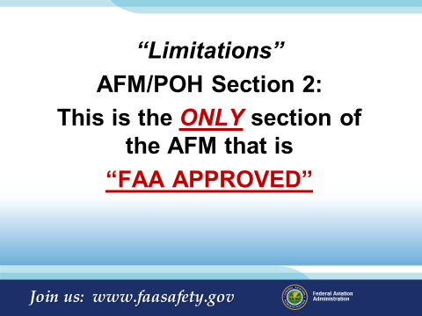 | Slide 25  “Limitations” / AFM Section 2  This is the ONLY section of the AFM that is “FAA APPROVED”!  All other data is manufacturer suggested procedures, checklists, and data.  TC is also your FAA APPROVED document to support airworthiness for U.S. aircraft.  (Next Slide)
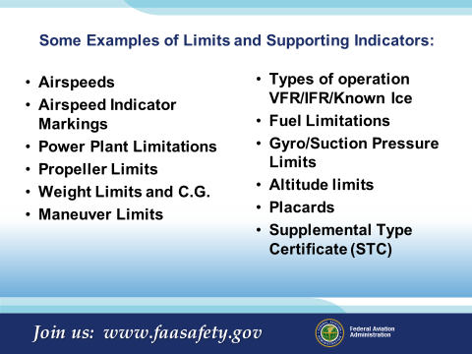 | Slide 26  - Airspeeds – AFM crosscheck?  - Airspeed Indicator Markings – Are they correct?  - Power Plant Limitations – Are they correct? Wind limited for start up?  - Propeller Limits - RPM? Surface operation limits?  - Weight Limits and C.G. – If an aircraft is altered, did that require a re-weigh?  - Maneuver Limits – Weight limiting? Category or Class limited?  - Types of operation VFR/IFR/Known Ice Limits – Boots Clean and polished?  - Fuel Limitations – Weight related? Landing or Take-Off?  - Gyro/Suction Pressure Limits – What are the limits?  - Altitude limits – Was the aircrafts altimeter properly tested to the service ceiling of the aircraft?  - Placards – Are placards in the right location, readable, and correct?  - Supplemental Type Certificates – Additional placards? Changes to the AFM?  Have any of you ever had to have your airspeed indicator replaced?  Or for that matter, any gauge replaced?  Is the propeller on the aircraft of the approved type and serial number? (Aircraft have been sold with invalid propellers).  When was the last time the aircraft was actually weighed?  (Time has showed us that most aircraft gain weight over time).  (Next Slide)
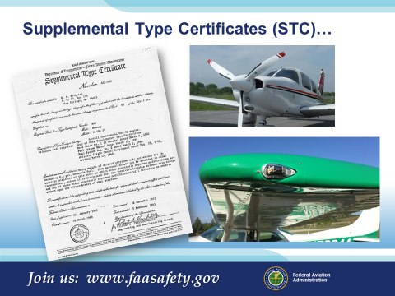 | Slide 27  A brief note on STCs:  Supplemental Type Certificates may be available for your aircraft. Everything from wing, tail, and gear door modifications, engine HP increase, Propeller change for pitch and speed, and lighting systems. No matter the change, if an STC is added to your aircraft, the TC has been altered in some way.  STCs usually include all supplemental information needed for a pilot to safely fly the aircraft. Placarding, performance, and safety of flight issues or limitations are part of the STC process.  Some common STCs seen on aircraft are:  Gross weight increase – all aircraft usually requires a structural change  Winglets – Ag aircraft and many GA after market installations  Gear door modifications such on the 690 Aero Commander and older Cessna C210s  Heating systems – Heater modification on the Piper Navajo  Vortex Generators – Affect performance and operating limitations  STOHL – Severely affect the performance and limitations of the aircraft  (Next Slide)
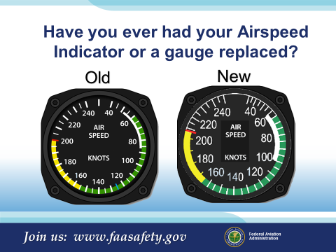 | Slide 28  Have you ever had your Airspeed Indicator or a gauge replaced?  Take a look to see how dissimilar these two airspeed indicators really are. The gauge on the Left is for your aircraft prior to MX, the other is the replacement. What do you see is different:  - Red Line is off by 8 kts.  - Yellow arc is off by 10 kts.  - White arc is off by 13 kts on the top and 8 kts on the bottom.  - Left one has a blue line at 125 kts.  Would this be considered allowed by the manufacturer?  No but...  As long as the gauge has the required markings to comply with the TCDS/AFM/POH/STC, the gauge could be used.  Oh! Was there a Pitot Static System inspection completed after the gauge was installed? There needs to be.  Note: In instances such as shown, the mechanic could make adjustments on the glass to reflect the TCDS/AFM/POH/STC airspeed markings. One additional mark would need to be made on the glass and the case to assist the pilot in insuring the glass had not moved. (See New gauge with marking applied)  (Next Slide)
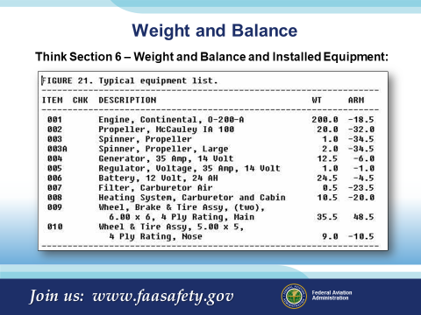 | Slide 29  One of the most ignored sections of the aircraft flight manual is the equipment list.  If an update or repair required a Major Repair & Alternation Form 337, you may have to update this section.  If new radios were installed or old radios removed, you may have to update this section.  If any of the above have taken place, the weight balance may have to be adjusted.  Presentation Note: Some manufactures have taken the liberty to note the standard and nonstandard equipment that has been certified for your particular aircraft. Verify with your mechanic that ANY installed equipment continues to meet the manufacturers original arm and moment found in the equipment list or the list is revised to reflect the changes in arm and moment data. Time, STC’s, various owners, various updates in equipment may have altered the original arm and moment for the listed or current installation.  (Next Slide)
 | Slide 30  The WINGS Pilot Proficiency Program.  - Pilots never stop learning, and those who participate in regular proficiency training are competent, confident, and safe.  - Earn WINGS awards and recognition based on a combination of practical knowledge and hands on coaching or skill  - Get started now!  (Next Slide)
 | Slide 31  WINGS/AMT Proficiency for All Airman:  - Drone Pilot  - Student Pilot  - Private Pilot  - Commercial Pilot  - Airline Transport Pilot  - CFI  - A&P Mechanic  - IA  - Repairman  (Next Slide)
 | Slide 32  The AMT Awards Program.  - The AMT Awards program can help you fulfill your commitment to aviation maintenance excellence through continuing education and training.  - Earn annual awards based on core training hours at Bronze, Silver, and Gold levels.  - Get started now!  (Next Slide)
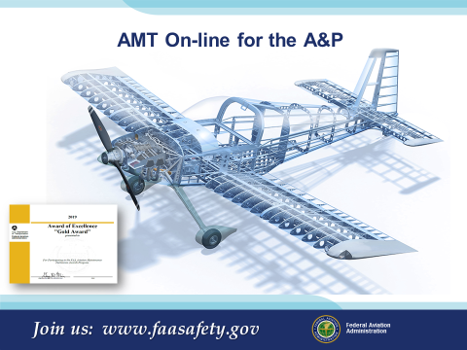 | Slide 33  AMT On-line for the A&P  (Next Slide)
 | Slide 34  One More Reason to Train with WINGS?  WINGS Industry Sweepstakes!  Paul and Fran Burger are offering $10,000 in their sweepstakes again this year!  The WINGS Sweepstakes mission is to reduce the nation's accident and incident rate by increasing pilot participation in the WINGS FAASTeam Pilot Proficiency Program. The  WINGS program has courses based on real world accident and incident causes so flight instructors, pilots and student pilots get training that can truly make a difference.  Studies indicate that pilots who complete WINGS phases are safer aviators. Please join us in saving lives.  Learn about the program and its many benefits at : https://www.mywingsinitiative.org/  The 2020 Sweepstakes awards 10 cash prizes! Prize levels include:  - Four (4) $1,500  - Four (4) $750  - Two (2) $500  (Next Slide)
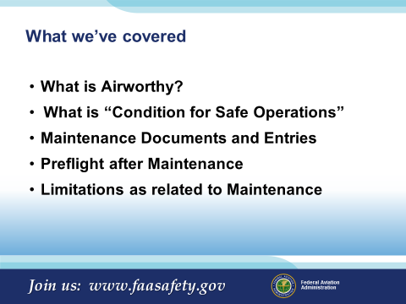 | Slide 35  What we’ve covered:  What is Airworthy?  What is “Condition for Safe Operations”  Maintenance Documents and Entries  Preflight after Maintenance  Limitations as related to Maintenance  (Next Slide)
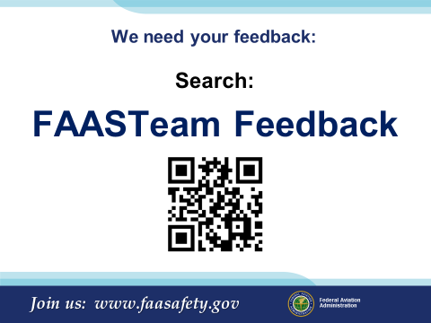 | Slide 36  The FAASTeam appreciates your feedback and looks forward to serving you as an advocate of aviation safety.  (Next Slide)
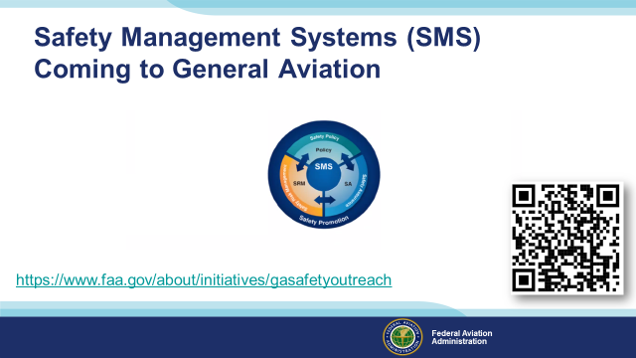 | Slide 37  Safety Management Systems are a set of policies and processes that can increase the safety and efficiency of any flight operation. And FAA is bringing SMS to General Aviation. You may have heard of SMS but thought it was only for large organizations but actually SMS can be scaled to fit any operation large or small.  There are 4 major components to a Safety Management System (Click)  Safety Policy – a documented commitment to safety that runs from the head of an organization to its newest member. (Click)  Safety Risk Management – a process that identifies hazards within an operation, determines to what extent an identified hazard may impact flight safety, and controls the risk of occurrence to an acceptable level. (Click)  Safety Assurance – By collecting and analyzing information derived from safety performance data Safety Assurance ensures the performance and effectiveness of Safety Risk Controls. (Click)  Safety Promotion communicates safety information and commitment throughout the organization. (Click)  You can find more information about Safety Management Systems at the URL on the Screen.  (Next Slide)
 | Slide 38  The End

Appendix I – Equipment and Staging
Equipment:
- Projection Screen & Video Projector suitable for expected audience
  - Remote computer/projector control available at lectern or presenter location
    - In lieu of remote – detail a Rep to computer/projector control.
- Presentation Computer
  - Note: It is strongly suggested that the entire program reside on this computer.
- Back up Projector/Computer/Media as available.
- PA system suitable for expected audience
  - Microphones for Moderator and Panel
    - Optional Microphone (s) for audience
- Lectern (optional)
Staging:
- Arrange the projection screen for maximum visibility from the audience.
- Equip with PA microphones
- Place Lectern to one side of screen. This will be used by presenters and moderator if so needed.
- IMPORTANT – Once you have completed outreach on this topic, please help us track the outreach you have done by entering a SAS record.

