Presentation Notes
Prelight After Maintenance
2021/02-19-218(I)PP

This outreach guidance is provided to all FAA and aviation industry groups that are participating in outreach efforts sponsored by the General Aviation Joint Steering Committee (GAJSC). It is important that all outreach on a given topic is coordinated and is free of conflicts. Therefore, all outreach products should be in alignment with the outline and concepts listed below for this topic.

Outreach Month: September 2023

Topic: Preflight After Maintenance (SCF-SE-28)
The FAA and industry will conduct a public education campaign emphasizing the safety benefits of Preflight After Maintenance.

Background:

The General Aviation Joint Safety Committee (GAJSC) and the National Transportation Safety Board (NTSB) have determined that a significant number of general aviation fatalities could be avoided if pilots were to conduct more thorough preflight inspections of aircraft that have just been returned to service. In-flight emergencies have been the direct result of maintenance personnel who have serviced or installed systems incorrectly.

Teaching Points:
- Learn all you can about the maintenance that was performed.
- Don’t assume the part(s) replaced are the only parts removed.
- Pay attention to trim positions. Check for unimpeded flight control surface deflections. Make sure they go in the proper direction!
- Make sure all inspection panels are secure and their fasteners are tight.
- Check fuel tank for water, sediment, and proper fuel grade.
- After an oil change, always check the engine oil level to ensure it has the proper amount of oil.
- Always check your logbook and paperwork prior to flight to ensure the correct records have been entered.
- If you see a warning tag / sign on the aircraft, or on the sign-out or status board, DO NOT FLY THE AIRCRAFT! Check with the maintenance facility prior to taking the aircraft.
- Participate in, or observe your mechanic perform, an annual or 100 hour inspection.

References:
- NTSB Safety Alert — Advanced Preflight After Maintenance: https://go.usa.gov/cK7Py
- FAA’s Advanced Preflight Pamphlet: https://go.usa.gov/xVy44
- “Advanced Preflight,” FAA Safety Briefing, Mar/Apr 2012: https://go.usa.gov/cK7ma
- 2023, Q4 CFI Open Forum – Foundation of an Advanced Preflight: https://bit.ly/3TkizhC

Abstract: This presentation acquaints the audience with maintenance-related problems found to be at the root of some of the most deadly causes of accidents in general aviation. Contributing to this is a pilot’s failure to identify maintenance discrepancies because of a lack of knowledge and improper techniques used during the preflight of the aircraft.

Format: Information Briefing – Power Point presentation

Required Personnel: FAASTeam Program Manager or designated FAASTeam Rep(s)

Optional Personnel: Flight Instructor or others who can speak on Preflight and are knowledgeable in Maintenance of an aircraft.

AFS 850 Support: This presentation is one of a three part project aimed at improving preflight understanding and knowledge. Part One, Foundation of an Advanced Preflight was designed for CFIs given in the 4th quarter of FY23. Part Two is the presentation you are reviewing here. Part Three will be available for FY24 as an Open Box or hands on presentation and forum where CFIs and Pilots are asked to preflight prestaged aircraft. Local Maintainers are brought into the mix to support the actions of the presenter with regard to setting up the aircraft for the task. They are then depended upon to return to service those aircraft made or found unairworthy.
In addition to this document, a Power Point presentation supporting this and the other programs is provided on the National FASTeam KSN. FPMs and presenters are encouraged to customize this presentation to reflect each individual program.

Slides | Script
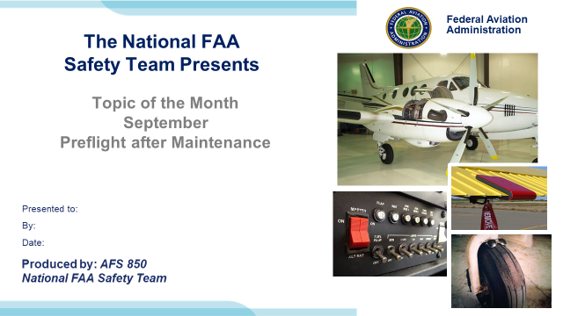 | Slide 1  2022/03-17-254(I)PP Original Author: Jay M Flowers; POC Kevin Clover, AFS-850 Operations Lead, Office 562-888-2020  Presentation Note: This is the title slide for “Preflight After Maintenance”.  - Script - We have included a script of suggested dialog with most slides. The script will always appear in a non-italic font. Presenters may read the script or modify it to suit their own presentation style. See template slides 5 and 6 for examples of a slides with script.  - Presentation Instructions - (stage direction and presentation suggestions) will be preceded by a Bold header: the instructions themselves will be in Italic fonts. See slides 2, for an example of slides with Presentation Instructions only.  - Program control instructions - will be in bold fonts and look like this: (Click) for building information within a slide; or this: (Next Slide) for slide advance.  - Background information - Some slides may contain background information that supports the concepts presented in the program.  Background information will always appear last and will be preceded by a bold Background: identification.  The production team hope you and your audience will enjoy the show. Break a leg!  (Next Slide)
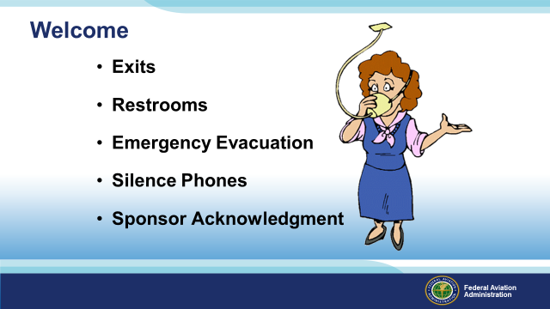 | Slide 2  Presentation Note: Here’s where you can discuss venue logistics, acknowledge sponsors, and deliver other information you want your audience to know in the beginning.  You can add slides after this one to fit your situation.  (Next Slide)
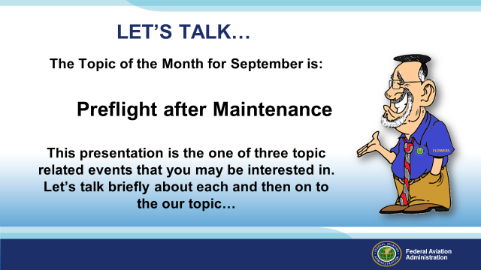 | Slide 3  The Topic of the Month for September is:  Preflight after maintenance  This presentation is the one of three topic related events that you may be interested in. Let’s talk  briefly about each and then on to the our topic…  (Next Slide)
 | Slide 4  Earlier this Quarter,  CFI Open Forums covered: Preflight After Maintenance and how to properly teach you as an advanced student.  Why advanced student? This tasking is for going beyond the normal preflight, doing everything we can to preflight the aircraft.  CFIs understand that they are the foundation and by examples set, they foster learning that will affect safety now and in the future.  Contact your local CFI, FAASTeam Program Manager (FPM) or FAASTeam Representative, for more information on this topic or future forums designed to support your training.  (Next Slide)
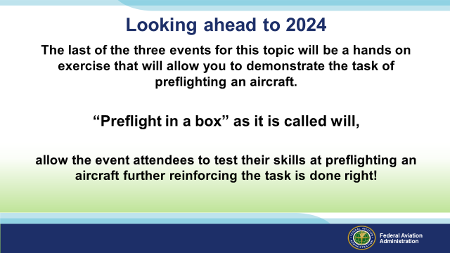 | Slide 5  The last of the three events for this topic will be a hands on exercise that will allow you to demonstrate the act of preflighting an aircraft.  Preflight in a box as it is called will,  after a short discussion, allow the event attendees to test their skills at preflighting and further reinforce the task is done right!  (Next Slide)
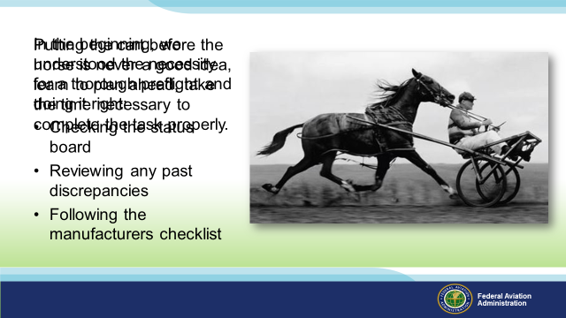 | Slide 6  We are all students of aviation wouldn’t you agree?!  In the beginning, we understood the necessity for a thorough preflight and doing it right:  - Following the manufacturers checklist  - Checking the status board  - Reviewing any past discrepancies  We understood the important stuff pointed out by our CFIs, but do we still remember what’s not on the manufacturers checklist? Items that are just as important:  - Who flew the aircraft last?  Presentation Note: Give audience time to respond.  Note: If the aircraft is based at a training school or there is student activity in the aircraft wear on tires and such my of higher concern than a personally owned aircraft.  - What maintenance has the aircraft had?  Presentation Note: Give audience time to respond.  - Did I truly check under the cowling or just check the oil?  Presentation Note: Give audience time to respond.  - How many of you use a flashlight for your daytime preflight?  - How easy is it to see through that little oil access door to the rest of the engine and its components?  Presentation Note: Give audience time to respond.  - Did I truly look at the landing gear, brakes, and brake lines on my Mooney or just look from above?  Presentation Note: Give audience time to respond  - Did I look at the bottom side of the tire or just the front of the tire for wear ‘n tear?  Over the years we have learned that planning ahead or in this case reviewing the history of the aircraft is beneficial to the outcome of every flight.  (Click)  One might say we are not “Putting the cart before the horse”, preventing what may be life threatening in the future.  One question does come to mind with this photo: How is he going to stop?  At some point in our careers we will find an aircraft that has been altered:  - New equipment, GPS, or Fuel totalizer  - STC changes to limitations or general operations of the aircraft  Staying ahead of the game simply involves knowing everything you can about an aircraft before you pick up the checklist and preflight the aircraft.  As students this presentation will introduce you to various processes necessary to properly preflight an aircraft.  (Next Slide)
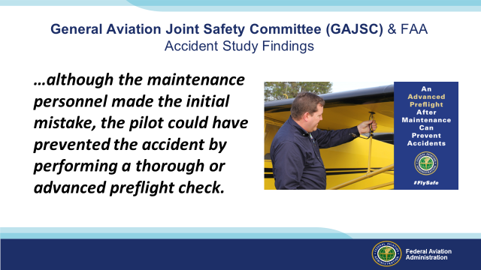 | Slide 7  The General Aviation Joint Safety Committee (GAJSC) and the National Transportation Safety Board (NTSB) have determined that a significant number of general aviation fatalities could be avoided if pilots were to conduct more thorough preflight inspections of aircraft that have just been returned to service. In-flight emergencies have been the direct result of maintenance personnel who have serviced or installed systems incorrectly. In many cases, although the maintenance personnel made the initial mistake, the pilot could have prevented the accident by performing a thorough or advanced preflight check.  (Next Slide)
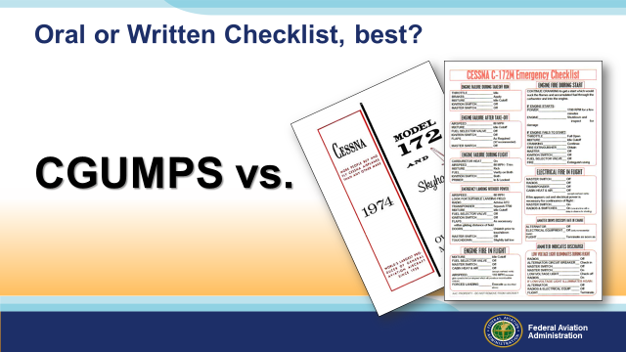 | Slide 8  Oral or written checklist, which one do you use?  An aviation checklist is a tool used to identify any potential risks to aircraft before take-off, in flight, landing, and taxiing. It guides pilots and aircraft safety officers in ensuring airworthiness. It helps determine irregularities that need to be addressed immediately to prevent any flight incidents or fatalities.  When is the last time you looked at the checklist?  Presenter: Pause for a response and discussion.  The WHOLE check list?  Presenter: Pause for a response and discussion.  When did you last look at the Emergency Procedures for your aircraft?  Presenter: Pause for a response and discussion.  (Next Slide)
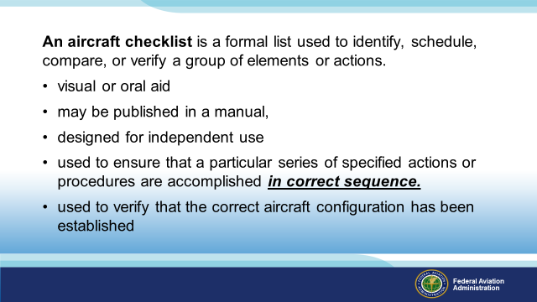 | Slide 9  An aircraft checklist is a formal list used to identify, schedule, compare, or verify a group of elements or actions.  - visual or oral aid that enables the user to overcome the limitations of short-term human memory.  - may be published in a manual,  - designed for independent use so that the user does not have to reference a manual.  - used to ensure that a particular series of specified actions or procedures are accomplished in correct sequence.  - is used to verify that the correct aircraft configuration has been established in specified phases of flight.  (Next Slide)
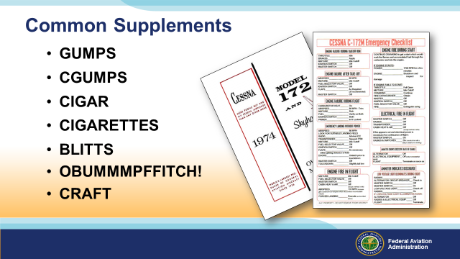 | Slide 10  Common supplements for a written check list could be:  GUMPS – Gas, Undercarriage, Mixture, Pump or Prop, Seatbelts  (Click)  Although GUMPS is an acronym for an inflight and not preflight check, the preflight should never be abbreviated to an acronym. Remember, the preflight is a look at your WHOLE aircraft and not just parts of the aircraft. The manufacturer or owner generally will have a preflight checklist that will catch the “this stuff will kill you” items but the advanced preflight was intended go deeper than just what could kill you. Add those items that are particular to your aircraft. We want you home safely, something tells me you do too!  So, is an abbreviated acronym type checklist considered a valid checklist?  Presenter: Pause for a response and discussion.  Other Acronyms you may have heard of:  CGUMPS – Carb Heat, Gas, Undercarriage, Mixture, Prop, Seatbelts  (Click)  CIGAR – Controls, Instruments, Gas, Airplane Secure, Run-up or,  Controls, Instruments, Gas, Attitude, Run-up  (Click)  CIGARETTES - Controls, Instruments, Gas, Flaps, Trim, Prop, Radios, Straps (Where is the “F” and the …)  (Click)  BLITTS – Boost Pump, Lights, Instruments, Transponder, Take-Off Time, Seatbelts  (Click)  OBUMMMPFFITCH! – Open Carburettor Heat, Brakes Free, Undercarriage down and locked, Mixtures, Master Switch, Magnetos, Propeller, Fuel, Flaps, Instruments, Temperatures and Pressures, Close carburettor heat, Hatches or doors, Harnesses…(I forgot what these are even for…)  (Click)  CRAFT – Clearance Limit, Altitude, Frequency, Transponder  Just to name a few…in short, use a checklist you understand and is inclusive of all manufacturer suggested checklist items for all phases of flight.  (Next Slide)
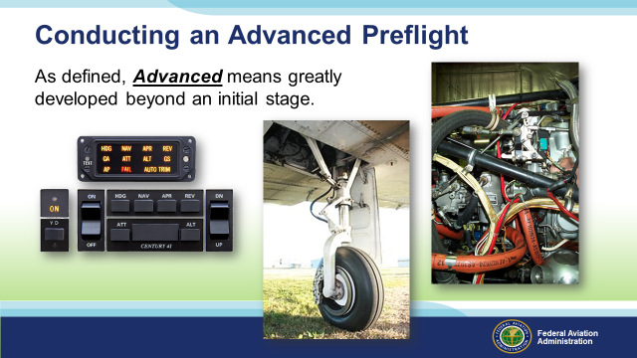 | Slide 11  Conducting an Advanced Preflight:  As defined, Advanced means greatly developed beyond an initial stage.  You might say that as you gain more experience as a pilot you become more comfortable, have less stress, and predictably we start to get complacent. Without warning, the act of the preflight becomes consequential rather than necessary.  The items shown here are probably the most overlooked items on your checklist.  - Taken the cowling off lately?  - Not saying you have to but can you really see if hoses or clamps are leak free and still fastened?  - Birds nest in the cowl?  - Hornets nest or worse Mud Daubers?  - How much can you really see through the oil access door?  Presenter: Pause for a response and discussion.  - Crawled under the aircraft to really inspect the gear system lately?  - Squat switches  - Hydraulic lines  - Fuses or Circuit Breakers – (oddly enough some do still have fuses) What is the purpose of a fuse or circuit breaker? If you mean some aircraft have fuses in wheel wells – say so.  - Gear and Trunnion structures  - Brakes  - Gear door attach points and safety wires or keys  Presenter: Pause for a response and discussion.  - Testing an auto pilot prior to every use? There is an old adage that says “If you have not tested it prior to flight, DON’T USE IT”. Some of us older, bold pilots can tell you stories on this one.  Presenter: Pause for a response and discussion.  (Next Slide)
 | Slide 12  Presenter: A quick story from the author if you’d like.  I had been scheduled to fly our Piper Navajo from Bismarck, ND to Coeur d’Alene, ID to drop off a patient. Normally the aircraft would be inspected or in maintenance every 50 hours for an oil change but we had had a long stretch of late night, long flights that had taken the time between 100 Hour inspections to 75 hours. Knowing the trip to Idaho was another long one our Maintenance Director decided to drop the oil and at the least get some fresh oil in prior to the flight.  4 days into a 7 trip week, I preflighted the aircraft as I had done earlier during that week. As before, the aircraft looked fine and was readied for the late afternoon trip. The flight was basically uneventful with clear skies and temps cool so the turbulence was minimal over the mountains and the winds upstairs were basically lite.  One delay and another at Coeur d’Alene we departed late that night for what turned out to be an overnight stop at Great Falls, MT. The Minimum Enroute Altitude (MEA) across that section of the Rockies was over 13,000 feet so some regulatory oxygen and a cruise altitude of 15,000 feet kept are single engine climb safety margin within reach if we needed it. No turbulence, no moon, just stars shining brightly overhead and the glow of the Navajos turbochargers at more than 1600 degrees.  Crossing front range, we descended into the Great Falls, MT (KGTF) airport and landed without incident around 11pm. As we taxied in I noticed what looked like water dripping from the trailing edge of my left cowling? ”I don’t remember being in rain or moisture out there…” As I pulled up to shut down the line guy said “careful getting out of the aircraft, appears to be some oil dripping off the left nacelle”. Now he’s got my attention.  As I exited the aircraft there was no question we had a major oil leak on the left side. Once clear of the aircraft I had the line crew help me schedule maintenance to take a look the following morning.  Next morning, by the time I caught a lift to the airport, the mechanics had the cowling off and began their inspection of the aircraft. A quick check of the oil and we discovered that the engine was only down one quart from the previous check in Coeur d’Alene. With no visible sign of an oil leak other than that trailing back along the nacelle, our next step was to start up the engine. As I called “Clear” and started to crank the left engine a stream of oil came rushing out of the oil filter! I guess we found the exit point but why there?  The Navajo had had an auxiliary heater added to the left side some time back and was basically a heater box mounted on the exhaust like your Cessna 172. This included an array of scat tubing that routed heat to the cabin.  Here is something to think about: Normally, the mechanics would have to remove the scat tubing to perform the oil change. On this particular occasion, rather than doing a complete oil change and inspection, maintainers only changed the oil and left the filter for the next inspection. Unbeknown to all those involved, the scat tubbing had rubbed on the filter long enough to wear through the support wire which left the broken wire as a sharp point! With this, the wire became a drill bit which found its way into the oil filter…on arrival into KGTF the scat bit must have worked its way back out from either lack of air flow in the cowling or something but VOILA, major oil leak!  Moral to this not so short story. Skipping the 50 hour oil change to keep the aircraft running was not the issue but failing to complete the entire inspection later on, prior to returning to service, could have been disastrous had the scat bit backed out over the mountains, at night, in rugged terrain, with no survival gear.  DON’T CUT CORNERS!  (Next Slide)
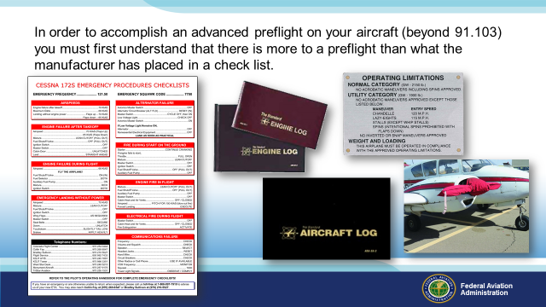 | Slide 13  In order to accomplish an advanced preflight on any aircraft (In addition to 91.103) you must first understand that there is more to a preflight than what the manufacturer has placed in a check list.  Rarely are two aircraft alike. Equipment, weight and balance, configuration, all determine the depth of the preflight and the time it will take to properly assess your aircrafts readiness for flight.  Did the aircraft come out of maintenance recently? Check the log books, IT IS YOUR RESPONSIBILITY!  Placards are something we use when we need to, but seldom do we check to see if ALL the placards for a given aircraft are in the right place, readable, or include the correct data. Remember, the limitations found on these placards can be found in the Aircraft Flight Manual (AFM), Pilots Operating Handbook (POH), and the Type Certificate Data Sheet (TCDS) for the aircraft, review as needed but review is the key.  Items generally NOT found on a checklist:  - Engine Blankets – REMOVED/OFF, Stowed, are you going to need them later in the flight? Secured and added to the weight and balance calculations.  Presenter ask the question: How many of you include your IPad, briefcase, headset, extension cords, engine blankets, portable heaters, and emergency gear in your weight and balance?  - Pitot Tube Covers –  - Exterior Gust locks – Generally, exterior gust locks are added by the owner. Gust lock on the yoke, manufacturer.  - Winter fronts – Kind of a North Country thing but not in the check list  - Cowl Plugs -  - Wheel chocks – How many of you have looked right at the wheel chock but failed to remove before taxi?  - Tie Downs – Remove…kind of like the wheel chocks, how many of you have???  - Tow bar – some stow in a baggage compartment, others were an afterthought by the owner.  Presenter: Ask the audience if they have items not found in the check list on their aircraft.  (Next Slide)
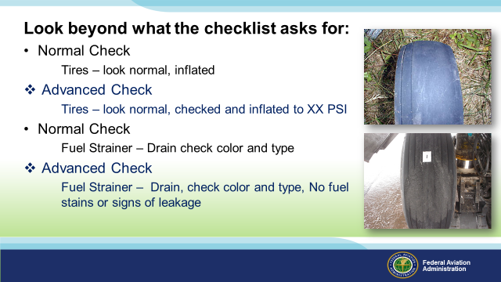 | Slide 14  Look beyond what the checklist asks for:  - Normal Check  Tires – look normal, inflated  - Advanced Check  Tires – look normal, checked and inflated per AFM to XX PSI  Note: The First Picture is a Tire that has been running over inflated  Note: The second picture is a tire that has been given a flat spot form heavy breaking  - Normal Check  Fuel Strainer – Drain check color and type  - Advanced Check  Fuel Strainer – Drain, check color and type, No fuel stains or  signs of leakage  (Next Slide)
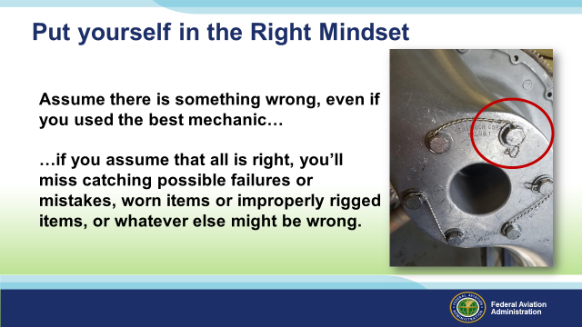 | Slide 15  Assume that there is something wrong, even if you used the best mechanic.  …if you assume that all is right, you’ll miss catching any possible mistakes, worn items or improperly rigged items, or whatever else might be wrong.  For instances, take a look at this propeller hub that has been safety wired after maintenance. See anything wrong?  Presentation Note: Give audience time to look over slide.  (Click)  Note that the safety wire identified was not correctly fastened. (use the other two pairs of safety tied bolts as examples)  Always take extra time to look over any part(s) of the aircraft that have had maintenance recently performed on them.  (Next Slide)
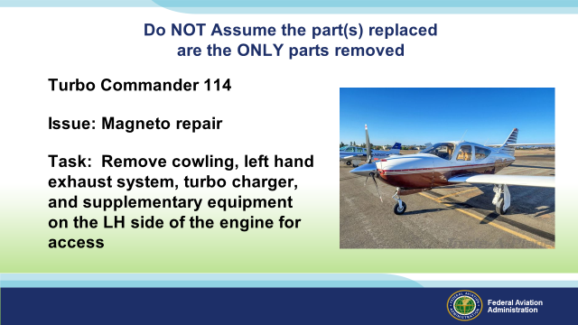 | Slide 16  Do NOT Assume the part(s) replaced are the ONLY parts removed!  Example: Commander 114TC  - Issue: Magneto replacement  - Task: Remove cowling, Left Hand exhaust system, turbo charger, and supplementary equipment on the LH side of the engine for access.  - What was being fixed again?  Example: Cessna 172  - Issue: Alternator Belt replacement  - Task: Remover the propeller, loosen the alternator, remove the belt, reinstall…  (Next Slide)
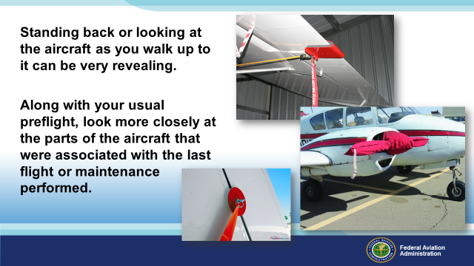 | Slide 17  Standing back or looking at the aircraft as you walk up to it can be very revealing.  Since 1994, there have been 69 Accidents where a form of control lock was found as the main causal factor in an accident.  Along with your close and personal preflight, look from afar you may be surprised at what you can see.  (Next Slide)
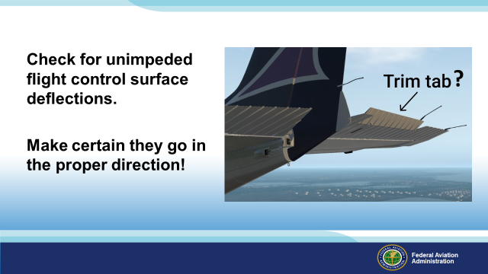 | Slide 18  Check for unimpeded flight control surface deflections. Make certain everything moves in the proper direction!  Does the trim tab in this picture seem normal to you?  Presentation Note: Give audience time to look over slide.  - Nose up Trim?  - Nose Down Trim?  - On the ground or in flight?  - Sitting on the ramp, ties down, secured?  Note: Could the seat belt be holding the yoke back in the secured position?  Presentation Note: Give audience time to look over slide.  (Next Slide)
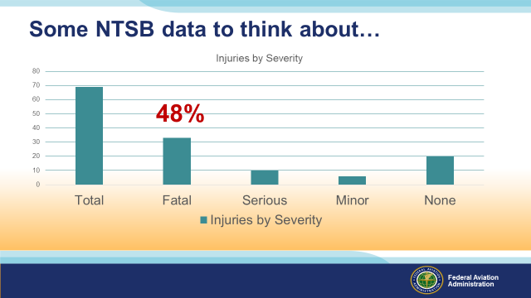 | Slide 19  Some data to think about. Since 1994 there have been 69 accidents involving control locks as the main causal factor.  48% of the accidents listed here ended with Fatalities.  A 50/50 chance of survival if you don’t preflight completely or 100% chance of survival if you train and manage the flight prior to takeoff.  (Next Slide)
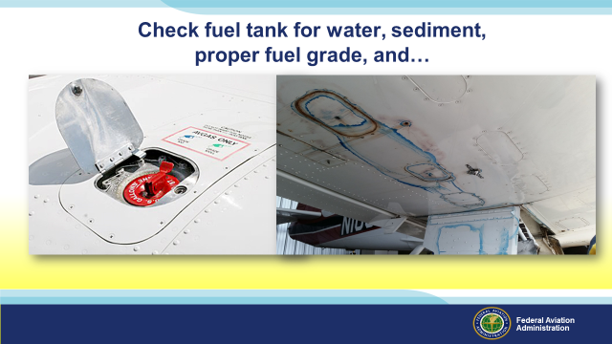 | Slide 20  Check fuel tank for water, sediment, proper fuel grade and…look at the fuel tank structure.  (Click)  So please share your thoughts on this picture.  - Structure Issue?  - Seal Issue?  - Multiple Issues?  Presentation Note: Give audience time to look over slide.  Keep in mind that if you are not looking under the wing as well as over the wing in this case, you are not properly preflighting this aircraft. Systemic leak issues can be devastating for aircraft structures. Corrosion, bonding issues, even allowance of toxic chemicals into the cockpit are all a concern for any leak on an aircraft. In most cases such as this, the issue IS visible from the outside of the aircraft.  (Next Slide)
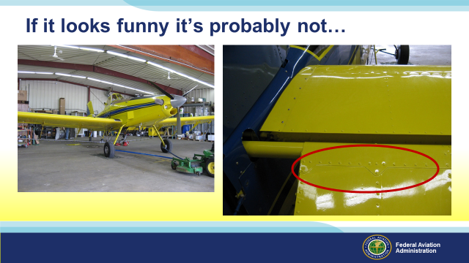 | Slide 21  If it looks funny it’s probably not…  In this photo, the new owner of this Air Tractor was conducting an Annual inspection in preparation for the up coming spray season. At first everything appeared to be in good shape, until the he noticed what looked like corrosion under the paint on this elevator.  (Next Slide)
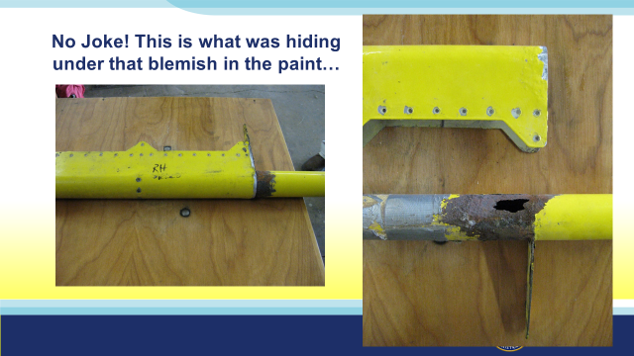 | Slide 22  No Joke! This is what was hiding under that blemish in the paint…  It’s one thing to ignore the rust on your car, but it is entirely another to ignore rust or corrosion on an aircraft. The initial inspection for the this purchase found no issues and was returned to service by the original owner. The new owner felt he needed a personal look at the aircraft so a second Annual was accomplished to verify.  It was during the preflight that the suspect Elevator showed signs of issue near the torque tube structure.  The elevator was removed and the torque tube revealed the cause of the deformation of the painted surface.  An inspection of the opposite torque tube revealed the same issue of corrosion. Both torques tubes were replaced and the repairman returned the aircraft to service.  What if anything should you be inspecting after this repair?  Presentation Note: Give audience time to respond.  - Safety nuts, wires, cables? (Airworthy)  - Did the repair require documentation? (Yes)  - Did the repair require the elevator be rebalanced prior to being returned to service? (Yes)  (Next Slide)
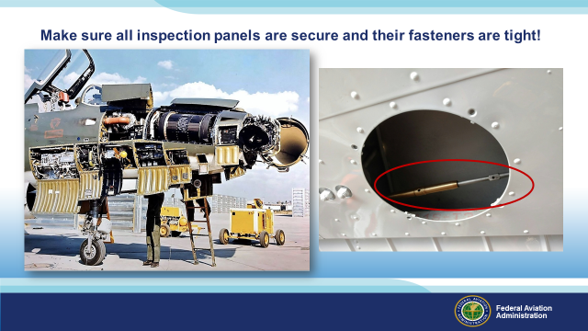 | Slide 23  Some aircraft have many inspection doors, panels, or hatches. All need to be checked and secured prior to your departure.  See anything wrong with the aileron cable in the picture on the right?  Presentation Note: Give audience time to look over slide.  (Click)  Perhaps there needs to be a safety wire there? May have to ask the mechanic just to be sure.  (Next Slide)
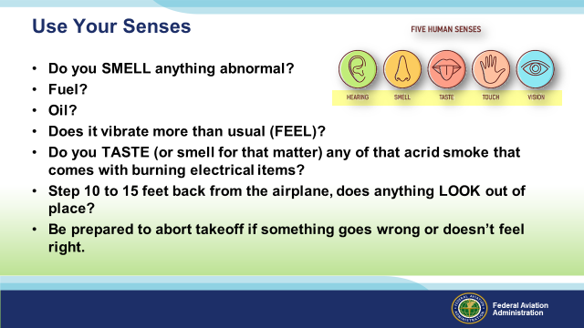 | Slide 24  Use your senses during your walk around and in your everyday flying:  - Do you SMELL anything abnormal?  - Fuel? (Grade, Additives possibly)  - Oil? Oil Grade my change, Oil weight, Oil type (Mineral Oil to Synthetic)  - Does it vibrate more than usual (how does it feel in flight)?  - Do you TASTE (or smell for that matter) any of that acrid smoke that comes with burning electrical items?  - Step 10 to 15 feet back from the airplane, does anything LOOK out of place?  - Do the Ailerons look even or matched in the neutral position  - Does the trim look right?  - Be prepared to abort the takeoff if something goes wrong or doesn’t feel right.  (Next Slide)
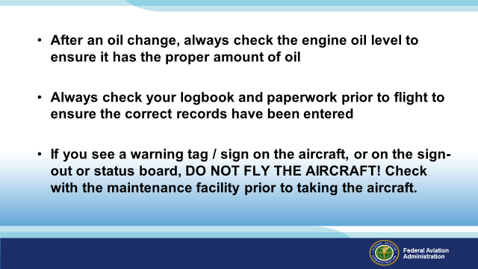 | Slide 25  - After an oil change, always check the engine oil level to ensure it has the proper amount of oil  - Where do you find what kind of oil was used? (Engine Logbook)  - Standard Grade Oil? (Engine Logbook)  - Synthetic Oil? (Engine Logbook)  - Mineral Oil? (Maybe not anymore…)  - Vegetable Oil? (just checking)  - Always check your Engine/Airframe logbook and paperwork prior to flight to ensure the correct records have been entered  - Verify the proper oil grade and type were used for your aircraft.  - If you see a warning tag/sign on the aircraft, or on the sign-out or status board, DO NOT FLY THE AIRCRAFT! Check with the maintenance facility prior to taking the aircraft.  (Next Slide)
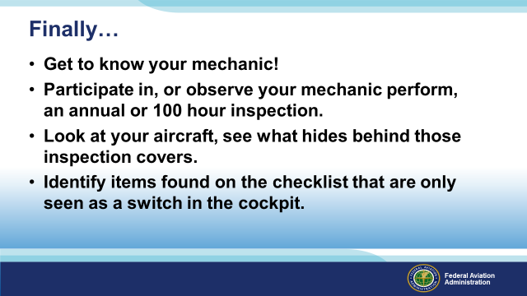 | Slide 26  - Get to know your mechanic!  - Participate in, or observe your mechanic perform, an annual or 100 hour inspection.  - Look at your aircraft, see what hides behind those inspection covers. Not saying you must but if the aircraft is new to you…  - Identify items fond on the checklist that are only seen as a switch in the cockpit.  (Next Slide)
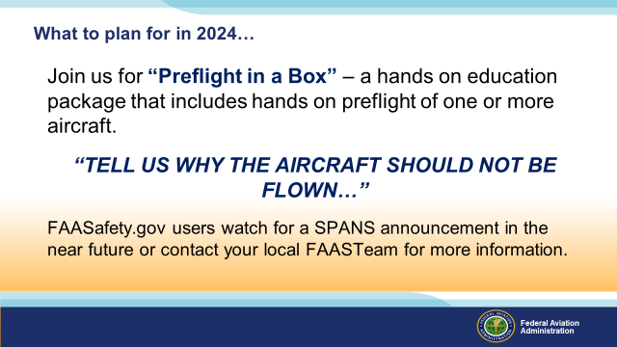 | Slide 27  Join us for Part 3 –  “Preflight in a Box” – a hands on education package that includes hands on preflight of one or more aircraft.  “TELL US WHY THE AIRCRAFT SHOULD NOT BE FLOWN…”  FAASafety.gov users watch for a SPANS announcement in the next year or contact your local FAASTeam for more information.  (Next Slide)
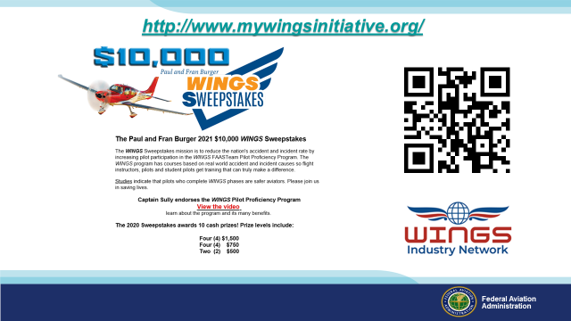 | Slide 28  Now there are even more reasons to participate in WINGS. Every time you complete a WINGS Phase you’re eligible to win cash the WINGS Sweepstakes.  The sweepstakes is generously funded by Paul Burger, a long time advocate for general aviation safety and a retired aviator who believes participation in this program saves lives. VISIT WWW.MYWINGSINITATIVE.ORG to learn more and enter the sweepstakes.  (Next Slide)
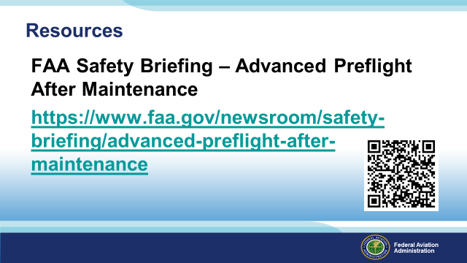 | Slide 29  Here are a few references for additional information:  I’ll leave this slide on screen while I take some questions from the audience.  AC 90-114B Automatic Dependent Surveillance-Broadcast Operations  AC 00-63A Use of Flight Deck Displays of Digital Weather and Aeronautical Information (This AC has a Change Revision CH2 coming out very shortly) This AC addresses both the Federal Aviation Administration (FAA) FIS–Broadcast (FIS-B) provided through the Automatic Dependent Surveillance–Broadcast (ADS-B) Universal Access Transceiver (UAT) network and non-FAA FIS systems provided through commercial data link services.  Presentation note: Take questions from the audience while they copy information from the screen. Then:  (Next Slide)
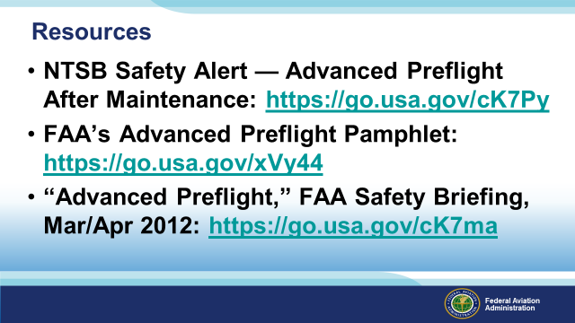 | Slide 30  - NTSB Safety Alert — Advanced Preflight After Maintenance: https://go.usa.gov/cK7Py  - FAA’s Advanced Preflight Pamphlet: https://go.usa.gov/xVy44  - “Advanced Preflight,” FAA Safety Briefing, Mar/Apr 2012: https://go.usa.gov/cK7ma  (Next Slide)
 | Slide 31  Questions from anyone?  (Next Slide)
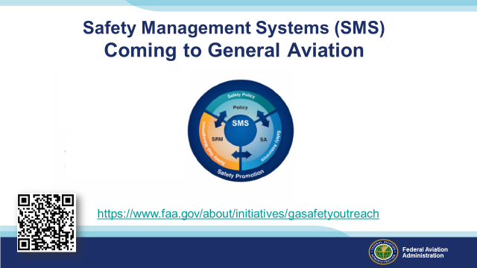 | Slide 32  Safety Management Systems are a set of policies and processes that can increase the safety and efficiency of any flight operation. And FAA is bringing SMS to General Aviation. You may have heard of SMS but thought it was only for large organizations but actually SMS can be scaled to fit any operation large or small.  There are 4 major components to a Safety Management System (Click)  Safety Policy – a documented commitment to safety that runs from the head of an organization to its newest member. (Click)  Safety Risk Management – a process that identifies hazards within an operation, determines to what extent an identified hazard may impact flight safety, and controls the risk of occurrence to an acceptable level. (Click)  Safety Assurance – By collecting and analyzing information derived from safety performance data Safety Assurance ensures the performance and effectiveness of Safety Risk Controls. (Click)  Safety Promotion communicates safety information and commitment throughout the organization. (Click)  You can find more information about Safety Management Systems at the URL on the Screen.  (Next Slide)
 | Slide 33  We welcome all feedback. You can scan the QR code on screen to reach our feedback webpage.  (Next Slide)
Slide 34
The End

Appendix I – Equipment and Staging

Equipment:
- Projection Screen & Video Projector suitable for expected audience
  - Remote computer/projector control available at lectern or presenter location
    - In lieu of remote – detail a Rep to computer/projector control.
- Presentation Computer
  - Note: It is strongly suggested that the entire program reside on this computer.
- Back up Projector/Computer/Media as available.
- PA system suitable for expected audience
  - Microphones for Moderator and Panel
    - Optional Microphone (s) for audience
- Lectern (optional)

Staging:
- Arrange the projection screen for maximum visibility from the audience.
- Equip with PA microphones
- Place Lectern to one side of screen. This will be used by presenters and moderator if so needed.
- IMPORTANT – Once you have completed outreach on this topic, please help us track the outreach you have done by entering a SAS record.
