Outreach Guidance Document

2022/12-07-272(I)PP
This outreach guidance is provided to all FAA and aviation industry groups that are participating in outreach efforts sponsored by the General Aviation Joint Steering Committee (GAJSC). It is important that all outreach on a given topic is coordinated and is free of conflicts. Therefore, all outreach products should be in alignment with the outline and concepts listed below for this topic.

Outreach Month: March 2024

Topic: Pilot Proficiency and WINGS
This is a short introduction to the WINGS Pilot Proficiency Program and the top five reasons for pilots and flight instructors to choose WINGS. The program also includes information on the E-Z WINGS web application produced by the WINGS industry Network.

Background:

Proficiency training is so beneficial to aviation safety that it is required of most professional pilots. Proficiency training is also beneficial to general aviation pilots as well. Studys have shown that pilots who participate in regular proficiency training are much less likely to experience accidents.

The FAA WINGS Pilot Proficiency Program is one way for general aviation pilots to ensure they are competent, confident, and safe in their flight operations.

Note: This program discusses WINGSPro activities. We suggest you invite local WINGSPros to attend and to assist with the presentation.

Teaching Points:

- WINGS is FAA’s Pilot Proficiency Program.
- WINGS is most beneficial if training is not done all at once but rather spaced out throughout the year.
- The WINGS Topic of the Quarter is an easy way to pursue regular proficiency training.
- Completion of any phase of WINGS satisfies the 14 CFR 61.56 requirements for Flight Reviews.
- E-Z WINGS is a simple way to request WINGS credit for selected activities.
- A cadre of WINGSPros is available to assist Flight Instructors and pilots with WINGS.

References:
- Pilot Proficiency and WINGS PowerPoint
  - Available on the National FAASTeam Share Point site under Approved Presentations\General Resources\Core\Safety Promotion\WINGS Promotion\WINGS for FPMs and Reps
- AC 61-91J – WINGS – Pilot Proficiency Programs

- AC 61-98D – Currency Requirements and Guidance for the Flight Review and Instrument Proficiency Check
- FAASafety.gov
- Off Airports Ops Guide
ttps://www.faasafety.gov/gslac/ALC/libview_normal.aspx?id=135893

- Personal Minimums Development Guide
https://www.faasafety.gov/gslac/ALC/lib_categoryview.aspx?categoryId=15&r_s=50&r_c=50
- WINGS Information and Guidance
https://faasafety.gov/gslac/ALC/lib_categoryview.aspx?categoryId=39

Abstract: Lasting 10 to 15 minutes, this presentation acquaints the audience with the benefits of engaging in regular proficiency training through the FAA WINGS Pilot Proficiency Program.
Format: Information Briefing - Power Point presentation
Required Personnel – FAASTeam Program Manager or designated FAASTeam Rep (s)
Optional Personnel – DPEs, CFIs, WINGSPros, and other pilots who can speak on the benefits of proficiency training.
National FAASTeam Support:
In addition to this guidance document, a Power Point presentation that supports the program is provided. FPMs and presenters are encouraged to customize this presentation to reflect each individual program.

Slides | Script
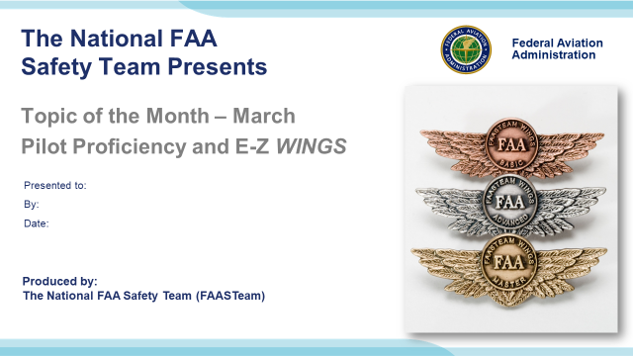 | Slide 1  2022/03-23-255(I)PP Original Author: John Steuernagle 03/23/2022; POC Kevin Clover National FAASTeam Program Manager (Ops), Office (562-888-2020 revised by John Steuernagle 03/23/2022.  Presentation Note: This is the title slide for Pilot Proficiency and WINGS  - Script - We have included a script of suggested dialog with most slides. The script will always appear in a non-italic font. Presenters may read the script or modify it to suit their own presentation style. See template slides 5 and 6 for examples of a slides with script.  - Presentation Instructions - (stage direction and presentation suggestions) will be preceded by a Bold header: the instructions themselves will be in Italic fonts. See slides 2, for an example of slides with Presentation Instructions only.  - Program control instructions - will be in bold fonts and look like this: (Click) for building information within a slide; or this: (Next Slide) for slide advance.  - Background information - Some slides may contain background information that supports the concepts presented in the program.  Background information will always appear last and will be preceded by a bold Background: identification.  The production team hope you and your audience will enjoy the show. Break a leg!  (Next Slide)
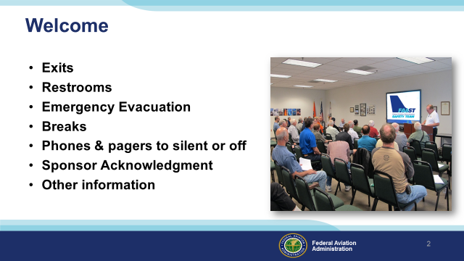 | Slide 2  Presentation Note: Here’s where you can discuss venue logistics, acknowledge sponsors, and deliver other information you want your audience to know in the beginning.  You can add slides after this one to fit your situation. (Next Slide)
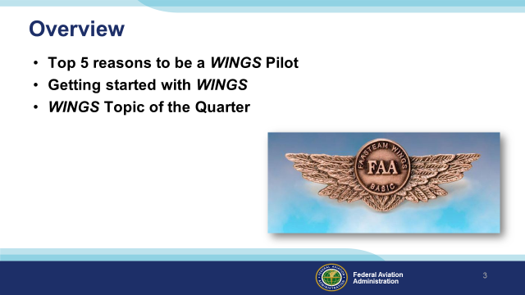 | Slide 3  Today’s presentation is all about WINGS – FAA’s Pilot Proficiency Program. We’ll begin with the top 5 reasons to be a WINGS Pilot  Next we’ll show how easy it is to get started on your personal Path to Proficiency.  And we’ll talk about the WINGS Topic of the Quarter Program.  So let’s get started with reason number five.  Presentation Note: If you’ll be discussing additional items, add them to this list  (Next Slide)
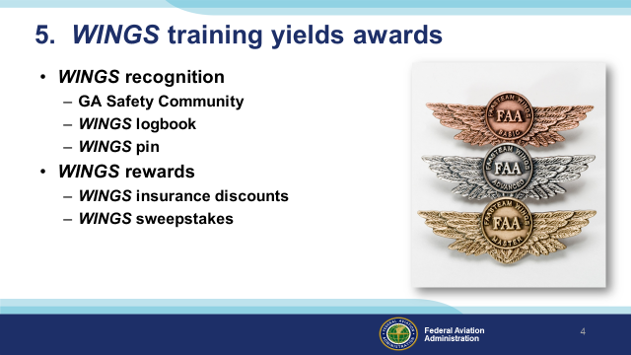 | Slide 4  Documented WINGS proficiency training earns awards. To be clear – we don’t choose proficiency training because it’s easy or because we’re looking  for bling but it is nice to be recognized for our achievements. As a WINGS pilot you are recognized as a member in good standing of the General Aviation Safety Community. All of your WINGS training is permanently recorded in your online WINGS logbook and when you earn a WINGS phase you can receive a lapel pin. (Click)  Aircraft insurance carriers recognize the value of regular Proficiency Training and they may offer premium discounts to WINGS pilots.  And WINGS Pilots who earn a phase and their Instructors can win pilot products from the WINGS Industry Network.  (Next Slide)
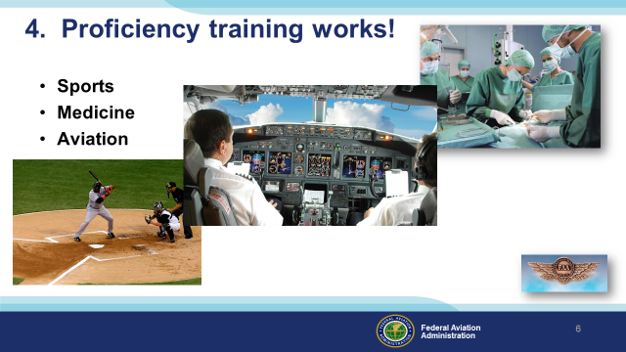 | Slide 5  Reason number four – proficiency training works!  Can you imagine how well professional athletes would perform if they didn’t practice between games or stay in shape during the off season? (Click)  Would you choose to be treated by doctors who had no continuing education since graduating from medical school? (Click)  Or how about a professional pilot flight crew who never train for emergencies?  (Next Slide)
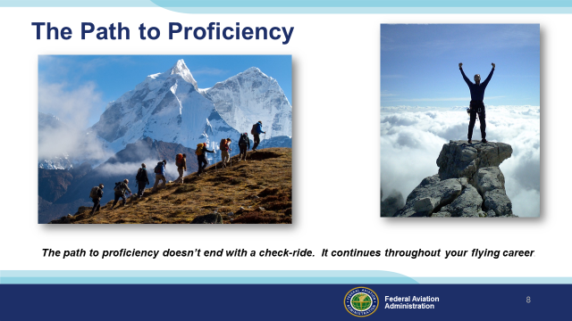 | Slide 6  Pros know that proficiency is not a destination but rather a journey that never ends. Regular training keeps them at peak performance every time they take to the air. Pilots who follow the Path to Proficiency are well aware of their capabilities and their limitations. They dedicate time and resources to training and practice. And they understand that continuing education through Proficiency Training is essential to keeping them on top of their game.  (Next Slide)
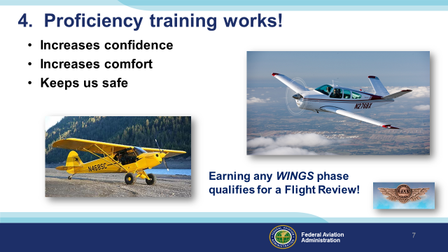 | Slide 7  Proficiency training works for General Aviation pilots too. WINGS is a proficiency training system specifically designed for GA pilots and, regular participation will keep you on top of your flying game. Pilots who participate in the FAA WINGS Pilot Proficiency program fly with more confidence. They and their passengers are comfortable in the air.  Most importantly - proficiency training keeps us safe. (Click)  And pilots who earn WINGS phases also qualify for a flight review.  (Next Slide)
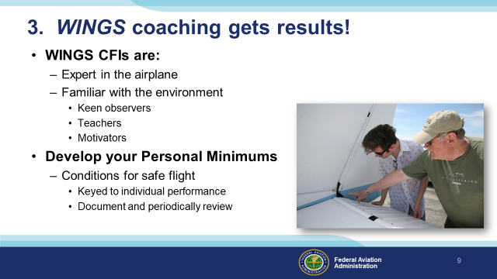 | Slide 8  Reason number three – WINGS coaching gets results! Every profession relies on coaching to keep practitioners sharp. All Flight Instructors are trained in performance evaluation and critique and most make great coaches. WINGS Instructors are expert in your aircraft and the training environment. They are keen observers and teachers who will push you to excellence in flying. (Click)  Together you and your WINGS CFI can develop your Personal Minimums – A set of conditions, procedures, rules, criteria, and guidelines that help pilots to decide when it’s safe to fly. As the name implies, your Personal Minimums are unique to you and keyed to your demonstrated ability. In consultation with your coach, you’ll develop and document your personal minimums based on your individual performance. Pilot performance changes over time and WINGS pilots continue to improve. WINGS training gives you regular opportunities to review and update your pilot performance profile and personal minimums but you need a reference point to start.  (Next Slide)
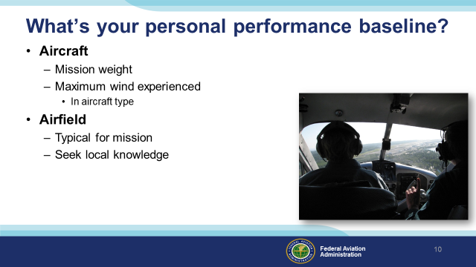 | Slide 9  In order to establish personal minimums you need to have a baseline – think of it as your personal, documented, demonstration of performance. We suggest you document your performance at least once a year with a WINGS CFI. Try to pick a day when you can experience actual cross-wind conditions in the airplane you usually fly and loaded to your typical mission weight. Select an airfield that’s typical for the missions you fly. If you’re planning trips to a short, obstructed runway; try to find something similar to train on. Gather information about the destination airfield from pilots who’ve flown there and share that information with your instructor. That will help your CFI to construct realistic scenarios for you to fly.  (Next Slide)
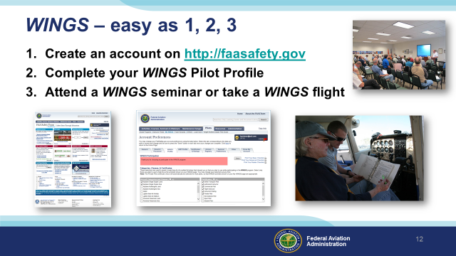 | Slide 10  Getting started in WINGS is as easy as one, two, three.  - Create an account on faasafety.gov  - Complete your WINGS Pilot Profile  - Attend a WINGS seminar or take a WINGS flight with your CFI.  (Next Slide)
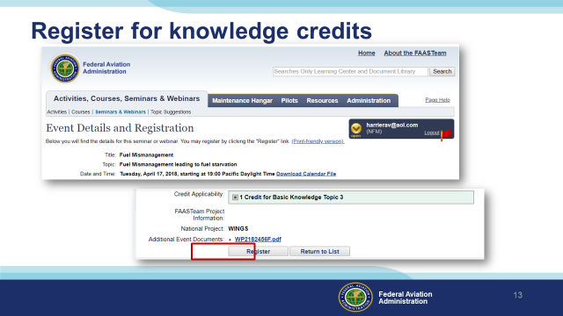 | Slide 11  For seminars and webinars you can pre-register for credit on FAASafety.gov or, in the case of live seminars, you can register via the sign-in sheet at the seminar door.  (Next Slide)
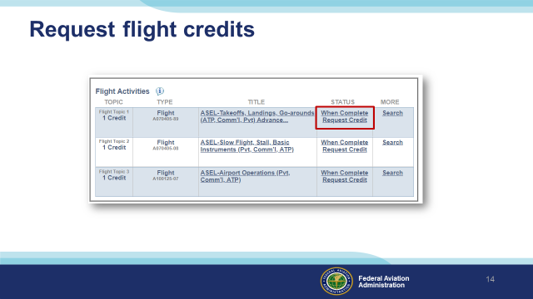 | Slide 12  You’ll need to request credit for each flight activity. It’s easy to do. Just go to your “My Wings” page and click on request credit after the activity has been completed  (Next Slide)
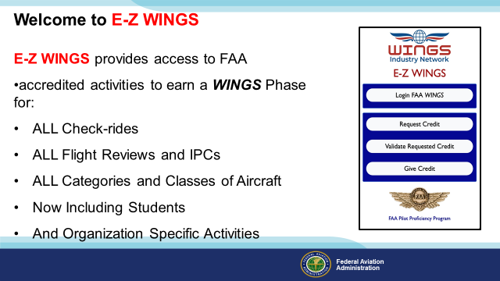 | Slide 13  E_Z WINGS is a web application that makes it easy for pilots to request and receive credit for:  - All Practical Tests,  - All Flight Reviews and IPCs,  - In All categories and classes of aircraft,  - And for organization-specific activities.  And E-Z WINGS works for all pilots and student pilots.  (Next Slide)
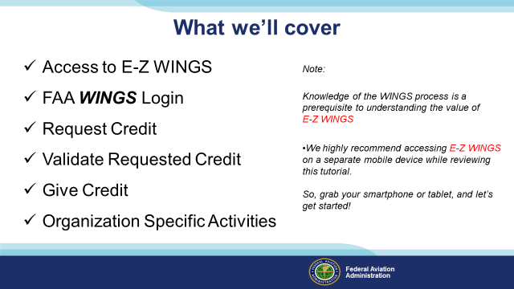 | Slide 14  Here’s the list of what we’ll cover in the next few minutes. We encourage you to access E-Z WINGS on your smart phone or tablet as we go along. So get your smart phone or tablet out & we’ll get started.  (Next Slide)
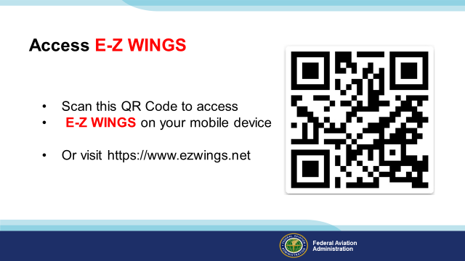 | Slide 15  Scan the QR code or navigate to the URL on screen.  Presentation note: Give the audience time to access e-z wings then:  (Next Slide)
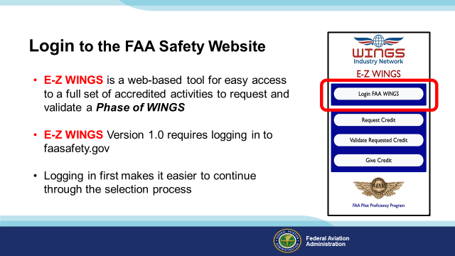 | Slide 16  E-Z WINGS works together with FAASafety.gov to access a set of common WINGS activities with just a few clicks. Once you see the application on your device click on Login FAA WINGS.  (Next Slide)
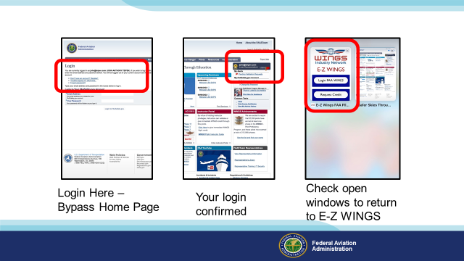 | Slide 17  Clicking Login will bypass the FAASafety.gov home page and bring you directly to the login screen.  Once you’ve successfully logged in, return to E-Z WINGS to request credit.  (Next Slide)
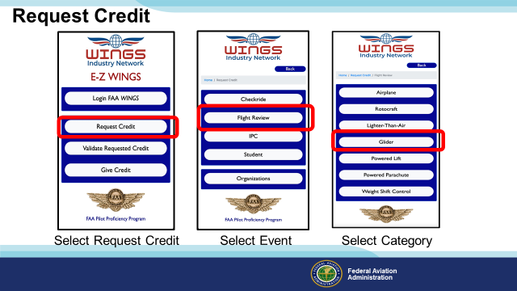 | Slide 18  After you request credit you’ll need to select an event.  Currently we offer Practical test or Check ride, Flight Review, Instrument Proficiency Check, Student Pilot, and selected organizational events.  Next select the applicable aircraft category from the list.  (Next Slide)
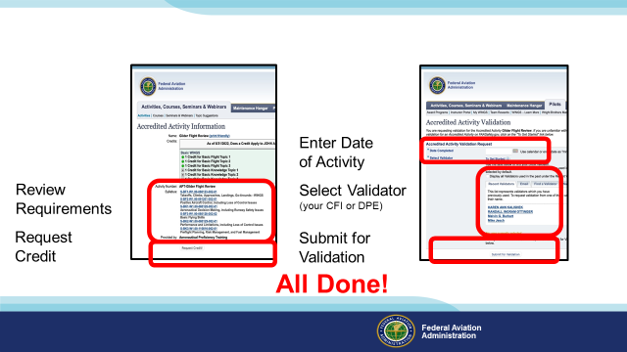 | Slide 19  You’ll next see a screen that describes the selected activity. Click on Request Credit, then input the date your activity was completed, select a validator, click “Submit for Validation” and you’re done.  (Next Slide)
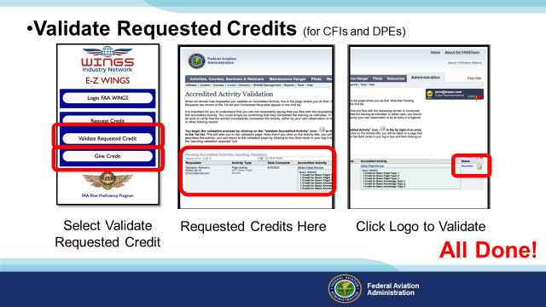 | Slide 20  CFIs and DPEs can use E-Z WINGS too. When they select “Validate Requested Credit” , all credit requests will automatically appear. (Click)  Click on the logotype to validate the request and you’re done. (Click)  Event organizers can also use E-Z WINGS to give credit for event attendance. See your local FPM or WINGSPro for details.  (Next Slide)
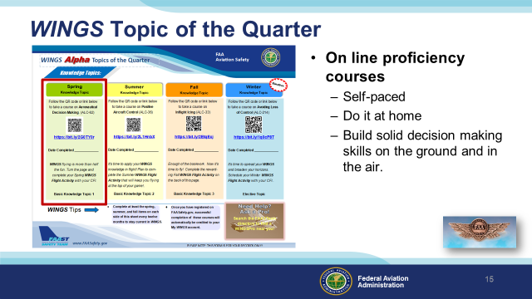 | Slide 21  Proficiency Training works best if it’s not done all at once, but rather spaced out at regular intervals. The WINGS Topic of the Quarter program consists of eight activities pursued over the course of one year. Because a full year’s proficiency is mapped out for you, It’s an excellent way to get started with WINGS.  Each quarter, WINGS Pilots take an on-line safety course. All courses are self-paced. Most take no more than an hour or two and they can be completed at home. Our online courses build solid decision making skills that you’ll employ on the ground and in the air.  (Next Slide)
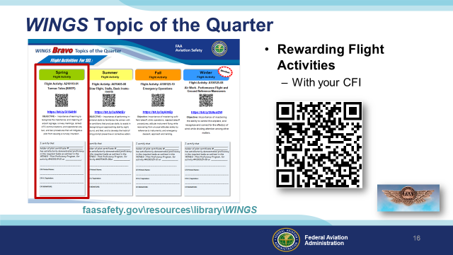 | Slide 22  Program participants also fly with a Flight Instructor to complete a WINGS Flight Activity at least once each quarter. (Click)  To access WINGS Topic of the Quarter Checklists and other WINGS information just navigate to FAASafety.gov. then click on Resources\Library\WINGS or scan the QR code on screen.  (Next Slide)  Background: You can access the FAASafety.gov library here:  https://faasafety.gov/gslac/ALC/lib_categoryview.aspx?categoryId=39  (Next Slide)
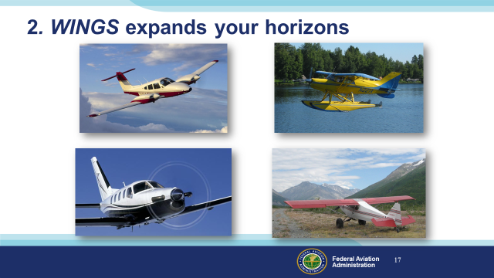 | Slide 23  Reason Number 2 – WINGS proficiency training expands your horizons.  Pilots usually think of proficiency training in terms of their usual aviation operations but if you are willing to expand your horizons there are host of options that go well beyond the hundred dollar hamburger to make proficiency flying more interesting. Twin engine, turbine, or instrument training can boost capability and confidence in cross country operations. Seaplane and tailwheel training are particularly satisfying for folks who learned in nose wheel airplanes.  And even if you don’t take on the challenges of another rating or airframe, there’s another great way to expand your horizons.  (Next Slide)
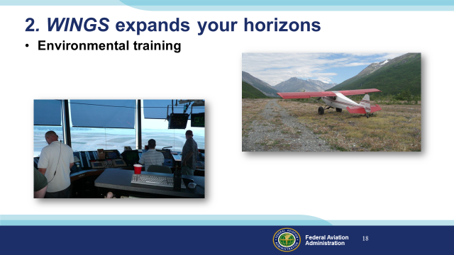 | Slide 24  Training in new operational environments builds confidence too. If you learned to fly at a small country airport you’re probably very comfortable in a non-towered environment. How about a trip to a major metropolitan airport with your flight coach? The traffic and rapid pace of ATC communications can be daunting at first but mastering the environment can be very satisfying.  Likewise, big city pilots who are comfortable with busy towered operations can be overwhelmed when operating to non-towered or back country airstrips. Back country transition training can acquaint you with the nuances of rural environments and ensure your wilderness flying can be done safely.  (Next Slide)
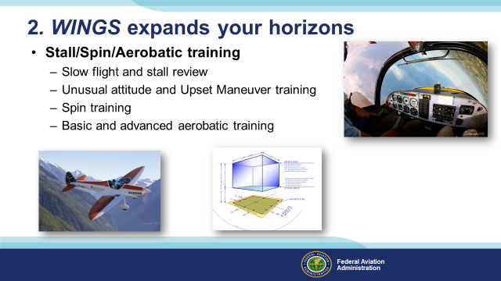 | Slide 25  A solid review of stalls, slow flight and spins is a great way to prevent loss of control accidents and it’s a natural stepping stone to aerobatic training. Once again WINGS CFIs can coach you to realize your maximum performance potential. Here’s a list of available training to consider:  - Begin with a review of stalls and slow flight. This should be done at least annually to maintain peak performance.  - Unusual attitude training and review are essential for VFR and Instrument pilots alike. Upset maneuver training includes unusual attitudes but may exceed typical unusual attitude pitch and bank values. Upset maneuver training is common in large airplane operations and includes over and under speed situations.  - Spin training begins with incipient spin recognition and prevention and progresses to multiple-turn spins and precision recoveries.  - Basic and advanced aerobatic training leverages all of your performance and progresses to competency and comfort in any aircraft attitude.  (Next Slide)
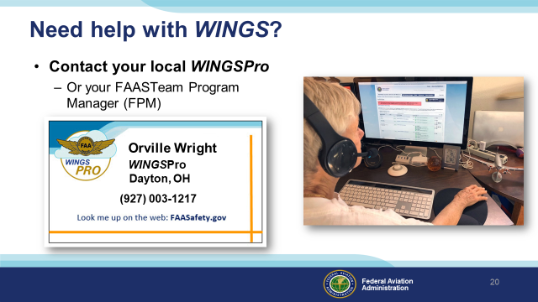 | Slide 26  WINGS is a robust proficiency training program that works for all pilot certification levels and all general aviation aircraft. As such, it can be a little intimidating at first. That’s why volunteer WINGSPros in your area are available to help you with anything related to WINGS. Here’s how to find your local WINGSPro(s).  Presentation note: You may want to introduce local WINGSPros in attendance and ask them to present this section. Your WINGSPros can edit the slide text to include their name and contact information.  (Next Slide)
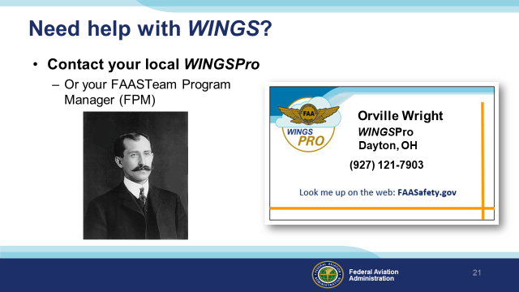 | Slide 27  WINGS is a robust proficiency training program that works for all pilot certification levels and all general aviation aircraft. As such, it can be a little intimidating at first. That’s why volunteer WINGSPros in your area are available to help you with anything related to WINGS. Here’s how to find your local WINGSPro(s).  Presentation note: This is hidden. You may want to use it as an an alternative to Slide No. 20.  Presentation note: You may want to introduce local WINGSPros in attendance and ask them to present this section. Your WINGSPros can edit the slide to include their name, photo, and contact information.  (Next Slide)
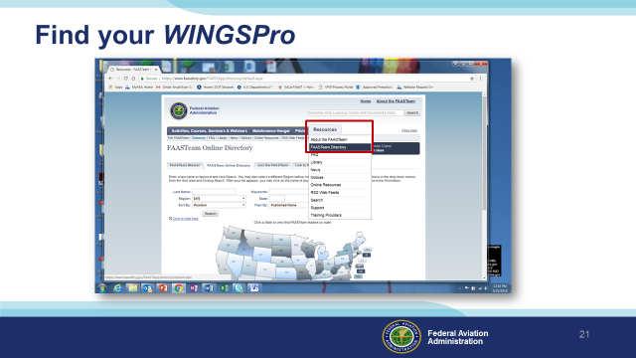 | Slide 28  To find your local WINGSPros just navigate to FAASafety.gov. Hover over the resources tab and click on FAASTeam Directory.  (Next Slide)
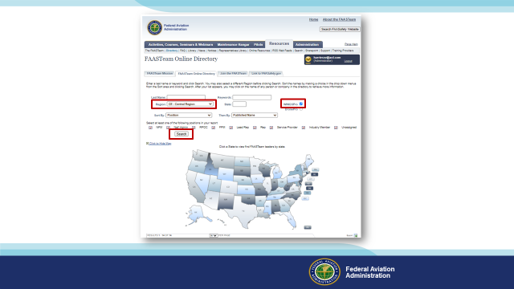 | Slide 29  Presentation note: This will be more effective if you replace the following illustrations with those that feature local AOR searches and WINGS Pro results.  First select your region and district in this drop down box. (Click)  Next click the WINGSPro box, (Click)  Then click on search. Your WINGSPros will appear in the list below.  (Next Slide)
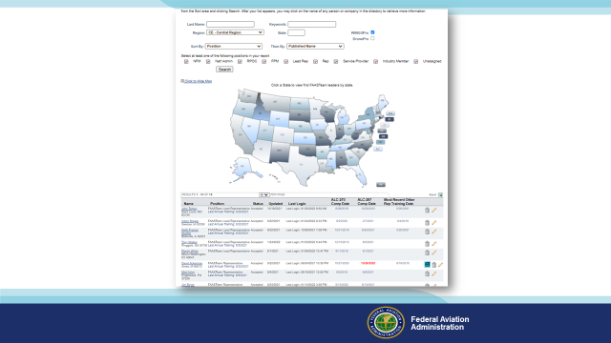 | Slide 30  Here’s a partial list of WINGS Pros in the Central Region.  (Next Slide)
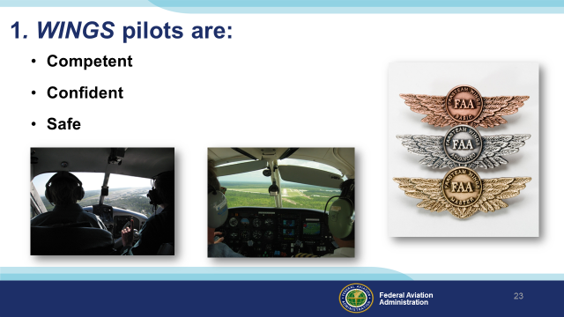 | Slide 31  Finally, WINGS training yields Proficiency and Peace of Mind. There’s nothing like the feeling you get when you know you’re playing your A game and in order to do that you need good coaching. (Click)  WINGS pilots are Competent. They fly regularly with a WINGS CFIs who challenge them to review what they know, explore new horizons, and to always do their best. Vince Lombardi, the famous football coach said, “Practice does not make perfect. Only perfect practice makes perfect”. For pilots that means  flying with precision, on course, on altitude, on speed all the time. (Click)  WINGS pilots are Confident. They are well aware of their capabilities and their limitations. They are coached to exercise sound pre and in-flight risk management so they are rarely surprised by unanticipated conditions. Of course they must dedicate time and money to their proficiency programs but it’s well worth it for the peace of mind that comes with confidence. (Click)  And, most importantly; WINGS pilots and their passengers enjoy the benefits of safe flight operations every time they take to the air.  (Next Slide)
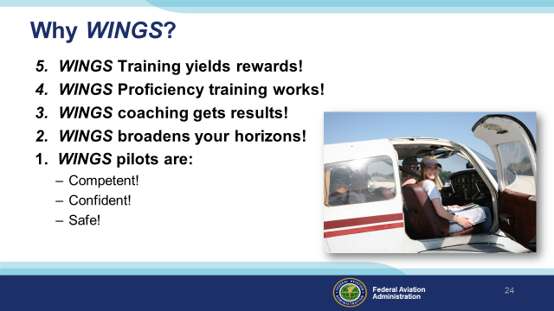 | Slide 32  So here they are again. The top 5 reasons to choose WINGS. Proficiency is key to success in almost every thing worth doing – especially flying. Proficient pilots are competent, confident, and safe.  (Next Slide)
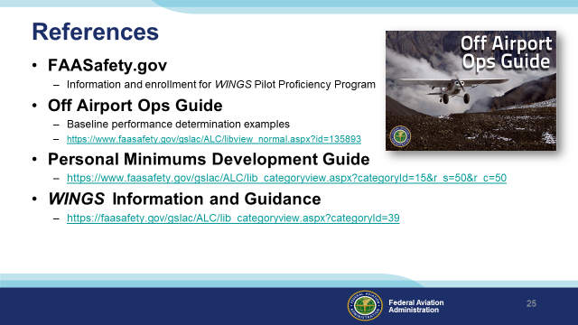 | Slide 33  Here are a few references for additional information:  FAASafety.gov is the FAASTeam website where you’ll find a wealth of safety information. You can enroll and track your progress in the FAA WINGS Pilot Proficiency Program here.  Look in the FAASafety.gov library for the Off Airport Operations Guide. In it you’ll find instructions for developing a short field performance baseline together with other useful information on operating to small fields.  Also in the FAASafety.gov Library – the Personal Minimums Development Guide – Your documented proficiency performance can be used to develop minimums that are tailored to you, your aircraft, and your mission.  The Library also contains additional WINGS Information and Guidance  I’ll leave this slide on screen while I take some questions from the audience.  Presentation note: Take questions from the audience while they copy information from the screen. Then:  (Next Slide)
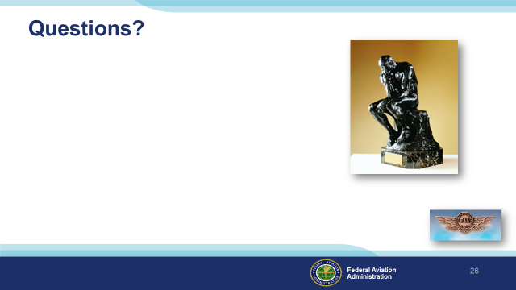 | Slide 34  Presentation Note: You may wish to provide your contact information and main FSDO phone number here. You can also add WINGSPro contact information.  Modify with your information or leave blank.  (Next Slide)
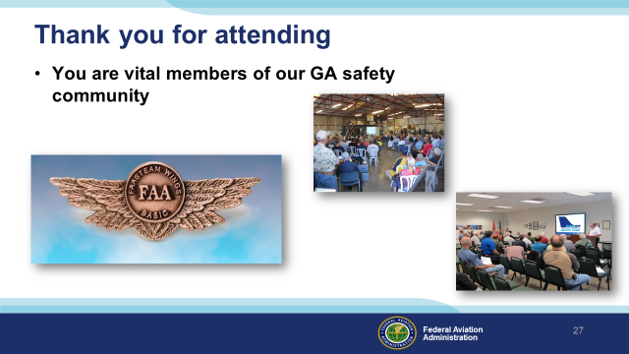 | Slide 35  Your presence here shows that you are vital members of our General Aviation Safety Community. The high standards you keep and the examples you set are a great credit to you and to GA.  Thank you for attending.  (Next Slide)
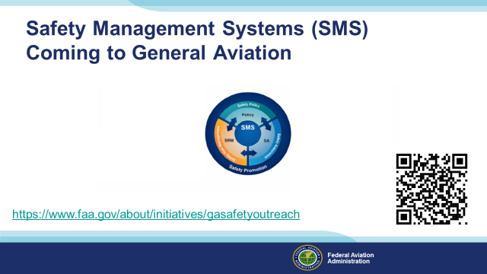 | Slide 36  Safety Management Systems are a set of policies and processes that can increase the safety and efficiency of any flight operation. And FAA is bringing SMS to General Aviation. You may have heard of SMS but thought it was only for large organizations but actually SMS can be scaled to fit any operation large or small.  There are 4 major components to a Safety Management System (Click)  Safety Policy – a documented commitment to safety that runs from the head of an organization to its newest member. (Click)  Safety Risk Management – a process that identifies hazards within an operation, determines to what extent an identified hazard may impact flight safety, and controls the risk of occurrence to an acceptable level. (Click)  Safety Assurance – By collecting and analyzing information derived from safety performance data Safety Assurance ensures the performance and effectiveness of Safety Risk Controls. (Click)  Safety Promotion communicates safety information and commitment throughout the organization. (Click)  You can find more information about Safety Management Systems at the URL on the Screen.  (Next Slide)
Slide 37

(The End)

Appendix I – Equipment and Staging
Equipment:
- Projection Screen & Video Projector suitable for expected audience
  - Remote computer/projector control available at lectern or presenter location
    - In lieu of remote – detail a Rep to computer/projector control.
- Presentation Computer
  - Note: It is strongly suggested that the entire program reside on this computer.
- Back up Projector/Computer/Media as available.
- PA system suitable for expected audience
  - Microphones for Moderator and Panel
    - Optional Microphone (s) for audience
- Lectern (optional)
Staging:
- Arrange the projection screen for maximum visibility from the audience.
- Equip with PA microphones
- Place Lectern to one side of screen. This will be used by presenters and moderator.
IMPORTANT – Once you have completed outreach on this topic, please help us track the outreach you have done by entering a SAS record.
