General Aviation Joint Safety Committee
Loss of Control Working Group

Pre-flight & In-flight Weather Resources
2022/12-07-276(I)PP

This outreach guidance is provided to all FAA and aviation industry groups that are participating in outreach efforts sponsored by the General Aviation Joint Safety Committee (GAJSC). It is important that all outreach on a given topic is coordinated and is free of conflicts. Therefore, all outreach products should be in alignment with the outline and concepts listed below for this topic.

Outreach Month: August 2024

Topic: In-flight Weather Resources
The FAA and industry will conduct a public education campaign emphasizing the value of education with respect to pre and in-flight weather information resources.

Background:

The 21st Century has brought an unprecedented wealth of information to general aviation cockpits. Near real time graphical and textual weather products contribute greatly to pilot situational awareness and decision making. But pilots must understand the capabilities and limitations of the equipment and the information it provides.

Teaching Points:

- More pre and in-flight weather information is available then ever before but with that wealth of information comes complexity. Pilots must be comfortable with their choice of weather information services and they must be competent in making critical flight decisions based on assessments of the information provided.
- A thorough understanding of weather information resources capabilities and limitations is essential to safe flight.
- Weather information procurement and weather decision making should be covered in any proficiency training program.

Reference:
- Aviation Weather Handbook FAA-H-8083-28
https://www.faa.gov/sites/faa.gov/files/FAA-H-8083-28_FAA_Web.pdf
- AC 91-92 - Pilot’s Guide to a Preflight Briefing
https://www.faa.gov/regulations_policies/advisory
_circulars/index.cfm/go/document.information/document
ID/1036892
- Aeronautical Information Manual

Abstract: Lasting 10 to 20 minutes, this presentation acquaints the audience with the availability of modern pre and in-flight weather information services and technology.
.
National FAASTeam Support:
In addition to this guidance document, a Power Point presentation that supports the program is provided. FPMs and presenters are encouraged to customize this presentation to reflect each individual program.

Slides | Script
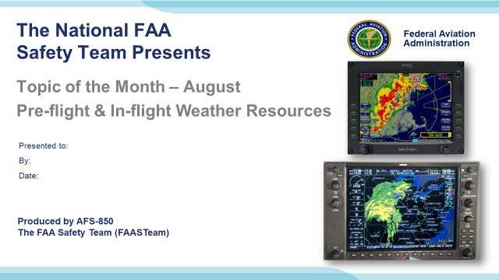 | Slide 1  022/12-07-276(I)PP Original Author: John Steuernagle 01/30/2021; Edited by Mike Jesch 2022; POC Kevin Clover AFS-850 Operations Program Manager, Office (562-888-2020 revised by JS 09/09/2021 – Revised by Mike Jesch FAASTeam Lead Rep. August 2022.  Presentation Note: This is the title slide for Pre-flight and In-Flight Weather Resources.  - Script - We have included a script of suggested dialog with most slides. The script will always appear in a non-italic font. Presenters may read the script or modify it to suit their own presentation style. See template slides 5 and 6 for examples of a slides with script.  - Presentation Instructions - (stage direction and presentation suggestions) will be preceded by a Bold header: the instructions themselves will be in Italic fonts. See slides 2, for an example of slides with Presentation Instructions only.  - Program control instructions - will be in bold fonts and look like this: (Click) for building information within a slide; or this: (Next Slide) for slide advance.  - Background information - Some slides may contain background information that supports the concepts presented in the program.  Background information will always appear last and will be preceded by a bold Background: identification.  The production team hope you and your audience will enjoy the show. Break a leg!  (Next Slide)
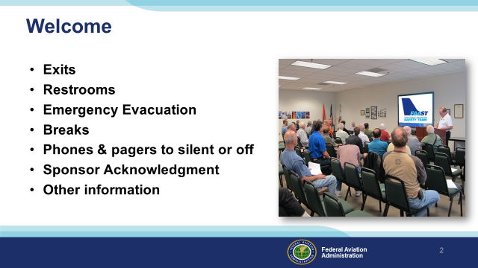 | Slide 2  Presentation Note: Here’s where you can discuss venue logistics, acknowledge sponsors, and deliver other information you want your audience to know in the beginning.  You can add slides after this one to fit your situation. (Next Slide)
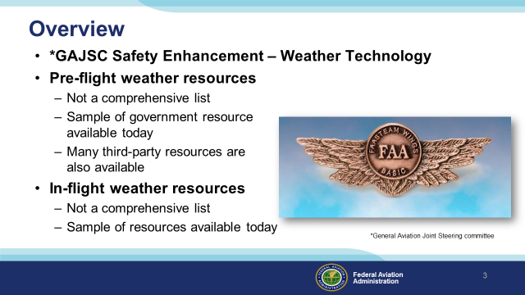 | Slide 3  The General Aviation Joint Safety Committee is a government/industry group that looks at GA mishap experience and makes recommendations (they call them safety enhancements) for safety improvement. This program addresses their recommendation that GA pilots be apprised of advances in weather technology that can enhance the safety of flight.  In this program, we’ll discuss automated resources that are available for you to conduct a preflight briefing. We also discuss weather information resources that are available to general aviation pilots in flight.  Technology is advancing so quickly that we can’t claim our list of resources is at all comprehensive but rather a sampling of what’s available to pilots today.  Presentation Note: If you’ll be discussing additional items, add them to this list  (Next Slide)
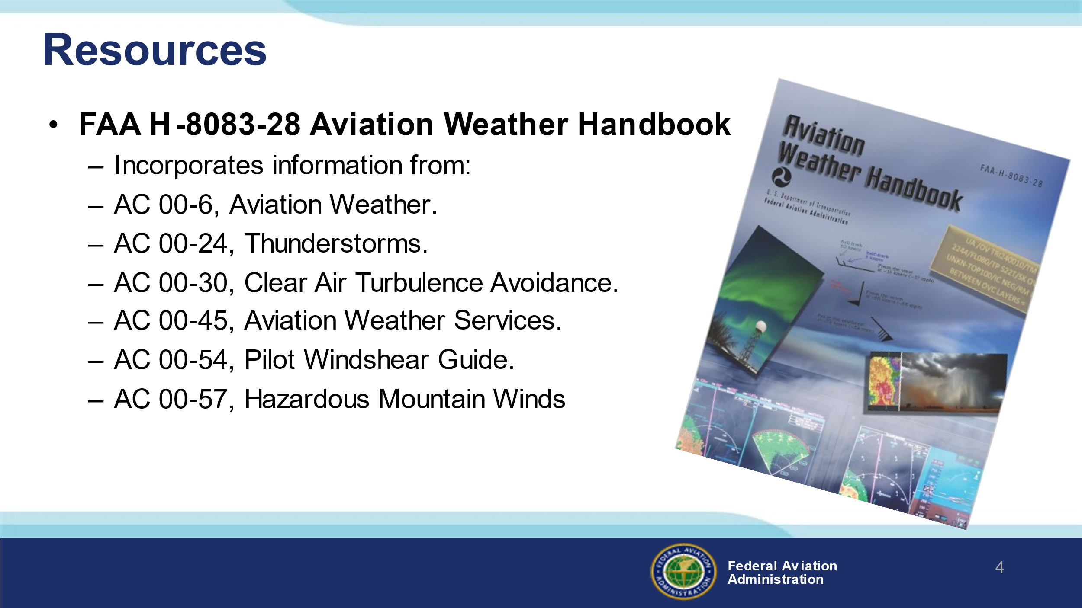 | Slide 4  Much of the information presented here is taken from FAAs Aviation Weather Handbook. This publication incorporates information from the Advisory Circulars on screen. The latest edition is a welcome omnibus weather reference for all pilots.  (Next Slide)
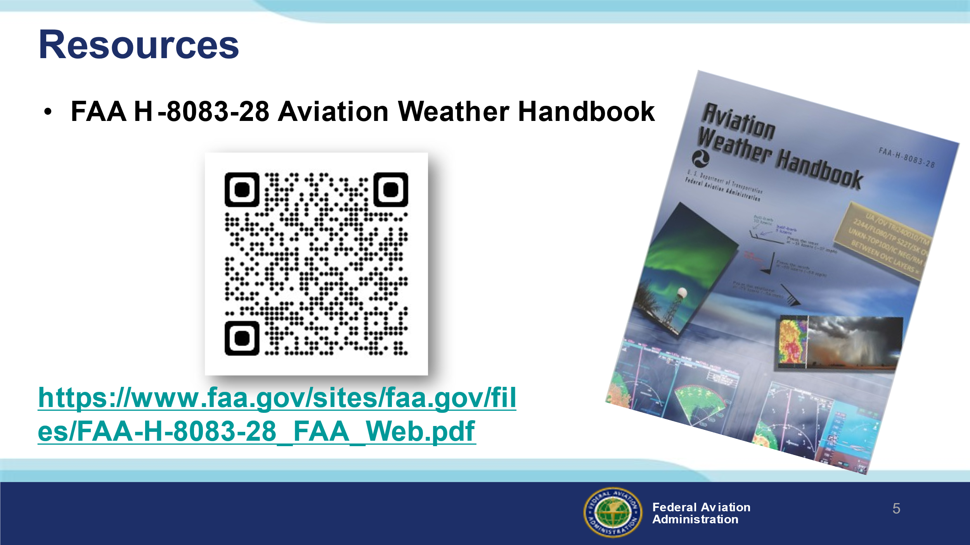 | Slide 5  Scan the QR code or navigate to the URL on screen to download your copy.  (Next Slide)  https://www.faa.gov/sites/faa.gov/files/FAA-H-8083-28_FAA_Web.pdf
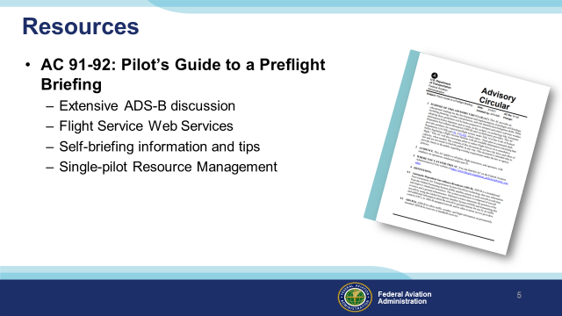 | Slide 6  We’ll also draw heavily on AC91-92 – The Pilot’s Guide to a Preflight Briefing – released in March of 2021. This publication features extensive ADS-B information, Flight Service Web Services, Self-briefing information and tips and Single-pilot Resource Management. (Click)  We’ll list additional information resources at the end of this presentation.  (Next Slide)
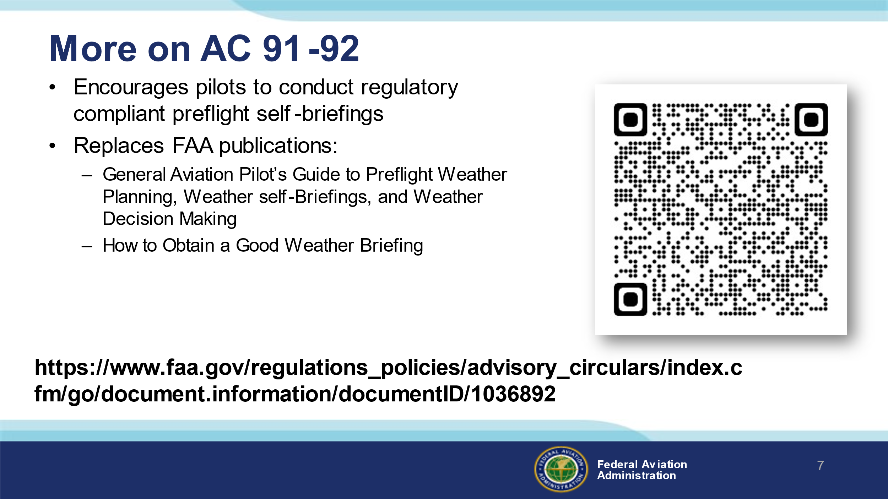 | Slide 7  AC 91-92, offers valuable information on the conduct of regulatory compliant self briefings and it assists in 14CFR §§ 91.103 compliance.  The AC replaces FAA publications:  - General Aviation Pilot’s Guide to Preflight Weather Planning, Weather self-Briefings, and Weather Decision Making  - How to Obtain a Good Weather Briefing  (Next Slide)
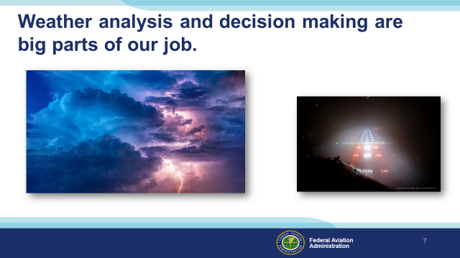 | Slide 8  Weather analysis and decision making are big parts of every pilot’s job. We know the weather at our departure airport but en route weather is less certain. (Click)  And of course we need to know if weather conditions will permit a landing at our destination.  (Next Slide)
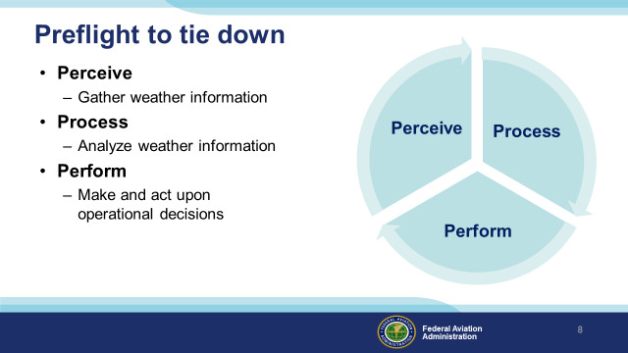 | Slide 9  Weather information gathering, analysis, and decision making begin with the preflight and continue throughout. While en route we need to continually: (Click)  Perceive present weather conditions and gather additional weather information from various sources. (Click)  Process weather information by comparing present weather with forecasts and by relating present and expected weather conditions to aircraft and pilot performance capabilities. (Click)  Perform by making operational decisions and acting upon them. (Click)  This process continues throughout the flight. Our perception of the results of our performance decisions further informs and refines our analysis.  (Next Slide)
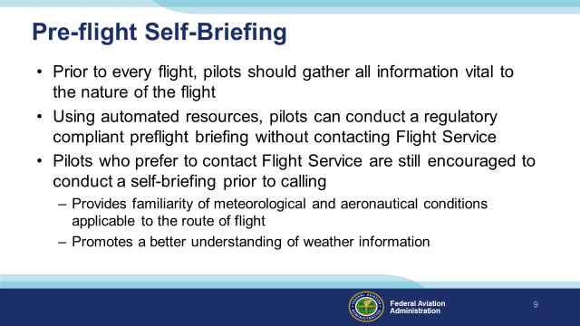 | Slide 10  Regulations require that, during our pre-flight planning, we gather all pertinent information with regard to each flight.  We can use automated weather information resources to gather weather information without contacting Flight Service  Pilot can still contact Flight Service but they are highly encouraged to conduct a self-briefing prior to the call. That way they’ll have  a good idea and understanding of weather conditions before speaking with a briefer.  (Next Slide)
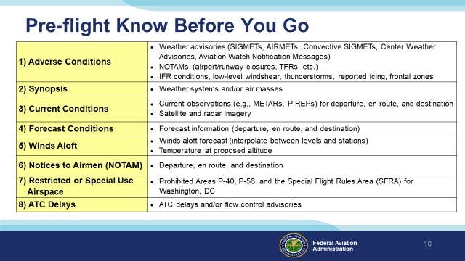 | Slide 11  - Flight Service uses this general list of elements for providing Standard Weather Briefings.  - We suggest that pilots use the same list when conducting a preflight self-briefing using automated resources.  - Using this list of elements when conducting a preflight self-briefing regardless of the automated resource will assist a pilot in complying with Title 14 of the Code of Federal Regulations (14 CFR) part 91, §§ 91.103.  - There are also interactive graphics (e.g. GFA or 1800wxbrief.com Interactive maps) available that depict some of these elements to assist in understanding what information is applicate to the route of flight.  (Next Slide)
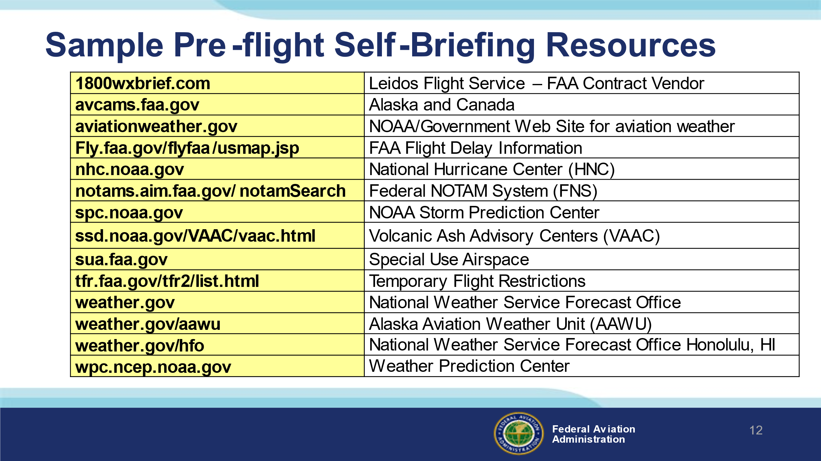 | Slide 12  Here’s a list of government and third-party automated resources that may be used for conducting pre-flight self-briefings.  (Next Slide)  Presentation note: Here are some Frequently Asked & Answered Questions on using automated preflight resources. You may get some of the questions listed below. If so, refer to the answer listed.  Q1: Does my self-briefing need to be recorded or documented by the automation sites(s) I use?  A1: There is no requirement for a self-brief to be recorded  If you prefer to have your self-briefing preparation, be recorded, consider invoking the Standard Briefing functionality on 1800wxbrief.com. Third-party applications may also offer a recorded briefing functionality  Q2: I like the Graphical tools (GFA, Interactive Maps) when conducting preflight planning. Do I still need to use the “Standard Briefing” functionality on the planning website or app that provides a full textual briefing?  A2: Full textual (aka Standard Briefing) functionality is not required to be invoked  The goal is to conduct a comprehensive preflight self-briefing; if you have done this (i.e., covered all the checklist items) using the graphical tools, you do not need to invoke a full textual briefing  However, the Standard Briefing functionality is a good idea as a double check that you have not missed something in your own workflow  Q3: If I conduct a self-brief and still decide to call Flight Service, will they know what I have done online?
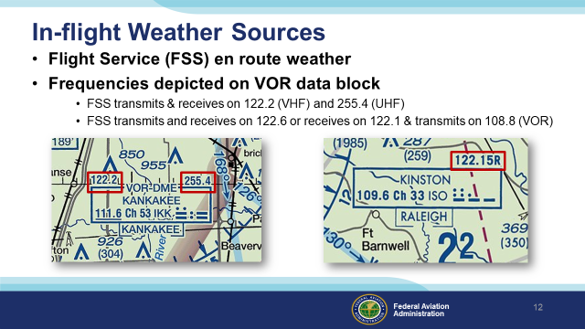 | Slide 13  Let’s begin with FAA Flight Service. FSS stations provide en route weather via voice communication in a couple of different ways. In this example, aircraft flying near the Kankakee VOR can contact Flight Service on 122.2 Mhz. Aircraft equipped with UHF Comm radios can contact FSS on 255.4 Mhz. (Click)  Here Flight Service can receive on 122.1 Mhz. and transmit over the Kinston VOR on 109.6 Mhz. If you choose the VOR communication option, be sure to enable voice on your VOR receiver and adjust the audio volume so you can hear the FSS transmissions.  (Next Slide)
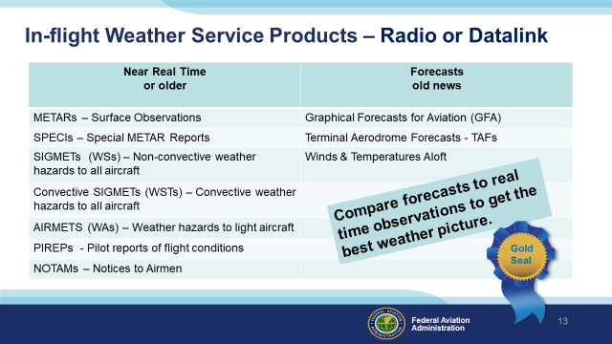 | Slide 14  Here are some of the products available for en route access. You may receive this information via radio (flight Service) or via data link. More about data link later.  Whenever you access weather information it’s important to know how old that information is. Some of the products in the left hand column could be more than an hour old when you receive them. Others may be quite recent. That’s why it’s important to note the times when observations were taken and/or the product validity time span.  Products in the right hand column will be older than those in the left. (Click)  Forecasts work best when you compare them with more current weather observations. That way you can see if weather is developing earlier or later than the forecast schedule.  PIREPs – Pilots are the best resource for reporting inflight weather conditions and confirming forecasts are correct or not.  (Next Slide)
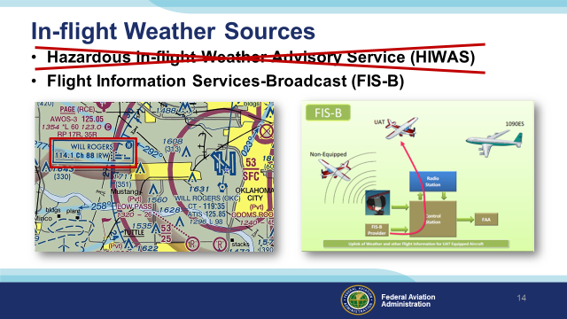 | Slide 15  The letter H in a VOR data block indicates a couple of things:  - the ability to receive HIWAS (Hazardous in-flight Weather Advisory broadcasts. As the name implies, these were pre-recorded advisories of hazardous weather conditions. (Click)  - It also indicates that you’re consulting an out dated chart because HIWAS was decommissioned in January of 2020. (Click)  Also in January most aircraft are required to be equipped with ADS-B out. For those of us who are equipped with ADS-B In, FAA is providing an impressive set of weather information products collectively known as Flight Information Services – Broadcast or FIS-B.  (Next Slide)
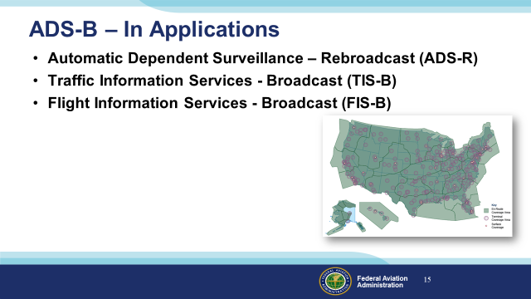 | Slide 16  Although ADS-B In equipment is not required, there are some compelling reasons why pilots are considering installing it. As you can see from the coverage map, en route ADS-B In service is available throughout the country. With ADS-B In you get a suite of traffic, weather, and flight information products. Let’s take a look at how it works.  (Next Slide)
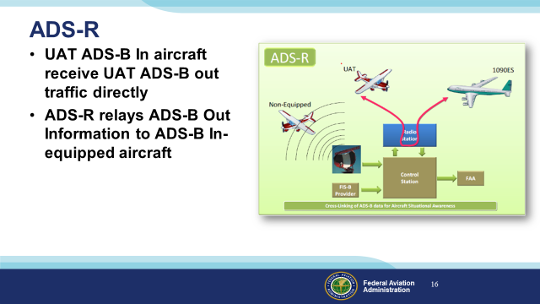 | Slide 17  Universal Access Transceiver (UAT) - equipped ADS-B In aircraft receive traffic information directly from UAT ADS-B out aircraft. (Click)  ADS-R rebroadcasts traffic information derived from UAT and 1090 Extended Squitter positions so that even though the two systems don’t exchange information directly, traffic information is available to both.  There’s also a way for ADS-B in users to see aircraft that are not ADS-B Out equipped.  (Next Slide)
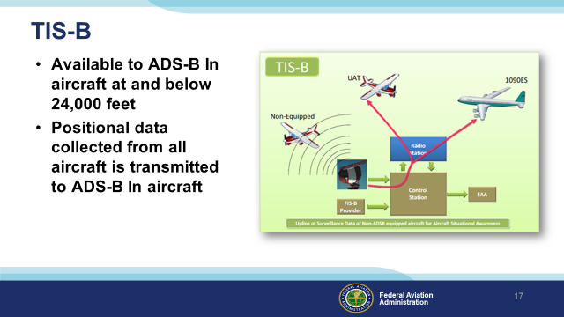 | Slide 18  The ADS-B system transmits TIS-B data on both links to equipped aircraft flying within coverage. TIS-B uses data from ADS-B, radar, Wide Area Multilateration (WAM), and surface multilateration systems like ASDE-X to create accurate near-real-time position reports.  In order to receive TIS-B information you must be ADS-B In equipped, within coverage of an ADS-B ground station and an FAA radar or multilateration system.  Background: Multilateration systems are employed to provide surveillance outside of radar coverage.  - Wide Area Multilateration (WAM) is comprised of a network of relatively small sensors that can be deployed in areas that are problematic for radar installations. WAM capabilities an be combined within a set of ADS-B ground stations.  - Surface Multilateration consists of sensors deployed on airports. The data provided by these sensors is integrated with airport surveillance radar and ADS-B sensor data to create an accurate picture of ground traffic on the airport. The equipment and sensors is collectively known as Airport Surface Detection Equipment (ASDE-X)  (Next Slide)
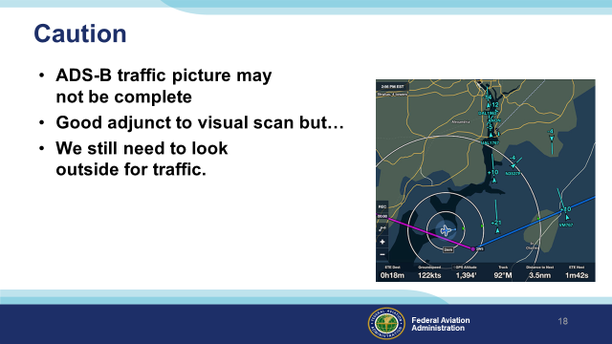 | Slide 19  ADS-B In is not guaranteed to display all traffic in a given area. It’s a great situational awareness and collision avoidance tool but it’s also a compelling distraction. We still need to look outside our windows.  (Next Slide)
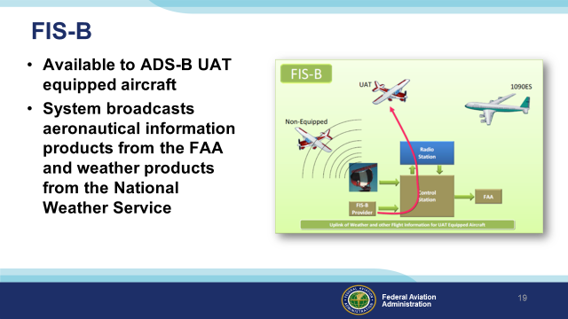 | Slide 20  FIS-B information is available to UAT (Universal Access Transceiver) equipped aircraft only. The system broadcasts aeronautical information products from the FAA and weather products from the National Weather Service.  (Next Slide)
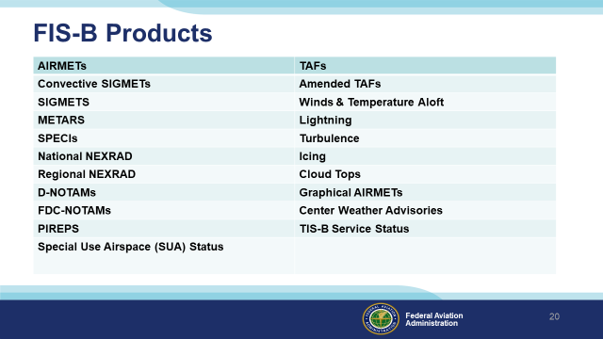 | Slide 21  Here’s a list of text and graphical FIS-B products – available free of charge to ADS-B In users. As you can see – it’s quite extensive and more products may be added in the future.  (Next Slide)
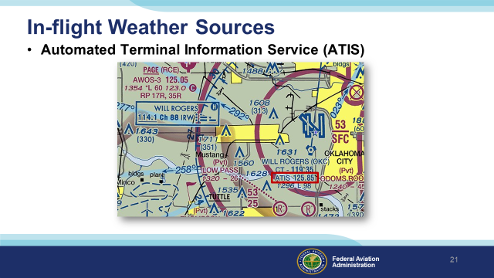 | Slide 22  We’re all familiar with Automated Terminal Information Service available at most towered airports. ATIS provides basic weather and runway information but what about non-towered airports?  (Next Slide)
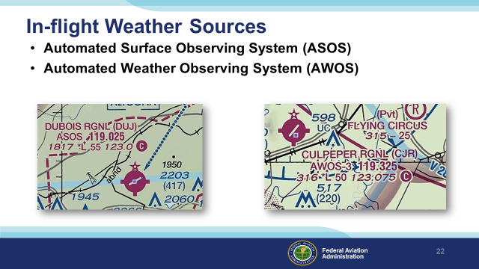 | Slide 23  Many smaller airports are served by ASOS or AWOS automated weather observing systems. In fact, most of the weather data used to produce aviation weather reports and forecasts is now gathered by automated systems. These systems are constantly updating weather observations and averaging the data to give an accurate picture of present conditions. There are about one thousand ASOS and even more AWOS systems deployed throughout the United States..  (Next Slide)
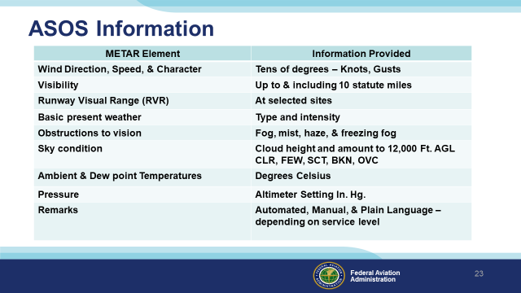 | Slide 24  Here’s a chart of what’s available from an ASOS installation. At some locations information may be augmented by human observers.  Presentation note: Take a minute or so to discuss the information provided by ASOS, then:  (Next Slide)
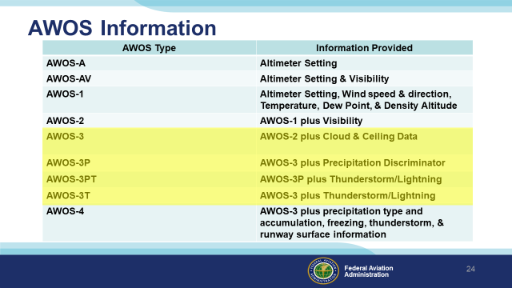 | Slide 25  As you can see there is a wide range of information available from AWOS depending on the type of equipment installed. (Click)  Most of the AWOS installations are a variation of AWOS-3 so you’ll have Altimeter Setting, Wind, Temperature (older installations may report in degrees Fahrenheit), Dew Point, Density Altitude, Cloud and Ceiling data. Newer installations may add precipitation type and thunderstorm/lightning information.  (Next Slide)
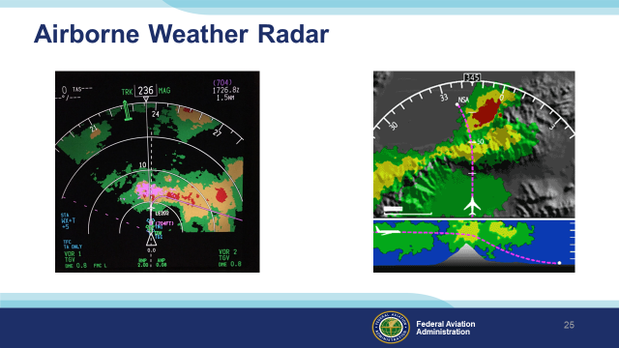 | Slide 26  For those of us who can afford it, Airborne Weather Radar is a very useful information source. It does require interpretation though and there are some limitations to consider.  (Next Slide)
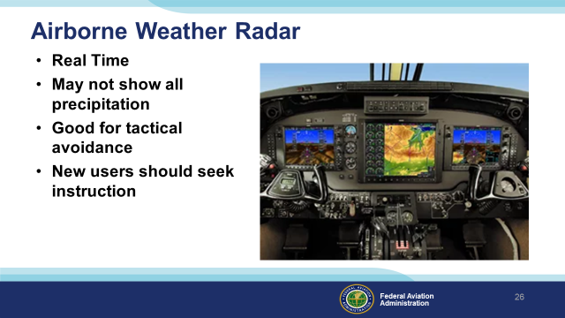 | Slide 27  Airborne radar looks at precipitation and pilots know that the heavier the precipitation – the greater the associated turbulence will be. Because radar returns are immediate it’s a good choice for tactical weather avoidance. Heavy precipitation can mask additional precipitation behind it so it’s best to find wide clear areas so you can get a good picture of what’s beyond the radar return.  If you’re a new radar user be sure to get some instruction on operation and interpretation before you base tactical decisions on radar information.  (Next Slide)
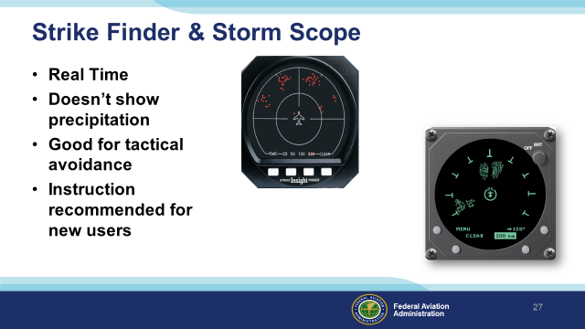 | Slide 28  Another real time solution is lightning detection equipment. Although it doesn’t show precipitation it does indicate lightning strikes that accompany convective weather. Some installations integrate radar and storm scope information on a multi-function display.  As with radar, instruction is highly recommended for new users.  (Next Slide)
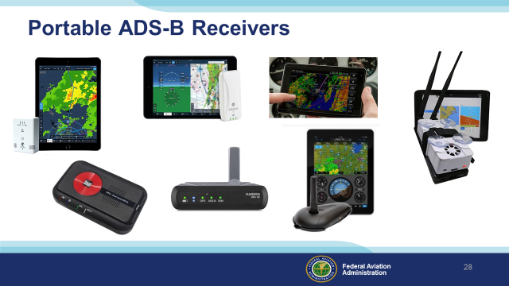 | Slide 29  If you don’t want to equip with a panel-mounted ADS-B In, there are many portable ADS-B Receivers to choose from. These receivers can transmit text and graphics to a variety of portable devices and displays. One caution here – you’ll need to have sufficient battery capacity or auxiliary power available to power receivers and displays for the planned duration of your flight and any delays or diversions that may occur.  (Next Slide)
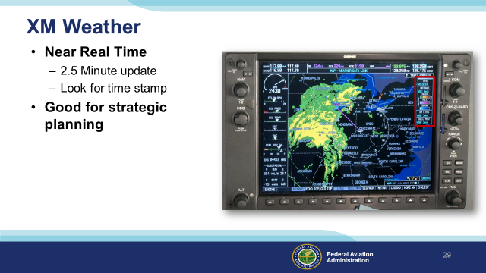 | Slide 30  XM Radio is a subscription service that provides test, graphical, and audio information to en route users. XM Weather imagery is processed in near real time – usually at two and a half-minute intervals. But the imagery information could be older so, as with any weather information, be sure to check the time that the graphic data was collected.  (Next Slide)
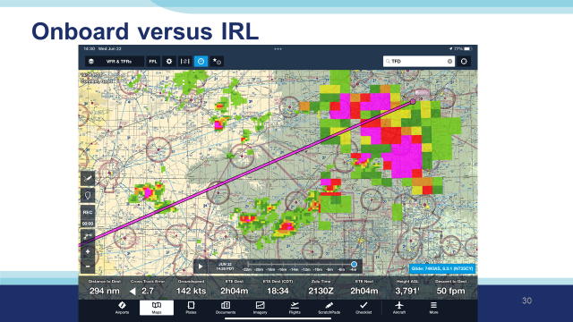 | Slide 31  In ForeFlight, you get little control over what radar images you see. It simultaneously shows both Regional – nearer to the aircraft – and CONUS – more distant. You can tell by the increased resolution nearer to the aircraft.  (Next Slide)
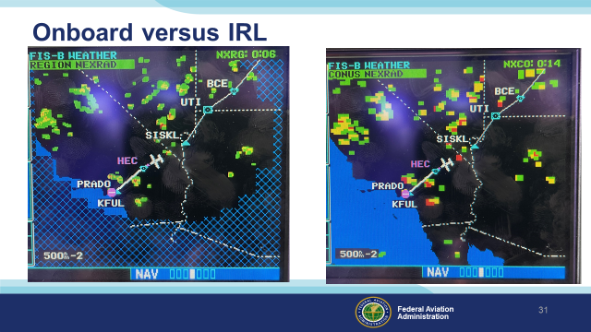 | Slide 32  This clearly illustrates the difference between Regional and CONUS Nexrad data. The hatched area is beyond the range of the regional. Better resolution, but more limited range. CONUS is better range, but lower resolution. Also note the difference in age of the newest data, 6 minutes old versus 14 minutes old. Keep in mind, this is how long ago the data was received by the device; not the time the data was gathered nor the time the image was created.  (Next Slide)
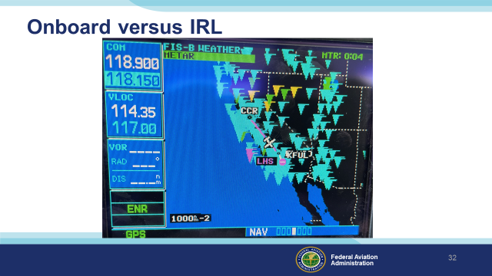 | Slide 33  This is the graphical METAR display on the GNS530W with FIS-B data received through a GTX345 transponder. Flags are color coded to indicate the current weather.  (Next Slide)
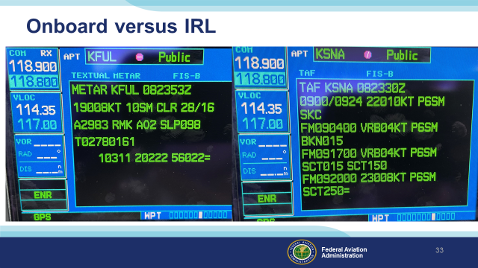 | Slide 34  Textual METAR and TAF info. Note: ATIS is not available, just the METAR and SPECI data. So, you still need to listen to the ATIS to get NOTAMs and Approach and Runway information.  (Next Slide)
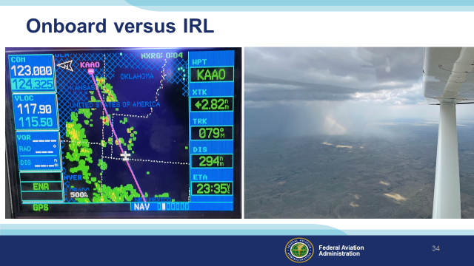 | Slide 35  Here’s an example taken from a GNS530W showing regional Nexrad data. Note the hashmarked areas beyond the range of current data. (Click)  For comparison, here’s an image taken out the window looking at the same weather. When flying near an area like this, I like to keep an eye on reported ceilings at nearby airports to ensure that I can stay well below those ceilings.  (Next Slide)
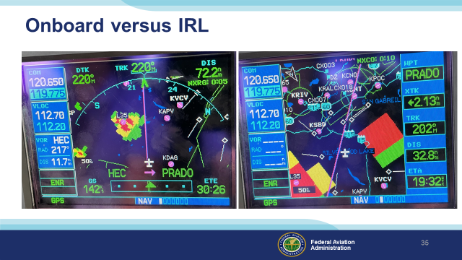 | Slide 36  Left is Regional Radar via ADS-B, Right is CONUS Radar.  Note the different ages: they are different data and have a different transmit schedule. Regional is 150-250NM from the ADS-B transmitter site. It is higher resolution than the CONUS image. Both types of radar data are transmitted in “chunks”, and it will take several chunks to make a complete picture.  These are “composite” radar images. That is, a composite of the radar picture at all tilt angles. There is precipitation somewhere in that column of space; not necessarily all at one altitude. We have no control over the tilt angle or radar gain control, so we can’t really analyze that column of air from onboard.  Note the difference in “blockiness” between the two images. This illustrates the resolution difference between the two types of radar images.  Note the severe contouring… the transition from black (no return) through green and yellow to red, sometimes directly from black to red with no transition. This indicates areas of extreme convection that should be avoided.  (Next Slide)
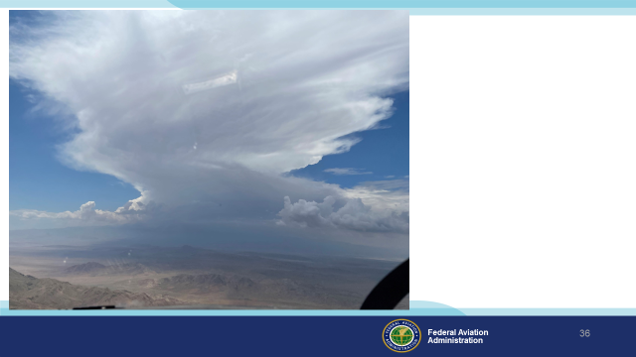 | Slide 37  This is the visual on the storm to the left of our track.  (Next Slide)
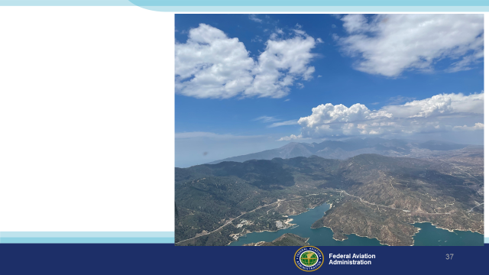 | Slide 38  And this is the visual to the storm on the right of our track. Not nearly as scary as the CONUS image would have let us believe.  (Next Slide)
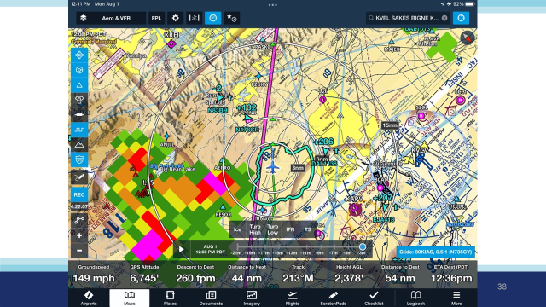 | Slide 39  Here’s an iPad/ForeFlight Screenshot of the same weather. Note weather on the right is almost non-existent, while we see heavy contouring over Big Bear Lake, as we saw on the installed avionics as well as out the window.  (Next Slide)
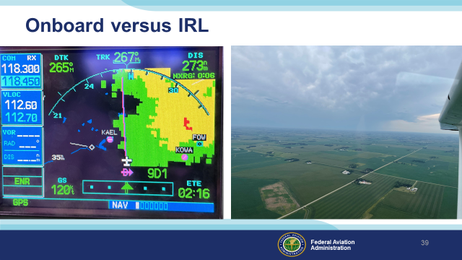 | Slide 40  Here’s an example of mild contouring… Notice wide swaths of green and yellow, with just a touch of red way away in the middle of it. This is not so bad to fly in.  I advise to stay underneath weather like this. If you get in it, it can easily outclimb you, you will lose site of it, and it’s easy to blunder into heavier portions of the weather. If you stay underneath it, you can stay visual with it and deviate as necessary.  (Next Slide)
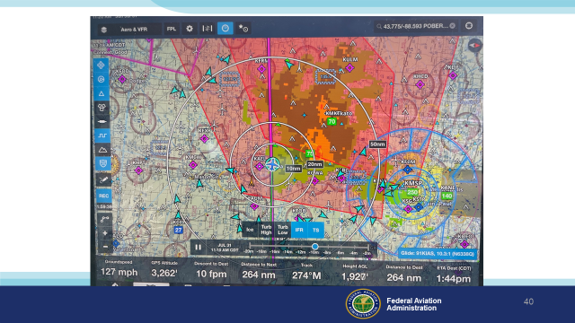 | Slide 41  Here’s another ForeFlight screen shot, with IFR and Thunderstorm SIGMETS overlaid with the radar. Note additional gradients of green.  (Next Slide)
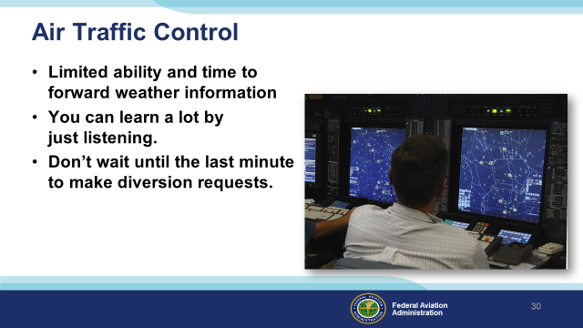 | Slide 42  Air traffic controllers are another in-flight weather information resource. They do have the ability to show weather on their displays but that capability is limited and when you most need information they may be  too busy – dealing with re routing requests – to provide it.  You can learn a lot by monitoring air traffic control frequencies though. You’ll hear what pilots are requesting and what ATC can provide. If you make your weather decisions with that in mind your requests are more likely to be granted.  Once again – don’t wait till the last minute to request a diversion. ATC needs some time to process your request.  (Next Slide)
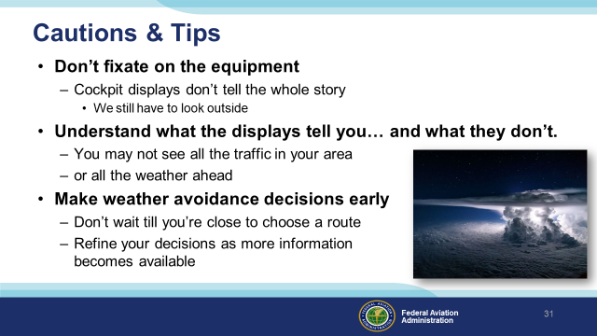 | Slide 43  In-cockpit information displays can be compelling distractions. Don’t fixate on the box to the exclusion of other flight management tasks. Cockpit displays – no matter how sophisticated and comprehensive they may be – don’t tell the whole story. A big part of our job is still looking out the window.  It’s important to thoroughly understand what the displays are telling you, and just as important, what they aren’t. Displays may not depict all the traffic in your area or all the weather ahead.  It’s best to make in-flight decisions early rather than waiting until the last minute to act. Landing to refuel is much less stressful if you have an hour or so of fuel remaining. Likewise rerouting or diversion is easier if you have some maneuvering room and time to select the best alternative.  By continuous reference to all weather resources available to you in the cockpit, you’ll have a comprehensive picture of the weather and any decisions will be well informed.  (Next Slide)
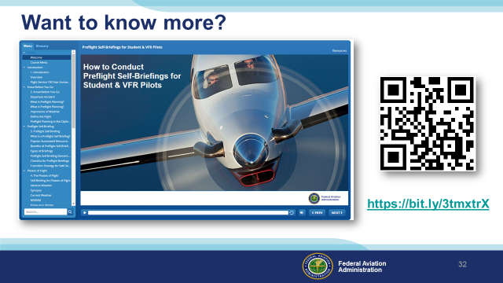 | Slide 44  Accurate weather information is vitally important to all pilots. In this presentation we’ve told you what’s available in the way of weather info sources, but we’ve said little about how to use them. For that we recommend FAAs new course – How to Conduct Preflight Self-Briefings for Student & VFR Pilots. The course is available on FAASafety.gov.  (Next Slide)
 | Slide 45  Can you imagine how well professional athletes would perform if they didn’t practice between games or stay in shape during the off season? (Click)  Would you choose to be treated by doctors who had no continuing education since graduating from medical school? (Click)  Or how about a professional pilot flight crew who never train for emergencies?  Pros know that proficiency is not a destination but rather a journey that never ends.  Regular training keeps the them at peak performance every time they take to the air.  (Next Slide)
 | Slide 46  Proficiency training works for General Aviation pilots too. Pilots who participate in the FAA WINGS Pilot Proficiency program fly with more confidence. They and their passengers are comfortable in the air. And proficiency training can expand our horizons by exploring the operational capabilities of our present aircraft or introducing us to more complex and capable planes as well as more challenging destinations.  Most importantly - proficiency training keeps us safe. (Click)  And pilots who earn WINGS phases also qualify for a flight review.  (Next Slide)
 | Slide 47  So why WINGS? Well proficiency is key to success in almost every thing worth doing – especially flying. Proficient pilots are confident, capable, and safe.  WINGS is a proficiency training system specifically designed for general aviation pilots and, regular participation will keep you on top of your flying game.  (Next Slide)
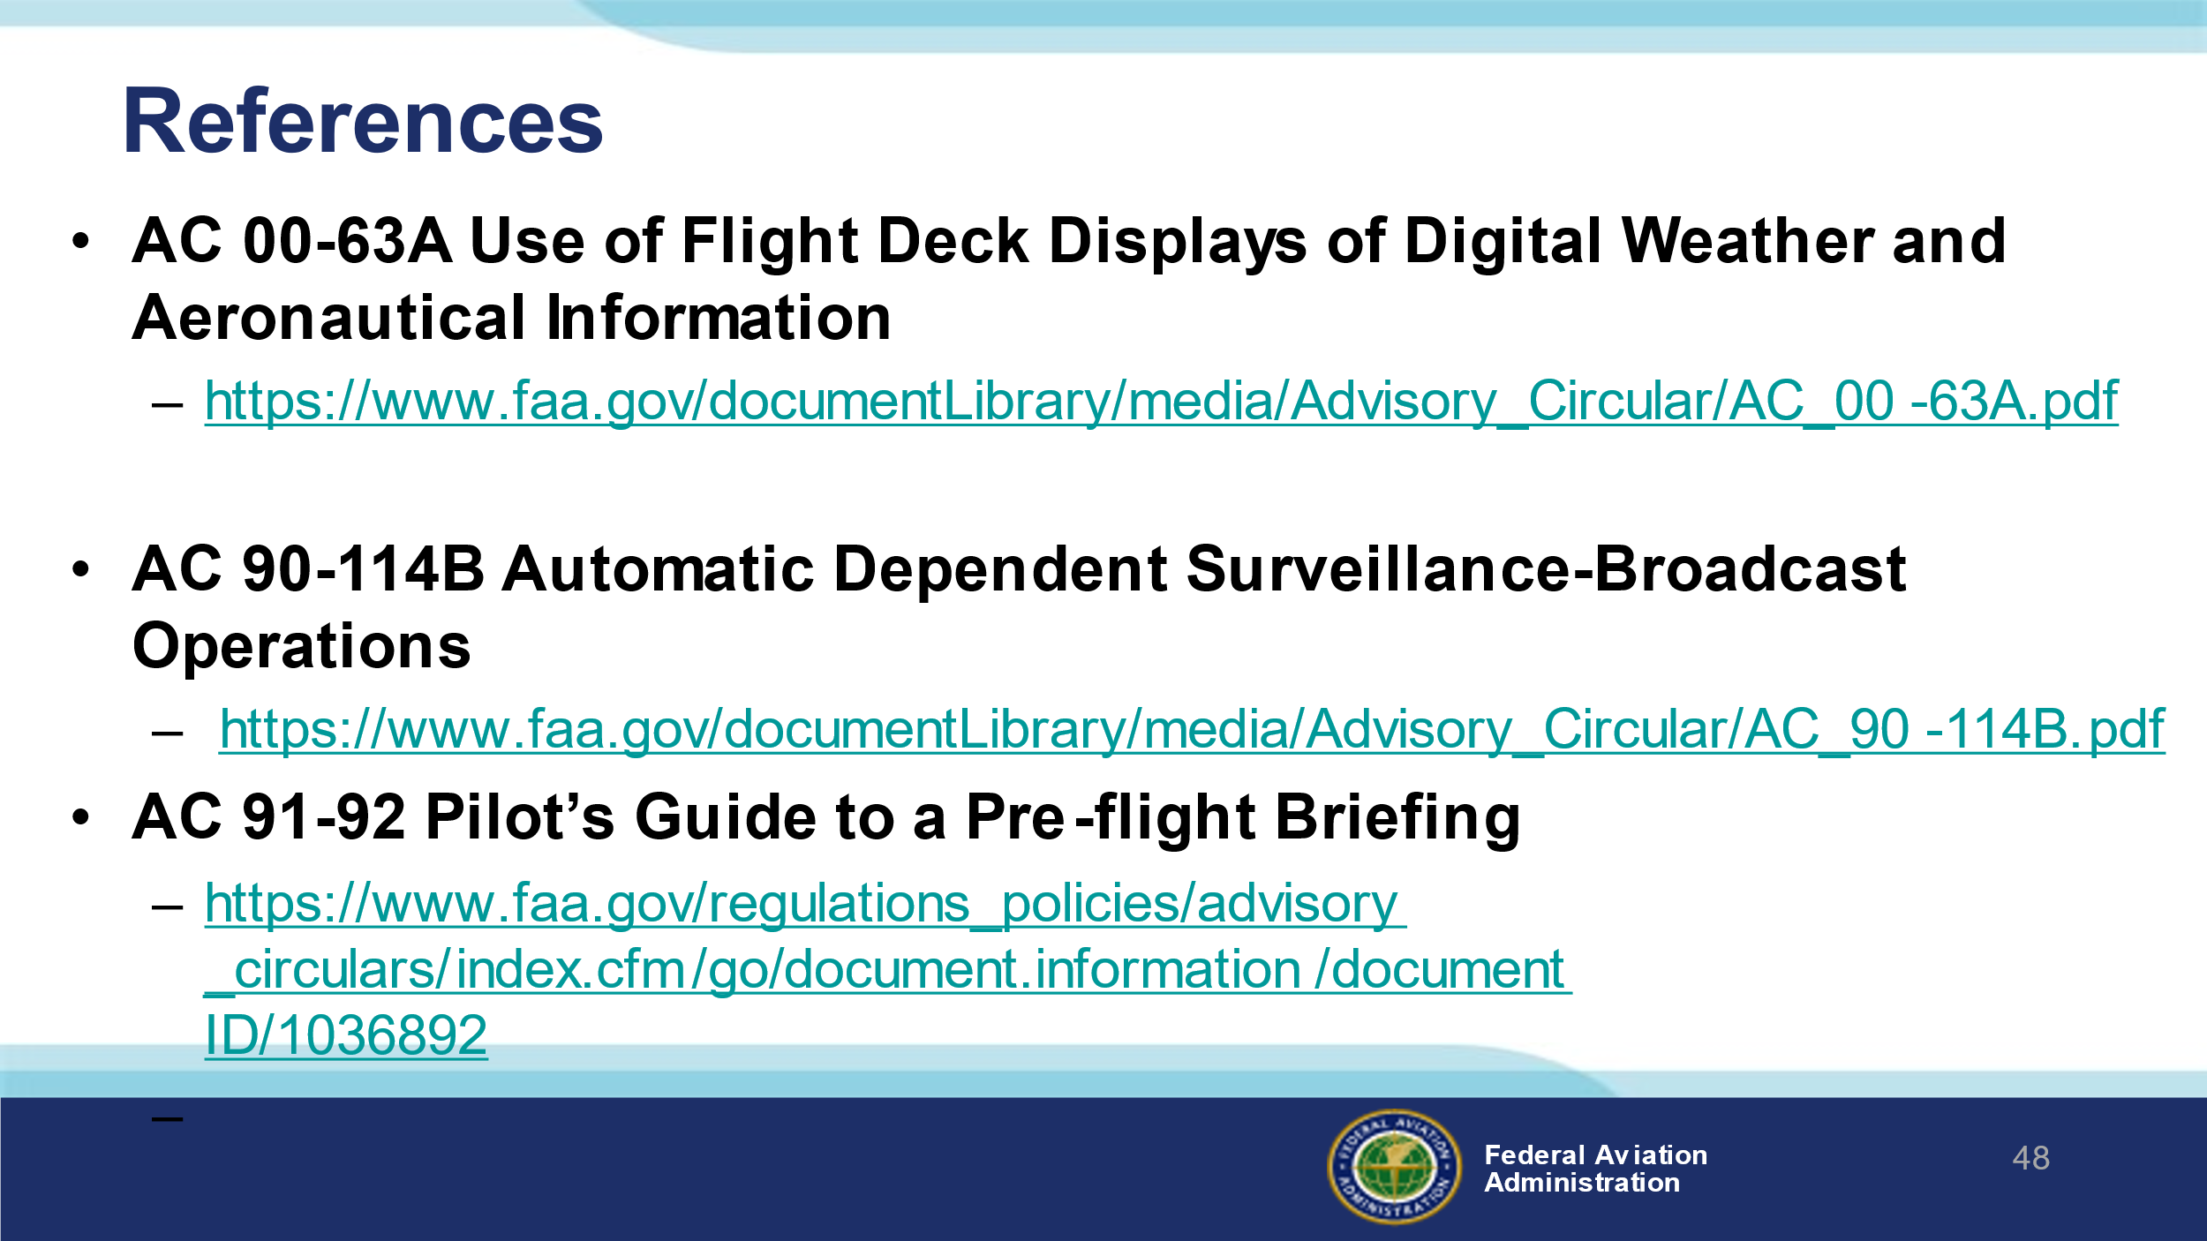 | Slide 48  Here are a few references for additional information:  I’ll leave this slide on screen while I take some questions from the audience.  AC 90-114B Automatic Dependent Surveillance-Broadcast Operations  AC 00-63A Use of Flight Deck Displays of Digital Weather and Aeronautical Information (This AC has a Change Revision CH2 coming out very shortly) This AC addresses both the Federal Aviation Administration (FAA) FIS–Broadcast (FIS-B) provided through the Automatic Dependent Surveillance–Broadcast (ADS-B) Universal Access Transceiver (UAT) network and non-FAA FIS systems provided through commercial data link services.  Presentation note: Take questions from the audience while they copy information from the screen. Then:  (Next Slide)
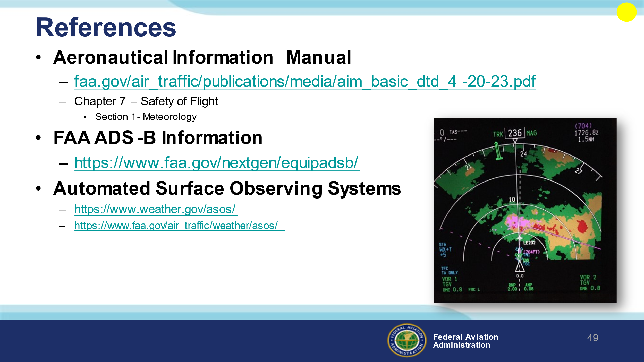 | Slide 49  Here are a few references for additional information:  I’ll leave this slide on screen while I take some questions from the audience.  Presentation note: Take questions from the audience while they copy information from the screen. Then:  (Next Slide)
 | Slide 50  Safety Management Systems are a set of policies and processes that can increase the safety and efficiency of any flight operation. And FAA is bringing SMS to General Aviation. You may have heard of SMS but thought it was only for large organizations but actually SMS can be scaled to fit any operation large or small.  There are 4 major components to a Safety Management System (Click)  Safety Policy – a documented commitment to safety that runs from the head of an organization to its newest member. (Click)  Safety Risk Management – a process that identifies hazards within an operation, determines to what extent an identified hazard may impact flight safety, and controls the risk of occurrence to an acceptable level. (Click)  Safety Assurance – By collecting and analyzing information derived from safety performance data Safety Assurance ensures the performance and effectiveness of Safety Risk Controls. (Click)  Safety Promotion communicates safety information and commitment throughout the organization. (Click)  You can find more information about Safety Management Systems at the URL on the Screen.  (Next Slide)
 | Slide 51  Presentation Note: You may wish to provide your contact information and main FSDO phone number here. You can also add WINGSPro contact information.  Modify with your information or leave blank.  (Next Slide)
 | Slide 52  Your presence here shows that you are vital members of our General Aviation Safety Community. The high standards you keep and the examples you set are a great credit to you and to GA.  Thank you for attending.  (Next Slide)
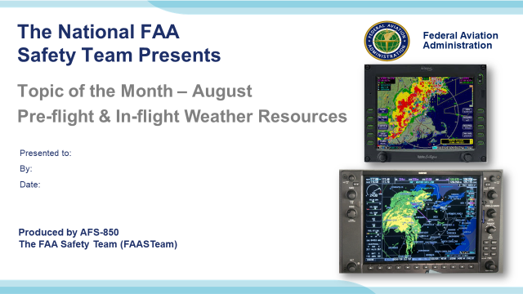 | Slide 53  (The End)

Appendix I – Equipment and Staging
Equipment:
- Projection Screen & Video Projector suitable for expected audience
  - Remote computer/projector control available at lectern or presenter location
    - In lieu of remote – detail a Rep to computer/projector control.
- Presentation Computer
  - Note: It is strongly suggested that the entire program reside on this computer.
- Back up Projector/Computer/Media as available.
- PA system suitable for expected audience
  - Microphones for Moderator and Panel
    - Optional Microphone (s) for audience
- Lectern (optional)
Staging:
- Arrange the projection screen for maximum visibility from the audience.
- Equip with PA microphones
- Place Lectern to one side of screen. This will be used by presenters and moderator

IMPORTANT – Once you have completed outreach on this topic, please help us track the outreach you have done by entering a PTRS record.
