General Aviation Joint Safety Committee
CFIT Working Group

Outreach Guidance Document
2023/10-29-295(I)PP

This outreach guidance is provided to all FAA and aviation industry groups that are participating in outreach efforts sponsored by the General Aviation Joint Safety Committee (GAJSC). It is important that all outreach on a given topic is coordinated and is free of conflicts. Therefore, all outreach products should be in alignment with the outline and concepts listed below for this topic.

Outreach Month: November 2025

Topic: Overreliance on Automation
The FAA and industry will conduct a public education campaign emphasizing the dangers of Overreliance on Automation and best practices for safe flight operations with Technically advance aircraft and avionics.

Background:

GAJSC study of Fatal General Aviation Loss of Control Accidents found that a significant number may have been been caused, at least in part, by pilot reliance on
aircraft automation rather than hand-flying skill and proficiency.

Teaching Points:

- Aircraft automation has reduced pilot’s physical workload but in many cases
increased cognitive workload.
- GA pilots quickly come to trust automated aircraft control and mistrust their hands-on flying ability.
- Relying on automated control quickly diminishes hand-flying proficiency.
- Pilot Deviations have increased despite the ability to navigate more accurately with GPS recievers and moving map displays.
- Pilots are not good at monitoring automated systems and consequently can miss significant deviations from plan and be surprised at what their aircraft are doing.

References:
- Overreliance on Automation PowerPoint
  - Available on the National FAASTeam Share Point site under Approved Resources.

- Human Factors for Pilots – on line courses on FAASafety.gov
  - Module 3 – Human Performance
  - Module 9 – Human Information Processing
  - Module 10 – Design and Automation

Abstract: Lasting 15 to 20 minutes, this presentation acquaints the audience with the challenges of modern GA aircraft and automated systems. Best practices for maintaining proficiency while flying with automated equipment are discussed.

Format: Information Briefing - Power Point presentation
Required Personnel – FAASTeam Program Manager or designated FAASTeam Rep (s)
Optional Personnel – AME’s and other medical practitioners who can speak on the topic of in-flight illusions.

National FAASTeam Support:
In addition to this guidance document, a Power Point presentation that supports the program and a folder containing background information are provided. FPMs and presenters are encouraged to customize this presentation to reflect each individual program.

Slides | Script
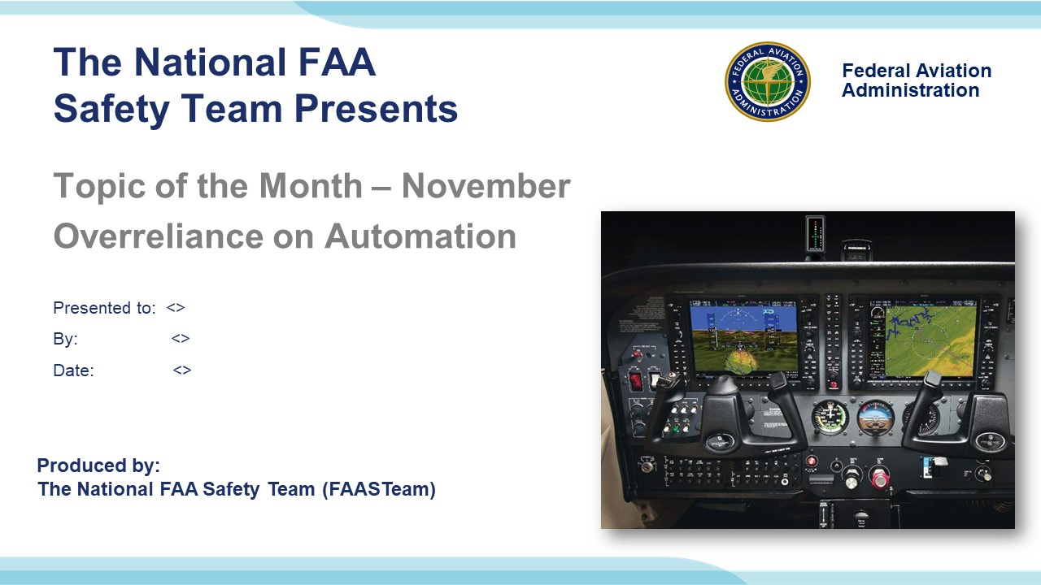 | Slide 1  2023/10-29-295(I)PP Original Author: John Steuernagle; POC Kevin Clover, National FAASTeam Program Manager (Operations), Office 562-888-2020.  Presentation note: This is the title slide for FY 2025 Topic of the Month – November – Overreliance on Automation.  Script - We have included a script of suggested dialog with most slides. The script will always appear in a non-italic font. Presenters may read the script or modify it to suit their own presentation style. See template slides 5 and 6 for examples of a slides with script.  Presentation Instructions - (stage direction and presentation suggestions) will be preceded by a Bold header: the instructions themselves will be in Italic fonts. See slides 2, for an example of slides with Presentation Instructions only.  Program control instructions - will be in bold fonts and look like this: (Click) for building information within a slide; or this: (Next Slide) for slide advance.  Background information - Some slides may contain background information that supports the concepts presented in the program.  .  The production team hope you and your audience will enjoy the show. Break a leg!  (Next Slide)
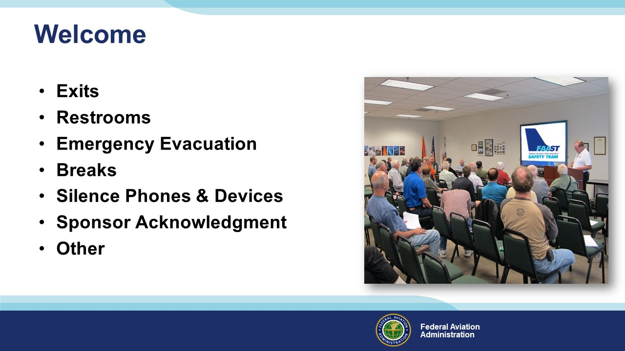 | Slide 2  Presentation Note: Here’s where you can discuss venue logistics, acknowledge sponsors, and deliver other information you want your audience to know in the beginning.  You can add slides after this one to fit your situation.  (Next Slide)
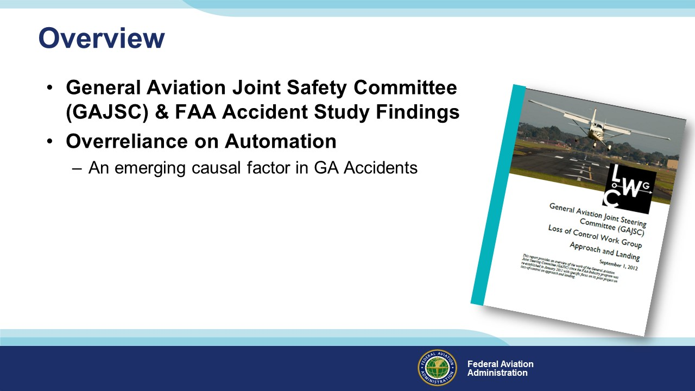 | Slide 3  In this presentation we’ll talk a little bit about recent GAJSC and FAA studies that deal with pilot management of automated aircraft systems. As the GA fleet equips with advanced technology, those studies have identified Overreliance on Automation as an emerging causal factor in accidents and incidents.  Presentation Note: If you’ll be discussing additional items, add them to this list.  (Next Slide)
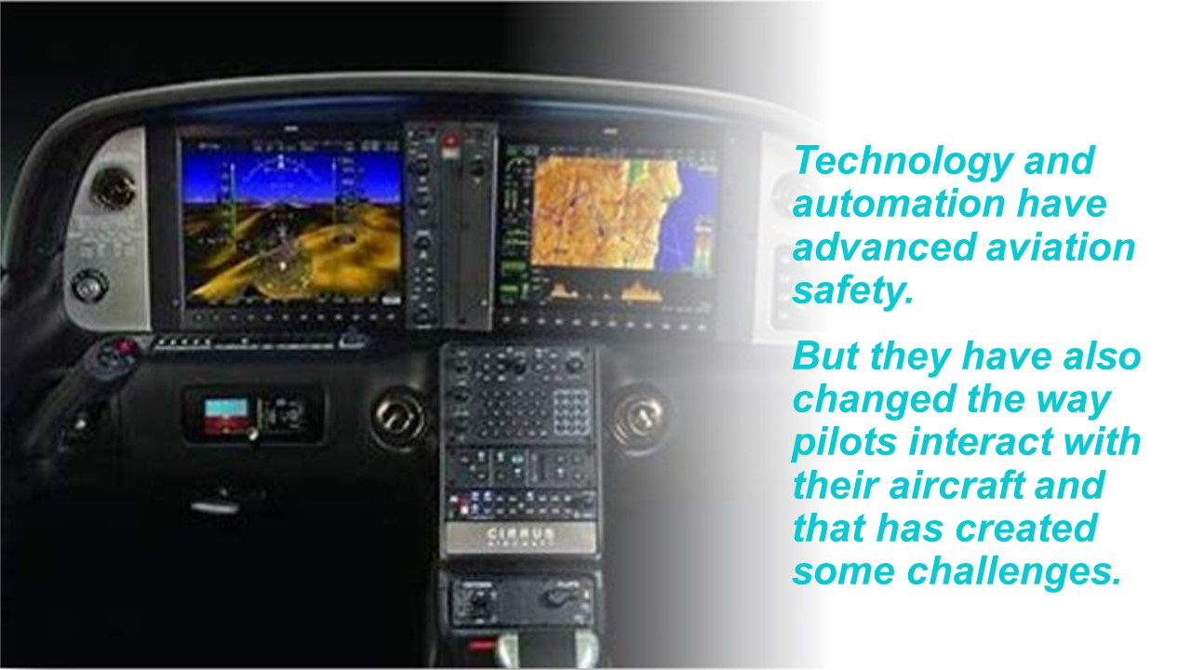 | Slide 4  Today, let’s turn our attention to Technology and Automation.  Technology and automation have indisputably advanced aviation safety, but they have also changed the way pilots – particularly general aviation pilots – interact with their aircraft and that has created some challenges.  Interestingly, those changes are not confined to aviation.  (Next Slide)
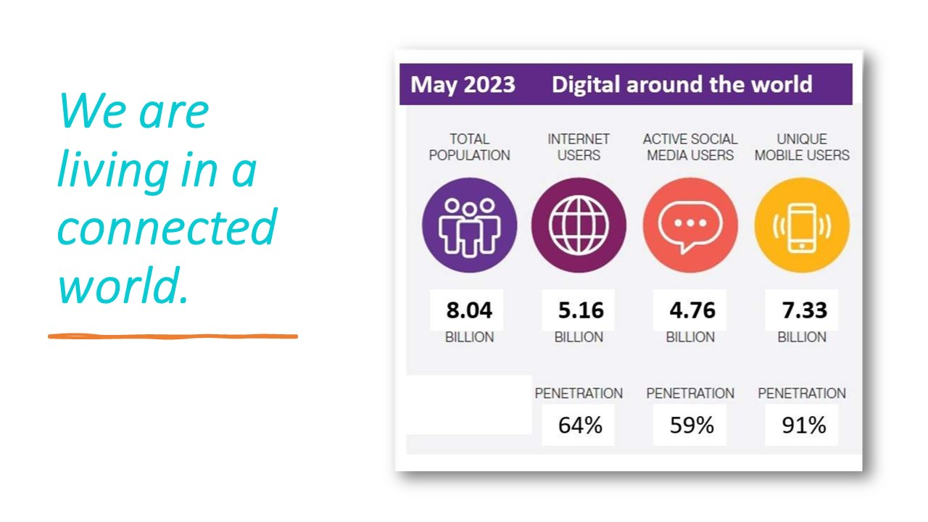 | Slide 5  We are living in a connected world. More than half the world's population are internet users and a staggering 91% own at least one cell phone. We are bombarded with more information from more sources more frequently than ever before. Managing the flow and making sense of that information is challenging all of us - not only on the ground but also in the air.  Our connected society has brought information and education to remote locations throughout the world and to urban populations in pandemic isolation. Now learning can take place wherever there is a computer or mobile device and internet access. But distance learning comes at the expense of traditional and critical social interactions in and out of classrooms. Laboratory exercises are difficult or impossible to conduct when students are in hundreds of individual locations, and the astounding volume of on-line information and opinion may compromise development of critical thinking skills.  Communications that could take weeks less than one hundred years ago are now virtually instantaneous. But extended, thoughtful dialogs and correspondence have been replaced by thousands of sound bites and text messages. Internet and social media addiction is a real issue as technology, intended to bring us closer together has, in many cases, enabled social anonymity and driven us further apart.  In the cockpit, automation has greatly reduced the airplane handling workload, but it also requires pilots to perform in areas where humans don't do so well.  (Next Slide)
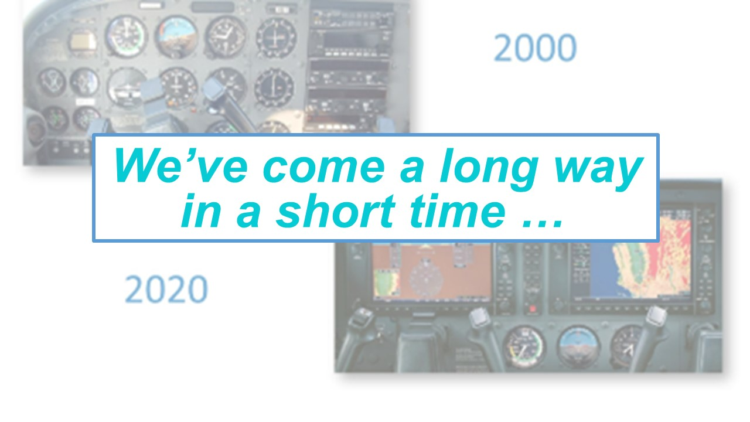 | Slide 6  We’ve come a long way in a short time, and pilots’ roles have changed from active aircraft control to passive monitoring of automated control systems.  Paradoxically, technology and automation have eased pilot workload in some areas but increased it in others. With modern navigation systems, we can program an entire flight before takeoff, but making changes to that plan can be much more complicated than tuning a new Nav frequency and intercepting a course.  Cockpit automation has greatly reduced the airplane handling workload, but it also requires pilots to perform in areas where humans don’t do so well.  (Next Slide)
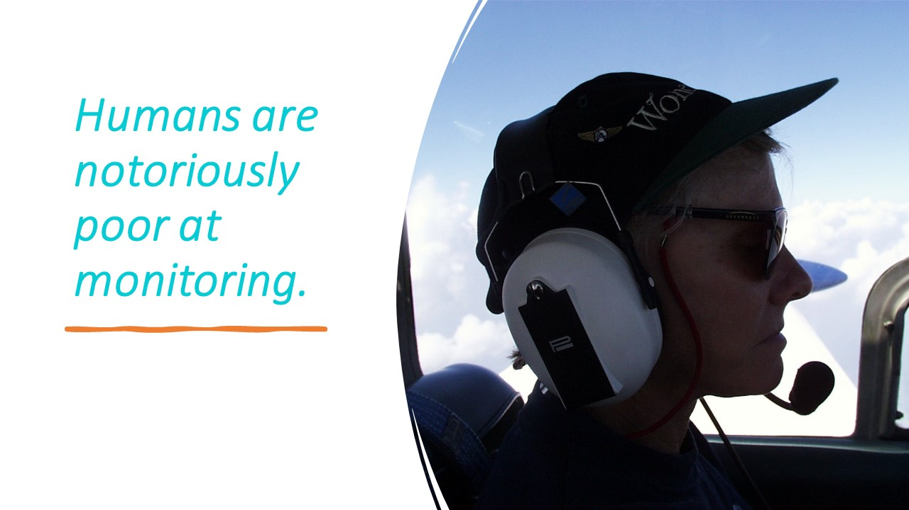 | Slide 7  Humans are notoriously poor at monitoring. We quickly become bored and may miss important information. Monitoring and managing automated systems can decrease the time spent scanning for traffic. And although autopilots can fly more precisely than any human, overreliance on them quickly degrades hand-flying skill and confidence.  (Next Slide)
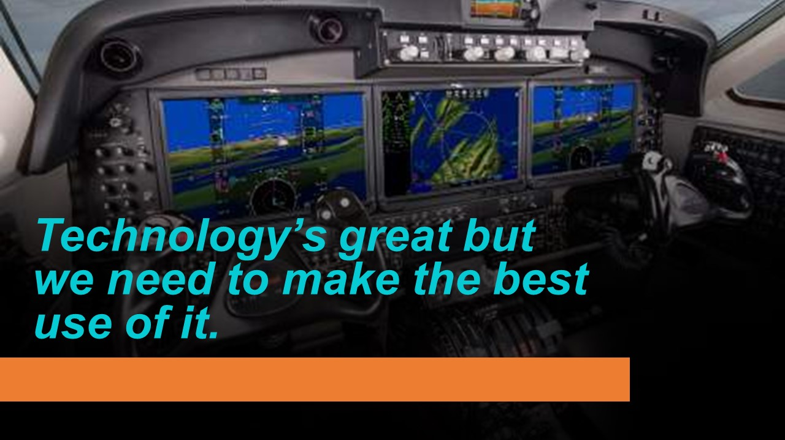 | Slide 8  On balance though, technology and automation have made and will continue to make huge improvements in aviation safety. But to realize full benefit from aviation technologies, pilots need to know how to make the best use of them.  That’s a challenge because there’s a lot more for us to manage than ever before.  (Next Slide)
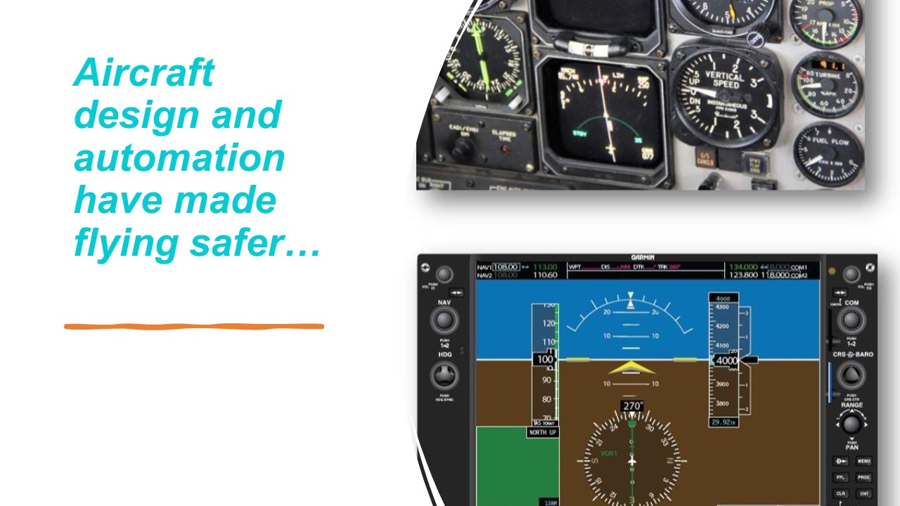 | Slide 9  Aircraft design and automation have made flying safer. But, to take advantage of safety innovations, pilots must adapt to the equipment and the procedures for its use. Maintaining aeronautical knowledge and skills is just as important now as it has been in the past. A regular program of proficiency training is essential for pilots to bring their 'A game' to every flight.  (Next Slide)
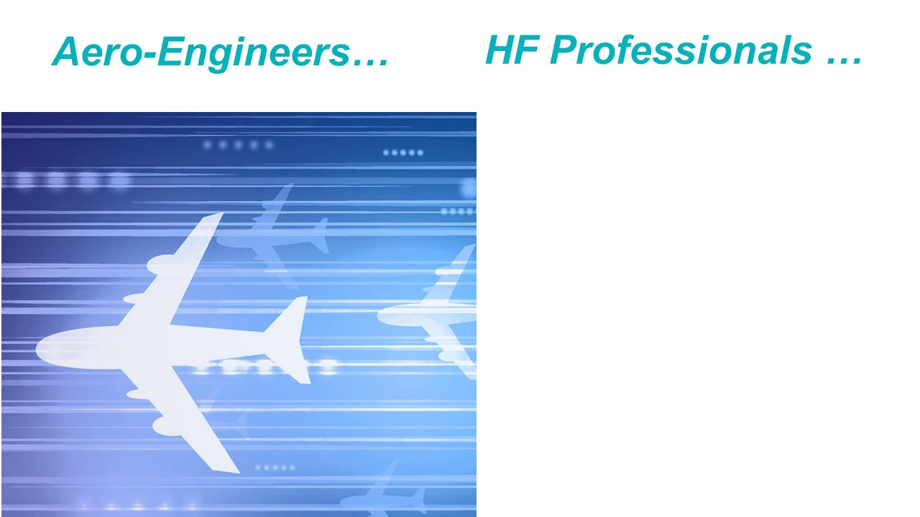 | Slide 10  When considering recent technological advances Aeronautical Engineers would likely say “it's a shame that humans haven't developed at the same rate”. (Click)  But Human Factors Professionals know that people don't evolve at the same rate as technology, and they would likely say, 'it's too bad that equipment designers don't give proper consideration to human factors when introducing new technology’.  In fact, equipment designers do give a lot of consideration to the user interface. Well-designed interfaces feel intuitive. Those that are not, can leave pilots scratching their heads and wondering, 'What's it doing now?’  It would be nice if all technology were intuitive to all users but that just isn't possible. Gone are the days of standard cockpit instrumentation. Aviation automation is complex, and every manufacturer feels their design is best. Let’s take a look at the complexity Paradox.  (Next Slide)
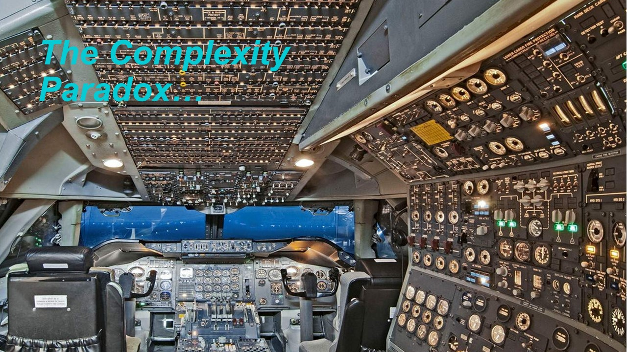 | Slide 11  As aircraft evolved, designers increased the number of systems and displays, intending to reduce errors by providing pilots with more and better information on which to base their decisions.  But the proliferation of warnings and displays actually had the opposite effect. Pilots were still missing important information, making mistakes and poor decisions.  In attempts to design pilot error out of the system, designers responded with even more complex automated systems. But that led to increased pilot demands to monitor those systems for malfunctions and failures. Once again, pilots were becoming task saturated and they were making mistakes.  (Next Slide)
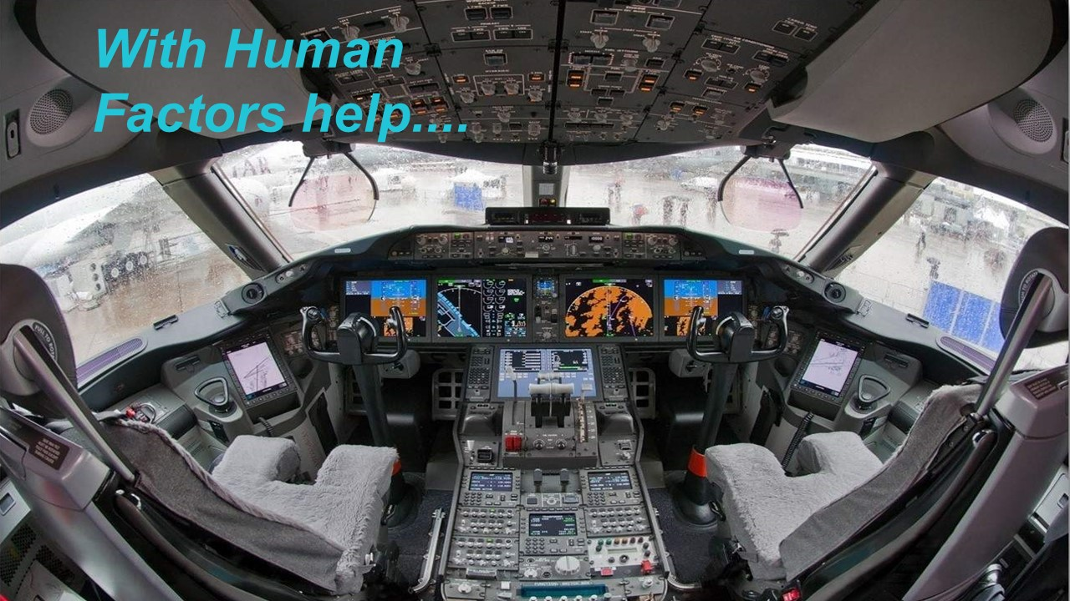 | Slide 12  With Human Factors help, designers are now focused on improving displays and the interactions between pilots and cockpit automation, referred to as the Human-Machine-Interface (HMI).  Cockpits are still very complex places to work, and Flight Engineers are no longer there to share the load but Human Factors assistance in automation design has resulted in a manageable pilot workload.  And there’s one big advantage airline pilots have that many of us don’t. What would that be?  Presentation note: Collect audience responses to the question. They may include, airline training, second pilot, etc. The answer we’re looking for is, Standard Equipment. Most airline pilots fly only one type of Flight Management System. GA Pilots may be called upon to deal with several models and manufacturers.  When answers have been collected and discussed:  That’s right – Airline pilots usually fly one type of aircraft and one Flight Management System. GA Pilots fly many makes and models of aircraft and we may have to manage several navigation systems.  And we’re often required to transition from 'steam gauge' instrumentation to glass cockpits and occasionally from glass to steam gauges.  (Next Slide)
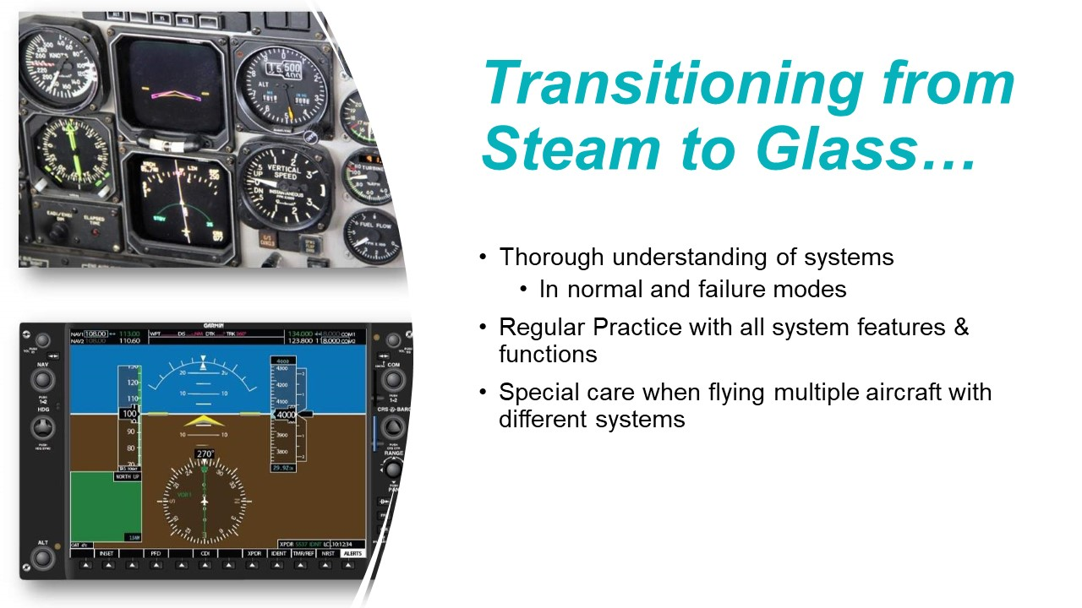 | Slide 13  As with the airlines, Electronic Flight Information System and Display Technology brings more information to General Aviation cockpits than ever before. But it comes at a price. Each make and model requires pilots to:  - Acquire a thorough understanding of the systems and their use in normal and failure modes.  - Practice regularly with all system features and to maintain proficiency.  - Take special care when flying multiple aircraft with different systems. (Click)  We talk a lot about transitioning from steam to glass but what about the other way around? As you might imagine, pilots who learned in glass cockpits first have difficulties in transitioning to steam gauge aircraft.  Although instrument interpretation is straight forward, there’s a lot of information missing and multiple sources to provide it.  Thorough familiarity with the equipment you’re flying is essential – especially if you’re flying IFR.  (Next Slide)
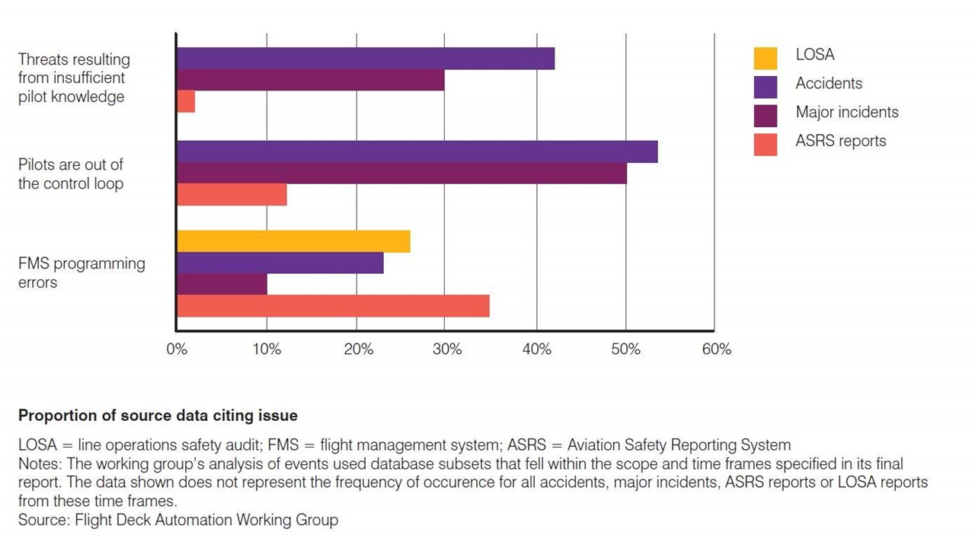 | Slide 14  An analysis of Accident, Major Incident, Line Oriented Safety Audit (LOSA), and Aviation Safety Reporting System (ASRS) data reveals some interesting information.  - Insufficient pilot knowledge was cited in 30 to 50% of accidents and major incidents.  - Quality instruction and regular proficiency training will help, as will reducing the volume of knowledge necessary to conduct safe operations.  - Pilots out of the control loop were factors in 50 to 55 % of accidents and major incidents.  - Pilot engagement is vital to safe operations but it's hard to preserve pilot engagement when principal pilot tasks consist of monitoring the performance of automated equipment.  - Flight Management System programming errors were found in fewer accident/incident events but  they were well represented in ASRS reporting and LOSA audits.  - The data show us that errors are common, and although they don't often result in accidents or incidents, designing 'human friendly' systems and error-tolerant procedures is essential to reducing the number and consequences of errors.  - Well-designed human-machine interfaces reduce programming complexity resulting in fewer programming mistakes.  This was obviously a study of professional pilots but we’re seeing essentially the same result in GA operations.  (Next Slide)
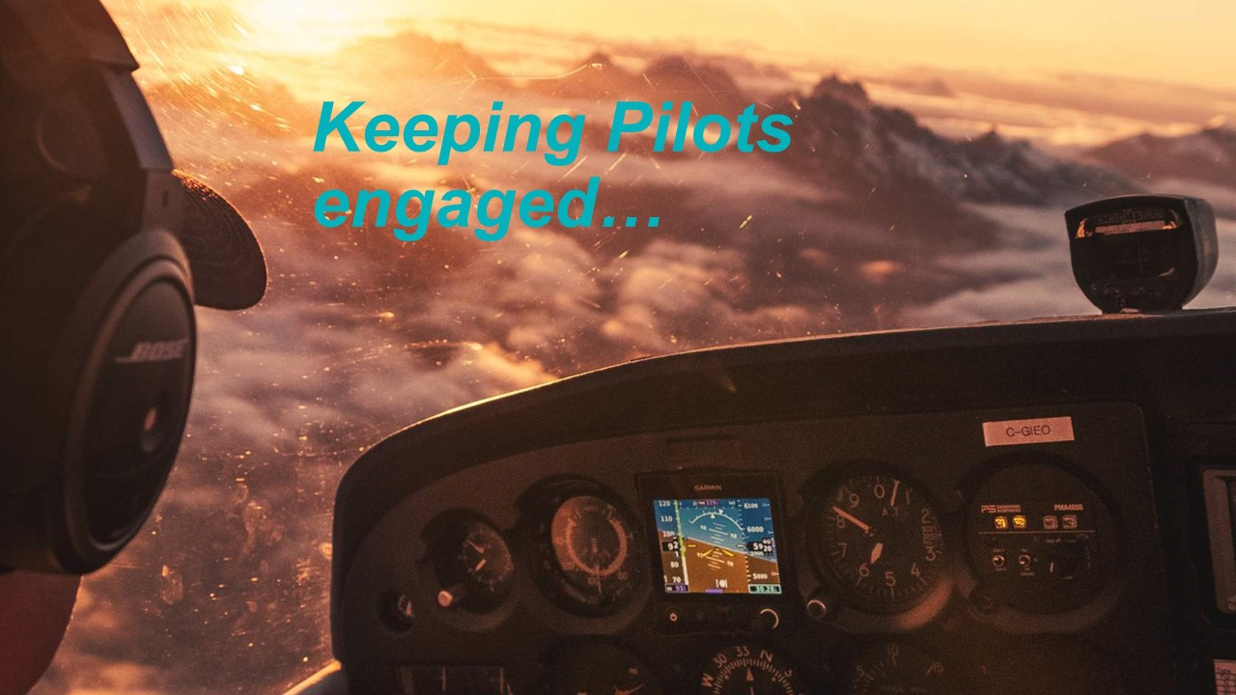 | Slide 15  Keeping Pilots engaged has always been a challenge and, with commercial flights lasting more than fifteen hours, fatigue and boredom are definitely factors to consider. Airline staffing and operations procedures provide for crew rest periods during long flights. But what about General Aviation Pilots?  GA Pilots may not fly fifteen-hours at a stretch, but we do put in long workdays that can easily exceed the allowable duty hours for professional crews. And speaking of crews, that’s a luxury most GA Pilots don’t have. So, most of us are going it alone – often at the end of a long day. These are times when our minds tend to wander and that’s not helpful when we need to be fully engaged in the flying tasks at hand.  Note: Human Factors Module 3 – Human Performance, addresses best practices for dealing with fatigue.  (Next Slide)
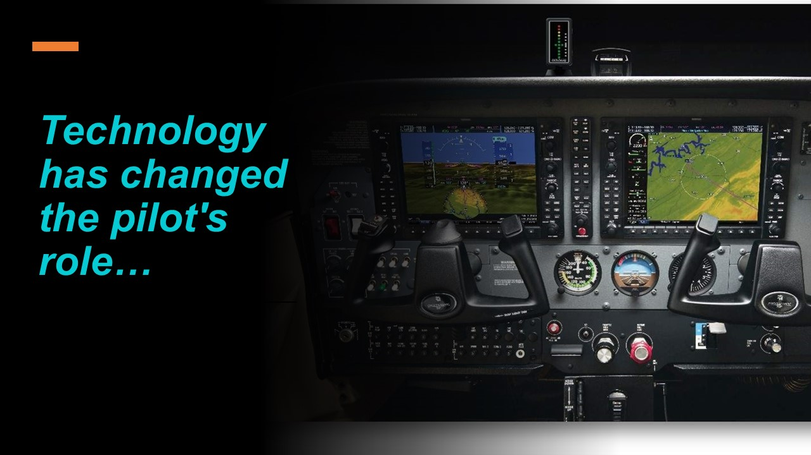 | Slide 16  We've already discussed the fact that technology and automation require pilots to spend less time controlling their aircraft and more time monitoring automated systems. Advanced cockpit monitoring and alerting systems include:  - devices in the cockpit such as autopilots and auto-throttles that automate or eliminate pilot actions,  - other devices such as altitude and heading alerts that warn pilots of deviations,  - and devices such as ground proximity warning (GPWS), terrain awareness warning system, and traffic collision avoidance system (TCAS) resolution advisories that demand action.  - Some automated devices such as stick shakers and load limiters will either prevent pilot actions or autonomously take action if the aircraft is about to exceed flight limitations.  (Next Slide)
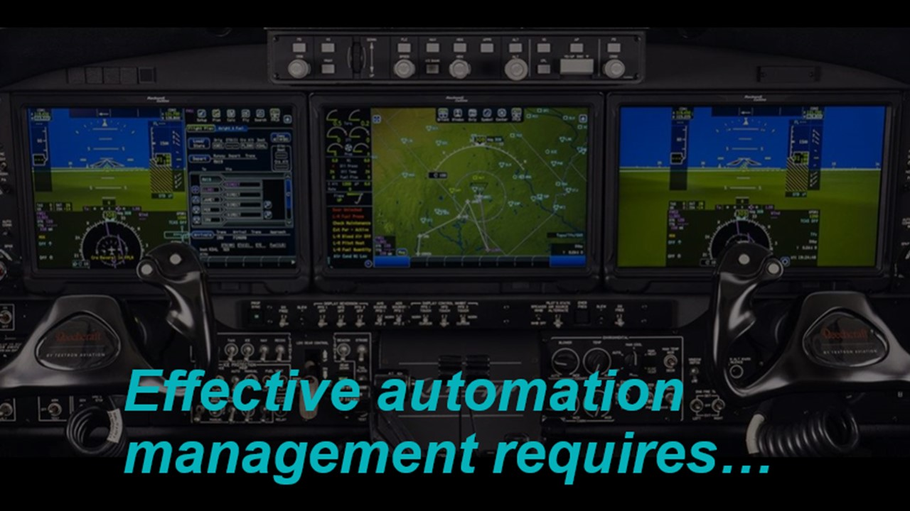 | Slide 17  Effective automation management requires…  - Thorough pilot understanding of normal and failure mode system operation and performance.  - Pilot proficiency in programming, monitoring, and reversion to manual control.  That’s a lot of responsibility for pilots to assume and that responsibility can sometimes be challenged by the three key objectives of cockpit automation that we’ll address in the next slide.  (Next Slide)
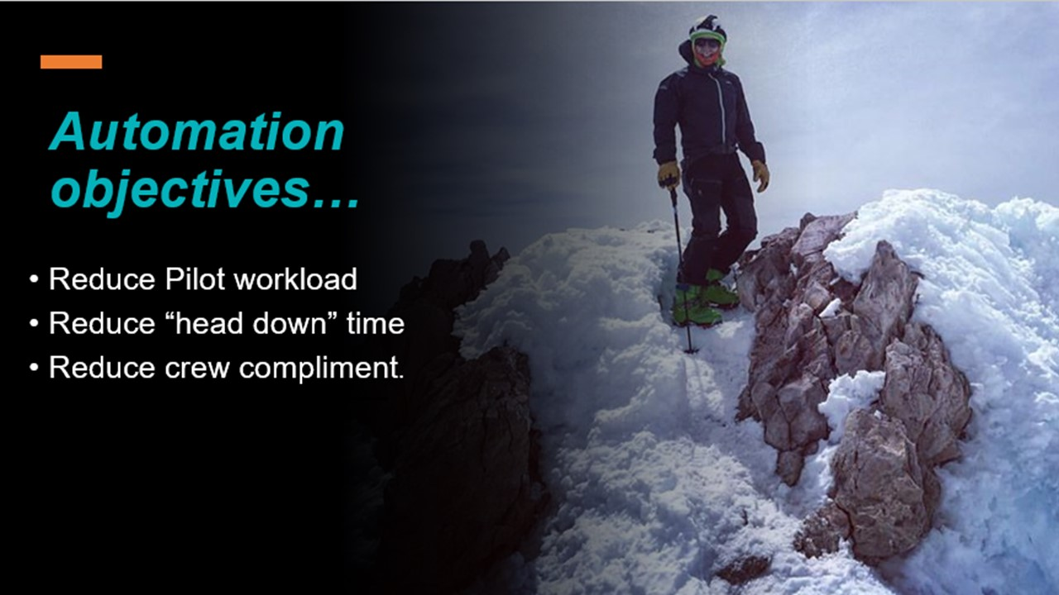 | Slide 18  Automation does reduce physical workload, but physical activity promotes task engagement and some feel that cognitive workload actually increases with automation. Also, aircraft handling skill diminishes rapidly with autopilot use. Flight Instructors need to ensure that our students maintain a balance between monitoring and actively controlling their aircraft. (Click)  Automating flight controls does ease pilots’ responsibility to constantly reference flight and navigation instruments, but increased programming and system monitoring tasks have, by some accounts, actually increased “head down” time. Once again, it’s a question of balance. We must ensure that we spend most of our time heads up and fully engaged with flight progress.  Thankfully, reducing crew compliment is an automation objective that we don’t have to be concerned with ….. Yet. Automation has reduced cockpit workload sufficiently to eliminate Flight Engineer positions in most new transport category aircraft. Automated system monitoring and alert functions warn pilots of incipient problems. As automation improves, there is growing interest in reducing flight crew to a single pilot. We have also seen this trend in high-end GA aircraft that once required two pilots but now require only one. Obviously, solo pilots operating complex aircraft must be thoroughly familiar with and competent in operating all aircraft systems and controls.  (Next Slide)
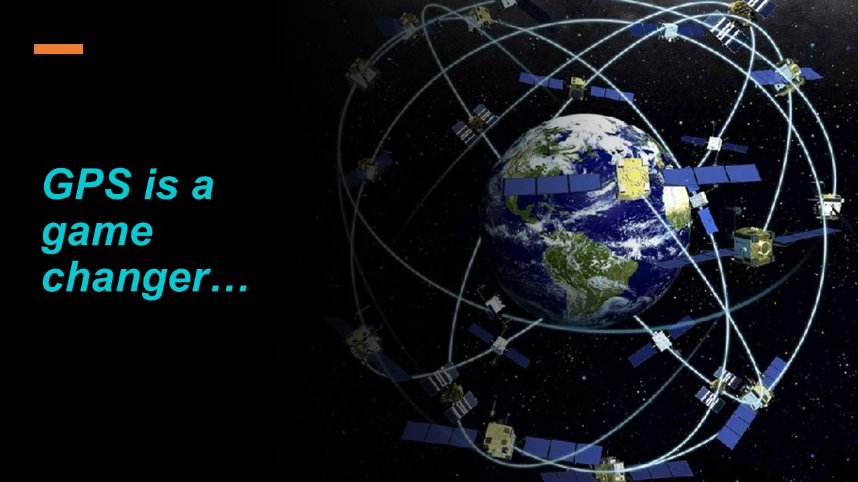 | Slide 19  GPS has revolutionized navigation for everyone and changed the judgement, decision making, navigation strategies, and skill levels of GA Pilots.  General Aviation pilots have quickly become overconfident in GPS navigation and moving map technology to the detriment of traditional navigation skills and it's not uncommon for them to have no backup plan for GPS outages.  We’ve even seen an increase in Pilot Deviations with the advent of GPS navigation.  (Next Slide)
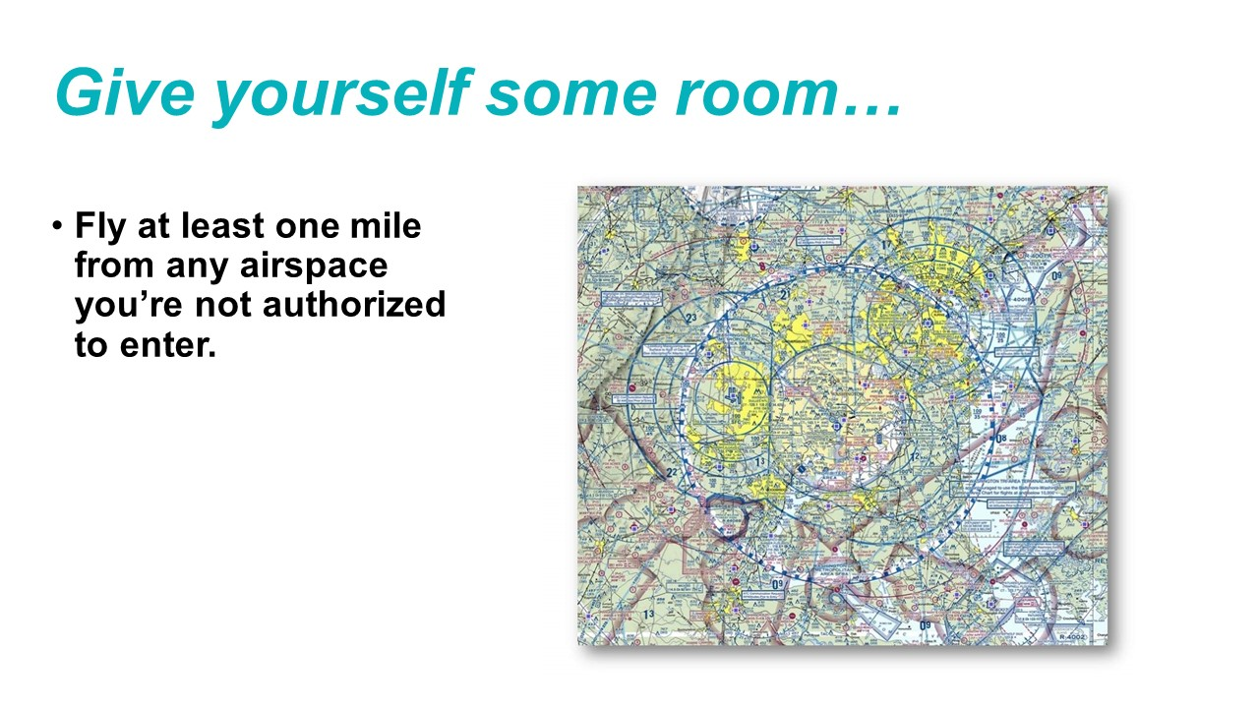 | Slide 20  GPS and moving map technology have revolutionized navigation. But the precise positioning information they provide has emboldened some pilots to fly very close to areas they are trying to avoid. (Click)  ATC radar trumps GPS in these cases so pilots are well advised to give themselves a buffer of at least a mile from any airspace they are not authorized to enter.  (Next Slide)
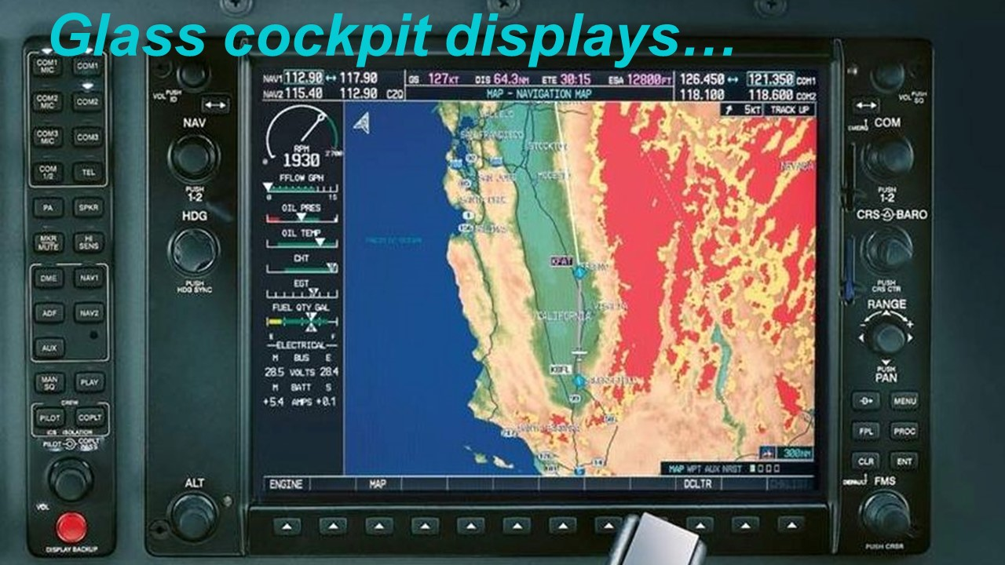 | Slide 21  Glass cockpit displays present another paradox - today's flexible displays feature a myriad of information possibilities that support heightened situational awareness, but the panoply of options can lead to confusion and limit pilots' situational awareness.  As their name implies, multi-function displays (MFDs) have many options for choosing what information will be presented and how aircraft automation will act on it. This has led to problems with:  - incorrect data entry,  - programming errors,  - missing critical information,  - automation mode confusion,  - difficulty in accessing critical information quickly, particularly when it is buried within menus controlled by soft keys and,  - degraded situational awareness.  (Next Slide)
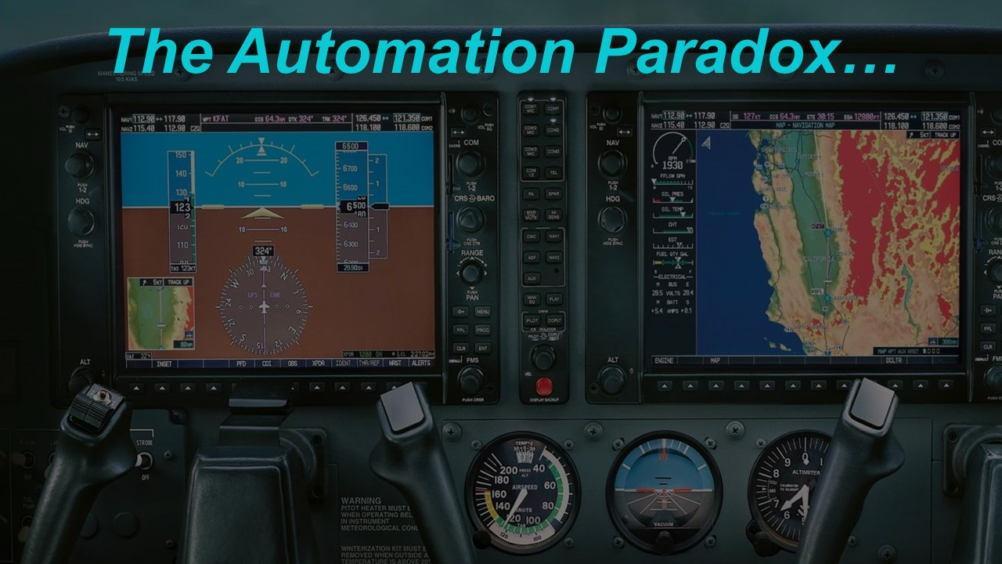 | Slide 22  Automation has indisputably reduced pilots' physical workload, but many aviators feel that their cognitive workload has increased. Glass cockpit displays can easily become cluttered with symbols, text, warnings, and graphical instrument representations. With so much information available in one place and so many configuration possibilities, it's easy for important information to hide in the clutter.  (Next Slide)
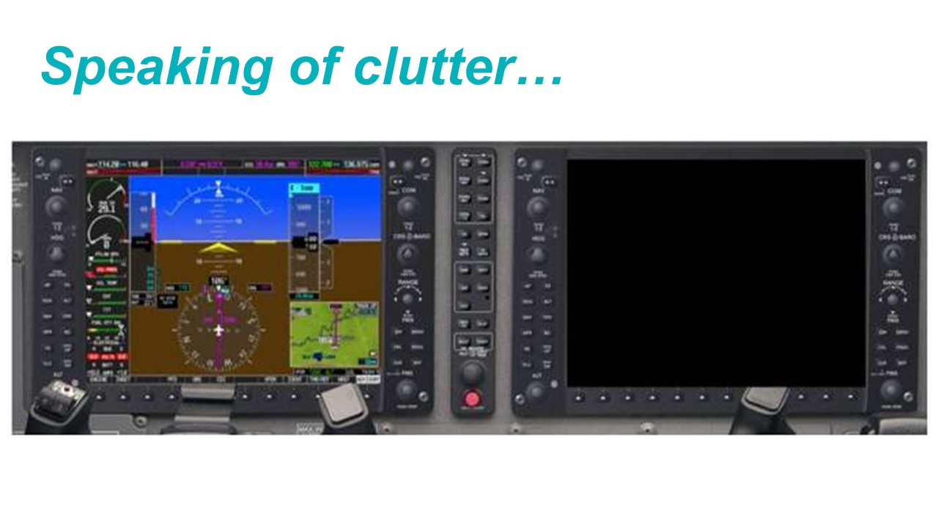 | Slide 23  Here we see the consequence of a display failure. Information from the Multi-function/Nav Display has been transferred to the Primary Flight Display. Imagine the stress pilots would feel if the first time they had to deal with this situation was in IMC flight.  (Next Slide)
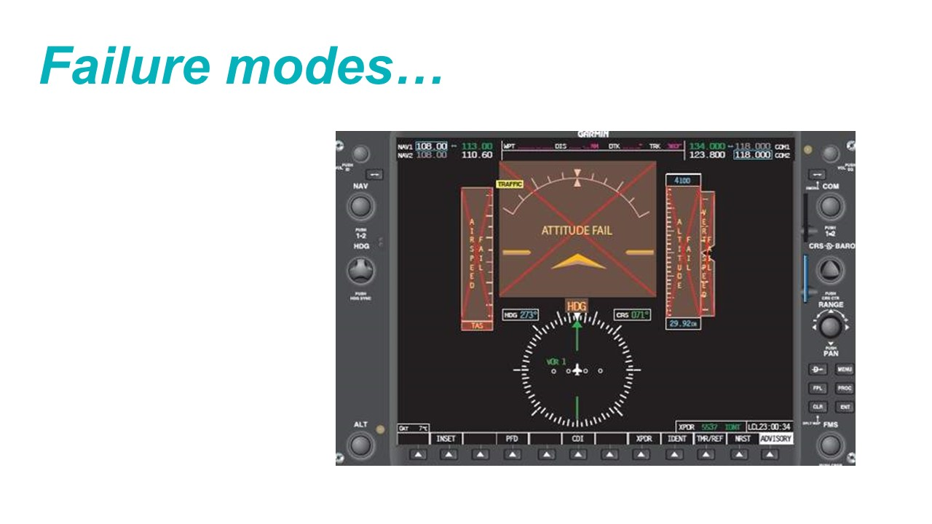 | Slide 24  Modern avionics are so reliable that failures are a very rare occurrence. But they do happen, and pilots need to be proficient in dealing with instrument and display failures. Emergency procedures practice in the aircraft or a simulator with a CFI is the best way to attain and maintain that critical proficiency.  Even when everything is working properly, errors in automation programming and management can have significant consequences.  There’s just a couple more points to make before we wrap it up and they have to do with the difference between startle and surprise.  (Next Slide)
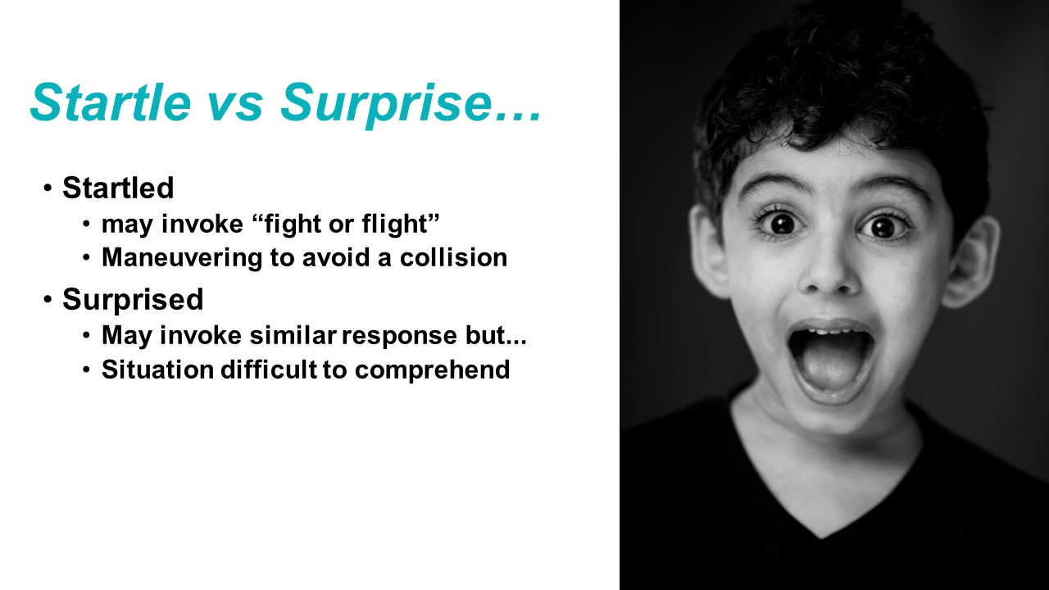 | Slide 25  All humans are subject to reflexive behaviors that have enabled us to survive and prosper.  - When we're startled, a perception of danger can trigger a 'fight or flight response' that's quite useful when perceiving a predator about to pounce. But fight or flight doesn't work so well when we're flying an aircraft. Here a more nuanced response is usually best.  - Maneuvering to avoid an imminent collision threat would be a controlled response to a startling event. (Click)  - When surprised, we may respond similarly but there will also be a difficulty in comprehending our situation.  - If, while on short final, the Tower instructs us to go-around, we will maneuver as instructed but likely won't immediately comprehend the reason for the go-around instruction.  Next Slide
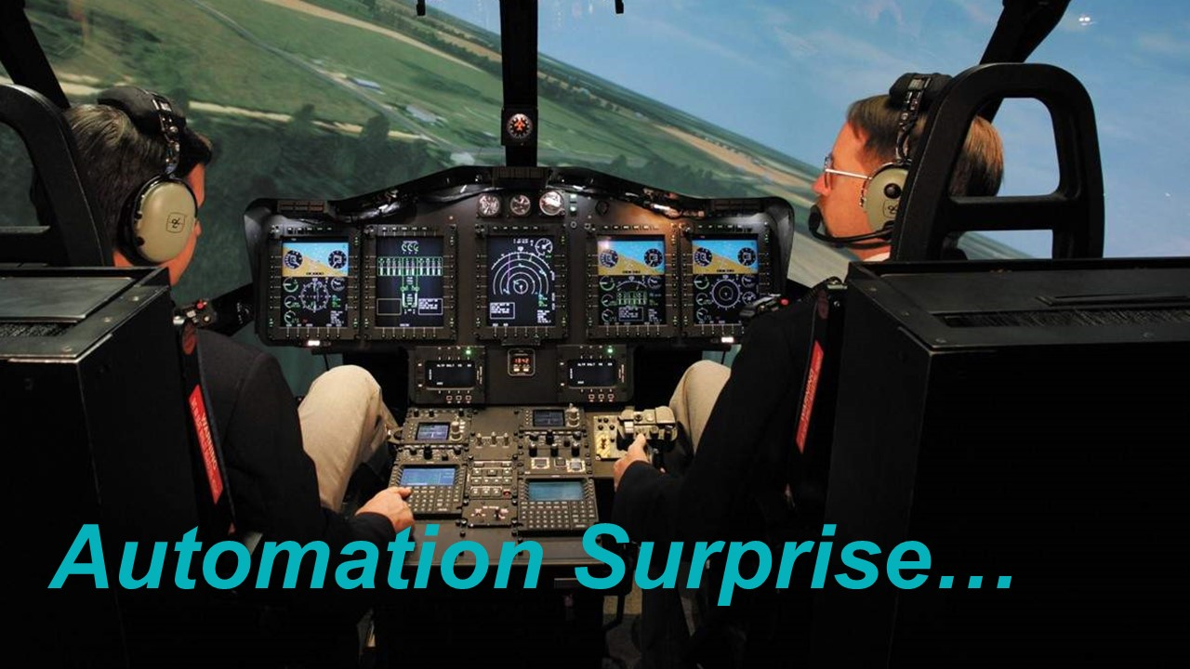 | Slide 26  In an ideal world, pilots would always know what to expect from their aircraft and its systems. But errors in data entry or system management can and do surprise us as we try to comprehend, “what's it doing now?”  Automation mode confusion or programming errors may first become apparent when the aircraft flies through an approach course intercept or an assigned altitude. These are times when pilots must 'be in the moment' in order to quickly detect the deviation and correct the problem.  - The most expedient response to these situations may be to disconnect the autopilot and hand fly the aircraft while correcting programming or mode selection errors.  - But pilots who are not confident of their hand flying skills may be tempted to leave the autopilot engaged while "programming their way out' of their difficulties.  - This could work but only if the pilot is thoroughly familiar with the automated system and its controls. Otherwise, the course or altitude deviation will likely be greater than it would be if the automation were temporarily disconnected while correction is made.  Any training we can get that will prepare us for automation surprise is well worth the effort. We want to respond safely and that takes some discussion and practice. (Next Slide)
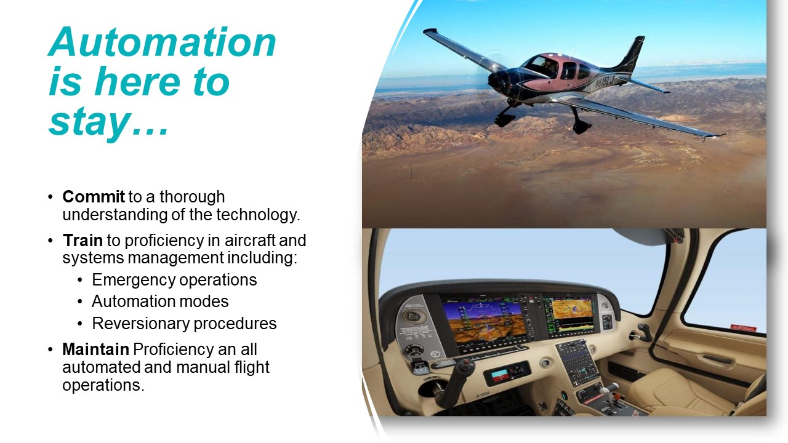 | Slide 27  Eventually, Technologically Advanced Aircraft will become the rule rather than the exception but for now, GA pilots have a choice. We can stick with traditional aircraft and instrumentation, or we can embrace TAA. If the latter is our choice, we must:  - Commit to a thorough understanding of all the technology our aircraft have to offer,  - Train to proficiency in aircraft and systems management including emergency operations, automation modes, and reversionary procedures and.  - Maintain proficiency in all automated and manual flight operations.  (Next Slide)
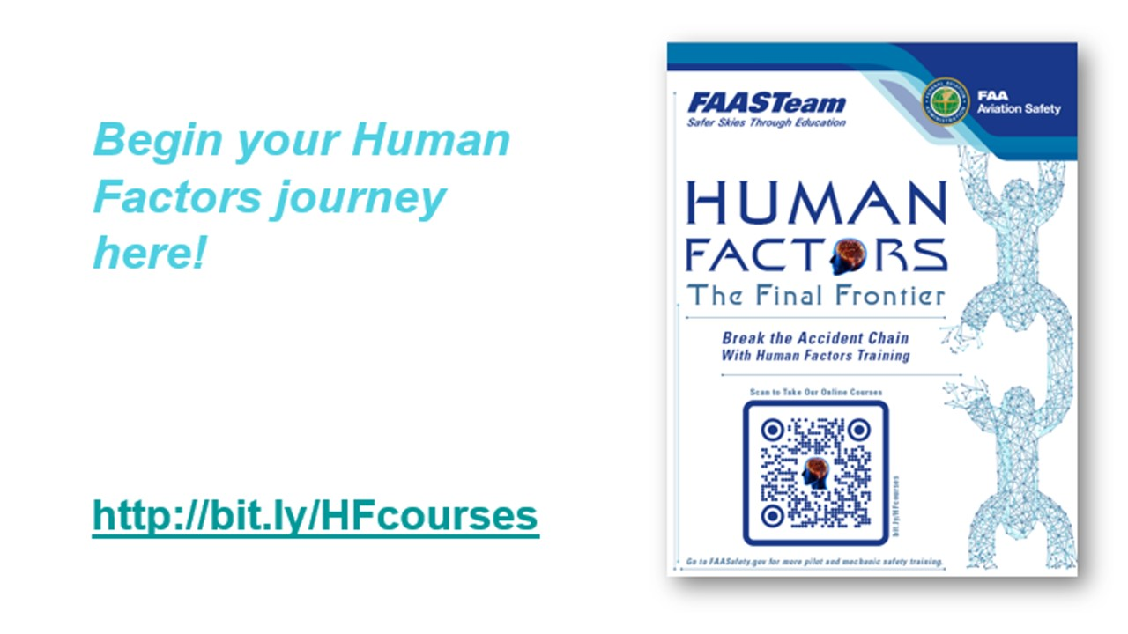 | Slide 28  If you’d like to learn more about automation and how to best make use of it, we recommend our series of Human Factors courses available on FAASafety.gov. Module 10 deals with design and automation but we hope you’ll explore the 9 other modules in the course series.  (Next Slide)
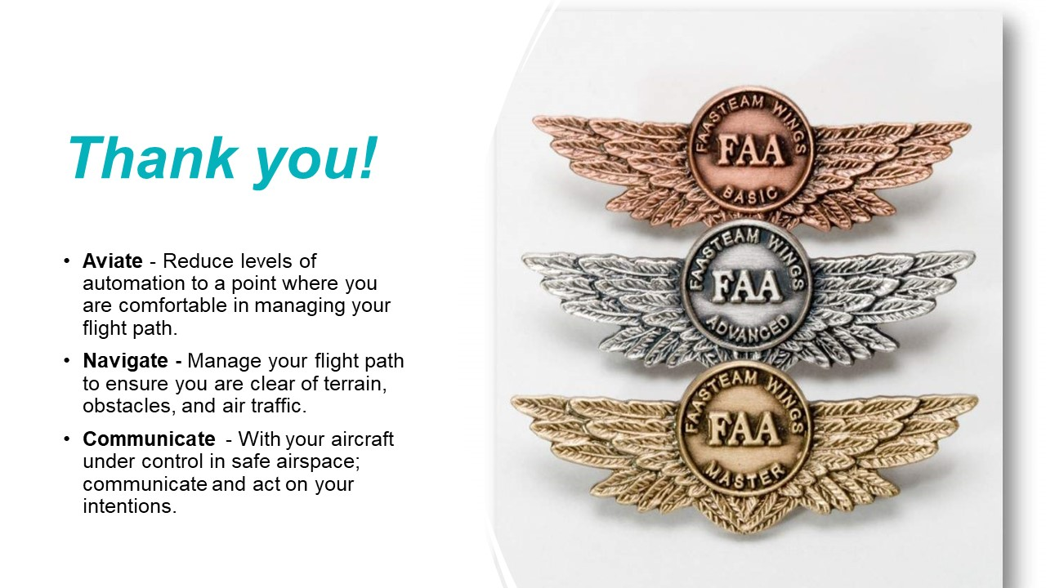 | Slide 29  Please accept our best wishes for safe flying and, no matter what level of automation you’re flying remember to always, (Click)  - Aviate - Reduce levels of automation to a point where you are comfortable in managing your flight path. (Click)  - Navigate - Manage your flight path to ensure you are clear of terrain, obstacles, and air traffic. (Click)  - Communicate - With your aircraft under control in safe airspace; communicate and act on your intentions.  (Next Slide)
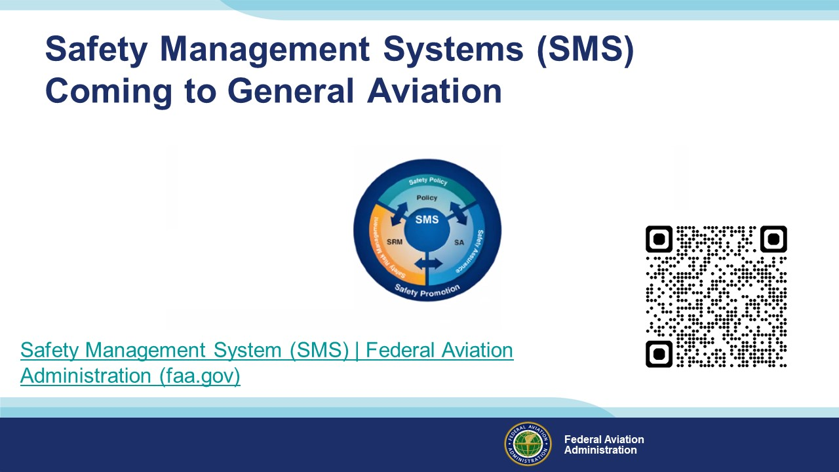 | Slide 30  Safety Management Systems are a set of policies and processes that can increase the safety and efficiency of any flight operation. And FAA is bringing SMS to General Aviation. You may have heard of SMS but thought it was only for large organizations but actually SMS can be scaled to fit any operation large or small.  There are 4 major components to a Safety Management System (Click)  Safety Policy – a documented commitment to safety that runs from the head of an organization to its newest member. (Click)  Safety Risk Management – a process that identifies hazards within an operation, determines to what extent an identified hazard may impact flight safety, and controls the risk of occurrence to an acceptable level. (Click)  Safety Assurance – By collecting and analyzing information derived from safety performance data Safety Assurance ensures the performance and effectiveness of Safety Risk Controls. (Click)  Safety Promotion communicates safety information and commitment throughout the organization. (Click)  You can find more information about Safety Management Systems at the URL on the Screen.  Presentation note: Allow sufficient time for audience to copy link then:  (Next Slide)
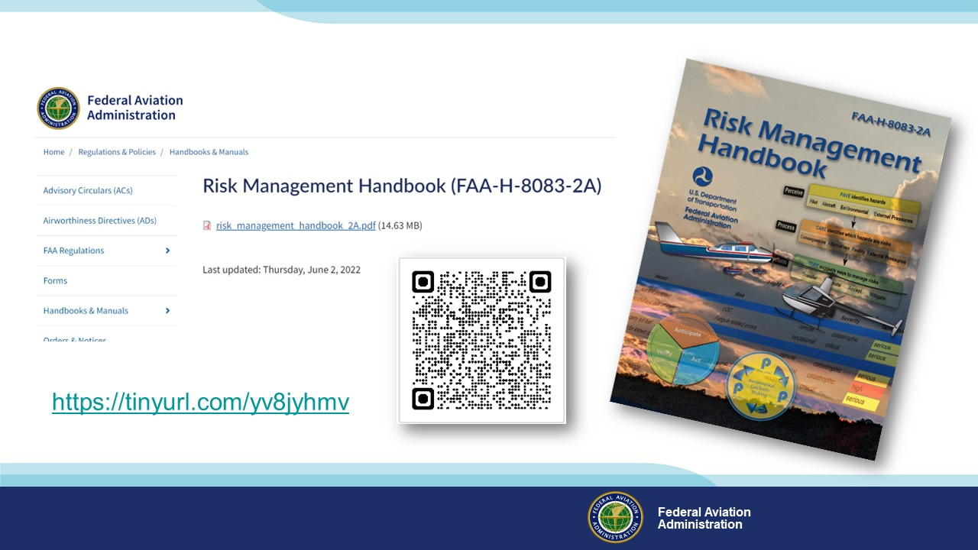 | Slide 31  For more information on Safety Management, we recommend FAA’s Risk Management Handbook. It’s a great addition to every pilot’s library.  (Next Slide)
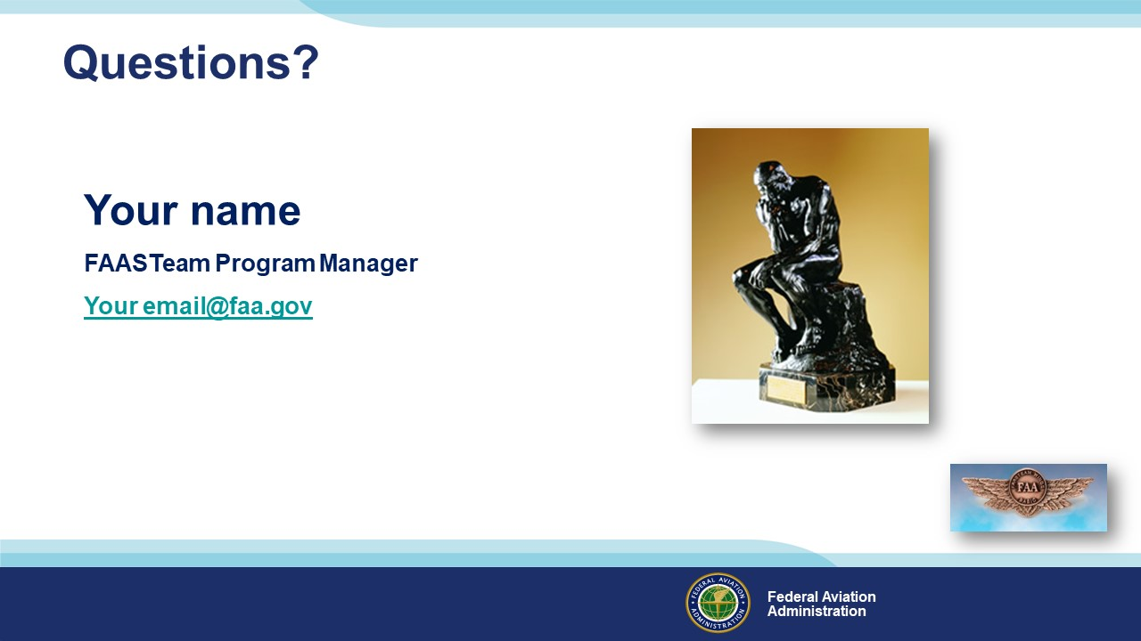 | Slide 32  Presentation Note: You may wish to provide your contact information and main FSDO phone number here. You can also add WINGSPro contact information.  Modify with your information or leave blank.  (Next Slide)
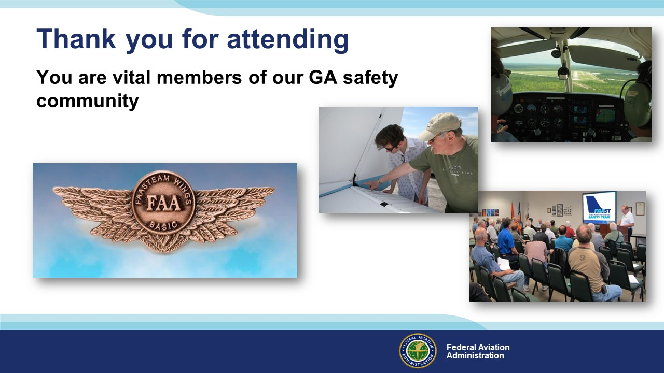 | Slide 33  Your presence here shows that you are vital members of our General Aviation Safety Community. The high standards you keep and the examples you set are a great credit to you and to GA.  Thank you for attending.  (Next Slide)
Slide 34

(The End)

Appendix I – Equipment and Staging
Equipment:
- Projection Screen & Video Projector suitable for expected audience
  - Remote computer/projector control available at lectern or presenter location
    - In lieu of remote – detail a Rep to computer/projector control.
- Presentation Computer
  - Note: It is strongly suggested that the entire program reside on this computer.
- Back up Projector/Computer/Media as available.
- PA system suitable for expected audience
  - Microphones for Moderator and Panel
    - Optional Microphone (s) for audience
- Lectern (optional)
Staging:
- Arrange the projection screen for maximum visibility from the audience.
- Equip with PA microphones
- Place Lectern to one side of screen. This will be used by presenters and moderator

IMPORTANT – Once you have completed outreach on this topic, please help us track the outreach you have done by entering a SAS record.

