General Aviation Joint Safety Committee
CFIT Working Group

Outreach Guidance Document
2023/10-29-297(I)PP

This outreach guidance is provided to all FAA and aviation industry groups that are participating in outreach efforts sponsored by the General Aviation Joint Safety Committee (GAJSC). It is important that all outreach on a given topic is coordinated and is free of conflicts. Therefore, all outreach products should be in alignment with the outline and concepts listed below for this topic.

Outreach Month: January 2025

Topic: GA Safety Culture
The FAA and industry will conduct a public education campaign emphasizing the benefits of strong safety cultures.

Teaching Points:
- We are all subject to cultural influences.
- Teachers, mentors, family, colleagues, and community all shape the way we see the world and conduct our lives.
- Robust safety cultures are key to consistently safe flight operations. They empower people to work safely and do the right things even when no one is watching.

References:
- GA Safety Culture PowerPoint show and Presenter Notes
  - Available on the National FAASTeam Share Point site under Approved Resources.

- Human Factors for Pilots – on line courses on FAASafety.gov
  - Module 2 – Safety Culture

Abstract: Lasting 10 to 20 minutes, this presentation acquaints the audience with the benefits of fostering strong safety cultures. It enumerates the attributes of effect safety cultures and directs learners to the FAASTeam Human Factors course series on FAASafety.gov.

Format: Information Briefing - Power Point presentation
Required Personnel – FAASTeam Program Manager or designated FAASTeam Rep (s)
Optional Personnel – AME’s and other medical practitioners who can speak on the topic of positive safety cultures.

National FAASTeam Support:
In addition to this guidance document, a Power Point presentation that supports the program and a folder containing background information are provided. FPMs and presenters are encouraged to customize this presentation to reflect each individual program.

Slides | Script
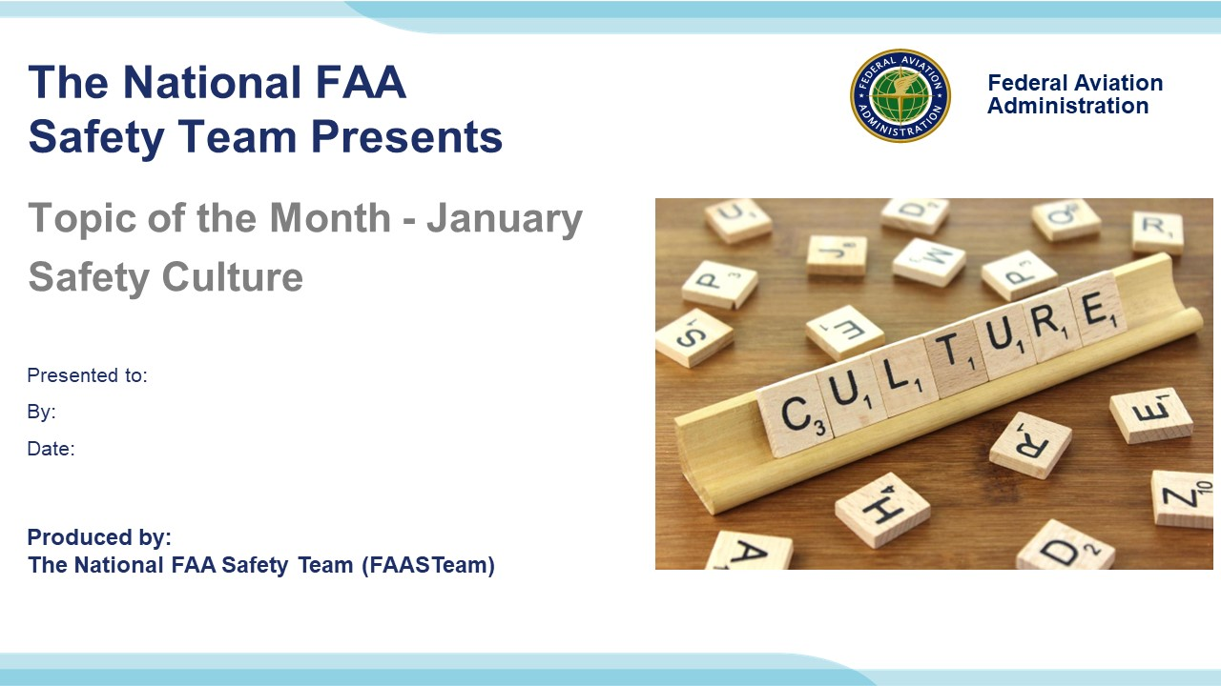 | Slide 1  2023/10-29-294(I)PP Original Author: John Steuernagle; POC Kevin Clover, National FAASTeam Program Manager (Operations), Office 562-888-2020.  Presentation note: This is the title slide for FY 2025 Topic of the Month – January – Safety Culture.  Script - We have included a script of suggested dialog with most slides. The script will always appear in a non-italic font. Presenters may read the script or modify it to suit their own presentation style. See template slides 5 and 6 for examples of a slides with script.  Presentation Instructions - (stage direction and presentation suggestions) will be preceded by a Bold header: the instructions themselves will be in Italic fonts. See slides 2, for an example of slides with Presentation Instructions only.  Program control instructions - will be in bold fonts and look like this: (Click) for building information within a slide; or this: (Next Slide) for slide advance.  Background information - Some slides may contain background information that supports the concepts presented in the program.  .  The production team hope you and your audience will enjoy the show. Break a leg!  (Next Slide)
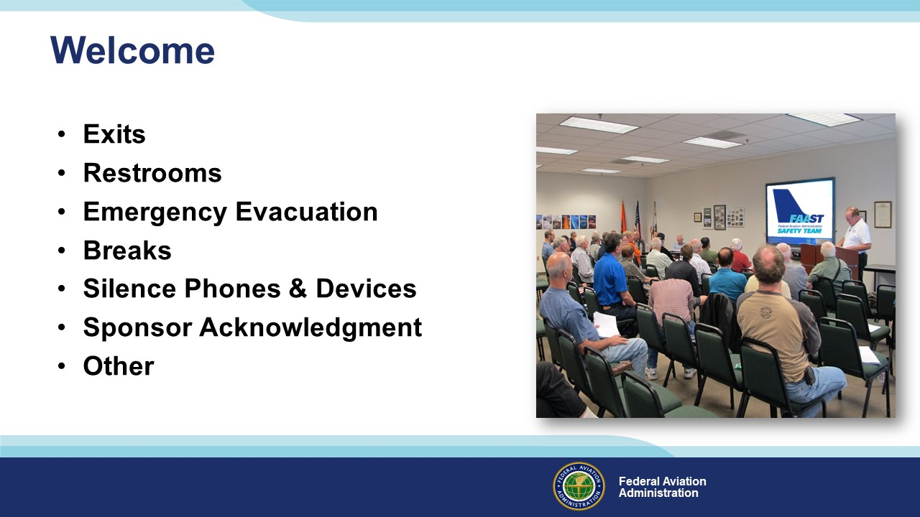 | Slide 2  Presentation Note: Here’s where you can discuss venue logistics, acknowledge sponsors, and deliver other information you want your audience to know in the beginning.  You can add slides after this one to fit your situation.  (Next Slide)
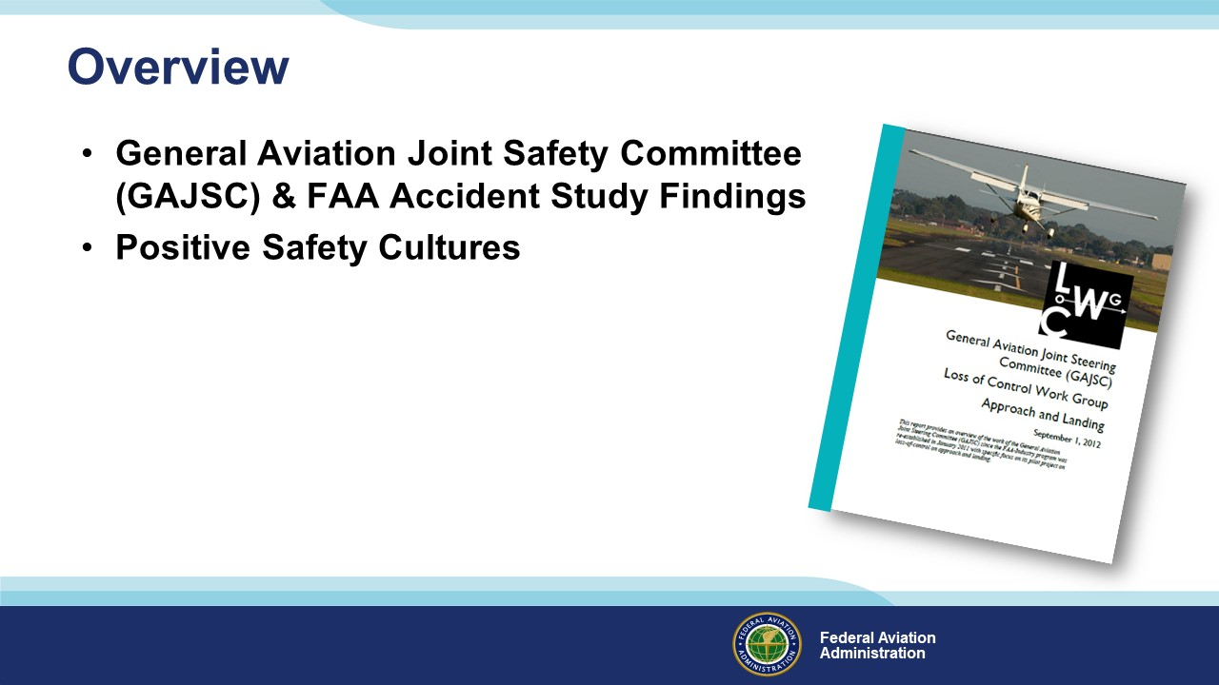 | Slide 3  In this presentation we’ll talk a little bit about recent GAJSC Safety Enhancements and FAA Safety Recommendations with respect to positive safety cultures.  Let’s begin with a definition of Culture.  Presentation Note: If you’ll be discussing additional items, add them to this list  (Next Slide)
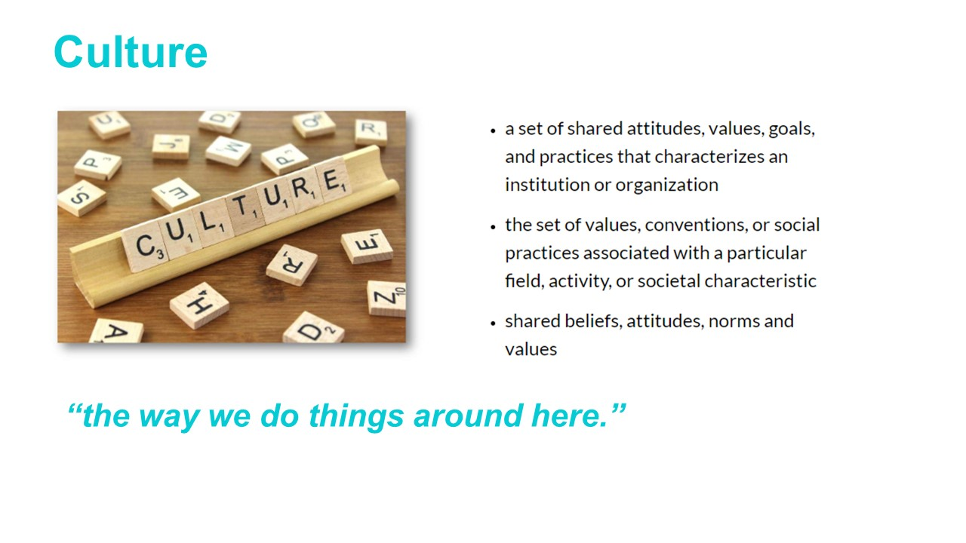 | Slide 4  The beliefs, attitudes, norms and values that people within an organization share are described as Organizational Culture. (Click)  You might describe culture as, “the way we do things around here.  Safety culture is an essential part of organizational culture. It affects the way the organization manages safety and therefore, the ultimate effectiveness of its safety management system.  Culture has a profound influence on individual pilots too bot sometimes they don’t see it that way.  (Next Slide)
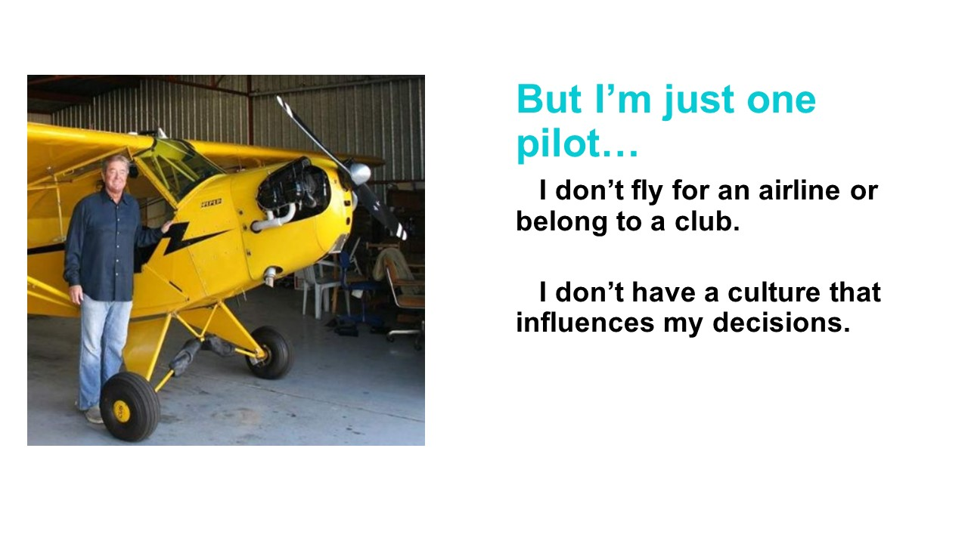 | Slide 5  While we might not think we’re part of an aviation organization the fact is, we are all subject to cultural influences. We share values and beliefs with our Flight Instructors, fellow pilots, and aviation mentors. Likewise, we’re influenced by the values and beliefs of our family, work colleagues, and friends. All of these influence “the way we do things around here”. Hopefully, those influences argue for a positive and robust safety culture.  Although much of aviation safety culture discussions center on organizational cultures.  (Next Slide)
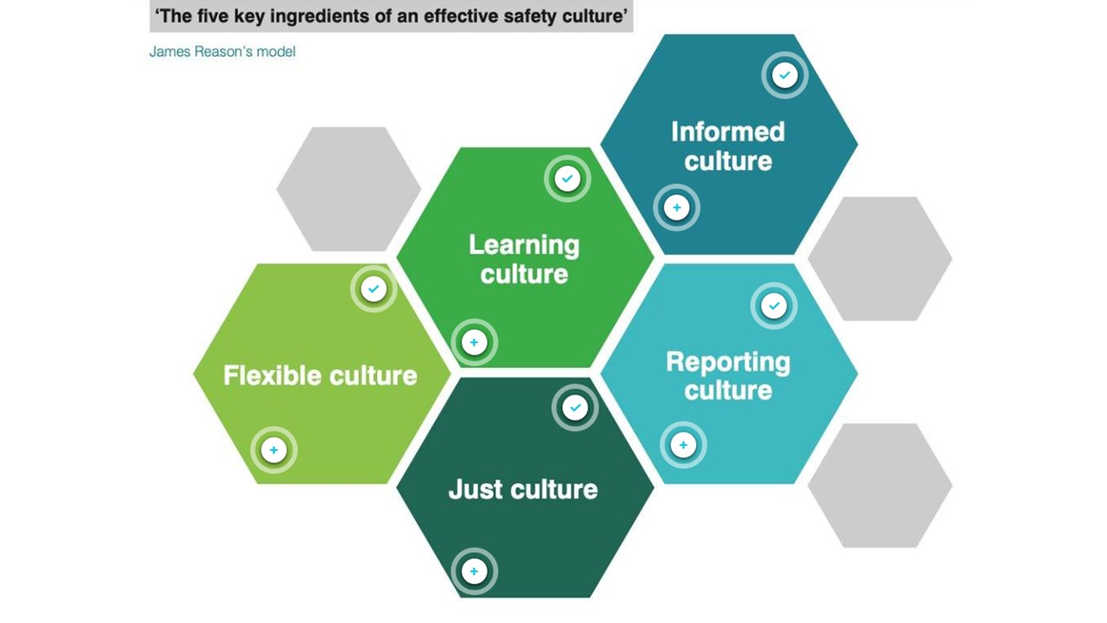 | Slide 6  Here are Dr. Reason’s five key ingredients of effective safety cultures. We’ll look at them from organizational and individual pilot points of view.  (Next Slide)
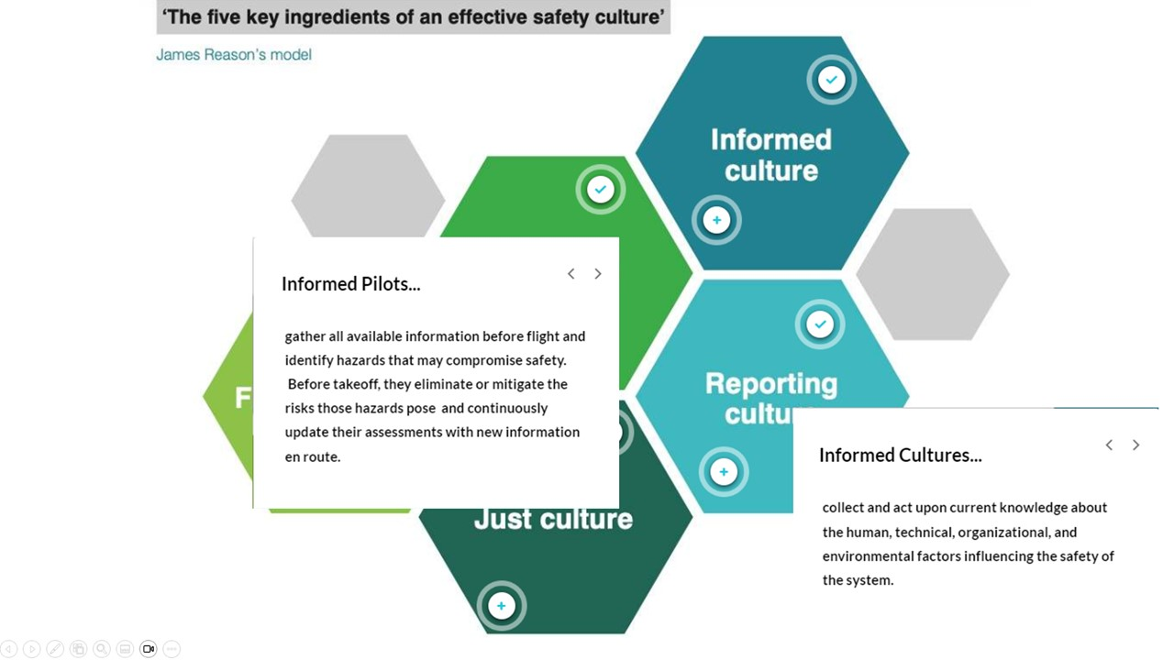 | Slide 7  Informed cultures collect and act upon a wealth of human, technical, organizational, and environmental factors.  Informed pilots do the same thing. But they don’t usually have the depth of experience and informational data points available to organizations.  They can keep themselves solidly in the informational loop by reading aviation articles on line or in print., attending seminars such as these and participating in proficiency training.  (Next Slide)
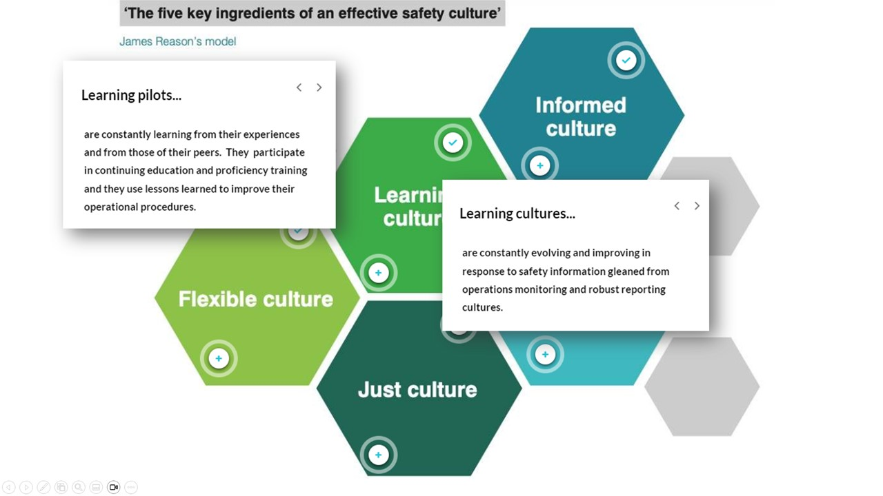 | Slide 8  Learning cultures are constantly improving their processes with information gained from operations monitoring and current technological developments.  Learning pilots keep abreast of regulatory and technological developments. They participate in proficiency training activities and they employ lessons learned to improve their flight and ground operations.  (Next Slide)
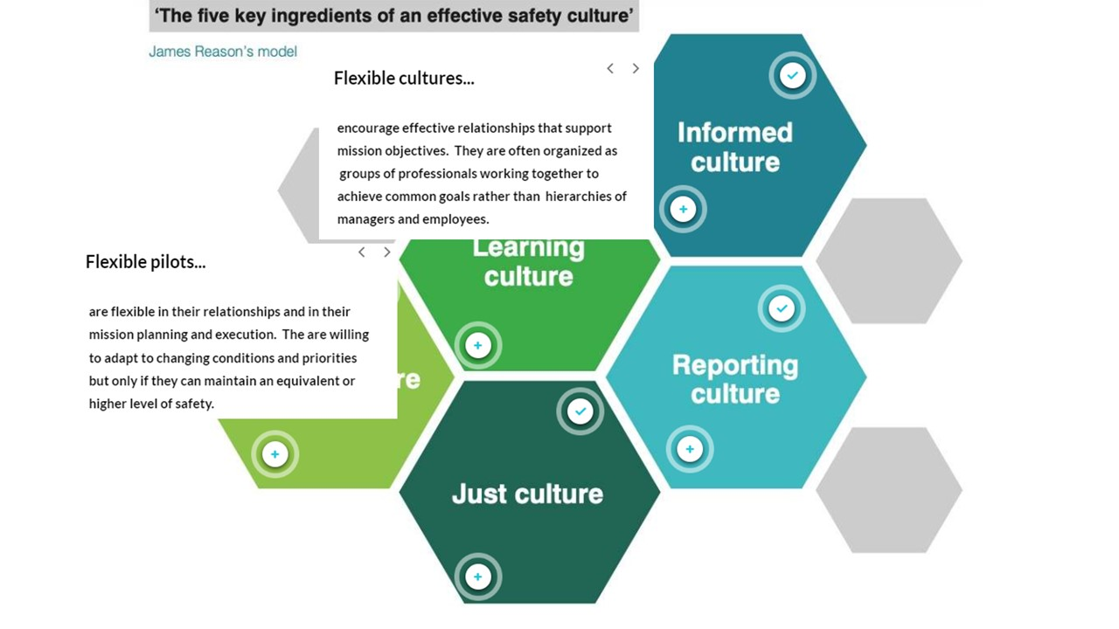 | Slide 9  As the title implies, Flexible Cultures support effective internal and external relationships that support mission objectives. They willingly consider alternative solutions to operational challenges and collectively agree on best courses of action.  Flexible pilots are willing and able to adapt to changing conditions and priorities but only if they can maintain an equivalent or higher level of safety.  (Next Slide)
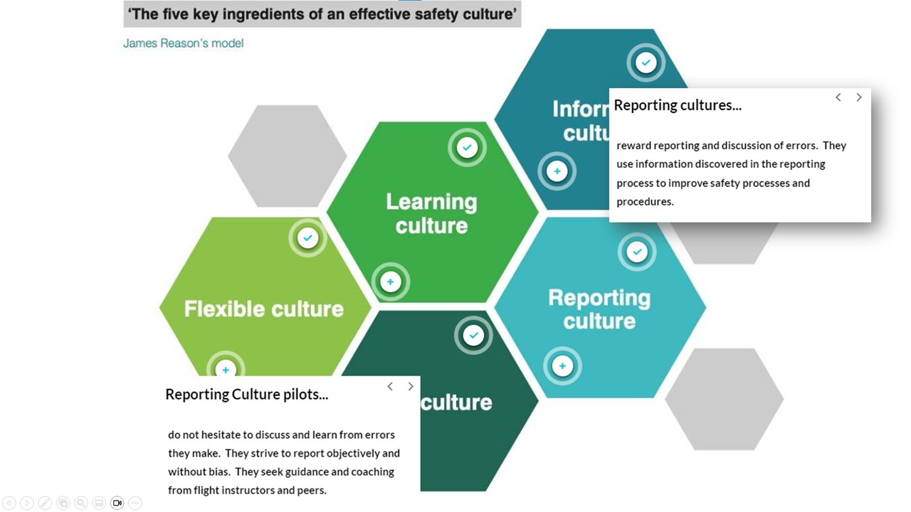 | Slide 10  Here’s where human factors knowledge and experience have made a great difference. Reporting cultures reward rather than punish the reporting of errors. They know that’s the most effective way to improve their processes and procedures.  Similarly, Reporting Culture Pilots don’t hesitate to report and discuss their errors. They seek guidance and coaching from their peers and from flight instructors in order to improve their performance.  (Next Slide)
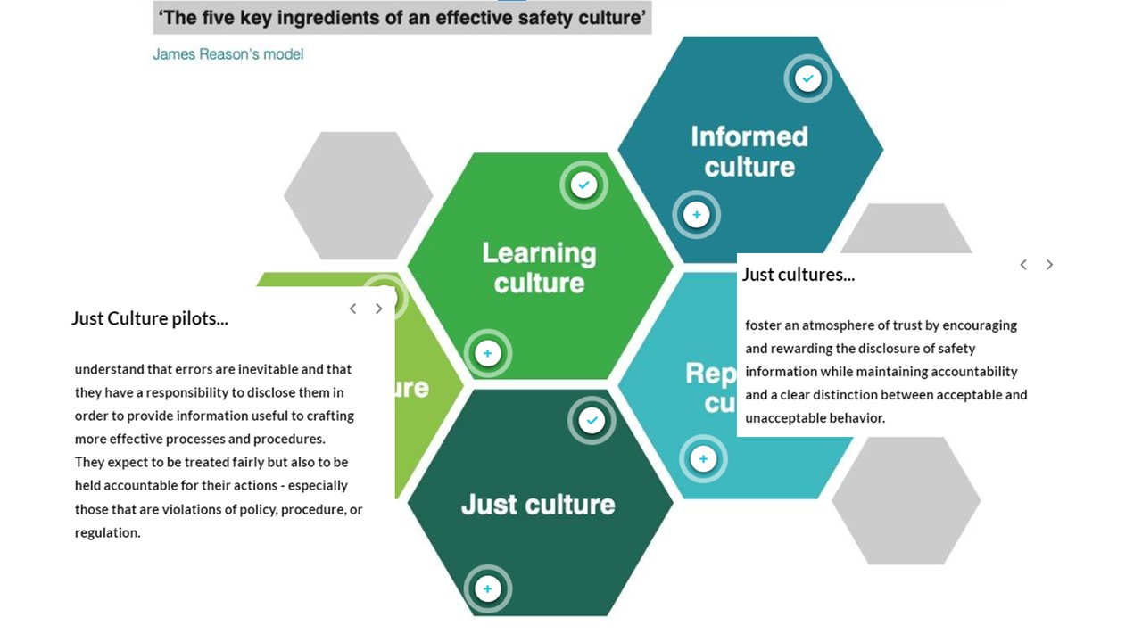 | Slide 11  Finally, Just Cultures foster trust by encouraging and rewarding disclosure of operational errors. Their members expect to be held accountable for their actions and they know intentional violation of rules, policies, and procedures will result in consequences.  Just Culture Pilots accept the responsibility to disclose errors. They expect to be held accountable for their actions and to be treated fairly.  (Next Slide)
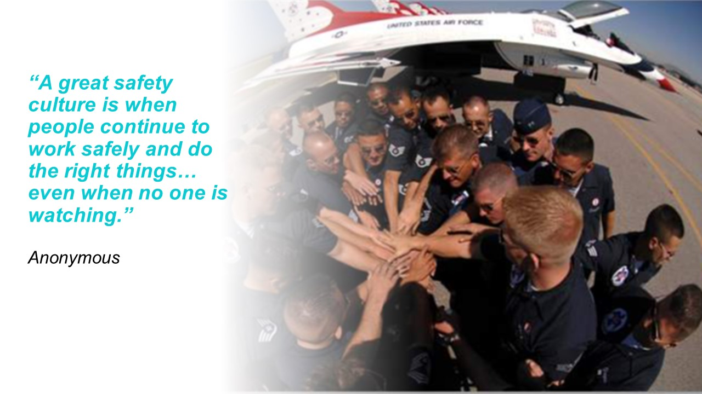 | Slide 12  Those 5 elements boil down to this: “A great safety culture is when people continue to work (and fly) safely and do the right things – even when no one is watching.”  (Next Slide)
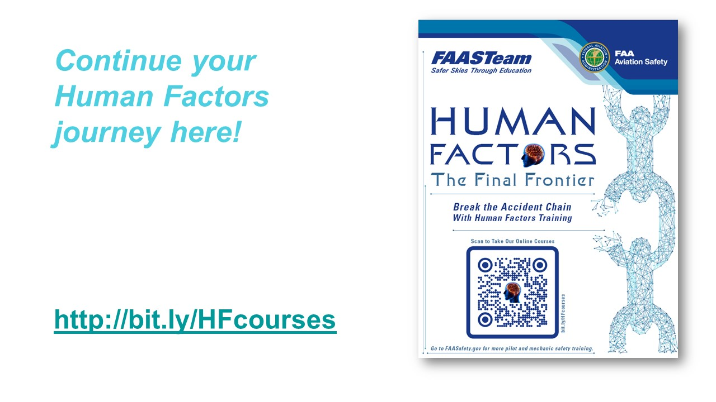 | Slide 13  There’s much more to know about safety culture. If you’d like to learn more, check out our FAASTeam series of online Human Factors for Pilots courses on FAASafety.gov. Navigate to the URL or scan the QR code on screen for a FAASTeam Human Factors course catalog that features direct links to each of the courses.  Presentation note: Allow time for audience to copy URL or scan QR code. Then advance to:  (Next Slide)
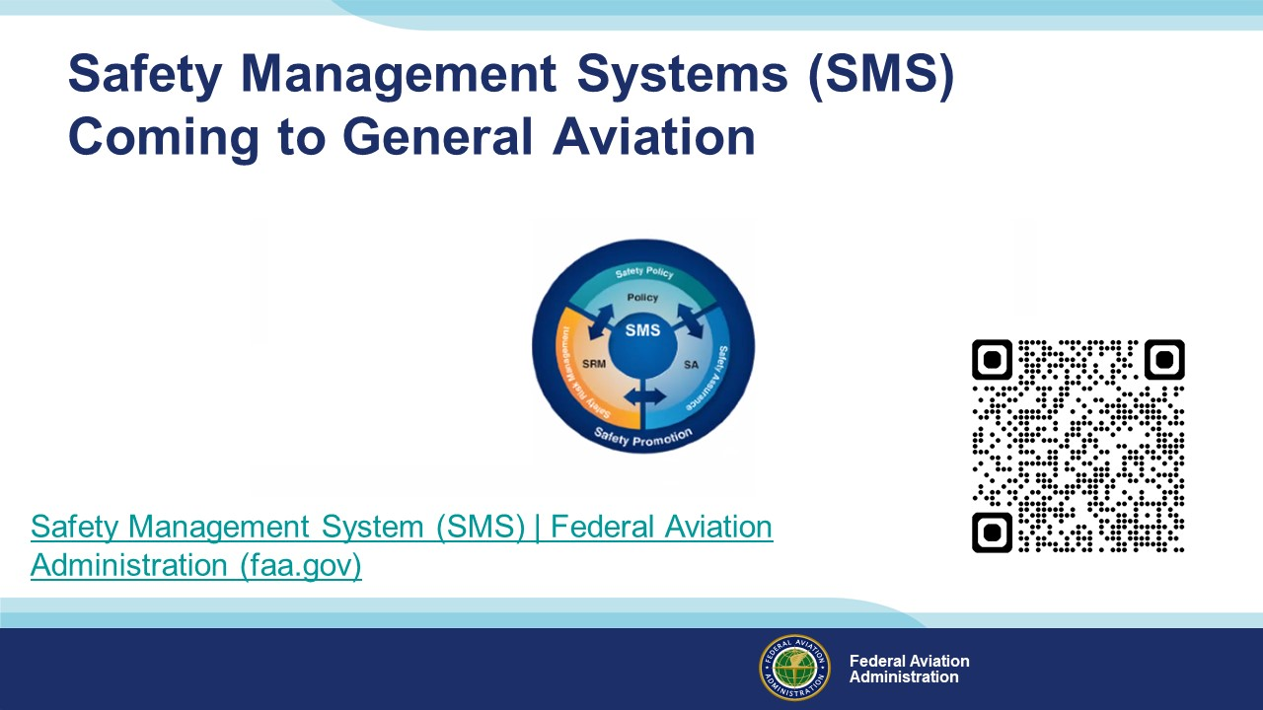 | Slide 14  Safety Management Systems are a set of policies and processes that can increase the safety and efficiency of any flight operation. And FAA is bringing SMS to General Aviation. You may have heard of SMS but thought it was only for large organizations but actually SMS can be scaled to fit any operation large or small.  There are 4 major components to a Safety Management System (Click)  Safety Policy – a documented commitment to safety that runs from the head of an organization to its newest member. (Click)  Safety Risk Management – a process that identifies hazards within an operation, determines to what extent an identified hazard may impact flight safety, and controls the risk of occurrence to an acceptable level. (Click)  Safety Assurance – By collecting and analyzing information derived from safety performance data Safety Assurance ensures the performance and effectiveness of Safety Risk Controls. (Click)  Safety Promotion communicates safety information and commitment throughout the organization. (Click)  You can find more information about Safety Management Systems at the URL on the Screen.  Presentation note: Allow sufficient time for audience to copy link then:  (Next Slide)
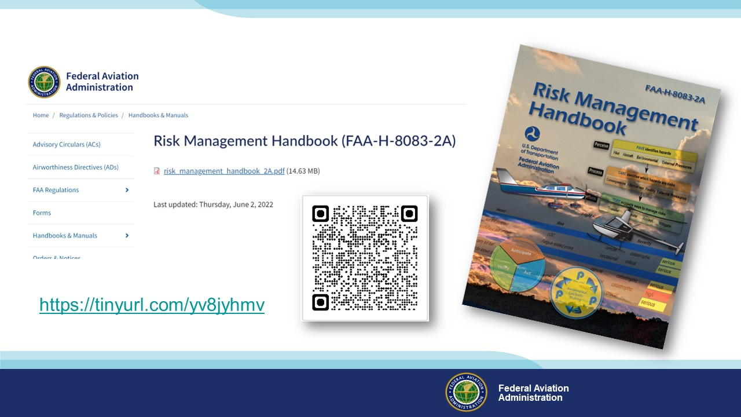 | Slide 15  For more information on Safety Risk Management, we recommend FAA’s Risk Management Handbook. It’s a great addition to every pilot’s library.  Presentation note: Allow time for audience to copy URL or scan QR code. Then advance to:  (Next Slide)
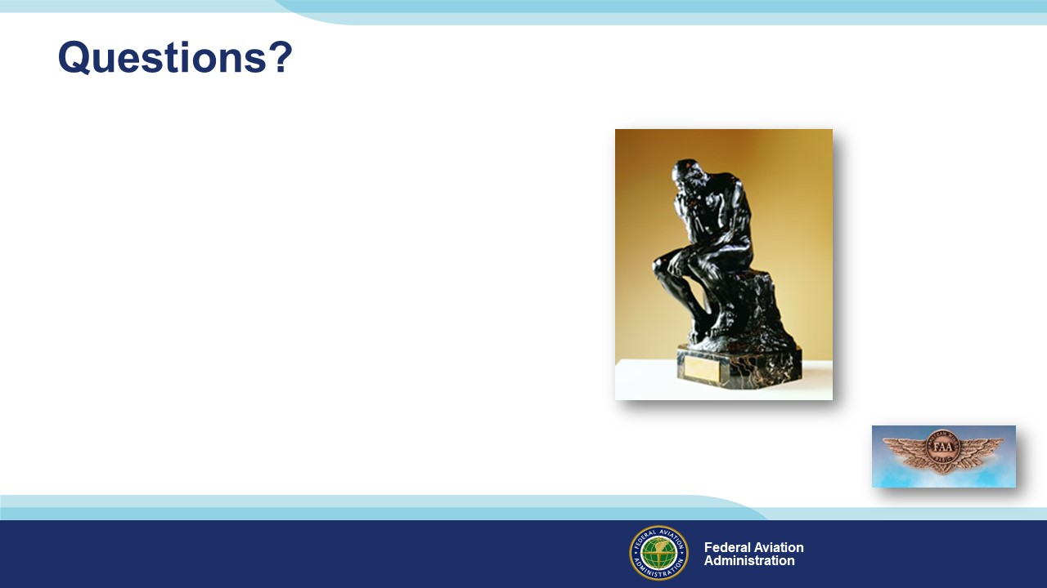 | Slide 16  Presentation Note: You may wish to provide your contact information and main FSDO phone number here. You can also add WINGSPro contact information.  Modify with your information or leave blank.  (Next Slide)
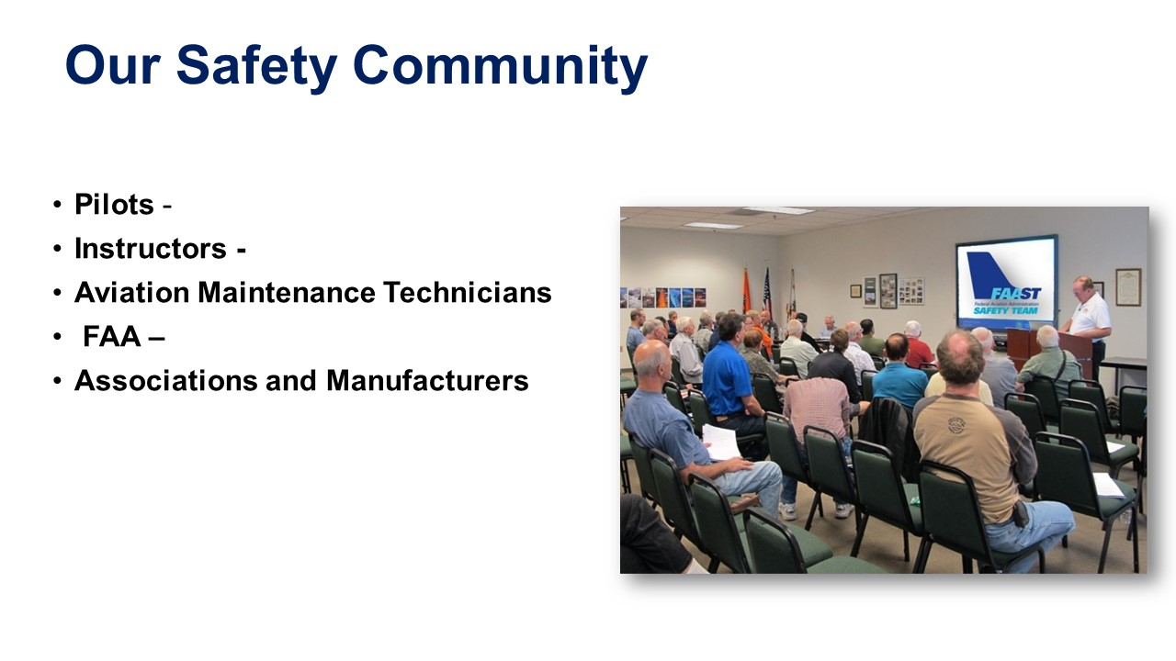 | Slide 17  Your presence here attests to your commitment to safe flight operations. You are all members in good standing of our safety community, and we applaud your dedication to and passion for excellence and safety.  (Next Slide)
 | Slide 18  Thank you for attending!  (Next Slide)
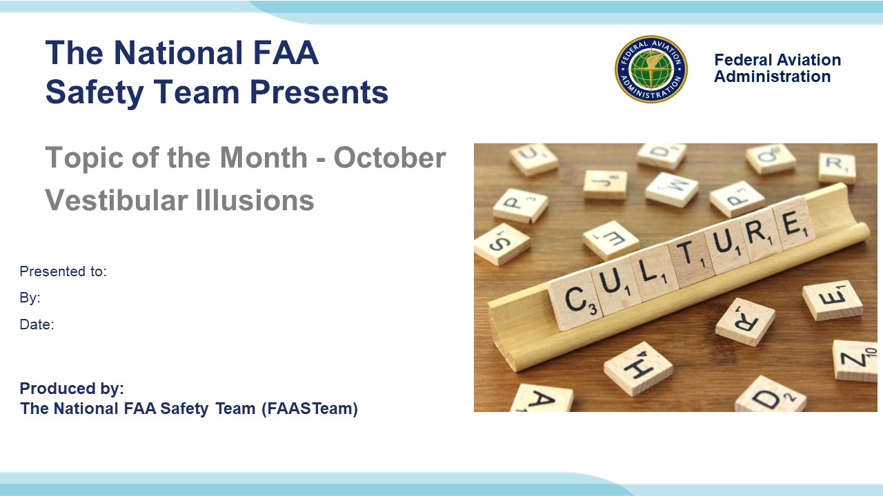 | Slide 19  (The End)

Appendix I – Equipment and Staging
Equipment:
- Projection Screen & Video Projector suitable for expected audience
  - Remote computer/projector control available at lectern or presenter location
    - In lieu of remote – detail a Rep to computer/projector control.
- Presentation Computer
  - Note: It is strongly suggested that the entire program reside on this computer.
- Back up Projector/Computer/Media as available.
- PA system suitable for expected audience
  - Microphones for Moderator and Panel
    - Optional Microphone (s) for audience
- Lectern (optional)
Staging:
- Arrange the projection screen for maximum visibility from the audience.
- Equip with PA microphones
- Place Lectern to one side of screen. This will be used by presenters and moderator

IMPORTANT – Once you have completed outreach on this topic, please help us track the outreach you have done by entering a SAS record.

