General Aviation Joint Safety Committee
CFIT Working Group

Outreach Guidance Document
2023/10-29-298(I)PP

This outreach guidance is provided to all FAA and aviation industry groups that are participating in outreach efforts sponsored by the General Aviation Joint Safety Committee (GAJSC). It is important that all outreach on a given topic is coordinated and is free of conflicts. Therefore, all outreach products should be in alignment with the outline and concepts listed below for this topic.

Outreach Month: February 2025

Topic: General Aviation Survival
The FAA and industry will conduct a public education campaign emphasizing the benefits of survival knowledge, skill, equipage, and planning to General Aviation flight operations.

Background:

A GAJSC study found that lack of survival knowledge and equipment was a factor in
a number of cases where General Aviation pilots made successful off-airport landings but succumbed to environmental challenges on the ground..

Teaching Points:

- Basic survival knowledge and equipment can greatly improve odds of surviving after a forced landing.
- Dress according to the environment over which you’re flying.
- Carry basic survival tools on your person.
- When flying to or over remote areas consider 406 MHz personal locator beacons and or satellite phones.
- The most important factor in survival success is the will to survive. .

References
- Basic Survival Skills for Aviation
  - Basic Survival Skills for Aviation (faa.gov) .

- Deep Survival – by Laurence Gonzales
  - W.W. Norton & Company – http://wwnorton.com

Abstract: Lasting 10 to 20 minutes, this presentation acquaints the audience with the safety benefits of acquiring knowledge, skill, and equipment in preparation for survival..
Format: Information Briefing - Power Point presentation
Required Personnel – FAASTeam Program Manager or designated FAASTeam Rep (s)
Optional Personnel – CFIs and Survival Instructors who can speak on Survival.

National FAASTeam Support:
In addition to this guidance document, a Power Point presentation that supports the program is provided. FPMs and presenters are encouraged to customize this presentation to reflect each individual program.

Slides | Script
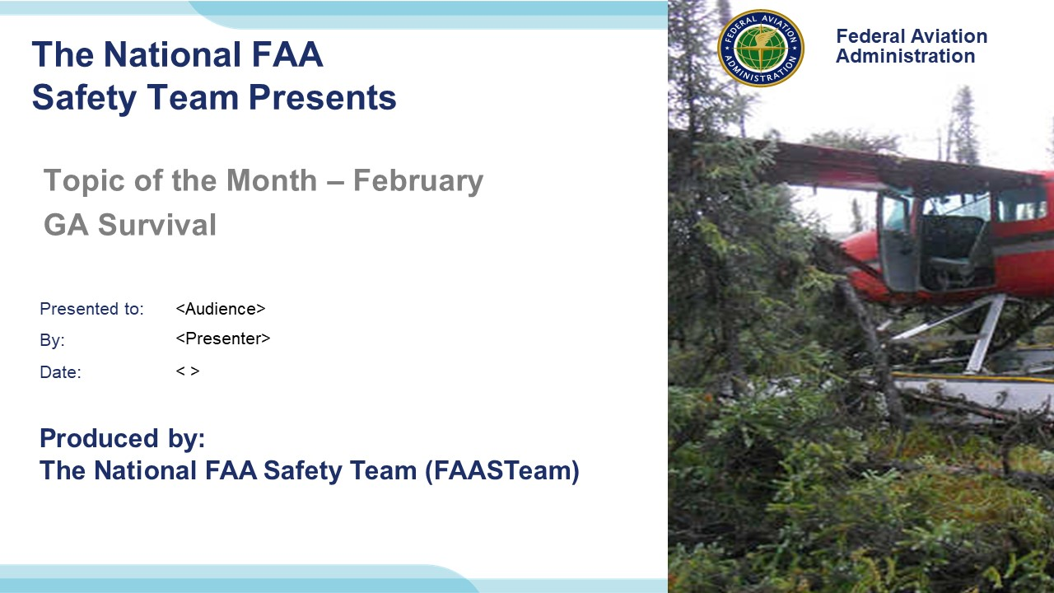 | Slide 1  2023/10-29-298(I)PP Original Author: John Steuernagle; POC Kevin Clover, National FAASTeam Program Manager (Operations), Office 562-888-2020.  Presentation note: This is the title slide for FY 2025 Topic of the Month – January – Safety Culture.  Script - We have included a script of suggested dialog with most slides. The script will always appear in a non-italic font. Presenters may read the script or modify it to suit their own presentation style. See template slides 5 and 6 for examples of a slides with script.  Presentation Instructions - (stage direction and presentation suggestions) will be preceded by a Bold header: the instructions themselves will be in Italic fonts. See slide 2, for an example of slides with Presentation Instructions only.  Program control instructions - will be in bold fonts and look like this: (Click) for building information within a slide; or this: (Next Slide) for slide advance.  Background information - Some slides may contain background information that supports the concepts presented in the program.  .  The production team hope you and your audience will enjoy the show. Break a leg!  (Next Slide)
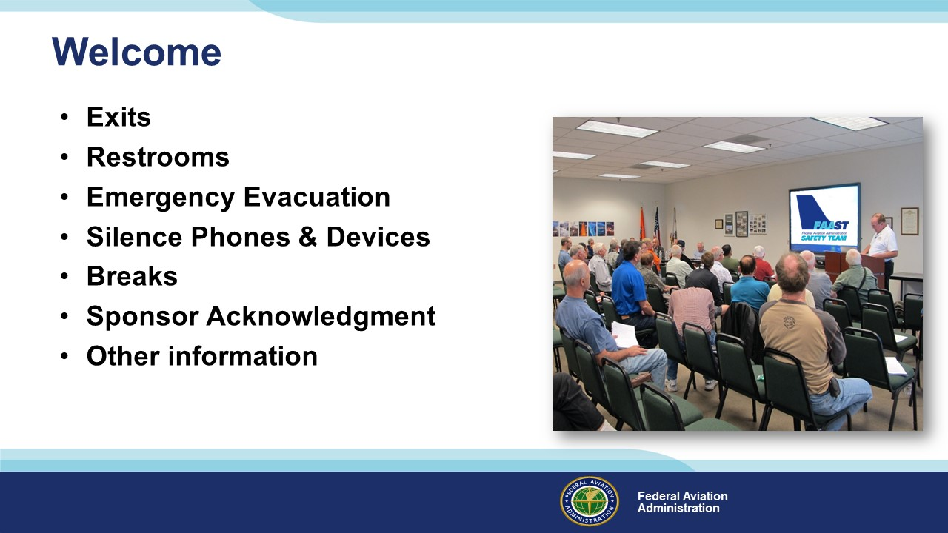 | Slide 2  Presentation Note: Here’s where you can discuss venue logistics, acknowledge sponsors, and deliver other information you want your audience to know in the beginning.  You can add slides after this one to fit your situation.  (Next Slide)
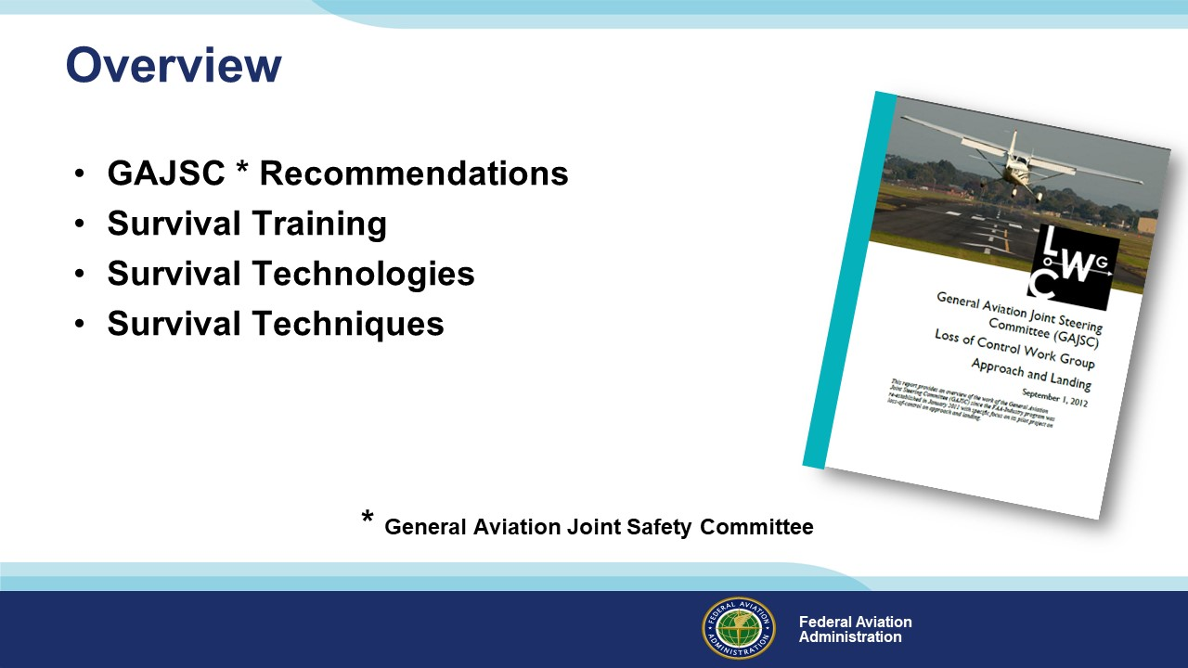 | Slide 3  In this presentation we’ll address recommendations from the General Aviation Joint Safety Committee – a government / industry group that analyzes GA accidents and incidents. The Committee feels that improved survival planning before flight can significantly improve pilots’ chances of surviving accidents and incidents and they recommend survival training such as the free Basic Survival Course taught by FAAs Civil Aeromedical Institute in Oklahoma City, OK. Survival is a huge topic, so we’ll just address a few technologies and techniques in the hope that you’ll be motivated to learn more about a fascinating subject.  Presentation Note: If you’ll be discussing additional items, add them to this list  (Next Slide)
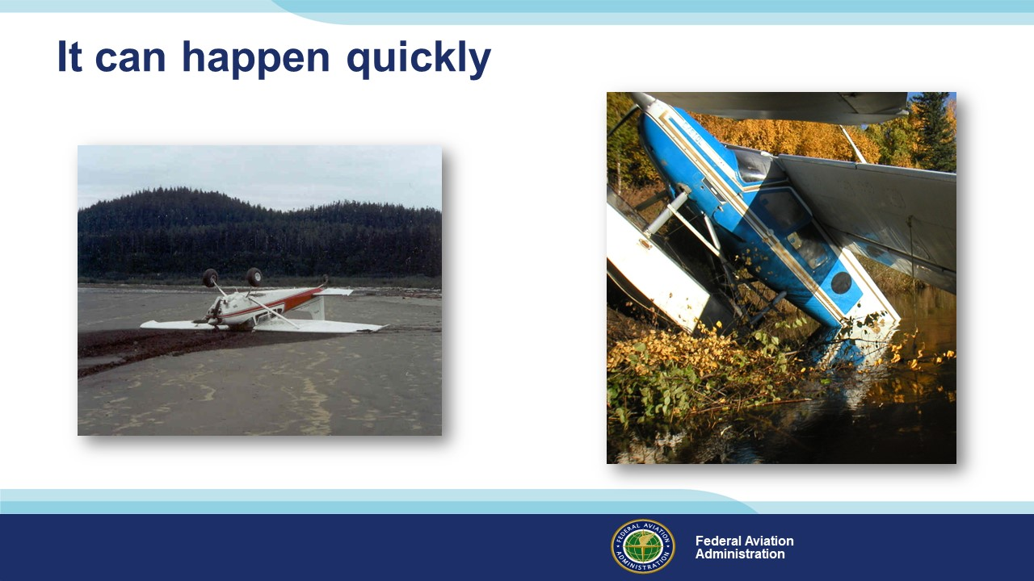 | Slide 4  It can happen quickly – One minute you’re cruising along and the next you may find yourself on the ground in a survival situation. Coping successfully in times like these requires knowledge, discipline, and planning.  (Next Slide)
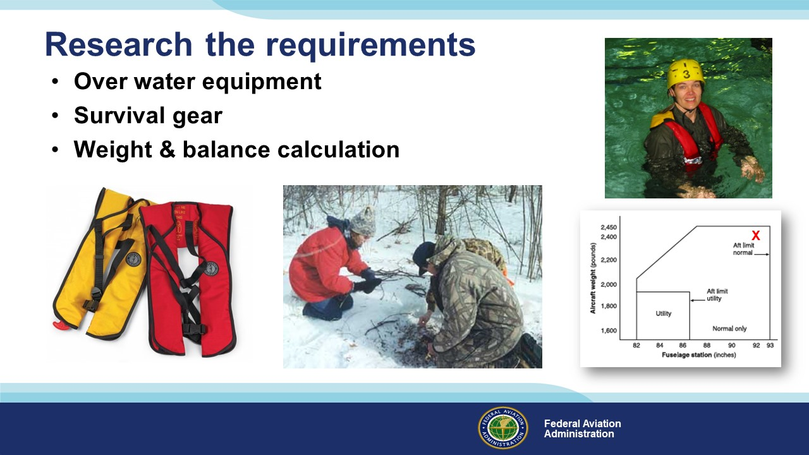 | Slide 5  Planning for survival begins with a search of equipment requirements for the areas you plan to operate within. If you’re planning a flight over water, through Canada, or to Alaska be sure to research requirements for flotation, signaling, and survival equipment. (Click)  And be sure to do a weight and balance calculation to include the extra gear.  (Next Slide)
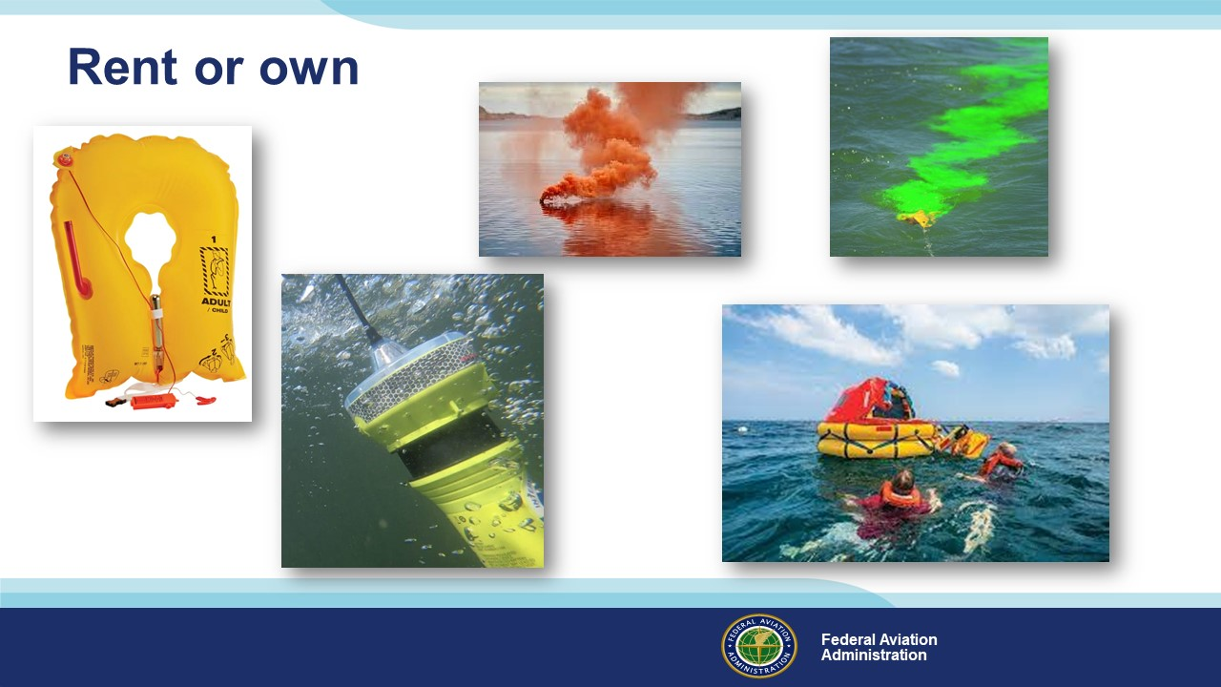 | Slide 6  If you make frequent trips over water or to the back country, it might make sense to own and maintain expensive survival equipment to supplement what you carry on every flight. If it’s just an occasional trip to the islands though, renting equipment is probably your best bet. Just be sure to allow enough lead time to reserve your equipment and plan whether to pick it up en route or have it shipped to you.  (Next Slide)
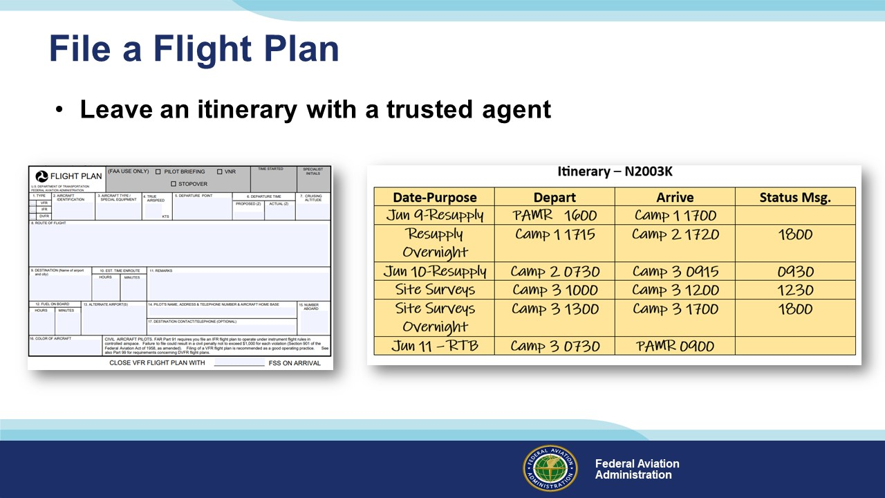 | Slide 7  Speaking of planning, filing a flight plan is an obvious safety benefit for any flight – particularly if you’re operating over water or in sparsely populated areas. (Click)  For extended trips to the boonies, it’s also a good idea to leave a detailed itinerary that includes a communication schedule, with a trusted agent before you depart. If you haven’t called in on schedule, your agent can notify authorities to begin a search. You should also consider carrying some recent technology on your trips to the bush.  (Next Slide)
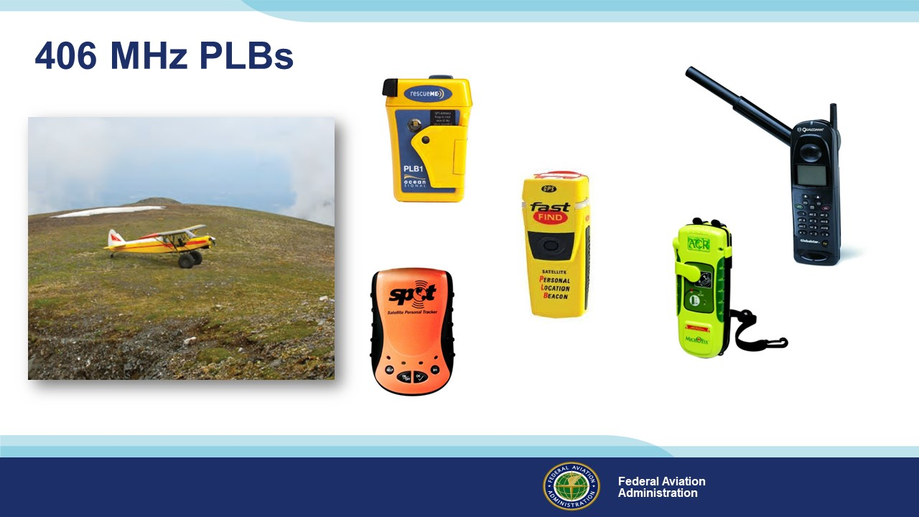 | Slide 8  406 Mhz. Personal Locator Beacons are great to have – especially on flights to or over remote areas.. These relatively low-cost devices are a great adjunct to the aircraft ELT.  They’re handy enough to always have with you and they’re not just for aviation. You can use them for hiking, camping, hunting, & fishing – or for peace of mind on any road less  travelled. Many of them can also process messages from you to the folks back home. You can let them know if you need help or if everything’s all right. (Click)  Satellite phones are now available for purchase or rent. Not a bad idea if you’re planning over water or remote area flying.  We’ll talk more about survival equipment later but first let’s discuss some survival tips that are applicable to any aircraft.  (Next Slide)
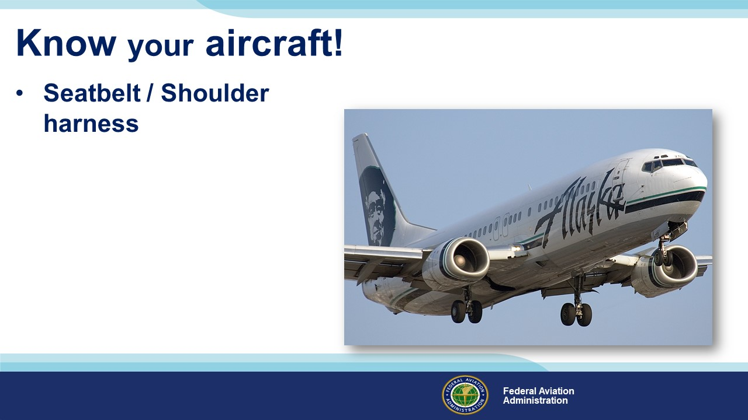 | Slide 9  Knowledge of your aircraft – even when it’s unable to fly after a forced landing can be critical. Let’s begin with seatbelts and restraint systems.  (Next Slide)
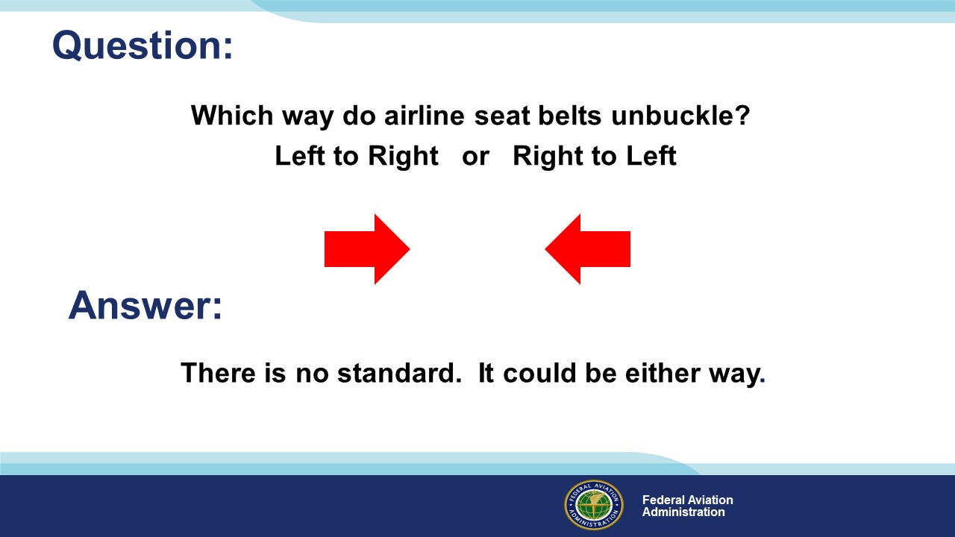 | Slide 10  We’ve all heard the airline safety briefing many times on many carriers so here’s a question:  Which way do airline seat belts unbuckle (Click)  – from left to right, or from right to left?  Ask the audience for a show of hands then: (Click)  The answer is there is no standard. It could be either way.  (Next Slide)
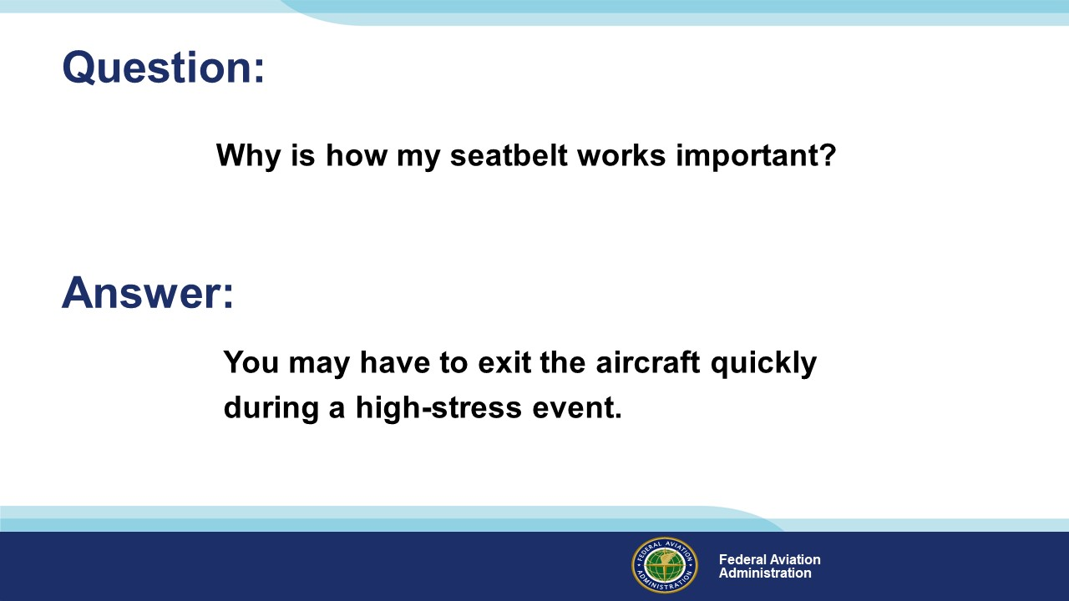 | Slide 11  Why does how your seatbelt work matter? (Click)  Well, you may be very motivated to exit the aircraft. That motivation could compromise your thinking and that could result in a deadly delay.  (Next Slide)
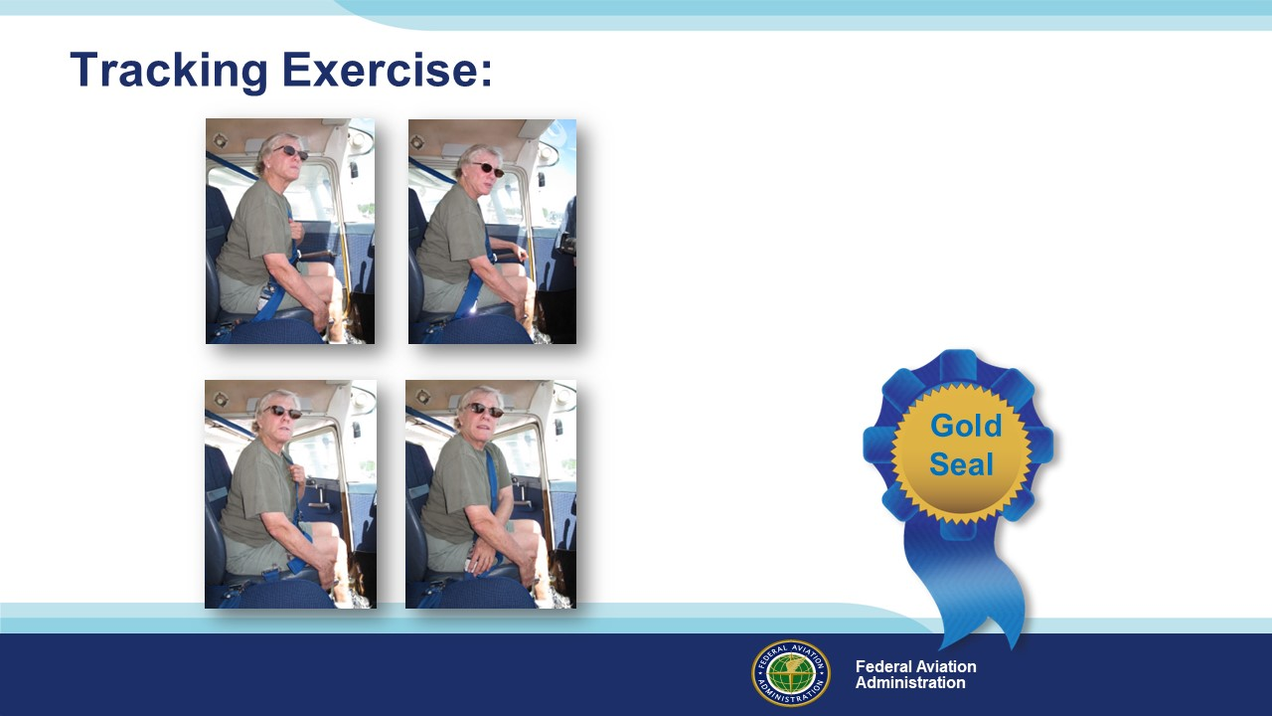 | Slide 12  Here’s an exercise that will improve your chances of doing the right things in the right sequence to exit your aircraft quickly. Please follow along as we go through the steps.  Encourage the audience to go through the motions from their seats.  First of all, imagine you’re sitting in your usual seat in the airplane you usually fly. Visualize which hand you’ll use to open the exit closest to you. Have you got the picture?  Good – now take your other hand and hold on to you seat like this (Click)  Keep you seat holding hand in position for the rest of the exercise. Now locate your sternum as our pilot is doing in the illustration. Our sternum is something we always have with us  and it’s easy to find – even in the dark. We’ll use it as a reference to find other important parts of the aircraft. Once you find your sternum reference point, move your hand to your lap and from  there track to the door latch. (Click) In some airplanes you’ll have to track to 2 door latches.  Unlatch the door, push it open, and return to your reference point. (Click)  Now that you’re at your reference point again track down to your lap and from there to your seat belt release all the while holding tightly on to your seat with your other hand. (Click)  Release your seat belt and prepare to exit. Don’t let go of your seat though. I’ll tell you when to do that. (Click)  This little exercise could save your life in an emergency in almost any vehicle and it’s worth a gold seal.  (Next Slide)
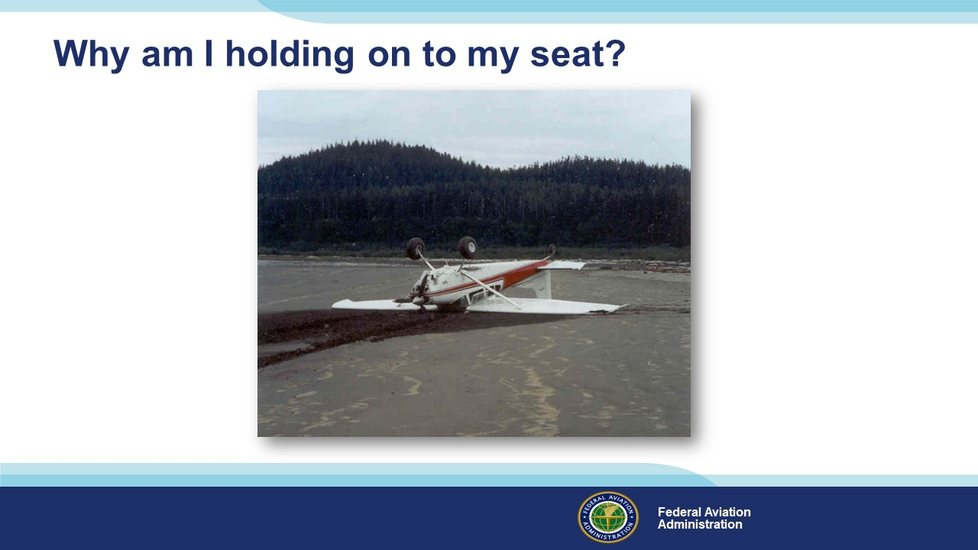 | Slide 13  Now I know you’re wondering why you’re still holding on to your seats when the whole object of the exercise was to undo the seatbelt and exit. (Click)  Answer – Because we might be upside down & unbuckling the belt without preparation could lead to a spinal injury or cracked skull. Also - some buckles are difficult or impossible to  unlatch when they’re under load. You can use your seat holding hand to take the strain off the buckle before unlatching it.  (Next Slide)
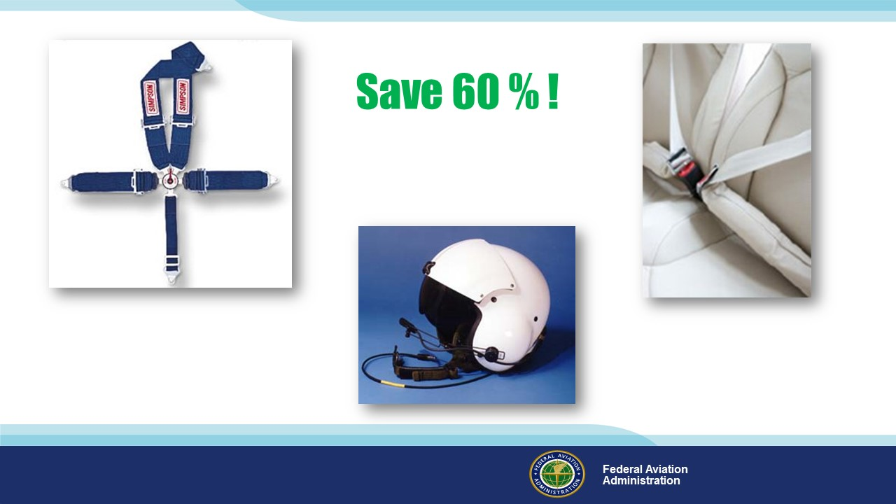 | Slide 14  If you saw a sign that said just this “Save 60%!” would you want to know more? (Click)  Well in Alaska we could reduce General Aviation fatalities by 60% through adoption of these technologies; four or five-point seatbelts or airbag seatbelts and helmets.  Granted Alaskan accidents tend to take place off airport, and many are in low-speed aircraft so the impact forces are less but it’s certainly something to think about  when you’re replacing your seatbelts.  (Next Slide)
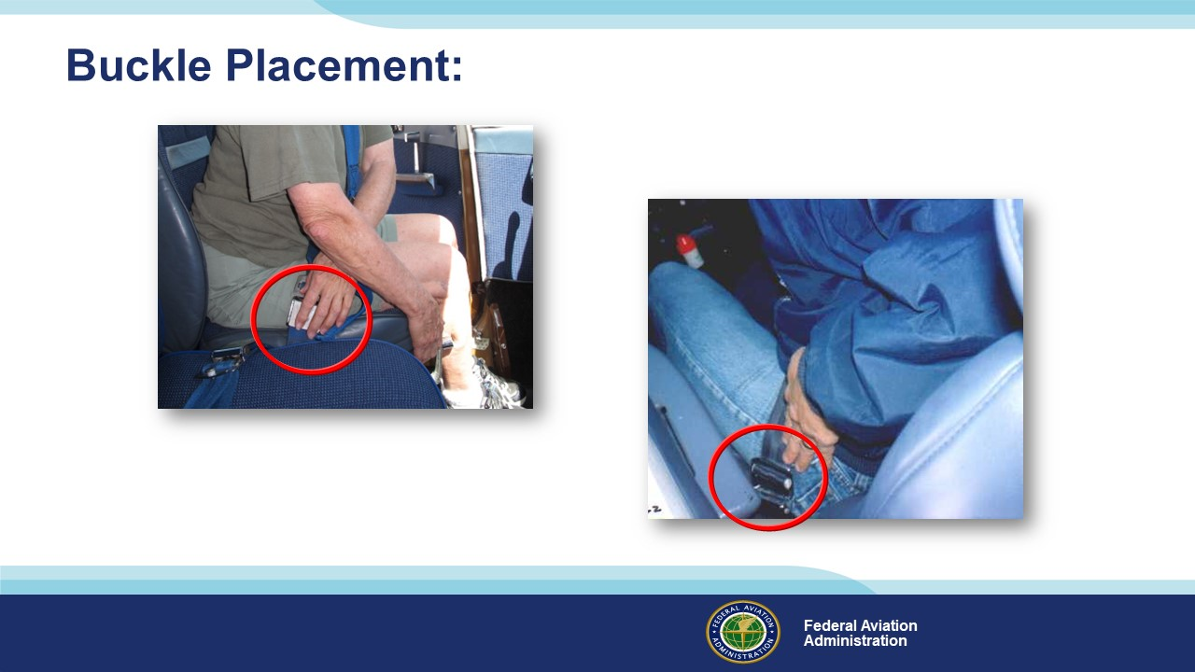 | Slide 15  Just one more thing about seat belts. Buckle placement is important. (Click)  In this illustration, the seat belt buckle is low on the pilot’s left side. With the door closed, the buckle will be under the armrest. If the door were jammed, precious time could be  Spent in cutting the seatbelt & finding another exit. (Click)  Here the buckle is low on the pilot’s right side and it’s unobstructed – a much better choice for buckle placement.  (Next Slide)
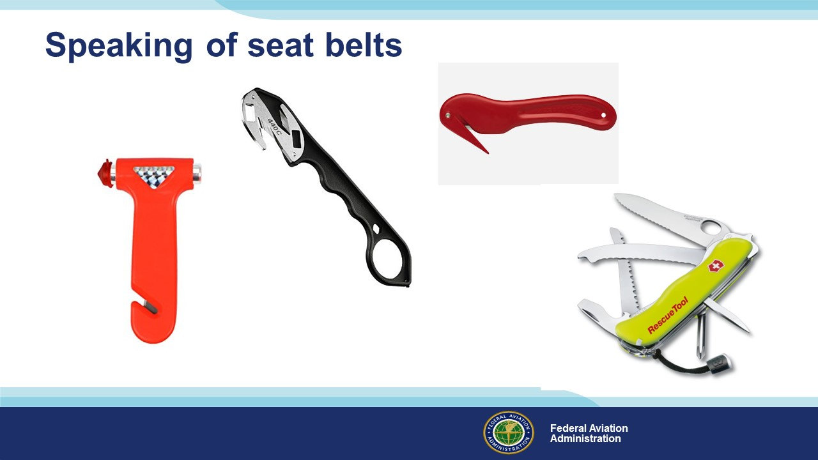 | Slide 16  Once your seatbelts or harness have done their job, you’ll want to get clear of them quickly. Single point belt releases are a wonderful thing but if they’re inaccessible you’ll need a Plan B. A seatbelt cutter or multi-purpose extraction tool fills the bill, and you’ll need to have it where you can access it quickly. That means not in the glove box or the emergency kit in the baggage area or the flight bag. Accessible means on your person in a pocket that you can easily reach while wearing your restraint system.  Some folks say, “I carry a pocketknife – that’ll cut through any seat belt”. They’re right of course but the trouble with a knife is you can do a lot of damage to yourself while trying to cut through a seat belt. This is one time where you ought to consider a specialty tool. More about tools later.  (Next Slide)
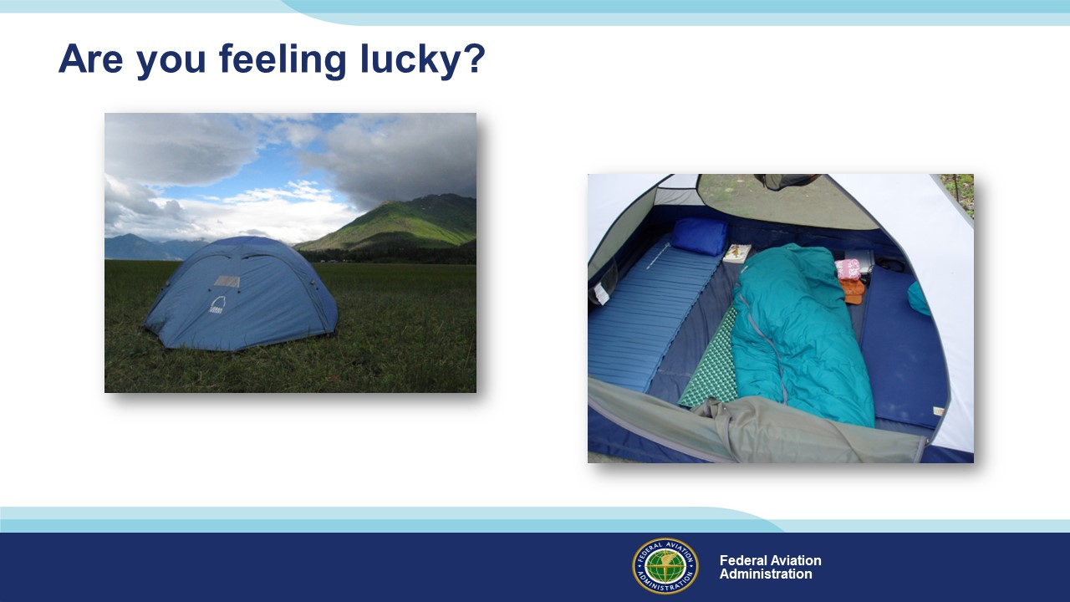 | Slide 17  The nature of forced landings is such that we don’t get to pick when and where they’ll happen. (Click)  If you’re lucky, you’ll arrive on the ground intact with all your survival gear. You can set up camp and enjoy the great outdoors while waiting for rescue.  We’re not always lucky though and if your aircraft burns or sinks, your gear may be lost, and you’ll end up with what you’re wearing.  (Next Slide)
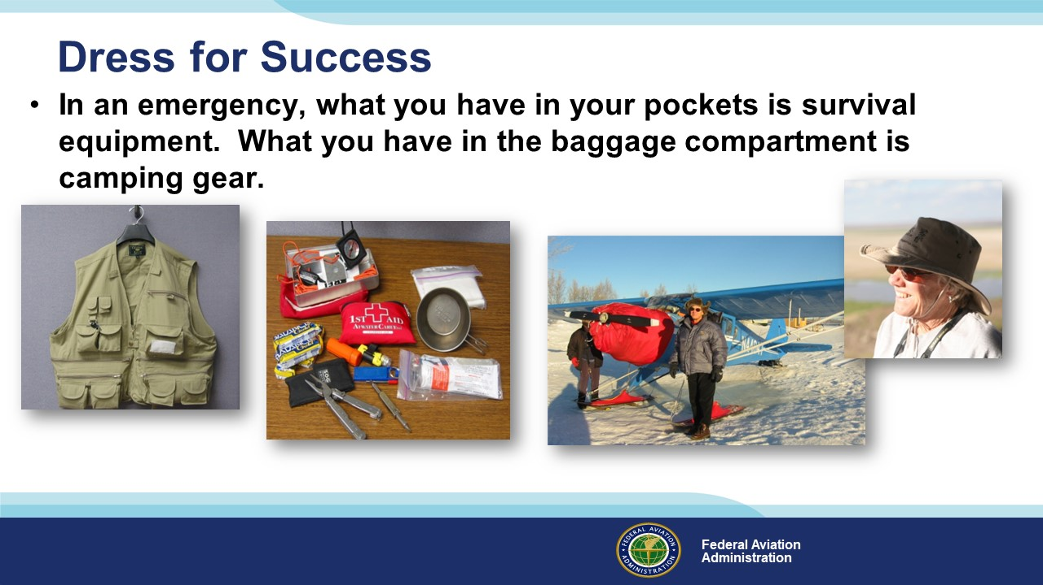 | Slide 18  Plan to dress for success. That means wearing – not just packing - clothing that matches the environment over which you’re flying. You may be comfortable in your climate-controlled cabin at ten thousand feet but in the event of a forced landing, you may have to exit the aircraft quickly and gear that’s stowed in baggage compartments may not be accessible.  Dressing in layers is always a good idea. That way you can adjust as conditions change. For instance; temperatures on the ground can vary significantly from daytime highs to nighttime lows. Be sure to wear long sleeves and trousers closed-toe footwear suitable for hiking and a hat. Although goose down is a wonderful insulator when it’s dry, it’s not very good when soaked so synthetic insulation will serve you better when it’s wet. (Click)  In an emergency, what you have in your pockets is survival equipment. What you have in the baggage compartment is camping gear. Many bush pilots wear vests that contain essential survival equipment. That way they’re at least equipped with the basics to survive the first few hours on the ground.  (Next Slide)
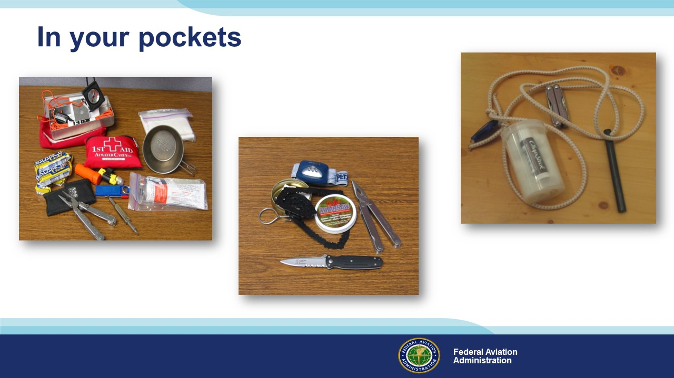 | Slide 19  Here are some survival items that many Alaskan aviators carry in a vest or in their pockets. We have a hand compass, signaling mirror and 50 feet of para cord, a small first aid kit, a couple of power bars and a mini first aid kit. There’s also a mini flashlight, matches in a waterproof container, a titanium cup, paper tissue, a multi-purpose tool, a combination screwdriver and a packet of tea and/or instant coffee. (Click)  Here’s a compact fire making kit that includes a spark stick and striker, cotton balls, and lip balm. The lip balm provides wax that will enable a cotton ball to burn long enough to start a camp or signal fire. (Click)  Some pilots supplement these items with a dedicated pocket-knife, easier and safer to use than the knife blade on a multi-purpose tool, a headlamp, so handy it should probably be considered essential, and a flexible chain saw that’s smaller, lighter, and easier to use than an axe.  (Next Slide)
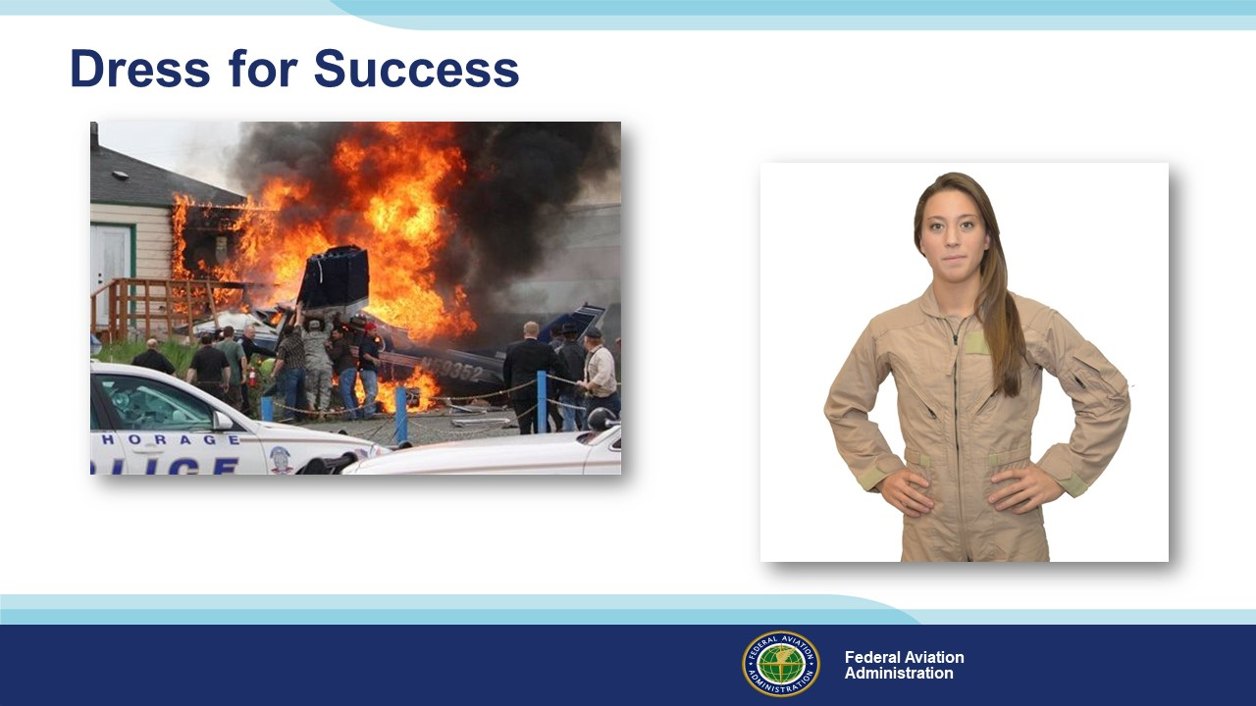 | Slide 20  And speaking of dressing for success – fire retardant clothing makes a lot of sense. I know you don’t plan to land off airport, but fire is a distinct possibility in emergency landings and it’s not uncommon for pilots & passengers to survive the landing only to perish from burns afterwards. Four of the five aircraft occupants survived the crash pictured here – all with serious burns. (Click)  You may not want to go the Nomex flight suit route but at least consider cotton or wool outer garments, long sleeves, trousers rather than shorts or skirts, and closed toe shoes rather than sandals. Once again’ you make it through the landing and exit with what you’re wearing and there’ll be no time for a costume change on the way to the ground.  (Next Slide)
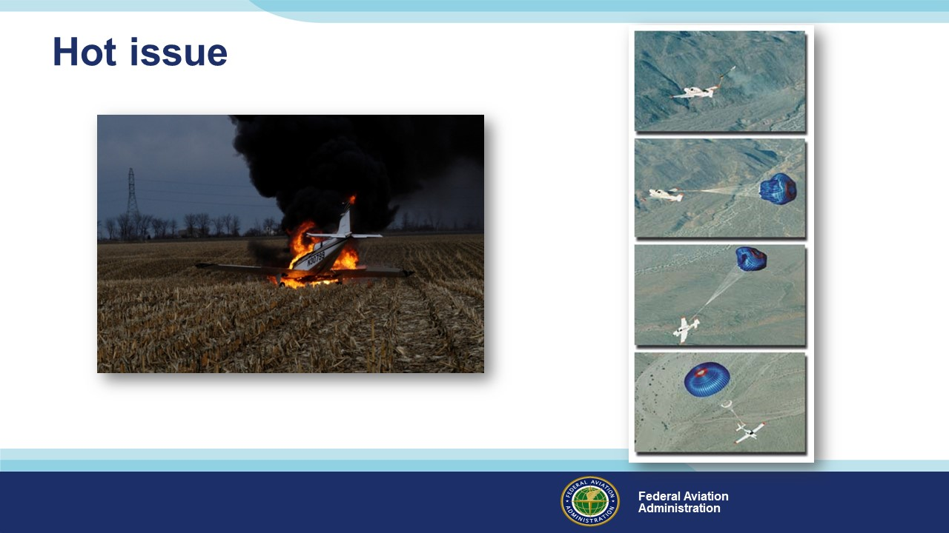 | Slide 21  Fire has always been a big issue with aircraft accidents. The pilot of this airplane made a successful forced landing but within 2 minutes of landing, the aircraft was engulfed in flame.  There are technologies available today that will reduce the chances of having a fire in the air or on the ground. Fire prevention fuel tank inserts can significantly reduce the chance of post impact fire.  And speaking of impacts, (Click) ballistic parachute technology has matured to the point that it’s standard equipment on at least one GA single-engine airplane and it can be retrofitted to many others.  (Next Slide)
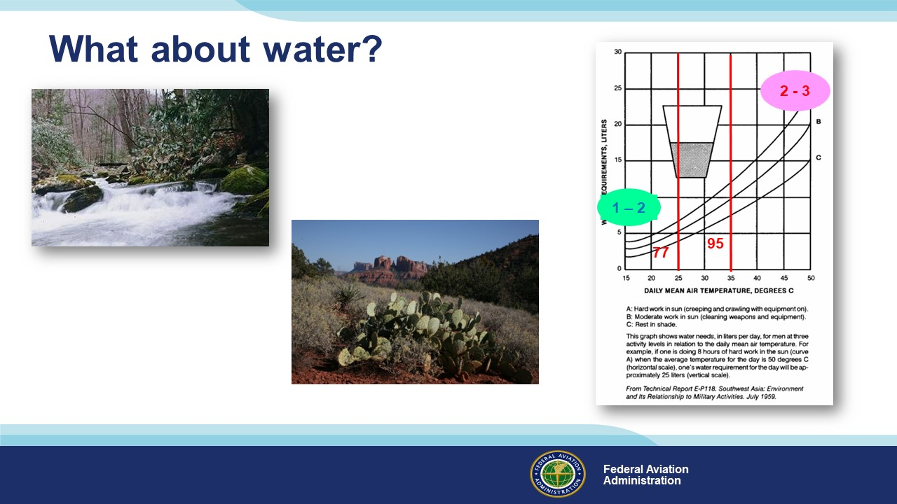 | Slide 22  Hydration is so important to survival that we need to plan for it on every flight. Water is heavy to pack, and it may or may not be easy to find on the ground. (Click)  Your planning should include at least one quart of water for each occupant. How much more to carry depends on where you’ll be flying and the temperature. (Click)  At 25⁰ Celsius/77⁰ Fahrenheit, adults need 1 to 2 gallons of water per day. (Click)  If the temperature increases to 25⁰ Celsius/95⁰ Fahrenheit, we’ll need 2 to 3 gallons per person per day. That’s a lot of water to pack.  (Next Slide)
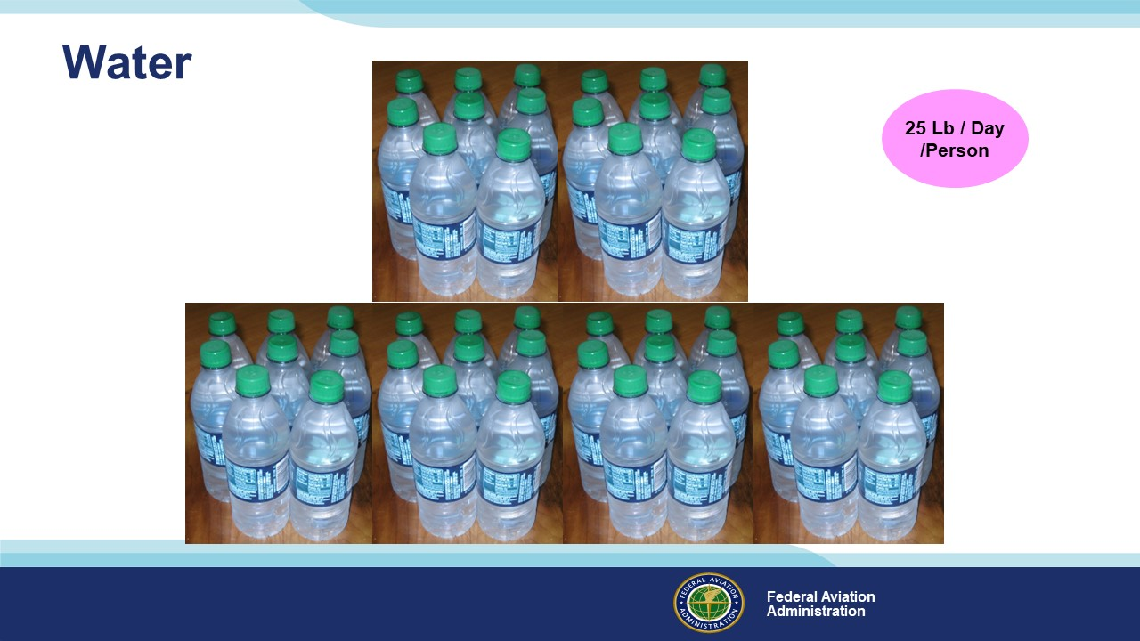 | Slide 23  Here’s a gallon of water. It’s sufficient for 1 person at 77⁰ F providing they’re mostly at rest and in the shade. (Click)  If they’re working at 95⁰ F. though; they’ll need this much water. (Click)  And two people working in 95⁰ weather will require this much water to be adequately hydrated. (Click)  That works out to a whopping 25 Lb. per person per day.  (Next Slide)
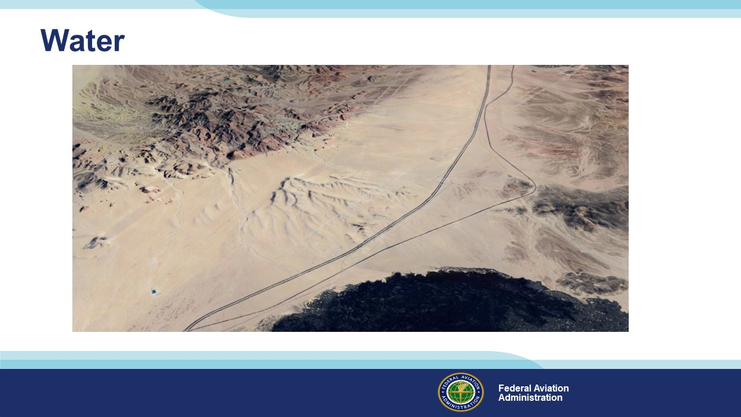 | Slide 24  Water in sparsely populated arid environments is hard to come by. That’s why many pilots plan to fly within gliding distance of major highways. Emergency landings on or adjacent to highways often work out well and ground-bound travelers are usually available to assist. The extra margin of safety is well worth a few more minutes in the air.  (Next Slide)
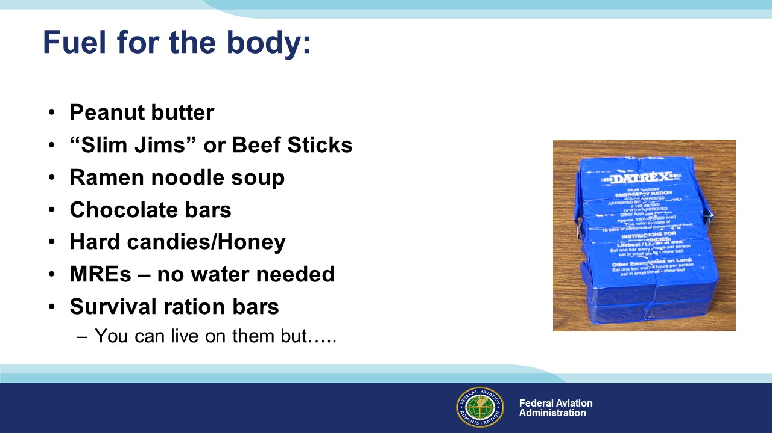 | Slide 25  Here’s a list of easy to pack foods that can sustain you at least temporarily. We know of several Alaskan aviators who fly with a half-gallon plastic bag of peanut butter. It’s easy to carry between layers where it doesn’t freeze and quite efficient as a nutrient. The survival rations pictured here last practically forever without refrigeration and their taste is…well, difficult to describe. Suffice it to say that living on survival rations really motivates you to facilitate a speedy rescue.  (Next Slide)
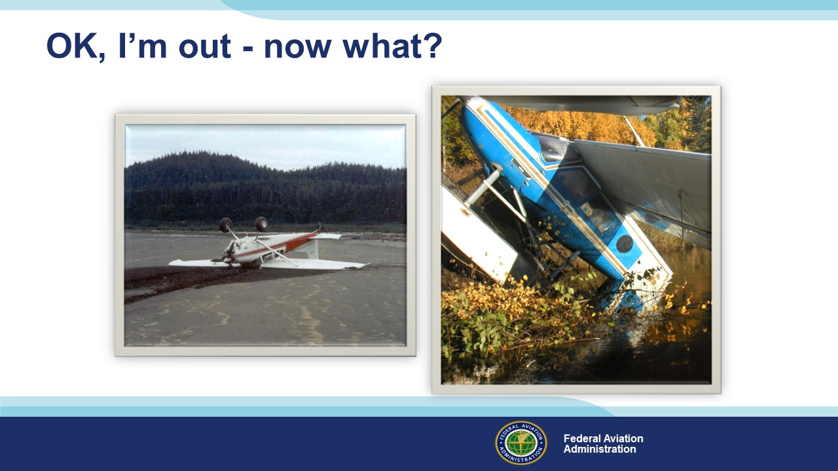 | Slide 26  OK, you’ve made a successful forced landing, you’re out of the aircraft and you have all your gear – now what.  (Next Slide)
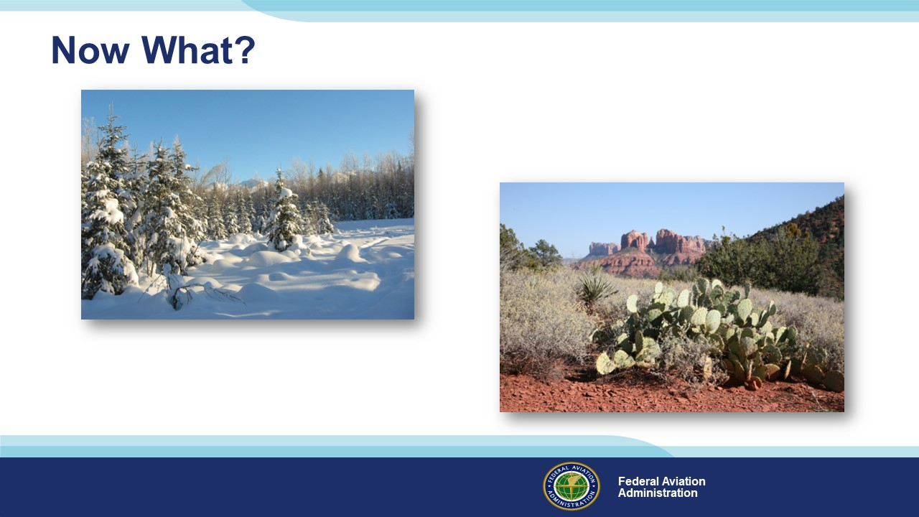 | Slide 27  If you’re lucky enough to land close to civilization you land on or next to a highway and wait for help; but if you’re in Alaska, or the Sonoran Desert. That could be a different situation altogether.  Hopefully, you chose a route that took you close to a highway. That’s not possible for a lot of Alaska but it’s relatively easy to do in most of the lower-48. No matter  where you land, there are some things that must be done quickly. Let’s look at them in the context of some survival limits.  (Next Slide)
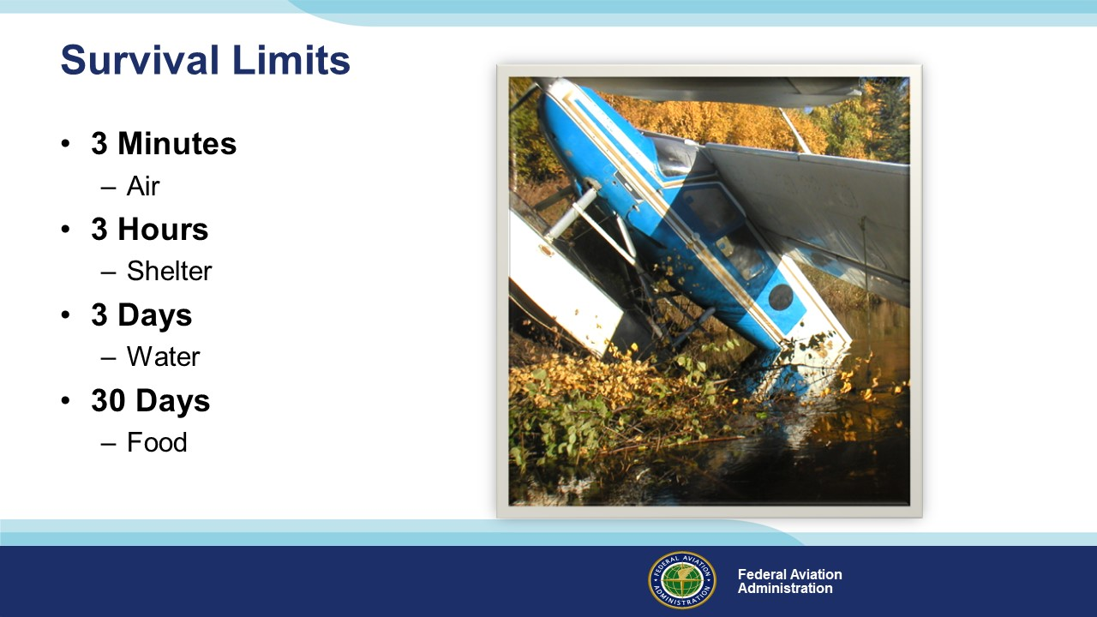 | Slide 28  Wherever you are there are limits to how long you can survive so let’s take a simplistic look at human endurance limits. (Click)  There have been some notable exceptions but most of us can live up to 3 minutes without air. (Click)  Three hours is about the longest we can last in relatively harsh environments without shelter. Shelter, by the way, includes the clothes we’re wearing. (Click)  We may not feel good about it but most of us can last up to three days without water. (Click)  And we can last a whole lot longer than that without food.  (Next Slide)
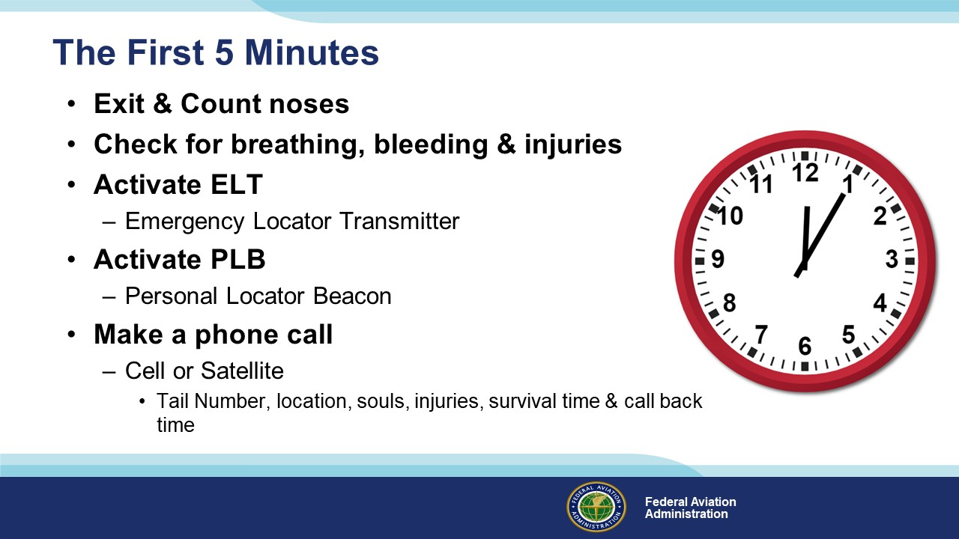 | Slide 29  So, here’s what we need to do in the first 5 minutes after we land: (Click)  Exit the aircraft & account for the occupants. Do this as quickly as you can so you can get on to (Click)  Checking for breathing, bleeding, and injuries in this order. Horrendous looking injuries are insignificant if the person who received them isn’t breathing or is bleeding profusely, so attend to those things first. Then deal with the other damage. (Click)  Activate your ELT and your PLB (Personal Locator Beacon) if you have one. (Click)  Next – make a phone call. In much of the continental United States cell phone service is available – especially along major highways. In remote areas, a satellite phone is always a good idea. They’re now much more affordable to purchase and they can be rented for individual trips.  Calling 911 might work in urban areas but if you’re in a very populated area chances are somebody’s already on the way to your location. Call one of the FAA Regional Operations Centers if you have the number or call Flight Service. (Click)  Give them your tail number, location, number of people, preliminary extent of injuries (you can elaborate on this during your 2nd phone call), the number of days you can survive where you are, and a time when you’ll call back.  You don’t want to get into a long conversation at this point. On the initial call there’s almost nothing of value they can tell you but by the time you call back they’ll have some information for you.  Hang up and switch off to conserve battery power and set about organizing your camp.  (Next Slide)
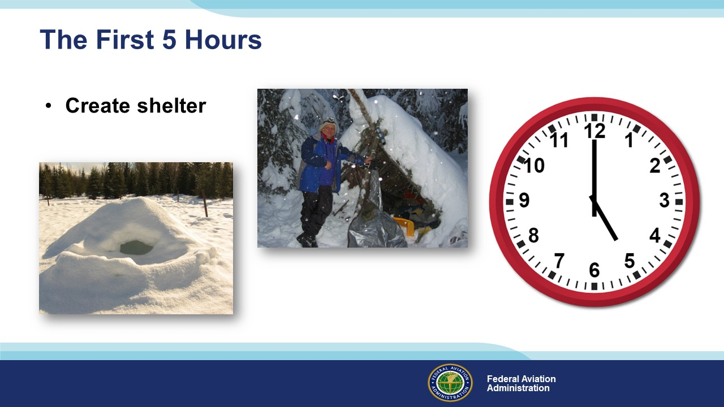 | Slide 30  Here’s what you’ll need to do in the first 5 hours. Note that we’re creating shelter early on before the need for it becomes critical. We could devote an entire program to creating shelter from items at hand. It could be as simple as unloading tent and camping supplies and setting them up to digging a snow cave or fashioning a lean to from nature-provided components.  But creating shelter, although critical, is by no means the only thing we need to do in the first 5 hours on the ground. Here’s the rest of the list.  (Next Slide)
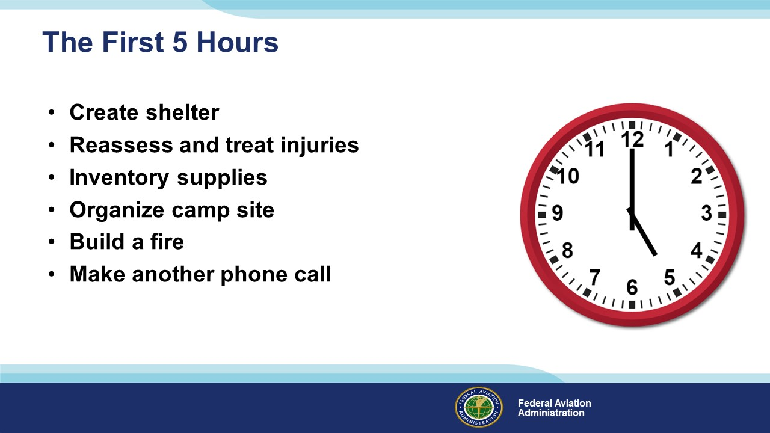 | Slide 31  We’ll need to reassess and treat injuries, inventory our supplies and equipment organize our camp site, and carefully build a fire.  A fire can have a powerful, positive effect on morale but be very careful to contain it. You can’t afford to start a forest fire centered on your landing site.  During your second phone call you can elaborate on your situation and learn about rescue efforts that are getting underway.  (Next Slide)
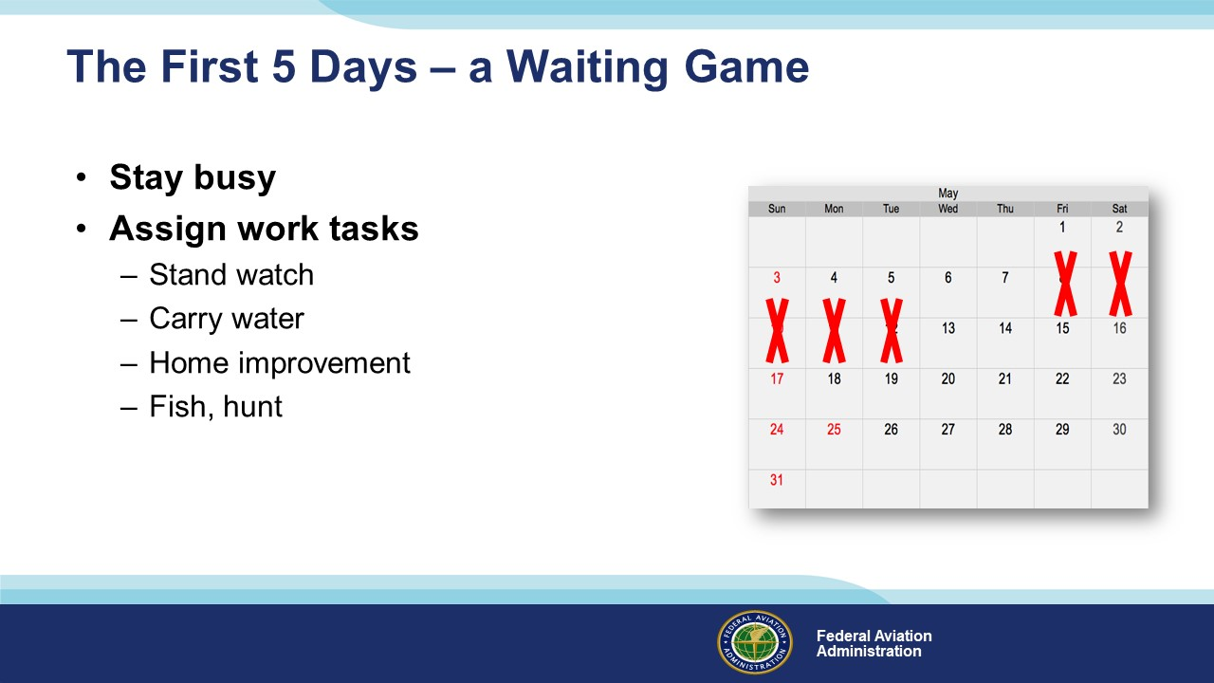 | Slide 32  Now your survival becomes a waiting game. The key to good morale is to stay busy. Make sure everyone has a job to do and encourage them  to do their best.  By the way – fishing and hunting, if you’re not experienced with and good at it can be quite unproductive. Packing a few days worth of rations can at least sustain you  as you set about living off the land.  (Next Slide)
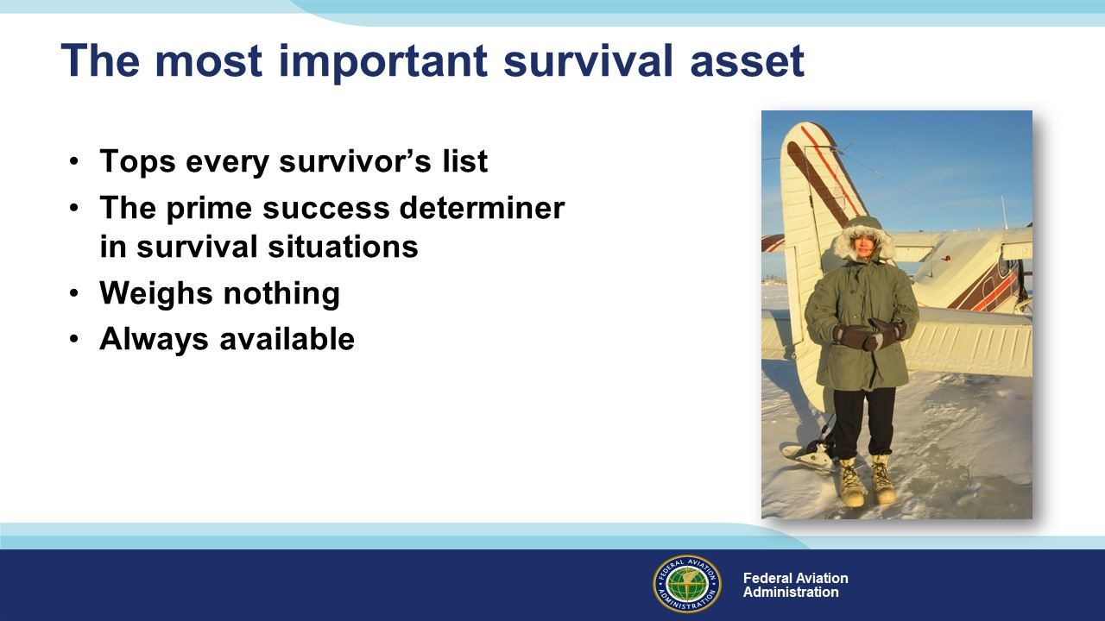 | Slide 33  This is the end of a very short presentation. The volume of information you might find useful would take days to convey so, as we said in the beginning, we hope we’ve  piqued your interest in the subject. Likewise, the list of items you’d like to have in your survival kit could fill dozens of equipment catalogs.  There is one item that tops every successful survivor’s list. It’s considered by experts to be the prime factor in determining whether one lives or dies.  It weighs nothing and it’s always available.  It is – of course………………  (Next Slide)
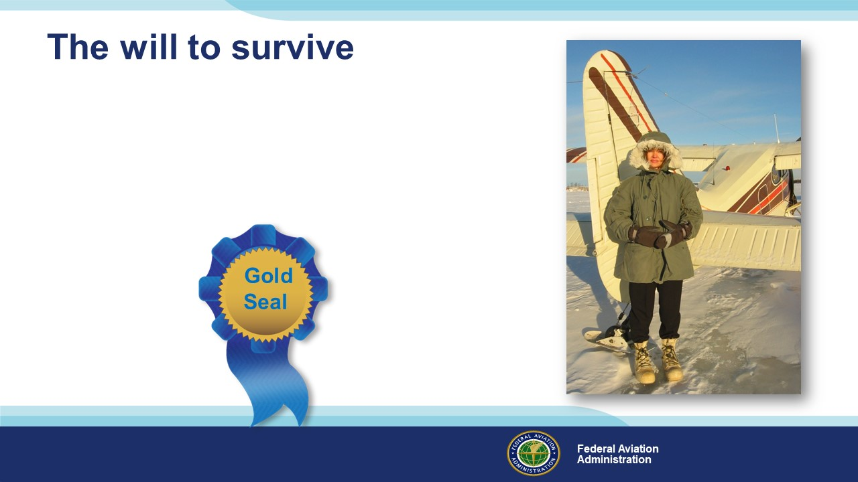 | Slide 34  The will to survive.  With it – there’s almost nothing we can’t cope with.  Without it – we will be in grave jeopardy no matter how well equipped or benign the environment.  (Next Slide)
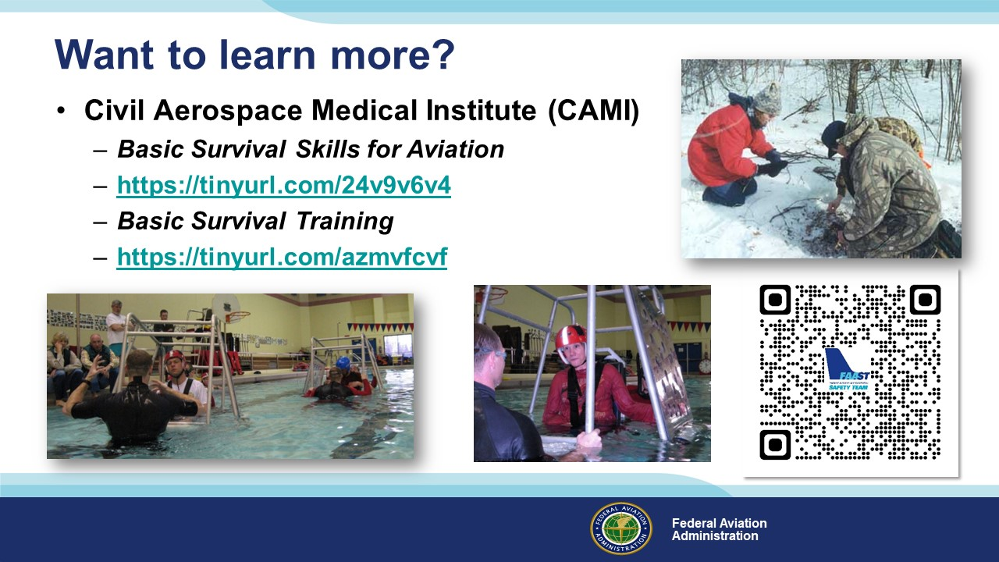 | Slide 35  Want to learn more?  The Civil Aerospace Medical Institute provides a survival manual, Basic Survival Skills for Aviation. You can download a copy at the URL or QR code on screen. (Click)  CAMI also offers a Basic Survival Training course. You can learn more about it by navigating to this website.  Presentation note: If you have time and an internet connection you can click on the hot link and go to the CAMI website or to the URL on screen.  There are many commercial in-depth survival training courses available as well. We encourage you to consider attending one of them.  (Next Slide)
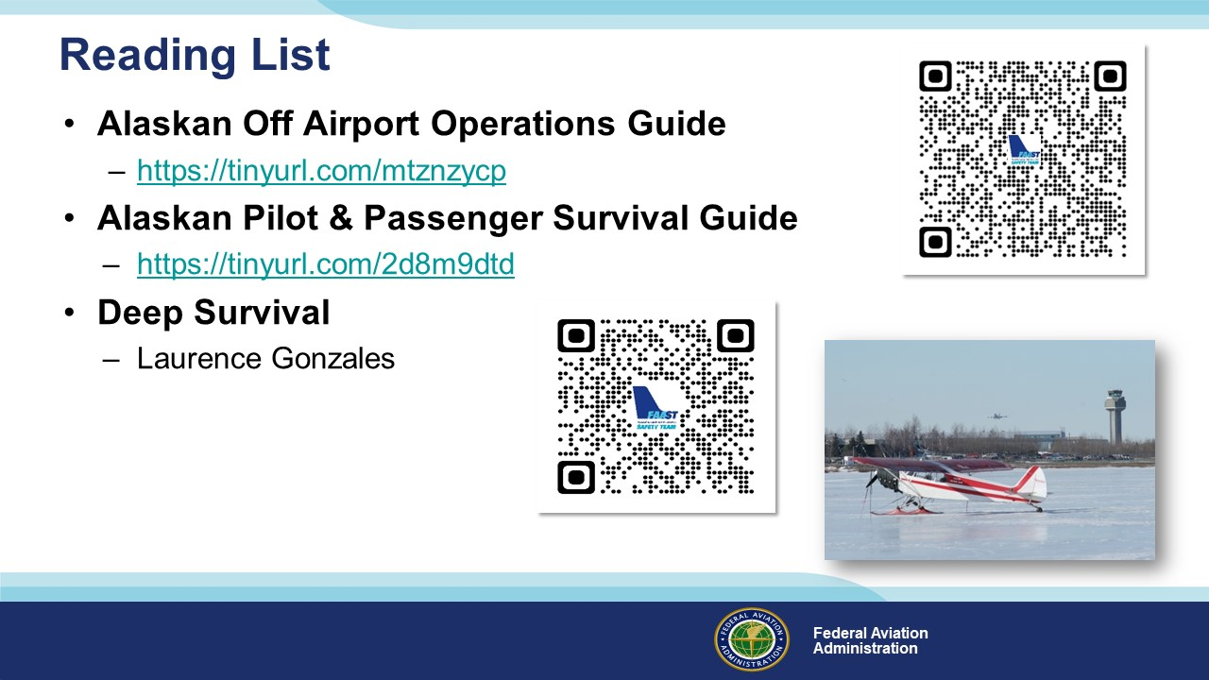 | Slide 36  Finally, here are some reading resources for you to consider (Click)  The Alaskan Off-Airport Operations Guide offers techniques for operating on short, unpaved surfaces. Familiarity with these techniques  can improve forced landing performance. (Click)  The Survival Guide offers suggestions for coping with off airport survival situations. (Click)  Deep Survival by Laurence Gonzales is an excellent treatise on the psychology of survival. It’s an easy read with lots of real-life examples.  (Next Slide)
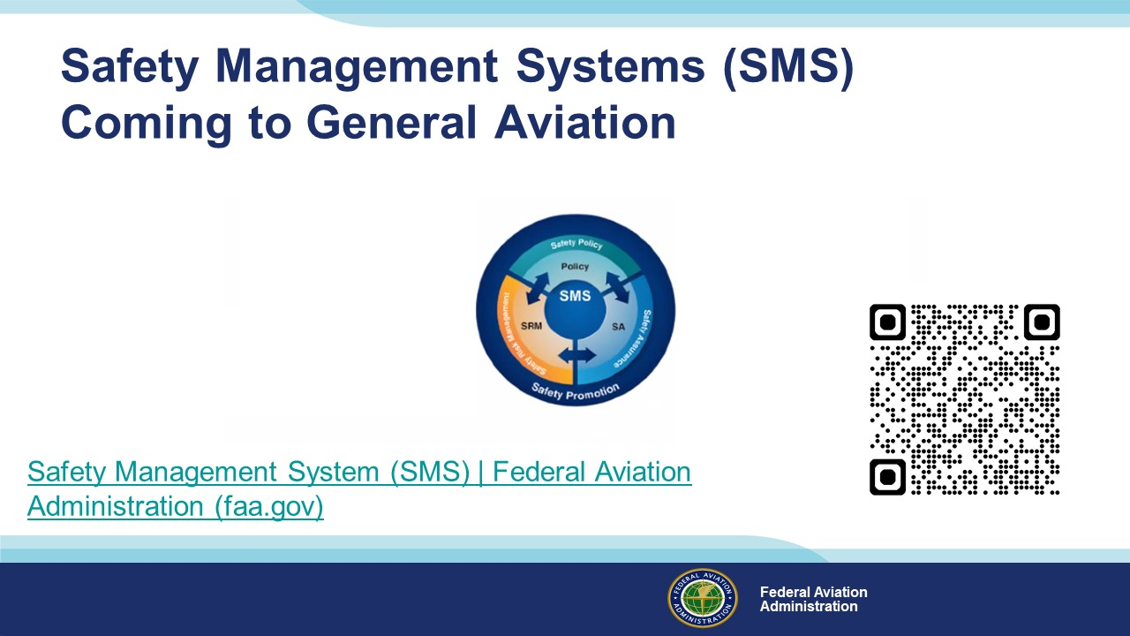 | Slide 37  Safety Management Systems are a set of policies and processes that can increase the safety and efficiency of any flight operation. And FAA is bringing SMS to General Aviation. You may have heard of SMS but thought it was only for large organizations but actually SMS can be scaled to fit any operation large or small.  There are 4 major components to a Safety Management System (Click)  Safety Policy – a documented commitment to safety that runs from the head of an organization to its newest member. (Click)  Safety Risk Management – a process that identifies hazards within an operation, determines to what extent an identified hazard may impact flight safety, and controls the risk of occurrence to an acceptable level. (Click)  Safety Assurance – By collecting and analyzing information derived from safety performance data Safety Assurance ensures the performance and effectiveness of Safety Risk Controls. (Click)  Safety Promotion communicates safety information and commitment throughout the organization. (Click)  You can find more information about Safety Management Systems at the URL on the Screen.  Presentation note: Allow sufficient time for audience to copy link then:  (Next Slide)
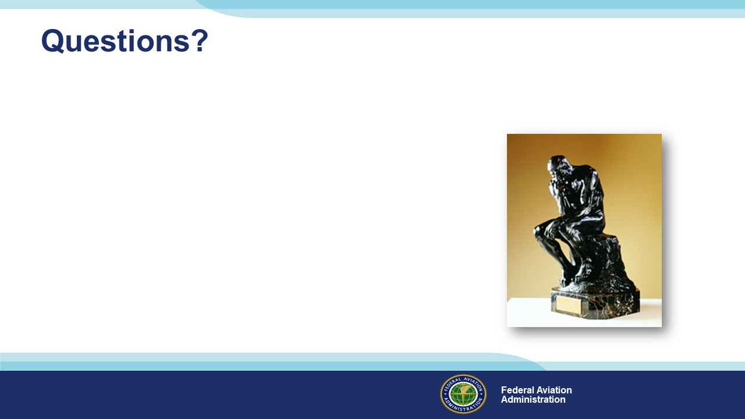 | Slide 38  Presentation Note: You may wish to provide your contact information and main FSDO phone number here. Modify with  Your information or leave blank.  (Next Slide)
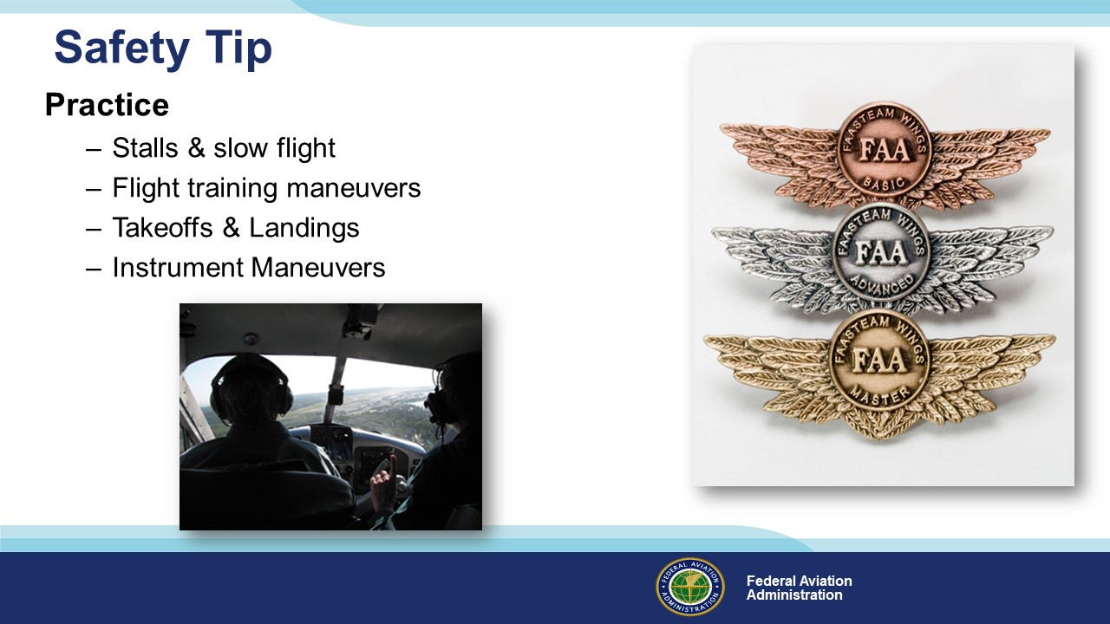 | Slide 39  An airplane owner once asked an experienced instructor pilot, “What’s the best thing to put in my airplane to increase safety?”  Without hesitation, the instructor answered, “Gasoline”. (Click)  That’s right – the most effective safety tool for any pilot is practicing the art and science of flying. That means more than  a monthly trip for the hundred-dollar hamburger. Book some time with a CFI at least once a year to practice the items on this list. (Click)  And be sure to document your achievement in the Wings Proficiency Program. It’s a great way to stay on top of your game.  (Next Slide)
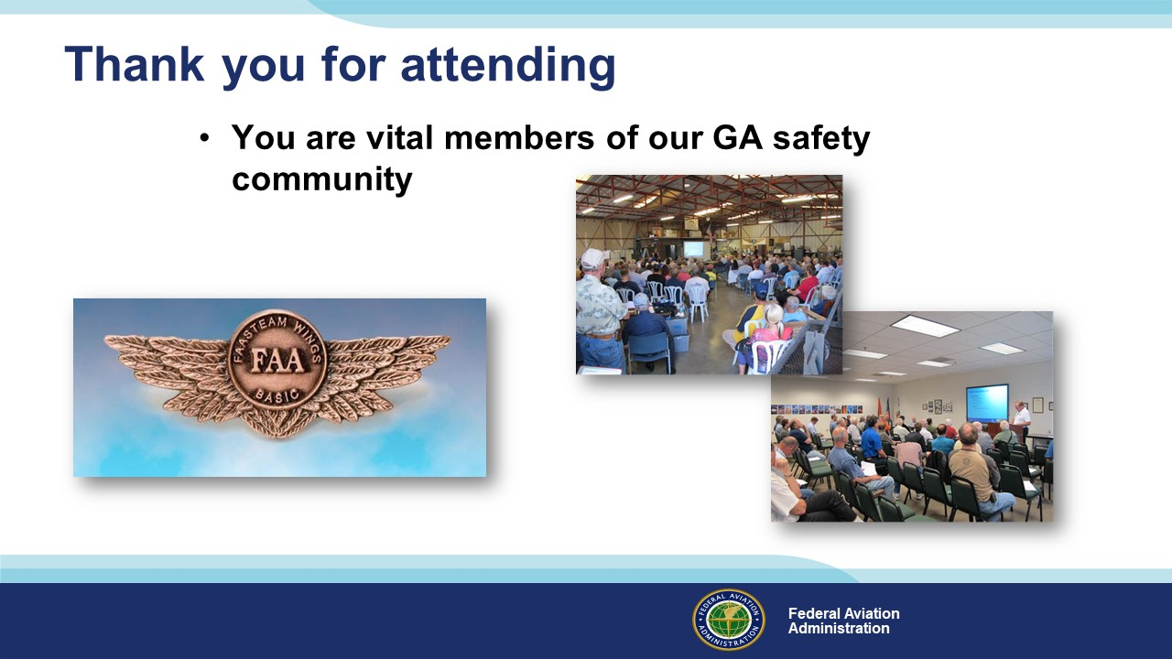 | Slide 40  Your presence here shows that you are vital members of our General Aviation Safety Community. The high standards you keep and the examples you set are a great credit to you and to GA.  Thank you for attending.  (Next Slide)
Slide 41
(The End)

Appendix I – Equipment and Staging
Equipment:
- Projection Screen & Video Projector suitable for expected audience
  - Remote computer/projector control available at lectern or presenter location
    - In lieu of remote – detail a Rep to computer/projector control.
- Presentation Computer
  - Note: It is strongly suggested that the entire program reside on this computer.
- Back up Projector/Computer/Media as available.
- PA system suitable for expected audience
  - Microphones for Moderator and Panel
    - Optional Microphone (s) for audience
- Lectern (optional)
Staging:
- Arrange the projection screen for maximum visibility from the audience.
- Equip with PA microphones
- Place Lectern to one side of screen. This will be used by presenters and moderator

IMPORTANT – Once you have completed outreach on this topic, please help us track the outreach you have done by entering a SAS record.

