Outreach Guidance Document

2023/10-29-299(I)PP

This outreach guidance is provided to all FAA and aviation industry groups that are participating in outreach efforts sponsored by the General Aviation Joint Steering Committee (GAJSC). It is important that all outreach on a given topic is coordinated and is free of conflicts. Therefore, all outreach products should be in alignment with the outline and concepts listed below for this topic.

Outreach Month: March 2025

Topic: Risk-based Flight Review and WINGS
This program introduces the concept of basing Flight Reviews on risks that pilots run during normal flight operations and on those risks associated with new aircraft and/or flight environments. The program also emphasizes the benefits of participation in the FAA WINGS Pilot Proficiency Program.

Background:

Safety Risk Management is a major contributor to safer and more effective General Aviation flight operations. A Risk-based Flight Review can identify hazards and risks associated with pilot operations and provide guidance in eliminating or mitigating those risks to acceptable levels.

The FAA WINGS Pilot Proficiency Program is one way for general aviation pilots to ensure they are competent, confident, and safe in their flight operations.

Note: This program discusses WINGSPro activities. We suggest you invite local WINGSPros to attend and to assist with the presentation.

Teaching Points:

- The basic elements of Safety Risk Management are Hazard Identification, Risk Assessment, and Risk elimination or mitigation to acceptable levels.
- Conducting a Risk-based Flight review is one way to introduce Safety Risk Management to General Aviation pilots. It also serves to identify risks associated with individual pilots’ flight operations and to devise strategies to eliminate or mitigate those risks to acceptable levels. .
- WINGS Pilot Proficiency Training is one means to maintain and improve pilot proficiency.
- The WINGS Topic of the Quarter is an easy way to pursue regular proficiency training.
- Completion of any phase of WINGS satisfies the 14 CFR 61.56 requirements for Flight Reviews.
- A cadre of WINGSPros is available to assist Flight Instructors and pilots with WINGS.

References:
- Risk-Based Flight Review and WINGS PowerPoint
  - Available on the National FAASTeam Share Point site
- Conducting an Effective Flight Review – FAASafety.gov Library.
- AC 61-91J – WINGS – Pilot Proficiency Programs
- AC 61-98D – Currency Requirements and Guidance for the Flight Review and Instrument Proficiency Check
- FAASafety.gov
- Off Airports Ops Guide
ttps://www.faasafety.gov/gslac/ALC/libview_normal.aspx?id=135893
- Personal Minimums Development Guide
https://www.faasafety.gov/gslac/ALC/lib_categoryview.aspx?categoryId=15&r_s=50&r_c=50
- WINGS Information and Guidance
https://faasafety.gov/gslac/ALC/lib_categoryview.aspx?categoryId=39

Abstract: Lasting 10 to 15 minutes, this presentation acquaints the audience with the benefits of engaging in regular proficiency training through the FAA WINGS Pilot Proficiency Program.
Format: Information Briefing - Power Point presentation
Required Personnel – FAASTeam Program Manager or designated FAASTeam Rep (s)
Optional Personnel – DPEs, CFIs, WINGSPros, and other pilots who can speak on the benefits of proficiency training.
National FAASTeam Support:
In addition to this guidance document, a Power Point presentation that supports the program is provided. FPMs and presenters are encouraged to customize this presentation to reflect each individual program.

Slides | Script
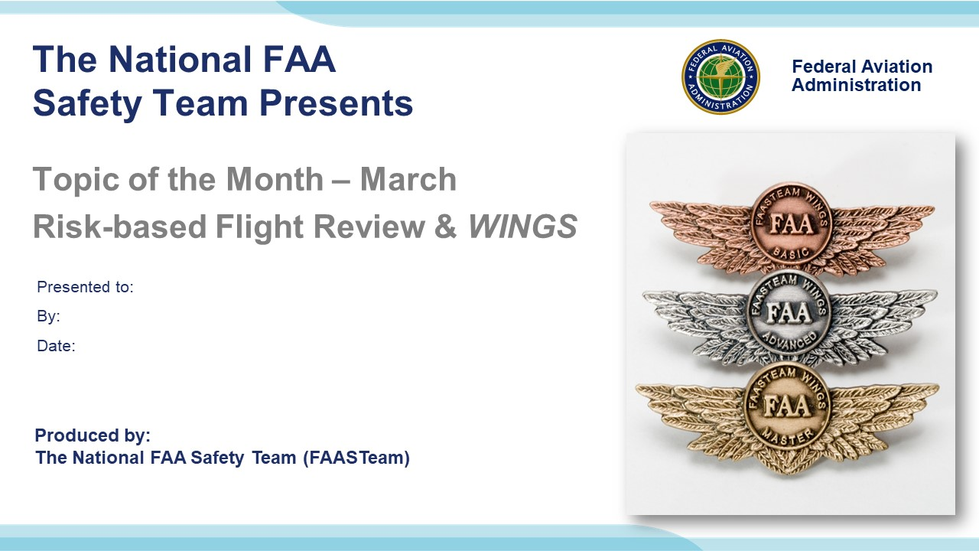 | Slide 1  2022/03-23-255(I)PP Original Author: John Steuernagle 03/23/2022; POC Kevin Clover National FAASTeam Program Manager (Ops), Office (562-888-2020  Presentation Note: This is the title slide for Pilot Proficiency and WINGS  - Script - We have included a script of suggested dialog with most slides. The script will always appear in a non-italic font. Presenters may read the script or modify it to suit their own presentation style. See template slides 5 and 6 for examples of a slides with script.  - Presentation Instructions - (stage direction and presentation suggestions) will be preceded by a Bold header: the instructions themselves will be in Italic fonts. See slides 2, for an example of slides with Presentation Instructions only.  - Program control instructions - will be in bold fonts and look like this: (Click) for building information within a slide; or this: (Next Slide) for slide advance.  - Background information - Some slides may contain background information that supports the concepts presented in the program.  Background information will always appear last and will be preceded by a bold Background: identification.  The production team hope you and your audience will enjoy the show. Break a leg!  (Next Slide)
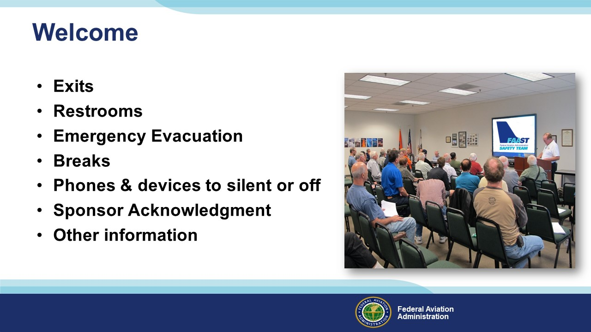 | Slide 2  Presentation Note: Here’s where you can discuss venue logistics, acknowledge sponsors, and deliver other information you want your audience to know in the beginning.  You can add slides after this one to fit your situation. (Next Slide)
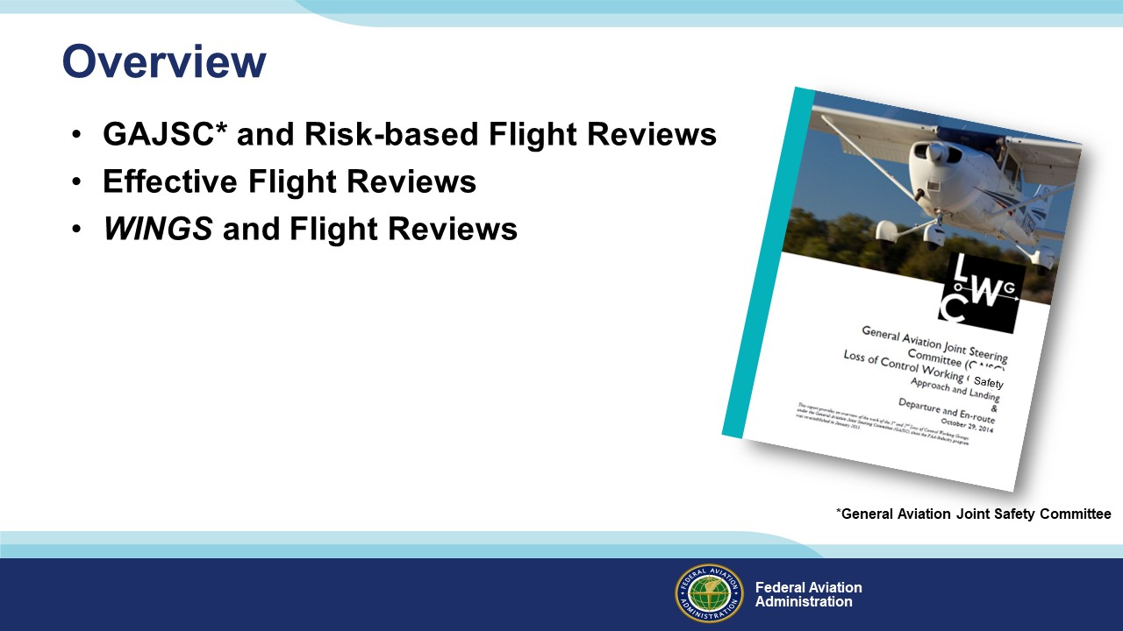 | Slide 3  Today’s presentation is dedicated to Flight Reviews. They’re something nearly all of us go through every two years and the General Aviation Joint Safety Committee feel that Flight Reviews that are based on risk can go a long way toward preventing accidents.  Basing flight reviews on risk is one way to achieve an effective evaluation and education experience. So, we’ll discuss elements of effective Flight Reviews as well. And, to do that, we’ll reference a document available on FAASafety.gov.  Presentation Note: If you’ll be discussing additional items, add them to this list.  (Next Slide)
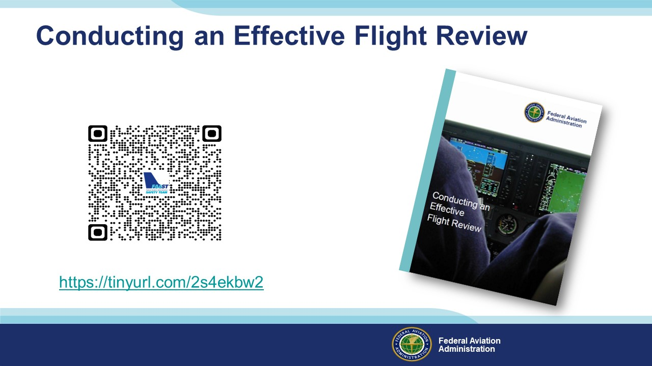 | Slide 4  You can download a copy of Conducting an Effective Flight Review by accessing the QR code or URL on screen. It’s written for flight instructors but it’s also excellent for preparing their clients for a great flight review experience. And it features dozens of hyperlinks to useful information for pilots and Flight Instructors alike. Let’s see how we can use this document to prepare for a risk-based flight review.  (Next Slide)
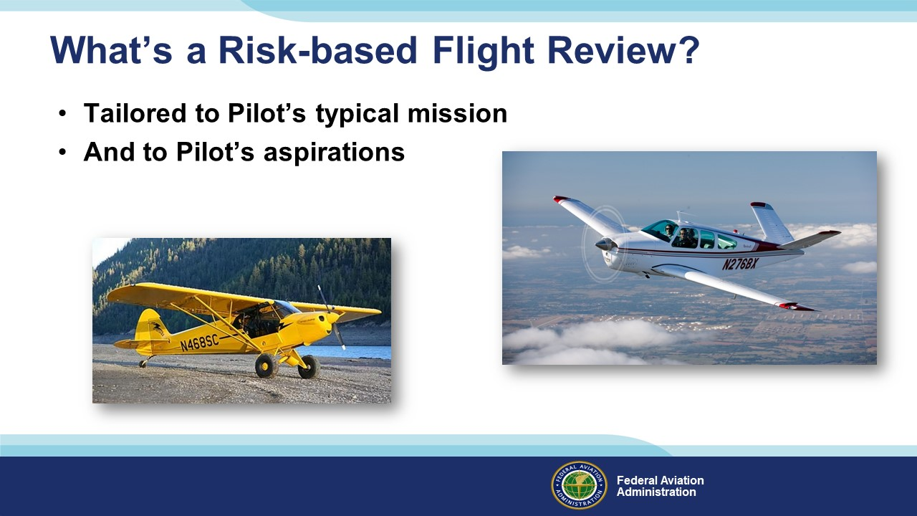 | Slide 5  As the name implies – a Risk-based Flight Review addresses risks associated with the familiar missions and flight environments  where the pilot normally operates. (Click)  But it also addresses things the pilot wants to do in the future. Both of these review aspects require a conversation with your Flight Instructor and some advance planning.  That’s why it’s essential to conduct a pre-review interview to plan what will be covered in the review.  (Next Slide)
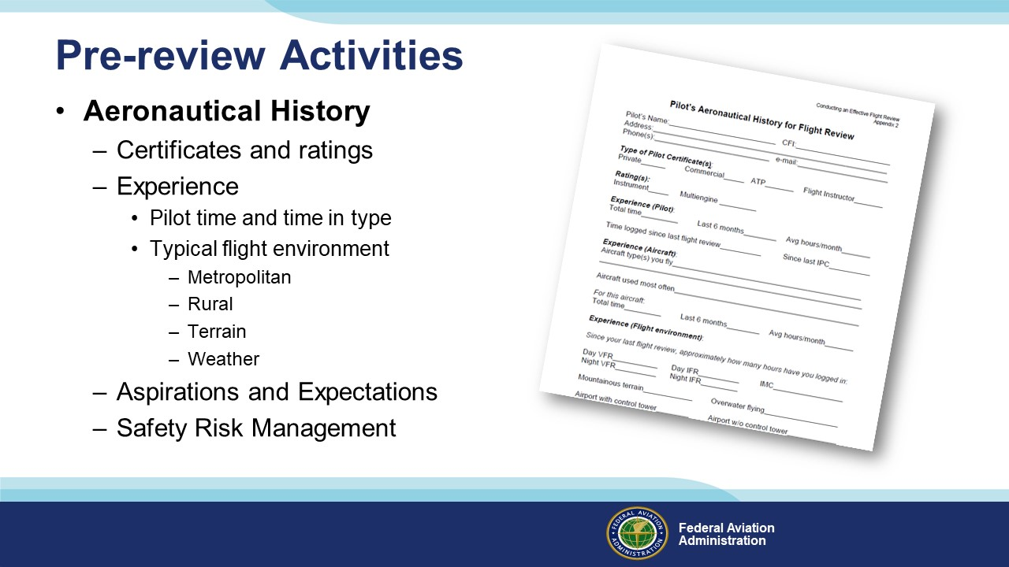 | Slide 6  The Conducting an Effective Flight Review appendix contains a form to collect aeronautical history. Providing this information before the review will allow your CFI to develop a review plan to efficiently evaluate your capabilities in normal operations and to explore flying challenges that you would like to pursue. If, for instance, you fly in a high-traffic density operational environment, some time spent in non-towered airport and short field operations will make you more competent and confident when flying to remote areas. Similarly, if you’re at home in the boonies, a trip to a tower-controlled field in Class B or C airspace will help you to be more comfortable in high-traffic environments and Air Traffic Control. When discussing these topics, it’s also a good practice to set instructor and client expectations for the review. Reviews for pilots who don’t fly often or who don’t fly to unfamiliar destinations will likely take longer than reviews for pilots who are current and comfortable in all airspace classes. And of course, you’ll discuss the Safety Risk Management process and apply it throughout planning and flight.  (Next Slide)
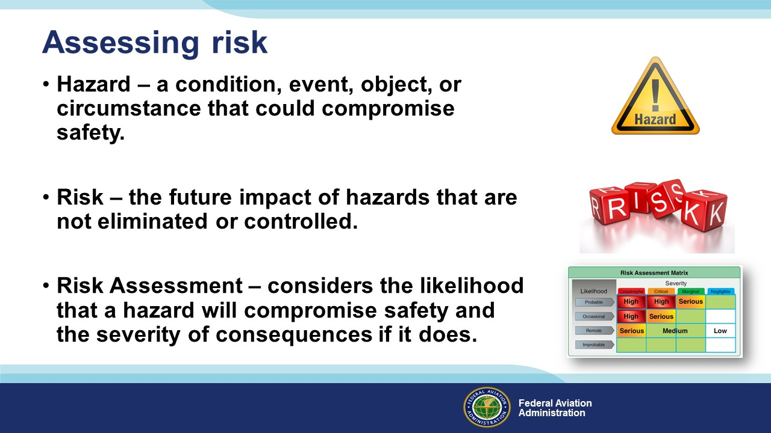 | Slide 7  You and your Instructor will discuss flight hazards that are unique to your flight operations. (Click)  And you’ll identify the risk that those hazards will negatively impact your flying. (Click)  Your Risk Assessment – will tell you the likelihood that a given risk will negatively impact your operation and the severity of consequences if it does. Armed with that information, you and your CFI can plan instructional activities that will mitigate your risks to acceptable levels.  (Next Slide)
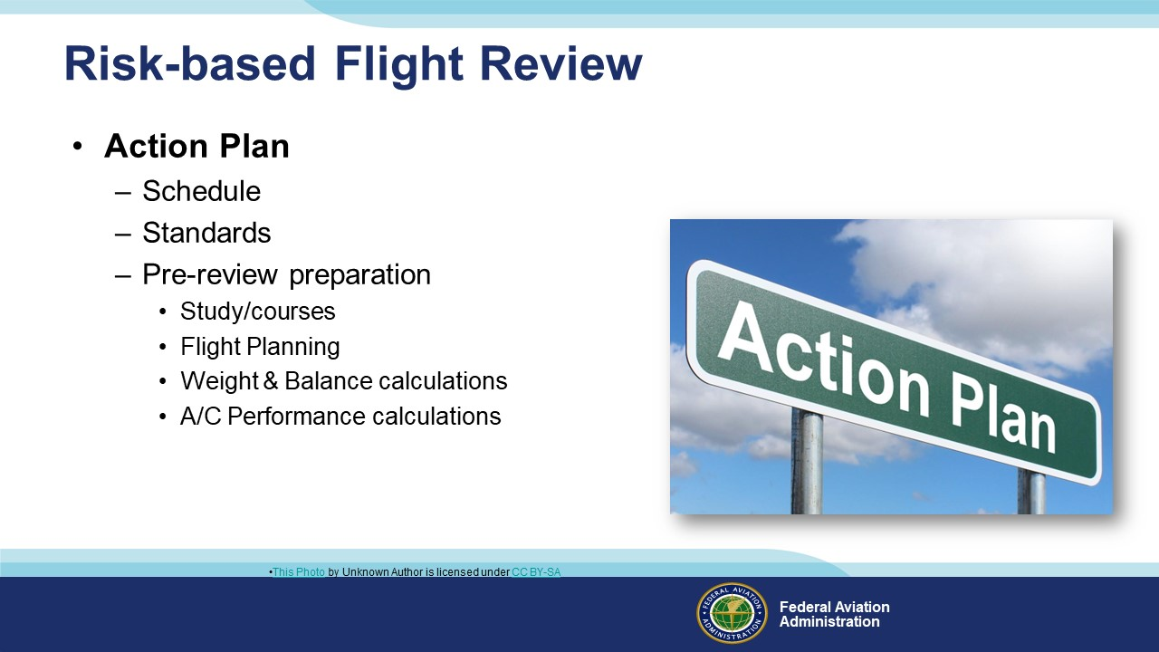 | Slide 8  The Risk-based Flight Review Action will include a schedule of pilot capabilities to be evaluated and risk reduction/mitigation activities to pursue. Successful completion standards for each activity will be agreed to and any Pre-review preparation activities will be identified.  Preparation activities might include study of regulations or completion of courses on FAASafety.gov, planning a flight, weight and balance, and aircraft performance calculations.  (Next Slide)
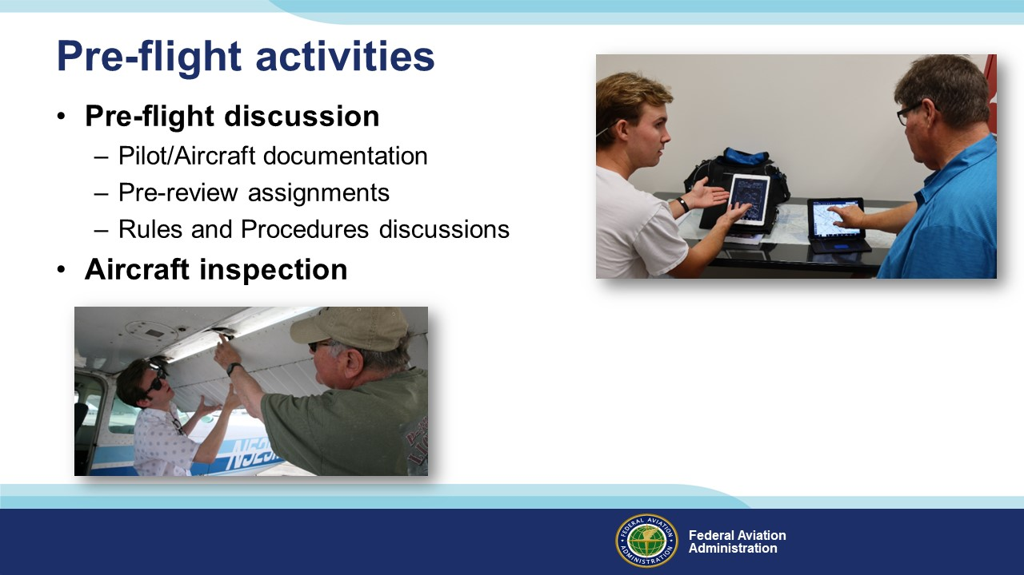 | Slide 9  Flight Review pre-flight activities will include a review of pilot and aircraft documentation, pre-review study assignments and activities, and a discussion of aviation rules and procedures. Pre-flight activities will generally end with an aircraft inspection just prior to flight.  (Next Slide)
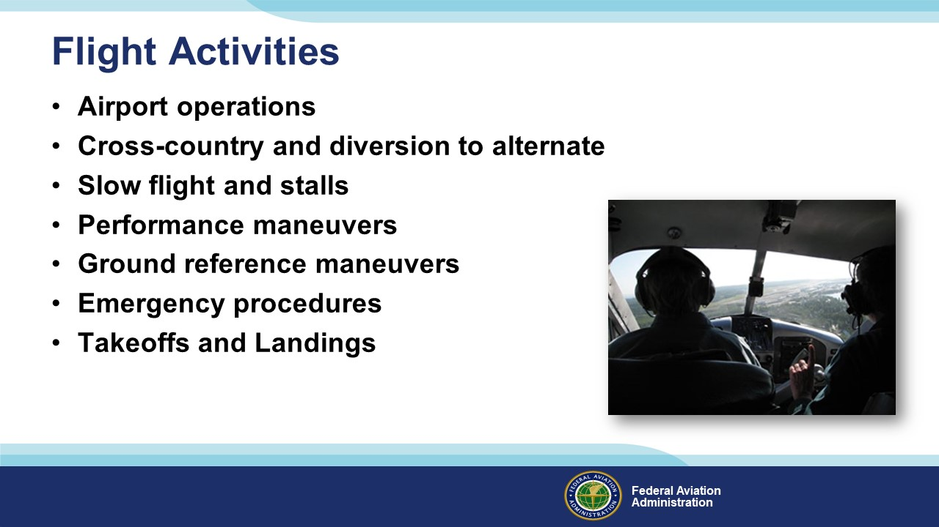 | Slide 10  Flight activities will include the items listed on screen and any special activities discussed in the pre-review.  (Next Slide)
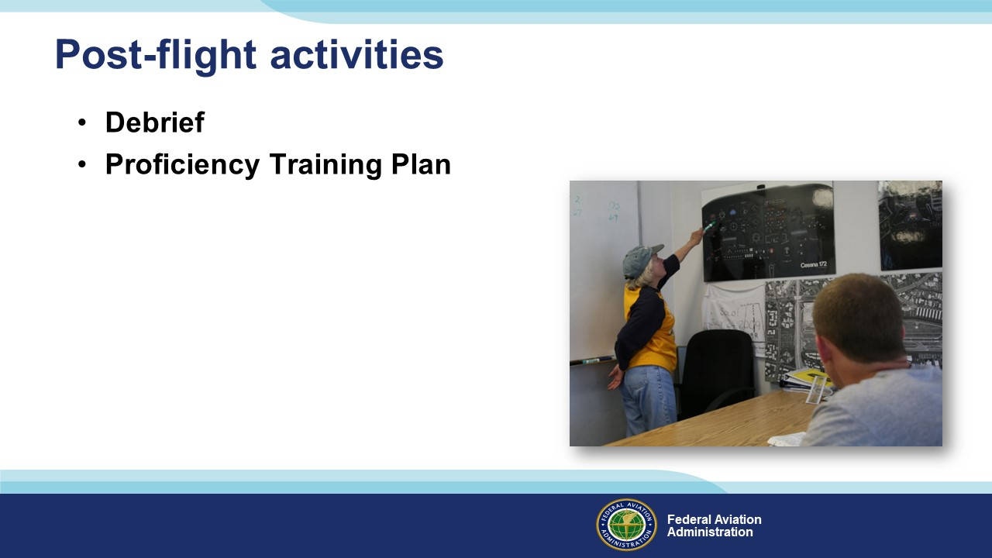 | Slide 11  Post-flight activities should include a thorough debrief. You should expect an honest and comprehensive assessment of your performance with suggestions for improvement. This is also an excellent time to develop a proficiency training plan that will not only ensure that you maintain your proficiency level but also enable you to attain higher levels of performance and additional capabilities.  (Next Slide)
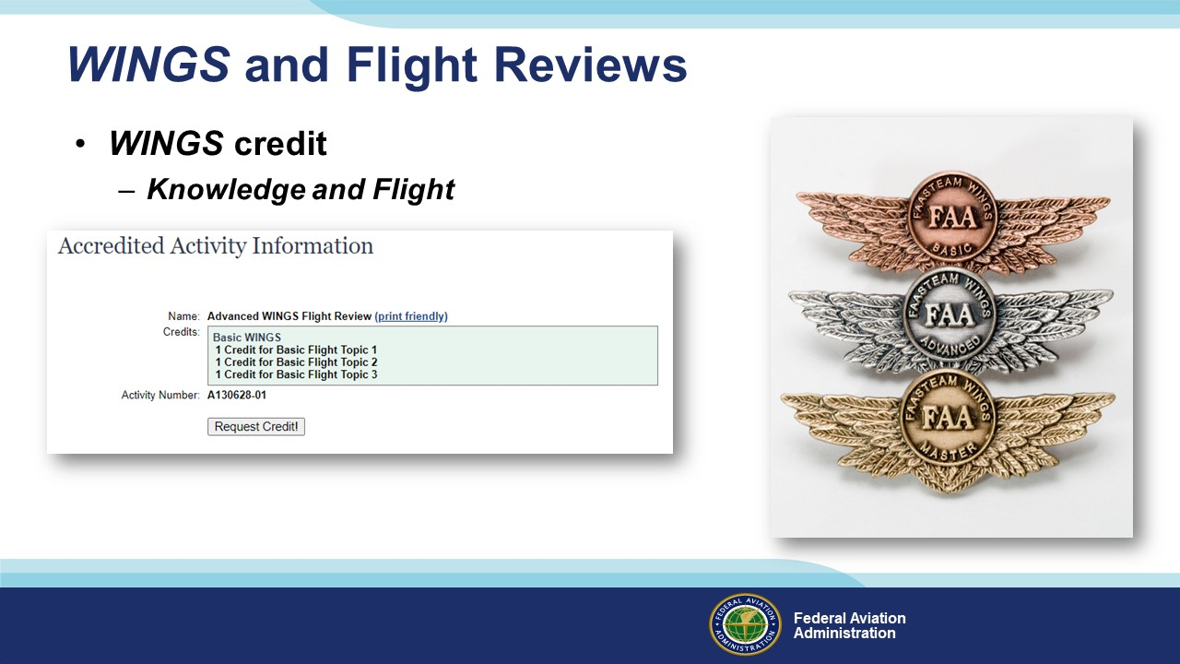 | Slide 12  WINGS knowledge and flight activities are available on FAASafety.gov. Completing the Advanced WINGS Flight Review Flight Activity, together with 3-WINGS knowledge activities will earn a Flight Review. In fact, earning any phase of WINGS satisfies the requirements of 14.CFR § 61.56.  (Next Slide)
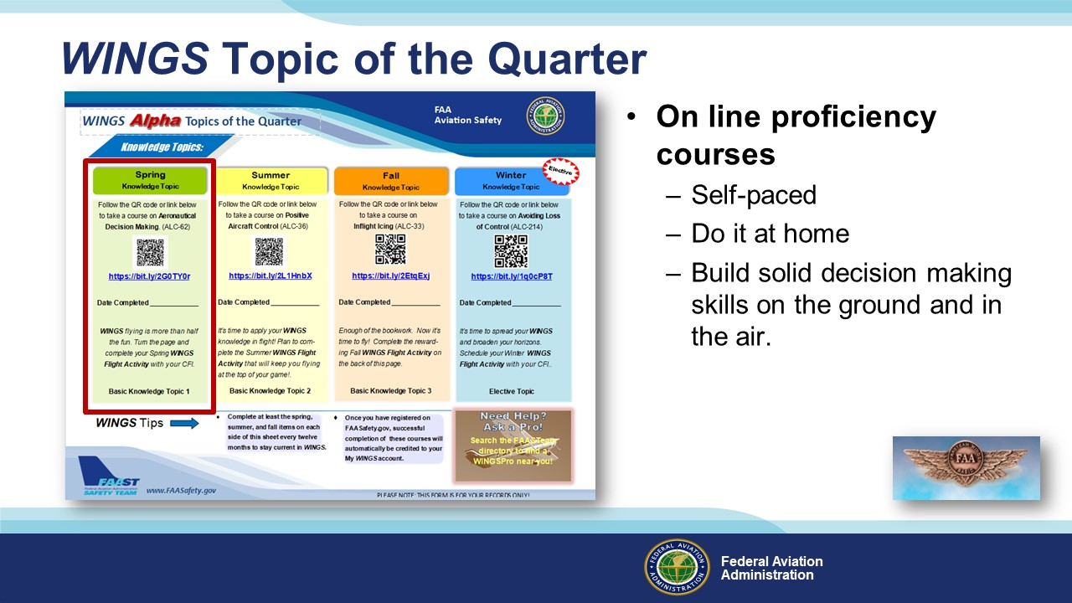 | Slide 13  Proficiency Training works best if it’s not done all at once, but rather spaced out at regular intervals. The WINGS Topic of the Quarter program consists of eight activities pursued over the course of one year. Because a full year’s proficiency is mapped out for you, It’s an excellent way to get started with WINGS.  Each quarter, WINGS Pilots take an on-line safety course. All courses are self-paced. Most take no more than an hour or two and they can be completed at home. Our online courses build solid decision-making skills that you’ll employ on the ground and in the air.  (Next Slide)
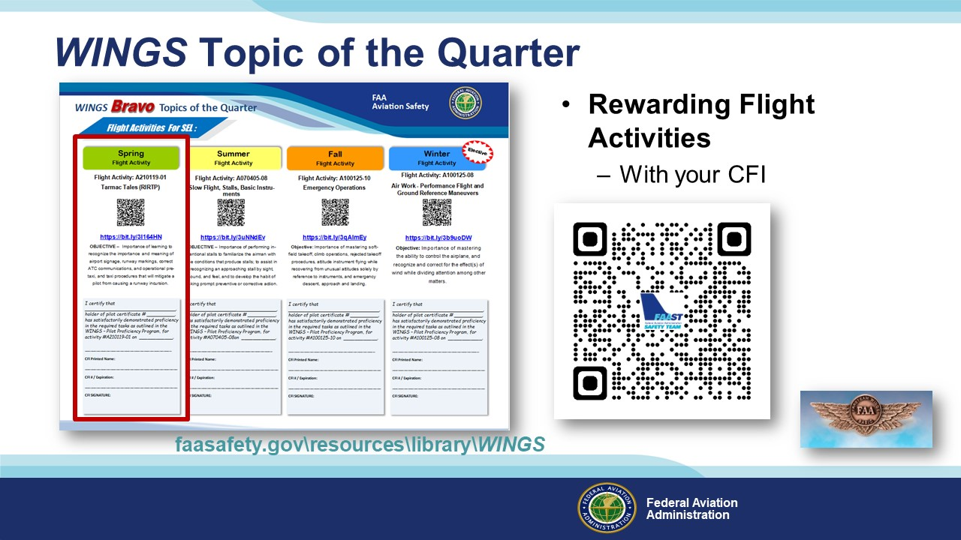 | Slide 14  Program participants also fly with a Flight Instructor to complete a WINGS Flight Activity at least once each quarter. (Click)  To access WINGS Topic of the Quarter Checklists and other WINGS information just navigate to FAASafety.gov. then click on Resources\Library\WINGS or scan the QR code on screen.  (Next Slide)  Background: You can access the FAASafety.gov library here: https://faasafety.gov/gslac/ALC/lib_categoryview.aspx?categoryId=39
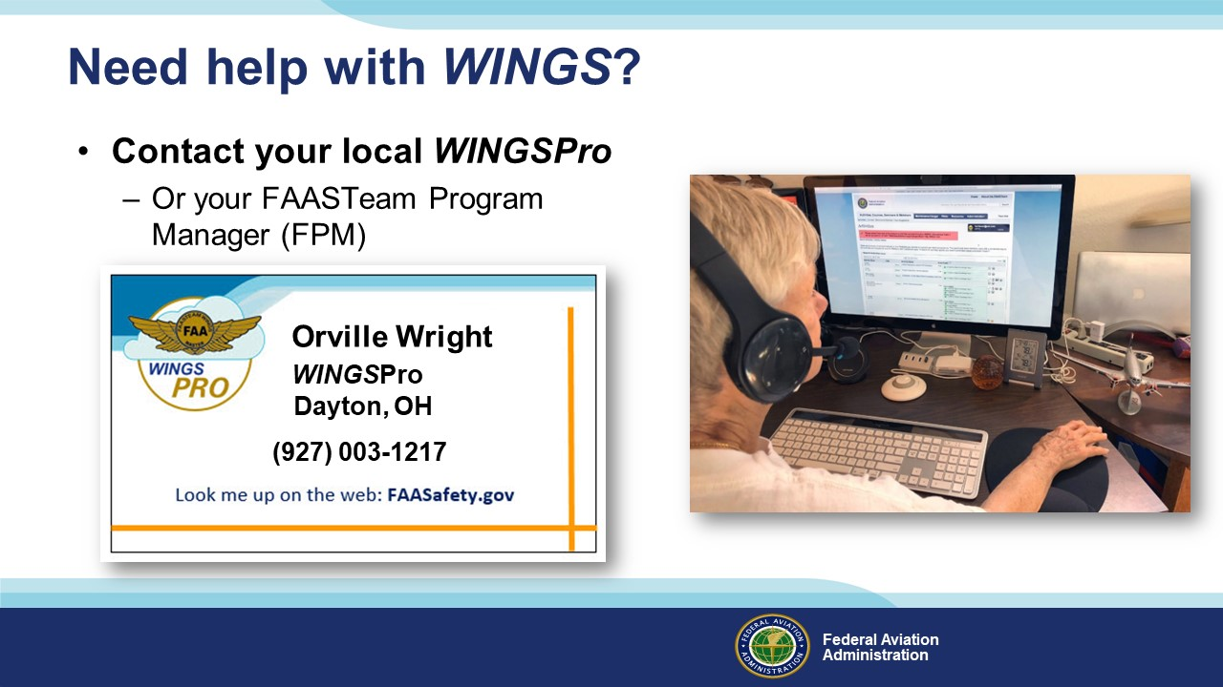 | Slide 15  WINGS is a robust proficiency training program that works for all pilot certification levels and all general aviation aircraft. As such, it can be a little intimidating at first. That’s why volunteer WINGSPros in your area are available to help you with anything related to WINGS. Here’s how to find your local WINGSPro(s).  Presentation note: You may want to introduce local WINGSPros in attendance and ask them to present this section. Your WINGSPros can edit the slide text to include their name and contact information.  (Next Slide)
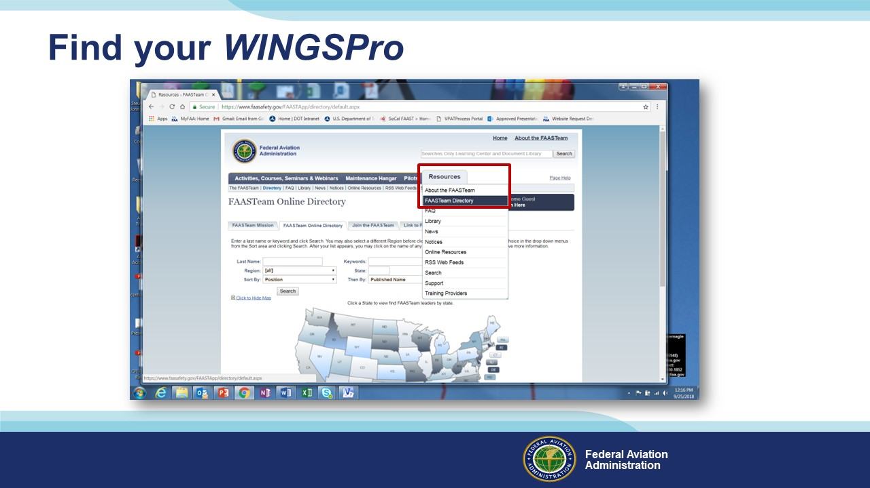 | Slide 16  To find your local WINGSPros just navigate to FAASafety.gov. Hover over the resources tab and click on FAASTeam Directory.  (Next Slide)
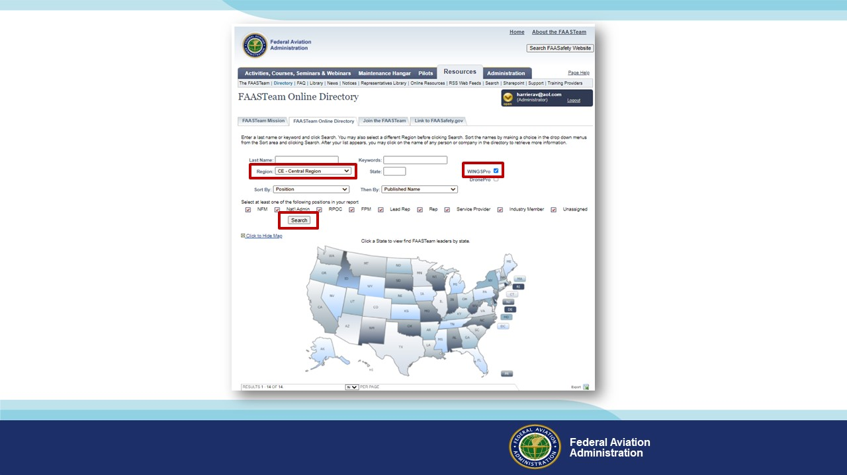 | Slide 17  Presentation note: This will be more effective if you replace the following illustrations with those that feature local AOR searches and WINGS Pro results.  First select your region and district in this dropdown box. (Click)  Next click the WINGSPro box, (Click)  Then click on search. Your WINGSPros will appear in the list below.  (Next Slide)
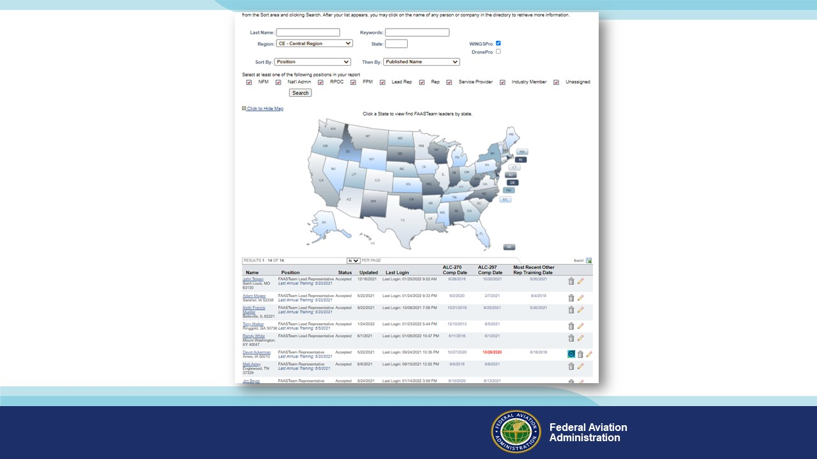 | Slide 18  Here’s a partial list of WINGS Pros in the Central Region.  (Next Slide)
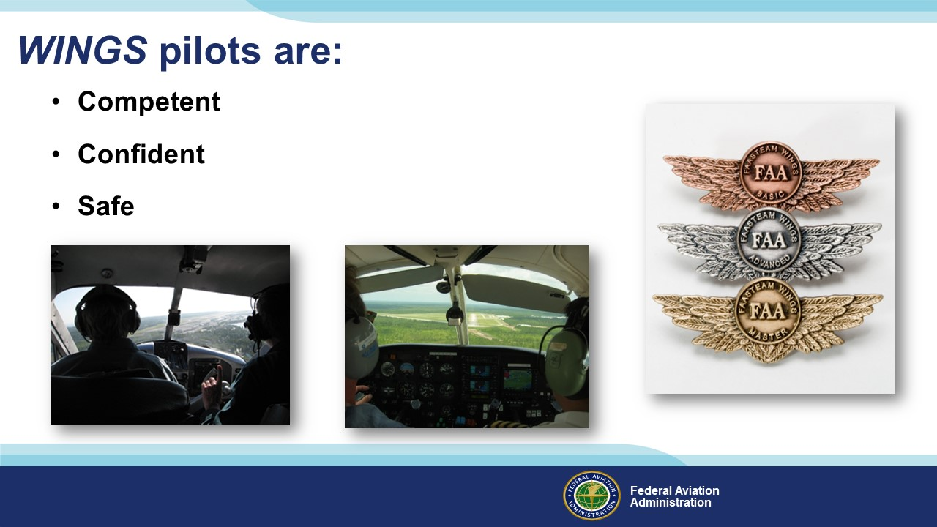 | Slide 19  Finally, WINGS training yields Proficiency and Peace of Mind. There’s nothing like the feeling you get when you know you’re playing your A game and in order to do that you need good coaching. (Click)  WINGS pilots are Competent. They fly regularly with WINGS CFIs who challenge them to review what they know, explore new horizons, and to always do their best. Vince Lombardi, the famous football coach said, “Practice does not make perfect. Only perfect practice makes perfect”. For pilots that means flying with precision, on course, on altitude, on speed all the time. (Click)  WINGS pilots are Confident. They are well aware of their capabilities and their limitations. They are coached to exercise sound pre and in-flight risk management so they are rarely surprised by unanticipated conditions. Of course, they must dedicate time and money to their proficiency programs but it’s well worth it for the peace of mind that comes with confidence. (Click)  And, most importantly; WINGS pilots and their passengers enjoy the benefits of safe flight operations every time they take to the air.  (Next Slide)
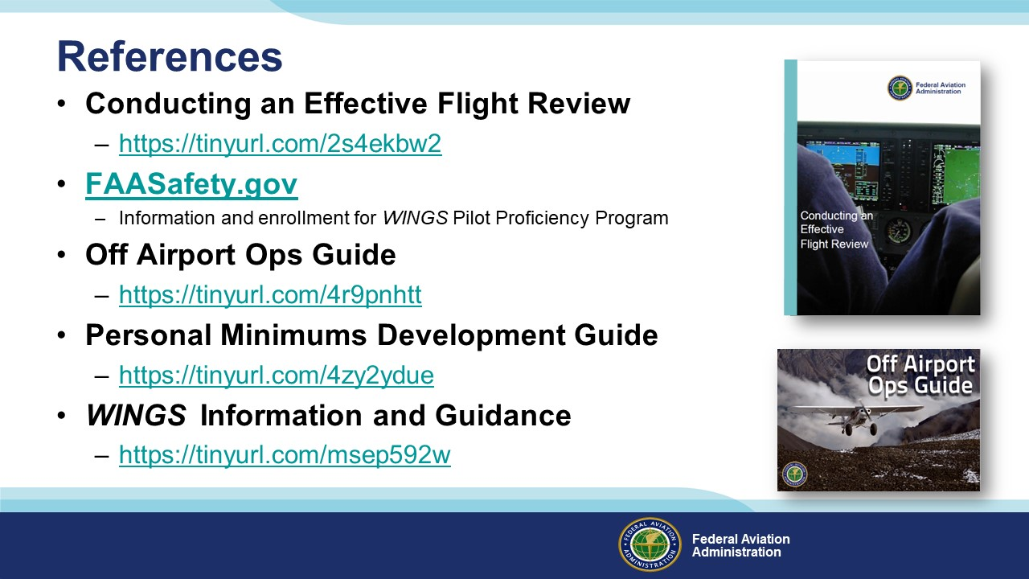 | Slide 20  Here are a few references for additional information:  FAASafety.gov is the FAASTeam website where you’ll find a wealth of safety information. You can enroll and track your progress in the FAA WINGS Pilot Proficiency Program here.  Look in the FAASafety.gov library for the Off Airport Operations Guide. In it you’ll find instructions for developing a short field performance baseline together with other useful information on operating to small fields.  Also, in the FAASafety.gov Library – the Personal Minimums Development Guide – Your documented proficiency performance can be used to develop minimums that are tailored to you, your aircraft, and your mission.  The Library also contains additional WINGS Information and Guidance  I’ll leave this slide on screen while I take some questions from the audience.  Presentation note: Take questions from the audience while they copy information from the screen. Then:  (Next Slide)
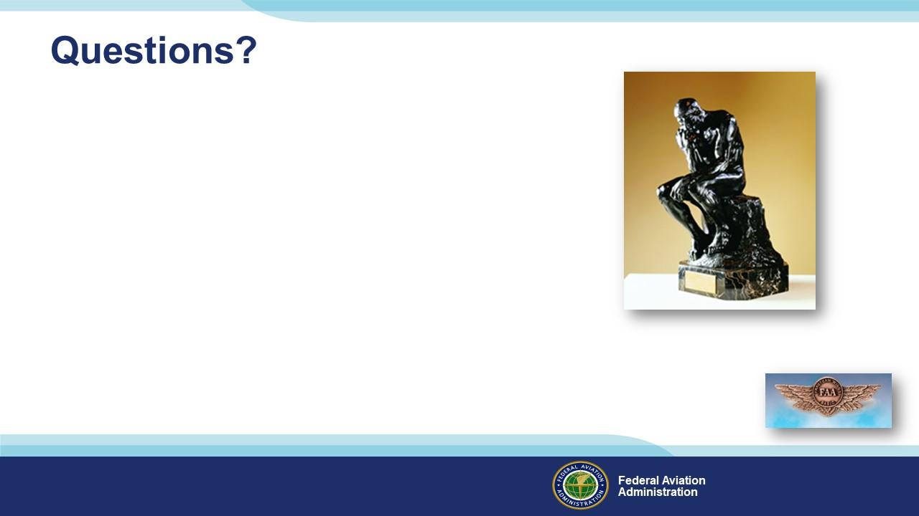 | Slide 21  Presentation Note: You may wish to provide your contact information and main FSDO phone number here. You can also add WINGSPro contact information.  Modify with your information or leave blank.  (Next Slide)
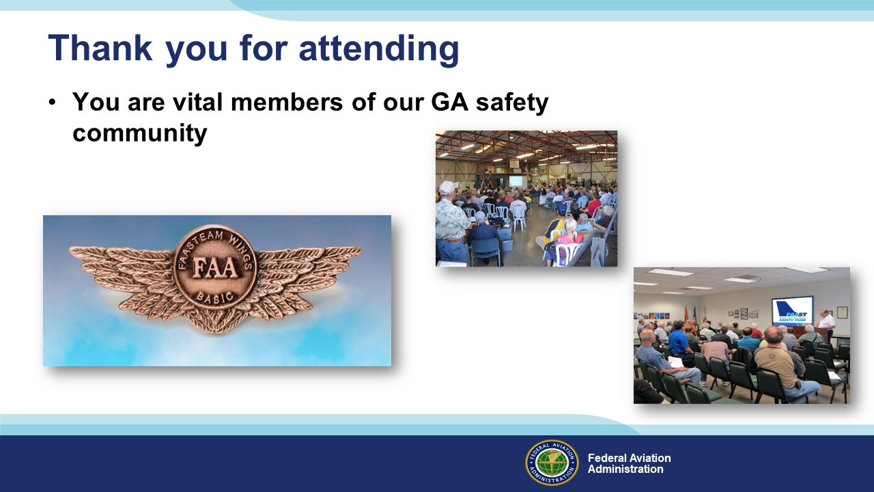 | Slide 22  Safety Management Systems are a set of policies and processes that can increase the safety and efficiency of any flight operation. And FAA is bringing SMS to General Aviation. You may have heard of SMS but thought it was only for large organizations but actually SMS can be scaled to fit any operation large or small.  There are 4 major components to a Safety Management System (Click)  Safety Policy – a documented commitment to safety that runs from the head of an organization to its newest member. (Click)  Safety Risk Management – a process that identifies hazards within an operation, determines to what extent an identified hazard may impact flight safety, and controls the risk of occurrence to an acceptable level. (Click)  Safety Assurance – By collecting and analyzing information derived from safety performance data Safety Assurance ensures the performance and effectiveness of Safety Risk Controls. (Click)  Safety Promotion communicates safety information and commitment throughout the organization. (Click)  You can find more information about Safety Management Systems at the URL on the Screen.  (Next Slide) (Next Slide)
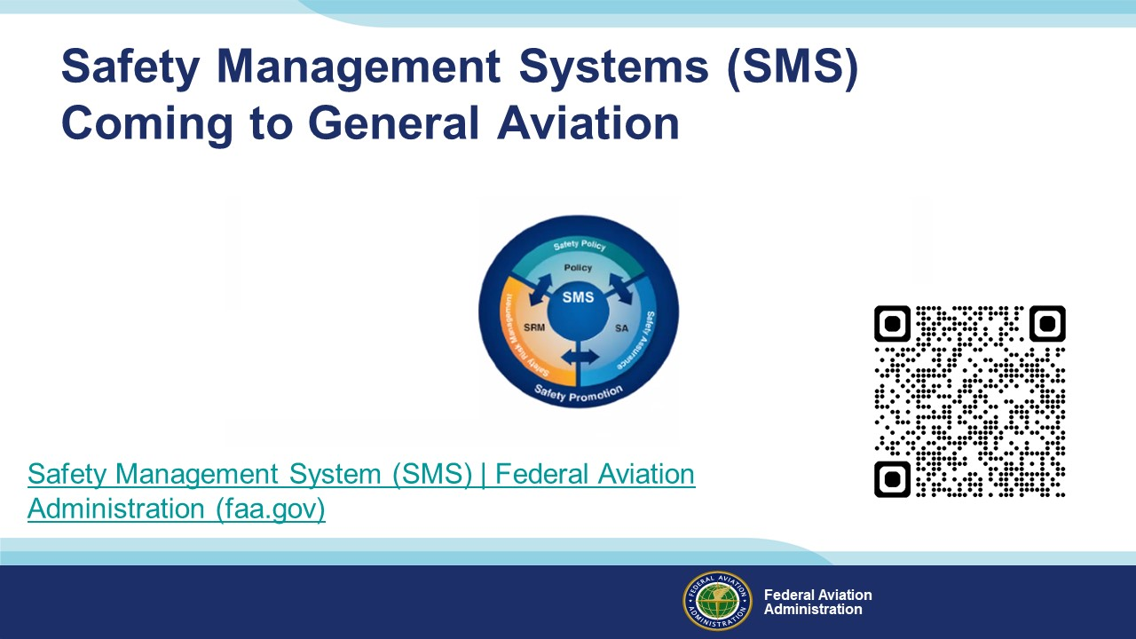 | Slide 23  Your presence here shows that you are vital members of our General Aviation Safety Community. The high standards you keep and the examples you set are a great credit to you and to GA.  Thank you for attending.  (Next Slide)
Slide 24

(The End)

Appendix I – Equipment and Staging
Equipment:
- Projection Screen & Video Projector suitable for expected audience
  - Remote computer/projector control available at lectern or presenter location
    - In lieu of remote – detail a Rep to computer/projector control.
- Presentation Computer
  - Note: It is strongly suggested that the entire program reside on this computer.
- Back up Projector/Computer/Media as available.
- PA system suitable for expected audience
  - Microphones for Moderator and Panel
    - Optional Microphone (s) for audience
- Lectern (optional)
Staging:
- Arrange the projection screen for maximum visibility from the audience.
- Equip with PA microphones
- Place Lectern to one side of screen. This will be used by presenters and moderator.
IMPORTANT – Once you have completed outreach on this topic, please help us track the outreach you have done by entering a SAS record.
