General Aviation Joint Safety Committee
System/Component Failure Working Group

Outreach Guidance Document
2023/10-29-301(I)PP

This outreach guidance is provided to all FAA and aviation industry groups that are participating in outreach efforts sponsored by the General Aviation Joint Safety Committee (GAJSC). It is important that all outreach on a given topic is coordinated and is free of conflicts. Therefore, all outreach products should be in alignment with the outline and concepts listed below for this topic.

Outreach Month: May 2025

Topic: Approval for Return to Service (GAJSC SCF Work Group)
The FAA and industry will conduct a public education campaign emphasizing the benefits of stabilized approaches for VFR and IFR operations and for making and acting on timely go-around decisions.

Background:

The GAJSC feels pilots often have an incomplete awareness of their responsibilities for the airworthiness of the aircraft they fly. That lack of awareness can lead to accepting unairworthy aircraft for flight operations. This presentation explains the importance of proper return to service determination and documentation.

Teaching Points:

- It is the pilot’s responsibility to ensure the mechanic properly documents the aircraft’s return to service.
- The return to service must be documented in the aircraft logbooks.
- Flying aircraft that have not been properly returned to service is not only contrary to regulations but may very well pose significant safety hazards.

References
- FAA Plane Sense Publication
- AC 43-9C – Maintenance Records

Abstract: Lasting 10 to 15 minutes, this presentation acquaints the audience with the safety benefits of ensuring that aircraft accepted for flight operations are airworthy and that they have been properly returned to service after maintenance.

Format: Information Briefing - Power Point presentation

Required Personnel – FAASTeam Program Manager or designated FAASTeam Reps.

Optional Personnel – CFIs and DPS who can speak on the benefits of stabilized approaches and go-arounds.

National FAASTeam Support:
In addition to this guidance document, a Power Point presentation that supports the program is provided. FPMs and presenters are encouraged to customize this presentation to reflect each individual program.

Slides | Script
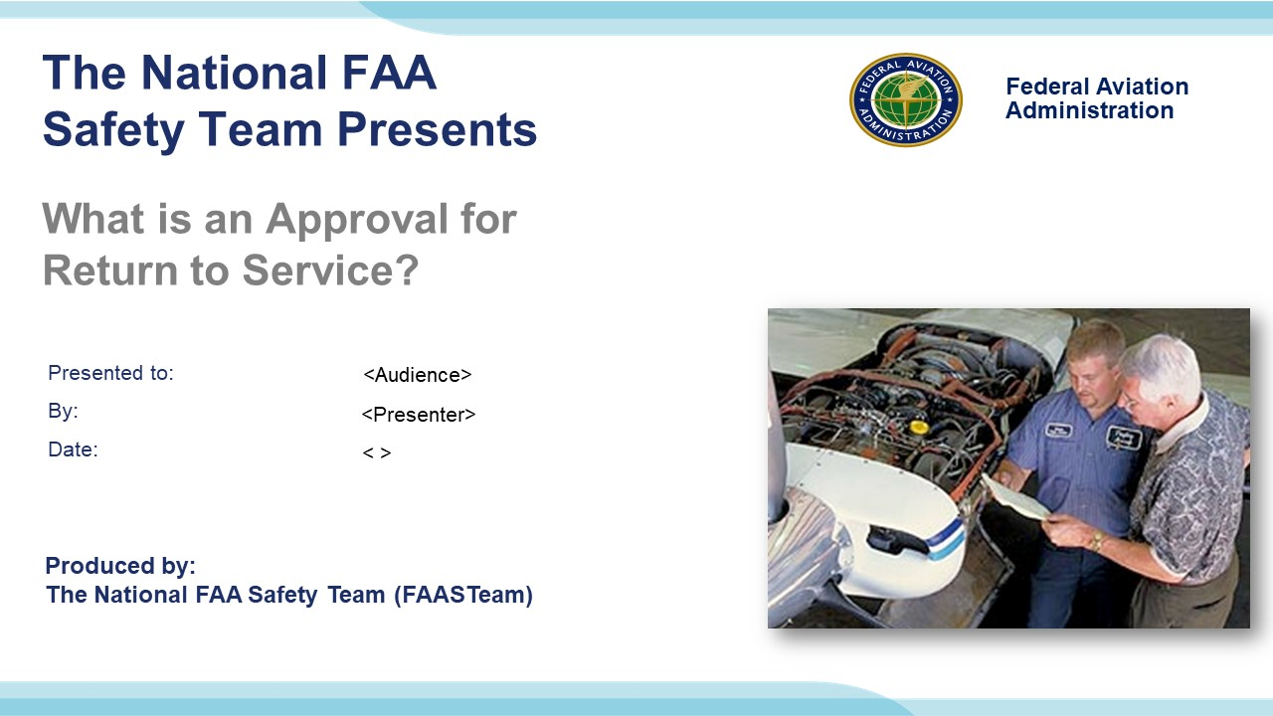 | Slide 1  2023/10-29-301(I)PP Original Author: (Guy Minor) (10-03-2018); POC (Guy Minor), National FAASTeam Program Manager – Airworthiness. Office (707-704-3530); revision: 1 May 2024.  Presentation Note: This is the title slide for What is an Approval for Return to Service  Script - We have included a script of suggested dialog with most slides. The script will always appear in a non-italic font. Presenters may read the script or modify it to suit their own presentation style. See template slides 3 and 4 for examples of a slides with script.  Presentation Instructions - (stage direction and presentation suggestions) will be preceded by a Bold header: the instructions themselves will be in Italic fonts. See slide 2, for an example of slides with Presentation Instructions only.  Program control instructions - will be in bold fonts and look like this: (Click) for building information within a slide; or this: (Next Slide) for slide advance.  Background information - Some slides may contain background information that supports the concepts presented in the program.  .  The production team hope you and your audience will enjoy the show. Break a leg!  (Next Slide)
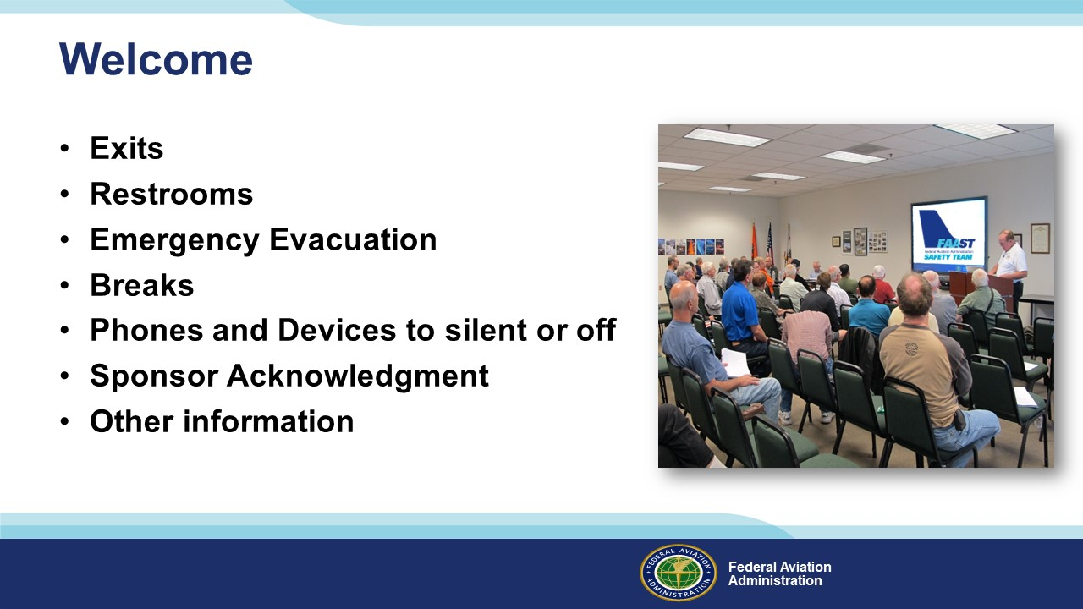 | Slide 2  Presentation Note: Here’s where you can discuss venue logistics, acknowledge sponsors, and deliver other information you want your audience to know in the beginning.  You can add slides after this one to fit your situation.  (Next Slide)
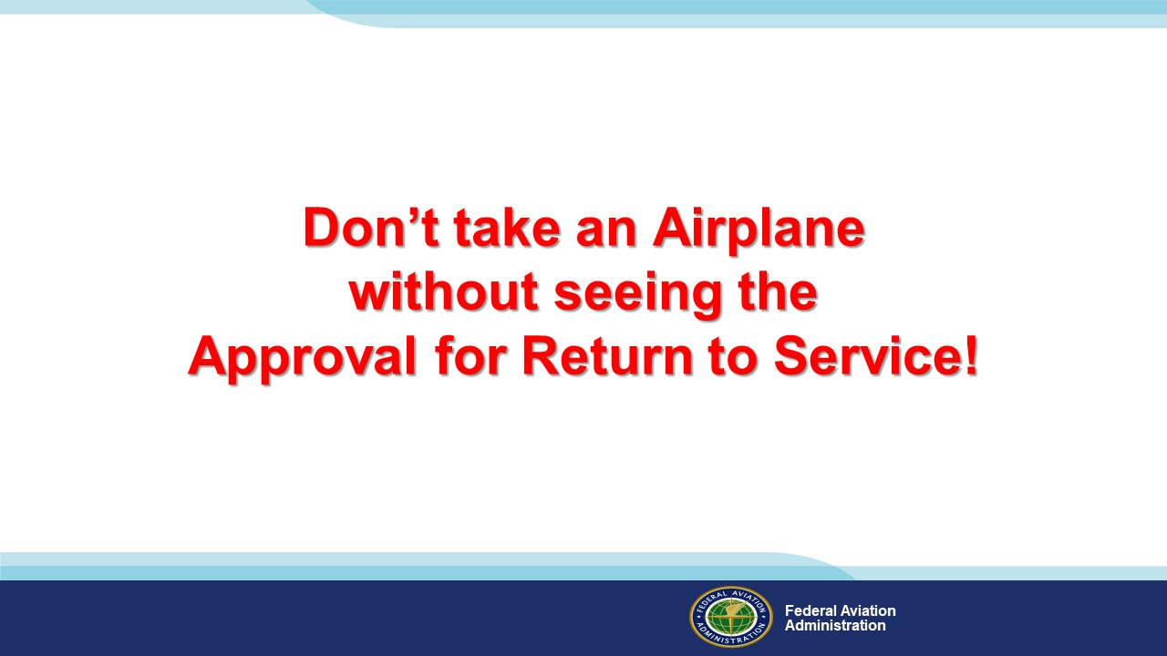 | Slide 3  This is the bottom line…on top. But just what is an Approval for Return to Service and where do you find it? An Approval for Return to Service is a document, created by a certificated aircraft maintenance professional, that attests to the airworthiness of aircraft that have undergone maintenance. That makes sense. Almost any maintenance activity in progress will render an aircraft unairworthy. Before they can accept an aircraft for flight operations pilots have to know that maintenance has been performed to accepted standards and the aircraft is once again airworthy.  So that’s what an Approval for Return to Service is. Now, what does it look like and where might a pilot find it?  (Next Slide)
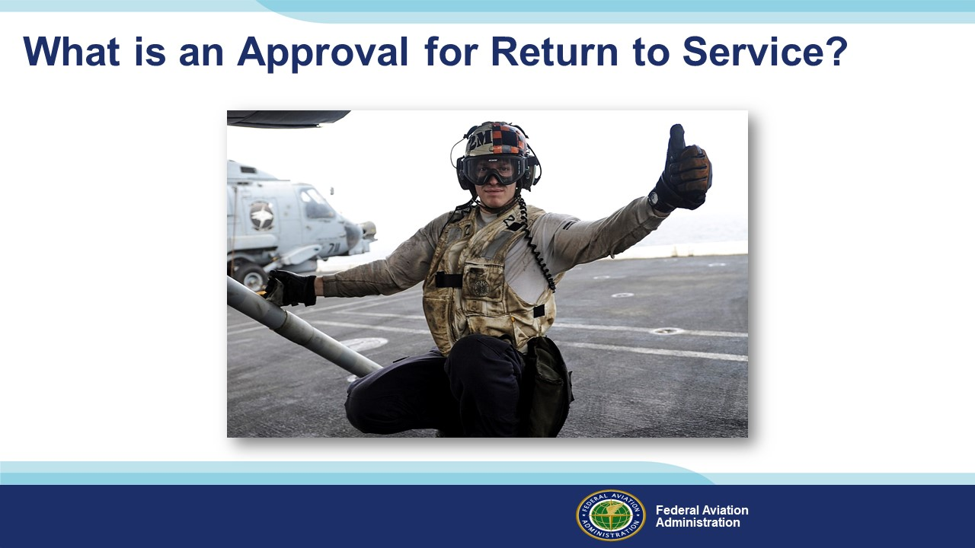 | Slide 4  Is it when the mechanic walks by and gives you a thumbs up? “Good to go”…. No…ooo!  (Next Slide)
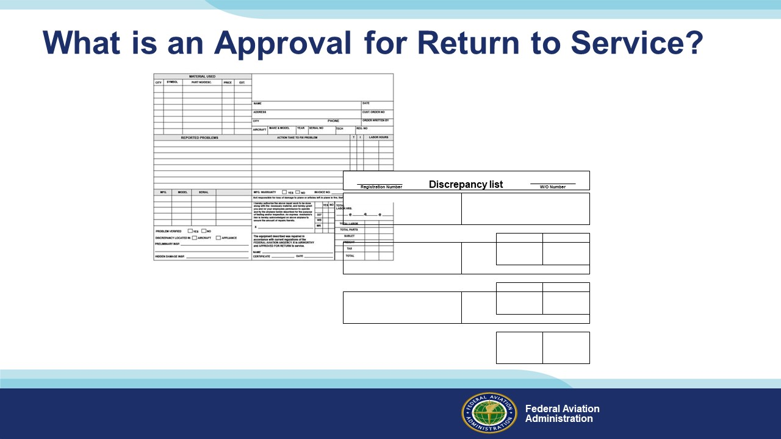 | Slide 5  Is it when the mechanic says, “Don’t worry it is all documented on the work order”? That’s what I used to tell my customers, but ......Nope that’s not it!  (Next Slide)
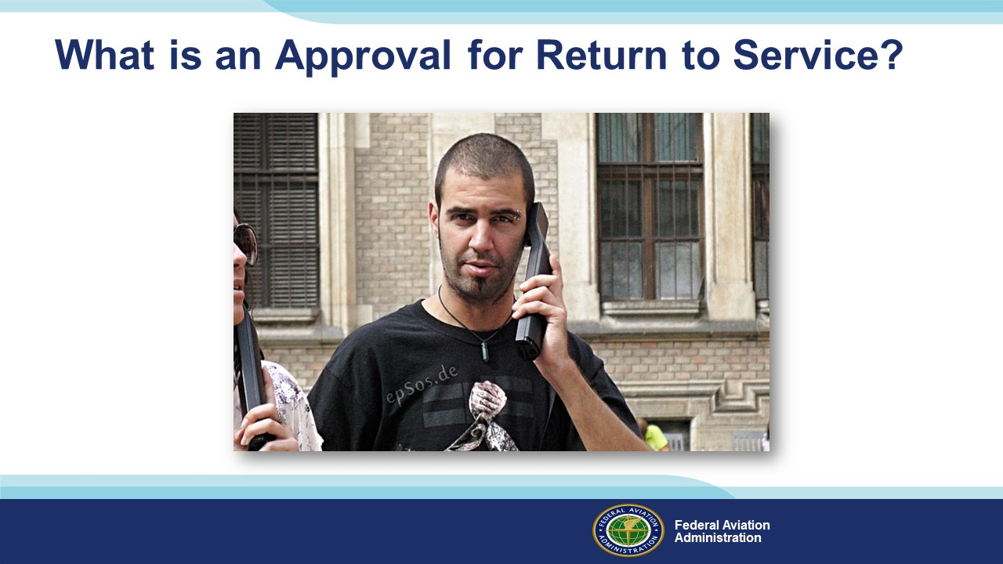 | Slide 6  Is it when the mechanic calls ou to leave a message with your spouse that the airplane should be ready  tomorrow? ….Da? Nyet! Not it!  (Next Slide)
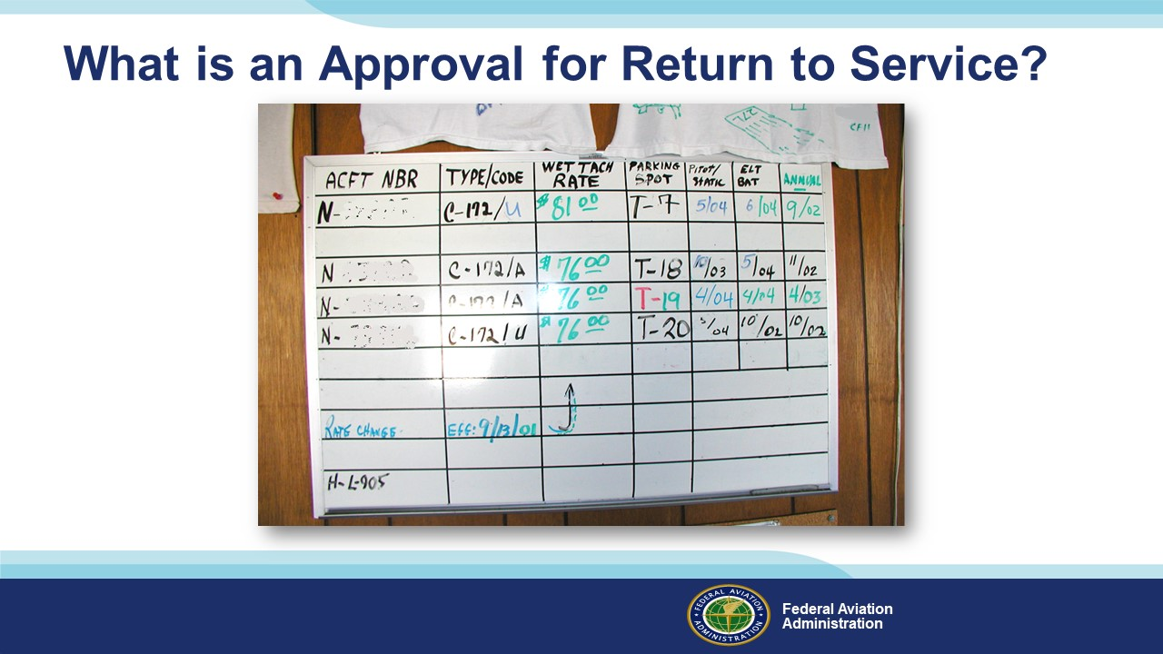 | Slide 7  Is it when the date and tach time look good on the status board?....... Negative!  (Next Slide)
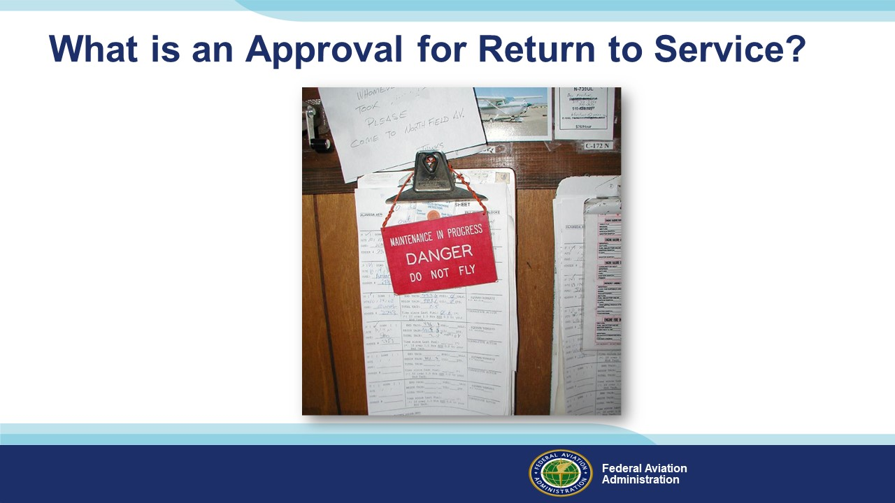 | Slide 8  Is it when the big red sign is not hanging on the yoke? ……. That’s not it!  (Next Slide)
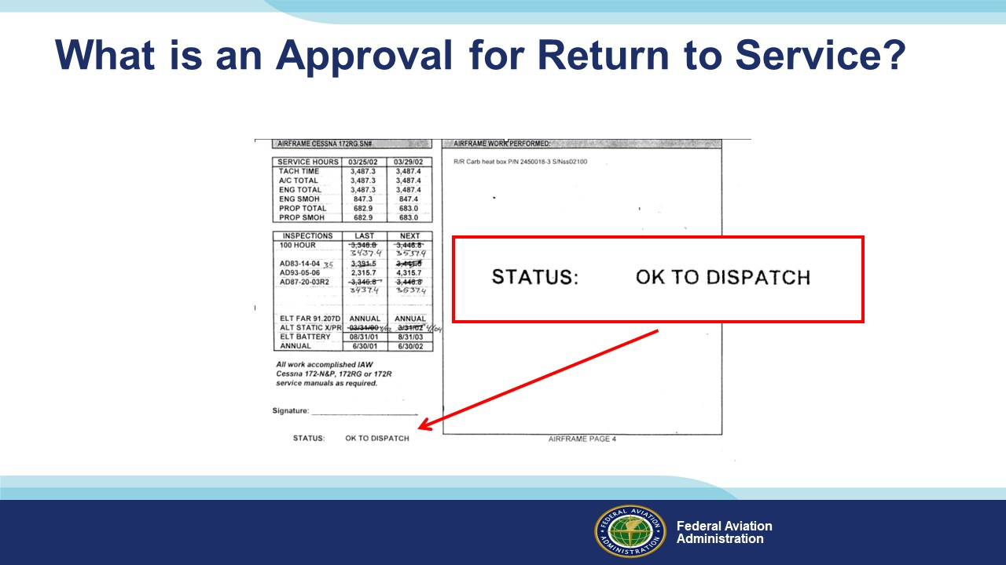 | Slide 9  The status clipboard says, “OK to dispatch….No Way!  *If you want to get an inspector to ask the question, then put that on your dispatch sheet.  (Next Slide)
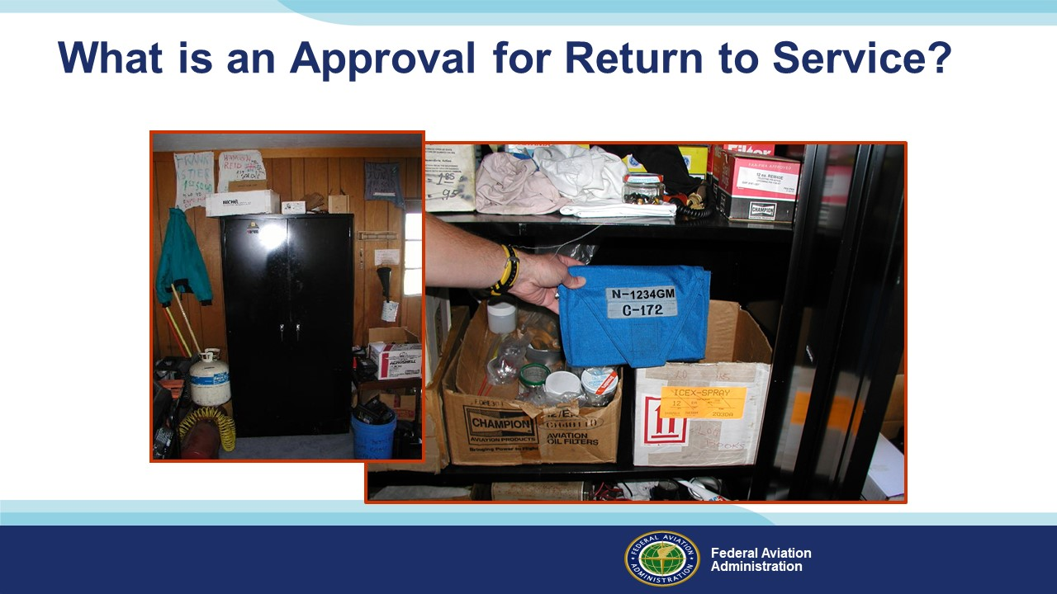 | Slide 10  Yep…..This is where you will probably find it. Dig thorough the half-used cans of Ozium, broken microphones, bottles of oil, spark plugs, and toilet plungers. There you will find the aircraft’s logbooks. In those logbooks you will find the approval for return to service.  (Next Slide)
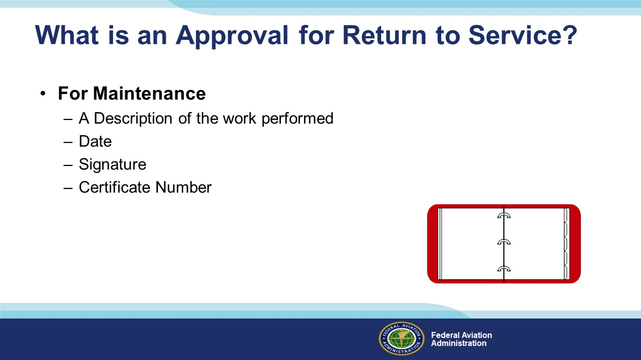 | Slide 11  You should expect to see this for any maintenance that has been done to the aircraft.  (Next Slide)
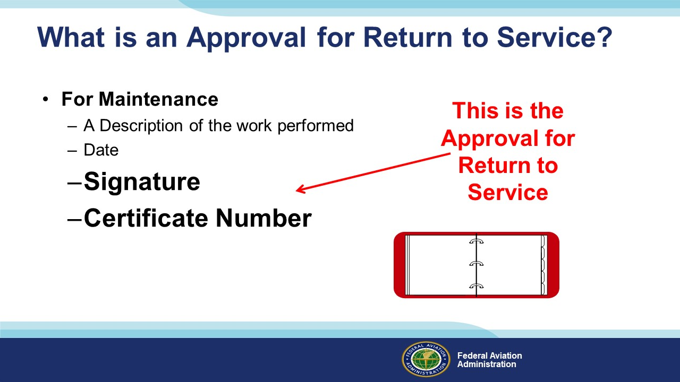 | Slide 12  The signature and certificate number are the approval for return to service.  (Next Slide)
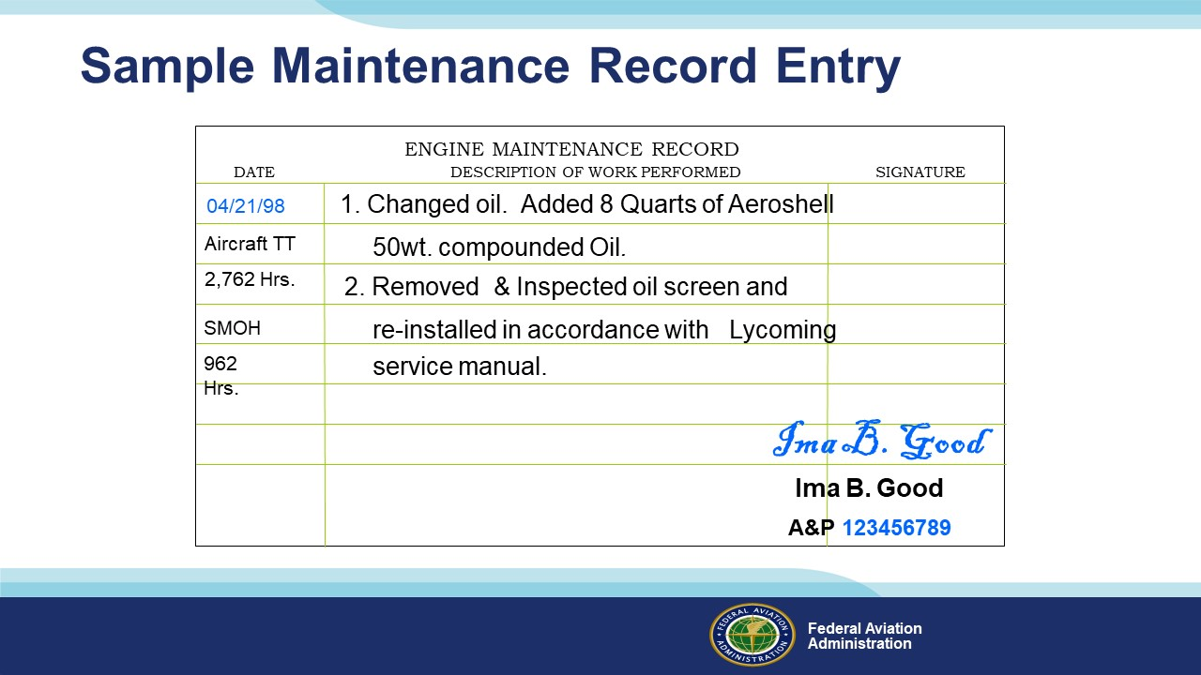 | Slide 13  The entry should look like this. Notice the Date, Signature and Certificate number.  (Next Slide)
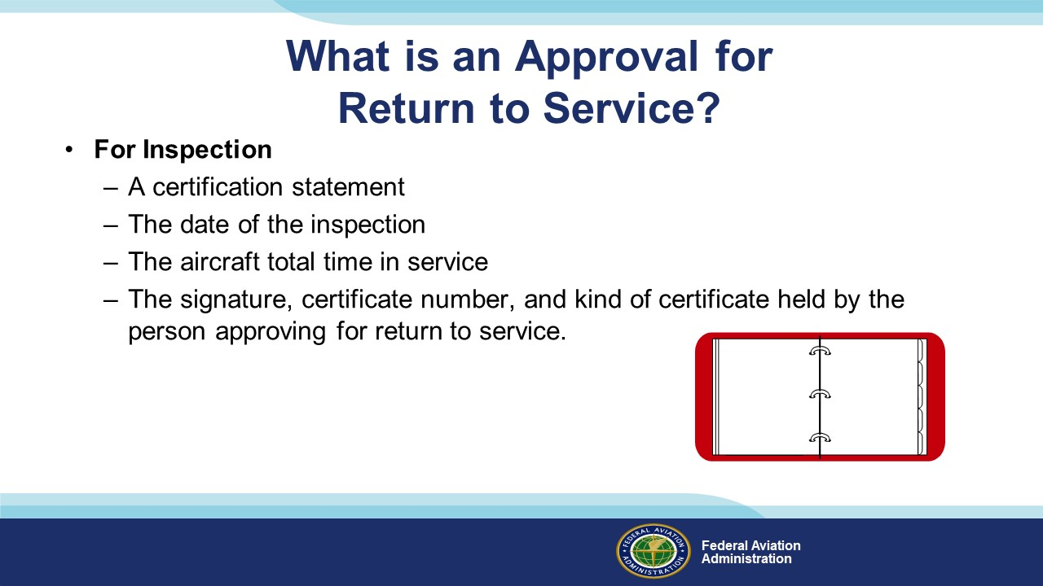 | Slide 14  You should see this for every inspection, and you will be able to check either the date, or the total time, to see if the aircraft can still fly.  (Next Slide)
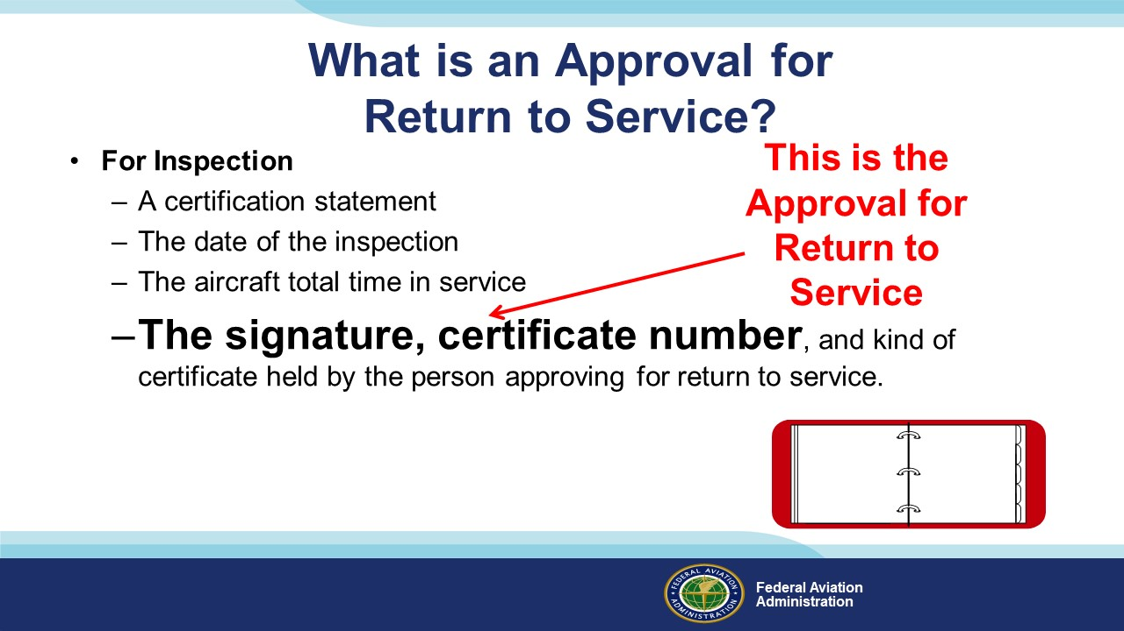 | Slide 15  Again, here is the approval for return to service.  (Next Slide)
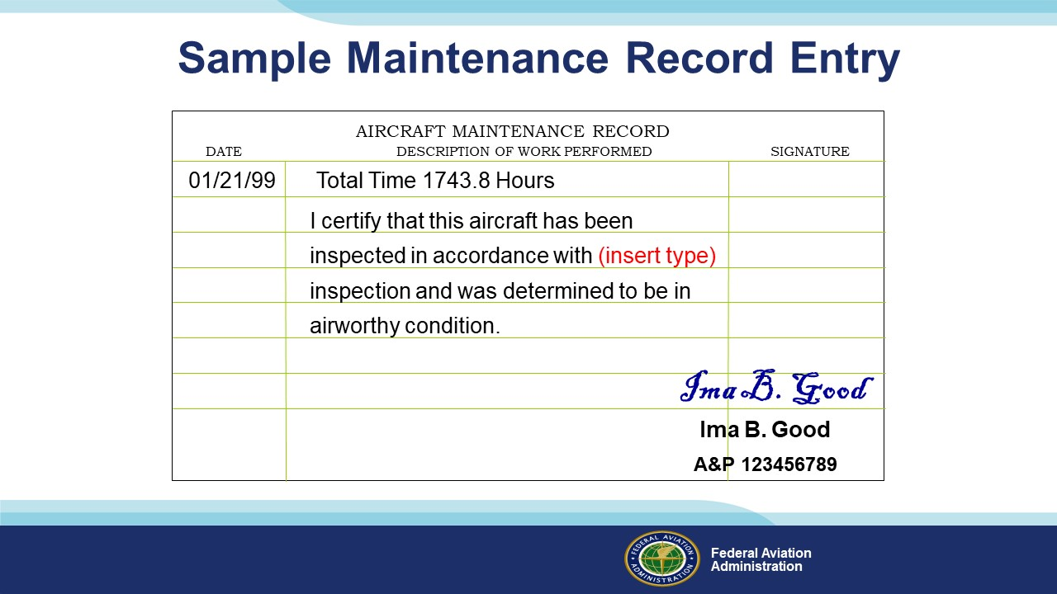 | Slide 16  The entry should look like this.  (Next Slide)
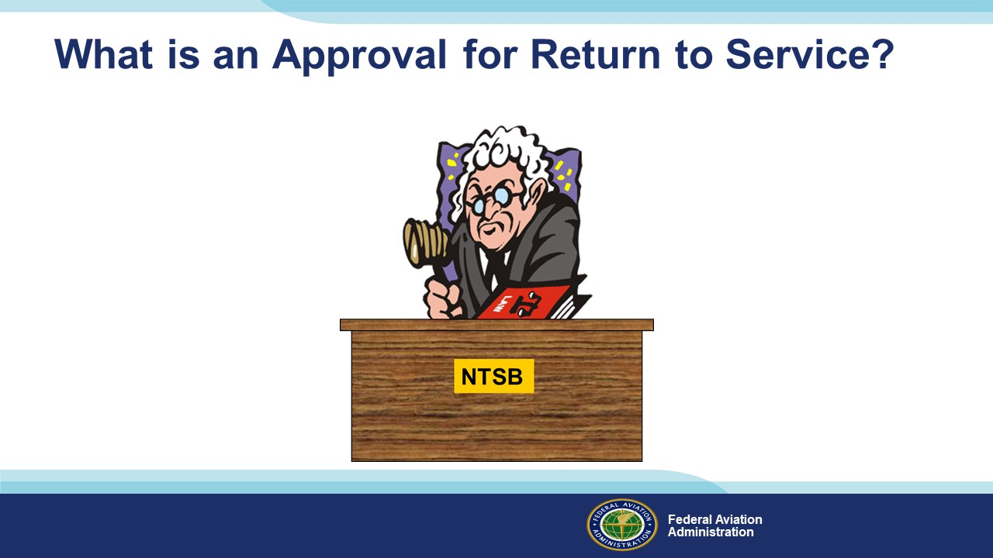 | Slide 17  If you fly without an approval for return to service, and something happens, you will get to meet the NTSB Administrative Law Judge. The meeting will be all you. The mechanic won’t be there. That is the topic of a different presentation.  (Next Slide)
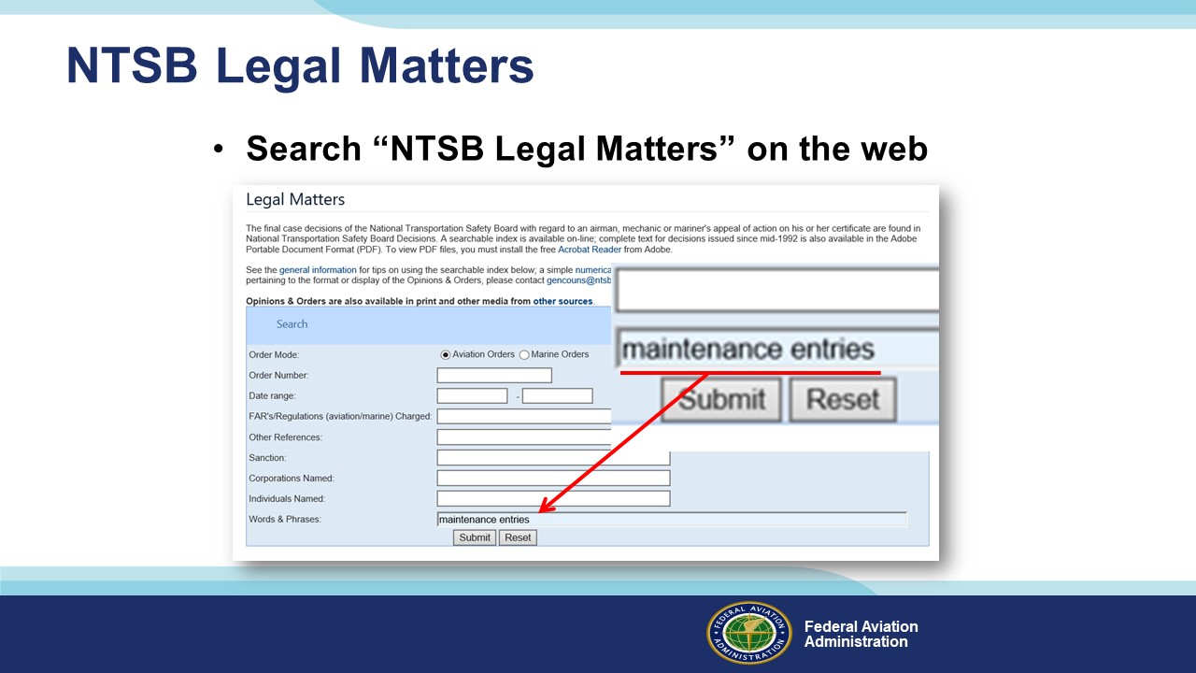 | Slide 18  If you would like to read some appealed cases on the topic of maintenance entries, search NTSB Legal Matters, and then enter maintenance entries in the, words and phrases, box of the search engine. You will find that it is the pilot’s responsibility to make sure the mechanics put the appropriate entry in the permanent maintenance records indicating their approval for return to service.  (Next Slide)
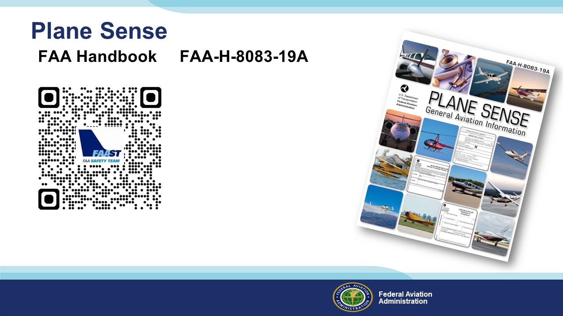 | Slide 19  This is a GREAT…FREE… publication that will explain many other ways to stay out of trouble. Just put Plane Sense in your browser. It is free on FAA.gov.  (Next Slide)
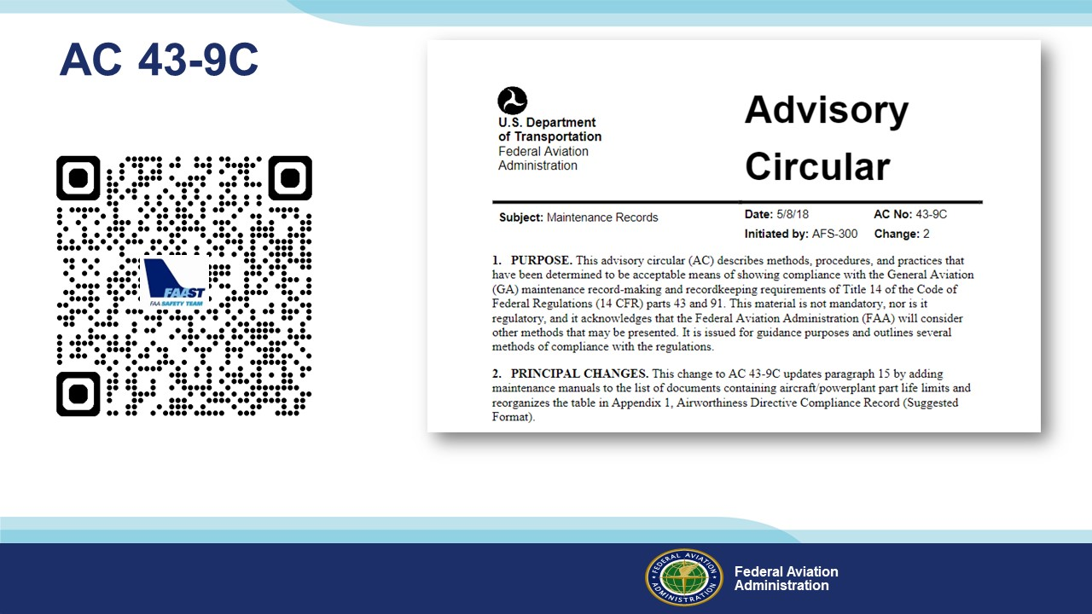 | Slide 20  This is also a good resource to help you understand maintenance records. It is free on FAA.gov. Just scan the QR code on screen or put AC 43-9C in your browser.  (Next Slide)
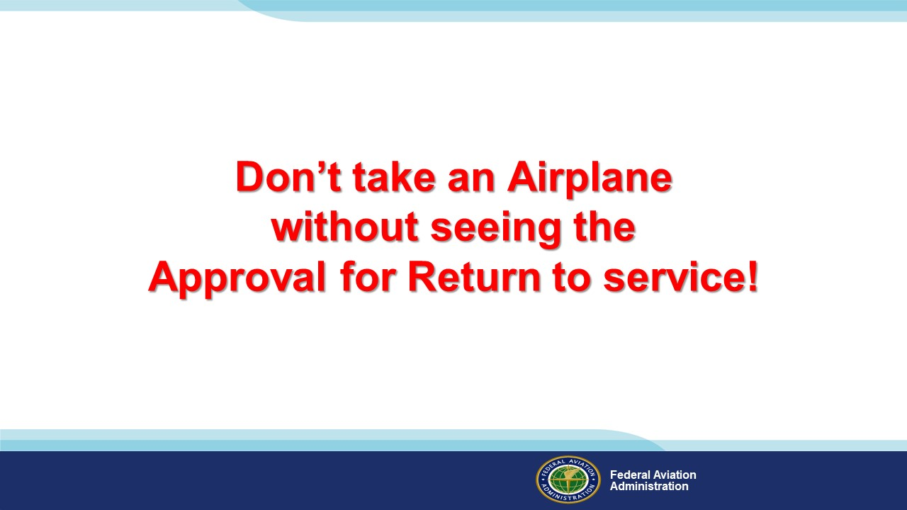 | Slide 21  This is the bottom line…on the bottom, because it is the bottom line. Don’t take an Airplane without seeing the Approval for Return to service!  (Next Slide)
 | Slide 22  Presentation Note: You may wish to provide your contact information and main FSDO phone number here. Modify with your information or leave blank.  (Next Slide)
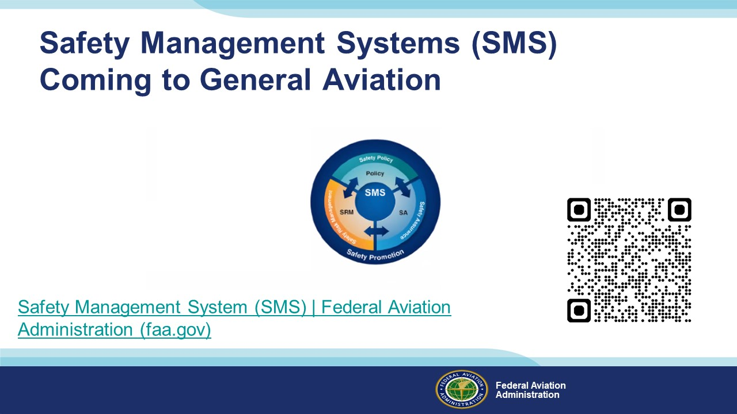 | Slide 23  Safety Management Systems are a set of policies and processes that can increase the safety and efficiency of any flight operation. And FAA is bringing SMS to General Aviation. You may have heard of SMS but thought it was only for large organizations but actually SMS can be scaled to fit any operation large or small.  There are 4 major components to a Safety Management System (Click)  Safety Policy – a documented commitment to safety that runs from the head of an organization to its newest member. (Click)  Safety Risk Management – a process that identifies hazards within an operation, determines to what extent an identified hazard may impact flight safety, and controls the risk of occurrence to an acceptable level. (Click)  Safety Assurance – By collecting and analyzing information derived from safety performance data Safety Assurance ensures the performance and effectiveness of Safety Risk Controls. (Click)  Safety Promotion communicates safety information and commitment throughout the organization. (Click)  You can find more information about Safety Management Systems at the URL on the Screen.  Presentation note: Allow sufficient time for audience to copy link then:  (Next Slide)
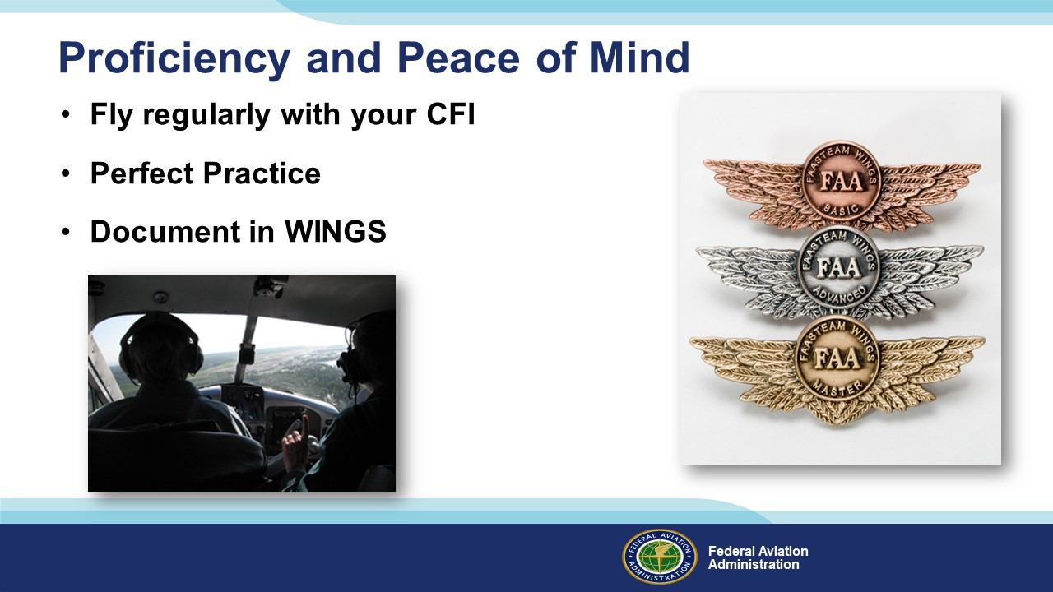 | Slide 24  There’s nothing like the feeling you get when you know you’re playing your A game and in order to do that you need a good coach (Click)  So, fly regularly with a CFI who will challenge you to review what you know, explore new horizons, and to always do your best. Of course you’ll  have to dedicate time and money to your proficiency program but it’s well worth it for the peace of mind that comes with confidence. (Click)  Vince Lombardi, the famous football coach said, “Practice does not make perfect. Only perfect practice makes perfect.” For pilots that means  flying with precision. On course, on altitude, on speed all the time. (Click)  And be sure to document your achievement in the Wings Proficiency Program. It’s a great way to stay on top of your game and keep you flight review current.  (Next Slide)
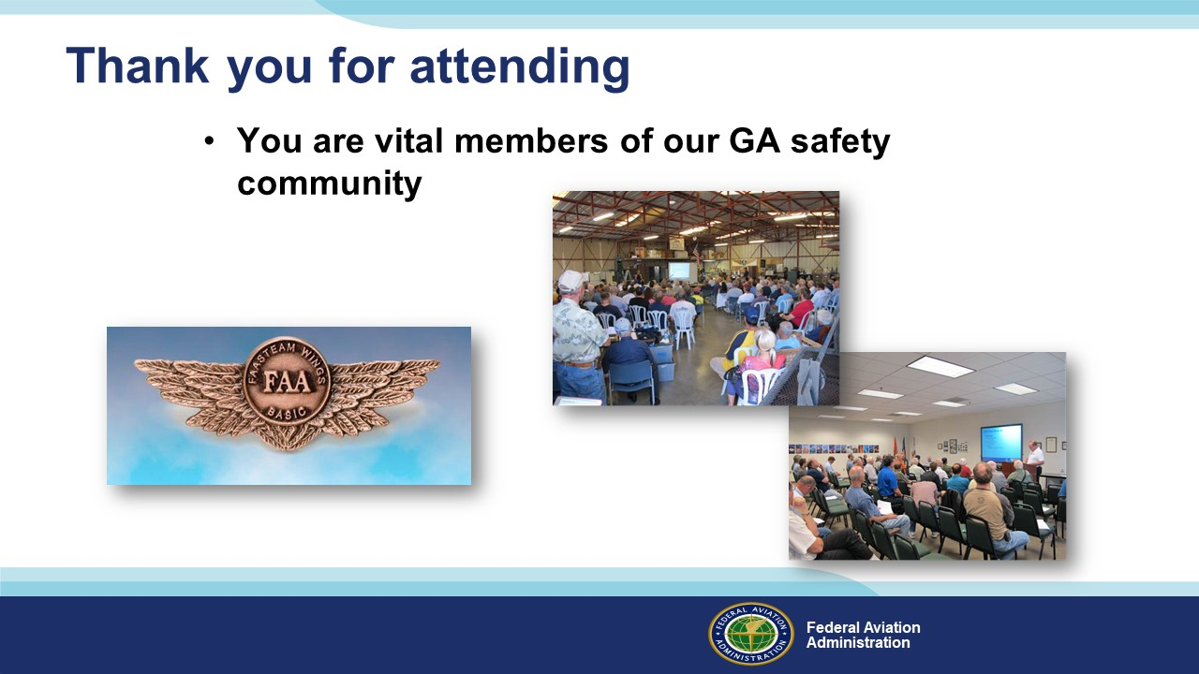 | Slide 25  Your presence here shows that you are vital members of our General Aviation Safety Community. The high standards you keep and the examples you set are a great credit to you and to GA.  Thank you for attending.  (Next Slide)
Slide 26

(The End)

Appendix I – Equipment and Staging
Equipment:
- Projection Screen & Video Projector suitable for expected audience
  - Remote computer/projector control available at lectern or presenter location
    - In lieu of remote – detail a Rep to computer/projector control.
- Presentation Computer
  - Note: It is strongly suggested that the entire program reside on this computer.
- Back up Projector/Computer/Media as available.
- PA system suitable for expected audience
  - Microphones for Moderator and Panel
    - Optional Microphone (s) for audience
- Lectern (optional)
Staging:
- Arrange the projection screen for maximum visibility from the audience.
- Equip with PA microphones
- Place Lectern to one side of screen. This will be used by presenters and moderator

IMPORTANT – Once you have completed outreach on this topic, please help us track the outreach you have done by entering a SAS record.

