General Aviation Joint Safety Committee
CFIT Working Group

Outreach Guidance Document
2023/10-29-302(I)PP

This outreach guidance is provided to all FAA and aviation industry groups that are participating in outreach efforts sponsored by the General Aviation Joint Safety Committee (GAJSC). It is important that all outreach on a given topic is coordinated and is free of conflicts. Therefore, all outreach products should be in alignment with the outline and concepts listed below for this topic.

Outreach Month: June 2025

Topic: Regulatory Roadblock Reduction
The FAA and industry will conduct a public education campaign emphasizing the benefits of reducing regulatory burden to certification while maintaining high safety standards..

Background:

A GAJSC study found that regulatory burden and compliance expence inhibits approval and adoption of modern safety technologies. Reducing that burden and expense would encourage development, manufacture, and installation of technologies.

Teaching Points:

- Modern safety technologies can substantially reduce the number and severity of general aviation accidents.
- Acquisition expense and installation procedures discourage universal adoption of safety technologies.
- Consensus-based manufacturing standards with rigorous process and product oversight can result in safer, more efficient, and less costly general aviation aircraft and equipment.

References
  - GAJSC Loss of Control on Approach, Landing, Departure, and En route Workgroup Report
  - https://www.gajsc.org/download/2230/?tmstv=1714594678

Abstract: Lasting 10 to 15minutes, this presentation acquaints the audience with the safety benefits of:
- Installation and use of modern safety technologies
- Consensus-based manufacturing standards
- Modern Aircraft and Equipment Certification Regulations

Format: Information Briefing - Power Point presentation

Required Personnel – FAASTeam Program Manager or designated FAASTeam Reps.

Optional Personnel – CFIs and DPS who can speak on the benefits of reducing regulatory roadblocks to aircraft and equipment certification.

National FAASTeam Support:
In addition to this guidance document, a Power Point presentation that supports the program is provided. FPMs and presenters are encouraged to customize this presentation to reflect each individual program.

Slides | Script
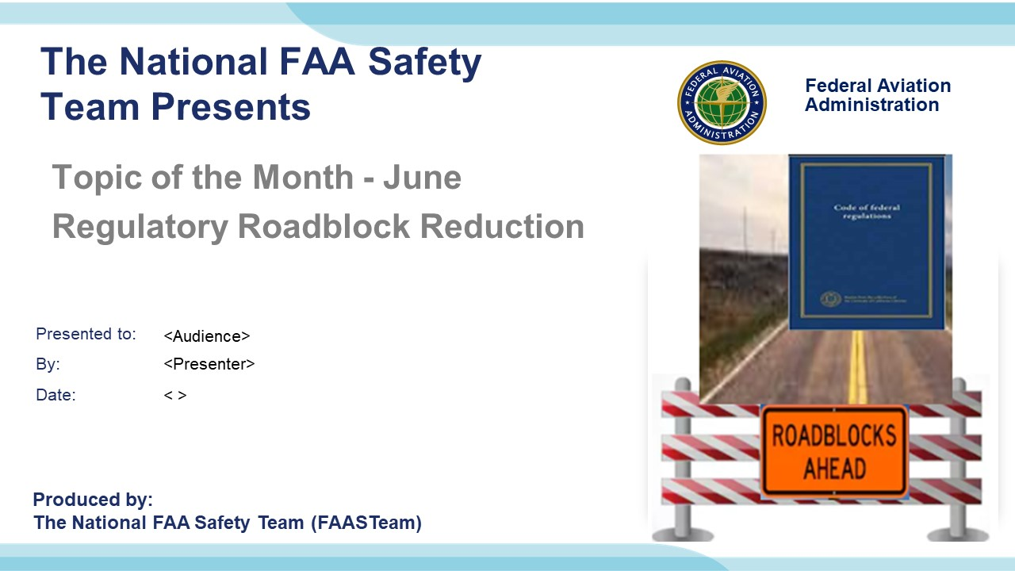 | Slide 1  2023/10-29-302(I)PP- Original Author: James Lamb 03/14/2018 SLT; POC Kevin Clover - National FAASTeam Program Mgr. (Operations), Office 562-888-2020; Revised by J Steuernagle (05/01/2024)  Presentation Note: This is the title slide for Regulatory Roadblock Reduction  Script - We have included a script of suggested dialog with most slides. The script will always appear in a non-italic font. Presenters may read the script or modify it to suit their own presentation style. See template slides 5 and 6 for examples of a slides with script.  Presentation Instructions - (stage direction and presentation suggestions) will be preceded by a Bold header: the instructions themselves will be in Italic fonts. See slide 2, for an example of slides with Presentation Instructions only.  Program control instructions - will be in bold fonts and look like this: (Click) for building information within a slide; or this: (Next Slide) for slide advance.  Background information - Some slides may contain background information that supports the concepts presented in the program.  .  The production team hope you and your audience will enjoy the show. Break a leg!  (Next Slide)
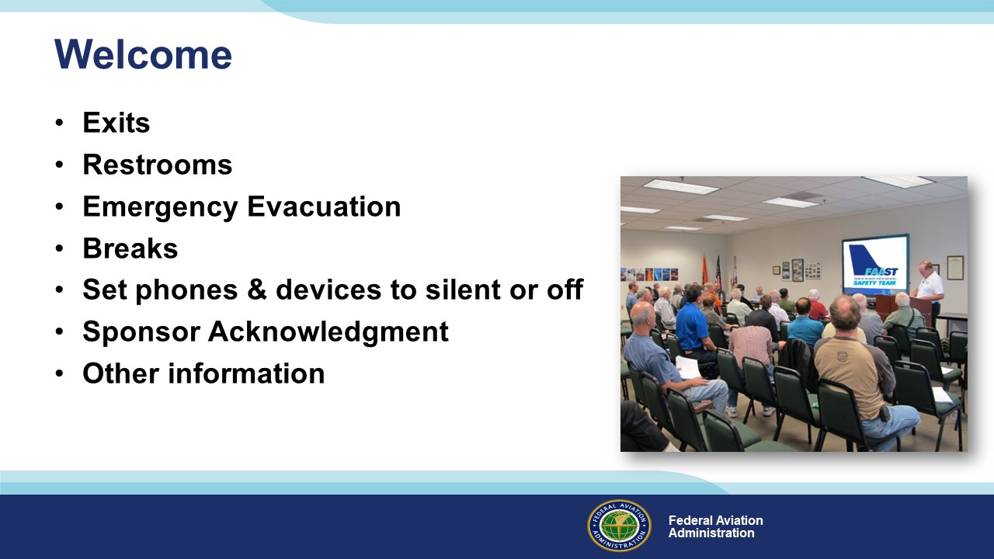 | Slide 2  Presentation Note: Here’s where you can discuss venue logistics, acknowledge sponsors, and deliver other information you want your audience to know in the beginning.  You can add slides after this one to fit your situation.  (Next Slide)
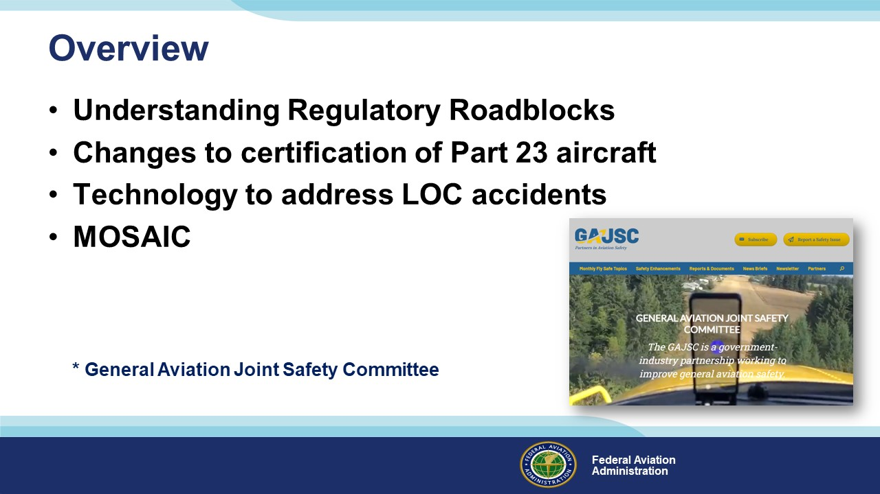 | Slide 3  In this presentation we’ll talk about recommendations from a work group known as the General Aviation Joint Safety Committee (GAJSC) that studies General Aviation mishaps and provides mitigation strategies. For this month’s topic, we review their study results and recommendations for “Loss of Control on Approach and Landing, Departure, and En Route. We’ll also touch on changes to certification requirements for General Aviation aircraft and FAA’s MOSAIC - a new certification paradigm for Light Sport aircraft.  Presentation Note: If you’ll be discussing additional items, add them to this list  (Next Slide)
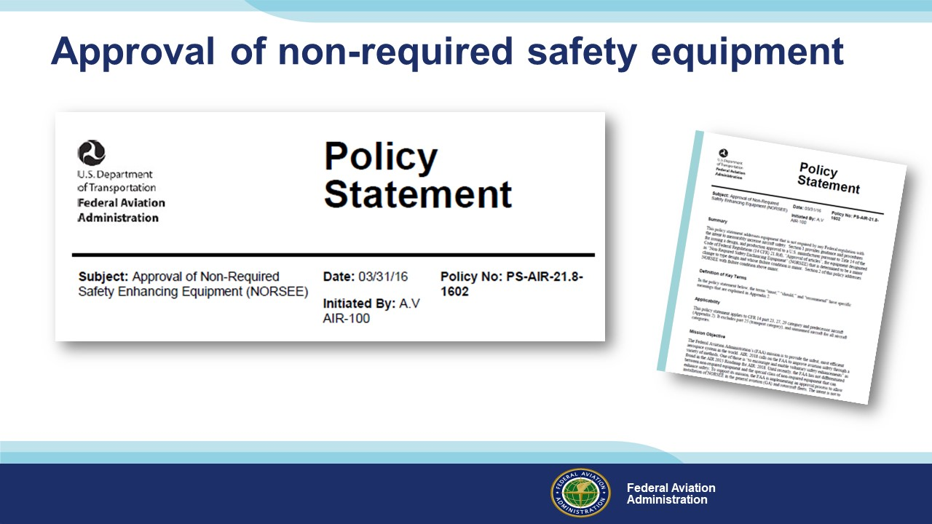 | Slide 4  In 2016 the FAA took a major step toward easing the approval requirements for installation of non-required safety enhancing equipment. The policy statement acknowledges the benefits of equipping with safety gear and makes it easier for aircraft owners and manufacturers to do so.  (Next Slide)
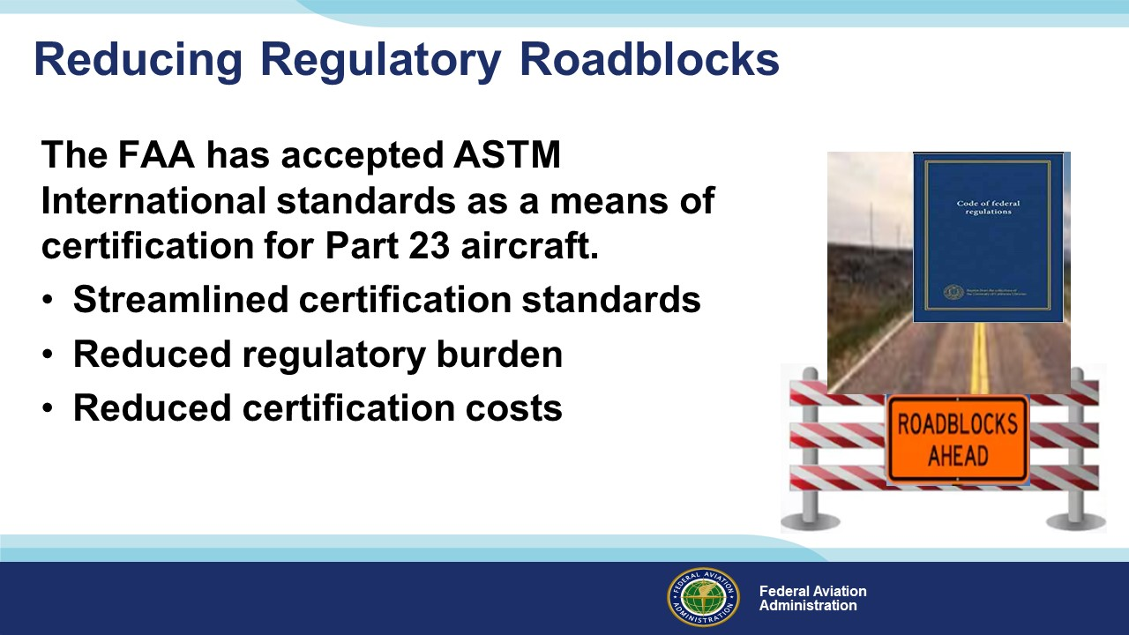 | Slide 5  Recommendations from the GAJSC included reducing regulatory roadblocks that affect initial certification and installation of additional avionics technology. The committee believes that extensive certification requirements for installation of additional risk mitigating avionics in small GA aircraft results in an expense that is too large a fraction of the airplane’s value to justify the expense.  Part 23 regulations will continue to be used as a means of certification, but the administrator has deemed the ASTM standards to provide "at least the same level of safety as the corresponding requirements in part 23, amendment 23-64."  For the past few years, the FAA has allowed ASTM consensus standards as a means of certification for Light Sport Aircraft. The agency has also made provisions within part 23 to streamline the certification of safety components such as angle-of-attack indicators. The catalyst for these changes was the Small Airplane Revitalization Act of 2013.  (Next Slide)
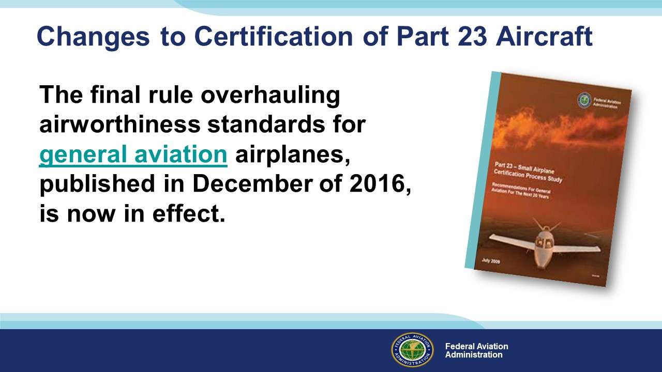 | Slide 6  The Federal Aviation Administration (FAA) expects this rule will enable faster installation of innovative, safety-enhancing technologies into small airplanes, while reducing costs for the aviation industry.  With these performance-based standards, the FAA delivers on its promise to implement forward-looking, flexible rules that encourage innovation. Specifically, the new part 23 revolutionizes standards for airplanes weighing 19,000 pounds or less and with 19 or fewer passenger seats by replacing prescriptive requirements with performance-based standards coupled with consensus-based compliance methods for specific designs and technologies.  This regulatory change is a leading example of how the FAA is transforming its Aircraft Certification Service into an agile organization that can support aviation industry innovation in the coming years.  (Next Slide)
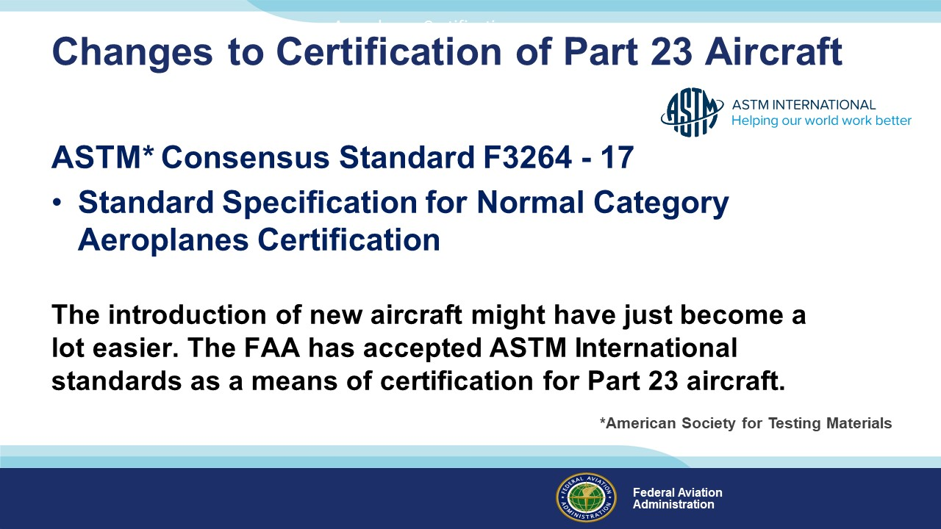 | Slide 7  ASTM Consensus Standard F3264 - 17 identifies the industry standards which have been determined by consensus to demonstrate compliance with the requirements (“the Rules”) for Level 1, 2, 3, 4 Normal Category Aeroplanes.  The FAA announced its acceptance of 30 published ASTM International consensus standards for certification of normal category Part 23 airplanes. The new Means of Compliance (MOC) are, according to the FAA, “an acceptable means, but not the only means, of showing compliance to the applicable regulations in Part 23 [and] provide at least the same level of safety as the corresponding requirements.”  (Next Slide)
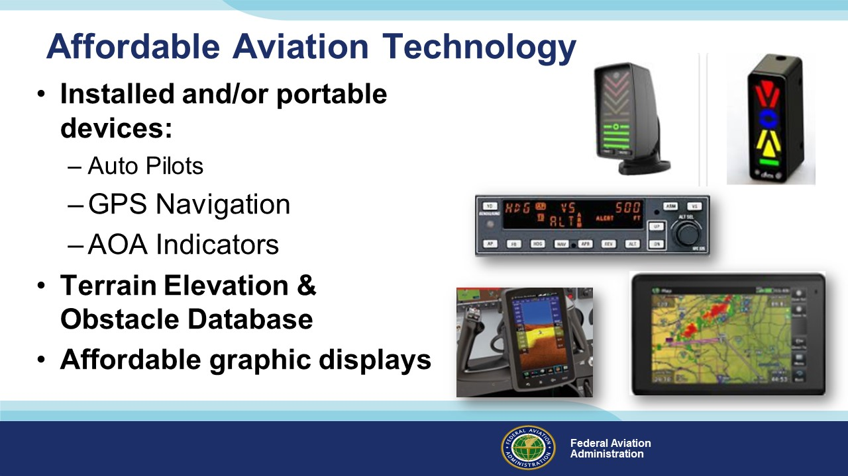 | Slide 8  The GAJSC suggests that there is an opportunity to affect the value verses cost ratio for new equipment such that a large percentage of general aviation aircraft owners will elect to purchase and install safety enhancing equipment. They also suggest:  - a “baseline” approved Digital Terrain Elevation and Obstacles Database provided by the Federal government at a very low cost or free. It would be important to aerial application and rotorcraft communities and therefore the obstacle database must include obstacles down to 10 feet.  - augmented programs that will speed up the development of low-cost graphical displays that reduce pilot workload and improve situational awareness.  (Next Slide)
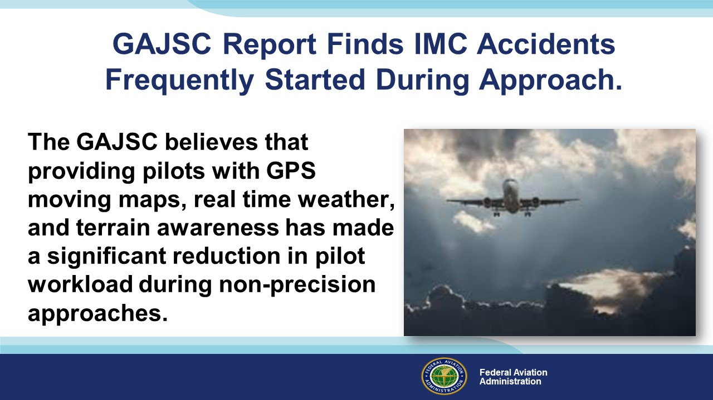 | Slide 9  Reducing the regulatory barriers to encourage the development and installation of smart technology to integrate the piloting, navigation and control systems would improve envelope protection and reduce pilot workload.  (Next Slide)
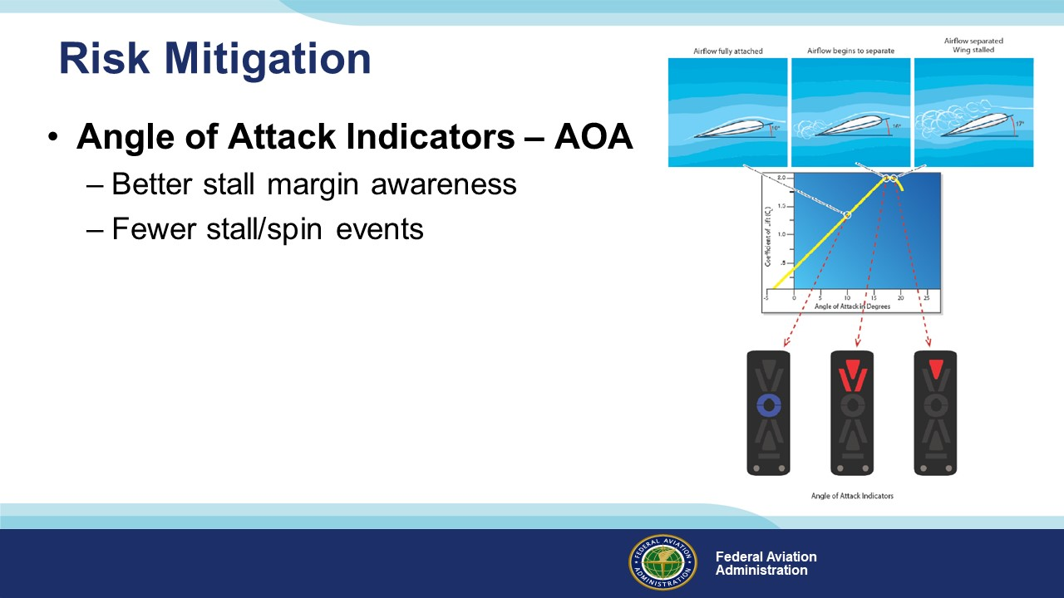 | Slide 10  The FAA along with the General Aviation Joint Steering Committee (GAJSC) is promoting Angle of Attack (AOA) indicators as one of the many safety initiatives aimed at reducing the General Aviation accident rate. AOA indicators will specifically target Loss of Control (LOC) accidents. Loss of control is the number one root cause of fatalities in both General Aviation (GA) and Commercial Aviation. More than 25% of General Aviation fatal accidents occur during the maneuvering phase of flight. Of those accidents-half involve stall/spin scenarios. Technology such as AOA indicators can have a tremendous impact on reversing this trend and are increasingly affordable for GA airplanes. (Reference: Instrument Flying Handbook “FAA-H-8083-15B”)  The AOA indicator provides pilots with an awareness (visual and audio) of their margin above stall. The system accounts for all conditions such as weight and acceleration by design, whereas using stall speed does not. AOA system installations should be easy because they are not required equipment and do not interface with any existing equipment. The GAJSC suggest that AOA system installations should be easy because they are not required equipment and do not interface with any existing equipment.  (Next Slide)
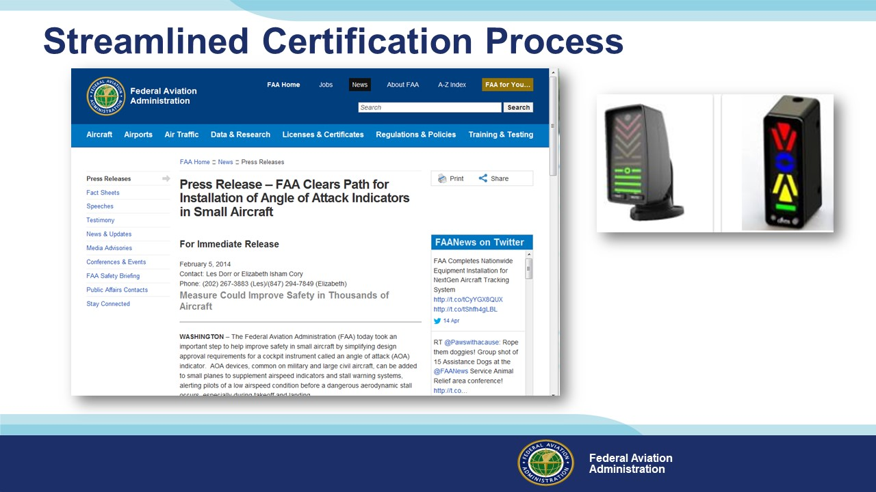 | Slide 11  FAA’s Small Airplane Directorate has streamlined the process for production and retrofit approval of AOA devices and for other devices such as autopilots.  (Next Slide)
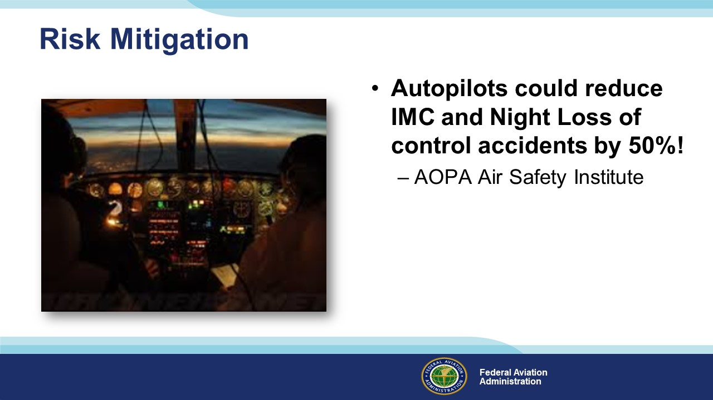 | Slide 12  An autopilot can be capable of many very time intensive tasks, helping the pilot focus on the overall status of the aircraft and flight. Proper use of an autopilot helps automate the process of guiding and controlling the aircraft. Autopilots can automate tasks, such as maintaining an altitude, climbing or descending to an assigned altitude, turning to and maintaining an assigned heading, intercepting a course, guiding the aircraft between waypoints that make up a route programmed into an FMS, and flying a precision or nonprecision approach.  (Reference: “Advanced Avionics Handbook”, FAA-H-8083-6 / Chapter 4 – Automated Flight Control  An AOPA Air Safety Institute report suggests that LOC accidents at night and in IMC would drop by 50 percent simply by installing autopilots in the more than 100,000 IFR capable GA airplanes.  (Next Slide)
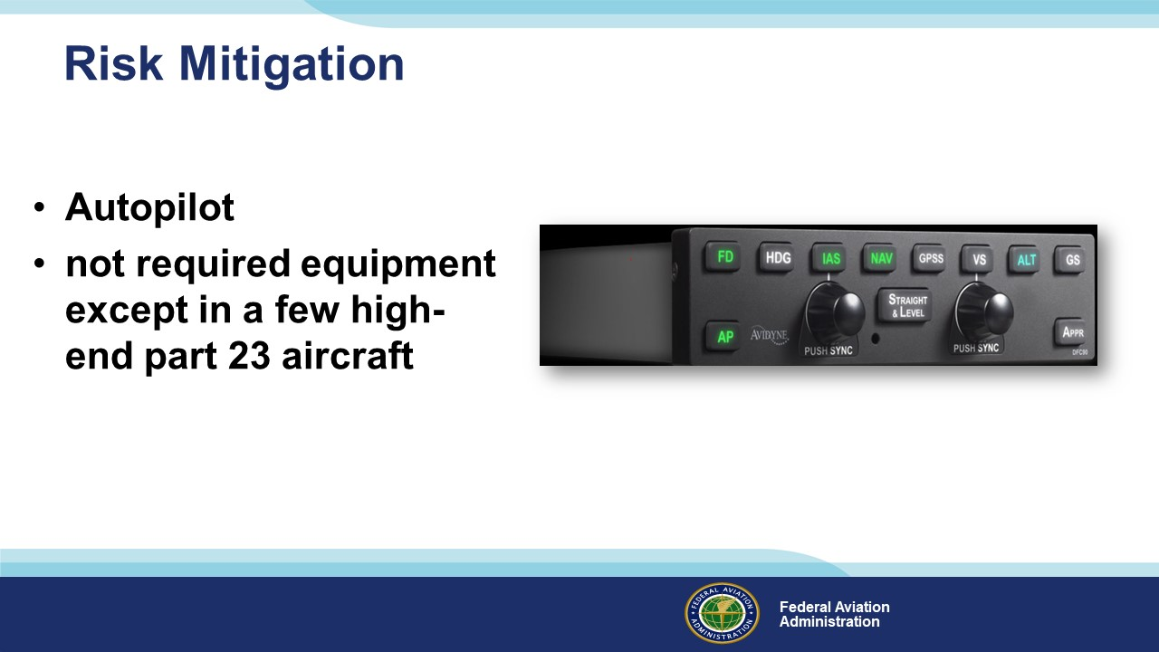 | Slide 13  The GAJSC’s report suggests that the FAA should find ways to help reduce the cost to about half of what it costs today to install safety enhancing technology. Given that an installation may have minimal risk but offer substantial safety benefit, the FAA should apply a risk management approach to address the current situation in which the FAA is actually an obstacle to getting safety enhancing technology into the GA fleet.  The report states homebuilders can install an autopilot for as little as $2,500. However, for most light airplanes that cost would be between $10,000 and $15,000 with the airplane value around $20,000 to $100,000. That is simply too large a fraction of the airplane’s value to justify the expense. But consumer demand may well drive more affordable options in the future. In the meantime, we’re also seeing progress in Light-Sport Aircraft certification.  (Next Slide)
Slide Removed from PPT | Slide 14  Slide Removed from PPT  (Next Slide)
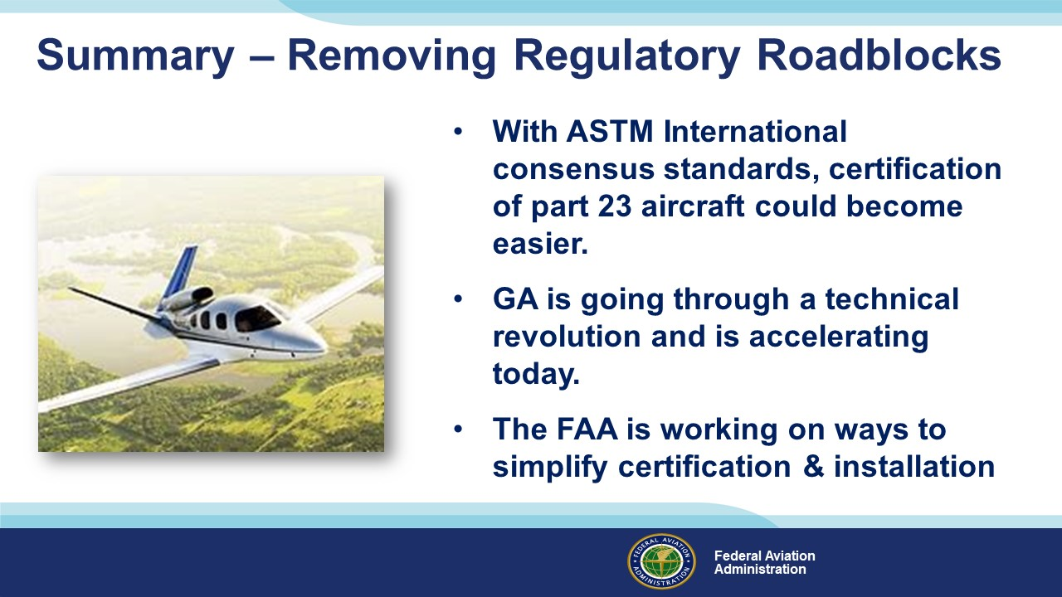 | Slide 15  - GA is going through a technical revolution that started in the mid 1990’s and is accelerating today.  - Taking advantage of the rapidly expanding technical revolution is important to the goal of reducing GA accidents.  - The technology to address LOC accidents can, in some cases, be designed as a portable device; but more typically, technologies that can address LOC accidents must be installed on the airplane. This is the main reason that cost keeps this technology out of small airplanes.  - The FAA has the responsibility to ensure that devices meet the safety aspect prior to approving them.  - Clearly the FAA is on the right track but must find ways to help reduce the cost to about half of what it costs today to install safety enhancing technology.  - If done properly the GA fleet can reap the potential benefit of reward with a balanced risk approach.  (Next Slide)
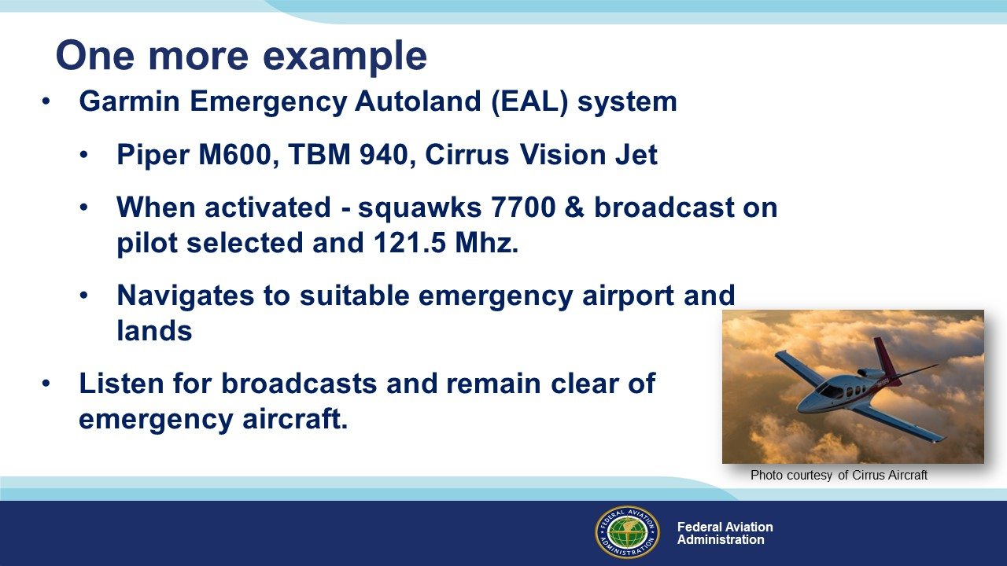 | Slide 16  Before we go, here’s one more example of how streamlined certification is increasing safety. As of today, 3 aircraft have been certified with Garmin’s Emergency Autoland (EAL) system.  The system can be activated by pilots, passengers, or the aircraft itself. Once activated, the system will squawk 7700 and broadcast on the last pilot-selected frequency and on the emergency guard (121.5 Mhz) frequency.  The aircraft will then navigate to a suitable emergency airport and land. When within 12 miles of the landing airport, the aircraft will broadcast advisories on the appropriate ATC or common traffic advisory (CTAF) frequency and on guard.  Pilots should listen for these broadcasts and ensure they remain clear of the emergency aircraft.  (Next Slide)
 | Slide 17  Presentation Note: You may wish to provide your contact information and main FSDO phone number here. Modify with  Your information or leave blank.  (Next Slide)
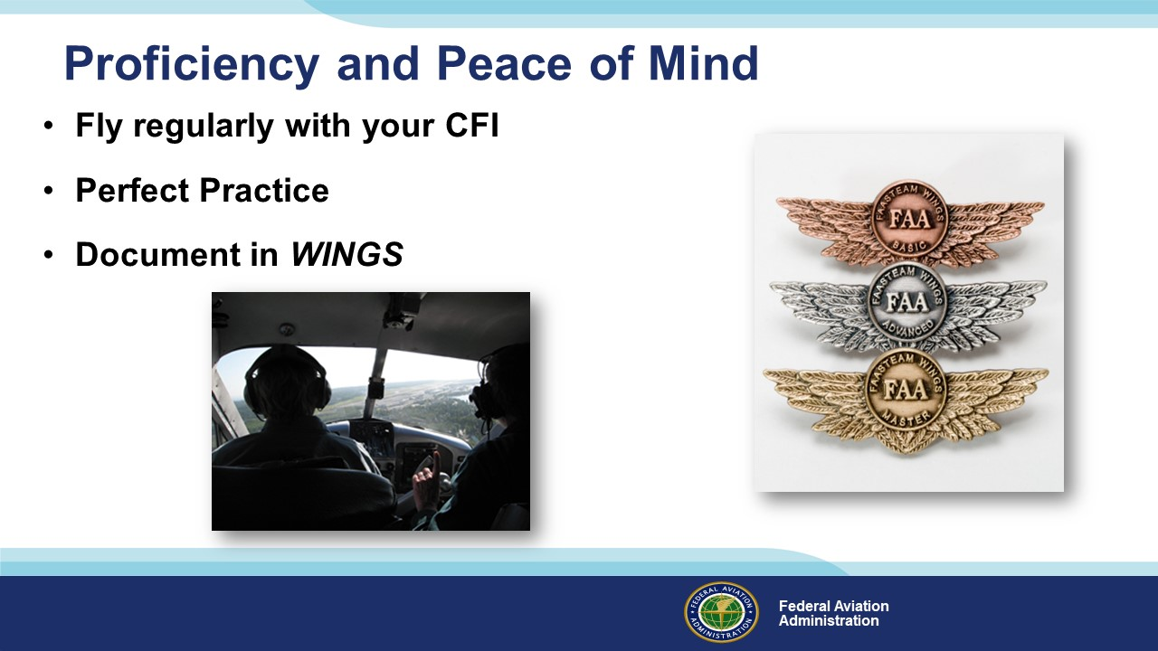 | Slide 18  There’s nothing like the feeling you get when you know you’re playing your A game and in order to do that you need a good coach (Click)  So fly regularly with a CFI who will challenge you to review what you know, explore new horizons, and to always do your best. Of course you’ll  have to dedicate time and money to your proficiency program but it’s well worth it for the peace of mind that comes with confidence. (Click)  Vince Lombardi, the famous football coach said, “Practice does not make perfect. Only perfect practice makes perfect.” For pilots that means  flying with precision. On course, on altitude, on speed all the time. (Click)  And be sure to document your achievement in the Wings Proficiency Program. It’s a great way to stay on top of your game and keep you flight review current.  (Next Slide)
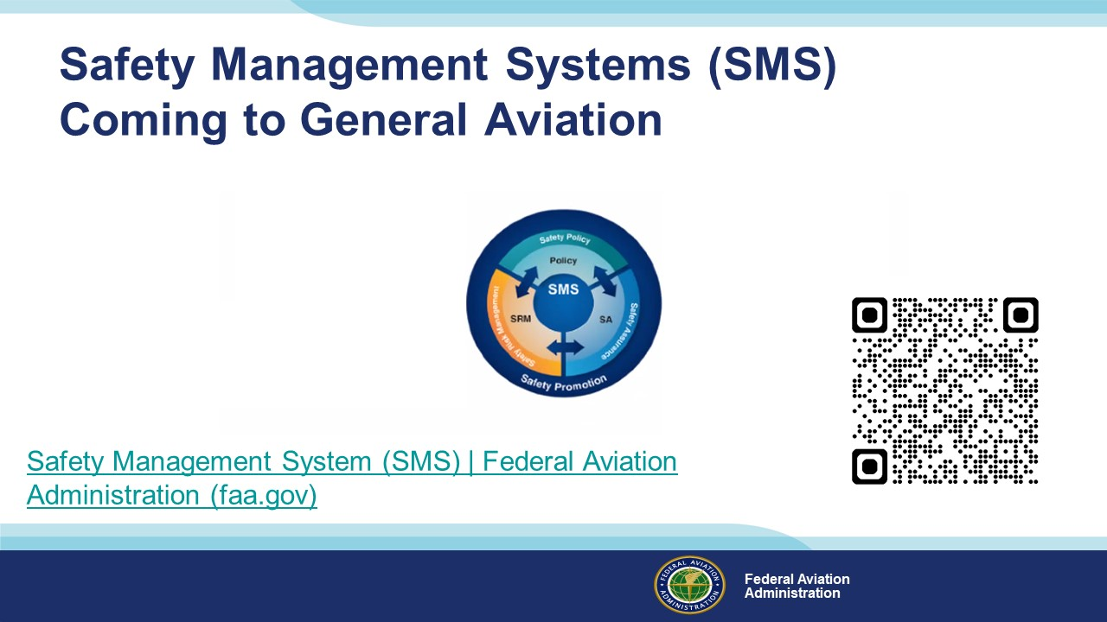 | Slide 19  Safety Management Systems are a set of policies and processes that can increase the safety and efficiency of any flight operation. And FAA is bringing SMS to General Aviation. You may have heard of SMS but thought it was only for large organizations but actually SMS can be scaled to fit any operation large or small.  There are 4 major components to a Safety Management System (Click)  Safety Policy – a documented commitment to safety that runs from the head of an organization to its newest member. (Click)  Safety Risk Management – a process that identifies hazards within an operation, determines to what extent an identified hazard may impact flight safety, and controls the risk of occurrence to an acceptable level. (Click)  Safety Assurance – By collecting and analyzing information derived from safety performance data Safety Assurance ensures the performance and effectiveness of Safety Risk Controls. (Click)  Safety Promotion communicates safety information and commitment throughout the organization. (Click)  You can find more information about Safety Management Systems at the URL on the Screen.  Presentation note: Allow sufficient time for audience to copy link then:  (Next Slide)
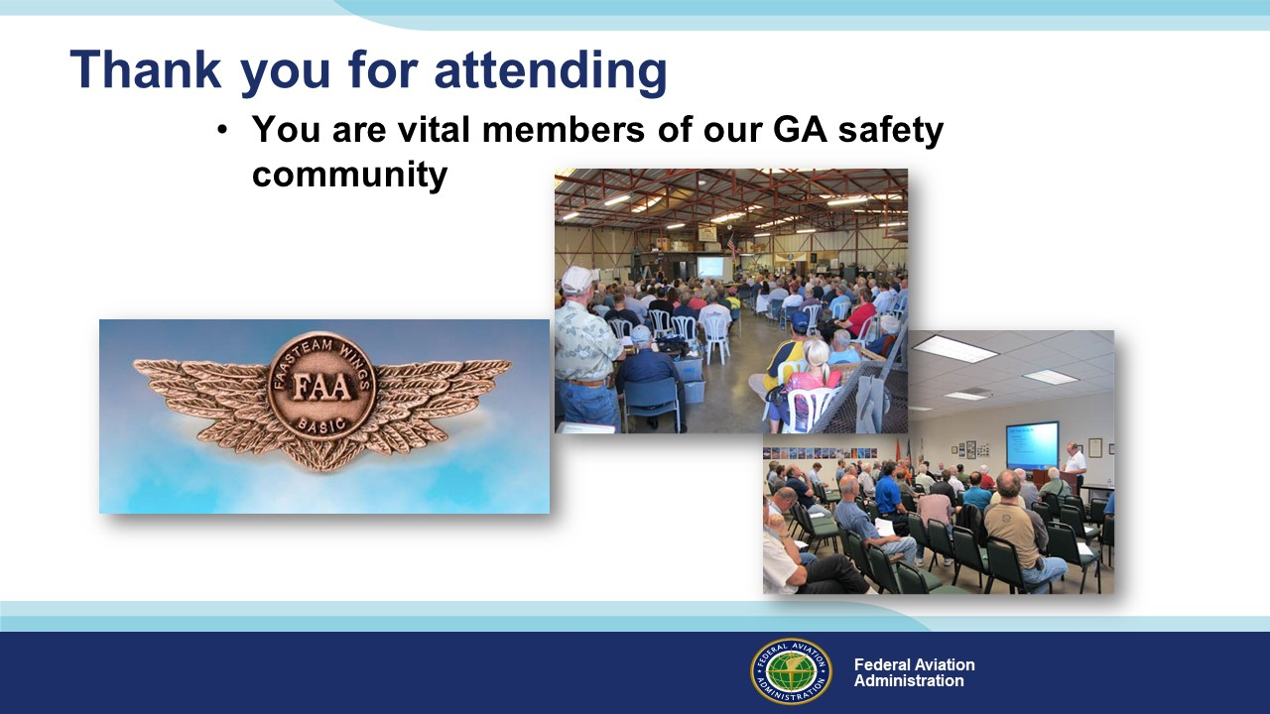 | Slide 20  Your presence here shows that you are vital members of our General Aviation Safety Community. The high standards you keep and the examples you set are a great credit to you and to GA.  Thank you for attending.  (Next Slide)
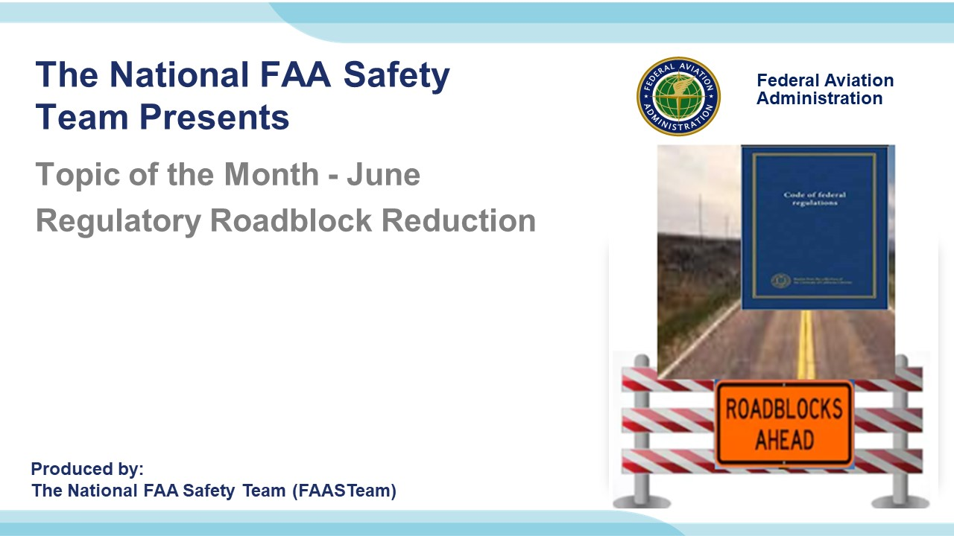 | Slide 21  (The End)

Appendix I – Equipment and Staging
Equipment:
- Projection Screen & Video Projector suitable for expected audience
  - Remote computer/projector control available at lectern or presenter location
    - In lieu of remote – detail a Rep to computer/projector control.
- Presentation Computer
  - Note: It is strongly suggested that the entire program reside on this computer.
- Back up Projector/Computer/Media as available.
- PA system suitable for expected audience
  - Microphones for Moderator and Panel
    - Optional Microphone (s) for audience
- Lectern (optional)
Staging:
- Arrange the projection screen for maximum visibility from the audience.
- Equip with PA microphones
- Place Lectern to one side of screen. This will be used by presenters and moderator

IMPORTANT – Once you have completed outreach on this topic, please help us track the outreach you have done by entering a SAS record.

