General Aviation Joint Safety Committee
CFIT Working Group

Outreach Guidance Document
2023/10-29-303(I)PP

This outreach guidance is provided to all FAA and aviation industry groups that are participating in outreach efforts sponsored by the General Aviation Joint Safety Committee (GAJSC). It is important that all outreach on a given topic is coordinated and is free of conflicts. Therefore, all outreach products should be in alignment with the outline and concepts listed below for this topic.

Outreach Month: July 2025

Topic: General Aviation Operations Over Water
The FAA and industry will conduct a public education campaign emphasizing the benefits of flight planning, survival, and equipage for General Aviation operations over water and beyond gliding distance from shore.

Background:

Studies suggest that planning and knowledge of over-water Pre- and In-flight processes and procedures can reduce the frequency of water landings (ditchings) and the severity of consequence should a pilot be forced to ditch.

Teaching Points:

- Basic survival knowledge and equipment can greatly improve chances of surviving after a ditching.
- Pilots should plan for the shortest possible overwater routes and fly at higher altitudes to increase gliding distance.
- GA Passengers and crew should wear Personal Flotation Devices while flying over water.
- When flying to or over remote areas consider 406 MHz personal locator beacons and or satellite phones.
- The most important factor in survival success is the will to survive. .

References
- Basic Survival Skills for Aviation
  - Basic Survival Skills for Aviation (faa.gov) .

- Deep Survival – by Laurence Gonzales
  - W.W. Norton & Company – http://wwnorton.com

Abstract: Lasting 10 to 20 minutes, this presentation acquaints the audience with the safety benefits of acquiring knowledge, skill, and equipment in support of over-water flight operations.
Format: Information Briefing - Power Point presentation
Required Personnel – FAASTeam Program Manager or designated FAASTeam Rep (s)
Optional Personnel – CFIs and Survival Instructors who can speak on Survival.

National FAASTeam Support:
In addition to this guidance document, a Power Point presentation that supports the program is provided. FPMs and presenters are encouraged to customize this presentation to reflect each individual program.

Slides | Script
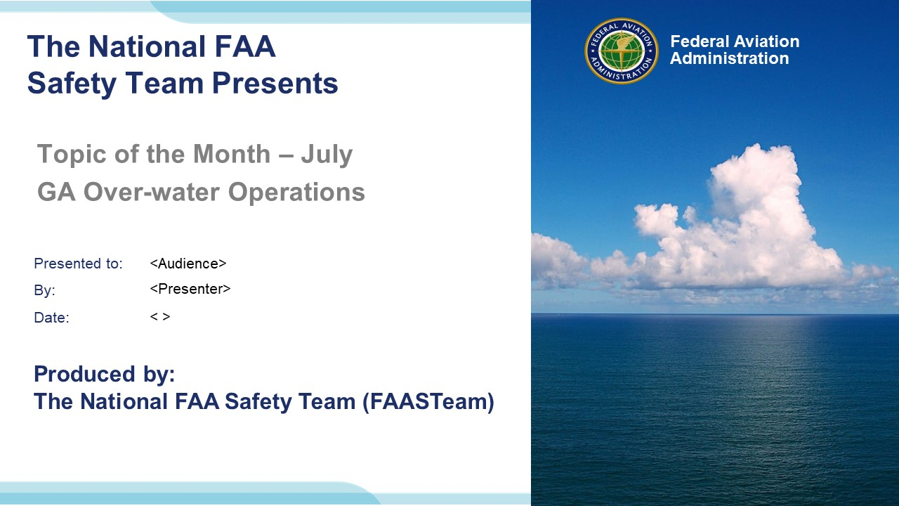 | Slide 1  2023/10-29-298(I)PP Original Author: John Steuernagle; POC Kevin Clover, National FAASTeam Program Manager (Operations), Office 562-888-2020.  Presentation note: This is the title slide for FY 2025 Topic of the Month – January – Safety Culture.  Script - We have included a script of suggested dialog with most slides. The script will always appear in a non-italic font. Presenters may read the script or modify it to suit their own presentation style. See template slides 5 and 6 for examples of a slides with script.  Presentation Instructions - (stage direction and presentation suggestions) will be preceded by a Bold header: the instructions themselves will be in Italic fonts. See slide 2, for an example of slides with Presentation Instructions only.  Program control instructions - will be in bold fonts and look like this: (Click) for building information within a slide; or this: (Next Slide) for slide advance.  Background information - Some slides may contain background information that supports the concepts presented in the program.  .  The production team hope you and your audience will enjoy the show. Break a leg!  (Next Slide)
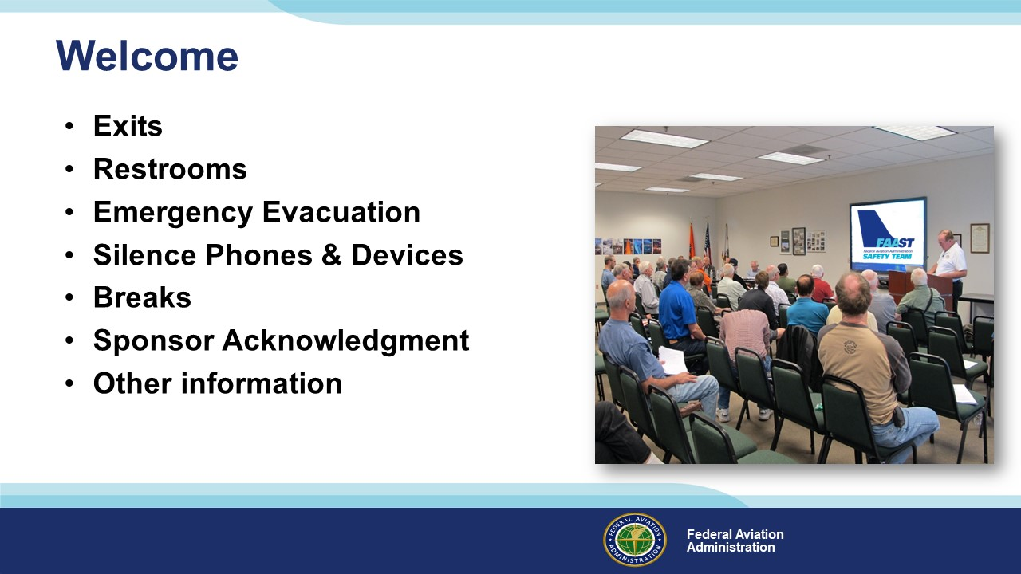 | Slide 2  Presentation Note: Here’s where you can discuss venue logistics, acknowledge sponsors, and deliver other information you want your audience to know in the beginning.  You can add slides after this one to fit your situation.  (Next Slide)
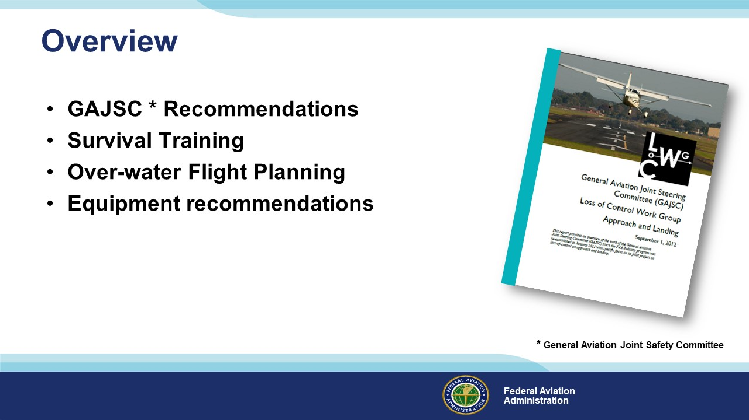 | Slide 3  In this presentation we’ll address recommendations from the General Aviation Joint Safety Committee – a government / industry group that analyzes GA accidents and incidents. The Committee feels that improved survival planning, training, and equipping with emergency gear before flight can significantly improve pilots’ chances of surviving water landings. In a previous program we discussed land and water survival knowledge and training. This program will focus on over-water operations.  Presentation Note: If you’ll be discussing additional items, add them to this list  (Next Slide)
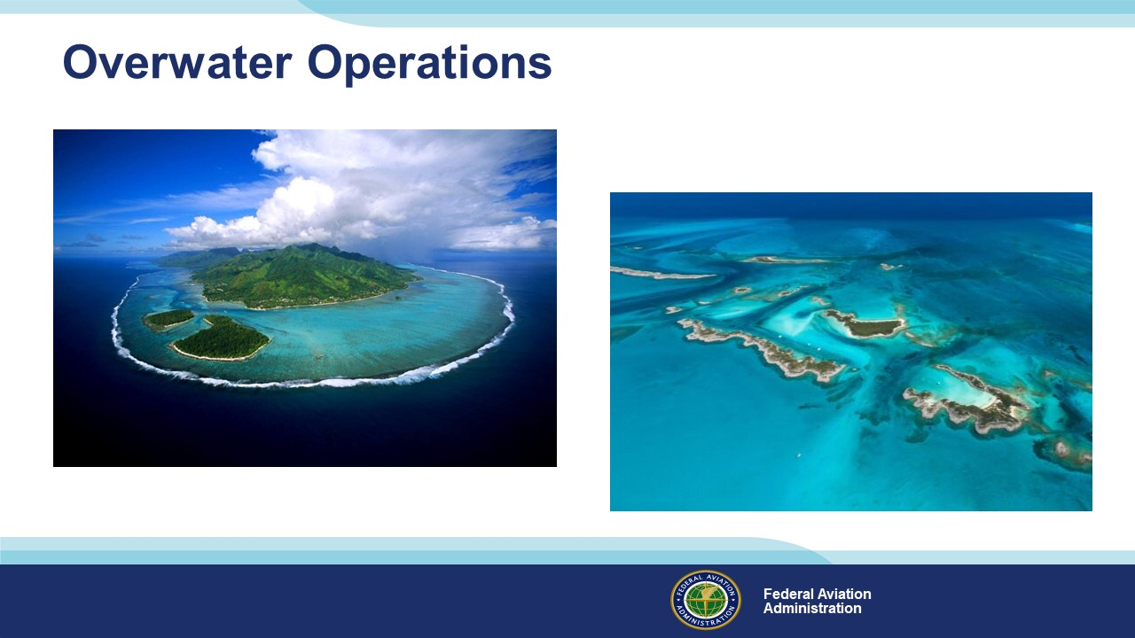 | Slide 4  When we contemplate over-water operations, they’re usually thinking of trans-oceanic flights or island hopping in the Caribbean or South-Pacific. Long stretches over open water mean the engine must keep running or we’ll soon be swimming. That means we should know the principles of successful water landings (ditching), equip with appropriate survival and rescue gear, and know how to use it.  But trans-oceanic flights are not the only ones that could end up in the water. There are many places in the United States where a forced landing can require us to swim to survive.  (Next Slide)
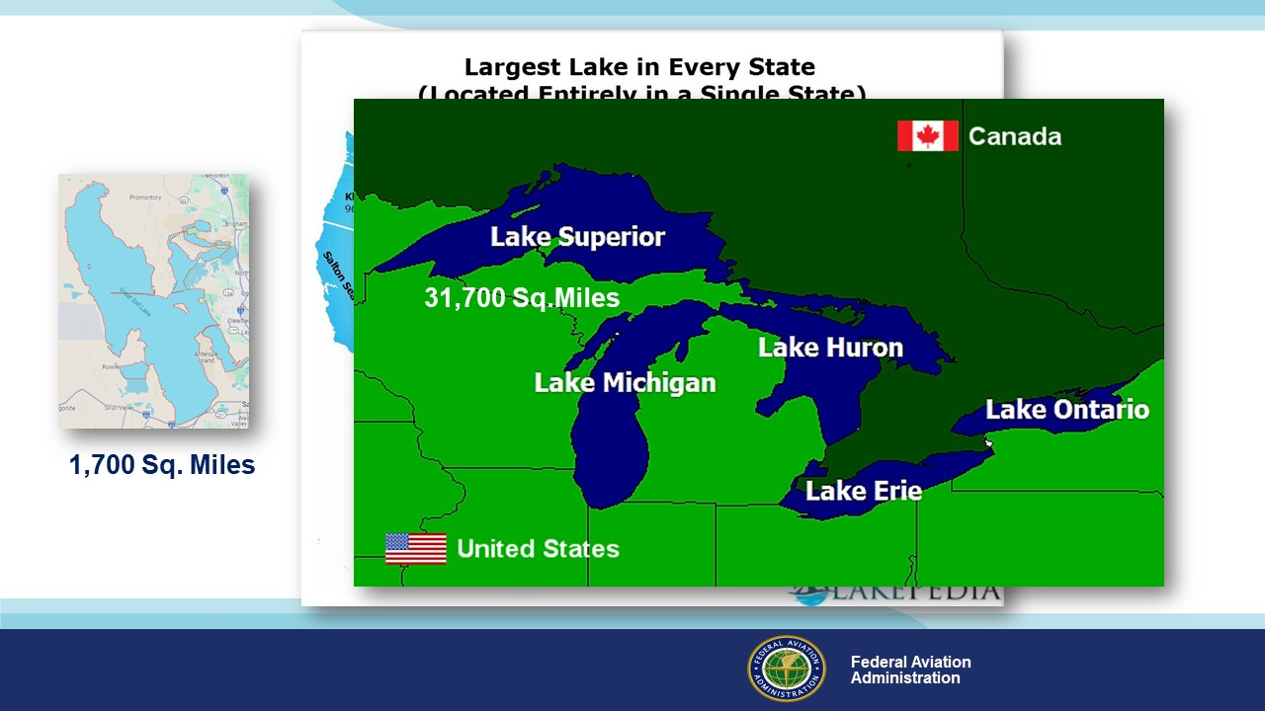 | Slide 5  When we think of lakes in the United States, the five Great Lakes on the northern tier and the Great Salt Lake in Utah come to mind. Lake Superior, the largest freshwater lake in the world, is roughly the size of South Carolina or the country of Austria. If we lose power while overflying any of these, we may end up in the water. (Click)  But there are hundreds of lakes and rivers where, depending on course and altitude, a ditching might be our best or only option. That’s why we need to plan our route to avoid or minimize our time over water and to equip for survival and rescue if we’re forced to ditch.  Here’s an example:  (Next Slide)
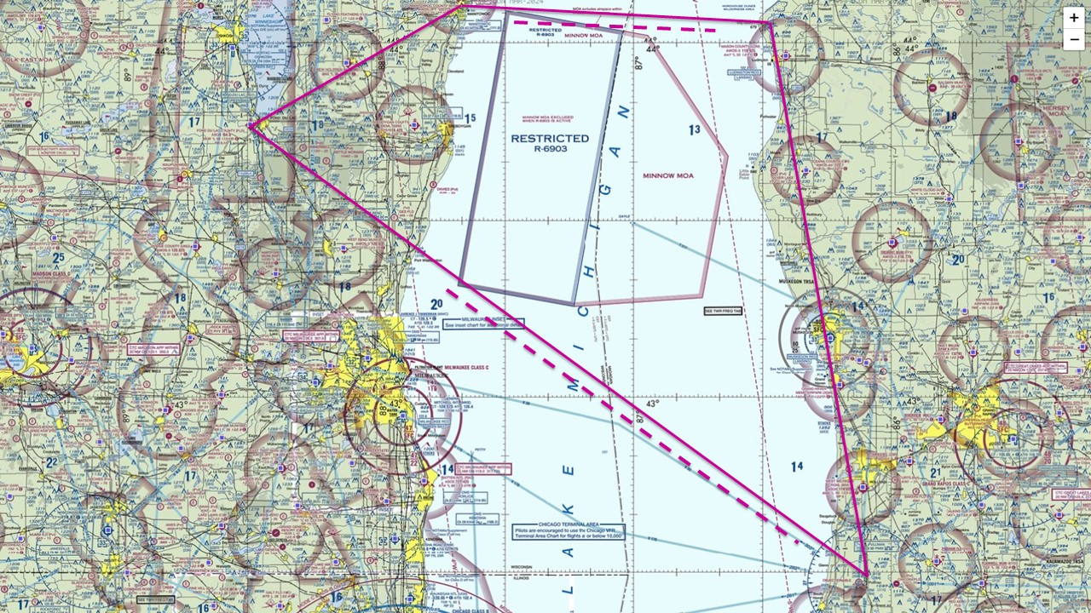 | Slide 6  Let’s say we’re on the way to Fond du Lac, Wisconsin traveling northwest at 6,500 feet in a Cessna 172. The direct route involves an 88-nautical mile over-water segment. Lake Michigan’s mean surface elevation is 575 MSL so figure we’ll be about 6,000 feet above the water. With power off, we can glide approximately 1.5 miles per thousand feet of altitude above the surface. (Click)  So that means we’ll have about 70 miles where we can’t glide to shore if our engine fails. (Click)  We could go further north for a narrower crossing, but we’d still have a 30-mile open water leg, and the trip would be 60 miles longer. Whichever route we choose the higher we can cruise – the better. Altitude will give you more time to deal with emergencies, improve communications, and reduce the time you’re beyond gliding distance from shore. You may not be required to equip with flotation, signaling, and survival gear but for trips like this, it makes sense. We’ll get into specifics soon but first let’s talk a bit more about flight planning.  (Next Slide)
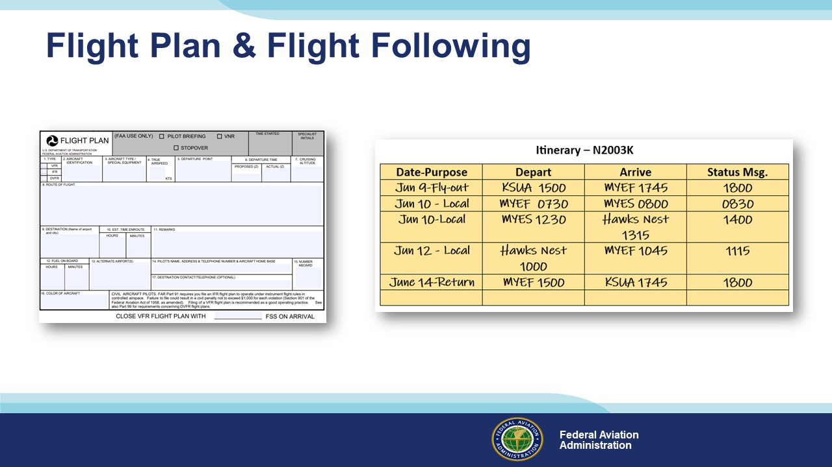 | Slide 7  Obviously, you’ll want to file a flight plan for any over-water flight and requesting flight following makes sense too. But especially if you’re going on a multi-day trip to areas where communication may be a challenge, you may also want to file an itinerary with a trusted agent before you leave. If you’re equipped with a Satellite Phone, or even a Satellite Messaging Device, you can transmit periodic status reports to your agent. A missing status report could trigger and target search and rescue efforts even if no flying was planned for the day.  (Next Slide)
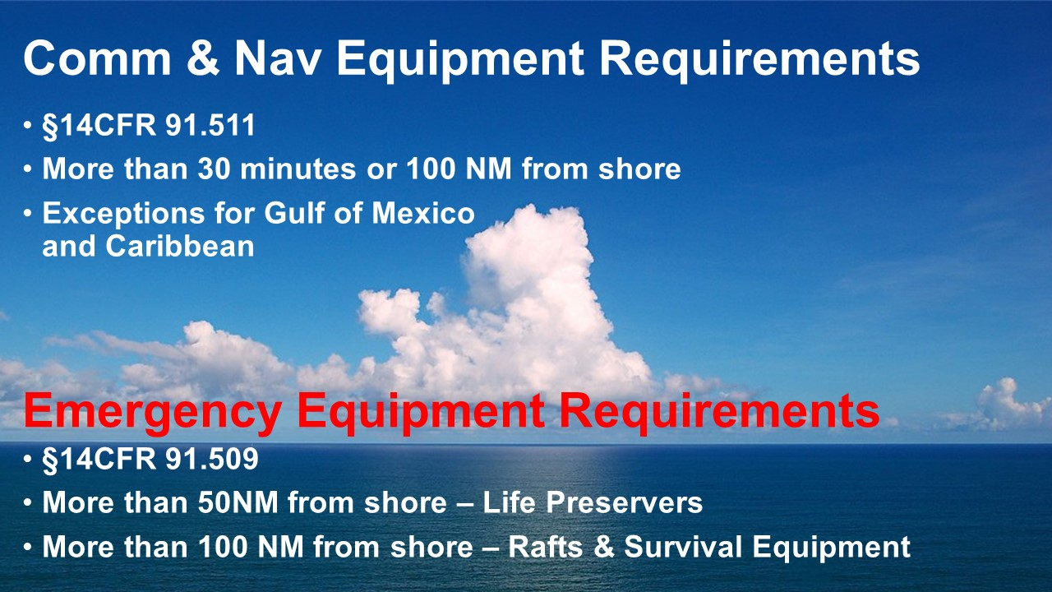 | Slide 8  Once you can no longer see land, one piece of ocean looks like any other so pilotage won’t work. Likewise, VOR, ADF, and VHF Communications may not be available. (Click)  That’s why 14CFR 91.511 specifies Communication and navigation equipment required when operating over 30-minutes flying time or 100 nautical miles from the nearest shore. Depending on where you’re flying that means you may have to equip with at least one High Frequency Radio. (Click)  The emergency equipment requirements in §14CFR 91.509 are a good guide for any over-water operations beyond gliding distance to shore.  (Next Slide)
 | Slide 9  If weather permits, we suggest that you plan to leave early and do your over water flying in daylight.  If you should have to ditch, it’s easier to get out of your aircraft and into your raft and you’ll be easier to spot. (Click)  If you must ditch in the dark the chances are very good that you’ll have to spend at least one night at sea. Either way, if you’re going to survive any time in the water, you’ll need some survival equipment.  (Next Slide)
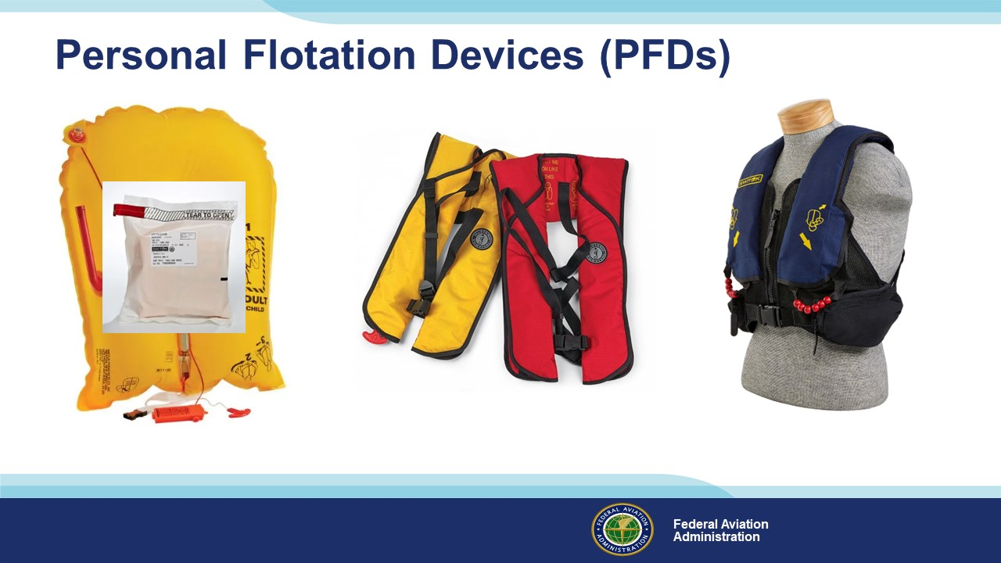 | Slide 10  The most immediate water survival need will be something to keep us afloat. We’re all familiar with the standard airline life vest. We’ve seen the demonstration dozens if not hundreds of times but few of us have had the opportunity to locate and open the package then don and adjust the PFD. (Click)  Likewise, we’ve heard the instructions on PFD inflation and the warning to inflate only after exiting the aircraft. Airline operations assume there will be time for passengers to locate and don their PFDs. We don’t have that luxury in GA operations. If we want PFDs to be available when needed, we’ll have to wear them – at least while we’re operating beyond gliding range of shore. (Click)  These inflatable PFDs are wearable and relatively compact. There are many to choose from that won’t significantly restrict your movement or impede egress from the aircraft – providing you don’t inflate before exiting of course. We recommend models with pockets for essential personal survival gear or wearing your PDF over a survival vest. More about that later.  Once we’re floating in the water, our next most urgent task will be to get out before we get too cold to function. Here’s why.  (Next Slide)
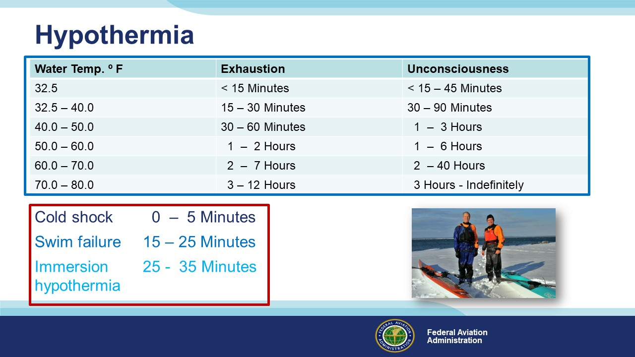 | Slide 11  Survival time is quite variable and by some accounts, this chart is optimistic. Still, it gives us an idea of how long we might be able to survive immersion and the key to longevity is, “the warmer, the better.” Until we reach 80º F – 26.6º C that is. Above that temperature survival time decreases. But wait, there’s more. Let’s consider sudden immersion in 50º F water – about the middle of the scale. (Click)  Sudden immersion in cold water causes a gasping reflex in most people. If our face is under water when this occurs, our PFD won’t be able to save us. Cold shock can be fatal unless we remain calm and control our breathing. (Click)  Although our chart says we have 1 to 2 hours before exhaustion, at this temperature, we may only be able to swim for 15 to 25 minutes. (Click)  Exhaustion and Unconsciousness make self-rescue impossible. That’s why these kayakers are wearing layered insulating garments under dry suits. Without this gear they would be challenged to recover from an otherwise minor boating event.  (Next Slide)
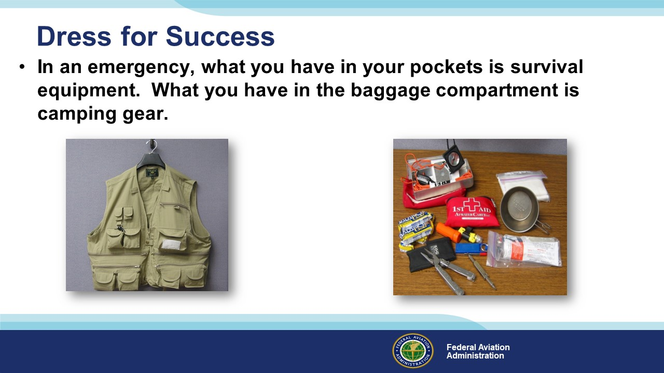 | Slide 12  No matter where you’re flying, plan to dress for success. That means wearing – not just packing - clothing that matches the environment over which you’re flying. You may be comfortable in your climate-controlled cabin at ten thousand feet but in the event of a ditching you may have to exit the aircraft quickly and gear that’s stowed in baggage compartments may not be accessible.  Dressing in layers is always a good idea. That way you can adjust as conditions change. Be sure to wear long sleeves and trousers closed-toe footwear and a hat. Don’t worry about clothing “dragging you down” if you end up in the water. Clothing won’t substantially affect your buoyancy although excessive equipment will. (Click)  In an emergency, what you have in your pockets is survival equipment. What you have in the baggage compartment may not be recoverable after a water landing. Many over-water pilots wear vests that contain essential survival equipment under their PFD. That way they’re at least equipped with the basics to survive the first few hours at sea.  Unless we’re engaged in single-engine trans oceanic operations, we’re unlikely to wear immersion gear while flying but we can increase our survival time by dressing in insulating layers and by taking a life raft along on over-water trips.  (Next Slide)
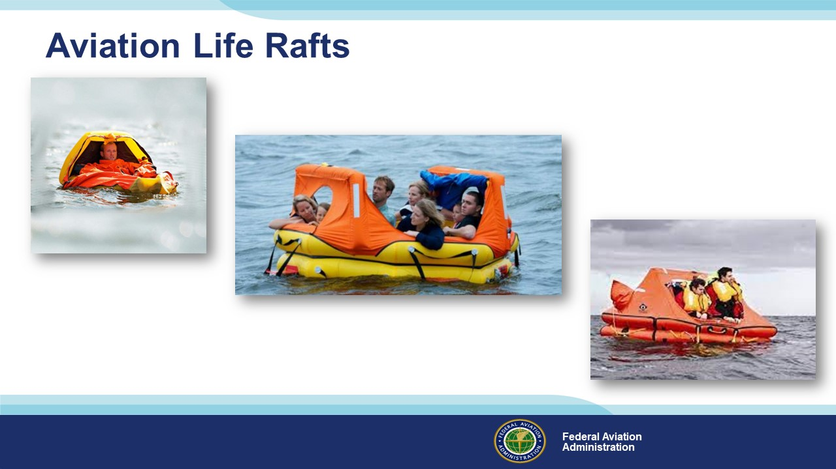 | Slide 13  Life rafts are expensive and they’re heavy but well worth having if you must spend any time on the water. They can extend your survival time from minutes or hours to days or weeks.  (Next Slide)
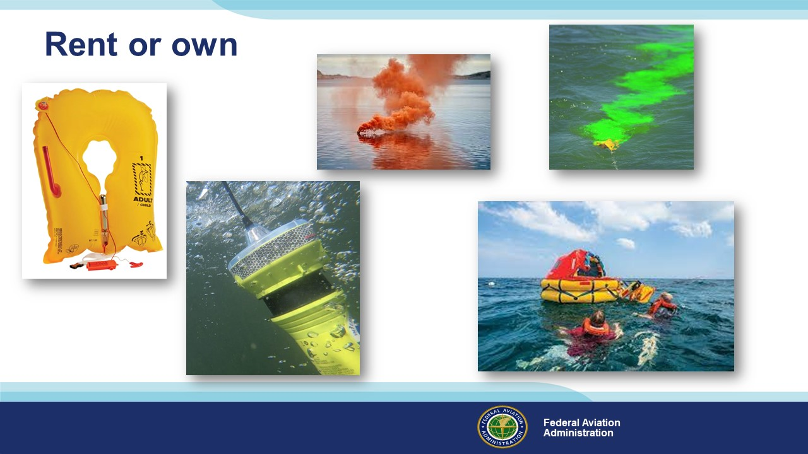 | Slide 14  If you make frequent trips over water or to the back country, it might make sense to own and maintain expensive survival equipment to supplement what you carry on every flight. If it’s just an occasional trip to the islands though, renting equipment is probably your best bet.  There are many sources of rental survival gear and, as you might expect, most are located on the coasts and they’re convenient to airports. Many pilots land and pick up their rental gear there, but you can also arrange for shipment to your home field in advance of your trip. Just be sure to allow enough lead time to reserve your equipment and plan whether to pick it up en route or have it shipped to you.  (Next Slide)
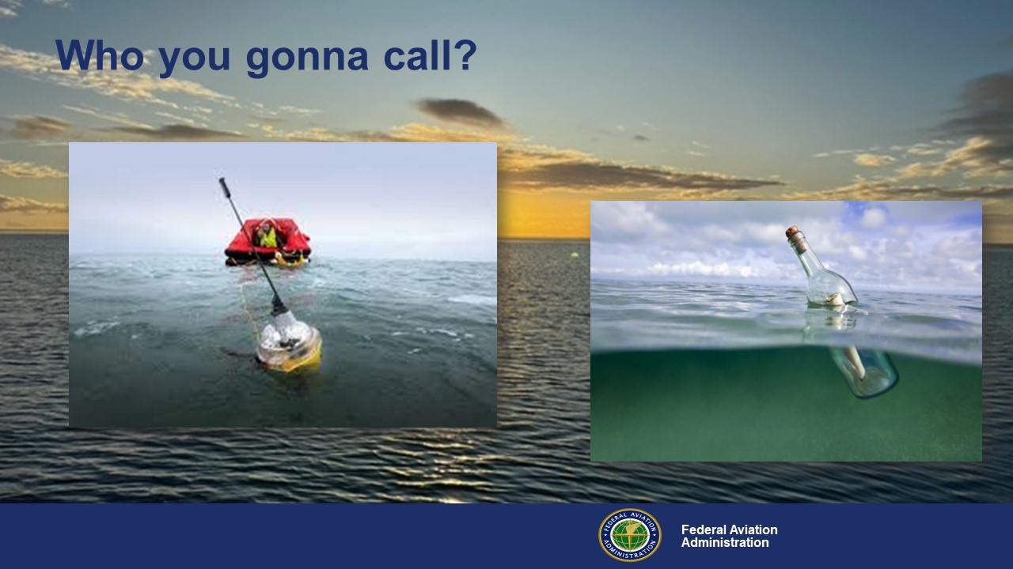 | Slide 15  So, you’ve pulled off a successful ditching and you were able to deploy your raft and survival equipment. Now that everyone’s accounted for, who are you going to call? (Click)  Well, there’s the time-honored note in a bottle technology. It could work, but maybe not in our lifetime. How about something a little more 21st Century? (Click)  That’s more like it. An Emergency Position Indicating Radio Beacon or EPIRB. Your aircraft had an ELT of course but unless you managed to grab it on your way out the door it could be several hundred feet below you and miles away by now.  (Next Slide)
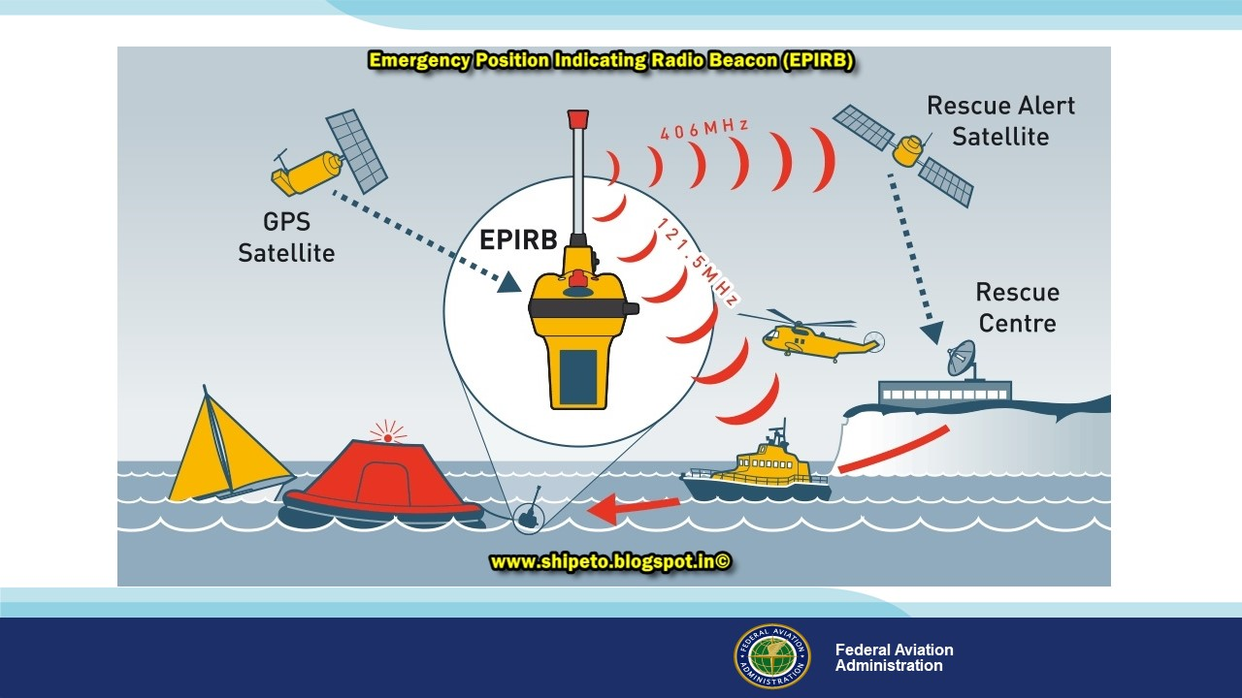 | Slide 16  You can think of EPIRBs as marine ELTs. They’re waterproof and they transmit information on 121.5 and 406 MHz emergency frequencies. Here an EPIRB attached to a life raft, alerts authorities to your situation via satellite and rescue aircraft and vessels can pinpoint your position as they approach.  EPIRBs are standard equipment on many life rafts, or they can be purchased or rented individually. An EPIRB is essential equipment for over-water operations and there are also numerous supplemental equipment options to consider as well.  (Next Slide)
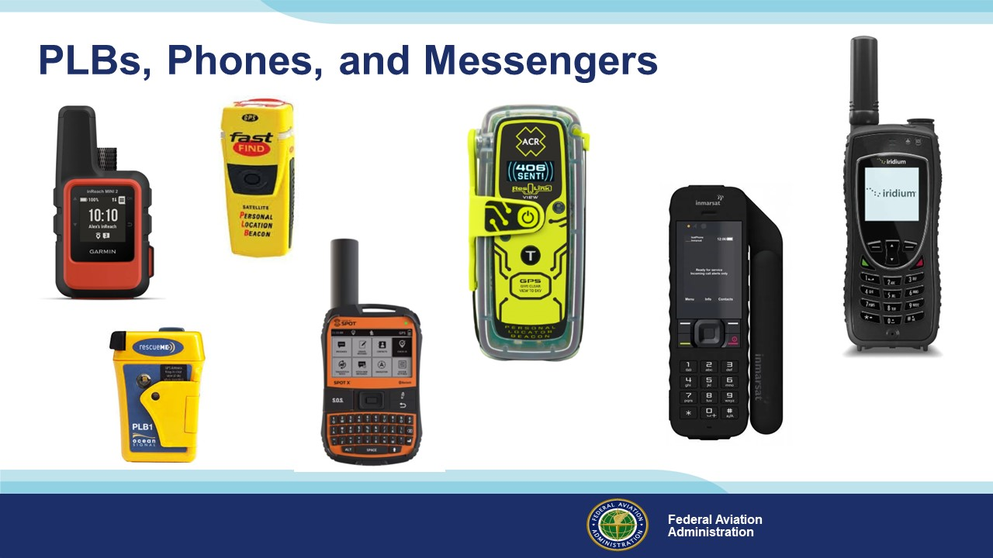 | Slide 17  406 Mhz. Personal Locator Beacons are great to have – especially on flights over water. These relatively low-cost devices are a great adjunct to aircraft ELTs and EPIRBs. They’re handy enough to always have with you and they’re not just for aviation. You can use them for hiking, camping, hunting, & fishing – or for peace of mind on any road less travelled. (Click)  Satellite Messenger Devices can feature one or two-way text messaging that you can use to call for help or to check in with your trusted agent. Many of them can also process messages from you to the folks back home. You can let them know if you need help or if everything’s all right. (Click)  Satellite phones are now available for purchase or rent. Not a bad idea if you’re planning over water or remote area flying.  (Next Slide)
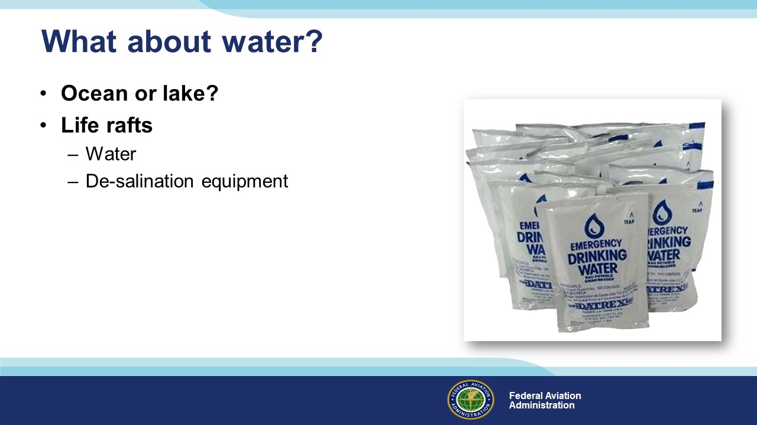 | Slide 18  How much water we need is of course dependent on whether we land in the ocean or a fresh-water lake. Either way a couple of water packets in your survival vest is a good idea. They will keep you hydrated until you’re aboard your life raft. Raft survival kits should contain more fresh water and a desalination kit.  (Next Slide)
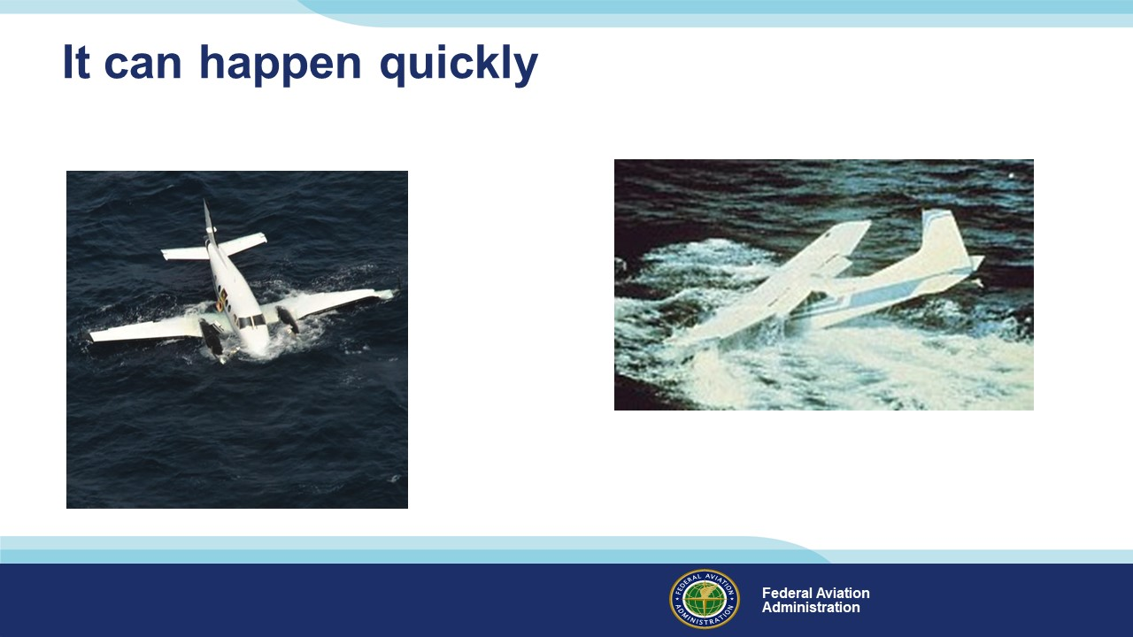 | Slide 19  It can happen quickly – One minute you’re cruising along and the next you may find yourself in the water in a survival situation. Coping successfully in times like these requires knowledge, discipline, and planning.  (Next Slide)
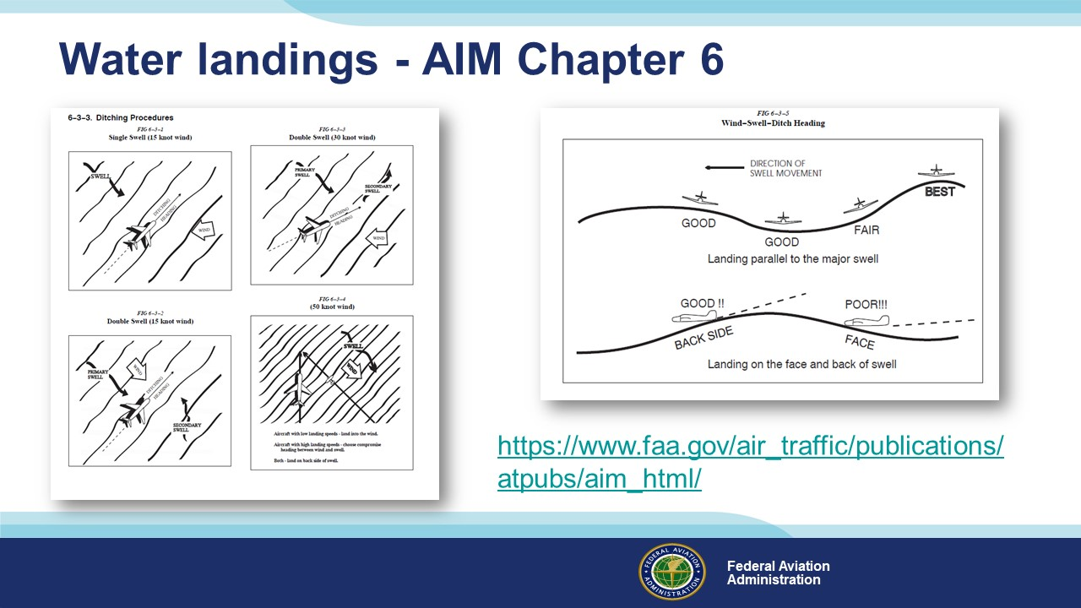 | Slide 20  Making a good water landing – ditching - is the essential first step to water survival. Pilots should review ditching procedures in the Aeronautical Information Manual Chapter before conducting over-water operations. Having those procedures fresh in our minds will help us to successfully pull off a maneuver few of us ever get to practice.  (Next Slide)
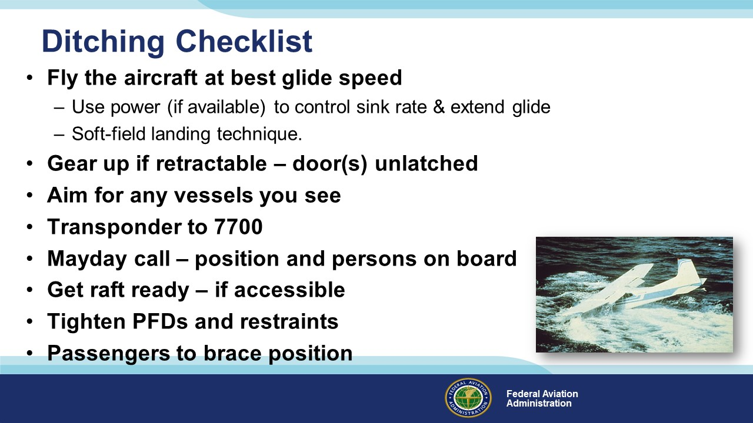 | Slide 21  How much can be accomplished before ditching is directly proportional to how high we’ve been cruising and how much power is available. Use available power to control sink rate and extend your radius of action. Unlatch doors, plan for a gear-up soft field landing, and maintain control throughout. This is the time for the best soft-field landing you’ve ever made.  Remove eyeglasses and stow in a pocket. They may be lost on deceleration and after landing you won’t have time to look for them. If there’s time - secure loose items in the cockpit.  Your life raft should be in an in-flight accessible location. If possible – relocate it to a back seat passenger position where it can be one of the first things out the door.  With these preparations accomplished, it’s time for everyone but the pilot to assume brace positions.  (Next Slide)
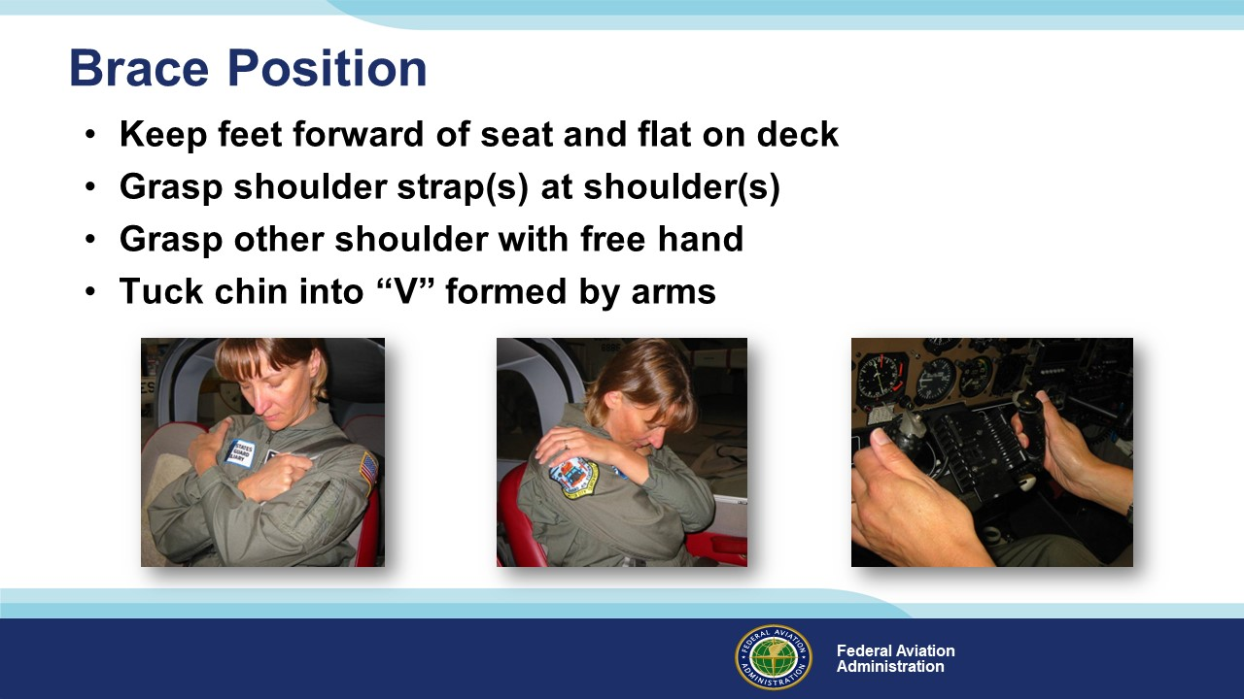 | Slide 22  The aircraft will decelerate rapidly at touchdown and may turn upside down. Before landing, ensure that seatbelts are positioned low on hips and as tight as possible. Passengers should brace for landing by keeping feet forward of the seat crush zone and flat on the deck. If equipped with a double shoulder harness, cross arms and grasp each shoulder strap to form a “V”. For single-shoulder strap restraints, grasp the shoulder strap with one hand and grasp the opposite shoulder with the other hand. (Click)  Tilt chin forward into the “V” before impact. (Click)  Pilots must maintain control throughout but do place thumbs outside of the control yoke as shown before landing. Use a soft field landing technique cushioned with any power available and touch down as slow as possible but don’t stall.  (Next Slide)
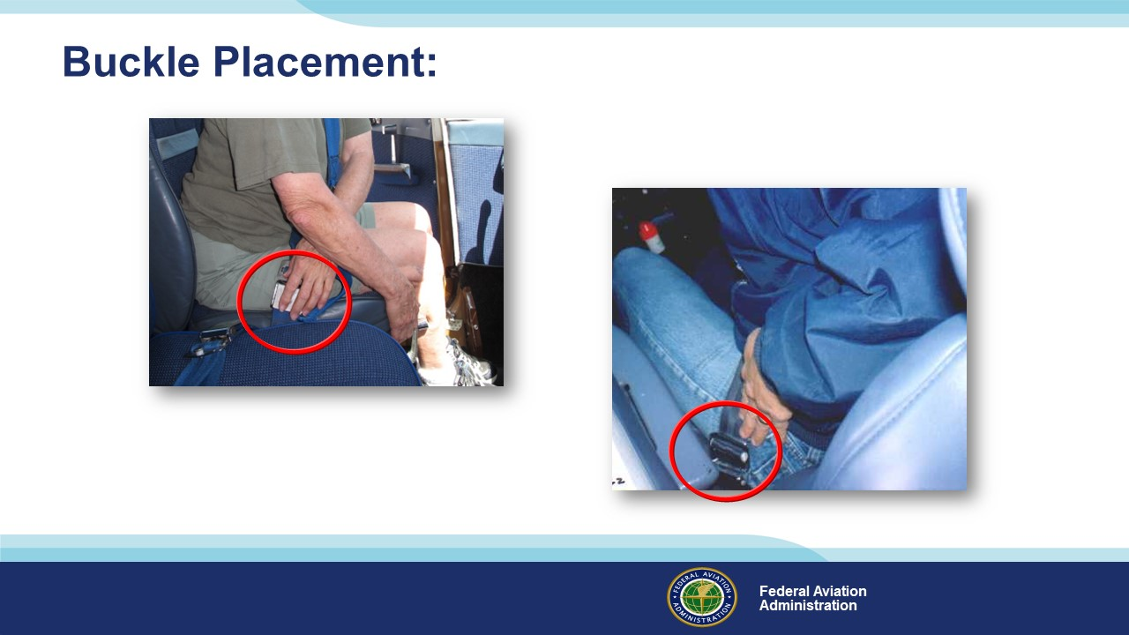 | Slide 23  Just a couple more things about seat belts: Buckle placement is important. (Click)  In this illustration, the seat belt buckle is low on the pilot’s left side. With the door closed, the buckle will be under the armrest. If the door were jammed, precious time could be  Spent in cutting the seatbelt & finding another exit. (Click)  Here the buckle is low on the pilot’s right side and it’s unobstructed – a much better choice for buckle placement.  (Next Slide)
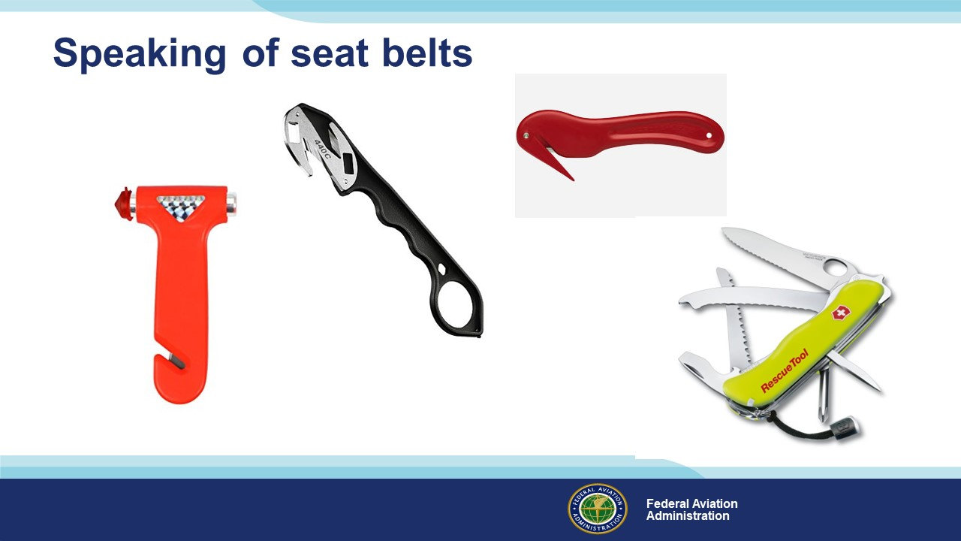 | Slide 24  Once your seatbelts or harness have done their job, you’ll want to get clear of them quickly. Single point belt releases are a wonderful thing but if they’re inaccessible you’ll need a Plan B. A seatbelt cutter or multi-purpose extraction tool fills the bill, and you’ll need to have it where you can access it quickly. That means not in the glove box or the emergency kit in the baggage area or the flight bag. Accessible means on your person in a pocket that you can easily reach while wearing your restraint system.  Some folks say, “I carry a pocketknife – that’ll cut through any seat belt”. They’re right of course but the trouble with a knife is you can do a lot of damage to yourself while trying to cut through a seat belt. This is one time where you ought to consider a specialty tool.  (Next Slide)
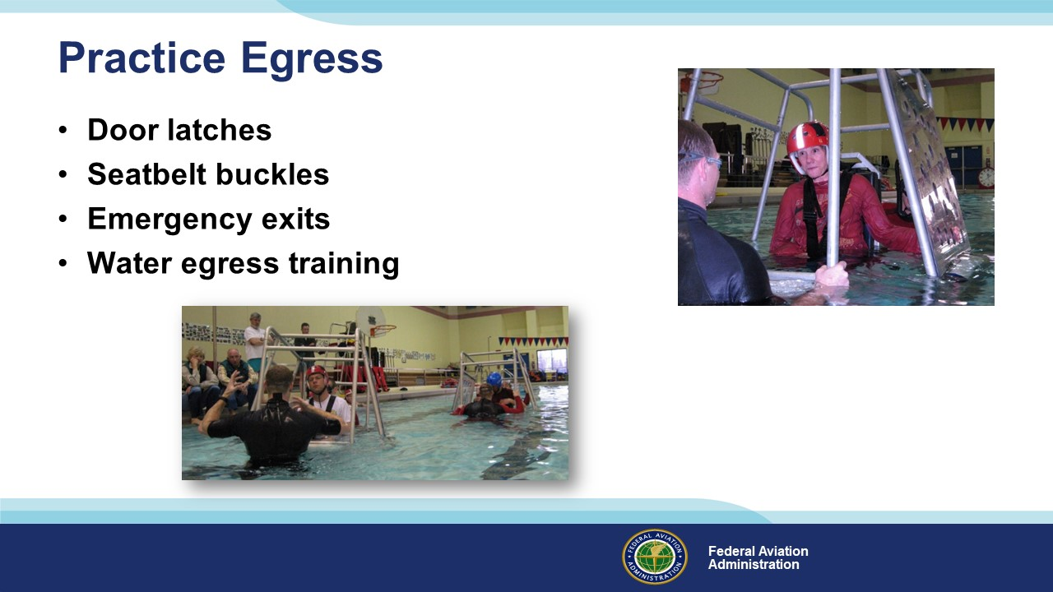 | Slide 25  Once in the water, the obvious next step is to exit the aircraft before it sinks. Successful egress is more likely if you have good muscle memory as to door latch location and operation, emergency exits, and restraint systems.  Water egress training, available from various institutions and vendors, is highly recommended for pilots and passengers alike.  (Next Slide)
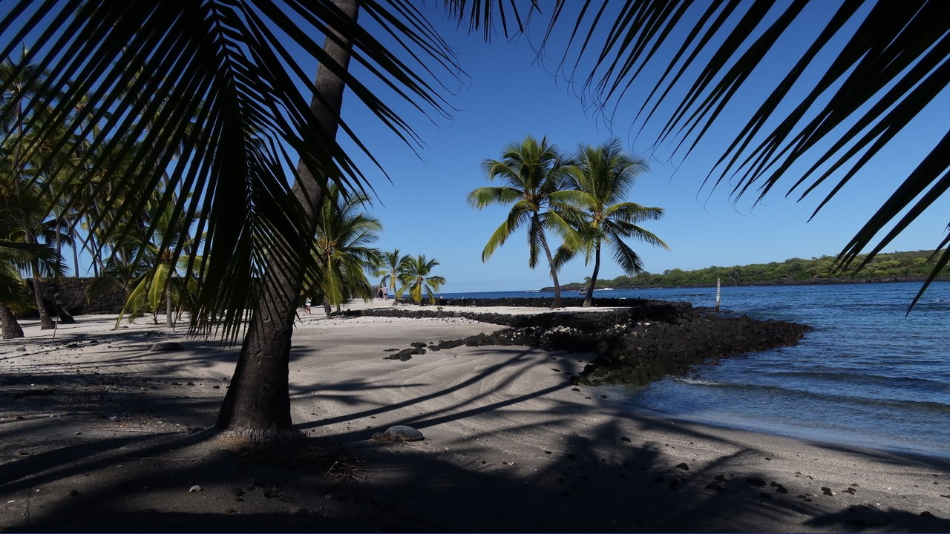 | Slide 26  Well, that’s a quick look at over-water flying considerations. We’ve spent most of our time talking about what to do if trips don’t go as planned but the vast majority of GA over-water flights are successful. We hope you’ll consider expanding your horizons with over-water operations and we trust that if you do, you’ll be prepared for anything.  Yes, there’s a lot to know and prepare for but there’s no denying the destinations are worth the effort.  (Next Slide)
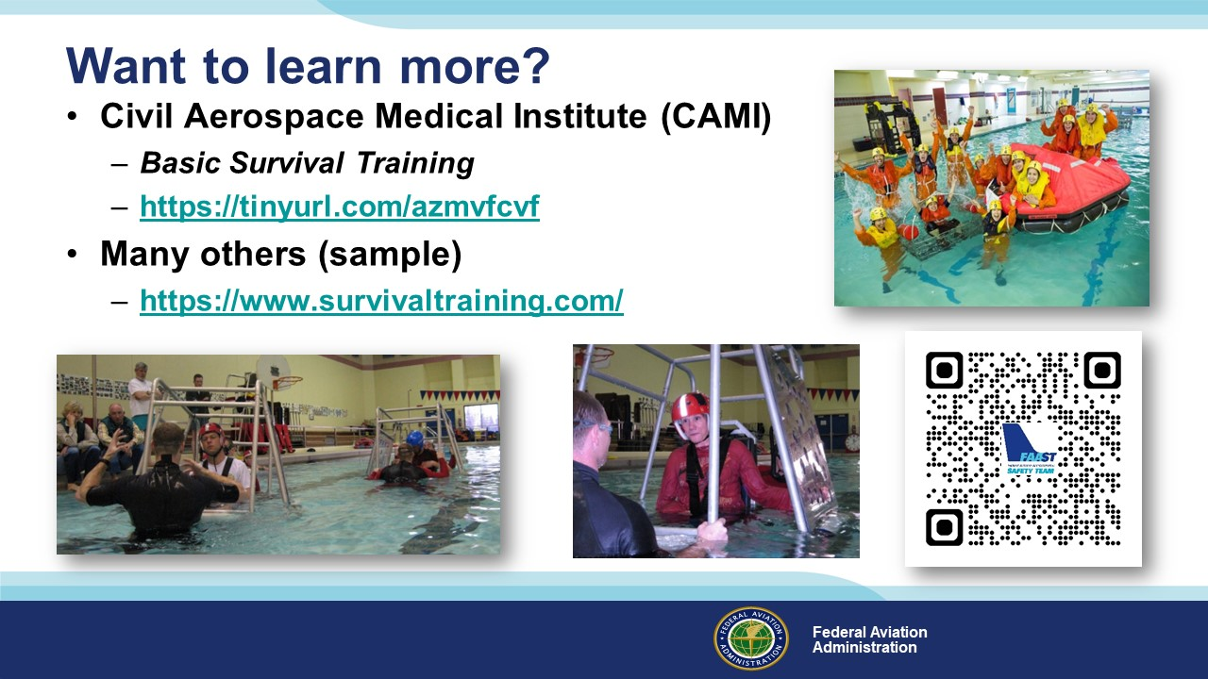 | Slide 27  Want to learn more?  The Civil Aerospace Medical Institute offers a Basic Survival Training course. You can learn more about it by navigating to this website.  Presentation note: If you have time and an internet connection you can click on the hot link and go to the CAMI website or to the URL on screen. (Click)  There are many commercial in-depth survival training courses available as well. Here’s a link to one in Anchorage, Alaska. We encourage you to consider attending one of them.  (Next Slide)
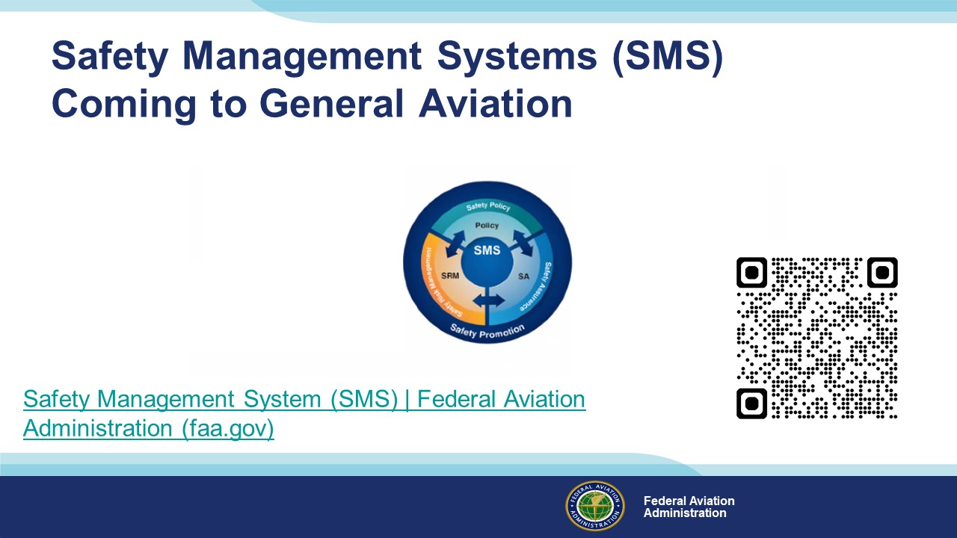 | Slide 28  Safety Management Systems are a set of policies and processes that can increase the safety and efficiency of any flight operation. And FAA is bringing SMS to General Aviation. You may have heard of SMS but thought it was only for large organizations but actually SMS can be scaled to fit any operation large or small.  There are 4 major components to a Safety Management System (Click)  Safety Policy – a documented commitment to safety that runs from the head of an organization to its newest member. (Click)  Safety Risk Management – a process that identifies hazards within an operation, determines to what extent an identified hazard may impact flight safety, and controls the risk of occurrence to an acceptable level. (Click)  Safety Assurance – By collecting and analyzing information derived from safety performance data Safety Assurance ensures the performance and effectiveness of Safety Risk Controls. (Click)  Safety Promotion communicates safety information and commitment throughout the organization. (Click)  You can find more information about Safety Management Systems at the URL on the Screen.  Presentation note: Allow sufficient time for audience to copy link then:  (Next Slide)
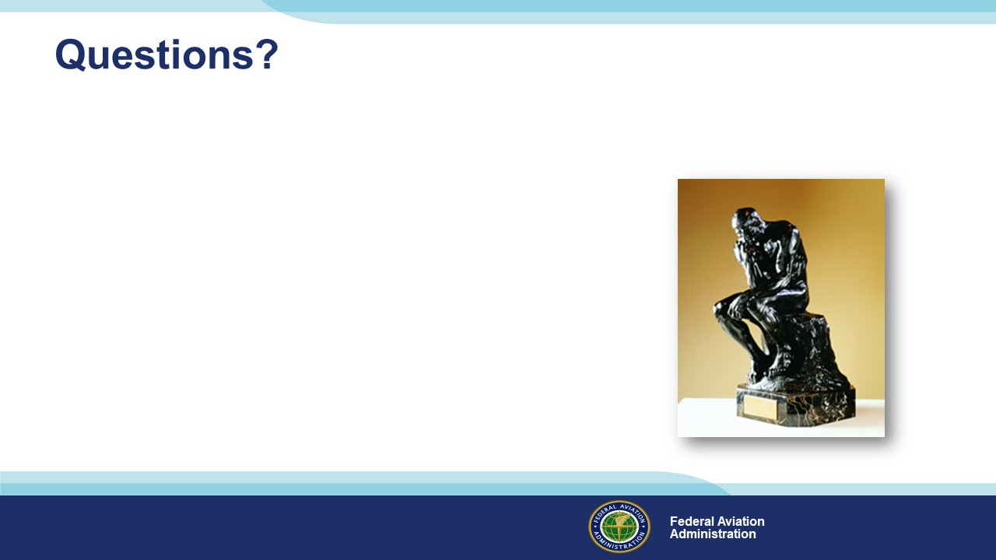 | Slide 29  Presentation Note: You may wish to provide your contact information and main FSDO phone number here. Modify with  Your information or leave blank.  (Next Slide)
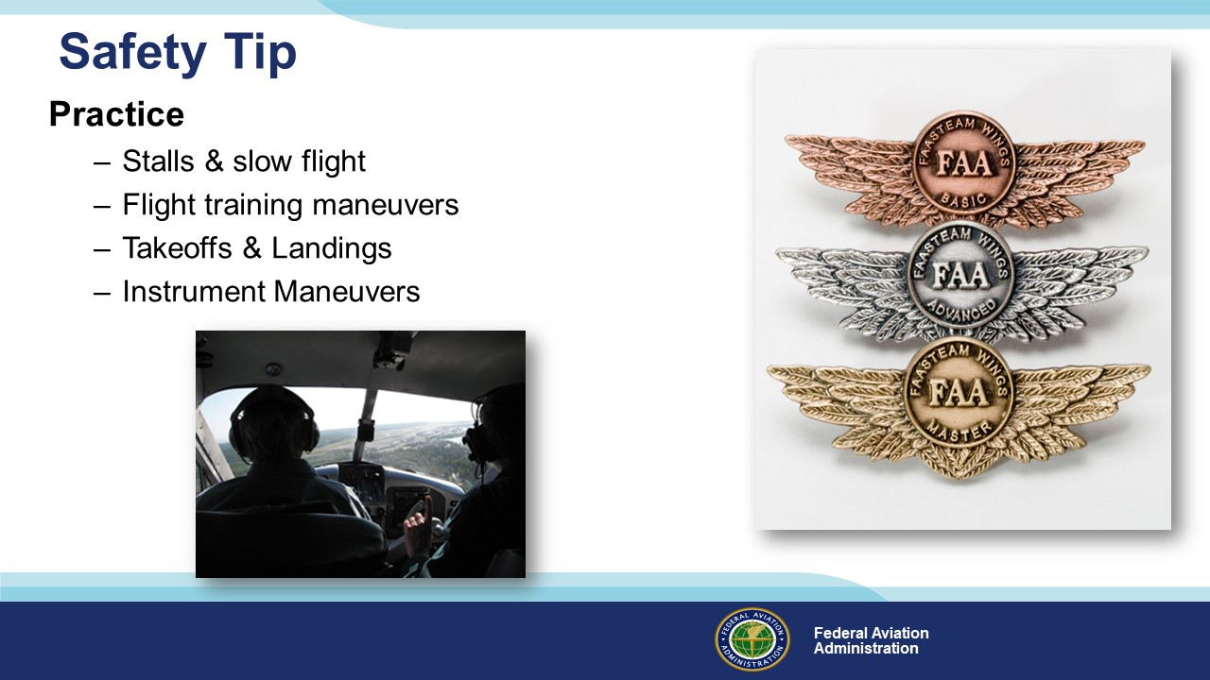 | Slide 30  An airplane owner once asked an experienced instructor pilot, “What’s the best thing to put in my airplane to increase safety?”  Without hesitation, the instructor answered, “Gasoline”. (Click)  That’s right – the most effective safety tool for any pilot is practicing the art and science of flying. That means more than  a monthly trip for the hundred-dollar hamburger. Book some time with a CFI at least once a year to practice the items on this list. (Click)  And be sure to document your achievement in the Wings Proficiency Program. It’s a great way to stay on top of your game.  (Next Slide)
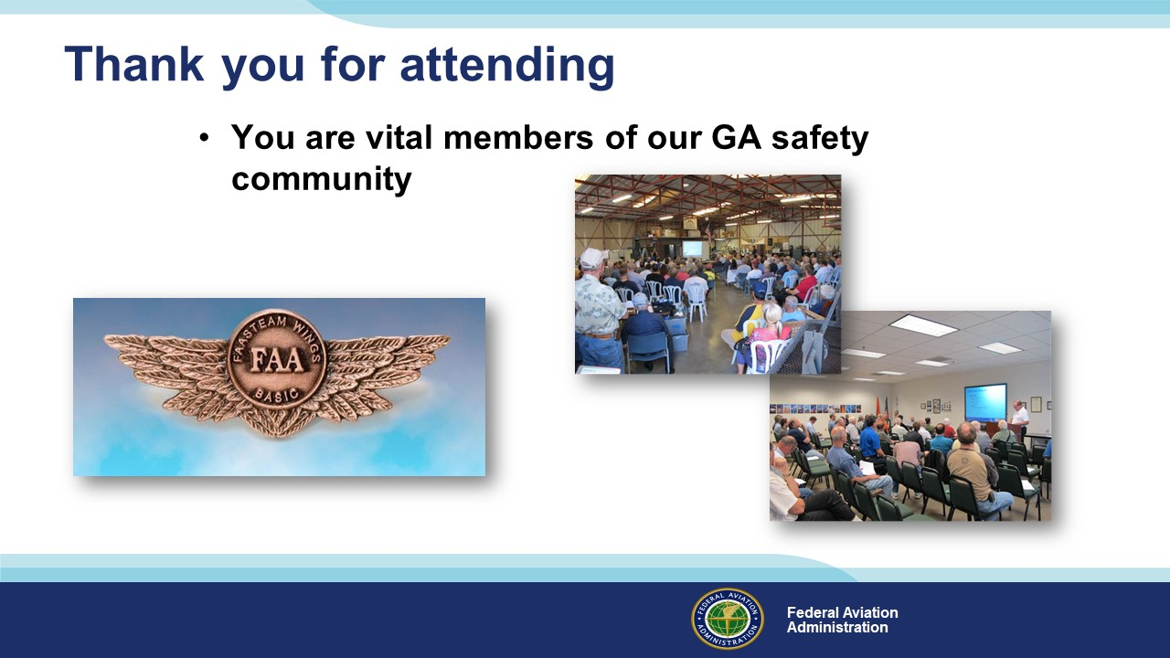 | Slide 31  Your presence here shows that you are vital members of our General Aviation Safety Community. The high standards you keep and the examples you set are a great credit to you and to GA.  Thank you for attending.  (Next Slide)
Slide 32

(The End)

Appendix I – Equipment and Staging
Equipment:
- Projection Screen & Video Projector suitable for expected audience
  - Remote computer/projector control available at lectern or presenter location
    - In lieu of remote – detail a Rep to computer/projector control.
- Presentation Computer
  - Note: It is strongly suggested that the entire program reside on this computer.
- Back up Projector/Computer/Media as available.
- PA system suitable for expected audience
  - Microphones for Moderator and Panel
    - Optional Microphone (s) for audience
- Lectern (optional)
Staging:
- Arrange the projection screen for maximum visibility from the audience.
- Equip with PA microphones
- Place Lectern to one side of screen. This will be used by presenters and moderator

IMPORTANT – Once you have completed outreach on this topic, please help us track the outreach you have done by entering a SAS record.

